Individual Guide On Micro Sprite Scooter
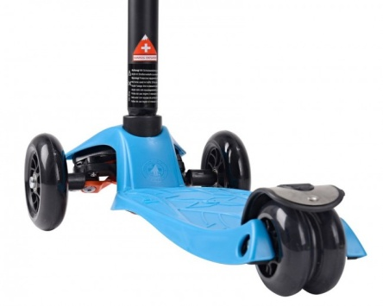
While our grandmothers were young mothers, they just had the fundamental products for rearing a child - they absolutely did not have the luxuries we have today that makes our lives easier when looking after little one. An example is the baby crib. Today is just a different story. The range is really huge that it's usually very confusing what things to seek out and where you should look when you are looking for baby furniture. Baby bed is among the essential furniture within the complete list. Today, you'd definitely want to adorn your baby's crib, so why not choose gorgeous and adorable cot mobiles. Having baby cot mobiles is one of the best tips for early instructional growth, and modern baby mobiles have a superb selection of designs that include every one of the sensory organs of the new born baby. Musical mobiles are best, since the restful melody of the audio help calm the infant. Are you hunting about maxi micro scooter? Check out the earlier outlined site.
It has been well established that traditional music, played to your child in the womb or from an early age, does result in cerebral progress ahead of children who've no such audio feedback. Really the most enjoyment mobiles will be the versions with creatures and dancing insects. They truly are quite cute and elaborate with a hint of imagination placed in. Creatures are a well known element among baby bed mobiles. An animal baby mobile might include jungle animals, like monkeys, zebras, and tigers. Others could have farm animals, including cattle or sheep. Sheep are typical, since they will be associated with sleep.
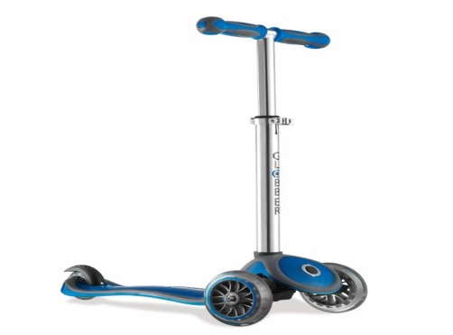
Apart from animals, baby mobiles might have different toys and forms. Monochrome graphic aids could be highlighted. There also might be shapes or heroes. The nice vibrant shades surely attract baby's awareness too, which can be what you would like to achieve. Visit the following site, if you are hunting for additional information regarding 3 wheel scooter. Baby cot mobiles may have a cover on the dangling toys and foundation. Amobile having a canopy design may be coordinated to the fabrics found in a baby's bedding. The canopy can also be anything interesting for child to check out, in addition to the baby toys. Instead of a cover style, baby mobiles might be hanged in an even more innovative method. Vivid animals and forms could be suspended in a link style or they may be hanged from plastic rods. Are you hunting for globber scooter? Visit the previously talked about site. Most baby mobiles possess a spinning function, however, some, such as the chain link layout, will not. With regards to things that preserve infant's attention, mobiles go a long way towards acquiring one of those important and much beloved giggles.

