Legacy

White Paper

Project Page
www.Legacycash.org

Legacy Contract
0x9a806aE99B997d6B86294b3488c060461F22629B

Audit:

Legacy© | White Paper | Februari 2022 | All Rights Reserved

Legacy official

Legacy© | White Paper | Februari 2022 | All Rights Reserved

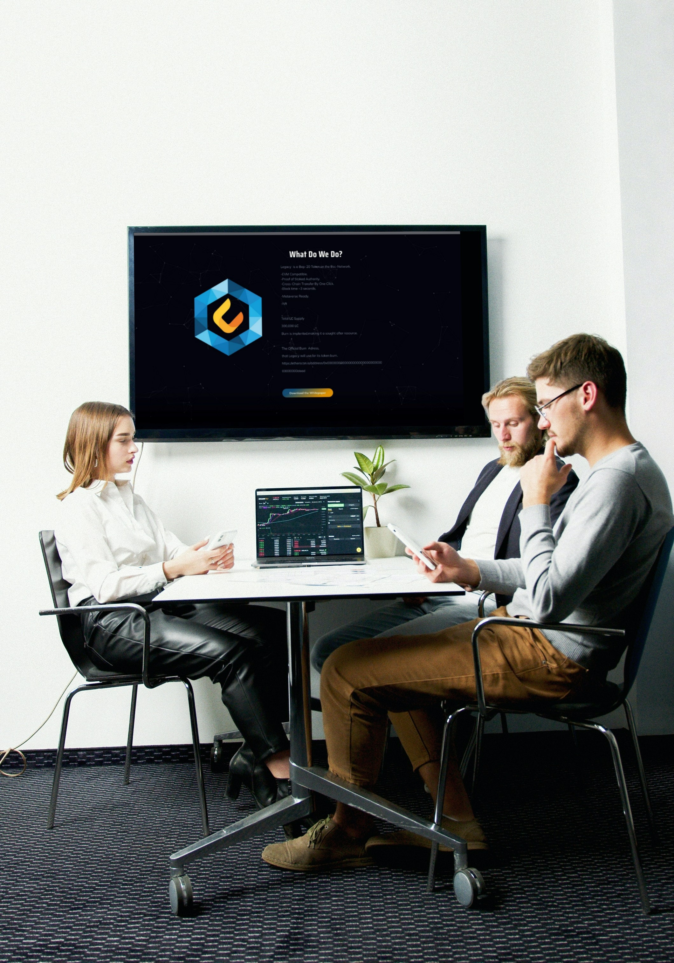

Legacy© | White Paper | Februari 2022 | All Rights Reserved

Legacy (Lc) Binance Blockchain

Name Legacy
Type Bep20
Symbol Lc
Platform Smartchain
Supply 300,000
Burnable Burnable Events, reduction to 150,000 max supply

Legacy© | White Paper | Februari 2022 | All Rights Reserved

LEGACY ROADMAP

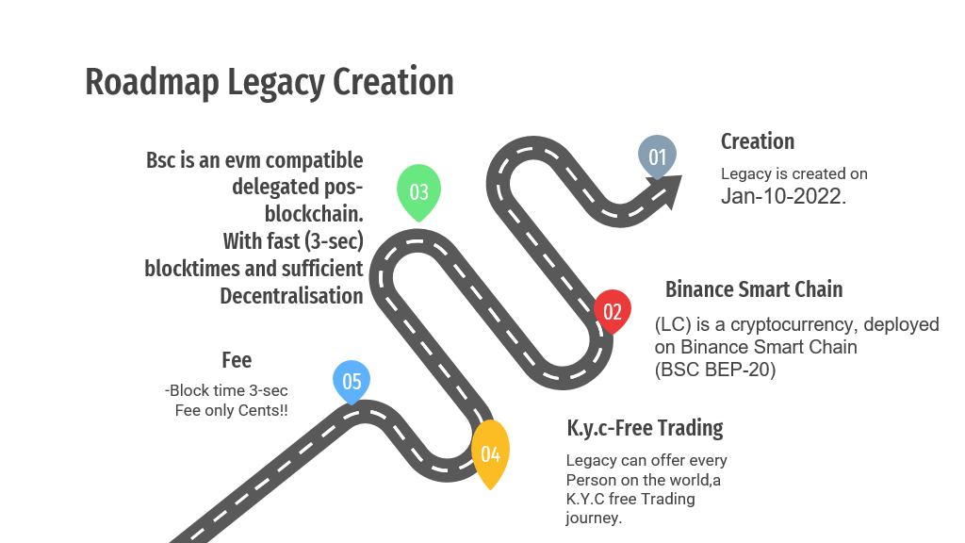

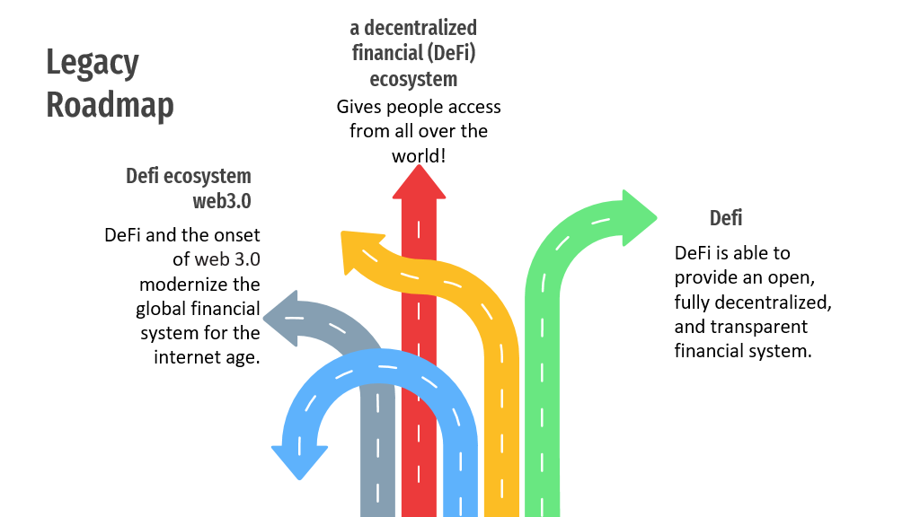

Legacy© | White Paper | Februari 2022 | All Rights Reserved

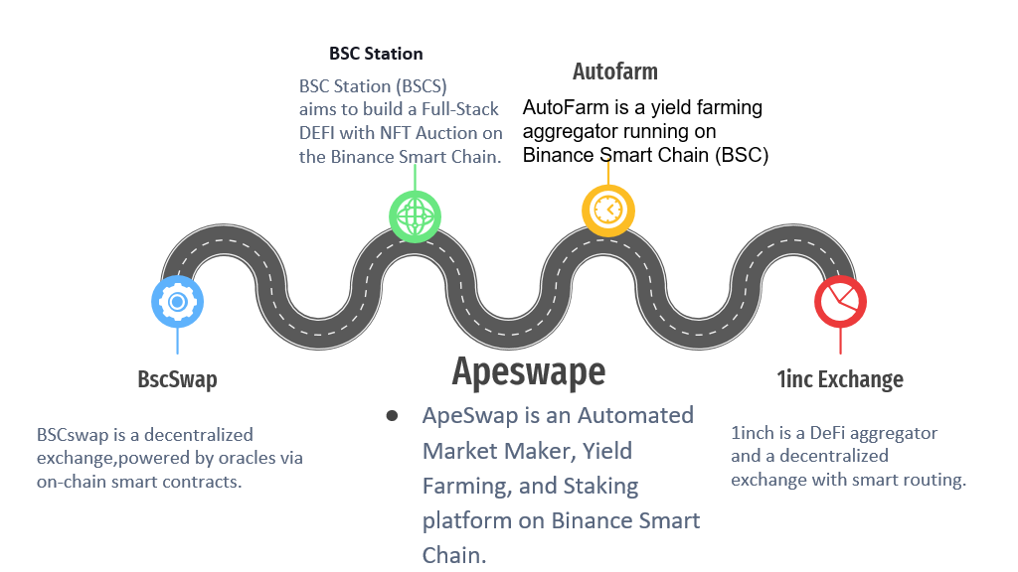
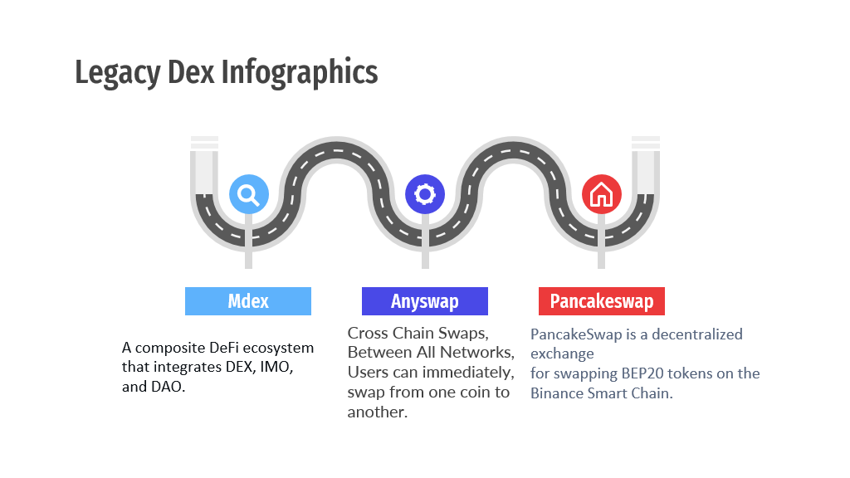
Legacy© | White Paper | Februari 2022 | All Rights Reserved

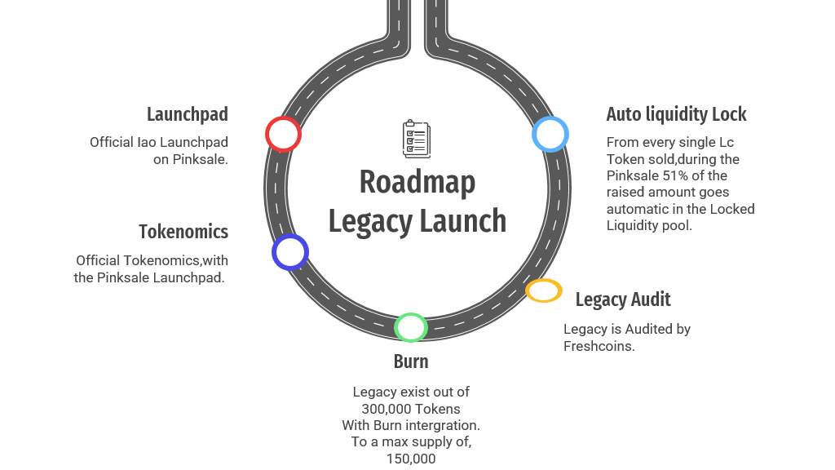

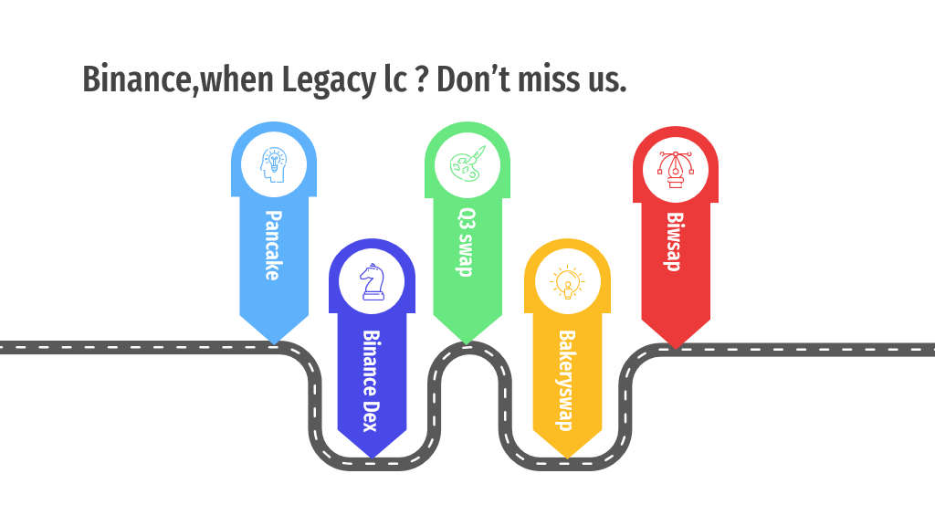

Legacy© | White Paper | Februari 2022 | All Rights Reserved

About Legacy

Legacy is a Decentralized Eco Friendly Token,(Defi)

Legacy uses a Next Generation Cross Chain smart contracts EVM between networks,
To ensure transparent and fair deals.

Legacy is a bep-20 token on the Binance smart chain,with a 300,000 supply.
Burn able events are intergrated, to a reduce of 150,000 max supply.

Beyond the simple management of decentralized applications,our goal is to create a Decentralized Legacy Eco Friendly Dex.

Legacy can interact with all Blockchains supported by Evm,simplicity in one click.

-Ethereum mainnet -Fantom Opera
-Harmony Mainnet -Xdai chain
-Oneledger -Celo Mainnet
-Energy Webchain -Theta Mainnet
-Iotex Network -Ontology Mainnet

Legacy© | White Paper | Februari 2022 | All Rights Reserved

ABOUT LEGACY Eco Friendly Consumption & Foundation

-We from legacy,try to help to reduce the energy consumption.

This is verry important for legacy to be a part of,and help Build back better.
A cleaner world for us,and for the future generation's,our bsc chain is Co-Neutral.
We don’t need heigh energy consumption like Pow networks do need.
Ever human and animal,deserve to live on a healty and clean earth.
Animals deserve to live in a safe peace fully part of nature,unfortly nature getting destroyed 24/7.
Duo to heigh energy consumption,and big company's spreading rapidly,there for a lot of forest getting destroyed,we from Legacy are against this.

We stimulate to be Clean and eco friendly energy,not only for us but also for the next generation's after us and nature.
There for Legacy will set up a foundation,we will Donate a percentage of our Launchpad raised cap.
This we will donate to a,Eco friendly tree planting charitable organisation with a complete documentation.

Legacy© | White Paper | Februari 2022 | All Rights Reserved

Legacy Use Cases & Collebrations.

-Scalability
-Interact with all blockchains,
-trough smart contracts,Next Gen Crosschain.
-Metaverse Ready.
-Fast 3second Block Transfers.
-Burn Events.
-Nft Marketplace.
-Legacy is Supported by 16 Dex Swap Platforms.

Legacy x Ledger

Legacy X Ledger collebration you can store your Legacy tokens, On all Nano Ledger device's cold wallet stored.

Legacy is a accepted on the ledger Visa Debit card,you can pay in all Retail stores with ur legacy tokens as payment .

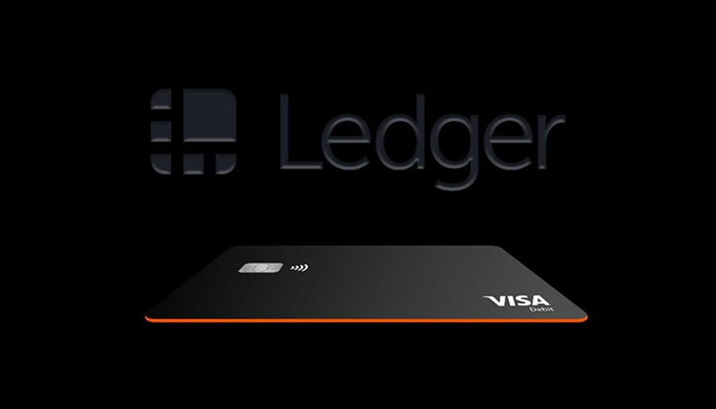

Legacy© | White Paper | Februari 2022 | All Rights Reserved

Will be updated soon,with a lot more content!!!!!!!!

