・輒・ま・よ | ル4  -み 地む毯。総 | 0 | 当
、曇でミー
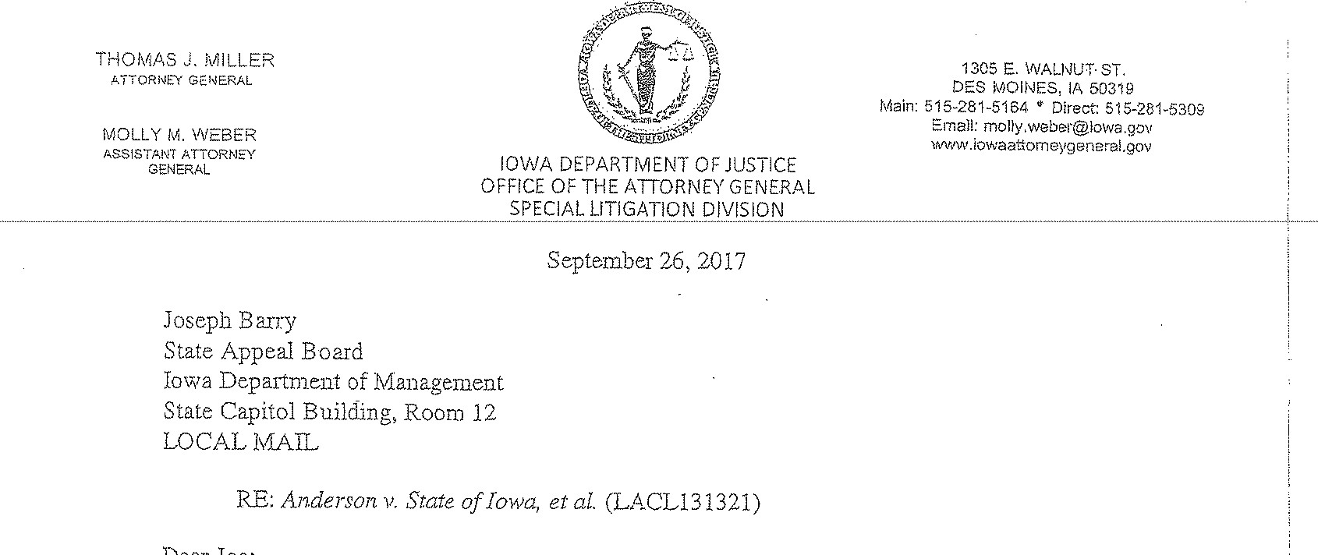
DeaŸ Joe:
We have reached agreement to settle this lawsuit for $1,750,000.00, subject to the approval of the State Appeal Board. The lawsuit alleged sex discrimination, sexual harassment, and retaliation in violation of the Iowa Civil Rights Act against the State of Iowa, the Iowa Senate. and the Iowa-Senate Republican Caucus. Plaintiff alleged that she was terminaÍed because of sex discrimination and retaliation. "The jury reached a verdict in favor of Plaintiff, and post-trial 1110tions are pending.
Please forward to me checks in the following payable to:
- Kirsten address—the of $1,044,775.60 without deduction or withholding.
- Coppolla, McConville, Coppolla, Carroll, Hockenbeïg, & Scalise, FID —in the amount of $705,224.40 to the Coppola Law Film Trust Account for. attorneys* fees and costs.
I have enclosed a copy of the proposed release.
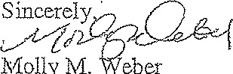Molly M. eber
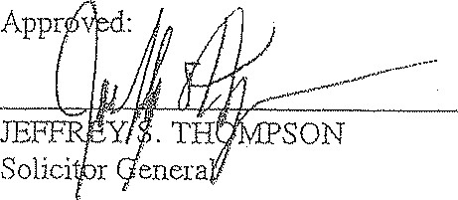 Assistant Attorney General
cc: B arrett Harvey
Pam O'Brien
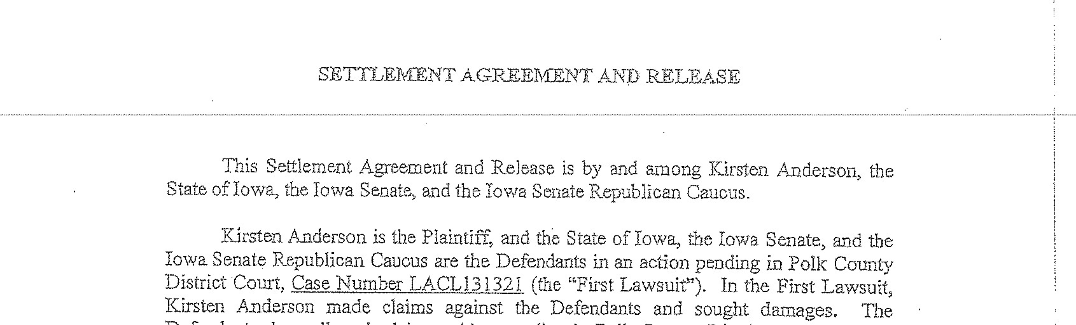
District Court, Case Number LACL131321 (the "First Lawsuit"). In the First Lawsu{t; Kirsten Anderson made claims against the Defendants and sought damages.
Defendants deny all such claims. Also pending in Polk C,0ünty District Court is Case Number LACL132844 (the "Second Lawsuit") in which Kirsten Anderson is the Plaintiff and the State of Iowa, the Iowa Senate, the Iowa Senate. Republican Caucus, Senator Bill Dix, Eric Johansen, and Ed Failor, Jr. are the Defendants. In the Second Lawsuit, Kirsten Anderson made claims against the Defendants and sought damages. The Defendants deny all such claims,
The parties have agreed to compromise and settle al] of Kirsten Aliderson ^{S} s claims arising from the First Lawsuit. The 'Plaintiff has also agreed to dismiss the Second Lawsuit with Drejudiceo Based on the mutual promises and covenants exchanged and fôr other good and valuable consideration, the adequacy and receipï- of which are acknowledged, the parties agree:
- Satisfacfoa and Dismissal. Tha parties stipulate that subsequent to the execution of this Settlement Agreement and Reiease, in return for payment> the Plaintiff will file a release and satisfaction of judgment indicating the release also includes post judgment rights to attorney fees and costs, and a dismissal with prejudice of the Second Lawsuit. Each party will bear its own costs.
- Kirsten Anderson Releases.
  - Releasin Parties. The covenants, and releases made by Kirsten Anderson in this Settlement Agreement and Release are made by her in her own capacity and on behalf of all persons and entities claiming by, through, or under her or through which she makes her claims, including, blit not limited her heirss assigns, representatives, executors. and spouse.
  - Released Parties. The covenants, waivers, and releases of Kirsten Anderson in this Settlement Agreement and Release are made to and
for the benefit of the State of lovea, the Iowa Senate, the Iowa Senate Republican Caucus, and any State agencies, officers, directors.
affiliates, advisors. attorneys, agents; predecessors, successors, assigns, and employees, including, but not limited to, Senator Bill Di.X> Eric Johaasen, and Ed Failor, Jr. (collectively, the "Released Parties").
  - Claims Released. The claims released throu•h this Settlement Agreement and Release shall include and extend to any and all claims, demands, causes of action, and/or liabilities of 01' against the Released Parties, whether or not they are now known, that Kirsten Anderson has or may have against the Released Parties, individually and/or jointly, or that otherwise exist or mav have been raised in the First or Second Lawsuits, Without limiting the preceding sentence, the clairns which Kirsten Anderson waives and releases this Settlement Agreement and Release include those claims asserted or capable of being asserÉed in the First and Second Lawsuits and shall extend to all claims arising out of or relating to 14-irsten Anderson's recruitment, hiring, employment, telTIS, and conditions of emDloyment5 or cessation of- such employment with the State of Iowa, the Iowa Senate, and/or the Iowa Senate Republican-Caucus;• and any claiãls for back pay, emotional distress, front pay; front pay reimbursement, loss of earning capacity, injunctive or equitable relief, all for attorneys ⁵ fees, CùSts, and disbursements arising out of cr relating to the First and Second Lawsuits. Such released claims collectively are referred to as the "Claims.'
  - Waiver Release and Covenant IN^{T}Ot to Sue, Kirsten Anderson irrevocably and unconditionally releases, waives, acquits5 and forever discharges all Released Parties from the Claims and agrees to hold them harmless from any cost, liability, or expenseh including attorneys' fees, costs, and expenses, arising from or related to any action hereafter which asserts anv o? the Claims. Kirsten Anderson further covenants that she in her own caoacity or through her shall not sue or make demand upon or seek damages from any of the Released Parties for any of the Claims.
- Payments. Upon satisfaction by Kirsten Anderson of all conditions precedent, the State of Iowa, on behalf of all Released Parties, will pay Kirsten Anderson the lump sum of $1,750.000.00 as follows:
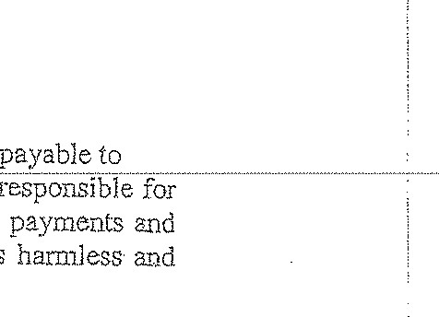
$1,044,775.60 without deduction or withholding made Kirštë.n A.ñdêr§óñ shàl.j be solely any and all taxes that thereafter may be due on these shall hold the State of Iowa and the Released indemnify th3ïT1 froln any liability thereon,
Parties
(b) for attorneys' fees and costs made payable to Coppola Law Firm Trust Accoùnts Coppola, McConviIle, Coopola> Caroll, Hockenberg, & Scalise, P.C.
Kirsten Anderson acknowledges that this pavment is in compromise of a dispute and that such payment is not to be construed as the State cf Iowa or of the Released Parties conceding the reasonableness of the attorneys' fees costs, and is not to be construed as' an admission of Liability or wrongdoing on the part of the State of Iowa or any of the Released Parties, and that the State of Iowa and all Released Paffies expressly deny any such liability or wrongdoing.
- Re_pxgsentation of Kirsten Kirsten Anderson hereby æpresen.ts and warrants that she (a) has authority to enter into this Settlement Agreement and Release; (b) holds the Claims free and clear of any liens and has not pledged- er assi¿ned those claims to any third party; (c) has not commenced or been subject to any bankruptcy or insolvency proceeding that affects or could affect her rights to accept payment and release Claims under this Settlement' Agreement and Release; (d) has nat received any promise of firther considerati01); (e) does not know of any other person who holds any rights to sue for the causes of action either asserted in the First and/or Second Lawsuits or the Claims subject to the releases made hereunder; and (f)shall be solely liable for the, reporting and payment of taxes due, if any, on the settlement amounts received hereunder. Kirsten Anderson further agrees fo indemnify and hold harmless each. of the Released Parties from and against any and all claims, actions, causes of actions, demands, rights, darnaoes, costs, losses of serv'ices, expenses, compensation, taxes, or property damages (including attorneys ⁹ fees, expenses, and costs of defense) which any person, partnership, corporation, entity, association, agency, or other organization may bring against them alleging facts and circumstances that are contrary to, inconsistent with, or arising from the breach of, the representations and warranties of this Paragraph 4,
- Reasonable Time to Consider. Kirsten Anderson understands and acknowledges that she has been given a reasonable period of time to consider whether she wishes to enter into this Settlement Agreement and Release and to be bound by its terms. Kirsten Anderson further acknowledges that the terms of this Settlement
Agee-ment and Release were negotiated by her} through her legal counsel, over a sifficient period of Time so that she now has carefully read and fully understands and -accepts-the-terrn-s• contained--irž-•-t-lïi-s• Settlëfiïëî.ît Ãgfëêmêñt ---ä.ñd "Ré.lêà§e and their legal effect. Kirsten represents that she has been advised to consult with dn attorney prior to signing this Settlement Agreement and Release and has done so. Kirsten Anderson ñù"ther represents that her decision to sign or not to sign this Settlement Agreement and Release is her own voluntary decision made with full knowledge of its terms.
6, Counferoartsv This Settlement Agreement and .Releas3 rnay be signed in counterparts.
Choice of Law/Consent to Jurisdiction. •This Settlement Agreement and Reiease shall be governed by and construed under the laws of the State of Iowa, Each 13arty consents fe the personal jurisdiction of the state courts in Iowa with respect to any action seeking to enforce the tern-IS of this Settlement Agreement and Release-
8. Severability, If a court of competent jurisdiction shall determine that any part-of this Settlement Agreement and Release is invalid or voidp the remaining parts not so declared sbalj_ be considered valid and binding on the parties,
9, Entire A eelnent. This Settlement Agreement and Release constitutes the entire ageernent be?yveen the parties. The terms of this Settlement Agreement and Release- are contractüa) and not mereiv recital. None of the ten:ns Shali be aHered or modified in whole or in part except in writing acknowledged by each narty. Headings are for convenience only and do not alter the express terms Of this Settlement Agreement and Release. All representations, warranties, and indemnities under this Settlement Agreement and Release shall survive the termination, expiration, and performance thereof.
10. Required ApDrovals. The parties acknowledge that this -Settlement Agreement and Release must be approved by Senator Bill Dix on behalf of the Iowa Senate and the Iowa Senate Republican Caucus. The parties further acknowledge that the State Apoeal Board must approve the payment of state funds pursuant to this Settlement Agreement and Release. The Attorney General's office has reviewed and will recommend approval of this Settlement Agreement and Release,
4.

DOCUMENTV
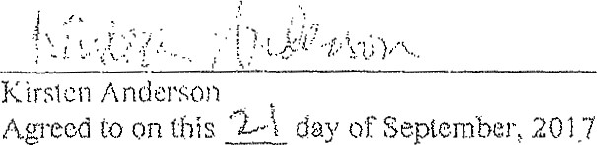
2017.
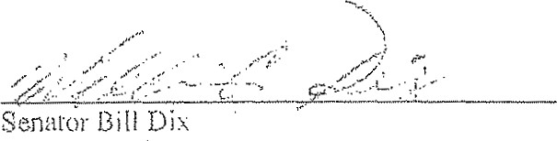
Iowa
Senate
and
Iowa Senafe Republican Caucus
Agreed on this "day of September, 20.17.
Approved as to legal form and content:
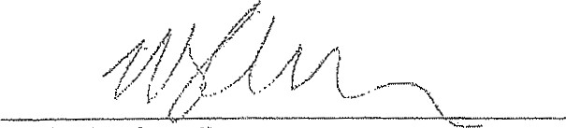
Michael J. Carroll
Atfomey for Kirsten Anderson
On this day

