Task Objective
Goal: Create a guaranteed net (gross-up) bonus calculated per cent from an average based on earnings for the last 12 months. The percent value is determined according to the organisational assignment (infotype 0001).
No schedule approved (could be monthly), paid on request. Once the decision to pay the bonus and the list of employees to be remunerated are provided to HR, the bonus should be calculated and paid in three days.
Per cent determination rule, list of wage types included into average calculation, posting and tax details provided.
Context: Manual data entry should be avoided. IT department should not perform any actions required by productive operation.
Payroll is decentralised on factories, and not to be centralised in the immediate future.
Payroll accountants on factory N are currently not ready to accept changes to the currently working payroll process (assuming additional workload) with respect to this bonus. HR administration is centralised, and HR specialists maintain employee data for factory N as well from the HR shared centre.

solution Recommendation
Summary.
It is recommended to use standard off-cycles for bonus, type A as it is possible to calculate averages.
Considering taxes are not required to be calculated in off-cycle run, the amount estimated automatically from previously filled in IT0267 is simply paid to the employees. At the same time the same amount should be entered into the infotype IT0015 to be paid in the next regular payroll run, from which the off-cycle payment is going to be deducted.

TASK DECLARATION
In case if IT0267 is not entered for some reason and off-cycle run not performed, the bonus will be normally paid during next regular payroll run (ready to use workaround for factory N).
Taxes and gross-up are calculated during regular run, the standard function GRSUP, to be configured as a property of the bonus wage type.
Both in the IT0267 and IT0015 data is entered automatically by standard programs, Mass generator of IT0267 HRUU0267 and transaction PA70 Fast entry with the report RPLFST00 to enable selection employees with a long list.
A small ABAP development is seen necessary to fulfil the logic of determination the amount from organisational assignment IT0001. This is seen as a stand-our separate development of the indirect valuation module - so that the amount is automatically derived on the date of infotype change and can be seen in IT0267 and IT0015, one module will work for both infotypes.
Payslip forms to be slightly redesigned to comply with off-cycles so that employees can check the off-cycle payslip on the ESS portal.

Process.
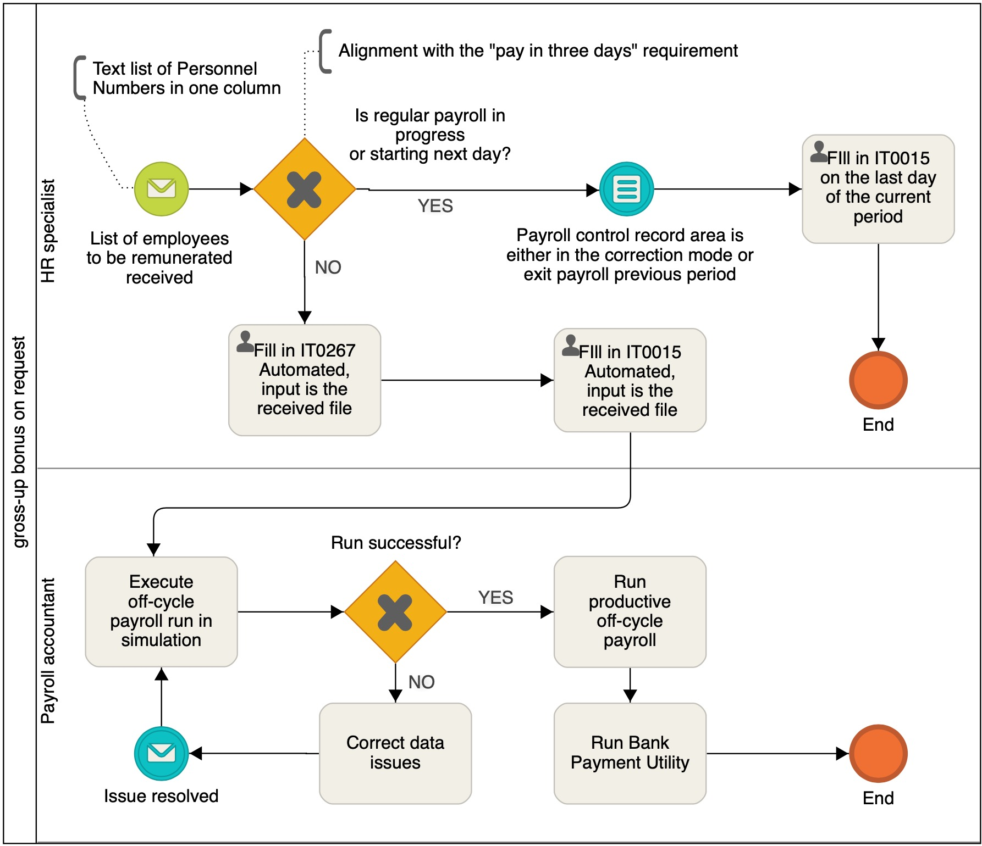
The below process to be implemented.
Configuration steps
- Create wage type. Configure it for appropriate EE subgroup groupings, for IT0015, 0267. Configure gross-up cumulation.
- Develop ABAP indirect valuation module.
- Configure off-cycle, new averages and gross-up.
- Update payslip to support off-cycles.
solution proposal

ITertop proposes to implement the given recommendation by its own strength according to the below plan.
Workload below is estimated in man-hours of an ITertop associate, paid on Time & Materials basis.
Phase | Actions | Deliverables  (documentation underlined) | Load
Identification | - interviews  - analysis  - preliminary solution plan | The current Task Declaration Document, completed | gratis
Preparation | - contract communication | - the Contract, signed | gratis
 | - user availability, test and training plans  - agree with Basis team on imports | - Service Request Document, with the process owners specified and other details  - Solution Plan including testing dates, user communication schedule, import schedule, and first production run | 6h
 | Communication with the N factory accountants on separate workshop | - agreement on the workshop dates where the process to be explained | 2h
Realization | - System configuration | - Configuration Description Document | 24h
 | - Unit test | - Test scenarios (off-cycle and regular) | 2h
 | - import to quality system QAS on successful in DEV  - HR/payroll training (QAS) | - User Manual sign-off | 4h
 | - user acceptance testing (QAS) | - UAT sign-off | 2h
 | - bank penny test (QAS) | - successful penny test | 2h
 | - preparation of pros&cons matrix  - communication with the N factory accountants | - agreement on usage off-cycle or workaround | 4h
Deployment | - import to production  - final test  - support during 1st production use | - client final approval | 4h
Total |  |  | 50h

Workload is preliminary estimated using the currently available information and can be changed later on a reasonable basis (e.g. updates of the business requirements, collaborations with client teams, change of user availability plans, etc.).

