How Do I Prepare for Laser Hair Removal?
Laser hair removal is the process in which people destroy their hair follicles by means of continuous pulses of concentrated light. Once the follicle is destroyed it will never produce hair again, but it takes a few treatments to get to this desired outcome.
The first stages of laser hair removal will gradually damage the follicle in which the treated hair will typically grow back much thinner and sparser. After which the treatments will continue about every month until the follicles are completely rendered gone.
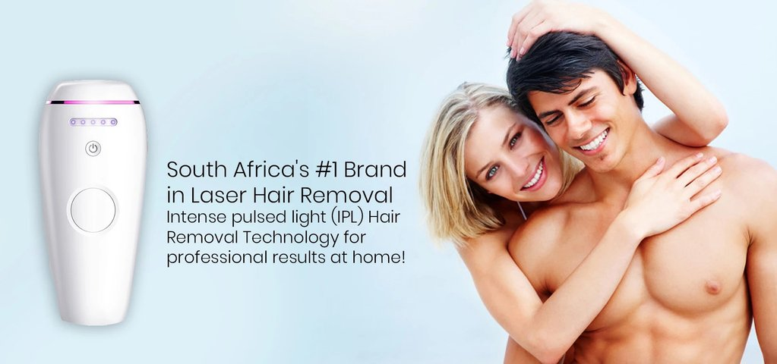
There are two ways people can get this special hair removal treatment, either by going to a specialized facility that offers this service, or simply purchasing a laser hair device at-home device that allows a user to do it themselves. In both cases, it is important to know the right ways to prepare. Though it is certainly possible to go into a treatment with no prior planning, for the most optimal results it is highly recommended.

Take a Shower Before you make use of the device
While this might seem like a given to most people, be sure to take a shower on the day of your treatment beforehand. Not only is this simple hygiene, but it removes any lingering cosmetics that might still be resting on the skin. These products can interfere with the laser, acting as a shield of sorts for the hair follicles.
This can result in a patchy job as well as irritated skin with certain ingredients found in creams and lotions. It is equally important to keep deodorant and related products off the area that is to be treated as they too can cause similar drawbacks.

Let Your Hair Grow a Bit
Though it might seem unconventional, it will be a much easier process for you if the area you are looking to have treated is grown out a little. This is especially true if it is your first ever session. Do not let it grow too long as this could cause a higher chance of burns; let it grow to where it is just visible.
Not only does this help familiarize whoever is utilizing the laser to where the problem hair is precisely located, but it also stops any issues that might have occurred otherwise. Means of removing hair like plucking, waxing, or the electrolysis method can disturb the follicle and thus cause major interference for the laser. After your first treatment, however, you should shave prior to all the following sessions. In this case, it is best to use a sharp, clean razor.

Try Not to Tan
It is common knowledge to most clients of the laser hair removal industry that skin lightening has a chance of occurring after a session. What they don’t know is that this is usually due to not avoiding the sun and tanning salon in the weeks leading up to treatment. Darker skin pigments have a much higher chance to display lightening than a paler complexion.
This is why it is important to keep away from UV rays and other means of tanning. If you do have to spend some time outside, be sure to pack sunscreen with at least 30 SPF and apply it as often as directed.

Dress Accordingly
Though it might be tempting to wear what you find typical for a trip to town or lounging around the house, try and find clothes that leave the area that will be undergoing laser hair removal exposed.
Items such as shorts or a tank-top are ideal. This way, when it comes time to start the process, it will be easy to access all the needed areas without rolling or completely removing items. On the occasion that you don’t have these types of clothes available to you, try and find something that is loose-fitting and doesn’t cling to the skin; articles such as these will cause irritation and sometimes pain after the session is complete. If all else fails, at least plan on bringing an extra set of larger sized clothing to change into.

Don’t Bleach Your Hair
While having a lighter skin tone is better for laser hair removal, the same cannot be said about hair color. The darker the undesirable hair is, the easier it will be for the laser to detect and thus target. Depending on the shade of hair it could be extremely difficult to get a full and effective treatment.
As such, it is important that you do not bleach any of the hair you plan on getting treated before going to a session. If you already have bleached hair and you wish to use a laser hair removal service, wait until the darker, more natural color has grown back in. This may take a few cycles of shaving and growing, but it is priceless when compared to the aggravation the laser treatment would cause you otherwise.

Check Your Medications
Believe it or not, some medications can increase your risk of side effects during and after a session. These drugs are known as photosensitive medications; a type of medicine that reacts to UV rays.
While a majority of prescribed drugs do not fall under this list, it is a good idea to check and make sure any medication you take on a regular basis or that is taken prior to a session is cleared. If you are not sure whether a certain medicine falls into this category or not, ask your doctor or check a list of dependable sources online. It is always better to be safe than have to face the consequences of potential side effects.

You’re Ready to Go
After preparing in all the possible ways listed above, you will be ready for your laser hair removal session. Now you can simply buy the right laser device for a hair removal treatment at your own home. Be sure to double-check that you have done everything needed prior to beginning, then you can continue confidently with the knowledge that you will be receiving the most optimal experience possible.

Original article can be found at - https://www.bareskin.co.za/blogs/news/how-do-i-prepare-for-laser-hair-removal

