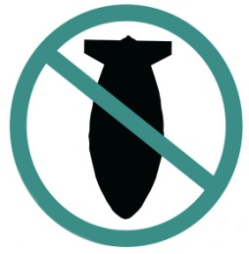

STOP THE WAR COALITION
stopwar.org.uk @STWuk fb.com/stopthewarcoalition

Stop Arming Saudi Arabia
By signing this petition you are agreeing to Stop the War Coalition contacting you by email as part of our campaigning.
StWC respects data protection and keeps all your data secure. We do not use your data for any other purpose.
Return to: Stop the War Coalition, 86 Durham Road, London, N7 7DT. Tel: 020 7561 4830

Saudi Arabia is fighting a devastating war on Yemen, causing widespread casualties, starvation and suffering. The results of the war have been, in the words of the UN’s Yemen envoy Johannes van der Klauwe, “a humanitarian catastrophe”. Currently 60% of its population are going hungry. Many of the weapons the repressive Saudi regime are using have been supplied by Britain. Despite a call from the European Parliament for an arms embargo, Britain’s arms trade with Saudi continues. We ask you to support an immediate embargo.
Name | Postcode | Email

