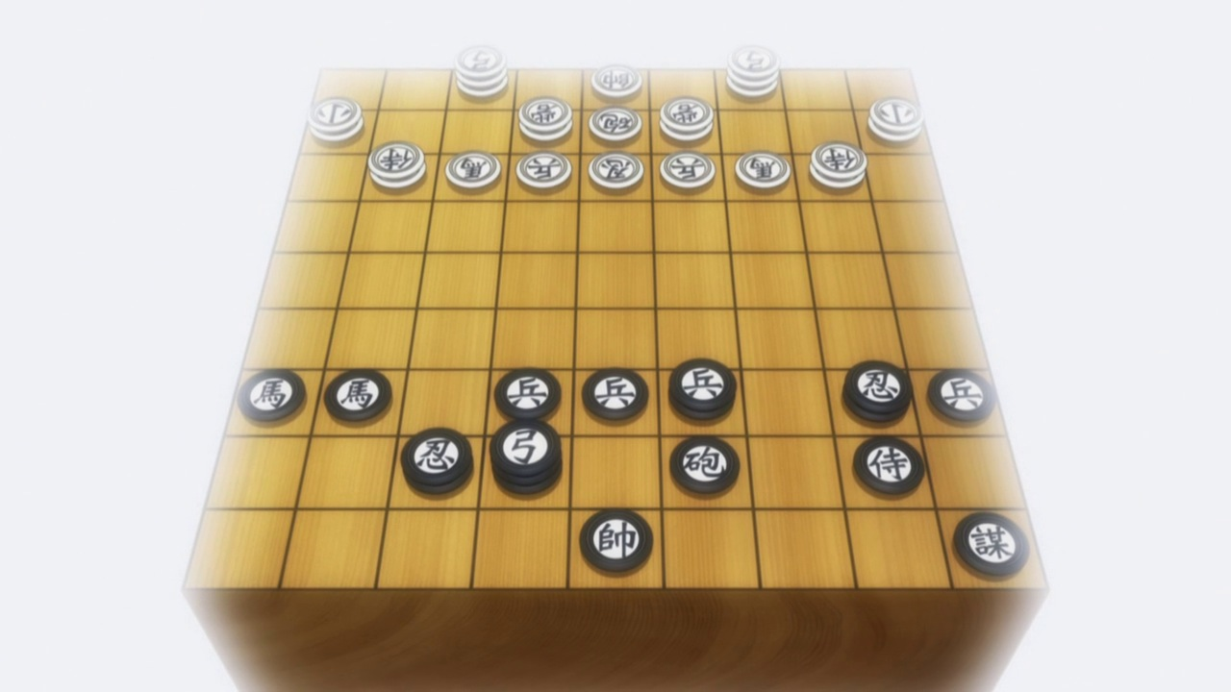

GUNGI

Gungi is a two-player strategy board game played on a gungi board, a gameboard with 81 squares arranged in an 9x9 grid.
The horizontal rows are referred to as either ranks or rows and the vertical as either files or columns
The game also includes a stacking element allowing pieces to be arranged on top of one another up to 3 high. Because of this, the board should be thought of as also having 3 layers of height to form an overall 9x9x3 cuboid
Each player begins with 38 pieces “in hand”:
- marshal 1
- lieutenant general 2
- major general 4
- general 6
- counsel 2
- spy 2
- knight 2
- samurai 2
- cannon 2
- archer 2
- fortress 2
- musketeer 2
- pawn 9.
Each of these 13 types of pieces move differently, and many also effect the moves of the pieces around them
The objective of gungi is to checkmate the opponent's king by placing it under an inescapable threat of capture. It follows the same rules for check and checkmate found in western chess. To this end, a player's pieces are used to attack and capture the opponent's pieces, while supporting each other. During the game, play typically involves making exchanges of one of your pieces for an opponent's similar piece, but also finding and engineering opportunities to trade one piece for two, or to get a better position.

The Rules of Play
The game differs from most other chess variants in a few ways.
Initial Placement: This could be considered a game in its own right and is perhaps the most important strategic period of the game
- Players begin with 38 pieces “in hand”
- Instead of each piece starting the game on a predetermined square, players take 26 turns freely placing one piece at a time anywhere within their starting area: the first 3 rows beginning at their side of the board
- After players have taken turns placing their first 18 pieces, they gain the ability to “pass” instead of placing a new piece on the 8 subsequent rounds
- A player may pass multiple times in a row until either both players agree to pass, or 26 total placement rounds have been played
- A player may not pass if their marshal, equivalent to the king in chess, has not yet been placed
- In this way players must place a minimum of 18 and may place a maximum of 26 of their pieces onto the board during the 26-round initial set up
- Players may declare that they are finished placing any time after they have placed at least 18 of their pieces
- Once a player declares that they’re finished their opponent may continue to place pieces freely, up to their 26-piece/placement round maximum
- Players do not need to place the same number or type of pieces as their opponent
- Pieces may be stacked up to 3 high and a stack is usually referred to as a tower
- Players may place multiple pieces of the same type in the same column, row, or tower
- Not all rows, columns, and spaces need to be filled and any number may be left empty of pieces
- Pieces may never be stacked on marshals
Game Begins:
Players should now have 18-26 pieces, including their marshal arranged within their starting area and 12-20 pieces remaining “in hand.” Players will now take turns until one of them manages to checkmate the other or until one side concedes defeat. The game is considered a draw if the same moves are perfectly repeated 3 times in a row
- A turn can consist of one of 3 things
- A piece “in hand” can be “dropped” onto any space on the board
- A piece may move from one space to another
- Capture. A piece may move onto a square occupied by an opponent’s piece, remove that piece from the board, and occupy that space in its place
Drops
- Pieces may be placed onto any area of the board during a drop move, including the opponents starting area
- Drops may only be made onto empty spaces
- Remember that the board has 3 levels of height. Spaces on top of other pieces, including opponent’s pieces, may be considered empty and be dropped on forming towers. Remember towers can only be up to 3 pieces high
- Drop moves can never be used to capture an opponent’s piece
- Marshals(kings) may never be stacked upon either by drops or normal movement
- A drop can be used to place an opponent in check or even checkmate
- A pawn can never be dropped in a way that would place an opponent in check or checkmate
Towers
- Only the top piece in a tower may move or be captured by an opponent’s piece. The lower pieces of a tower are immobile and essentially become part of the 3-dimensional landscape of the board until the top piece is moved
Movement
- Each type of piece has its own movement pattern
- Most pieces have different movement patterns depending on which of the 3 height levels they are at when the turn begins
Able to move to this space

Starting position

Can move any number of spaces in this direction

1
Lieutenant General x2
The Lt. General also has the special rule:
All of your movable pieces able to draw an unobstructed straight, orthogonal, or diagonal line to the Lt General may move in any of their designated movement patterns no matter their height.

2
3

1
Major General x4

3
2

1
General x6

2
3

Fortress x2
Fortresses elevate all friendly pieces within their movement range as if they were stacked directly on the fortress. If a piece’s placement within its own tower already positions it in the 2nd or 3rd tier, it uses the highest of the two

Counsel x2
The counsel keeps the same movement pattern throughout all 3 tiers

1
Cannon x2
A cannon’s movement and attack/capture patterns are slightly different from each other.
These are its movement patterns at each of the three height tiers.
It attacks/captures at any arbitrary distance along a straight orthogonal line. It cannot capture a piece unless it has first jumped over an interposing piece. This interposing piece can be yours or one of your opponent’s pieces. In this way it is very similar to its Chinese and Korean chess counterparts
Its capture pattern means it becomes less of a threat as the game progresses and less pieces remain on the board
2
3

1
Musketeer x2

2
3

1
Samurai x2

2
3

1
Knight x2
The knight’s movement patterns allow it to jump over interspersed spaces. You may ignore all interspersing pieces occupying these spaces while moving a knight, yours and your opponents’ pieces cannot block its movement

2
3

1
Spy x2
The 3rd tier spy is gungi’s closest equivalent to a western queen

2
3

1
Archer x2
Much like the knight, the archer moves and captures ignoring all interposing spaces whether empty or occupied by your own or your opponent’s pieces

2
3

1
Pawn x9
If your pawn occupies the 1st tier of your 3rd starting row (7th row if black), it may move forward 2 spaces instead of 1. This is similar to the rules for pawns found in many other chess variants.
There is no en-passant equivalent in gungi
Pawns capture the same as they move in gungi. So, the 1st tier pawn can only capture directly ahead much like its shogi counterpart

2
3

Marshal
The marshal may not be used to check the opponents marshal. It may stack on opponents’ pieces as well as your own, but it may never be stacked upon

