Elminster
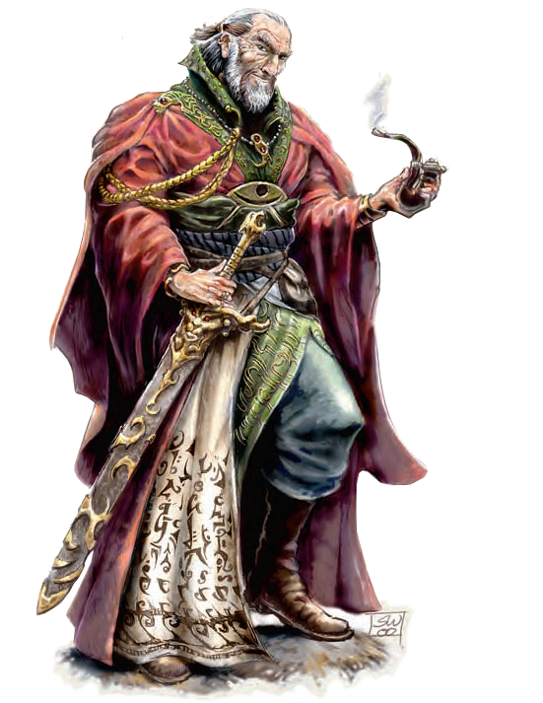
Male human (Chosen of Mystra) Ftr1 / Rog2 / Clr3 / Wiz20 / Acm5 / Epic4: CR 39; Medium-size humanoid; HD 1d10+7 plus 2d6+14 plus 3d8+21 plus 14d4+98; hp 219; Init +10; Spd 30 ft.; AC 29 (touch 17, flat-footed 25); Atk +17/+12/+7 melee (1d8+6/19–20, +5 thundering longsword) or +15/+10/+5 ranged touch (by spell); SA Sneak attack +1d6, turn undead 6/day; SQ Archmage high arcana, Chosen immunities, Chosen spell-like abilities, detect magic, enhanced Constitution, enhanced Intelligence, epic-level benefits, evasion, silver fire; SR 21; AL CG; SV Fort +17, Ref +13, Will +17; Str 13, Dex 18, Con 24, Int 24, Wis 18, Cha 17. Height 6 ft. 2 in.
Skills and Feats: Alchemy +27, Balance +6, Climb +5, Concentration +34, Decipher Script +9, Diplomacy +6, Handle Animal +7, Heal +8, Hide +8, Intimidate +11, Intuit Direction +6, Jump +5, Knowledge (arcana) +27, Knowledge (geography) +22, Knowledge (history) +17, Knowledge (Dalelands local) +17, Knowledge (nature) +17, Knowledge (nobility) +17, Knowledge (the planes) +22, Knowledge (religion) +12, Listen +13, Move Silently +8, Open Lock +6, Perform (dance) +6, Ride +8, Scry +27, Search +9, Sense Motive +11, Spellcraft +29, Spot +14, Swim +5, Tumble +5; Blooded, Craft Staff, Craft Wondrous Item, Expertise, Forge Ring, Heighten Spell, Improved Initiative, Luck of Heroes, Scribe Scroll, Skill Focus (Spellcraft), Spell Focus (Enchantment), Spell Focus (Evocation), Spell Penetration, Twin Spell.
Illustration by Sam Wood
Special Qualities: Archmage High Arcana: Arcane reach, mastery of counterspelling, mastery of elements, spell power +4 (total). Chosen Immunities: Elminster is completely unaffected by attacks that duplicate these effects: detect thoughts, disintegrate, Evard’s black tentacles, feeblemind, finger of death, fireball, magic missile, sunburst, temporal stasis. Chosen Spell-like Abilities (all 1/day): dispel magic, lesser ironguard, see invisibility, shapechange, Simbul’s synostodweomer (converts prepared spells into 2 points of healing per spell level), spider climb, teleport without error, thunderlance, true seeing. Detect Magic (Su): Line of sight. Enhanced Constitution: The Chosen of Mystra template adds +10 to Elminster’s Constitution. Enhanced Intelligence: Elminster used wish spells to increase his Intelligence. His Intelligence score has a +4 inherent bonus included in its value. Epic-Level Benefits: Bonus spell level 4 (included in the listing below), six effective levels of wizard and five of archmage (included in above total). Silver Fire (Su): See Chapter 2 for details.
Cleric Spells per Day: 4/4/3. Base DC = 14 + spell level, 16 + spell level for evocation and enchantment spells. Domains: Magic (use spell trigger or spell completion devices as a 26th-level wizard), Spell (+2 bonus on Concentration and Spellcraft checks). Caster level 3rd.
Wizard Spells per Day: 4/6/6/6/5/4/5/3/3/3/1/1/1/1. Base DC = 21 + spell level, 23 + spell level for evocation and enchantment spells. Caster level 25th.
Signature Possessions: Ring of protection +3, amulet of natural armor +5, bracers of armor +7, ring of regeneration, mantle of spell resistance, +5 thundering longsword, Elminster’s eversmoking pipe. As a very powerful wizard, Elminster has access to incredible resources and can acquire or make almost any nonartifact item he might need, given time. Like his onetime apprentice Vangerdahast, this ancient wizard is finally starting to seem truly old, prone to long reveries in which he sees again people and places now long vanished. The strongest of Mystra’s Chosen rarely moves directly against his foes, preferring to work through younger and more vigorous heroes.
The Sage of Shadowdale for years confounded the Zhentarim, the Red Wizards of Thay, and a hundred rival mages while at the same time training and rearing a long succession of apprentices who all became superb spellcasters in their own right. Before that he foiled renegade Chosen, helped found the Harpers, and raised several of the Seven Sisters. During the Time of Troubles, he saved Toril by holding Mystra’s power inside himself, surviving by his wits and the aid of the ranger Sharantyr rather than by his magic.
He’s also a passable fighter and thief and a superb dancer.
Elminster is a consummate actor and delights in acts of whimsy, helping the needy and lovelorn, and dispensing poetic justice to those who deserve it. He has a heart of gold, a deep need to bring tyrannical, pompous, and cruel persons low, and a crotchety, “Don’t push me” manner. After knowing the love of the goddess Mystra, nothing awes him or leaves him much afraid.

Character Description Terms
The nonplayer character descriptions in this book, whether presented in a section of their own or in a brief parenthetical mention in the text, use a lot of abbreviations. See Chapter 8: Running the Realms for information about characters of higher than 20th level.
Character Abbreviations: Standard Classes: Bbn, barbarian; Brd, bard; Clr, cleric; Drd, druid; Ftr, fighter; Mnk, monk; Pal, paladin; Rgr, ranger; Rog, rogue; Sor, sorcerer; Wiz, wizard. Specialist Wizards: Abj, abjurer; Cjr, conjurer; Div, diviner; Enc, enchanter; Evo, evoker; Ill, illusionist; Nec, necromancer; Tra, transmuter. Dungeon Master’s Guide Prestige Classes: Arc, arcane archer; Asn, assassin; Blk, blackguard; Def, dwarven defender; Lor, loremaster; Shd, shadowdancer. Forgotten Realms Prestige Classes: Acm, archmage; Chm, divine champion; Dev, arcane devotee; Dis, divine disciple; Gld, guild thief; Hrp, Harper scout; Hie, hierophant; Hth, hathran; Prp, Purple Dragon knight; Red, Red Wizard; Rnc, runecaster; Sha, shadow adept; Skr, divine seeker. Dungeon Master’s Guide NPC Classes: Adp, adept; Ari, aristocrat; Com, commoner; Exp, expert; War, warrior.
Elminster
Other Abbreviations: LG, lawful good; NG, neutral good; CG, chaotic good; LN, lawful neutral; N, neutral; CN, chaotic neutral; LE, lawful evil; NE, neutral evil; CE, chaotic evil; Str, Strength; Dex, Dexterity; Con, Constitution; Int, Intelligence; Wis, Wisdom; Cha, Charisma; HD, Hit Dice; hp, hit points; Init, initiative bonus; Atk, attacks; Spd, speed; AC, Armor Class; SA, special attacks; SQ, special qualities; AL, alignment; SV, saving throw bonuses; Fort, Fortitude; Ref, Reflex; Will, Will.

