Wanted To Start Your Grocery Delivery Business

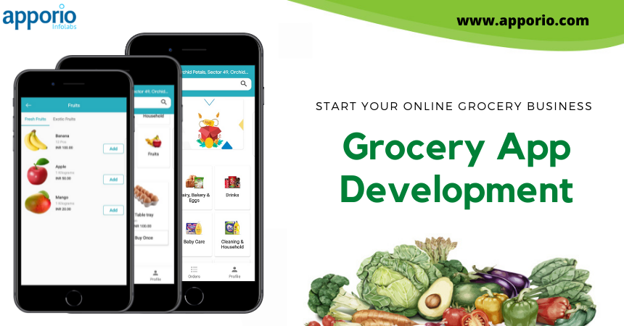

Introduction: What is a Grocery App and How Can it Improve Your Shopping Experience?
Grocery shopping is a pain. It takes time, you have to go to the store, and you have to pay for a lot of stuff that you don't need. With the growth of grocery apps, shopping has become easier and more convenient. To make this all possible grocery app development company started to build ready-made solutions that can be used by startups to solve their customer's problems.
With the help of an on-demand grocery delivery app, anyone can launch their online grocery business in less than 7 days. The grocery app allows people to shop for groceries without having to leave their homes or go out into the store. The app will tell them what they need and when they need it delivered at a price that is competitive with other stores.
Grocery delivery services are changing how people shop for groceries by making it convenient, affordable, and easy. They are also changing the way retailers operate by providing new opportunities for customers to purchase their products online as well as in-store.

Online Groceries vs. Traditional Store-Based Shopping
Online grocery shopping is a convenient and cost-effective way for people to shop. However, it is not without its drawbacks. One of the most serious issues with online grocery shopping is the lack of human interaction.
In contrast, store-based shopping offers a more personal experience. The customer can interact with the salesperson and ask questions about their products and make suggestions on what they might want to purchase. In addition, store-based shopping offers an opportunity for customers to build relationships with employees that can last beyond the transaction.
Online grocery shopping has been around for decades but recently has become more popular as more people are getting online every day. It provides convenience to consumers who have busy schedules as well as saving time due to no longer having to go out in search of products or ingredients themselves. If you want to start your online grocery business there are a number of supermarket app development companies available to help you.

How to Choose the Right Grocery Delivery App for Your Business
There are a lot of grocery delivery app development companies out there and it can be difficult to find the right one. Here are some factors you should keep in mind when choosing the best app for your business.
You should consider how much time will need for the grocery delivery app development, what the app offers, and which features are essential for your business.
The best grocery delivery apps have a customer-centric focus, offering personalized service that is tailored to each individual’s needs. They also offer convenient locations near your business or home with free delivery, as well as easy payment options like PayPal and credit card processing.

