WHAT WAY DRIVER’S LICENSES SERVICE AGENCIES CAN HELP YOU

If you want to get the driving license in the easiest possible way you will need to take assistance of the most reputed Driver’s licenses Service agencies. They will not only make you ready theoretically with the knowledge of different traffic rules and regulations but at the same time they will give you practical knowledge about how to drive a car perfectly and safely in the city.
For More Information Please Visit Our

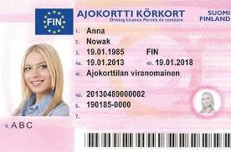Website:

OASISGLOBEASSISTANT.COM

