How to Loosen Tight Box Braids: Techniques for Comfort and Care

Title: Understanding the Importance of Loosening Tight Box Braids
Loosening tight box braids is essential for maintaining healthy hair and ensuring comfort during the braiding process. When box braids are too tight, they can cause scalp tension, breakage, and discomfort. By learning the techniques to loosen your box braids properly, you can alleviate these issues and enjoy a more comfortable braiding experience.
Transition words: Additionally, Moreover, Furthermore
Discover the top Vietnamese hair wholesale with premium quality products! Click to read amazing article.

Title: Identifying Signs of Tight Box Braids
Before you start loosening your box braids, it's important to identify signs that they are too tight. Some common signs include excessive scalp tension, a constant pulling sensation, headaches, and hair breakage near the roots. If you experience any of these symptoms, it's crucial to address the tightness as soon as possible.
Transition words: Moreover, Furthermore, Additionally
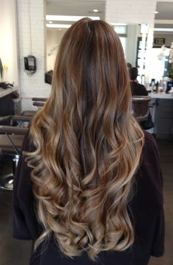

Title: Moisturizing Your Scalp and Hair
Before loosening your box braids, it's important to moisturize your scalp and hair to prevent further breakage and ease the removal process. Start by applying a lightweight oil, such as coconut oil or jojoba oil, to your scalp. Gently massage the oil into your scalp to nourish and hydrate it.
Next, apply a leave-in conditioner or a moisturizing spray to your braids, focusing on the roots and the length of your hair. This will help soften the braids and make them more pliable for loosening. Allow the moisturizing products to penetrate your hair for a few minutes before proceeding to the next step.
Transition words: Furthermore, Additionally, Moreover

Title: Loosening with Fingers
One of the simplest and most gentle techniques to loosen tight box braids is by using your fingers. Start by gently massaging your scalp with your fingertips, focusing on the areas where you feel the most tension. This will help release some of the tightness and improve circulation.
Next, carefully separate the braids using your fingers. Take a small section of the braid near the roots and gently pull it apart from the neighboring braids. Be cautious not to tug or pull too forcefully, as this can cause breakage. Repeat this process for each braid until they are adequately loosened.
Transition words: Moreover, Additionally, Furthermore3
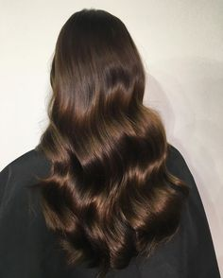

Title: Using a Hair Oil or Moisturizer
If your box braids are particularly tight or difficult to loosen with your fingers alone, you can use a hair oil or moisturizer to aid the process. Choose a lightweight hair oil, such as argan oil or grapeseed oil, and apply a small amount to your fingers.
Starting from the roots, carefully run your oiled fingers along each braid, applying gentle pressure to separate and loosen them. The oil will provide lubrication and make the braids more pliable. Be patient and work through each braid methodically to avoid causing any damage to your hair.
Transition words: Additionally, Furthermore, Moreover

Title: Steam Treatment for Easier Removal
If you're struggling to loosen your box braids, a steam treatment can be a helpful technique. Start by filling a bowl with hot water and placing it on a stable surface. Position your head over the bowl, ensuring that the steam is directed towards your braids.
Allow the steam to penetrate your braids for several minutes. The steam will help soften the hair and make it more pliable for loosening. While the braids are still warm and soft, gently separate them using your fingers or a wide-toothed comb. Be careful not to apply excessive force to avoid hair breakage.
Transition words: Furthermore, Additionally, Moreover

Title: Seeking Professional Assistance
If you've tried various techniques and are still unable to loosen your tight box braids safely, it may be best to seek professional assistance. A professional hairstylist experienced in braiding can help alleviate the tightness without causing damage to your hair.
Transition words: Additionally, Moreover, Furthermore

Title: Caring for Your Hair After Loosening Box Braids
Once you've successfully loosened your box braids, it's important to continue caring for your hair to promote its health and prevent breakage. Gently cleanse your scalp and hair with a sulfate-free shampoo, focusing on the roots to remove any buildup.
Follow up with a deep conditioning treatment to replenish moisture and nourish your hair. Avoid using heavy products or excessive heat styling immediately after removing the braids to give your hair a chance to recover. Embrace protective styles or low-manipulation hairstyles to minimize stress on your hair and promote healthy regrowth.
Transition words: Moreover, Furthermore, more tip, Additionally

