How Do UPS Access Points Work?
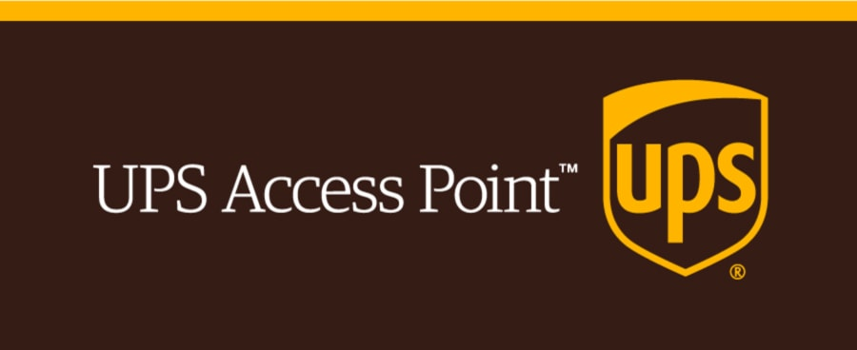
UPS access points can be used to pick up and drop off UPS packages at physical locations. When you place your order, UPS will deliver your package from the supplier to the chosen UPS access point. You will need to show proof of identification in order to pick up your package. When your package is available for pickup, you will be notified and can come pick it up when it's convenient.
What is the working principle of UPS Access Points?
What Are UPS Packages Going To?
Your UPS packages may not reach their destination for one of several reasons. The driver may not be able to deliver the package to the customer or leave it in a safe location. The driver might not be able to deliver the package to the address indicated on the package, due to incorrect or incomplete addresses. If the access point is not within a reasonable distance of the address, the driver may drop the package there.
How do I pick up a UPS package from my Access Point?
You will need a government-issued photo identification to pick up your UPS package at the access point. This could be a passport, driver's licence, passport or foreign national ID. You must have the full name of the ID match the Ship to label.
Are UPS Access Points Secure?
UPS Access Points can be trusted because they are often located in local businesses and grocery stores. They are located in a safe and accessible location which makes them less vulnerable to criminals. UPS also takes security measures to ensure that packages are delivered to these addresses. UPS may ask customers to use a password or show identification to pick up packages.
UPS Access Point allows you to return Amazon items
Amazon customers are able to return their items at UPS Access Point - What Is It?. Customers can either drop off their items with a pre-paid shipping label, or they can return the item without a box at nearly 5,000 The UPS Store locations.
What is the maximum time that a UPS Access Point can keep a package?
UPS My Choice(r), a member of UPS, can keep your package at the UPS Store or other UPS Access Point locations for up to seven days. Your package can be held at customer centres for up to five days. These options are both free.
What to do if UPS delivery is not delivered?
You can pick up your package from a UPS Access Point if you have missed UPS delivery. Your package will be returned as undeliverable to the sender after 7 calendar days.
Can I have a package delivered to a USPS store?
You can have your package delivered to any USPS location. You have two options: either pick up the package at the store or let the store store it until you are able to.
Is UPS my Choice Free?
Yes, UPS My Choice membership is completely free. There are two levels to your membership: premium and free. You can get shipping alerts by text or email. You can also change the delivery date or address. Premium membership includes additional features such as package tracking and delivery preferences.
What is the reason why my UPS package says "Delivered but not Delivered"?
A UPS package will display an "Out for Delivery" notification. This means the package was delivered to the UPS delivery center and dispatched to a UPS driver.
What is an UPS Access Point UK?
UPS Access Points are a UPS-affiliated retail store that offers convenient package drop-off and delivery close to your home or workplace. UPS Access Points are represented by many locations, including convenience stores and grocers.
Do I have to pick up my UPS package before delivery?
Yes, you can pick up your UPS package before delivery. You can retrieve your UPS package by rerouting it to a UPS Access Point.
Are You able to make money as a UPS Access Point?
The number of dollars a business can make from being a UPS Access Point is dependent on many factors including its size and location. Businesses that sign up as UPS Access Points typically make less than $1 per package. However, the benefits of being a neighborhood pick-up point are greater foot traffic.
What is the UPS Access Point's Guarantee for My Package UK?
UPS access points in the UK can hold packages for up to five days before they are released for collection. If the package isn't collected within this time, it will automatically be returned to Scan.
Is it possible to track UPS packages?
Yes. You can track UPS packages using the tracking number assigned to your shipment. This number is located on your shipment confirmation email or on the package label. You can access the UPS website to get the tracking number and fill it in the tracking form. This will give you the most current information regarding your package's location.

