Professional Design Guidelines to Make Your Custom Coffee Boxes Unique
Given the abundance of competition in the coffee and tea market, it's logical that you'd go to considerable measures to win and keep clients. Your organization will surely accomplish this with the help of eco-friendly packaging and eye-catching designs.
Here we will talk about how photos, colors, textures, fonts, and finishes have been expertly blended into the design of custom coffee boxes to create remarkable results.
The most asked questions by brands are: What are some best designs for coffee packaging? Make coffee products that stand out from the crowd by giving them customized eye-catching packaging. You've put forth a lot of effort to promote your environmental consciousness by only buying coffee from dependable farmers. To that end, why not use the same reasoning for your packaging? With the right packaging boxes, you can keep your products protected while also showcasing them to potential customers. Packaging for coffee beans has evolved beyond paper or plastic bags. Your company may seem more sophisticated and eco-friendly if you use innovative packaging and consider the impact of your actions on the environment. When developing your custom coffee boxes, keep these four things in mind if you want to boost your emerging beverage packaging for your promotions:
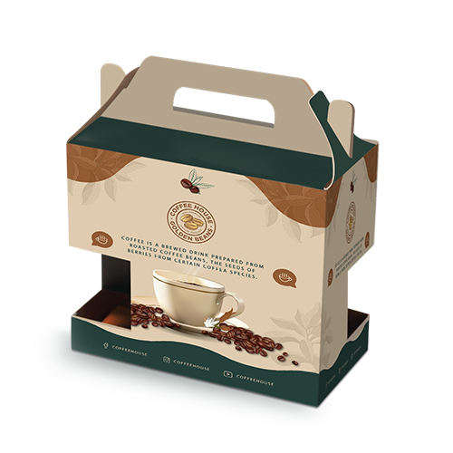
Stay unique & authentic
Even if you're selling tea, you don't have to advertise that it tastes like ginger or lemon or use brown or black packaging. Your chances of attracting new, enthusiastic buyers increases if your product is easily distinguishable from similar ones on the market. The origin of the coffee has a significant impact on how it is packaged. The label and blending specs were moved to the rear of the box so that the front could feature eye-catching graphics. The beautiful design of custom coffee boxes was lacking. They opted for eye-catching hues and a gilded logo to make a statement with the packaging. The colors used to represent the various flavors are all symbolic in their own way. Therefore, choose each and everything with utmost care and perfection.
Labels, sleeves, and stickers to make coffee boxes elegant
Stickers and sleeve wrapping are great ways to jazz up plain glass jars and tin cans you already have on hand. Both of these forms of packaging are easy to work with and need nothing in the way of preparation. Packaging sleeves are useful for storing and transporting a wide variety of products, including coffee beans, tea leaves, cold beverages, and bottled drinks. Stickers and sleeves are not just low-cost alternatives, but they're also easy to create. So, if you want to continue switching up your packaging, this is a great option to consider.
Materials, colors, and coatings
The greatest way to include ecology into your packaging is to use cardboard and Kraft paper. All of these parts are biodegradable on their own, but they may really shine when combined with other eco-quality benchmarks to make your company stand out. Soy or water-based ink is one of the most well-known and widely utilized self-sustaining methods. Using eco-friendly inks on the packaging makes it easy to reuse or recycle. It also makes it easier for both you and your customers to dispose of or break down the packaging. In order to prevent your personalized coffee boxes from breaking or scratching, lamination and coatings are a must-have. However, lamination is not eco-friendly since it requires using more plastic. You may also use aqueous varnishes. These are just as insulating as laminations, but they're water-based, so they won't harm the environment.
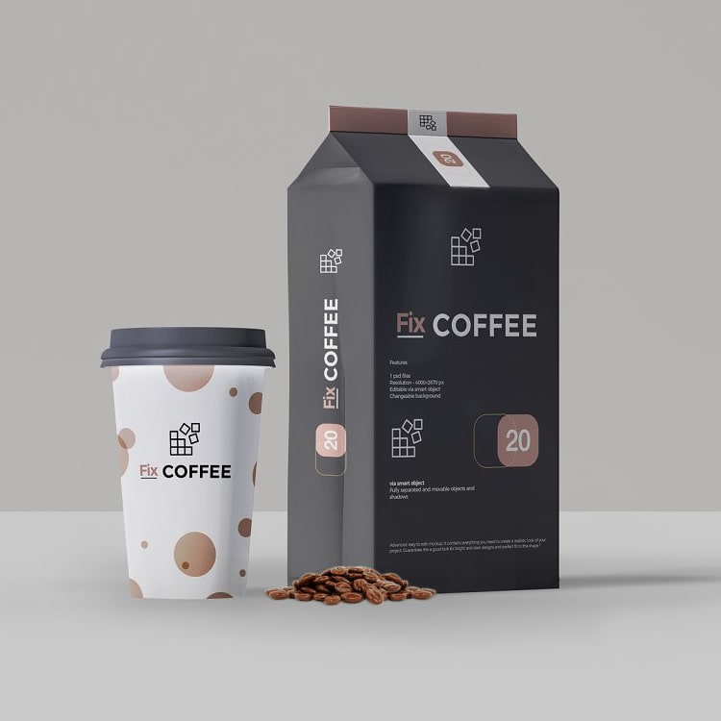
Custom-made boxes, tubes, and bags
Coffee beans don't have to be packaged in anything fancy. To stand out, use unconventional containers like paper tubes, tray and sleeve boxes, or paper bags. In any store, these packaging choices will make your products stand out and attract customers. Many businesses advise using paper bags for coffee bean packaging since they are the best option. Put these paper bags in a different container to ensure they make it safely. Use corrugated mailers or rigid cartons if you want something sturdy and secure for storing your coffee. Make use of inserts to keep your coffee beans in pristine condition all the way to their destination.

Essence
Custom coffee boxes are great for spreading brand awareness and telling engaging tales. The pods are protected and shown in a pull-out box with an internal holder. At the same time, the visual arts have refreshed the concept of the coffee pod. The silhouette was the starting point for the designers, who created humorous depictions of common objects like megaphones and bullets. Each image is a visual representation of a different flavor of the coffee. For instance, a coffee package with a dark color denotes a strong and robust flavor, whereas a package with a light tint denotes a moderate and smooth taste. Add each and every piece of information that a customer might require while purchasing your product.


