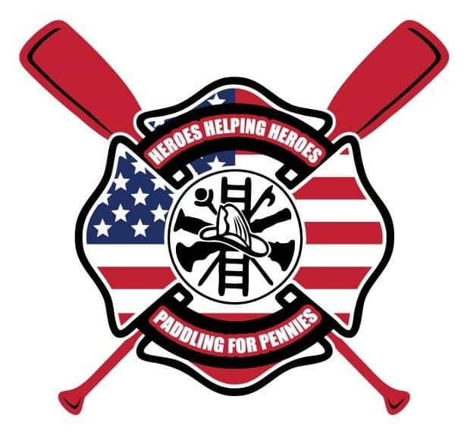
THINGS YOU NEED TO KNOW:
LONG PADDLE INFORMATION
The Neuse River from Falls Lake to New Bern NC
November 2nd -6th 2022

Whether you are padding the entire trip or joining us for one or two days, we want to prepare you for what to expect. Please read the information below thoroughly so you can be equipped for the challenge ahead.

- FUNDRAISING: Though we do not have a minimum requirement of fundraising to participate on this challenge, we hope you will consider doing so to support the organization. Folks can donate on your behalf right from this website. If you need brochures please email or call us.

- SPEED OF PADDLE: We strive to keep a speed of 5mp. We strongly recommend that you download an APP and test out your speed so that your ability matches your desire to support this particular paddle. Staying on schedule is important to reach our campsites before dark each day. Please make sure you can achieve this mph prior to committing.

- MEALS: Each day we will stop for lunch. YOU WILL NEED TO PACK APPROPRIATELY FOR BREAKFAST AND LUNCH FOR EACH LEG OF THE PADDLE

- DINNER WILL BE PROVIDED Dinner will be provided each night but you will need to pack appropriately for breakfast and lunches along the way. If you have dietary restrictions we recommend that you pack all your meals.
DAILY PADDLE SCHEDULE:
NEUSE RIVER PADDLE MILAGE INFORMATION
193 MILES
11/2/22-11/6/22

- All times are based on a desired 5mph speed.
- Times do not include and will be adjusted for bathroom/lunch breaks
DAY 1 NOVEMBER 2ND
Launch: Falls Canoe launch in AM (tbd)
(12101 Old Falls of Neuse Rd Wake Forest NC)
End: At a location in Smithfield Boat Ramp (this stop is at a private residence. Location disclosed only to participants)
Total Mileage……46.4
Total hrs… 9.5
DAY 2 NOVEMBER 3RD
Launch: Smithfield Boat Ramp…AM launch time tbd
End: US 117 Goldsboro Mar-Mac Fire Dept
Total Mileage…53.8
Total hrs…11
DAY 3 NOVEMBER 4TH
Launch: NC 581…. AM launch-time tbd
End: Kinston Campground 401 W Caswell St, Kinston, NC 28504
Total Mileage… 45.8
Total Hrs….9
Day 4 NOVEMBER 5TH
Launch: Kinston Campground…8am 401 West Caswell St
End: Cow Pen Landing
Total Mileage…35.7
Total Hrs….7 Hrs
Day 5 NOVEMBER 6TH
Launch: Cow Pen Landing…8am
End: New Bern Round House…11am 405 Harbor Drive New Bern
Total Mileage…10.8
Total Hrs…3

EQUIPMENT REQUIREMENTS: PFD, KAYAK & PADDLE
KAYAK AND VESSEL RELATED GEAR RECOMMENDATIONS (note these are suggestions based on prior year experiences from other paddlers):
- Minimum, 12ft or longer with rudder or retractable skeg (smaller vessels present difficulty in speed and steering)
- Paddle & extra paddle in event of loss or damage to main paddle
- Spray/sun skirt , cockpit cover for overnight stays in rain
- Touring sit in kayaks are best (cockpit cover in case of rain for overnight camping)
- Portage handles installed
- Rubber or gel pads for your heels to rest on
- paddle gloves
- Repair kit, to make quick repairs: extra wire for rudder, screw driver, duct tape, screw driver, things to repair holes etc.
We try to maintain 5mph and recommend attempting this with a phone app to clock yourself prior to the Long Paddle to determine your ability.
GEAR:
- PFD (all participants must have PFD participate in this event)
- Tent (some easy way to camp) we will camp all nights except night #2 where we will be at Maramac Fire Dept in Goldsboro
- Tarp
- Extra phone battery/ charger
- Sleeping pad
- poncho
- Dry bags for gear and clothing
- Sunglasses
- Auto sponge for removing water from boat (lighter and smaller than bilge pump)
- Extra paddle
- Tie down rope
- Headlamp
- Pocket knife
CLOTHING:
- Water shoes good enough for short treks on land
- Moisture wicking clothing is best
- Night time gear that will provide warmth
TOILETRIES:
- Sunscreen & bug spray
- Toilet paper
- Baby wipes
FOOD:
- Water (recommend a gallon per day, each stop at night will allow refilling of water jugs)
- Protein, protein, protein
- Snacks easy to eat while you are paddling
- Small things easily accessible not requiring refrigeration like pouches of chicken, tuna, beef jerky are just a few suggestions

***(These are recommendations only and are based on opinion of prior participants as minimum equipment endorsements and should only be considered as a guide)

IF YOU ARE INTERESTED IN JOINING US ON THE PADDLE OR FOR QUESTIONS REGARDING DONATING PLEASE EMAIL or call either allen.williford@gmail.com 919-921-1348 or Lisa Thompson printsofhonor@gmail.com 919-906-7247

Please note you are voluntarily participating in the activity and your participation in the activity is done entirely at your own risk. Participants will be given a liability form for submission prior to the Neuse River paddle.

