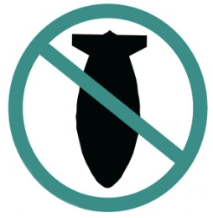

STOP THE WAR COALITION
stopwar.org.uk @STWuk fb.com/stopthewarcoalition
Free Palestine - Stop Arming Israel
In the last year more than 250 Palestinians have been killed on the Gaza strip and 29,000 wounded in attacks by the Israeli Defence Force. Illegal settlements in the occupied territories have accelerated leading to the expulsion of hundreds more families from their homes. Britain should stop selling arms to Israel immediately while it continues its assault on the Palestinians.
Name | Postcode | Email | Phone No.
By signing this petition you are agreeing to Stop the War Coalition contacting you by email as part of our campaigning. StWC respects data protection and keeps all your data secure. We do not use your data for any other purpose. Return to: Stop the War Coalition, 86 Durham Road, London, N7 7DT. Tel: 020 7561 4830
By signing this petition you are agreeing to Stop the War Coalition contacting you by email as part of our campaigning. StWC respects data protection and keeps your data secure. We do not sue your data for any other purpose.
Return to: Stop the War Coalition, 86 Durham Road, London N7 7DT. Tel: 020 7561 4830

