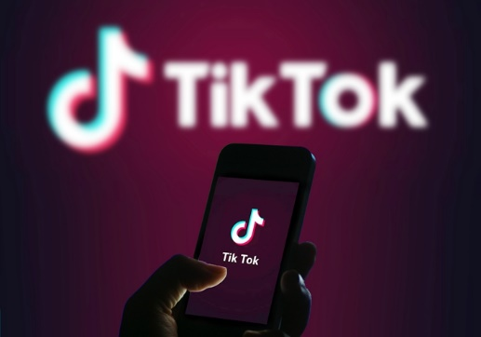
**DOWNLOAD TIKTOK VIDEOS: Free and Valuable Lesson**
Lots of people are now opting for social media where they are able to create or share their unique videos. This is exactly what TikTok, formerly recognized Musical.ly can do. With around 600 million videos being posted every day by its user base of roughly 100 million users. Given that, TikTok has built a name for itself as among the greatest social networks nowadays.

A huge part of the appeal is being able to see or make a new version of classic videos. A video might be 15-seconder up to one minute in length. Topics could cover everything such as hot dances, lip-sync or humorous quotes. Once the video is ready to make everybody laugh it can be easily shared through the app. Applications for video editing are accessible too. You will need a video to edit and a great place to start is TikTok. This post can assist you how to download TikTok videos.
TikTok Videos Using your Smartphone.You must install TikTok first on your iPhone or Android devices. If you successfully run the TikTok App, on the main window, you must see the Account icon. It’s on the bottom right area. Listing of videos will be shown on your profile page. Tap one of them you would like downloading. The video will play quickly. Share icon can be found while the video is playing. When you tap, you will see different choices to make including the Download option. When you tap it the video will get saved on your gallery.
Find an App to use as a TikTok Video Downloader
You can pick a lot of applications made solely for TikTok uses. When it's downloaded and functioning, check out tokdown.com here and find a video from your listing you wish to save. Once again tap the Share button, but this time choose the option that says Copy Link. The link you just copied can now be used to your TikTok video downloader app. Paste that link to that app. Options will be shown while the video is previewed. You might have two options before ultimately downloading it, an image or a video. Irrespective of which of it, the download time required won’t be that long.
Utilize an Email as your TikTok Video Downloader
Sharing the video via email is one of the options you can find once the Share button is tapped. With it, we'll be able to utilize an Email as our choice of TikTok video downloader. Make use of the above methods until you reach the Share button. Pick the Email option in sharing it. Complete the required data in the blank boxes. Emailed video must be received by the receiver. Open the e-mail to download the video either within your phone or computer.
The above steps make it easy to download TikTok videos. And regardless of the method chosen it won't take too long overall. It likely will only take a few minutes.

