Fantastic location in Wonder Lake

Managing Real Estate Broker with Property Up Inc. #471.017853

Live in this "top of the hill" home at 3919 Twin Oaks Dr., in Wonder Lake, IL 60097
*$255000
*5 bedroom
*2 baths
*Deerpath subdivison
*Next to park and backs up to nature preserve
*No neighbors to right or left
*Amazing views
*Gourmet kitchen with granite, double ovens, oven/range
*Custom walk-in pantry
*Hardwood entire first floor
*Two story
*Beautiful fireplace
*Professional landscaping
*Master suite features bath with stand up shower, whirlpool and walk-in closet
*Front porch
*Finished basement with wet bar, 1/2 bath and 5th bedroom
*Large rec room in basement
*Huge newer deck overlooks fully fenced yard and above ground pool
*Lots of closet space
*Newer drive has apron for extra parking
*Great neighborhood with winding streets, full grown trees and slight hills
*Move in ready
*School district 200
*$100 annual assessment
*$7023 taxes per year
*Central air
*Well and septic

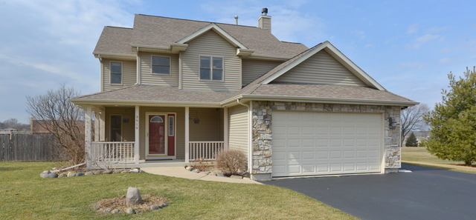

Wonder Lake is in McHenry County in northeastern Illinois and sits on the Wisconsin border. The population is 11,508 with equal numbers of males and females. There are 4151 households of which 1581 have children. The median age is 37.24. Over half of the population are married and 76% own homes. The work force is 62% white collar. Average household income is $83550 and 95% of the people drive to work.
There are several parks in Wonder Lake, two of which are in the Deerpath subdivision. Huff Park and Village Green are both located in the Deerpath subdivision. There are organized soccer leagues, softball and more activites available.
This listing is offered by John Herman. To see it email assistant @propertyup.com or call 847 847 4711.
POSTED BY
John Herman
Licensed Illinois Managing Broker

Call Now (847) 847-4711 For Real Estate Service.

Awards
Awarded as top 3% of all Agents by Chicago magazine - 5 Star Award winner 5 Years straight - 2011, 2012, 2013, 2014 & 2015!!!

