Introduction
At Class Creator we understand that making new classes for the upcoming academic year is an extremely complex and important task that impact the entire year.

Whether you are using Class Creator or not this document hopes to provide schools with a starting point and some resources make the process a little easier and a little less stressful.

We have tried to highlight some areas that your school will need to customise.

We have also provided alternatives in cases such as parent feedback (Accepted/Not Accepted) so please delete the section not appropriate to your needs.

This is not a legal document and schools will need to adjust it to suit their needs.

Please feel free to share it without restriction.

Tim Bowman
CEO of Class Creator (& former teacher)
tim@classcreator.io

Table of Contents

Introduction
Table of Contents
Student/Class Creation Placement Policy
Introduction and Objectives
Class Creation Process
Split/Composite/Multi-Age/Combined Classes
Parents Feedback
Accepted
Not Accepted
Announcement of New Classes
Final Report Card
By Mail
Changes in Assignment
New Student Enrollments
Class Creation Procedure & Timeline
Letter to Parents
Class Creator Workflow
Teacher Assessment Rubric
Acknowledgments
Contact Us

Student/Class Creation Placement Policy

Introduction and Objectives
It is the policy of the NAME OF SCHOOL/DEPARTMENT to place our students in heterogeneous classes. The ultimate goal is to come up with a placement for each child which will offer that child the greatest chance of success by placing them best possible learning environment, taking into account a variety of factors.

This important task contributes significantly to the creation of a positive class environment that enables students to reach their potential.

Class Creation Process
The process of assigning students to classes is a complex one with many “moving parts”. We must consider and make ongoing adjustments for:
- School Enrolment Numbers
- Funding for Staffing
- Physical Resources (Classrooms and buildings)

The process then begins:

- We make forecasts on enrolment numbers, funding and resources for the following academic year. Staffing assignments may change over due to a number of factors including enrolment, number of class sections needed at each grade level, and staff preferences for grade level assignments.
- After reviewing our student enrolment numbers per grade level, staffing and physical resources we determine the number of classes per grade level for the upcoming year. We are mindful that in the dynamic environment of an elementary school these numbers may change. As staffing is dependent upon the enrolment in each grade, multi-aged or combined classes may occur.
- Current teachers evaluate their each students using the following criteria:
To make balanced classes, student placement decisions will take into consideration the following:
- Gender
- Behaviour
- Academic Level
- Special Needs
- Social Relationships
- Developmental Level
- Learning Style
- Parents or guardians are asked to complete a similar profile form, the “Parent/Guardian Input for Class Placement” form, providing more information to be used by the Placement Team.
- Placement decisions are made at the school site by the professionals who work with the students. Grade level teachers, resource teachers and the principal will make placement decisions, with the principal being responsible for the final placement decision. Classes undergo extensive review in an effort to produce the best outcomes for all students. In order to ensure our classes are as balanced as possible we use specialized software (Class Creator) that provides feedback and alerts on student placements.

Factors relating to class composition also include:
- Class size
- Gender Balance
- Social Composition/Dynamics
- Peer Relationships
- Student-Teacher Considerations
(Optional, Classes may be made “blind” without teacher allocation)
- Allocation of Resources
- Student Mobility/Access
- Ethnicity and Cultural Considerations
- Separation of students based on potential negative outcomes
(Conflicts and family relationships)
- Parents Requests (Optional)

In order to ensure classes are balanced, lists are created “blind”. All classes are created without the sending/current teacher knowing who will be teaching the receiving/future class. School leadership will later take into consideration the individual and whole class needs when assigning teachers to classes.

The following timeline will be utilized for the establishment of split grade classes:
DATE | ACTIVITY | PERSON RESPONSIBLE
 | Draft initial grade/class configuration for their school. | School Leadership/Principal
 | Parents informed of placement request protocols via newsletter | School Administration
 | Deadline for parent placement requests | Parents
 | Initial student placements | Principal and/or Staff
 | “Meet the Teacher” or Testing of class composition | Principal and/or Staff
 | Revision of student placements | Principal and/or Staff
 | Parents notified of student placements | School Administration
 | Closure of parent complaints | Parents
 | Review and adjustments after parent requests/complaints | Principal
 | Summer/New students assigned to classes/grades | Principal

Split/Composite/Multi-Age/Combined Classes
Why are composite classes necessary?
The economics of school funding necessitates that each class be as “full as possible”. Composite classes are generally the result of having student enrolment numbers which do not allow for the appropriate Student:Teacher ratio.

For example if two grade one and two each have 60 students, and we aim to have class sizes of 24 we may create a composite:

With combined class
Grade 1: 2 classes of 24
Grade 1/2: 1 class of 24
Grade 2: 2 classes of 24
Total of 5 Teachers (Economically viable)

Without combined class:
Grade 1: 3 classes of 20
Grade 2: 3 classes of 20
Total of 6 Teachers (NOT Economically viable)

When creating composite classes do our very best to bring together students who will work well together and place an experienced teacher in those classrooms.

The following guidelines will be in place for combined classes:
1. The composition of a split class reflects the demographics of the school with access for inclusion students.
2. No student will be placed in split classes for consecutive years. (Optional)
3. The students will be recommended or placement in a split class by staff from the preceding grade level.
4. There will be a balance of students between the grade level populations in a split class.
5. New students to the school will not be considered for placement in split classes. (Optional)
6. Final decisions about student placements will be the responsibility of the Principal. (Optional)

Parents Feedback

Accepted
All parents will have the opportunity to inform the school of their child's special learning needs through use of the Student Information Form.

Parent/Guardian requests concerning student placement shall be based upon the preceding placement criteria. These requests shall be made in writing by the parent/guardian and received by the principal during a 2 week window that will be advertised in the Principal Newsletter of the preceding school year. Specific teacher requests will not be entertained, and the request will be returned. The principal shall consider the request if it is made in writing and it is valid based upon the placement criteria.

Requests for specific teachers are not appropriate and will not be considered when student placement is made.

ACCEPTABLE LETTERS INCLUDE:
- Issues relating to learning disabilities will be considered (testing from a psychologist and/or doctor diagnosis required and test results on file in the student’s permanent record).
- Issues relating to medical need or physical impairment will be considered. (Documentation required in health room records).
- Emotional issues which dramatically impact the learning environment will be considered. • Requests for a particular teaching style that would best match your child’s learning style.
- Parents of multiples (twins, triplets, etc.) may submit requests to have their children together/apart in the same class.

LETTERS WHICH WILL NOT BE CONSIDERED: (Letters will be discarded.)
- Requesting or “unrequesting” a teacher by name.
- Requesting that two students be placed in the same class unless there is a documented, valid need for special consideration.
- Requesting an “experienced” teacher or “first year teacher” (all teachers are highly qualified at NAME OF SCHOOL).

Not Accepted
We appreciate parents’ input regarding the educational setting for their child. However, as a staff we will not accept parental requests that name a particular teacher. Identification of a specific teacher has caused staff, parents, and children concerns and made the placement process increasingly difficult. The principal will review each grade level list in collaboration with the teaching team.

Announcement of New Classes
While we understand that parents (and students) are anxious to learn whom their children will have for a teacher, it is our practice to post class lists no sooner than the X days/weeks prior to school opening/closing. This is due to fluctuations in enrollment that often result in our having to make adjustments in class assignments. When placements are announced, your cooperation and support of this process provides the best possible outcome for students and staff.

Requests for changes in assignment

Accepted with protocol
Discussion on changes in any student assignment may be requested by the teacher or parent based on the placement criteria after the student has been in class at 15 days. Those teachers and parents involved shall meet with the principal and reach consensus concerning the student assignment. If a decision is made to reassign any student, she/he shall be transferred the principal makes the final decision

We take great lengths to ensure the best placement for all students. We take into account a large number of complex factors and every effort is made to ensure that students are placed in classes we believe will allow them to be happy and achieve their best.

For that reason, we recommend that students remain in the assigned classroom for the first week of school. If a parent has concerns regarding student placement it will be addressed beginning the second week of school. The new school year signifies a time of change and transition. Like any adult, students may need the gift of time in order to integrate into their new classroom community.

Parental appeals for change of placement, clearly indicating why the placement of the child is inappropriate, are to be directed in writing to the principal. Upon receipt of a written request for a change of placement, the following process will be used:
- The principal will discuss the request with the parent(s) following the first week of school;
- The principal will communicate placement concerns to the student’s classroom teacher. Families are encouraged to attend this meeting;
- The principal, classroom teacher and family will collaboratively develop a transition plan in order to meet the needs of the student. These stakeholders will schedule to meet within two weeks to assess the success of the transition plan;
- Should placement concerns remain following implementation of the transition plan, the principal will ultimately decide on the best course of action:
  - Keep the original placement,
  - Determine a second trial period for the original placement, and establish criteria for further review after the trial period, or
  - Grant a change of placement.

Not Accepted
The NAME OF SCHOOL staff takes classroom placement of all children very seriously and wants only the best for each child. It has been my experience that nearly all children are able to adjust rapidly to the different teachers they have over the years. This, too, is an important skill to learn--learning to get along with and work with a variety of people. (When students enter 7th grade, they will have a minimum of 6 different teachers and could have as many as 12 different teachers in one year.)

New Student Enrollments
In order to make the best placement for all students when new a student enrols at NAME OF SCHOOL we aim to gather as much data a possible on them from their caregivers and relevant educational institutions and support agencies. Once this data is collected, and reviewed the principal, the student will be allocated to the appropriate class.

Policy adopted: DATE
Revised: DATE

Letter to Parents

Written or Verbal Input Accepted (No Teacher Requests)
Dear SCHOOL NAME Parents/Guardians,
At the end of each school year, we begin to plan for the upcoming school year. One big area is student placement into classes.
Our grade level, resource, counselors, encore, special education teachers and administration work together as a team to place all of the grade level students into class groupings that are balanced based on ability levels. There are a variety of factors that we look at in placing students such as special programs, gender, and academic progress.
Placement of students is an important decision and we take it very seriously. We try to place all students with the right mix of peers and a teacher that provides them with the optimal learning environment. The administrative team takes in feedback and works with teachers to finalize the groupings and match the groupings with teachers.
Your input is important in helping us ensure that your child is placed in the most appropriate setting. Please share with us any information that you feel is needed in making this decision. It is very important to note, however, that we cannot accept any specific teacher requests. All of our teachers are passionate and are dedicated to doing their best for all of their students. In placing students, we will look at individual learning styles, class make up, and how teachers best support individual learning needs.
You can share your input with us in a number of ways but please make sure input is provided before date:
- Talk informally with your child’s classroom teacher.
- Write a letter, email, or note to me about your child’s classroom placement.
- Call us to discuss your concerns or thoughts via the phone.
Some areas to include in the letter are as follows:
- Academic strengths and/or weaknesses in reading, writing, and/or math
- Personality traits
- Organisational skills and work habits
- Any medical needs or accommodations
- Classroom environmental concerns
I guarantee that we will review every single piece of information about placement that comes to us and use it the best we can for placement.
Generally, placement will be mostly done by the end of the year, so please let us know by DATE then if you have input. I will make any changes as needed during the summer. We will also place all of the new students being registered over the summer. If you are a new student/parent, please feel free to write a letter, note, email, or talk with me about your child in regards to how we can best place them with a class and teacher.
You will be notified by DATE who your child's teacher will be for the upcoming school year.
Thank you for your continued support of our students and staff. If you have any questions, please contact me at EMAIL or PHONE
Kind regards
NAME
POSITION
NAME OF SCHOOL

2. Written Input (No Teacher Requests)
Dear SCHOOL NAME Parents/Guardians,
At the end of each school year, we begin to plan for the upcoming school year. One big area is student placement into classes.
As we begin to plan for the 2018 school year, we would like to make you aware of our student placement policy that is referenced when forming classes. Parents have this opportunity to provide information regarding their child and any special circumstance that might need to be considered.

We ask that you carefully read this information and make a note of the deadline (DATE) for submitting your letter, if you choose to do so. Only letters that have followed the guidelines below will be considered:

Student placement letters are neither encouraged nor discouraged but provide parents a means of expressing special circumstances that might need to be considered. Student placement is taken seriously and is initiated according to a process involving time and careful thought concerning the best interest of every child in each classroom. Classrooms are heterogeneously grouped to mirror our society.

In order to create balanced classes of students, the following factors are considered: gender, ethnicity, ability levels, student needs, behaviour concerns, and special program needs.

Please note that the final decision on all student placements rests with the administration. In order for letters to be considered, please submit to NAME by DATE. Students will be notified during the month of MONTH for class placement.

ACCEPTABLE LETTERS INCLUDE:
- Issues relating to learning disabilities will be considered (testing from a psychologist and/or doctor diagnosis required and test results on file in the student’s permanent record).
- Issues relating to medical need or physical impairment will be considered. (Documentation required in health room records).
- Emotional issues which dramatically impact the learning environment will be considered. Requests for a particular teaching style that would best match your child’s learning style.
- Parents of multiples (twins, triplets, etc.) may submit requests to have their children together in the same class.

LETTERS WHICH WILL NOT BE CONSIDERED:
- Requesting or “unrequesting” a teacher by name.
- Requesting that two students be placed in the same class unless there is a documented, valid need for special consideration.
- Requesting an “experienced” teacher or “first year teacher” (all teachers are highly qualified at NAME OF SCHOOL).

Kind regards
NAME
POSITION
NAME OF SCHOOL

3. Written Input (Teacher Requests)
Parent Input for Student Placement
Please return this form to the school by DATE.
Child’s Name:
Child’s Grade: Child’s Class:
Name Child Goes By at School (if different):

Parent/Caregiver’s Name (A):  Parent’s Email Address (A):  Parent’s Phone (A): | Parent/Caregiver’s Name (B):  Parent’s Email Address (B):  Parent’s Phone (B):

Please circle the items below that most represent your child’s academic and behavioural characteristics. This information will be utilized to help select a teacher for your child.

- Accepts suggestions & criticisms  - Appears self-confident  - Tends to be a follower  - Seems popular with friends  - Loud and Extroverted  - Follows instructions easily  - Has anxiety about a new grade level | - Seems to enjoy school  - Quiet and Introverted  - Has poor social skills  - Thrive with extension activities  - Cries easily, very sensitive  - A natural leader  - Has a poor self-concept

Describe the classroom environment in which your child would be most successful:

Describe specific concerns you have for your child (i.e. talkative, overachiever, unmotivated, nervous, quiet, withdrawn, hyperactive, medical concerns, etc.):

Additional comments pertaining to your child and his/her learning environment:

Requests for characteristics of your child’s teacher. (Please do not include teacher names. Final placements will be made with all factors being considered teacher considers may not be met.)

Kind regards
NAME
POSITION
NAME OF SCHOOL
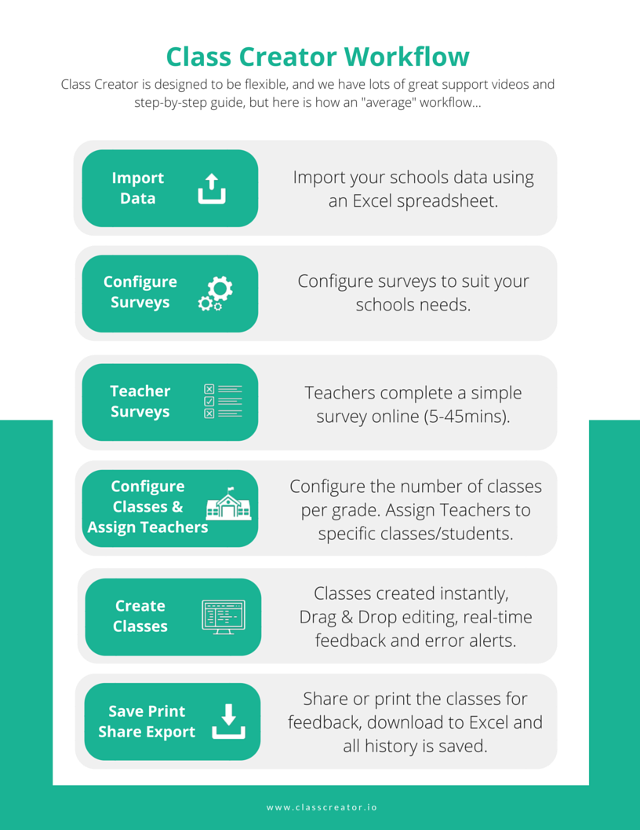
z

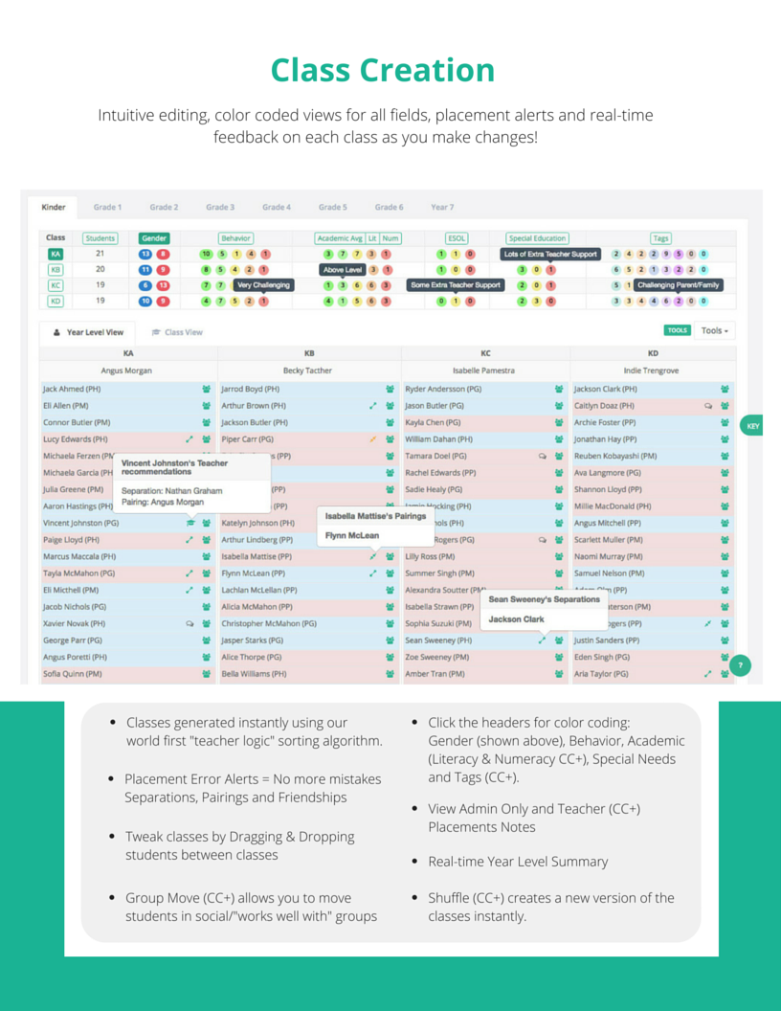

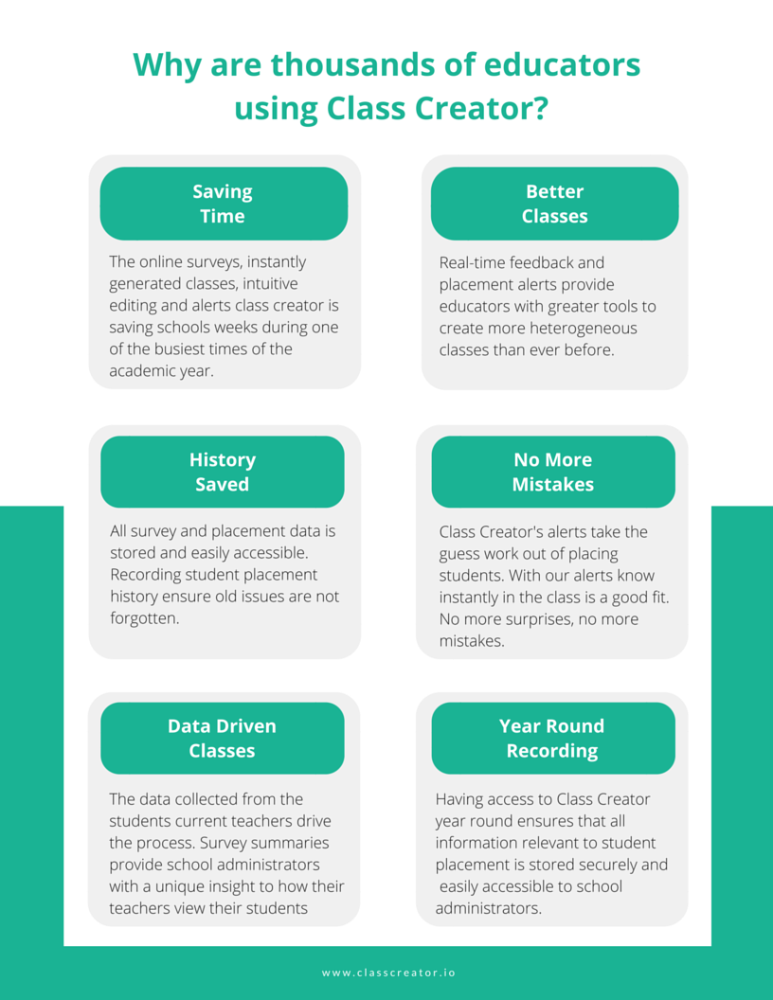

Assessment Rubric for Teachers (Editable)
Class Creator Behaviour | School Behaviour Descriptors
Very Good | The teacher never needs to contact parents, wellbeing staff or leadership about the child’s social/emotional needs and the child is well behaved at all times. The child is a positive influence on their peers.
Good | The teacher never needs to contact parents, wellbeing staff or leadership about the child’s social/emotional needs and the child is well behaved at all times.
Satisfactory | The teacher has occasionally (once per semester) had concerns about a child’s social/emotional needs and has spoken to parents, wellbeing staff or leadership and the child is well behaved with occasional reminders.
Challenging | The teacher has often, (several times per semester), spoken to parents, wellbeing staff or leadership about a child’s social/emotional needs. Behaviour requires frequent teacher support.
Very Challenging | Extreme misbehaviour requiring substantial teacher & leadership intervention.
Class Creator Academic | School Academic Descriptors
Well Above Level | The child is achieving 12 months or more above expected level in the core areas of literacy and numeracy verified by data. E.g. Reading Level.
Above Level | The child is achieving 6 months or more above expected level in the core areas of literacy and numeracy verified by data. E.g. Reading Level.
At Level | The child is achieving at expected level in the core areas of literacy and numeracy verified by data.
Below Level | The child is 6 months or more below expected level in literacy and numeracy verified by data.
Well Below Level | The child is 12 months or more below expected level in literacy and numeracy verified by data.
Class Creator Special Needs | School Special Needs Descriptors
None | No extra support and differentiation required.
Minimal Extra Teacher Support | Student requires some extra support and differentiation. Student receives ESL, Literacy or Numeracy Support.
Some Extra Teacher Support | Student requires significant extra support and differentiation.  Student is on an Individual Learning Plan.
Lots of Extra Teacher Support | Student requires lots of extra support and differentiation. Student is funded.
Class Creator Social | School Social Descriptors
Separations (Students & Teachers) | These students or teachers should be placed apart. Forced Separation.  Only use for the most essential situations.
Pairings  (Students & Teachers) | These students or teachers should be placed together. Forced Pairing.  Only use for the most essential situations.
Preferences (None, 3, 4 or 5) | - Student Friend Preferences or Teacher recommendations for “works well with”.  - Please complete all preferences (1st, 2nd…)  - If a preference is RED it is also a Separation, therefore it will not be met, so we would recommend selecting another preference.  - Students will be placed with 1+ preference where possible.
Tags (CCPLUS) | Select the stream that is most appropriate for the student.  Examples include:  - Ethnicity  - Gifted & Talented  - Sports/Arts Programs  - Challenging Parent  - Religion

Acknowledgments
This policy is largely drawn from the wisdom and experience of others. We appreciate the hours, days and weeks these policies have taken to create. If you wish to thank anyone for creating this resource please make sure you thank them, not us :-)

Thank you to the following schools and their staff for sharing their placements policies online:
- Frank Love Elementary School- http://wwwnew.nsd.org/Page/25527
- Clifford School - http://www.rcsd.k12.ca.us/domain/1295
- Blossom Hill Elementary School- http://bh.lgusd.org/apps/pages/index.jsp?uREC_ID=219685&type=d&pREC_ID=482435
- Gilham Eelementary School- http://gilham.4j.lane.edu/wp-content/uploads/2015/03/Gilham-Homeroom-Placement-Policy.pdf
- Greenville K-12- http://www.greenville.k12.sc.us/ccreek/Upload/uploads/Student%20Placement%20Teacher%20Request%20Policy%2015-16.pdf
- Bimbadeen Heights PS- http://www.bimbadeenheightsps.vic.edu.au/
- Pepper Ridge- Elementary- http://www.westada.org/domain/5312
- Edison Elementary School- http://edison.dpsk12.org/procedures-for-classroom-placement/
- Smithfield Elementary- https://www.google.com.au/url?sa=t&rct=j&q=&esrc=s&source=web&cd=2&cad=rja&uact=8&ved=0ahUKEwjvm-r11Y_LAhVDUZQKHaVhDOAQFgghMAE&url=http%3A%2F%2Fschools.cms.k12.nc.us%2FsmithfieldES%2FLists%2FAnnouncements%2FAttachments%2F88%2FParent_Placement_Form.doc&usg=AFQjCNGe7mOzIxmyoE7Zcd21lUHMoMWNYA&bvm=bv.114733917,d.dGo

Contact Us
Class Creator
Student Placement Software | Faster. Easier. Smarter.

Website: Classcreator.io

Blog: https://blog.classcreator.io/

Support: http://help.classcreator.io/help_center

info@classcreator.io

Tim Bowman
tim@classcreator.io

