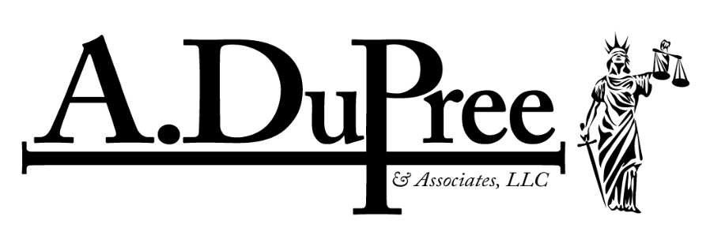

March 20, 2023
Kristen M. Clarke
Assistant Attorney General
U.S. Department of Justice, Civil Rights Division
950 Pennsylvania Ave. NW
Washington, D.C. 20530-0001

Dear Assistant Attorney General Clarke:
On March 11, 2022, Tyrea M. Pryor, a 39-year-old black man, was gunned down by Hunter Soule and Jamie Welsh, police officers with the Independence, Missouri Police Department (IPD), after Mr. Pryor crashed his Dodge Avenger. The crash rendered him incapacitated and the vehicle immobile. At the time Mr. Pryor was shot by Soule and Welsh, Pryor was unarmed and posed no threat to any officer nor the public. In fact, Jacob Pope, also a member of the IPD, vehicle’s dash camera depicted Welsh and Soule was standing on the driver’s side of Mr. Pryor’s inoperable vehicle. Next, Welsh yelled “Gun” “Gun” (See enclosed video), the dash camera shows Welsh and Soule firing at least fifteen shots, collectively, into the inoperable vehicle and Mr. Pryor’s incapacitation. Notably, the entire video, which still has not been fully released, also shows Alex Steele, a member of the IPD in the backseat. Steele was behind the driver seat in the inoperable vehicle at the time Welsh and Soule fired their weapons. Steele gave statements to Missouri State Highway Patrol (MSP) investigators that an assault styled rifle was lodged between the center console and Mr. Pryor’s right leg, also immovable after the crash. Steele stated that he had both of his hands on the rifle attempting to remove it from the vehicle at the time Welsh and Soule began to fire their weapons.
On February 9, 2023, Chief Deputy Prosecuting Attorney Dion Sankar and Chief Trial Assistant Prosecuting Attorney Jeremy Baldwin with the Jackson County Prosecutor’s Office met with Mr. Pryor’s family and attorneys. The family and attorneys were seeking answers on why Jackson County Prosecutor’s Office refused to present the killing of Mr. Pryor to a Jackson County Grand Jury, so they could deliberate as to whether to indict the shooting officers and possibly others. The Chief Deputy Prosecuting Attorney told Mr. Pryor’s family, that as tragic as this is the homicide was justified because the police involved in this shooting saw a handgun or pistol in Mr. Pryor’s hand. Notably, no handgun or pistol was found in the vehicle. However, in justifying the shooting death of Mr. Pryor, Mr. Sankar and Mr. Baldwin disclosed to the Pryor family that the shootings officers mistakenly identified Steele’s handgun to be that of Mr. Pryor at the time Welsh yelled “Gun” “Gun” that prompted Welsh and Soule to fire their weapons at least fifteen times.
At the time that the Elected Jackson County Prosecuting Attorney, Jean Peters-Baker, made her decision not to submit the case to the Grand Jury, the Jackson County Prosecutor’s Office was fully aware at the time Mr. Pryor was gunned down, that Mr. Pryor was unarmed, injured, incapacitated and posed no immediate threat to any officers or other individuals present at the crash scene or in the public. In fact, on February 9, 2023, the Jackson County Prosecutor’s Office was fully aware at the meeting with Mr. Pryor’s family that Steele gave a recorded statement to MSHP, that he had his duty weapon secured in his holster and was actively securing the lodged the AR-15 between the driver and passenger seats at the time Welsh yelled “Gun” “Gun” that prompted Welsh and Soule to fire their weapons at least fifteen shots into Mr. Pryor’s vehicle.
The most objective evidence, the video, shows that Soule and Welsh clearly violated Mr. Pryor’s Constitutional Rights according to 18 U.S.C. §242 by shooting and taking his life unjustifiably.
We stand ready to work with the DOJ to ensure full transparency in this matter. If you have any questions, please contact Harry M. Daniels (daniels@harrymdaniels.com or (678-664-8529) or Arimeta R. DuPree (dupree@adupreelaw.com or (816-521-0773).

Kind Regards,

Arimeta R. DuPree, Esq.
