STAR ACADEMY

ENCORE
18-05-2023
(+92)-306-4941878
FBSIE
Matric, FSc, A/O Level, MDCAT/NUMS and Supplementary Exams Pep with Dr.Sadaqat Baloch
Physics 11TH Past Paper MCQS
Name of student: ___________
FBSIE 2019 GROUP-I
i) Signals from remote control to the device operated by it travel with the speed of:
A. Light B. Ultrasonic C. Supersonic D. Sound
Answer: A. Light
ii) The effect produced by the superposition of waves from two coherent sources passing through the same region is called:
A. Diffraction B. Polarization C. Refraction D. Interference
Answer: D. Interference
iii) In which of the following processes maximum work can be obtained:
A. Isochoric B. Isothermal C. Adiabatic D. Isobaric
Answer: B. Isothermal
iv) Which of the following may be used as a valid formula to calculate the speed of ocean waves: (v=speed, g=acceleration due to gravity, λ=wavelength, ρ=density, h=depth):
A. gh/λ B. √(λg) C. λ/gh D. ρgh
Answer: B. √(λg)
v) In a cricket match, 500 spectators are counted one by one. How many significant figures will be there in the final result:
A. 1 B. 2 C. 3 D. 0
Answer: C. 3
vi) A person walks first 10 km north and 20 km east. The magnitude of the resultant vector is:
A. 22.36 km B. 22.46 km C. 25 23 km D. 20.36 km
Answer: A. 22.36 km
vii) For which angle the equation, |A.B| = |AxB| is correct:
A. 45º В. 60º C. 90º D. 0º
Answer: A. 45º
viii) When a block of wood of mass 2 kg is pushed along a horizontal fat surface of a bench, the force of friction is 4N. When the block is pushed along the bench with a force of 10N, it moves with a constant:
A. Speed of 5ms⁻¹ B. Acceleration of 3ms⁻² C. Acceleration of 5ms⁻² D. Speed of 3ms⁻¹
Answer: B. Acceleration of 3 ms⁻²
ix) A projectile is thrown so that it travels a maximum range of 100m. How high will it rise:
A. 400 m В. 500 m C. 250 m D. 25 m
Answer: D. 25 m
x) One horse power is equal to:
A. 746 Joules B. 746 KW C. 746 N D. 746 Watt
Answer: D. 746 Watt
xi) What is moment of inertia of a sphere:
A. (1/2)M²R B. (2/5)MR² C. (1/2)MR² D. MR²
Answer: B. (2/5)MR²
xii) If the earth suddenly stops rotating, the value of 'g' at equator would:
A. Remain unchanged B. Become Zero C. Increase D. Decrease
Answer: C. Increase
xiii) A raindrop of radius 'r' falls in the air with a terminal speed v. What should be the terminal speed of raindrop of radius 2r:
A. v_{t} B. 2v_{t} C. 4v_{t} D. v_{t}/2
Answer: C. 4v_{t}
xiv) Bernoulli's equation is based upon law of conservation of:
A. Energy B. Momentum C. Current D. Mass
Answer: A. Energy
xv) The time period of the same pendulum at Karachi and at Murree are related as (T_{M}=Time period at Murree, T_{K}=Time period at Karachi:
A. T_{K} > T_{M} B. T_{K} < T_{M} C. 2T_{K} = 3T_{M} D. T_{K} = T_{M}
Answer: B. T_{K} < T_{M}
xvi) In an isolated system the total energy of vibrating mass and spring is:
A. Variable B. Low C. High D. Constant
Answer: D. Constant
xvii) Which of the following factors has no effect on the speed of sound in a gas:
A. Pressure B. Temperature C. Density D. Humidity
Answer: A. Pressure
FBSIE 2019 GROUP-II
i) Which of the following is a pair of SI base units:
A. Ampere, Joule B. Coulomb, Second C. Kilogram, Kelvin D. Newton, Meter
Answer: C. Kilogram, Kelvin
ii) 1 km/ 1 Gm = ____________ :
A. μ B. μ m C. 10⁻⁶ m D. 10⁶ m
Answer: A. μ
iii) A person walks first 10 km north and 20 km east. Then the magnitude of the resultant vector is:
A. 20.36 km B. 22.36 km C. 22.46 km D. 25.23 km
Answer: B. 22.36 km
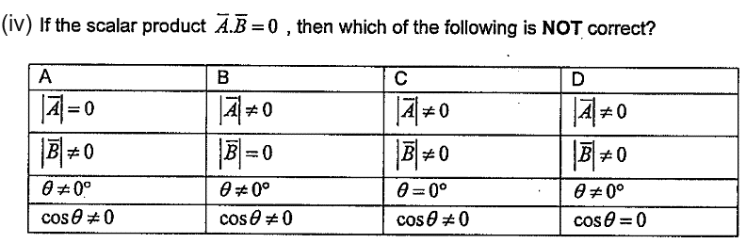

Answer: C.
v) A car takes 1 hour to travel 100 km along the main road and than ½ hour to travel 20 km along a side road. What is the average speed of the car for the Whole Journey:
A. 60 km h⁻¹ B. 70 km h⁻¹ C. 80 km h⁻¹ D. 100 km h⁻¹
Answer: C. 80 km h⁻¹
vi) Rate of change of velocity is called:
A. Speed B. Distance C. Acceleration D. Displacement
Answer: C. Acceleration
vii) An example of a non-conservative force is:
A. Electric force В. Magnetic force C. Gravitational force D. Frictional force
Answer: D. Frictional force
viii) The expression for escape velocity is given by:
A. 2g R² B. √(2gR) C. g R²/2 D. 2 gR
Answer: B. √(2gR)
ix) Artificial satellites move around:
A. Мoon В. Sun C. Stars D. Earth
Answer: D. Earth
x) What is the moment of inertia of a solid cylinder:
A. MR² B. 1/2 M²R C. 2/5 M²R D. 1/2 MR²
Answer: D. 1/2 MR²
xi) The pressure will be low where the speed of the fluid is:
A. Zero B. High C. Low D. Constant
Answer: B. High
xii) If the period of oscillation of mass (M) suspended from a spring is 2 s. then the period of mass 4M should be:
A. 1 s B. 2 s C. 4 s D. 8 s
Answer: B. 2 s
xiii) In an Isolated system, the total energy of a vibrating mass and spring is:
A. Constant B. Variable C. Low D. High
Answer: A. Constant
xiv) There is no net transfer of energy by particles of medium in:
A. Longitudinal wave B. Transverse wave C. Progressive wave D.Stationary wave
Answer: D. Stationary wave
xv) Which of the following factors has no effect on the speed of sound in a gas?
A. Humidity B. Pressure C. Temperature D. Density
Answer: B. Pressure
xvi) A real gas can be approximated to an ideal gas at:
A. Low density B. High pressure C. High density D. Low temperature
Answer: A. Low density
xvii) Coloured fringes observed in soap bubbles are the examples of:
A. Diffraction B. Interference C. Polarization D. Reflection
Answer: B. Interference
FBSIE 2018 GROUP-I
i) For an ideal gas, the internal energy is directly proportional to:
A. Volume B. Density C. Pressure D. Temperature
Answer: D. Temperature
ii) Thermal pollution is an inevitable consequence of:
A. First law of thermodynamics B. Newton's third law
C. 2nd law of thermodynamics D. Pascal's law
Answer: C. 2nd law of thermodynamics
iii) The Prefix one peta is:
A. 10⁹ B. 10¹⁸ C. 10¹⁵ D. 10¹²
Answer: C. 10¹⁵
iv) Counter clockwise Torque is:
A. Zero B. Infinite C. Negative D. Positive
Answer: D. Positive
v)
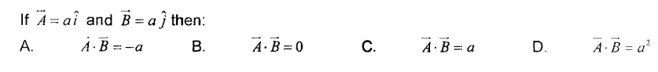
Answer: B.
vi) The motion and rest are:
A. Discrete B. Random C. Absolute D. Relative
Answer: D. Relative
vii) The fuel consumed by a typical rocket to provide enough upward thrust to overcome gravity is:
A. 1 0000kghr⁻¹ B. 10000kgs⁻¹ C. 10000gs⁻¹ D. 10000kg min⁻¹
Answer: B. 10000kgs⁻¹
viii) When the angle between force and displacement is greater than 90° , the work done is:
A. Negative B. Positive C. Maximum D. Zero
Answer: A. Negative
ix) Which of the following is non-conservative force?
A. Electric force B. Elastic spring force C. Gravitational force D. Normal force
Answer: D. Normal force
x) SI unit of angular momentum is:
A. Nm B. Radian C. Ns D. Js
Answer: D. Js
xi) Bernoulli's equation is based on the law of conservation of:
A. Charge B. Momentum C. Mass D. Energy
Answer: D. Energy
xii) If radius of the droplet is doubled, the terminal velocity increases:
A. Four times B. Eight times C. Two times D. Three times
Answer: A. Four times
xiii) Tuning of a radio is an example of:
A. Musical resonance B. Magnetic resonance C. Mechanical resonance D. Electrical resonance
Answer: D. Electrical resonance
xiv) If a transverse wave, travelling in a rarer medium, is reflected from a denser medium, it undergoes a path difference of:
A. λ/2 B. λ C. λ/8 D. λ/4
Answer: A. λ/2
xv) A diffraction grating has 5000 lines per cm. Its grating element is:
A. 2 x 10⁻³cm B. 0.2 x10⁻³cm C. 200 x 10⁻³cm D. 20 x10⁻³cm
Answer: B. 0.2 x10⁻³cm
xvi) For light of wavelength A through a lens of diameter D, the resolving power is given by:
A. 1.22 D/λ B. λ/1.22D C. 1.22 λ/D D. D/1.22λ
Answer: D. D/1.22λ
xvi) The Bragg equation is given as:
A. 2d sin θ = nλ B. 2nsin θ = d λ C. d sin θ = nλ D. n sin θ =dλ
Answer: A. 2d sin θ = nλ
FBSIE 2018 GROUP-II
i) The efficiency of diesel engine is about:
A. 30% to 35% B. 25% to 30% C. 45% to 50% D. 35% to 40%
Answer: D. 35% to 40%
ii) The entropy of universe always:
A. Increases and decreases simultaneously B. Remains constant
C. Increases D. Decreases
Answer: C. Increases
iii) One year is equal to:
A. 3.15 x 10⁷s B. 5.4 x 10⁴s C. 1.41 x 10¹⁷s D. 8.6 x 10⁴s
Answer: A. 3.15 x 10⁷s
iv) SI unit of Torque is:
A. Ns B. JC⁻¹ C. Js D. Nm
Answer: D. Nm
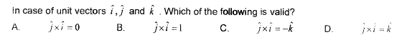
v)
Answer: C.
vi) The change in position of a body from initial position to final position is called:
A. Displacement B. Acceleration C. Position vector D. Velocity
Answer: A. Displacement
vii) The notation delta (ᇫ) is used to represent a:
A. Small change B. Big change C. Zero change D. Very small change
Answer: D. Very small change
viii) 1kWh is equal to:
A. 3.6 x 10⁶J B. 3.6 x 10⁻⁶J C. 3.6o x 10⁹J D. 3.6 x 10⁻⁹ J
Answer: A. 3.6 x 10⁶J
ix) If angle '⍬’ is greater than 90°, the work done is:
A. Maximum B, Positive C. Zero D. Negative
Answer: D. Negative
x) Moment of inertia of a thin rod about its length is:
Answer: C.
xi) The device used to measure the speed of liquid flow is called:
A. Speedometer B. Spectrometer C. Barometer D. Venturimeter
Answer: D. Venturimeter
xii) The dimensions of flow rate are:
A. (L⁻¹T⁻³] B. [L⁻¹T⁻²] C. [L³T⁻¹] D. [L²T⁻¹]
Answer: C. [L³T⁻¹]
xiii) For 1°C rise in temperature, the speed of sound increases by:
A. 0.61 ms⁻¹ B. 0.061 ms⁻¹ C. 61 ms⁻¹ D. 6.1 ms⁻¹
Answer: A. 0.61 ms⁻¹
xiv) To double the period of simple pendulum, its length must be:
A. increased two times B. Increased four times C. Decreased by 1/3 D. Decreased by 1/2
Answer: B. Increased four times
xv) In Michelson's interferometer, a fringe is shifted, each time the mirror is displaced through:
A. λ B. λ/2 C. λ/8 D. λ/4
Answer: B. λ/2
xvi) In normal adjustment, the length of astronomical telescope is:
A. 1/ƒ_{a}+ƒ_{e} B. ƒ_{e}/ƒ_{a} C. ƒ_{a}/ƒ_{e} D. ƒ_{a} + ƒ_{e}
Answer: D. ƒ_{a}+ƒ_{e}
xvii) Multimode step index fibre has a core of:
A. 50 μm B. 1000 μm C. 0.5 μm D. 5 μm
Answer: A. 50 μm
FBSIE 2017 GROUP-I
i) The dimensions of Power are:
A. [MLT⁻²] B. [MLT⁻³] C. [M²L²T⁻²] D. [ML²T⁻³]
Answer: D. [ML²T⁻³]
ii) The significant figures in 34.678 are:
A. 4 B. 3 C. 5 D. 2
Answer: C. 5
iii) Two forces are acting together on an object. The magnitude of their resultant is minimum , when the angle between the forces is:
A. 120º B. 180º C. 45º D. 60º
Answer: B. 180º
iv) If the scalar product of two vectors is 2√3 and the magnitude of their vector product is 2. The angle between them is:
A. 30º B. 60º C. 180º D. 120º
Answer: A. 30º
v) A car starts from rest and covers a distance of 100 m in one second with uniform acceleration. It's acceleration is:
A. 100 m/s² B. 200 m/s² C. 300 m/s² D. 50 m/s²
Answer: B. 200 m/s²
vi) A ball rolls off the edge of a table . The horizontal component of the ball's velocity remains constant during its entire trajectory because:
A. The net force acting on the ball is zero
B. The ball is not acted upon by a force in the horizontal direction
C. The ball is acted upon by a force the horizontal direction
D. The ball is acted upon by a force in the vertical direction.
Answer: B. The ball is not acted upon by a force in the horizontal direction
vii) Which of the following is the example of conservative force?
A. Tension in the string B. Propulsion force of rocket
C. Gravitational field D. Restoring force in compressed spring
Answer: C. Gravitational field
viii) Any body requires ____________ escape velocity, to escape from the gravitational pull of the mars:
A. 2.4 km/s B. 4.3 km/s C. 5 km/s D. 10.4 km/s
Answer: C. 5 km/s
ix) In dryer , water is pushed out of wet clothes due to:
A. Abundance of centripetal force B. lack of centripetal force
C. Friction D. Retarding force
Answer: A. Abundance of centripetal force
x) The SI-unit of co-efficient of viscosity is:
A. kgm⁻¹s⁻¹ B. kgm^{-1s-2} C. kgm⁻²s⁻¹ D. kgm⁻³s⁻²
Answer: A. kgm⁻¹s⁻¹
xi) A stone of mass 16 kg is attached to a string 144 m long and is whirled in a horizontal circle. The maximum tension the string can withstand is 16 N. The maximum velocity of revolution that can be given to the stone without breaking it, will be:
A. 20 ms⁻¹ B. 16 ms⁻¹ C. 14 ms⁻¹ D. 12 ms⁻¹
Answer: D. 12 ms⁻¹
xii) The property of fluid by which its own molecules are attracted is said to be:
A. Adhesion B. Cohesion C. Viscosity D. Surface Tension
Answer: D. Surface Tension
xiii) A simple pendulum is moved from the Earth to the Moon. How does it change the period of oscillations? (Acceleration due to gravity on moon=1.6 m/s⁻²)
A. The period is increased by factor √6 B. The period is increased by factor four
C. The period is decreased by factor √6 D. The period remains the same
Answer: B. The period is increased by factor four
xiv) Which of the following conditions is best for cooking purpose?
A. Isobaric B. Isochoric C. Adiabatic D. Isothermal
Answer: B. Isochoric
xv) What would be the efficiency of a Carnot engine operating with boiling water as one reservoir and a freezing mixture of ice and water as the other reservoir?
A. 27% B. 67% C. 12% D. 100%
Answer: A. 27%
xvi)
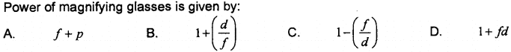
Answer: B. 1 + (d/f)
xvii) Optically active substance are those which:
A. Produce Polarized Light
B. Products double
C. Rotate the plane of polarization of polarized light
D. Convert a plane polarized light into circulatory polarized light
Answer: C. Rotate the plane of polarization of polarized light
FBSIE 2017 GROUP-II
i) A sound wave travailing in air has a wavelength of 1.6 x10⁻² m . If the velocity of sound is 320 m/s calculate the frequency of sound:
A. 2.0 x 10⁸ Hz B. 2.0 x10² Hz C. 2.0 x10⁵ Hz D. 2.0 x10⁷ Hz
Answer: Note:
All the option mentioned above are incorrect the correct Answer is :
2.0 x10⁴ Hz.
ii) Which of the following pairs of units are both derived units? (Mark 1)
A. Kilogram, Angstrom B. Ampere, Degree C. Newton, Candela D. Joule, Watt
Answer: D. Joule, Watt
iii) When two reference lines are drawn at right angles to each other. their point of intersection is called:
A. Coordinate system B. Origin C. Coordinate Axis D. Rectangular components
Answer: B. Origin
iv) Maximum number of components of a vector may be:
A. Infinite B. One C. Two D. Three
Answer: A. Infinite
v) Motorcycle safety helmet extends the time of collision and decreases:
A. Impulse B. Change of collision C. Force acting D. Velocity of Vehicle
Answer: C. Force acting
vi) A brick of mass 2 kg is dropped from a rest position 5 m above the ground. What is its velocity at a height of 3 m above the ground?
A. 12.4 m/s B. 6.3 m/s C. 7 m/s D. 1.2 m/s
Answer: B. 6.3 m/s
vii) Anybody requires ___________ escape velocity to escape from the gravitational pull of the Venus:
A. 5.5 km/s B. 2.4 km/s C. 4.3 km/s D. 10.4 km/s
Answer: D. 10.4 km/s
viii) One radian is equal to:
A. 47.6⁰ B. 34.3⁰ C. 53.7º D. 57.3⁰
Answer: D. 57.3⁰
ix) The Dimensions of co-efficient of viscosity are:
A. ML⁻³T⁻² B. ML⁻¹T⁻¹ C. ML⁻¹T⁻² D. ML⁻²T⁻³
Answer: B. ML⁻¹T⁻¹
x) A simple pendulum on earth has period of 6.0 s. What Is the approximate period of this pendulum on the moon where the acceleration due to gravity is roughly 1/6 of earth's gravity:
A. 15 s B. 1.0 s C. 36 s D. 2.4 s
Answer: A. 15 s
xi) The temperature at which a system undergoes a reversible isothermal process without transfer heat is called as:
A. Reversible temperature B. Critical temperature
C. Kelvin temperature D. Absolute zero temperature
Answer: D. Absolute zero temperature
xii) A frictionless heat engine can be 100% efficient only if its exhaust temperature is:
A. Zero kelvin B. Equal to its input temperature
C. Less than its input temperature D. Freezing point of water
Answer: A. Zero kelvin
xiii) The limit to which a microscope can be used to resolve details depends on:
A. The width of eye piece and Longer Wavelength
B. The width of objective and Short Wavelength
C. The width of eye piece and Short Wavelength
D. The width of objective and Longer Wavelength
Answer: B. The width of objective and Short Wavelength
xiv) According to Laplace's point of view, sound waves travel in air under the conditions of:
A. Isothermal B. Isobaric C. Isochoric D. Adiabatic
Answer: D. Adiabatic
xv) The refractive index of rarer medium with respect to a denser medium is:
A. Zero B. 1 C. Greater than 1 D. Smaller than 1
Answer: D. Smaller than 1
xvi) In a reversible cycle, the entropy of the system:
A. First increases and then decreases B. Increases
C. Decreases D. Does not change
Answer: B. Increases
xvii) A telescope is made of an objective of focal length 20 cm and an eye piece of focal length 5 cm, both are convex lenses. Calculate the angular magnification:
A. 15 B. 4 C. 5 D. 10
Answer: B. 4
FBSIE 2016 GROUP-I
i) Boltzmann constant k = R/N_{A}, where R is the general gas constant and N_{A} is the Avogadro’s number. What is the SI unit of k?
A. J mol⁻¹ K⁻¹ B. J mol K⁻¹ C. JK D. JK⁻¹
Answer: D. JK⁻¹
ii) Which of the following is the dimensions of angular momentum?
A. [ML²T⁻²] B. [MLT⁻¹] C. [MLT⁻²] D. [ML²T⁻¹]
Answer: D. [ML²T⁻¹]
iii) Which of the following pairs contains one vector and one scalar quantity?
A. Torque, Angular momentum B. Work, Power
C. Impulse, Torque D. Impulse, Energy
Answer: D. Impulse, Energy
iv) A girl throws a ball vertically upward with a velocity of 20 ms⁻¹. Ignore the air resistance, how long will it take to fall back to her hands?
A. 6 Seconds B. 2 Seconds C. 3 Seconds D. 4 Seconds
Answer: D. 4 Seconds
v) Which of the following quantities is equal to area under velocity-time graph?
A. Distance B. Acceleration C. Work Done D. Power
Answer: A. Distance
vi) What is equal to kilowatt-hour?
A. 3.6 MJ B. 3.6 μJ C. 3.6 mJ D. 3.6 kJ
Answer: A. 3.6 MJ
vii) A projectile is thrown with some initial velocity. For which pair of angles its range is equal?
A. 10º, 80º B. 10º, 40º C. 10º, 50º D. 10º, 70º
Answer: A. 10º, 80º
viii) Two vectors A and B are enclosing an angle θ. For which value of θ, A×B = A.B?
A. 90º B. 0º C. 45º D. 60º
Answer: C. 45º
ix) A hoop of mass “m” rolls down an inclined plane of height “h”, reaches the bottom with linear velocity “v” and angular velocity “ω”. If friction is ignored, what is the total energy of the hoop at the bottom of inclined plane?
A. mv² B. ¼ mv² C. ½ mv² D. ¾ mv²
Answer: C. ½ mv²
x) What is the length of simple pendulum whose time period is one second?
A. 0.25 m B. 2.00 m C. 0.99 m D. 0.50 m
Answer: A. 0.25 m
xi) For a mass spring system placed on a smooth horizontal surface oscillating with amplitude “x_{o}”. At what displacement from the mean position its energy is equal to its elastic potential energy?
A. x_{o}/4 B. x_{o} C. x_{o}/2 D. x_{o}/√2
Answer: A. x_{o}/4
xii) When two notes of frequencies “f₁” and “f₂” are sounded together, beats are produced. If f₁ > f₂ what will be the period of beats?
A. 1/(f₁-f₂) B. f₁ + f₂ C. f₁ – f₂ D. 1/(f₁ – f₂)
Answer: C. f₁ – f₂
xiii) Electric current measured by an ammeter is 0.5A. Which of the following correctly expresses this result?
A. 500 MA B. 50 mA C. 50 MA D. 500 mA
Answer: D. 500 mA
xiv) A stationary sound waves has series of nodes. The wavelength of the sound wave is “λ”. What is the distance between first and fifth node?
A. 2λ B. λ/4 C. λ/2 D. 3λ/2
Answer: A. 2λ
xv) Which of the following expressions does not have the units equal to joule? Where “P” is the linear momentum and “m” is the mass of the object moving with velocity “v”.
A. Fd B. P²/2m C. mv² D. Fv
Answer: D. Fv
xvi) A converging lens of focal length “f” is used as a magnifying glass. When is the final image formed at infinity?
A. f/d B. 1 + (d/f) C. 1 + (f/d) D. d/f
Answer: D. d/f
xvii) When light of wavelength “λ” is incident on a lens of diameter “D”. What is correct expression for its resolving power?
A. λ/1.22D B. 1.22D/λ C. 1.22λ/D D. D/1.22λ
Answer: A. λ/1.22D
FBSIE 2016 GROUP-II
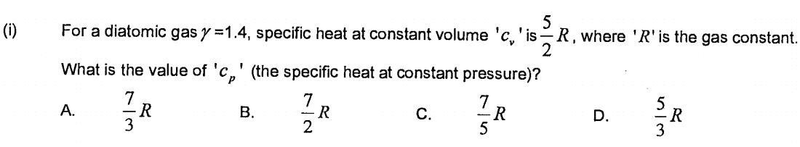
Answer: B. 7 / 2 R
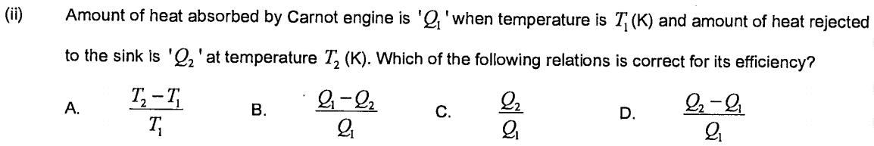
Answer: B. (Q₁ - Q₂) / Q₁
iii) Which of the following quantities has the dimension as [ML²T⁻³]?
A. Pressure B. Angular momentum C. Work D. power
Answer: D. power
iv) Which of the following pair contains both the vector quantities?
A. Torque, Angular momentum B. Velocity, Power
C. Work, Accelaration D. Energy, Impulse
Answer: A. Torque, Angular momentum
v) Which is equal to area under force-displacement graph?
A. Work done B. Power C. Acceleration D. Impulse
Answer: A. Work done
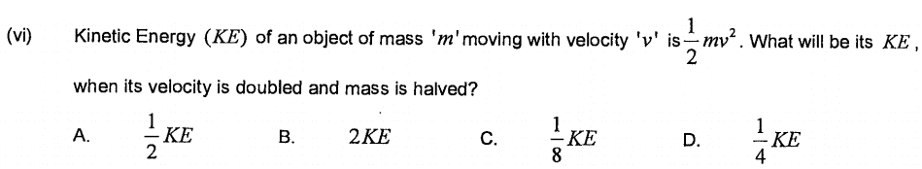
Answer: B. 2 K.E
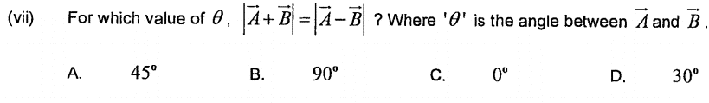
Answer: B. 90⁰
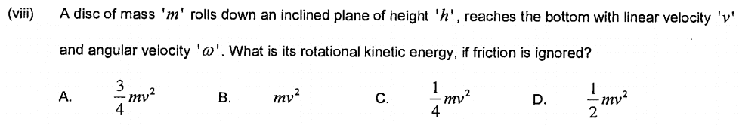
Answer: D. 1/4 (mv²)
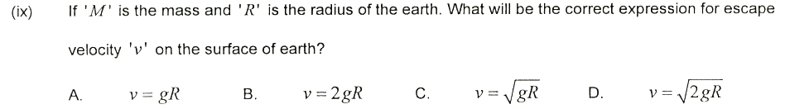
Answer: D. v = √ 2 gR
x) A simple pendulum having time period 2.0 seconds is called second's pendulum. What is its frequency?
A. 2.0Hz B. 4.0Hz C. 0.5Hz D. 1.0Hz
Answer: C. 0.5Hz
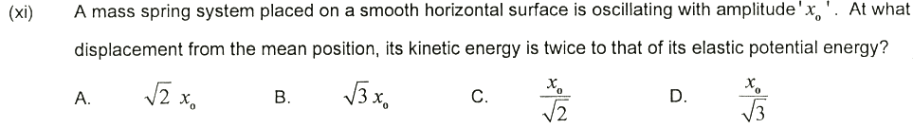
Answer: C. x_{o} / √2
xii) How many maximum numbers of beats per second can be recognized by a normal ear?
A. 8 B. 10 C. 2 D. 4
Answer: B. 10
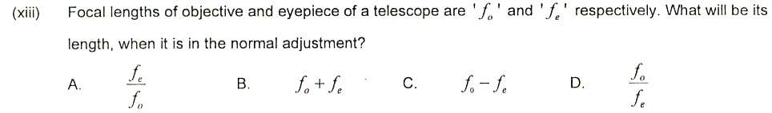
Answer: B. f_{o} + f_{e}
xiv) A stationary sound wave has a series of nodes. The distance between the first and sixth node is 30cm. What is the wavelength of the sound wave?
A. 10 cm B. 12 cm C. 5.0 cm D. 6.0 cm
Answer: B. 12 cm
xv) A 1000 Kg car accelerates from rest to 20ms⁻¹ in 10 seconds. What is the average power delivered to automobile engine?
A. 200 kW B. 2000 kW C. 2 kW D. 20 kW
Answer: D. 20 kW
xvi) In the white light spectrum obtained with the diffraction image of wavelength 'λ₁' coincide with the forth order image of second wavelength 'λ₂'. What is the ratio of two wavelengths λ₁: λ₂?
A. 3:4 B. 4:3 C. 2:1 D. 1:2
Answer: D. 1:2
xvii) Which of the following is correct for final image formed by a compound microscope?
A. it is virtual, erect and enlarged B. it is virtual, inverted and enlarged
C. it is real, inverted and enlarged D. it is real, erect and enlarged
Answer: B. it is virtual, inverted and enlarged
FBSIE 2015 GROUP-I
i) Light year is the unit of ________:
A. Time B. Distance C. Angular Displacement D. Velocity
Answer: B. Distance
ii) A. j=______________________
A. Zero B. A_{x} C. A_{y} D. A_{z}
Answer: C. A_{y}
iii) Two forces each of magnitude F act perpendicular to each other. Their resultant vector will have magnitude ________
A. 2F B. 2F² C. √2 F D. F/√2
Answer: C. √2 F
iv) A body is moving with a constant velocity of 10 ms⁻¹ in north-west direction. After 3 seconds its acceleration will be ________:
A. 10 ms⁻² B. 20 ms⁻² C. 30 ms⁻² D. Zero
Answer: D. Zero
v) Time taken by projectile to move from its point of projection to the point of maximum height is given by ________:
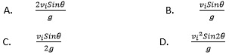

Answer: B.
vi) Maximum range of a projectile is given by ________:
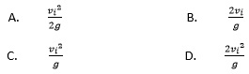
Answer: C.
vii) 45 rev/min = ________ rad/sec:
A. 90 π B. 4.71 C. 0.75 D. 90
Answer: B. 4.71
viii) For which position will the maximum blood pressure in the body have the smallest value?
A. Standing upright B. Sitting C. Lying horizontally D. Lying inclined
Answer: C. Lying horizontally
ix) What is the total distance travelled by an object moving with simple harmonic motion in a time equal to its time period, if its amplitude is x_{o}?
A. Zero B. x_{o} C. 2 x_{o} D. 4 x_{o}
Answer: D. 4 x_{o}
x) The projection of a particle moving in a circle executes simple harmonic motion. Its time period is________:
A. ω/2π B. 2π/ω C. 2πf D. 2πft
Answer: B. 2π/ω
xi) ________ of the light proves that light consists of transverse electromagnetic waves:
A. Interference B. Diffraction C. Polarization D. Dispersion
Answer: C. Polarization
xii) The distance between the objective and eye-piece of a telescope in normal adjustment is ________:
A. f_{o} + f_{e} B. f_{o}/f_{e} C. f₀ - f_{e} D. f_{e}/f_{o}
Answer: A. f_{o} + f_{e}
xiii) Nowadays, a new type of optical fibre is being used in which the central core has high refractive index and its density gradually decreases towards the periphery. This type of optical fibre is called:
A. Single mode step index fibre B. Multimode step index fibre
C. Multimode graded index fibre D. Double step index fibre
Answer: C. Multimode graded index fibre
xiv) For a geostationary satellite, the orbital radius measured from the centre of the Earth is:
A. 36000 km B. 42300 km C. 64000 km D. 72000 km
Answer: B. 42300 km
xv) If a heat 'Q' is absorbed or rejected by the system at corresponding temperature 'T' when the system is taken through a Carnot cycle and Q₃ is the heat absorbed or rejected by the system when it is at the temperature of triple point of water, then unknown temperature T in kelvin is given by:
A. 273 Q/Q₃ B. 273.16 Q₃/Q C. 273.61 Q₃/Q D. 273.16 Q/Q₃
Answer: D. 273.16 Q/Q₃
xvi) What is SI unit of entropy?
A. J kg⁻¹ K⁻¹ B. J K⁻¹ C. J kg⁻¹ D. J kg K⁻¹
Answer: B. J K⁻¹
xvii) Colour printing uses just following four colours to produce the entire range of colours:
A. Violet-Magenta-Yellow-Black B. Indigo-Blue-Green-Red
C. Black-Yellow-Magenta-Cyan D. Cyan-Magenta-Red-Violet
Answer: C. Black-Yellow-Magenta-Cyan
FBSIE 2015 GROUP-II
i) Steradian is the unit of:
A. Plane angle B. Solid angle C. Angular velocity D. Angular acceleration
Answer: B. Solid angle
ii) What are the dimensions of coefficient of viscosity?
A. ML²T⁻² B. ML²T⁻¹ C. M⁻¹L³T⁻² D. ML⁻¹T⁻¹
Answer: D. ML⁻¹T⁻¹
iii) If x - component of a vector (F_{x}) is positive and its y -component (F_{y}) is negative and tan⁻¹ (Fy/Fx) = ϕ then the angle θ which the resultant vector makes with the positive x- axis is given by:
A. θ = ϕ B. θ = 180°- ϕ C. θ = 180°+ ϕ D. θ =360° - ϕ
Answer: D. θ =360° - ϕ
iv) A.k =___________ ? (vector A. Unit vector k)
A. A_{x} B A_{y}B. A_{y} C. A_{z} D. zero
Answer: C. A_{z}
v) The product of Force and Time is called:
A. Impulse B. Linear Momentum C. Angular momentum D. Torque
Answer: A. Impulse
vi) For which of the following pairs of angles is range of Projectile the same:
A. Oº and 45° B. 15° and 60° C. 35° and 55º D. 30° and 75°
Answer: C. 35° and 55º
vii) A particle of mass “m” has momentum 'p’. Its kinetic energy is given by:
A. (1/2)mp B. (1/2) mp² C. (2p²)/m D. (1/2) p²/m
Answer: D. (1/2) p²/m
viii) What is the commercial unit of electrical energy?
A. Watt B. Kilowatt C. Kilowatt hour D. Horse power
Answer: C. Kilowatt hour
ix) A stone tied to the end of 20 cm long string is whirled in a horizontal circle. If the centripetal acceleration is 9.8 ms⁻² , then its angular velocity in rad.s⁻¹ will be:
A. 0.49 B. 7 C. 14 D. 21
Answer: B. 7
x) The terminal velocity of a fog droplet of radius "r" and density ρ moving in a fiuid having coefficient of viscosity η is given by:
A. 2gr²ρ/9η B. mg/6πηrv C. 4g/3πηr D. 2ηr²/9ρ
Answer: A. 2gr²ρ/9η
xi) 1 torr = __________ N.m⁻²:
A. 1.33 B. 13.33 C. 133.3 D. 1.0
Answer: C. 133.3
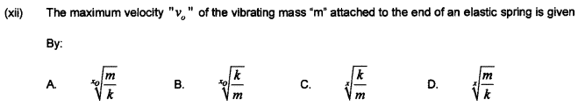
Answer: B. x_{o}√(k/m)
xiii) The periodic vibrations of sound between maximum and minimum loudness are called:
A. Intensity level B. Diffraction C. Beats D. Polarization
Answer: C. Beats
xiv) Bragg’s equation is given by:
A. dsinθ =nλ B. 2dsinθ=nλ C. L=mλ/2 D. Δy=λL/d
Answer: B. 2dsinθ=nλ
xv) The equation used by Michelson to determine the speed of light is given by: c = ?
A. 16fd B. 16f/d C. fd/16 D. 16d/f
Answer: A. 16fd
xvi) The efficiency of diesel engine is about:
A. 20% to 25% B. 25% to 30% C. 30% to 35% D. 35 % to 40 %
Answer: D. 35 % to 40 %
xvii) What is S.I Unit of latent heat of fusion?
A. J kgk⁻¹ B. J kg⁻¹ C. Jkg⁻¹k⁻¹ D. cal.gm.°C⁻¹
Answer: B. J kg⁻¹
FBSIE 2014 GROUP-I
i) Light year is the unit of:
A. Time B. Distance C. Light intensity D. Speed of light
Answer: B. Distance
ii) The moment of force is called:
A. Torque B. Impulse C. Angular momentum D. Force
Answer: A. Torque
iii) If R_{x} is negative and R_{y} component is positive, the direction of resultant R is:
A. θ = Ø B. θ = 180º – Ø C. θ = 180º + Ø D. 360º - Ø
Answer: B. θ = 180º - Ø
iv) If the range of a projectile is half to its maximum range, the angle of projection is:
A. 30º B. θ = 22.5º C. 15º D. 45º
Answer: C. 15º
v) The unit of impulse is:
A. Newton B. Joule-sec C. Joule D. Newton-sec
Answer: D. Newton-sec
vi) The energy released by burning 1 litre of petrol is ________:
A. 1000 J B. 7 × 10⁵ J C. 5 × 10⁷ J D. 4 × 10⁵ J
Answer: C. 5 × 10⁷ J
vii) The height of a geostationary satellite above the equator is:
A. 6.4 × 10⁶ m B. 3.6 × 10⁷ m C. 3.6 × 10⁻⁷ m D. 6 × 10²⁴ m
Answer: B. 3.6 × 10⁷ m
viii)
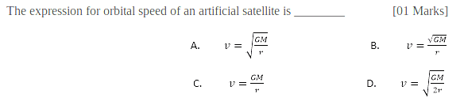

Answer: A.
ix)

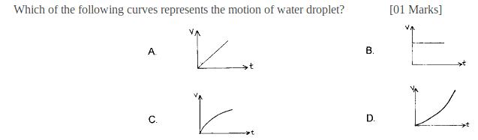
Answer: C.
x)

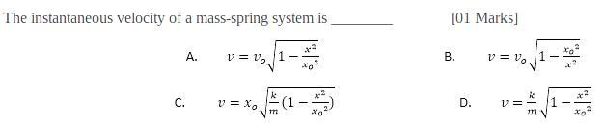
Answer: C.
xi)
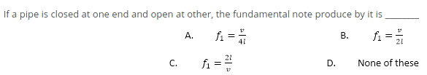
Answer: A.
xii) Colours seen on oily surface of water are due to:
A. Interference of light B. Diffraction of light C. Polarization of light D. Refraction of light
Answer: A. Interference of light
xiii) Technique used to study the structure of haemoglobin is:
A. X-rays diffraction B. Newton’s rings C. Polarization D. Interference
Answer: A. X-rays diffraction
xiv) The near point of normal human eye is:
A. 25 m B. 250 mm C. 2.5 cm D. None of these
Answer: B. 250 mm
xv) Speed of light in vacuum is:
A. 3 × 10⁸ cm/sec B. 3 × 10¹⁰ cm/sec C. 3 × 10⁸ m/sec D. None of these
Answer: C. 3 × 10⁸ m/sec

xvi)
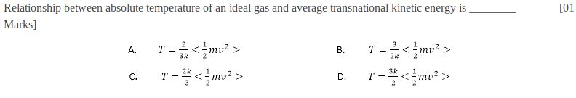

Answer: A.
xvii) The cloud formation in atmosphere is an example of:
A. Isothermal Process B. Adiabatic Process C. Isobaric Process D. Isochoric Process
Answer: B. Adiabatic Process
FBSIE 2014 GROUP-II
i) The solid angle of the sphere is:
A. 12.57 Sr. B. 6.28 Sr. C. 3.14 Sr. D. 57.3 Sr
Answer: A. 12.57 Sr.
ii) How would the two vectors of the same magnitude have to be oriented, if they were to be combined to give a resultant equal to a vector of the same magnitude?
A. 90º B. 0º C. 45º D. None of these
Answer: D. None of these
iii) A positive charge particle is moving in a uniform magnetic field with constant velocity. Its direction with respect to the magnetic field is:
A. 120º B. 0º C. 30º D. None of these
Answer: B. 0º
iv) Which of the following curves represents rocket motion?
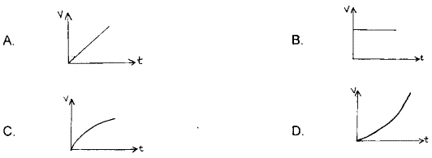

Answer: C
v) A projectile is thrown upward with velocity 'v_{i}' and angle 'θ' with respect to the horizontal.
At what point is its velocity v_{i}cosθ:
A. Initial B. Highest C. Final D. None of these
Answer: B. Highest
vi) The work done to move a body along x-axis is said to be positive, if applied force is in the quadrants:
A. I,IV B. II,III C. I,III D. II,IV
Answer: A. I,IV
vii) Moment of inertia of a solid disc is:
A. mr² B. 1/2 mr² C. 3/2 mr² D. 2/5 mr²
Answer: 1/2 mr²
viii) An airline pilot can find his position on the surface of the earth within accuracy of:
A. 100 m B. 10 km C. 10 m D. 1 km
Answer: C. 10 m
ix) The law of conservation of energy is the basis of:
A. Stoke's law B. Bernoulli's equation C. Terminal Velocity D. Equation of continuity
Answer: B. Bernoulli's equation
x) In a mass-spring , the angular frequency of a vibrating body is:
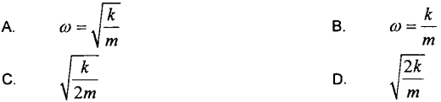
Answer: A.
xi) The sharpness of the resonance curve of resonating system depends on (the):
A. Damping B. Loss of K.E C. Loss of P.E D. Loss of K.E and P.E
Answer: A. Damping
xii) The speed of sound in water at 20ºC is:
A. 332 m/sec B. 1483 m/sec C. 315 m/sec D. 972 m/sec
Answer: B. 1483 m/sec
xiii) Star moving toward the earth show a:
A. Red shift B. Blue Shift C. White shift D. None of these
Answer: B. Blue Shift
xiv) The process used to determine the concentration of sugar in the blood is:
A. Polarization B. Optical activity C. Glare D. Diffraction
Answer: A. Polarization
xv) The unit of magnifying power of an instrument is:
A. Joule B. Watt C. No unit D. Diopter
Answer: C. No unit
xvi) Critical angle of glass is determined by:
A. Huygens principle B. Snell's law C. Law of reflection D. Ohm's law
Answer: B. Snell's law
xvii) A gas is enclosed in a container having pressure 'P' and volume 'v'. The product of 'P' and 'V' of the gas is:
A. Power B. Work C. Force D. Temperature
Answer: B. Work

