Organic Chemistry Chapter 16: Conjugation, Resonance, and Dienes
Conjugation
Conjugation occurs whenever p orbitals can overlap on three or more adjacent atoms. Two common conjugated systems are 1,3-dienes and allylic carbocations.
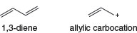
1,3-Dienes
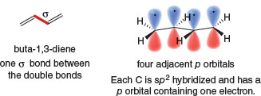
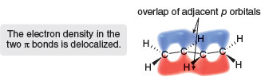
- When p orbitals overlap, the electron density in each of the π bonds is spread out over a larger volume, thus lowering the energy of the molecule and making it more stable.
.
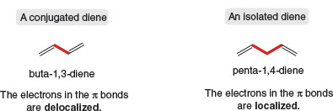

Allylic Carbocations
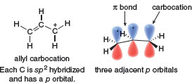
- Three p orbitals on three adjacent atoms, even if one of the p orbitals is empty, make the allyl carbocation conjugated.
Conjugation stabilizes the allyl carbocation because overlap of three adjacent p orbitals delocalizes the electron density of the π bond over three atoms.
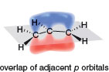

Resonance and Allylic Carbocations
Two resonance structures differ in the placement of π bonds and nonbonded electrons. The placement of atoms and σ bonds stays the same.
The Stability of Allylic Carbocations
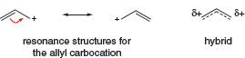
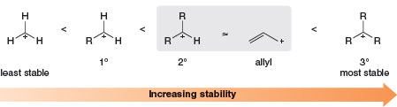

Allylic Carbocations in Biological Reactions
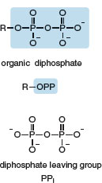
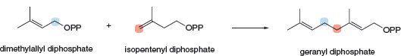

Mechanism 16.1 Biological Formation of Geranyl Diphosphate
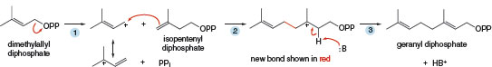
- Loss of the diphosphate leaving group forms an allylic carbocation.
- Nucleophilic attack of isopentenyl diphosphate on the allylic carbocation forms the new C C σ bond.
- Loss of a proton (shown with the general base, B:) forms geranyl diphosphate.

Common Examples of Resonance
Type [1] The Three Atom “Allyl” System, X=Y−Z*
- For any group of three atoms having a double bond X Y and an atom Z that contains a p orbital with zero, one, or two electrons, two resonance structures are possible:
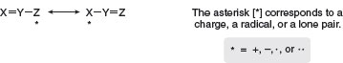
The two resonance structures differ in the location of the double bond, and either the charge, the radical, or the lone pair, generalized by [*].
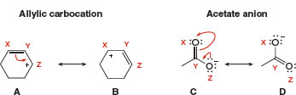

Type [2] Conjugated Double Bonds
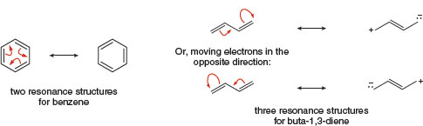
Type [3] Cations Having a Positive Charge Adjacent to a Lone Pair

- When a lone pair and a positive charge are located on adjacent atoms, two resonance structures can be drawn.

Type [4] Double Bonds Having One Atom More Electronegative Than the Other

- For a double bond X Y in which the electronegativity of Y > X, a second resonance structure can be drawn by moving the π electrons onto Y.
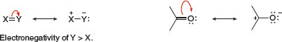

The Resonance Hybrid
The lower its energy, the more a resonance structure contributes to the overall structure of the hybrid.
Rule [1] | Resonance structures with more bonds and fewer charges are better.
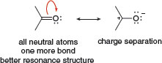
Rule [2] | Resonance structures in which every atom has an octet are better.
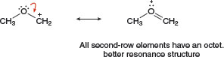
Rule [3] | Resonance structures that place a negative charge on a more electronegative atom are better.
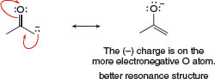

Electron Delocalization, Hybridization, and Geometry
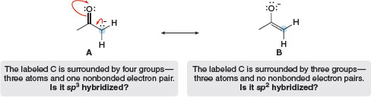

Three adjacent p orbitals make the anion conjugated.
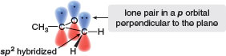
- In a system X Y Z:, Z is generally sp² hybridized, and the nonbonded electron pair occupies a p orbital to make the system conjugated.

Conjugated Dienes
Compounds with many π bonds are called polyenes.
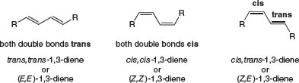
Two possible conformations result from rotation around the C C bond that joins the two double bonds.
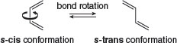
- The s-cis conformation has two double bonds on the same side of the single bond.
- The s-trans conformation has two double bonds on opposite sides of the single bond.

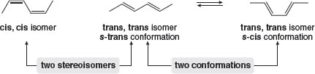

The Carbon—Carbon σ Bond Length in Buta-1,3-diene
Four features distinguish conjugated dienes from isolated dienes.
[1] | The C C single bond joining the two double bonds is unusually short.
[2] | Conjugated dienes are more stable than similar isolated dienes.
[3] | Some reactions of conjugated dienes are different than reactions of isolated double bonds.
[4] | Conjugated dienes absorb longer wavelengths of ultraviolet light.
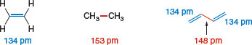

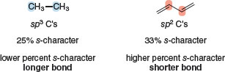
Based on hybridization, a C_{sp}² C_{sp}² bond should be shorter than a C_{sp}³ C_{sp}³bond because it is formed from orbitals having a higher percent s-character.
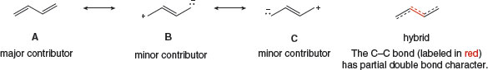
Based on resonance, the central C C bond in buta-1,3-diene is shorter because it has partial double bond character.

Stability of Conjugated Dienes
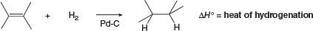
When hydrogenation gives the same alkane from two dienes, the more stable diene has the smaller heat of hydrogenation.
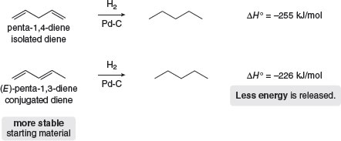

Relative energies of an isolated and conjugated diene
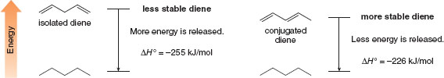
- A conjugated diene has a smaller heat of hydrogenation and is more stable than a similar isolated diene.

Electrophilic Addition: 1,2- Versus 1,4-Addition
- Electrophilic addition in conjugated dienes gives a mixture of products.
- Conjugated dienes undergo a unique addition reaction not seen in alkenes or isolated dienes.
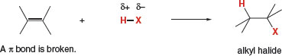

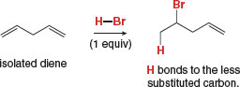
With a conjugated diene, electrophilic addition of one equivalent of HBr affords two products.
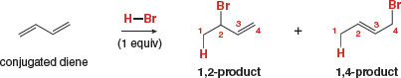
The ends of the 1,3-diene are called C1 and C4 arbitrarily, without regard to IUPAC numbering.
- The 1,2-addition product results from Markovnikov addition of HBr across two adjacent carbon atoms (C1 and C2) of the diene.
- The 1,4-addition product results from addition of HBr to the two end carbons (C1 and C4) of the diene. 1,4-Addition is also called conjugate addition.

Mechanism 16.2 Electrophilic Addition of HBr to a 1,3-Diene–1,2- and 1,4-Addition

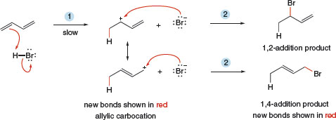
- H⁺ of HBr adds to a terminal carbon of the 1,3-diene to form a resonance-stabilized allylic carbocation.
- Nucleophilic attack of Br⁻ occurs at either site of the resonance-stabilized carbocation that bears a (+) charge, forming the 1,2- and 1,4-addition products.
- Addition of HX to a conjugated diene forms 1,2- and 1,4-products because of the resonance-stabilized allylic carbocation intermediate.

Kinetic Versus Thermodynamic Products

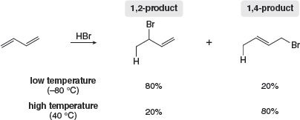
Page 619
- At low temperature the major product is formed by 1,2-addition.
- At higher temperature the major product is formed by 1,4-addition.
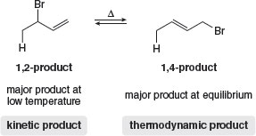
- The 1,2-product is formed faster because it predominates at low temperature. The product that is formed faster is called the kinetic product.
- The 1,4-product must be more stable because it predominates at equilibrium. The product that predominates at equilibrium is called the thermodynamic product.
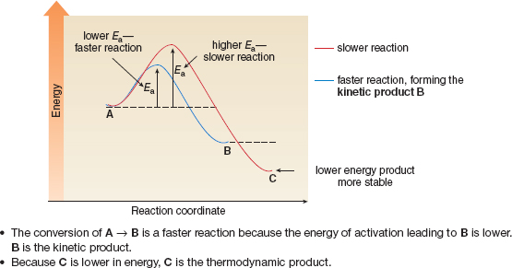
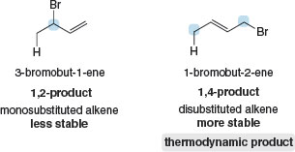
Page 620
- The more substituted alkene–1-bromobut-2-ene in this case—is the thermodynamic product.
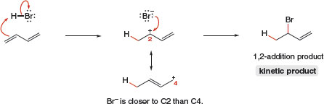
A proximity effect occurs because one species is close to another.
- The 1,2-product forms faster because of the proximity of Br⁻ to C2.
Energy diagram for the two-step addition of HBr to CH₂ = CH CH CH₂
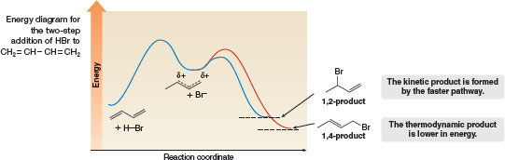
Why is the ratio of products temperature dependent?
- At low temperature, the energy of activation is the more important factor. Because most molecules do not have enough kinetic energy to overcome the higher energy barrier at lower temperature, they react by the faster pathway, forming the kinetic product.
- At higher temperature, most molecules have enough kinetic energy to reach either transition state. The two products are in equilibrium with each other, and the more stable compound—which is lower in energy—becomes the major product.

The Diels—Alder Reaction

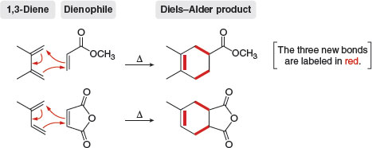
All Diels—Alder reactions have the following features in common:
[1] | They are initiated by heat; that is, the Diels—Alder reaction is a thermal reaction.
[2] | They form new six-membered rings.
[3] | Three π bonds break, and two new C C σ bonds and one new C C π bond form.
[4] | They are concerted; that is, all bonds are broken and formed in a single step.  How To Draw the Product of a Diels—Alder Reaction  Example Draw the product of the following Diels—Alder reaction:  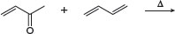  Specific Rules Governing the Diels—Alder Reaction  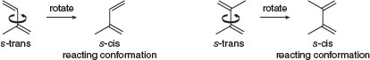  This rotation is prevented in cyclic dienes. As a result:  - When the two double bonds are constrained in the s-cis conformation, the diene is unusually reactive.  - When the two double bonds are constrained in the s-trans conformation, the diene is unreactive.  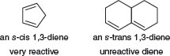
  Step [1] | Arrange the 1,3-diene and the dienophile next to each other, with the diene drawn in the s-cis conformation.  - This step is key: Rotate the diene so that it is drawn in the s -cis conformation, and place the end C's of the diene close to the double bond of the dienophile.  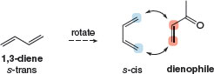
  Step [2] | Cleave the three π bonds and use arrows to show where the new bonds will be formed.  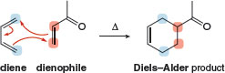
  Diene Reactivity
  Rule [1] | The diene can react only when it adopts the s-cis conformation.
Dienophile Reactivity

Rule [2] | Electron-withdrawing substituents in the dienophile increase the reaction rate.
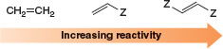
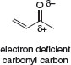

Common dienophiles in the Diels—Alder reaction
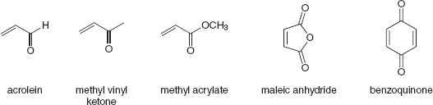

Stereospecificity

Rule [3] | The stereochemistry of the dienophile is retained in the product.
- A cis dienophile forms a cis-substituted cyclohexene.
- A trans dienophile forms a trans-substituted cyclohexene.
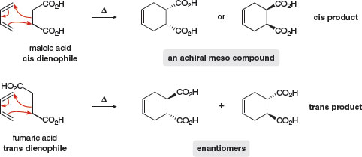

- A cyclic dienophile forms a bicyclic product. A bicyclic system in which the two rings share a common C – C bond is called a fused ring system. The two H atoms at the ring fusion must be cis, because they were cis in the starting dienophile. A bicyclic system of this sort is said to be cis-fused.
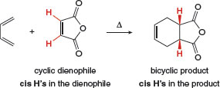

The Rule of Endo Addition

Rule [4] | When endo and exo products are possible, the endo product is preferred.
 | 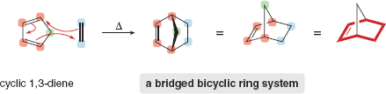
A bicyclic ring system in which the two rings share non-adjacent carbon atoms is called a bridged ring system.

Fused and bridged bicyclic ring systems compared
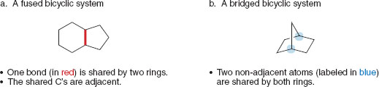

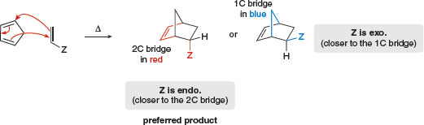
- A substituent on one bridge is endo if it is closer to the longer bridge that joins the two carbons common to both rings.
- A substituent is exo if it is closer to the shorter bridge that joins the carbons together.

In a Diels—Alder reaction, the endo product is preferred, as shown in two examples.
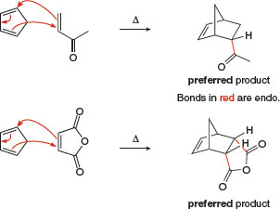

How endo and exo products are formed in the Diels—Alder reaction
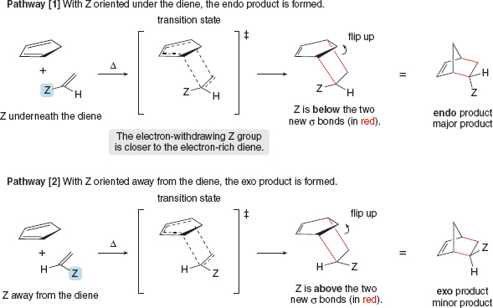

Other Facts About the Diels—Alder Reaction
- Locate the six-membered ring that contains the C C.
- Draw three arrows around the cyclohexene ring, beginning with the π bond. Each arrow moves two electrons to the adjacent bond, cleaving one π bond and two σ bonds, and forming three π bonds.
- Retain the stereochemistry of substituents on the C C of the dienophile. Cis substituents on the six-membered ring give a cis dienophile.

Finding the diene and dienophile needed for a Diels—Alder reaction
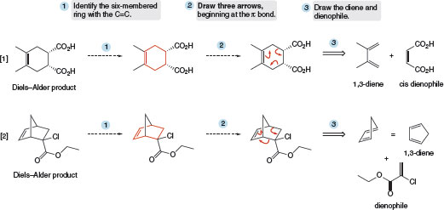

Retro Diels—Alder Reaction
- A reactive diene like cyclopenta-1,3-diene readily undergoes a Diels—Alder reaction with itself; that is, cyclopenta-1,3-diene dimerizes because one molecule acts as the diene and another acts as the dienophile.
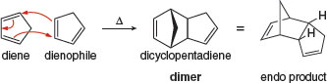
When heated, dicyclopentadiene undergoes a retro Diels—Alder reaction, and two molecules of cyclopentadiene are re-formed. If cyclopentadiene is immediately treated with a different dienophile, it reacts to form a new Diels—Alder adduct with this dienophile.
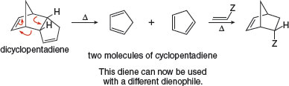

Conjugated Dienes and Ultraviolet Light
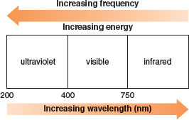
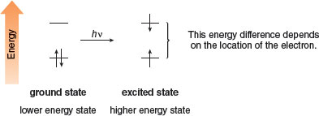
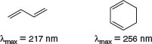
Page 631
- Conjugated dienes and polyenes absorb light in the UV region of the electromagnetic spectrum (200–400 nm).

