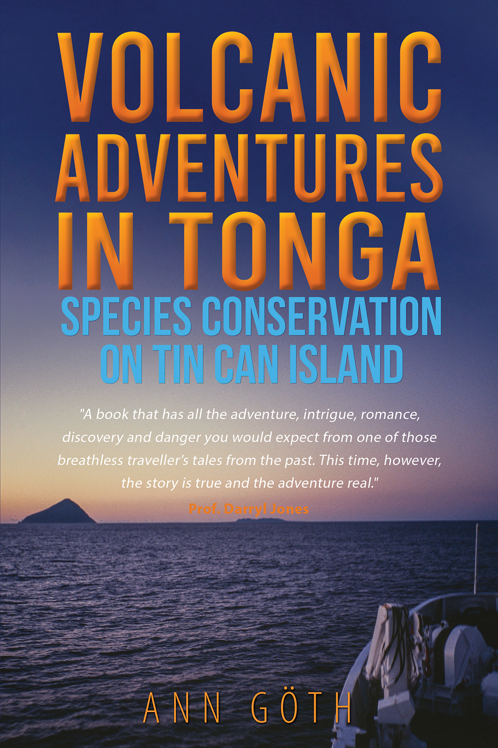

Ann Göth

Volcanic Adventures in Tonga
Species Conservation on
Tin Can Island


Copyright © Ann Göth 2023

The right of Ann Göth to be identified as author of this work has been asserted by the author in accordance with sections 77 and 78 of the Copyright, Designs and Patents Act 1988.

All rights reserved. No part of this publication may be reproduced, stored in a retrieval system, or transmitted in any form or by any means, electronic, mechanical, photocopying, recording, or otherwise, without the prior permission of the publishers.

Any person who commits any unauthorised act in relation to this publication may be liable to criminal prosecution and civil claims for damages.

The story, the experiences, and the words are the author’s alone.

A CIP catalogue record for this title is available from the British Library.

ISBN 9781035809516 (Paperback)
ISBN 9781035809523 (ePub e-book)

www.austinmacauley.com

First Published 2023
Austin Macauley Publishers Ltd®
1 Canada Square
Canary Wharf
London
E14 5AA

Disclaimer

All stories in this book are based on actual events. I have occasionally changed the order of events and combined similar content in one chapter for readability. In some parts, I have added information about the Polynesian culture that was unavailable to me in 1991–1993 but is now accessible through the internet. All people in this book, past and present, are real people. A few individuals permitted me to use their real names and for all others, I have changed names to protect their privacy.

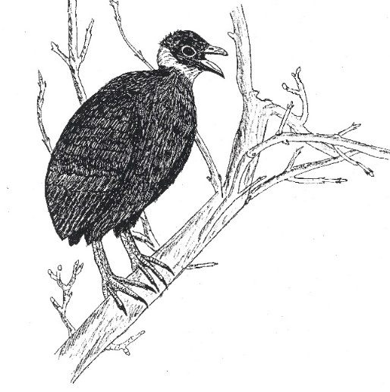

Malau singing

Foreword from Professor Darryl Jones

The family of birds known as the megapodes are among the most astonishing and bizarre of all Avian groups. When stories of these species and their behaviour reached Europe in the 18th Century, they were dismissed as fanciful tales from confused explorers. Birds burying their eggs in the sides of volcanoes or building huge mounds? Obviously, exaggerations of over-excited travellers trying to sell books.
When explorers finally investigated these otherwise unremarkable-looking birds, the list of remarkable features continued to grow. Some of these birds did construct enormous mounds of organic matter, which were used as incubation sites, while others abandoned their eggs deep inside volcanoes or hot sand. They were the only birds providing absolutely no parental care for their young, and their hatchlings were so advanced they were the only birds classed as super-precocial, being able to fend for themselves as soon as they hatched. And as the studies have continued, so have the discoveries.
There is a problem, however. Almost everything we know in detail about megapodes comes from just a few species. Apart from the three living in Australia, the other nineteen species occur in remote rainforests and on faraway islands, and they are often secretive and reclusive. Almost everywhere, local people exploit their eggs, and most species are now in decline.
The challenges associated with studying most megapodes are formidable. The logistics alone of spending the long periods of time necessary to really understand the lives of these birds in their natural habitats has meant that we know very little about most species. And the more remote they live, the less likely anyone will be motivated to undertake the arduous research required.
This is why Volcanic Adventures in Tonga is so compelling. Despite living in Europe, as far from a remote tropical island as possible, Ann Göth became intrigued, possibly even a little obsessed, with these strange birds. While the romantic dream of living on a tiny volcano in the South Pacific inevitably included the promise of adventure and discovery in a spectacular landscape, the reality was very different. In many ways, her experience was both far more challenging and yet far more rewarding than anyone could have expected.
Yet, despite the weather, discomfort and exhaustion, the scientific and conservation work Ann was able to complete was extraordinary in its detail and importance. Her discoveries transformed what was known about island-dwelling megapodes and also highlighted their precarious existence. Both local and global threats now bear down on these islands, bringing potentially catastrophic consequences to the wildlife and the people who live their intertwined lives there.
Dr Göth is now an international authority on megapodes, with an impressive resume of scientific publications, including the book we wrote together, Mound-builders. Long before PhDs and careful laboratory experiments under strictly controlled conditions, however, there was Ann’s remarkable and highly personal origin story. It has all the intrigue, adventure, romance, disappointment, discovery and danger you would expect from one of those breathless traveller’s tales of past eras. This time, however, the story is actually true.

Professor Emeritus Darryl Jones
Griffith University
Co-author of The Megapodes (Oxford University Press) and Mound-builders (CSIRO Publications).

15 November 1991

I am sitting in a bird hide in Tonga, on a volcano that is asleep. Geologists would call it dormant, and they also predict that this volcano will erupt again sometime soon. I am putting aside such sombre thoughts of eruptions—too scary. Instead, I focus on the sounds and sights around me. It’s been decades since the volcano has last erupted, enabling plants to flourish. It can’t get any lusher than this—dense vegetation in all shades of green, glossy big leaves typical for tropical plants. A few drops from the last bout of rain are still dripping down on me, and the air is steaming in 80-percent humidity. So close to the equator, it is no wonder my clothes are drenched in sweat, and the frequent daily showers bring welcome cooling relief.
My ears tune in to the sounds around me, but there are few. Silence is what I mainly experience, and even most of the birds seem to be asleep in the midday heat. The occasional ‘boo-hoo’ of a Pacific pigeon echoes through the forest, but otherwise, there is nothing to hear, apart from mosquitos buzzing and the wind whistling in the tall ironbark trees. I can’t hear my boyfriend preparing corned beef on our campfire, and there are no other people nearby. The closest few Polynesians live behind the 200-metre-high crater rim surrounding me, and the next outpost of Western civilisation lies beyond 400 kilometres of Pacific Ocean.
Suddenly, two Malau emerge from the jungle onto a small open area that is barren and covered in loose soil. I don’t move a muscle in my bird hide to not scare them away, apart from carefully fetching my notebook and pencil to write down my observations. The two birds sing a beautiful duet, with the male starting and the female joining in soon after. She then starts to dig in the loose soil, and within a few minutes, a burrow takes shape, which gradually becomes deep enough to swallow her whole body. With her large feet, she keeps digging and disappears into the hole. The only sign of her presence is the soil that flies out of the entrance in bursts and lands up to one metre from the burrow. Meanwhile, the male carefully watches over her, listening for any signs of predators that may endanger his vulnerable partner down in that burrow. He is watchful until she has completed what she has come to do: lay her one egg that weighs almost a quarter of her body weight. The volcano might be sleepy, but it is still active underground, and she will leave the incubation of her egg to this mighty power. For 60 days, her egg will be warmed by the volcano, enough for a chick to develop and hatch, deep down in that burrow.
This is not how birds usually behave, I know. They don’t dig holes like moles and use volcanos as incubators. But I am not observing any bird here. Malau are different, very different indeed, and they are the reason why I have come to this remote island on the other side of the world, all the way from Austria. It has taken months of preparation back home, then weeks of settling in and being accepted by the locals, before I can finally make this observation and get a glimpse into the life of a critically endangered and highly unusual bird.
The pair has filled the burrow with soil again and left. Just as I am about to leave my hide, a little head pops up out of that same burrow. Brown, fluffy and very cute, its body still buried in the soil. The little chick scans its surroundings for any dangerous animals that may eat or catch it. It is exhausted from having dug itself out of 1.5 metres depth, but without any parents to rely on, the young Malau needs to take good care of itself.

Chapter 1. Enthusiasm and Preparations

It is February 1991, I will soon turn 21, and my brain knows one thing: I desperately want to contribute to the conservation of endangered animals—somewhere, somehow. As an enthusiastic undergraduate student of biology, I have read sad tales about species extinction. It is my uttermost desire to do something about it.
Out of the blue, my boyfriend Ivo from Germany calls to ask whether I want to join him on a two-year conservation mission to help save an endangered and highly unusual bird on the remote island of Niuafo’ou in Tonga. My answer shoots out quicker than a cannonball. “Yes!” Little does it matter that I don’t know where Tonga is. My home is Austria, and the island kingdom of Tonga, on the other side of the world, had not been part of the Geography curriculum in school, with my childhood centred around skiing and climbing mountains, not coconut palms.
I am also not concerned that we have no earthly idea of how to fund this project, and that it could be a little challenging to spend two years on a remote island with a boyfriend I have only known for seven months. He, too, is a biology student and we share a deep interest in the natural world, but our relationship is still young after all. My enthusiasm and youthful optimism distract from such concerns. While seven months of relationship testing is short, we harmoniously spent the last summer holiday in a remote field station in Germany. He and I lived an elementary life in an old building container and studied birds together. This experience doesn’t quite compare to living on a remote island, but it’s a similar idea.
I can easily envisage these seven months with Ivo extending into two years, or even more, without any problems. During our time in the building container, I got to know him as a spirited, passionate, earnest, and yet complex and thoughtful man, the kind of man I could envisage spending two years on an island with. It’s not just our interest in all things living that we share, but also a matching sense of humour and physical stamina, both expected to be essential on an expedition like this. Also important is our similar resilience to mental challenges, though Ivo’s is probably more developed than mine. He was born and raised in East Germany (German Democratic Republic) behind ‘the Wall’ and attempted horrendous ways to escape that totalitarian Communist regime before eventually becoming a refugee in West Germany, years before the Wall came down. My upbringing was more stable, but I had to leave home early to attend high school and travelled extensively on my own, off the beaten track, in Ireland and Canada.
What is most appealing to me is that if I am accepted for this project, I will have a chance to prove to myself that I can step into the shoes of the explorers and conservationists I so much admire. Foremost, Jane Goodall and Dian Fossey, two inspirational women who survived many hardships to study and protect primates in the field. Will I be able to endure the unavoidable difficulties and deprivations that come with conducting fieldwork in a remote tropical destination? The adventurer in me has always loved the idea of being part of such an expedition, the idea of proving to myself that I can do more than live a comfortable life in Western civilisation, especially if it serves the purpose of saving an endangered species from extinction. It doesn’t have to be a primate; a bird will do. And I am an avid birdwatcher, after all.
This project will also help me satisfy my curiosity about two subjects I am interested in: ethnology, or the study of human cultures, and island biogeography. I am fascinated by how native people worldwide have established cultures and relationships with nature that are so different from ours. Being part of a remote community in Polynesia seems like a grand opportunity to experience this in person. Island biogeography is exciting because it involves such a large degree of chance, and to me, life is riddled with chance. A favourite quote above my bed reads, ‘Life is full of chances, don’t miss yours today’. The composition of island fauna and flora is often the result of chance too. An animal or plant clings to some driftwood or is carried by a storm and then, by pure luck, ends up on a tiny stretch of land in a vast ocean to establish a new population there. My approach to life is a bit like that: see where the wind carries me and cling to those opportunities. Living on a remote island for two years seems an opportunity not to be missed.
Now we have to tackle the task of turning our goodwill into an actual project. The easiest part is finding out where Niuafo’ou is. An atlas quickly tells us that it lies close to the equator—nice and humid—and is the northernmost of 171 scattered islands that make up the Kingdom of Tonga. The tiny dot in the Pacific Ocean measures only 8 kilometres in diameter. It lies 400 kilometres from the next larger island group, Vava’u, and 600 kilometres from Nuku’alofa, the capital of Tonga—a long way across the sea to the nearest comforts of Western civilisation.
Less straightforward is the retrieval of more detailed information about this island. The Internet is still unknown to us, so we visit several libraries instead. The musty smell of library basements, where old reports are only available on microfilm, makes us feel like mummies in a crypt. Microfilms are those small films with scaled-down reproductions of documents that you can only barely read with a particular machine. Occasionally, when reading with watery exhausted eyes for hours, we find our island mentioned in obscure travel reports.
What we discover is slightly alarming. Niuafo’ou is a dormant volcano, meaning it has erupted regularly since at least 1814 and can still erupt at any time. The last recorded eruption occurred in 1946, but there was most likely also a minor one in 1985. Our only consolation is that, so far, eruptions have always occurred in small parts of the island. All inhabitants managed to escape, except for two eruptions in 1814 and 1886, when casualties were reported. The villages are on the outside of the crater, and the peoples’ refuge was the crater rim, which is only 200 metres high because the top cone of the volcano collapsed in itself thousands of years ago.
Over the years, rainwater filled the centre of the almost circular island, creating a large crater lake. It is nice to know that we would have a lake to swim in as the island has no running water, and showers may be a rare commodity. It is also nice to discover that the name Niuafo’ou translates into ‘New Coconut Land’. Us Europeans, who have always associated coconut palms with a faraway tropical paradise, would be excited to go to an island named after them.
The second name for Niuafo’ou is also rather exotic: Tin Can Island. In the late 19th and early 20th century, when passing ships carried letters for the 400 islanders, the mail was sealed in tin cans and thrown overboard, about a mile offshore. Like today, the volcanic coast was far too rough for ships to get close to it, so they anchored far ashore. Then, alerted by the hoot of the ship, some strong men swam out to fetch the tin from the sea, day or night and ignoring sharks and currents, before collecting and then delivering the mail to its recipients. Sometimes they struggled up to six hours to retrieve the tin, and at least one got eaten by a shark. This tradition became well-known and admired, especially by passengers on passing cruise liners. As a result, the local post office started issuing and selling its own stamps. These contain the word Niuafo’ou instead of Tonga as the country of origin, and they are now much sought after by stamp collectors worldwide.
So far, we are still thinking of this expedition as a dream because our participation is not yet confirmed. Ivo’s supervisor, the Professor, had posted a note about it on his blackboard, which Ivo then read, but we still need to convince this man that we are the people for the job. The Professor, a tall, grey-haired academic in his late 60s, leads this project from the German University where Ivo is enrolled for his Master’s degree in Biology. Initially, the Professor firmly rejects the idea that a young woman should be part of such an expedition. After returning several times to his office, we convince the Professor of our enthusiasm, dedication and knowledge about the project, and finally, the job is ours.
The Professor recently visited a zoo in Tonga that is funded by a larger German zoo. As a result, he and the park’s manager, Mr Hopps, agreed to establish a conservation project for the endangered Malau bird. They decided that the Professor will find students to carry out the project and oversee the preparation of the mission, whereas Mr Hopps, also a German, will support the students within Tonga and apply for research permits and visas. We are glad to hear that we will have a local support person who has lived there for some years and is familiar with Anga Faka-Tongá—the Tongan way of life. From what we have read, this lifestyle is rather different to ours, and we will benefit from having the support of an insider. This fact is also a consolation for my parents, who admit to being a bit worried. They have always encouraged me to follow my adventurous spirits, but maybe they didn’t anticipate that, at the age of 21, I would already venture to such a remote place on the other side of the world. Ivo’s parents were more worried when he attempted to escape East Germany than they are now.
A phone call to Mr Hopps sheds some light on the true nature of our mission. The endangered bird’s official name is Polynesian megapode, its scientific name Megapodius pritchardii, but the locals call it Malau. Its fate is closely linked to Niuafo’ou and the volcano, and it is endemic, meaning it nowadays occurs nowhere else in the world. Its future on this one island is uncertain, so conservationists have suggested a translocation of some Malau to another volcanic island, to establish a second population as a safeguard for the future. Scientists who love studying fossil bones have found that this species used to occur on additional islands in the area, but the first Polynesians who settled here ate them and thus most likely contributed to their extinction on all islands except Niuafo’ou. A translocation would thus help restore the original distribution and protect this species from total extinction in the future.
The Malau belongs to a small group of unusual birds called Megapodes, 22 species that occur anywhere between the Nicobar Islands in the West and Tonga in the East. None of them incubate their eggs themselves by sitting on them. Instead, they use external heat sources for incubation. The Australian brush-turkey and malleefowl use the heat produced by rotting vegetation to incubate their eggs, but the Tongan Malau leave the incubation to the volcano. The females bury their eggs in the volcanically heated soil around the crater lake. This burying is the only parental care they provide, as the chicks have to dig themselves out upon hatching deep in the ground. The youngsters live entirely on their own from the moment they hatch, making Malau and all Megapodes the only birds on Earth that are so highly independent and grow up without any care from their parents.
One Englishman, David Todd, studied the birds ten years before us, and he published the fact that they are endangered for two reasons. First, a volcanic eruption, as predicted by geologists, could exterminate the population or reduce it to very low numbers. Second, people eat their eggs. Locals know where the birds lay their eggs week after week and year after year. Both men and women have high regard for the strength and stamina of those few men who manage to dig up the eggs from their deep burrows by hand, so the digging serves as both food provisioning and proof of masculinity.
All these factors led to the Malau being declared Critically Endangered by the International Union for the Conservation of Nature. Our first aim will be to determine how many Malau still exist, what threats they face, and study their behaviour and ecology. All of this will better enable us to propose suitable conservation measures. Our second aim will be to survey another uninhabited volcanic island in Tonga and maybe translocate some Malau there, hoping that we will establish a second population.
The Professor and Mr Hopps had the idea for the project, but they do not have the funds. So the job of writing letters to raise money falls to us, whereas our supervisors add credibility to the funding pleas. It is 1991, and the use of desktop computers is in its infancy. Ivo has some experience with the operating system MS-DOS, while I am a computer novice and suffer from considerable anguish when learning how to use this system. Nevertheless, we write many letters to potential funders, often without receiving a reply. Our funding pleas highlight the benefits of our dedication to conservation and the sustainability of a natural resource in Tonga. Eventually, after five months, we have gathered enough funds to sustain the project for two years. I am thrilled that apart from some larger conservation organisations and companies, a few family friends have also chipped in, as has my dear grandfather, a scientist who has always supported my passion for science.
All that is left to do is gather our equipment and explore our travelling options. It turns out that to get from Germany to Tonga, we can’t fly via Asia. This route would be the quickest and cheapest but only allows for 32 kg of luggage per person. So we choose the Western route via the US, as this lets us take twice as much baggage. Our main problem is that no airline offers tickets valid for two years, so we need to buy a one-way ticket. Luckily our contact, Mr Hopps, confidently assures us that this is okay and that we can enter Tonga without a return ticket because he has applied for a research permit for us. We trust he is correct and that we will indeed be able to obtain a return ticket when over there. While I tell my worried parents a lot of details about our project, this lack of a return ticket is one I diligently forget to mention.
Weighing equipment down to the gram becomes our favourite pastime during these next six weeks, while we gather what we think will be needed over two years. Our growing piles of stuff are slowly taking over a basement some friends kindly offer us. Occasionally, Ivo and I argue about what to take, for example, whether we need two or three pencils or can we afford to take an additional novel as a luxury weight. But overall, we get along well and enjoy the feeling of being real explorers who pack for their big expedition to the tropics. While spending all these months preparing, I stay with Ivo in his tiny one-room accommodation in a student dorm, which has just enough space to fit our mattress and a table. This intimate and confined existence is a bit of a test for what is to come, and it is going well.
A doctor friend of the family goes out of his way to supply us with a substantial medical kit, including prescription medications, especially when he hears about the absence of a doctor or hospital on the island. We are only glad that there is no Malaria in Tonga, so that is one problem less to tackle. But the lack of a medical service is a detail I also forget to mention to my parents. We repack our two waterproof backpack barrels several times until we have filled every square millimetre of space. Eventually, in mid-August 1991, we are ready to fly, cheerful and excited. At Frankfurt airport, the flight attendants kindly ignore our unusual hand luggage: three solar panels, which will provide electricity on the island, and a portable incubator for eggs. Maybe our enthusiastic smile distracts them from questioning the weight and dimensions of this baggage.

[END OF EXERPT]
I HOPE YOU ENJOYED THIS EXERPT!
If you did ,here are a few ways you can support my story:
- Share on social media! As a reader, your opinion of a book holds a lot of weight. In marketing terms, a friend’s recommendation means far more than any social media post or blog.
- If you are on Goodreads (easy to sign up), you can add it to your TBR list (To be read list). If you read the whole book, a review on Goodreads would mean a lot.
- If you are willing to order it, thank you!! Otherise you may like to request that your local library should carry this book.
Thank you for reading the exerpt!
Ann Göth
HOW TO ORDER
Please visit my facebook site for the best deals on ebook and paperback orders:
https://tinyurl.com/yc35c8fp

Paul Taylor, personal communication
Same as above
Steadman, D.W. (2006). Extinction and Biogeography of Tropical Pacific Birds. Chicago: University of Chicago Press.

