DNA
- Molecular structure of DNA
  - Found in nucleus
  - Made up of nucleotides
  - Each nucleotide has a phosphate group which make it acidic
  - If you put DNA in a neutral solution it’ll lose its hydrogens
  - When we see it with the negative charges that’s the conjugate base it’s already lost its hydrogens
  - 5 carbon sugar-ribose
  - In a linear chain the oxygen from carbon 4 grabs on to carbon 1
  - Get rid of one of the oxygens and replace hydroxyl with hydrogen and you get deoxyribose-2’ carbon
  - Nitrogenous bases
    - Purines-2 rings-adenine and guanine
    - Pyrimidines-1 ring-thymine and cytosine and uracil in RNA
  - Bases bond via H bonds
- Antiparallel structure of DNA strands
  - Sugar-phosphate-sugar-phosphate…
  - The strands are going in opposite directions-antiparallel
  - Can tell by looking at location of oxygen in the backbone or by counting carbons
  - Phosphodiester linkages-allow backbone to link up
  - 5’3’
- Telomeres and single copy vs repetitive DNA
  - Telomeres-end of chromosome
  - Mainly found in eukaryotic chromosomes
  - Protect ends of chromosomes from deterioration
  - Don’t have any genes in them
  - Chromosome replicating enzyme doesn’t get all the way to the end but it’s okay since the telomeres don’t have any genes in them
  - Act as a buffer zone
  - Prevent chromosomes from sticking to each other
  - With each replication telomeres get shorter and shorter
  - Telomerase-lengthens telomeres and brings them back to original length
  - No telomeres-chromosome can’t replicate-cell can’t divide and it dies
  - Single copy DNA-that DNA sequence doesn’t repeat
    - Holds most of the important info
    - Transcribed and translated-low mutation rate
  - Repetitive DNA-keeps repeating itself
    - Somewhat repetitive
    - Found near centromeres
    - May contain genes that are transcribed or translated, but there can also be parts of repetitive DNA that don’t contain genes which are not transcribed and translated
    - Higher mutation rate
  - Highly repetitive DNA
    - Contains no genes-not transcribed or translated
    - Even higher mutation rate
    - Not sure of purpose
    - Telomeres
      - Made of about 2000 repeats of GGTTAG
- Leading and lagging strands in DNA replication
  - DNA polymerase-the thing that’s adding nucleotides can only add nucleotides to 3’ end
  - New strand is going from 5’3’
  - Topoisomerase-helps unwind the tightly wound helix-breaks up part of backbone temporarily so it can unwind and then they get back together
  - Helicase-breaking down H bonds between bases
  - Topoisomerase unwinds it and the helicase breaks them up
  - DNA primase-puts in an RNA primer
  - Once we have primer then DNA polymerase can just start adding nucleotides
  - For lagging strand we add primer which is about 10 nucleotides long and then polymerase adds
  - Do it in steps for lagging strand not one long continuous process
  - Okazaki fragments-bits of DNA on lagging strand
  - DNA ligase-puts all the Okazaki fragments together
  - RNA will be replaced with DNA
- Transcription and mRNA processing
  - Transcription-take DNA and encode that info into mRNA
  - DNApre-mRNAmRNAleave nucleus and be translated into protein
  - RNA polymerase-creates the mRNA
  - Attaches to promoter sequence-where it starts
  - RNA polymerase separates the strands
  - Codes for RNA 5’3’ can only add to 3’ end
  - Template strand-side the RNA polymerase is interacting with
  - Coding strand-other strand
  - RNA will have same info as coding strand except RNA doesn’t have thymine it has uracil instead
  - RNA polymerase keeps going until it’s told to stop
    - Hairpin-mRNA forms a hairpin which impairs the polymerase to keep going
  - Processing-in eukaryotes not prokaryotes-this is pre-mRNA
    - 5’ cap-modified guanine-helps in translation since ribosomes attach to it
    - Poly-A tail-makes it less likely ends become damaged
    - Introns-“nonsense”-don’t code for protein-spliced out
    - Left with exons
- Speed and precision of DNA replication
  - Really fast
  - DNA polymerase in E. coli-around 1000 base pairs/sec
  - Can speed up or slow down
  - Generally 700+ bp/sec
  - Fairly precise-one mistake for approx. every 10 million nucleotides
  - There’s also proofreading to catch errors so error rate goes to 1 in 10⁹
- Translation (mRNA to protein)
  - Ribosome-proteins plus ribosomal RNA
  - Has two parts a larger top part and bottom part
  - Codon-every 3 nucleotides
  - AUG-start codon-where ribosome attaches
  - 64 possible combinations of 3 nucleotides but we only have 22 standard amino acids
  - Several codons can code for the same amino acid
  - 3 stop codons-UAA, UAG, UGA
  - tRNA-have anticodons that pair with appropriate codon on one end and the corresponding amino acid on the other end
  - 3 sites in ribosome-A, P, E
    - A (aminoacyl) site-where the tRNA binds
    - Peptide bonds forms between amino acid in the A site and P site and ribosome moves to the right
    - The P site tRNA moves to the E site and the A site tRNA moves to the P site
    - A site is open for another tRNA
    - P site is where polypeptide chain actually forms
    - E site is where they exit from
    - Keeps going until we get a stop codon
  - Stop codon and then polypeptide is released
- Differences in translation between prokaryotes and eukaryotes
  - Prokaryotic mRNA
    - Has noncoding region
    - Shine-Dalgarno sequence-the site the ribosome recognizes and binds to
    - Another noncoding region then AUG
    - Stop codon then another noncoding region
    - Don’t need cap and tail to prevent enzymatic breakdown b/c transcription and translation happen in same place and same time
    - First amino acid is always formylmethionine
  - Eukaryotic mRNA
    - 5’ cap-ribosomal binding site
    - Noncoding region then AUG
    - Stop codon then noncoding region then poly-A tail
    - Transcription happens in nucleus and translation happens in cytoplasm
    - First amino acid is methionine
- DNA repair 1
  - DNA polymerase 3-synthesizes new DNA, has ability to proofread and make sure there’s no mistakes
  - DNA pol 3 will go back and replace wrong base with right base-exonuclease activity-only remove from end of DNA strand
    - 3’5’ exonuclease activity
  - DNA pol 1-also has exonuclease activity, removes RNA primer
    - 5’3’ exonuclease activity
  - Mutations can occur if DNA repair mechanisms aren’t working properly
  - Mismatch repair mechanism
    - Happens after replication
    - Proteins recognize if there’s a problem and they can do that b/c if there’s a mismatch we have a distorted backbone
    - Mark incorrect base with a cut
    - Exonuclease removes incorrect nucleotide
    - DNA pol (either one) inserts correct nucleotide
    - DNA ligase connects the new one to the others and to its complementary one
    - In bacteria parental strand has methylated adenines-tells proteins which strand is correct/original
    - Not sure about how it knows in eukaryotic cells
- DNA repair 2
  - UV rays cause pyrimidine dimers-2 pyrimidines stuck together
  - Causes the backbone to stick out and the bond b/w the other bases to snap
  - Damage to structure to DNA but nucleotides are in correct order
  - Endogenous factors or internal factors can cause DNA damage
    - Ex. Some byproducts of metabolism
    - Reactive oxygen species like O2⁻ , peroxides
    - Enzymes like antioxidants protect against them
  - Exogenous or external factors can also cause damage
    - Ex. UV rays, gamma rays, X-rays
  - Can get rid of pyrimidine dimers via nucleotide excision repair
    - Endonuclease (can cut out nucleotides from within a DNA molecule) removes pyrimidine dimers and anything else that’s wrong
    - DNA pol brings in correct nuc and DNA ligase binds them all together
  - If repair mechs aren’t working
    - Dormant state-doesn’t divide anymore and ages
    - Programmed cell death or apoptosis-cell commits suicide and dies
    - Unregulated cell division-can cause cancer
- Semi Conservative Replication
  - Conservative replication-old pair and completely new pair
  - Dispersive replication-2 pairs of DNA with bits and pieces of old and new
  - Semi conservative replication-each pair has an old and a new strand
  - Meselson and Stahl
- Protein modifications
  - Co translational modification-modifications made while it’s being translated
    - Ex. Acetylation-happens to 80-90% of eukaryotic proteins
  - Post translational modification-after translation
    - Most happen in endoplasmic reticulum and Golgi apparatus
    - Ex. Glycosylation-adding carb to protein-blood types
    - Other ex. Lipidation, (de)phosphorylation, methylation, proteolysis, ubiquitination
- Jacob Monod lac operon
  - Skin cell and eye cell have same DNA but expression of different genes is what makes them unique
  - Gene expression is regulated at level of transcription-DNA that codes for a specific gene will be transcribed
  - Jacob and Monod discovered gene expression model via the mech of the lac operon
  - Lac operon has genes the make enzymes help e. coli break down lactose
  - Lac z gene codes for beta galactosidase-breaks lactose down into glucose and galactose
  - Lac y codes for lactose permease-helps cell bring lactose into cell
  - Lac a codes for enzyme which helps in lactose metabolism
  - Normally e. coli uses glucose for energy but if glucose isn’t available or if there’s suddenly a lot of lactose it will want to break that down
  - Genes are not expressed when there is glucose or there’s no lactose
  - Promoter site then we have operator site
  - Repressor sits on operator site blocking RNA polymerase-default-glucose is in the cell
  - Suddenly have lactose-binds to repressor causing the repressor to come off and RNA pol to go through
  - Lactose decreases the lactose comes off repressor and repressor goes back to operator site
Gene Control
- Jacob-Monod: he lac operon
  - Operon-unit of genomic DNA containing a cluster of genes that are under control of a single regulatory signal
  - Co-transcribed into a single mRNA strand-either translated together or separately
  - Either expressed altogether or not at all
  - Inducer molecule-presence of a certain molecule that induces the transcription of the genes
  - 3 structural genes-lacZ, Y, and A
  - 2 regulatory sequences-promoter
  - 2 other regulatory sequences upstream of operon-code for repressor
  - Glucose is present-repressor protein is expressed
  - Lactose enters-metabolite of lactose allolactose binds to repressor
  - Lactose permease lets lactose into cell
  - If we have both glucose and lactose the transport of glucose blocks transport of the inducer, lactose, into cell-inducer exclusion
  - Interaction between inducer and repressor molecules that mediate gene expression
- DNA and chromatin regulation
  - DNA packed into chromosomes in the form of chromatin-aka supercoiled DNA
  - Chromatin-DNA, histone proteins, and non-histone proteins
  - Nucleosomes-repeating units in chromatin, made up of 145 bp of DNA wrapped around 8 histones
  - 4 diff types of histones H2A, H2B, H3, and H4
  - Acetylation happens are amino terminal tails of histone proteins by histone acetyltransferase
  - Histone deacetylate removes acetyl groups
  - Acetylation leads to uncoiling allowing it to be accessed by transcriptional machinery for gene expression
  - Deacetylation leads to closed structure of chromatin w/less transcription
  - Heterochromatin-densely packed, transcriptionally inactive DNA
  - Euchromatin-less dense, transcriptionally active DNA
  - Histone deacetylation is combined with DNA methylation
  - DNA methylation adds methyls to cytosines altering expression of genes
    - Can physically impede binding of transcriptional proteins
    - Methylated DNA may be bound by methyl cpg-binding domain proteins which recruit additional proteins like histone deacetylase forming inactive heterochromatin
- Regulation of transcription
  - In prokaryotes we have general transcription factors-class of proteins that bind to specific sites on DNA to activate transcription
  - Basic transcriptional apparatus-general transcription factors, RNA polymerase, mediator multiple protein complex
  - Activators-enhance the interaction between RNA polymerase and a particular promoter
    - Increase attraction of RNA polymerase for the promoter
    - Ex. CAP activates transcription of the lac operon in e.coli
    - cAMP binds to CAP which allows it to bind to DNA
  - Enhancers-bound to activators in order to loop the DNA in a certain way that brings a specific promoter to the initiation complex and enhance the transcription of genes
    - Don’t act on promoter region itself
    - Bound to activator proteins which interact with mediator complex which recruits RNA pol and general transcription factors
  - Repressors-bind to operator impeding RNA pol
  - Inducer-initiates gene expression, interacts with repressor causing it to detach from operator
  - Silencer-regions of DNA bound by repressor proteins in order to silence gene expression
  - In prokaryotes regulation of transcription is needed to adapt to the changing outside environment
  - In eukaryotes regulation involves a combo of interactions b/w several transcription factors which allows it to respond to multiple conditions in the environment
  - Eukaryotes have nuclear envelope which prevents simultaneous transcription and translation
- Post-transcriptional regulation
  - Only happens in eukaryotes
  - Protects mRNA from premature degradation
  - Exons-code for ultimate protein product
  - Introns-noncoding regions
  - Splicosome-cleaves off intron and ligates the two cut ends together
  - Then gets a 5’ cap and 3’ poly-A tail
    - 5’ is the phosphate end
    - Adding a 5’ cap converts this end to a 3’ end by having a 5’ to 5’ linkage
      - Protects mRNA from exonucleases
      - Also promotes ribosomal binding
      - Helps regulation of nuclear export of mRNA
    - 3’ is the hydroxyl group
      - Adenosines are added to act as a buffer for exonucleases to increase half-life of mRNA
      - Helps promote translation and regulation nuclear export
      - Helps with transcription termination for the RNA pol
      - Polyadenylation is catalyzed by enzyme polyadenylate polymerase
  - RNA editing-relatively rare, may include insertion, deletion, and base substitution of nucleotides
- Non-coding RNA (ncRNA)
  - Functional RNA that skips translation
  - Ex. Micro RNA, ribosomal RNA, transfer RNA, etc.
  - Most of them participate in either transcription or translation
  - Micro RNA-function in transcriptional and post-transcriptional regulation of gene expression
    - Base pair with mRNA resulting in gene silencing through repression or degradation
  - Ribosomal RNA-used to translate mRNA to proteins
  - Transfer RNA-adapter molecule that links codons to corresponding amino acid
  - Snow RNA-small nucleolar RNA, guide covalent modifications of ribosomal RNA, transfer RNA, and small nuclear RNA
    - Primarily through methylation or pseudouridylation
  - Small nuclear RNA (snRNA)-processing of pre-mRNA in nucleus, aid in regulation of transcription factors or RNA pol 2, and maintain telomers
    - Can be associated with small nuclear ribonucleic proteins or snRPs-ex. Splicosome
- Oncogenes
  - Genes that code for proteins that normally direct cell growth
  - Start as proto-oncogenes and then get converted into oncogenes
    - Can be due to tumor-inducing agent or spontaneous
  - Products of these genes are usually involved in signal transduction and execution of mitogenic signals
  - Mitogen-chemical substance that promotes start of cell division, triggers mitosis
  - 3 ways to be turned into oncogenes
    - Deletion or point mutation
      - Can lead to protein produced in same amounts but is hyperactive
      - Maybe loss of regulation leading to overexpression of normal protein
    - Gene amplification or increased mRNA stability
      - Prolongs existence of mRNA leading to overexpression
    - Chromosomal rearrangement
      - Translocation of gene to nearby regulatory sequence that then causes normal protein to be overexpressed
      - Could have fusion to an actively transcribed gene which overexpresses the fusion protein or leads to a hyperactive fusion protein
    - Either have overexpressed normal protein or normal expression of hyperactive protein
  - SRC, RAS, MYC, receptor tyrosine kinase, and cytoplasmic tyrosine kinase
  - We can see RAS oncogene mutations in thyroid tumors, leukemia, and cancers of pancreas and colon
- Tumor suppressors
  - Genes whose proteins either have a halting effect on regulation of cell cycle, or they promote apoptosis, or both
  - Different types
    - Recognize DNA damage and either repair it or initiate program cell death-DNA repair proteins
    - Proteins that act as repressors of genes that are essential for continuation of cell cycle-cell cycle repressors
  - Two-hit hypothesis-both alleles must be mutated before effect is manifested
    - If one is okay it can still produce the protective protein
    - First proposed with cases of retinoblastoma-cancer that originates from immature cells of retina
    - Retinoblastoma protein prevents cell from replicating when DNA is damaged-binds and inhibits transcription factors and also attracts histone deacetylase protein
  - Dominant negative-mutated protein can prevent protein product of normal allele from functioning-exception to two-hit hypothesis
Genetic Mutations
- Introduction to genetic mutations
  - Mutation have the effect of making synthesize protein not turn out right
  - Ex. Sickle cell disease-mutate hemoglobin so we get HbS-difference is one glutamate residue becomes replaced with valine
  - Mistake during translation-cell only produces one mutated Hb for each overall mistake-not that big of an effect
  - Mistake during transcription-cell makes a few mutated Hb for each mistake b/c an individual mRNA is only translated a few times before being degraded-not that big of an effect
  - Mistake in DNA strand-all future Hb being produced would be mutated-this is where mutations usually result from
  - Can inherit genetic mutation from parents
  - Mutation can come on spontaneously like DNA replication errors or environmental factors
  - Can come on entirely randomly
- The different types of mutations
  - Point mutations-one of the DNA bases is replaced with another
  - Frame shift-add in a base, changes reading frame of RNA-get different codons and different amino acids
  - Nonsense mutations-leads to a premature stop codon
  - Missense mutations-any genetic mutation that changes an amino acid from one to another one
    - Silent mutations-mutation doesn’t affect the protein at all
    - Conservative mutations-new amino acid is the same type as original
    - Nonconservative mutations-new amino acid is different type from original
- The causes of genetic mutations
  - Point mutations are caused by base substitutions
    - Transition-swap between two purines or between two pyrimidines
    - Transversion-purine replaced by pyrimidine or vice versa
    - Mispairing-strand has non-Watson-Crick base pairing-much more common b/w a purine and a pyrimidine
  - Frame shift mutations
    - Insertion-extra DNA base enters sequence
    - Deletion-drop off one of the bases from the original sequence
  - Large scale mutations-usually seen at chromosomal level and can effect many genes
    - Translocation-gene from one chromosome is swapper for another gene on a different chromosome
      - Gene swapping between nonhomologous chromosomes
    - Chromosomal inversion-two genes on the chromosome switch places
    - These types of mutations affect how gene expression is regulated as well as changing what the gene actually codes for
- Mutagens and carcinogens
  - Mutagen-chemical substance or physical event that can cause genetic mutations
    - Ex. Certain poisons, UV light, radiation
    - Endogenous-comes from inside the person’s body
      - Ex. Reactive oxygen species-naturally occurring metabolites produced by mitochondria-superoxide or hydrogen peroxide
      - React with DNA and cause damage
      - Double strand break-break DNA into 2 smaller pieces
      - Base modification-nucleic acid bases are changed or swapped around
      - ROS does have some benefits and cells have ways to make sure they don’t cause damage, but sometimes levels get too high leading to oxidative stress
      - Antioxidants make sure ROS don’t damage our DNA
    - Exogenous-comes from outside the organism
      - Intercalators-jump into DNA double helix and can deform structure of DNA
      - Base analogs-pretend to be a certain base but then act differently that that base normally would
  - Carcinogens-something that can lead to cancer
    - Some might make mutation in DNA that lead to cancer
    - Some might increase rate at which bunch of cells divide without affecting DNA
    - Ex. Tobacco, asbestos, and UV radiation
- Effects of mutations
  - Mutations are generally mistakes in cell’s DNA that lead to abnormal protein production
  - Good mutation
    - Bacteria streptococcus pneumoniae
    - Treatment usually includes penicillin which kills bacteria
    - There are mutated bacteria that are resistant to penicillin so for them that’s a good mutation
  - Bad mutation
    - Cystic fibrosis-caused by mutation in CFTR gene
    - Makes it hard for people to breath
  - Some mutations can have favorable and some disadvantageous effects
    - Sickle cell disease-while it’s bad it also makes the diseases person less susceptible to malaria
Mendelian Genetics
- Introduction to Mendelian genetics
  - Human cell contains 46 chromosomes-23 from mom and 23 from dad
  - Allele-small section on chromosome that codes for a specific gene
  - Humans have at least 2 alleles for every specific gene
  - Homozygous-both alleles code for the same thing
  - Heterozygous-alleles code for different things-different aspect of the same gene
  - Dominant-if someone has two different alleles this one will win
  - Recessive-“hidden” trait
  - Blood types
    - AA-homozygous, will have blood type A
    - AO-heterozygous, will have blood type A since A is dominant over O
  - Genotype-looking at alleles and what they code for-AO
  - Phenotype-physical traits-blood type A
  - Two different genotypes can make the same phenotype
  - Use Punnett square to determine different genotypes from parents
 | A | O
A | AA | AO
A | AA | AO
  - All have the same phenotype
- Co-dominance and incomplete dominance
  - Ex. Flower with red petal allele and blue petal allele
  - Complete dominance-one allele is completely dominant over the other-red being dominant over blue so the petals are red
  - Co-dominance-two alleles are dominant together and both alleles show up in phenotype-some red petals and some blue petals
  - Incomplete dominance-mixture of two alleles, neither allele is completely dominant over each other-red and blue combine to form purple petals
- Worked example: Punnett squares
  - Monohybrid cross-crossing two hybrids for only one trait
- Hardy-Weinberg equation
  - Thinking through what allele frequencies might be
  - Assumptions for stable allele frequencies
    - No selection-natural or unnatural
    - No mutation
    - Large populations
  - P=dominant and q=recessive
  - P+q=1
  - P²+2pq+q²=1
  - P²=frequency of dominant allele
  - Q²=frequency of recessive allele
  - 2pq=frequency of heterozygous genotype
- Applying the Hardy-Weinberg equation
  - Brown eyes is dominant and blue eyes is recessive
  - 9% has blue eyes
    - Q²=.09
    - Q=.3
    - P=.7
DNA technology
- Gel electrophoresis
  - Cause DNA fragments to migrate through a gel because of the charge
  - Gel is in a buffer solution
  - Put samples in wells
  - Put a charge across the setup
  - Put negative electrode where the DNA is and put positive electrode at the other end
  - Since DNA is negatively charged it will want to migrate away from the negative electrode to the positive one
  - Smaller fragments migrate further down because they have to go through the gel and they’re less bulky
  - Wait for some time but not too long because then the fragments will fall off the other end
  - Have standardized solution-DNA ladder-which have known lengths of DNA so you can compare your DNA to the ladder to figure out the length
  - Put marker on DNA to make them visible-usually use ethidium bromide
- Polymerase chain reaction (PCR)
  - Make lots of copies of particular fragment of DNA
  - Want to make lots of copies so you can clone it into a plasmid and do other experiments with it
  - Denature strands-heat it up to about 96 deg C to split them apart
  - Cool it down to about 55 C and then primers show up
    - Order primers from a company and put a ton in your reaction
  - Primers anneal-bind to DNA at the specific ends of the region we want to copy
  - Heat it back up to 72 C
  - Polymerase comes in and extends the primer
    - Taq polymerase-heat resistant, can handle the high heat
  - Also need to have a lot of nucleotides
  - Either falls off or stops when we go to next step
  - Now we have double the strands we repeat it over and over-35 times is a typical number
  - Depends on length of fragment but usually takes about 2-3 hrs
- DNA libraries and generating cDNA
  - DNA library-put in the name of a protein and find out its DNA sequence
  - Take protein, find amino acid sequence, get mRNA from that, add enzyme reverse transcriptase, make complementary DNA or cDNA
  - cDNA is single stranded
  - Add DNA pol generates the double stranded DNA
  - Sequence double stranded DNA
    - Inject it into cloning vector
    - Add that to bacteria
    - Bacteria then produce lots of DNA-amplification
    - Sequence the DNA and put it in DNA library so anyone interested can use it
- DNA cloning and recombinant DNA
  - DNA cloning-making identical copies of DNA
  - Usually codes for something we care about
  - Double stranded DNA with gene we want to clone
  - Cut that gene out with restriction enzymes which recognize specific sequences
  - Want to put that gene into plasmid-piece of genetic material that sits outside of chromosomes but can replicate along with the machinery of the organism
  - Overhangs in plasmid and cut gene might be complementary making it easier for them to react
  - Restriction enzymes cut the plasmids as well
  - Add lots of DNA ligase to connect the two
  - Want to put plasmid into organism ex. E. coli
  - Give shock to the system, usually heat shock, which makes the organism take up the plasmid
  - Some of the bacteria will take up the plasmid
  - Grow the bacteria on a plate and let it replicate
  - To check if the bacteria have taken up the plasmid we also put an antibiotic resistant gene on the plasmid
  - Only the bacteria that have the plasmid are antibiotic resistant so you grow them on a plate that has antibiotics plus nutrients so only those ones will grow
- Hybridization (microarray)
  - Use DNA hybridization technology in order to assay the gene transcription profiles of something compared to a normal cell
  - Microarray chip has lots of microscopic wells in it which contain complementary mRNA strands
  - Label mRNA with different colors
  - Break cells apart and add to the well-add the irregular cell components and the regular cell components
  - mRNA is going to bind to complementary strands
  - If something is upregulated compared to regular you’d see lots of that color showing up
  - If something is downregulated you wouldn’t see that much of that color
- Expressing cloned genes
  - Isolate mRNA from gene of interest
  - Add reverse transcriptase to turn that mRNA into cDNA
  - Amplify cDNA by transforming it into plasmid and putting plasmid in bacteria
  - Bacteria will replicate producing lots of mRNA of interest
- Southern blot
  - Allows us to visualize a specific piece of DNA we’re interested in
  - First take long piece of DNA and cleave it
  - Run DNA through gel electrophoresis
  - Transfer gel to filter-take filter and put right on top of the gel for a bit letting fragments transfer
  - Take filter and expose it to radio-labeled DNA which is the complement of our gene of interest
  - Radio labeled DNA will anneal to gene of interest
  - Expose to x-ray to see the gene
- DNA sequencing
  - Take sample of DNA and use PCR to amplify sample
  - Add deoxynucleotides and dideoxynucleotides (ddNTP) to the mixture-it’s different from deoxynucleotides because it doesn’t have an oxygen at the end
  - Prevents elongation of strand since there’s no oxygen
  - Add fluorescents to label the different ddNTPs
  - Since PCR is creating millions of strands you’ll have strands of different lengths
  - Next you use gel electrophoresis to separate strands by size
  - Have computer analyze all the fluorescent labels and by doing that it’ll give you a DNA sequence
- Gene expression and function
  - Gene expression-process where a gene is used to synthesize some sort of product
  - Normally a protein but we can also have non-protein coding genes
  - Can have protein, rRNA, tRNA, small nuclear RNA
  - Knockout-knock out the gene you think is responsible for something and see if it actually is
  - Reverse genetics-sequence a gene and look for other gene sequences elsewhere in the genome that share a similar sequence
    - If you know what the homologous sequence does then you have a pretty good idea what this one does
- Applications of DNA technologies
  - Recombinant DNA was first used to create insulin and human growth hormone
  - Vaccines-use DNA tech to recreate the outer shell of the virus and inject that-cost effective and doesn’t carry risk of causing disease in host
  - Use DNA tech in forensics-use non-coding regions of genome to help identify specific individuals
    - Short tandem repeats STRs-short sequences of DNA 2 to 6 bp found in high amounts-use that to identify specific individuals
    - Also use mitochondrial DNA
    - Y chromosome typing-Y-STR, short repeats on Y chromosome
  - Use DNA tech in agriculture-scientists can create insect resistant crops, herbicide resistant, delay ripening of crops
- Safety and ethics of DNA technology
  - Safety concern would be what if we transferred cancer genes-put cancer genes in bacteria and then that bacteria could infect someone and transfer cancer genes
  - Need to protect researchers working with recombinant DNA from being effected-lots of safety guidelines in place
  - Ethics-is it ethical to fix a mutation in an unborn baby-don’t know long term effects of that fix
  - Ethics surrounding genetic modification
  - Fingerprint tracking and using saliva and isolated DNA-privacy issues
Chromosomal Inheritance
- Evidence that DNA is genetic material 1
  - One criterion used to define biological life-organism has the ability to reproduce
  - Parent organism must pass on material that contains instructions for living-genetic material
  - Genetic material-DNA
  - Friedrich Miescher-isolated material inside nucleus of cells
    - Found proteins and nucleic acid
  - Wilhelm Roux-looked at dividing cells
    - Noticed that when cells divided organelles weren’t neatly divided but the material in nucleus was divided in a very organized manner
    - Concluded the material in the nucleus was the genetic material
    - As long as daughter cells got the correct instructions it can make more organelles
- Evidence that DNA is genetic material 2
  - We know that the genetic material is either protein of nucleic acid so which is it
  - Alfred Hershey and Martha Chase-showed nucleic acid is genetic material
    - Used bacteriophage-virus that specifically infects bacterial cells, has nucleic acid, either DNA or RNA surrounded by protein coat
    - Virus DNA gets integrated into bacterial cell
    - Hershey and Chase took phages and let them reproduce in nutrient broth
    - Labeled amino acids in the broth with radioactive sulfur which labeled protein but not DNA
    - Then used those viruses to infect bacterial cell-protein coat remained outside cell
    - Centrifuged mixture to get rid of protein coats
    - Lysed cell and looked at viruses-saw that none of them were radioactively labeled
    - Concluded that protein coat must have remained outside so it couldn’t be the genetic material
    - Did another experiment where they took phages again and let them reproduce but this time they labeled the nucleic acid inside with radioactive phosphorous
    - Did the whole thing again with the bacterial cells
    - Protein coat ends up in supernatant and bacterial cells end up in pellet
    - Found lots of radioactively-labeled DNA in bacterial cells
    - Concluded that since DNA entered the cells it must be the nucleic acid that’s the genetic material
  - Watson and Crick published paper where they identified the structure of DNA
- Sex-linked traits
  - In some reptiles environmental factors decide gender
  - In mammals it’s a genetic basis
  - 22 pairs of homologous chromosomes are regular non-sex-determining chromosomes-autosomal chromosomes
  - Sex-determining chromosomes-not homologous
    - Long one-x chromosome
    - Short one-y chromosome
    - If you have a y chromosome you’re a male
    - If you have an x chromosome you’re a female
  - Mom is always donating x chromosome
  - Dad donates x or y-determining factor
  - X codes for 1500 genes
  - Y codes for 78 genes
  - Y does very little other than determining the gender
  - It does contain the SRY gene which plays a role in the development of male sexual organ
  - Color blindness and hemophilia are caused by mutations of x chromosome and they’re recessive mutations
  - Female would have to have two mutant x chromosomes to show the disorder but a male just needs it on the one x chromosome because he only has one x
  - Incidence of these is much higher in males than females
- Genetic recombination 1
  - Beginning of meiosis each chromosome duplicates
  - Count chromosomes by number of centromeres but we have two chromatids attached to one centromere
  - Prophase 1-homologous chromosomes pair up and form tetrad-has 4 chromatids
  - Synapsis-chromosomes get even closer and they might overlap or cross over at some spots-spot is called chiasma
  - Can also have synaptonemal complex-with the help of this will swap material downwards of the cross over point
  - Some bonds in the DNA broke and the DNAs swapped places
  - Whole process is called crossing over or genetic recombination
  - End of meiosis all the chromosomes get split into two and all the chromatids get separated into different gametes
  - Genetic recombination increases genetic variability
- Gene mapping
  - Use genetic recombination to figure out distance between genes on a chromosome
  - Sister chromatics-identical chromatids with identical genes on them
  - Maternal and paternal chromosomes, duplicate and then the two strands swap genetic information
  - Could have exchange between sister chromatids but since they’re the same it wouldn’t make a difference
  - The further apart two genes are, the more likely it is they will recombine
  - Centimorgan-unit of measurement, genetic map unit
  - If two genes are 1 centimorgan apart, it means that 1 out of 100 times that meiosis happens the two genes will be recombinant
  - If they’re 25 centimorgans apart then 25% of the time recombination will happen
- Extranuclear inheritance 1
  - There are certain organelles that have their own DNA
    - Mitochondria and chloroplasts
    - Can also replicated their DNA and replicate themselves independently of the nucleus of the cell in which they are
  - Mitochondrial DNA has about 37 genes in it mostly for cellular respiration
  - Chloroplasts are the site of photosynthesis
    - Stacks called granum which are made up of thylakoids which do photosynthesis
    - Has about 100 genes mostly for proteins involved in photosynthesis
  - Egg has n amount of chromosomes and sperm also has n and they fuse to make a zygote which has 2n
  - The sperm only gives the n amount of DNA
  - The mitochondria and organelles comes from egg
  - Maternal inheritance-only happens from maternal line
  - Chloroplasts and mitochondria exhibit maternal inheritance
  - Maternal inheritance is contrary to mendelian genetics because mendelian genetics doesn’t take into account any genetic info that comes from only one of the gametes
  - Extranuclear inheritance-any genes that are passed on from structures that are not in the nucleus
- Extranuclear inheritance 2
  - Carl Correns-did a lot of experiments with this plant called 4 o’clock plant-mirabilis jalapa
  - Interesting thing about this plant is you can have leaves that are diff colors within same plant
  - Green leaves and white leaves and some leaves that are both green and white
  - One of the genes in chloroplast DNA is a gene that makes chlorophyll which is involved in photosynthesis but it’s what makes the leaf green
  - White leaves have a mutation in the cpDNA (chloroplast DNA) that doesn’t allow it to produce chlorophyll
  - Third type of cell that has both types of chloroplasts
  - Correns noticed that when he crossed a whole bunch of plants together the progeny had nothing to do with the sperm cell or the pollen cell only the egg cell
  - If he took a seed from white cells where the egg cell was all the progeny had white leaves-didn’t matter what the pollen cell (male gamete) was
  - Because chloroplasts exhibit maternal inheritance
  - Take a cell from a leaf that had both white and green you’re going to end up with some leaves that are green, some white, and some mixed
  - Same concept applies to mitochondria
  - Endosymbiotic theory-mitochondria and chloroplasts were once independent prokaryotes, lived independently, which is why they have their own DNA
  - Eventually joined ancestral eukaryotic cell-like a host cell
  - Live together in symbiosis
  - Give the mitochondria and chloroplasts a nice place to live and gives them nutrients and in exchange the chloroplast makes glucose through photosynthesis and mitochondria uses that glucose to make ATP
  - That ATP is used as energy and mito and chloroplast get some of the ATP
Evolution and Population Dynamics
- Evolution and natural selection
  - Evolution is a process that occurs to population of organisms not individual members
  - Occurs over huge amounts of time
  - Natural selection drives evolution
  - Natural selection-one trait is advantageous over another and is selected to be passed on to future generations more than other traits
  - Disadvantageous trait is selected against
  - Natural because people aren’t actually selecting which traits are good and bad, it has to do with whoever has the greatest probability of surviving
  - Natural selection does not have to do with acquired characteristics-being taught a skill that makes you more likely to survive
  - Only applies to heritable traits
- Fitness and fecundity
  - Fitness-organism’s total ability to pass on traits to offspring
    - Combination of organisms ability to survive to an age where it can reproduce and its ability to actually reproduce when it gets there
  - Fecundity-how easily and how often an organism can produce offspring
  - Fecundity of asexual reproduction in something like e. coli is determined by how fast they can divide and increase population size
  - Sexual reproduction fecundity-how well an organism can mate with another and in humans carry and birth offspring
  - Higher fecundity is selected for-able to have more offspring and those offspring have more offspring
  - Fecundity also has to do with mate selection
- Alternative selection
  - Natural selection selects for individuals with high fitness
  - Group selection-genetic traits that benefit the population of group as a whole will be selected for even if they don’t directly increase fitness of individual with the trait
  - Traits that benefit survival into old age even though they can no longer reproduce can still be selected for because they help out younger generation increasing their fitness
    - Grandma taking care of grandkids increases their fitness
  - Artificial selection-outside force selecting which traits are desired, doesn’t occur naturally
- Genetic drift, bottleneck effect, and founder effect
  - Genetic drift-about random changes
    - No direct connection between traits and higher rate of reproduction
    - Happens more often with small populations
    - You could have less diversity, less variation in your population
  - Two types of genetic drift-bottleneck effect and founder effect
  - Bottleneck effect-a major disaster or event kills off a lot of the population so only a little bit of the population survives
    - Massive reduction in population and reduction variation in population
  - Founder effect-part of a group settles somewhere else by random chance, founders of a new population
    - Smaller population with a lot less variation
- Inbreeding
  - Inbreeding-when people in a population selectively have offspring with a certain smaller group within that larger population
  - When it happens with non-human populations almost always due to geographical barriers
  - Tay-Sachs disease-autosomal recessive disorder, much more likely in an inbred population
  - Huntington’s disease-autosomal dominant, more like in inbred populations
  - Carriers for dominant disorders are generally aware they’re affected, but with recessive disorders they may not even know until they’ve had a diseased child
- Reproductive isolation
  - Asexual reproduction-one organism divides into 2 identical daughter cells
  - Sexual reproduction-two members of the same species reproduce together in order to form genetically unique offspring
  - Different species-unable to have offspring together
  - Species problem-difficulty classifying asexual organisms into different categories
  - Sexually reproducing organisms are separated into different species by different forms of reproductive isolation
  - Many forces that stop 2 diff organisms from having offspring together: pre-zygotic and post-zygotic
  - Pre-zygotic-prevention of offspring prior to formation of zygote
    - Temporal/habit isolation-not all organisms mate at the same time or in the same place
    - Behavioral isolation-mate selection and how organisms go about attracting a mate-don’t all attract mates the same way
    - Mechanical isolation-physical inability of two organisms to mate
  - Post-zygotic-after zygote has been formed
    - Zygote mortality-zygote has a high mortality rate, unable to develop into mature offspring
  - Hybrid sterility-offspring can become a mature adult, but can’t mate and have offspring of its own
  - Two sexually reproducing organisms are not isolated by any of these then they’re generally of the same species
Principles of Bioenergetics
- Gibbs free energy introduction
  - Delta G or Gibbs free energy tells up whether or not a reaction will occur
  - Delta G units-joules/mol
  - Only concerned with products and reactants not the pathway of reaction-state function
  - Allows us to add delta G values from multiple reactions in an overall metabolic pathway
  - Delta G can be calculated but not measured
  - Delta G relies on multiple variable so scientists just combined all the variables into one parameter
  - 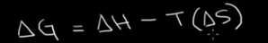
  - H=enthalpy-heat content
  - S=entropy-disorder
  - Negative delta G-spontaneous reaction
  - Positive delta G-non-spontaneous reaction and can’t proceed unless there’s an input of energy
- An analogy for Gibbs free energy
  - Enthalpy-whether or not energy was released or absorbed during a bond rearrangement
    - Negative delta H-release of energy
    - Favorable
  - Second law of thermodynamics-all systems tend toward disorder
  - Positive delta S-increase in entropy, favorable
  - 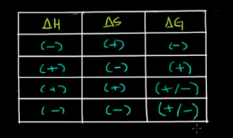
  - Temperature can be the deciding factor in whether or not a reaction is spontaneous
- Heat transfer
  - Energy in the form of heat goes from high heat to low heat
    - Holding a cold glass of water for a long time, heat goes from our body to the glass
    - We’re losing energy and cup is gaining energy
  - Heat is the amount of energy transferred due to change in temp
  - Temperature gradient-gradient wants to disappear so we have heat transfer
  - Temperature-absolute quantity, average kinetic energy of molecules in whatever we are measuring the temp of
  - Heat transfer occurs between a system and its surroundings
  - Q=heat transfer
    - Negative q-heat energy is being lost from system
- Enthalpy
  - Heat transfer for chemical reactions
  - Telling us what is happening from perspective of system
  - Units-joules/mol
  - Measure change in enthalpy involved monitoring the change in temp of the surroundings
  - Going from liquid to gas state-gaining heat so change in enthalpy is positive
  - Positive enthalpy-endothermic
  - Negative enthalpy-exothermic
- Le Chatelier’s principle
  - Dynamic equilibrium-rate of forward reaction if going at the same rate as the reverse reaction
  - Does not mean all the concentrations are the same
  - A+B<->C+D
  - Add more A-forward reaction would go faster than reverse until you reach equilibrium again
  - Le Chatelier’s principle-if you put stress on a reaction, the reaction is going to move in the direction that relieves the stress
  - A+B+heat<->C+D
  - Add heat-go forward more
  - Take away heat-go reverse more
  - N₂+3H₂<->2NH₃
  - Add pressure-pressure would be relieved if we end up with fewer molecules so we go to the side with the fewer molecules so it will go forward here
- Thermodynamics vs kinetics
  - If you look at an equation in reverse its delta G value is flipped
  - Thermodynamics has to do with delta G values
  - Kinetic energy barrier or activation energy-amount of energy required to form a high energy intermediate during the course of the reactions
  - In order to molecules to react they must have enough energy to overcome activation energy
  - The lower the free energy change the faster a reaction will occur
  - Enzymes lower activation energy of a reaction
  - Neither kinetics now thermodynamics solely determine whether a reaction will proceed
Overview of Metabolism
- Overview of metabolism: anabolism and catabolism
  - Four essential biomolecules-proteins, fats, carbohydrates, and nucleic acids
  - Requirements of life boil down to these essential biomolecules
  - Metabolism-study of how we’re able to obtain these important biomolecules
  - Eat food to obtain all these important biomolecules
  - Break down food through digestion into the component parts of all the biomolecules
  - Component parts
    - Proteins-amino acids
    - Fats-fatty acids
    - Carbohydrates-long chains of sugars
      - V. important carbohydrate is glucose
    - Nucleic acids-nucleotides
  - Break down the molecules and build them back up in the correct configuration
  - Catabolism-process of break down molecules in our body
  - Anabolism-process of building molecules back up
  - Building molecules requires energy
  - We get that energy by eating food
  - Energy currency of cells is ATP-when broken down to ADP and P it releases energy that can fuel these processes
  - When we digest food into subunits they can be broken down even further to produce energy needed to turn ADP back to ATP
  - Cellular respiration-process of taking these fuels and breaking them down into usable energy-catabolic process
  - Catabolism fuels anabolism
  - Catabolism and anabolism are regulated through hormones
- ATP: adenosine triphosphate
  - Adenosine and 3 phosphoryl groups
  - Adenosine is the adenine connected to a ribose
  - When the phosphoryl groups break off they can becomes phosphate
  - High energy bonds-electrons in the bond are in a high energy state
  - As the bonds are broken they go from a high energy state to a more comfortable state and they release energy
  - Requires energy to put the P back on
- ATP hydrolysis: Gibbs free energy
  - ATP is involved in many things like muscle contraction, some ion movement, etc.
  - Hydrolysis reaction when ATP combines with water has a very large negative delta G
  - Many biosynthesis reactions in the body have a positive delta G
  - Stringing amino acids together to form peptide chain-requires energy
  - Hydrolysis of ATP produces energy in excess of the energy needed in this reaction
  - Coupled a reaction with favorable delta G with a reaction that has an unfavorable delta G
- ATP hydrolysis: transfer of a phosphate group
  - Coupled reactions often occur simultaneously
  - ATP provides energy to reaction by donating one of its phosphate groups
  - 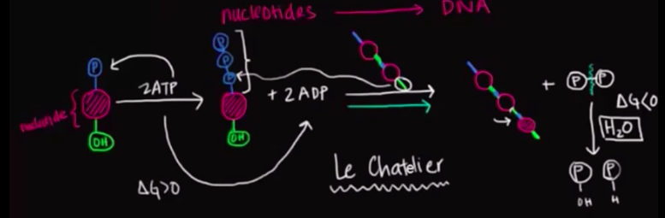
  - Le Chatelier-since we’re breaking down product the reaction keeps shifting forward
- Oxidation and reduction review from biological point-of-view
  - OIL RIG-oxidation is losing, reduction is gaining
  - Oxidizing-tend to lose electrons to oxygen, doesn’t have to be oxygen
  - Oxygen and hydrogen bond-oxygen is much more electronegative so it hogs the electrons
  - When we talk about ox and red we say there’s no partial charge-if one is hogging the electron, we assume he took it
  - H₂+O₂H₂O
  - In water oxygen is hogging the electrons from both the hydrogens so it has a charge of 2- and each hydrogen has a charge of 1+
  - Hydrogens have been oxidized-went from 0 charge to 1+
  - Oxygen has been reduced-went from 0 to 2-
  - Biologists look at it as oxidation is losing hydrogen atoms and reductions is gaining hydrogen atoms
  - Reasoning is that hydrogen tends to get swapped around
  - Something bound to hydrogen that gets swapped around they lost the electron they were hogging
- Oxidation and reduction in metabolism
  - Breakdown of glucose in cellular respiration
  - Start with electrochemistry
  - Build electrochemical cell for oxidation reduction reaction
  - Half cells connected by a wire that can isolate flow of electrons
  - Salt bridge connects two half cells allows flow of ions so there’s not a buildup of charge
  - Electrochemical cell lets us separate what’s losing electrons and what’s gaining electrons
  - Separating what’s being oxidized and reduced
  - Ultimately flow of electrons through wire allows us to perform energy requiring processes like lighting a light bulb
  - During cellular respiration we also isolate flow of electrons which produce chemical energy in the form of ATP-allows the body to convert ADP back to ATP
  - Glucose is broken down in many steps but overall it’s
glucose + oxygenwater + carbon dioxide
  - Glucose is being oxidized and oxygen is being reduced
  - Water is the reduced product of oxygen
  - Instead of wire in our body we have electron transport chain
  - Ox and red reactions happen in different places in mitochondria
  - It’s really the electron carrier molecules which directly donate electrons into circuit
- Electron carrier molecules
  - Glucose is oxidized to carbon dioxide
  - Electron carrier molecules are like a molecular shuttle
  - As glucose is broken down the metabolites are more and more oxidized
  - Electron carriers harness the electrons that are lost at each step of the breakdown process
  - All the electron carrier molecules are going to shuttle electrons to the electron transport chain in the mitochondria
  - Then we have enzymes which facilitate transfer of the electrons to final electron acceptor in the body-oxygen
  - Flow of electrons in ETC that produce ATP
  - If the breakdown of glucose was looked at as combustion it wouldn’t work as a combustion process because all the energy released would be unusable because the only usable form of energy is ATP
  - Also combustion is kinetically unfavorable
  - Benefits of using enzymes to break down glucose
    - Produce large number of metabolites
    - Slow and controlled oxidation of glucose allowing us to harness all the energy in the form of electrons-electron carrier molecules play a big role in this
  - Electron carriers are called coenzymes-help the enzymes perform their function
  - Enzymes involved in breakdown of glucose-dehydrogenase-take away the hydrogens
  - Take away two electrons along with a proton-hydride-has a negative charge
  - Electron carrier molecules mostly used in glucose breakdown-NAD and FAD
  - NAD⁺ + 2H⁺ + 2e⁻ NADH + H⁺
  - FAD + 2H⁺ + 2e⁻ FADH₂

- ATP hydrolysis mechanism
  - 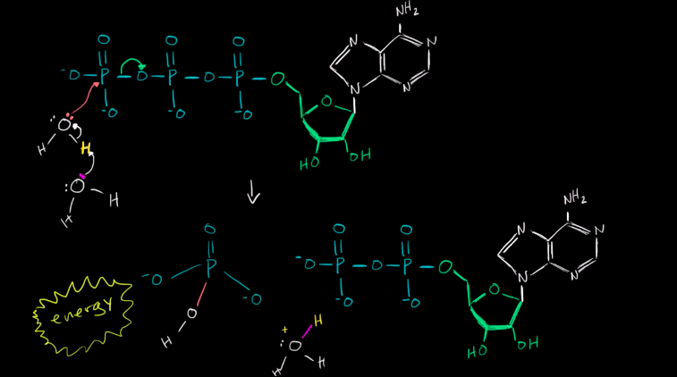
Carbohydrates
- Carbohydrates-naming and classification
  - Carbohydrate refers to a chemical compound made up of carbon atoms that are fully hydrated
  - C_{n}(H₂O)_{n}
  - Monosaccharide-one saccharide (carbohydrate), simple sugar
  - Carbohydrates fulfill our body’s energy needs
  - Main energy source for metabolism in our bodies is glucose
  - Glucose is monosaccharide
  - Polysaccharide-several saccharides or carbohydrates linked together
    - Ex. Cellulose
  - Sugars generally end in -ose
  - Triose-3 carbons-ex. Glyceraldehyde
  - Tetrose-4 carbons
  - Pentose-5 C
  - Hexose-6 C
    - Glucose-aldehyde
      - Since it’s an aldehyde it’s an aldohexose
    - Fructose-ketone
      - Since it’s a ketone it’s a ketohexose
  - Name based on length of carbon chain, number of carbons in chain, functional group in our carbohydrate, and stereochemistry of highest numbered chiral center
  - Fischer projection
    - Highest substituent is on right-R stereochemistry-D configuration
    - Highest substituent is on left-L configuration
- Carbohydrates-absolute configuration, epimers, common names
  - Humans are enzymatically programmed to break down and digest D sugars
  - D and L don’t refer to overall optical activity of the molecule
  - D and L configurations are enantiomers-differ at every chiral carbon not just the last one
  - 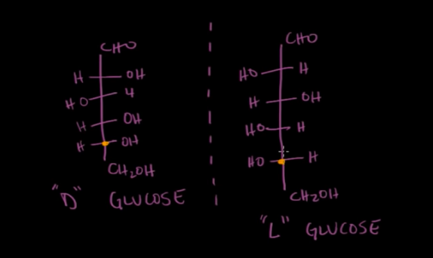
  - All of the D-aldohexoses are diastereomers of each other because they’re not superimposable
  - Epimers-diastereomers that differ at one chiral center
    - Ex. Glucose and galactose are C4 epimers
  - 2^{n}=number of stereoisomers where n is the number of chiral centers
  - For aldohexoses we have 4 chiral centers so 16 stereoisomers-8 are D and 8 are L
  - 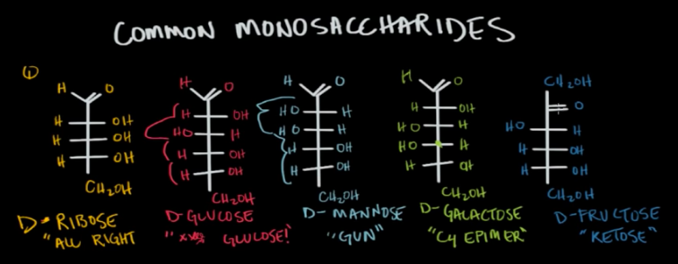
- Carbohydrates-cyclic structure and anomers
  - Polyhydroxylated-numerous hydroxyl groups that are in the carbohydrates
  - Carbinol carbon reacts with one of the hydroxyl groups
  - One nucleophilic attack by the alcohol-ring closing or intramolecular reaction
  - End up with hemiacetal or hemiketal
  - Hydroxyl oxygen after being deprotonated has a negative charge and attacks the partially positive carbonyl carbon
  - 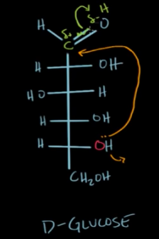
  - Form a six membered ring called pyranose, five membered rings are called furanose
  - Oxygen is in the top right corner
  - Number the carbons clockwise from there on
  - The carbonyl carbon is connected to 2 oxygens so it’s the anomeric carbon
  - Substituents on the right in the Fischer diagram go down and those on the left go up
  - 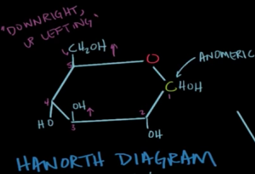
  - For the anomeric carbon the OH can be up or down so beta-up and alpha-down
  - 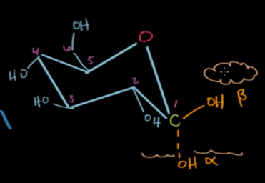
  - Some amount of acid or base caused the ring to close in the first place
  - In water the ring can open and close spontaneously
  - Constantly opening and closing and the C1 and C2 are constantly rotating forming the alpha and beta formations-mutarotation
  - Leads to beta and alpha in equilibrium concentrations-for glucose alpha 36% and beta 64%
  - Alpha is less favored here because it causes steric hindrance
- Carbohydrates-di and polysaccharides
  - Cyclic carbohydrates can react with alcohols to form acetals and ketals
  - Sometimes the alcohol is from another carbohydrate
  - When that happens the individual monosaccharides link together to make an acetal and we call that a glycosidic linkage
  - 2 monosaccharides-disaccharide
  - Most common linkage is anomeric carbon, C1, and C4
  - Have to clarify alpha and beta here as well
  - Common disaccharides
    - Lactose-made up of galactose and glucose
    - Maltose-2 glucoses
    - Sucrose-glucose and fructose
    - 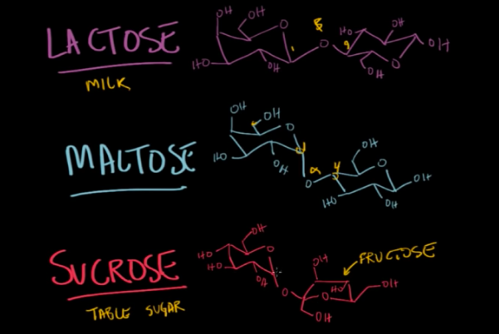
  - Sucrose, maltose, and lactose have acetals-when a carbon is linked to 2 OR groups
    - Sucrose has 2 acetals
    - Can’t further reduce an acetal so it’s a non-reducing sugar
  - Maltose and lactose also have hemiacetals which is when the carbon is linked to one OR group
    - Hemiacetal can be further reduced
    - Lactose and maltose are both reducing sugars
  - Keep adding to the hemiacetals and we get polysaccharides
  - Cellulose-polysaccharide in cell walls-made of repeating glucose units joined by beta 1,4 glycosidic bonds
  - Starch-alpha 1,4 links between glucose
  - Humans can break down alpha 1,4 links but lack the enzyme to break down beta 1,4 links
  - Glycogen-alpha 1,4 links, but once in a while you get alpha 1,6
    - Principally used as a source of storage of energy
    - Creates a functional store of glucose-we have lots of tails of glucose that can be chopped off pretty quickly to get glucose fast
- Keto-enol tautomerization
  - If you start with ketone or aldehyde and add a lot of acid or base the ketone or aldehyde will be in equilibrium with an enol
  - Enol has a double bond in the middle of carbonyl carbon and alpha carbon and the oxygen is a hydroxyl
  - Isomers of each other-tautomers
  - Not different resonance structures
  - Hydrogens attached to alpha carbon are alpha protons transferring one alpha proton and shifting double bond converts keto to enol form
  - Acid catalyzed keto-enol tautomerization
  - 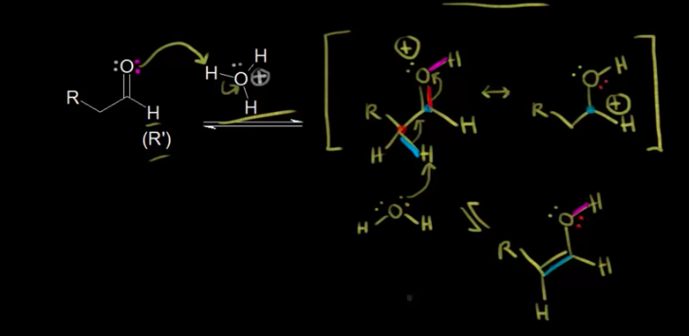
  - Enolate ion has 2 resonance structures-negative on carbon or oxygen
  - Oxygen is more electronegative it’s better to have negative charge on that
  - Base catalyzed keto-enol tautomerization
  - 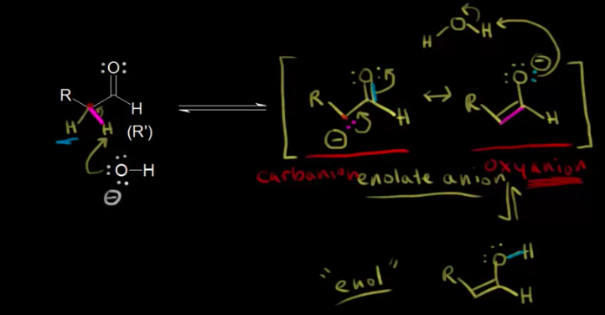
  - If the alpha carbon is chiral and only has one hydrogen the result will be planar enol
  - Can have enantiomers based on R and S configuration of the R group
  - Have equilibrium between keto and enol form
Carb Metabolism (2/10)
- Cellular respiration introduction
  - This is how we derive energy from glucose
  - Most of the carbs we eat end up as glucose
  - C₆H₁₂O₆ + 6O₂ 6CO₂ + 6H₂O + energy
  - This produces energy directly but that energy is used to produce ATP
  - Break down energy we get heat and 38 ATPs
  - 38 ATPs is the ideal circumstance but it’ll probably be around 29-30 ATPs
  - Parts of cellular respiration
    - Glycolysis-breaking up the glucose into 3-carbon pyruvate
      - Needs 2 ATPs and generates 4 ATPs-net generates 2 ATPs
      - Can occur without oxygen-anaerobic
      - If we don’t have oxygen the byproducts go through fermentation and our muscles produce lactic acid-lactic acid fermentation
    - Krebs cycle
      - Generates another 2 ATP
      - Aerobic
    - Electron transport chain
      - Produces 34 ATP
      - Aerobic
  - One mole of glucose produces 10 NADHs through the glycolysis and the Krebs cycle which drive the electron transport chain
- Overview of glycolysis
  - Two important phases of glycolysis
    - Investment phase-uses 2 ATPs to break the glucose into two 3-carbon compounds that have a phosphate group on them-PGAL phosphates
    - Payoff phase-each of the PGALs turn into pyruvate, another 3-carbon
      - Each of the PGALs produces 2 ATPs when they become pyruvates
      - Each also produce an NADH-NAD gets reduced to NADH
  - For every mol of glucose you need 2 NAD⁺, 2 ATPs, 4 ADPs, and 4P_{i}
  - Get 2 ATPs, 2 NADHs which can be used to produce 3 ATPs in the ETC, 2 pyruvates which are going to become acetyl-CoAs for the Krebs cycles
  - Once you reach G3P then you enter the payoff phase
  - G3P=PGAL
  - End result is glucose got split in half-it got oxidized
  - Carbon is now bonding more strongly with oxygen
- Gluconeogenesis: the big picture
  - Glucose stays within a constant range in our body
  - FED state-after you’ve eaten a meal, glucose is broken down and directly used to contribute to blood glucose levels
  - Fasten state-all the times the body is not eating, has to come up with 2 diff ways to regulate blood glucose levels
  - Body has glycogen-string of glucose molecules stored away
  - Body makes glycogen by using some of the glucose dumped into our body during the FED state in anticipation of the fasten state
  - Most of the glycogen is located in the liver
  - During fasting our body breaks down the glycogen into individual glucose molecules
  - Method of breaking down glycogen only lasts about 10-18 hours so we need to eat another meal
  - Second way to produce glucose is gluconeogenesis-creation of glucose
  - Body uses precursor molecules from non-carbohydrate source and reconfiguring them into glucose
  - Most commonly uses amino acids and lactate
  - Gluconeogenesis is almost the exact reverse of glycolysis
  - Start with pyruvate and go backwards
  - However 3 of the glycolysis reactions are irreversible so our body came up with different reaction pathways to compensate
- Gluconeogenesis: unique reactions
  - Pyruvate to phosphoenolpyruvate (PEP)
    - First pyruvate is turned into oxaloacetate which is also why amino acids can be used to produce glucose because they can be turned into OAA
    - 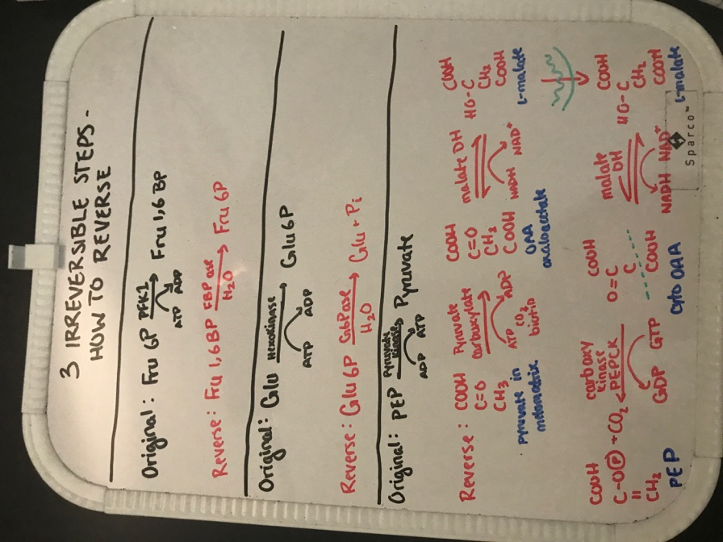
    - In the video they go straight form OAA to PEP via PEP carboxykinase
  - Phosphatase takes away phosphate groups
  - G6Pase is also used in breakdown of glycogen
  - People without G6Pase can’t break down glycogen and can’t produce glucose via gluconeogenesis meaning they’re severely hypoglycemic
- Regulation of glycolysis and gluconeogenesis
  - Regulation of these-we’re asking ourselves when is either of these pathways dominating?
  - There are fast-acting forms of regulation that happen within seconds and slow forms of regulation that take hours or even days
  - Fast-acting form-think of it like Le Chatelier’s principle
    - Ex. Influx of glucose-push the production of pyruvate
    - Allows equilibrium to adjust within seconds to promote glycolysis, also applies to gluconeogenesis
  - Another form of fast-acting is allosteric regulation
    - Allosteric regulators bind to portion of enzyme that’s not the active site
    - Can be inhibitory-inhibit the pathway OR they can promote the action of enzymes
    - ATP is a negative allosteric regulator for a couple of enzymes in glycolysis
    - If there’s a lot of ATP then we don’t need to perform glycolysis
    - AMP is a sign that the cell has used up all of its ATP so it is a negative allosteric regulator of one of the enzymes in gluconeogenesis
  - Slow-acting regulation-take advantage of transcriptional changes within a cell
    - If an organism is in a long term fasting state it will want to up-regulate the transcription of enzymes that promote something like gluconeogenesis
    - Going from DNA to mRNA to enzymes takes some time
  - Hormonal regulation-ability for the body to produce hormones which regulate whether glycolysis or gluconeogenesis is on or off
    - Insulin and glucagon
    - Depending on which one there is more of, the body will be doing more of glycolysis or gluconeogenesis
    - If blood glucose levels rise, it stimulates the body to release insulin-promotes glycolysis
    - If blood glucose levels decrease, it stimulates the body to release glucagon-promotes gluconeogenesis
    - Receptors bind to hormones floating in blood stream which causes a series of reactions to occur in the cell to modify enzymes-usually modification are gain or loss of phosphate group
      - Faster than DNA to mRNA to enzymes, but slower than Le Chatelier
- Pentose Phosphate Pathway
  - No ATP is consumed or produced
  - There are many side reactions taking place almost simultaneously with the breakdown of glucose
  - 2 primary products in pentose phosphate pathway (PPP)
    - Production of a 5-carbon pentose sugar specifically ribose 5 phosphate
      - It is important in producing DNA and RNA
    - Production of NADPH-primary role of this is to donate electrons
      - Really important in anabolic reaction
      - Also uses reducing power to maintain store if antioxidants inside the body
  - 2 phases of the PPP-oxidative phase and nonoxidative phase
  - Oxidative-G6P Ribose
    - Making NADPH along the way
    - Irreversible
  - Non-oxidative-ribulose 5P broken down by isomerase to ribose 5P
    - Interconvert sugars through transaldolase and transketolase
    - Although we can reinter-convert into ribose 5P we can’t go up to G6P
Krebs (citric acid) cycle and oxidative phosphorylation
- Krebs/citric acid cycle
  - Glycolysis occurs in cytoplasm of the cell
  - Krebs cycle occurs within the inner membrane of the mitochondria
  - Inner membrane(s)-crista(e)
  - Pyruvates from glycolysis get oxidized
    - Pyruvate oxidation-cleaves one carbon off of the pyruvate
    - Left with acetyl CoA
    - Also reduce some NAD⁺ to NADH
  - Acetyl CoA merges with oxaloacetic acid (4 carbon molecule), catalyzed by enzymes to form citric acid
  - Citric acid is oxidized over a bunch of steps and we end up at oxaloacetic acid
  - When the carbons are cleaved off they become CO₂
  - Do this process once you get 3 molecules of CO₂
  - Get NADHs and FADH₂s and ATPs during this process
  - Pyruvate oxidation gives us 2 NADHs and the formal Krebs cycle gives us 6 NADHs
  - 2 ATPs and 2 FADH₂s per cycle
  - These ATPs are inputs in the ETC
  - Every NADH produces 3 ATPs in the ETC-10 NADH gives us 30 ATP
  - Each FADH₂ produces 2 ATPs in the ETC-2 FADH₂ gives us 4 ATP
  - 30 and 4 ATP from these plus the 4 from the citric acid cycle gives us 38 ATPs
  - Krebs cycle is the entry point for other catabolic mechanism like protein or fat breakdown
  - Proteins can be broken down into amino acids which be broken down to acetyl CoA
  - Fats can be turned into glucose
  - Acetyl CoA is the general catabolic intermediary
- Regulation of pyruvate dehydrogenase
  - Coenzyme A is actually a thiol group-sulfur group
  - Pyruvate travels from cytosol into mitochondria and is then converted into acetyl CoA by pyruvate dehydrogenase
    - Uses a cofactor NAD⁺ which is converted into NADH-this is being reduced while pyruvate is being oxidized
    - Pyruvate loses a carbon in the form of carbon dioxide
  - Reaction going from pyruvate to acetyl CoA is irreversible-large negative delta G
  - Since it’s irreversible it’s a good place for regulation
  - 2 main uses for acetyl CoA
    - Entry to citric acid cycle and eventually produce electron carrier molecules
    - Can be used to produce fatty acids when ATP levels are high
  - Allosteric regulation of pyruvate DH
    - Activators-CoA, NAD⁺, pyruvate, AMP, calcium
    - Inhibitors-acetyl CoA, NADH, ATP, fatty acids
    - When we exercise skeletal muscle involves influx of calcium so free calcium alerts the cell that we need more energy
- Regulation of Krebs-TCA cycle
  - Acetyl CoA + 3NAD⁺ + FAD + GDP + P_{i} CO₂ + 3NADH + FADH₂ + GTP
  - Citric acid cycle is usually considered as always on, but to various degrees-need ATP going to tissues in the body
  - No hormonal control in CAC
  - Major form of regulation is allosteric regulation
  - Also regulated by substrate availability
  - Amino acids can be converted into alpha KG and enter the cycle from there making the cycle go faster
  - Reactions within CAC that have large negative delta G-basically irreversible
    - OAA + Acetyl CoA Citrate via citrate synthase
    - Isocitrate Alpha KG via isocitrate DH
    - Alpha KG Succinyl CoA via alpha KG DH
  - Allosteric inhibitors
    - NADH-inhibits all 3 since it’s an overall product of the CAC
    - ATP-if we have a lot then we don’t need to make more, only inhibits citrate synthase and isocitrate DH
    - Citrate-inhibits citrate synthase
    - Succinyl CoA-inhibits alpha KG DH and citrate synthase
  - Allosteric activators
    - ADP-buildup is a sign that cell is running out of ATP, activates citrate synthase and isocitrate DH
    - Calcium-buildup of calcium by exercising tells us we need more energy, activates isocitrate DH and alpha KG DH

- Electron transport chain
  - NADH indirectly produces 3 ATPs
  - FADH₂ indirectly produces 2 ATPs
  - Electron from FADH₂ are at a lower energy than the NADH ones
  - NADH gets oxidized-loses H
  - Electrons get transported to a series of transition molecules
  - As they go from one to the other they go into lower energy states
  - One is coenzyme Q and cytochrome C
  - Used to reduce oxygen into water at the very end
  - Every time electron goes from high energy to low energy state it releases energy
  - That energy is used to pump hydrogen protons across the cristae into outer membrane
  - Each reaction pumps out a certain number of hydrogen protons
  - Byproduct isn’t ATPs yet-it’s the proton gradient
  - Outer compartment becomes more acidic
  - Actually an electric gradient, an electric potential b/w the outer and inner membrane
  - Once we have the gradient the protons want to get back into the matrix but can’t because the crista is impermeable to them
  - Special protein ATP synthase-hydrogens go through it to come back into matrix and there’s an axle and the protons coming in cause it to spin causing an ADP and P to squeeze together to form ATP
  - Energy of the proton gradient drives the axle
  - Actually pushes 2 ATPs together
  - Per NADH it produces roughly 3 ATPs
  - Some protons might leak so their energy can’t be captured properly or some electrons might skip some steps so some of the energy is lost so you’re not always going to have exactly the max amount of ATP
  - Electrons from NADH and FADH₂ eventually show up and reduce oxygen to water
  - 30 ATPs from the 10 NADH + 4 ATP from the 2 FADH₂ + 2 net ATPs from glycolysis + 2 ATPs from Krebs = 38 ATPs
- Oxidative phosphorylation and chemiosmosis
  - Need 2 hydrogens to reduce the oxygen
  - Whole process of the ETC is one molecule after another getting oxidized until we have a final electron acceptor in water
  - Phosphorylation-adding a phosphate group to another molecule, in this case ADP
  - Oxidative phosphorylation-process of generating ATP via the hydrogen gradient
  - Chemiosmosis-transfer of the hydrogens through the membrane selectively
  - Substrate phosphorylation-enzyme phosphorylating without any chemiosmosis, without oxygen
- Regulation of oxidative phosphorylation
  - Oxidative phosphorylation is the common end pathway of aerobic respiration
  - Major form of regulation is looking at energy needs of cells-comparing ADP levels to ATP levels
  - No major hormonal or allosteric regulation
  - 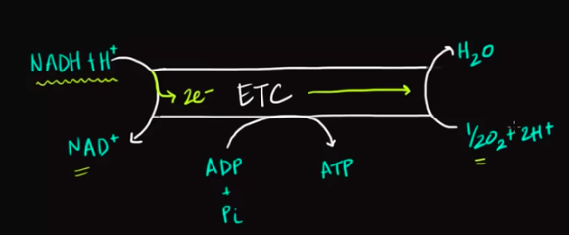
  - If we had more NADH, ADP, free phosphate, or oxygen (reactants)-the reaction would go in the forward direction
  - Level of oxygen is pretty constant so we don’t really consider that
  - Level of ADP that are more likely to alert ETC to make more ATP because it’s usually the limiting factor
  - More ATP then the flow of electrons would be slower and we’d produce less ATP-limiting factor just like ADP
  - Body usually keeps NAD⁺ and NADH in a pretty stable ratio
- Mitochondria, apoptosis, and oxidative stress
  - Mitochondria has a role in apoptosis which is programmed cell death
  - Necrosis-uncontrolled cell death usually in response to extreme stress
  - Usually apoptosis has some advantage to the organism
  - Embryological development of fingers and toes-apoptosis causes tissues between digits to die off leaving us with a hand with 5 separate digits
  - DNA damage can induce cell death-extensive damage beyond repair
  - Infection, especially by virus, can induce programmed cell death
  - Immune cells can recognize specific proteins on infected cells and send signals to the infected cell telling it to undergo programmed cell death
  - Environmental stress can also induce apoptosis-anything from deprivation of oxygen or nutrients, to deprivation of cell’s connection to other cells
  - In order to survive cell needs to get a signal that it’s close to other cells
  - Cells are constantly receiving signals from growth factors telling them to divide so if the signals are taking away the cells might undergo cell death
  - Reactive oxygen species can induce cell death
    - Oxygen species that have acquired an unstable number of electron
    - Super oxide anion, neutrally charged hydroxide molecule, hydrogen peroxide
  - To prevent ROS from reacting with things in our cells, we have enzymes that try to convert them to less reactive species and we also have antioxidant molecules to trap them
  - If the extent of oxidative damage is too high-cell undergoes cell death
  - Different pathways signaling cell death, but common endpoint is they all have an effect of mitochondria
  - Outer mitochondrial membrane becomes more permeable
  - 2 types of proteins in BCL-2 family
    - Pro-apoptotic and anti-apoptotic
  - When cell is healthy and not receiving signals the balance is in favor of anti
  - When the mito receives signals balance shifts in favor of pro which then facilitate increased permeability of outer mito membrane
  - Increased permeability allows cytochrome C to enter cytoplasm and activate caspases enzymes
  - Caspase is a type of protease (breaks down proteins)-specifically breaks down proteins after aspartate residue and proteins with cystine residue
  - Apoptosis is caspase mediated
  - Necrosis doesn’t use these enzymes
  - Caspase have a cascade action-one activated by cytochrome C can go activate another type of caspase
  - They can also activate other types of enzymes like nucleases that break down DNA
  - All together we have whole scale degradation
  - Surrounding cells can eat up the degraded polymers for reuse
- Calculating ATP produced in cellular respiration
  - Two main types of ways that we produce ATP in cellular respiration
    - Substrate level phosphorylation-usually metabolite, activate it with a phosphate group and then we can donate it directly to ADP and our molecule gets modified as well usually a hydroxy group
    - Oxidative phosphorylation-requires oxygen, flow of electrons powers ATP synthase which produces the bulk of our ATP
  - Range of 30-38 ATPs depending where you look-it was hard to calculate number of ATPs produced initially
  - Did experiments and found that for one molecule NADH you got 2-3 ATPs-rounded up to 3
  - For FADH₂ saw 1-2 ATPs-rounded up to 2
  - Upper range of ATP got us 38 ATPs
  - In the inner mitochondrial membrane we have 4 protein complexes for shuttling electrons and we also have ATP synthase
  - For every 2 electrons that flow by, protein complex 1 and complex 3 pump 4 protons into intermembrane space and complex 4 pumps 2 protons and protein complex 2 doesn’t really contribute
  - NADH donates at very first electron complex so we get 4+4+2=10 protons pumped
  - FADH₂ enters in complex 2 so we only get 4+2=6 or so protons pumped
  - 4 protons to produce 1 molecule of ATP (current understanding)
  - For every molecule of NADH based on the number of proton pumped we’d get 2.5 molecules of ATP
  - For FADH₂ we’d get 1.5 molecules
  - Glycolysis which happens in the cytosol also produces NADH but the membrane isn’t permeable to it so we have shuttle transport systems to shuttle the NADH, but depending on where the NADH is shuttled into the ETC we get different amounts of protons pumped for these NADH
  - 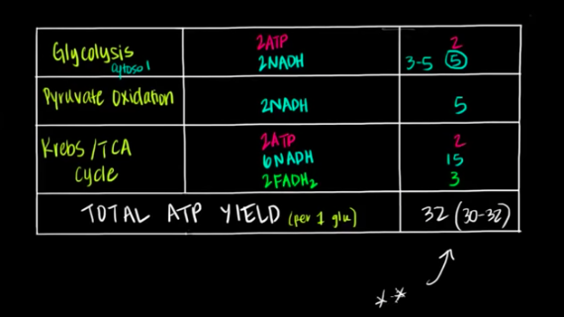
Fat and protein metabolism (2/10)
- Introduction to energy storage
  - Body has evolved to store fuel so we’re not reliant on the immediate nutrients right after a meal
  - 3 main types of fuel: glycogen, proteins, and fats
  - Glycogen-way of storing carbohydrates
    - Polymer of glucose molecules all attached to each other
    - Mostly stored in liver but also some in muscles
    - In an average 70 kg male we’d have around 480 grams of glycogen
    - We can extract about 4 kcal of energy from 1 gram of glycogen
    - Average intake of energy for humans is around 2000 kcal
  - Proteins-long chain of amino acids
    - Mostly stored in muscles
    - In an average 70 kg male we’d have around 6,000 gram of proteins
    - About 4 kcal of energy per gram of protein
  - Fats
    - Stored in specialized tissue called adipose tissue
    - 70 kg male-12,000 gram of fats
    - About 9 kcal of energy per gram of fat
  - Theoretically how long would someone be able to survive on each type of fuel
    - Glycogen- 500 grams x 4 kcal = 2000 kcal – last about a day
    - Protein- 6000 grams x 4 kcal = 24,000 kcal – 12 days
    - Fats- 12,000 grams x 10 kcal = 120,000 kcal – 60 days
  - Triacylglyceride=fat stored in the body
  - Acyl groups can vary in length based on the type of triacylglyceride and the types of fats we ingest
  - Only single bonds-saturated with hydrogens
  - Double bonds-unsaturated
  - Bulk of energy comes from long carbon hydrogen chains which are considered very high energy
  - These high energy carbon hydrogen bonds can be oxidized to produce ATP
  - Also really good form of energy because they’re relatively chemically inert-don’t react with other things in the body
  - Glucose and proteins have polar functional groups that can react in aqueous environment
  - Fats don’t have a large prominent role in the body-main purpose is just to produce energy
  - Proteins are used to make enzymes -need enzymes but also need energy
  - Fats are very hydrophobic-not weighed down by water
  - Glycogen has water weight-3 grams of water associate with 1 gram of glycogen or protein too
  - 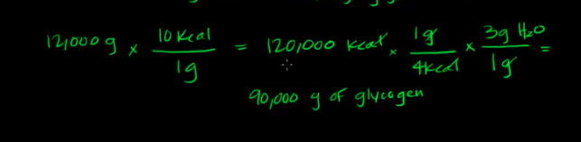
  - We’d need 90,000 g of glycogen to produce the same amount of kcal as the typical amount of fat-not practical
  - Fats are the most prominent type of energy storage molecule
- Digestion, mobilization, and transport of fats-part I
  - Small intestines contain enzymes, lipases, to break down the fat molecules into smaller pieces for the cells to absorb
  - Some of the lipases are secreted by the pancreas
  - Lipase enzymes must function in an aqueous environment but the fatty acids are hydrophobic so they’ll clump together and form drops
  - Liver secretes bile which has a hydrophobic and hydrophilic end
  - Bile breaks down the fat molecules into smaller pieces increasing the surface area for the lipase enzymes to act on
  - Lipase enzymes work by cleaving at the ester linkages of the triacylglycerides
  - Leaves the glycerol backbone and since we add water molecules as well it now has a hydroxyl group
  - Instead of acyl groups we have carboxylic acid groups
  - Form 3 of the carboxylic acid acyls which are called fatty acids
  - Molecules are now small enough to diffuse into intestinal cell
  - Once the molecules are in small intestines turn them back into triacylglycerides to make them compact and send them to fat storing tissue
  - Reform the ester groups and reform the molecules
  - Lipoprotein-body packages the triacylglycerides and other hydrophobic substances like cholesterol into core of protein molecules
  - Proteins have polar heads to interact with aqueous environment, but they’re hydrophobic enough to keep the molecules within them
  - Specific name for lipoprotein produced within intestinal cell-chylomicron
  - Cells are surrounded specialized lymphatic capillaries called lacteals which take up the chylomicrons
  - Lymphatic vessels drain into veins by the neck and shoulder
- Fatty acid synthesis-part I
  - Ultimate goal of fat metabolism is to deliver triacylglycerides or free fatty acids directly into bloodstream where they can eventually reach capillary beds
  - Then they diffuse into surrounding tissues where they can be taken up and oxidized to obtain energy in form of ATP
  - 3 sources of fat
    - Directly from diet
    - Directly from adipose cells
    - Synthesizing it directly in liver-it can convert excess glucose into fatty acids
  - Liver packages these fatty acids into triacylglycerides and along with cholesterol they go in specialized protein carrier molecule like chylomicrons but these are called VLDL-very low density lipoprotein
  - Glucose to fatty acid in liver-fatty acid synthesis
  - In the breakdown of glucose we have acetyl CoA which is a precursor for fatty acid synthesis
  - Enzymes for fatty acid synthesis are in cytoplasm
  - Acetyl CoA can’t be transported either way across the mitochondrial membrane
  - However we can shuttle citrate across
  - Enzyme in cytoplasm breaks up citrate to get acetyl CoA and OAA
  - The OAA is not needed to fatty acid synthesis so it can be turned into pyruvate and shuttled back to mitochondria where it’ll become acetyl CoA again and the cycle can continue
  - With that NADP⁺ gets reduced into NADPH which can help with anabolic reactions like fatty acid synthesis
- Digestion, mobilization, and transport of fats-part II
  - Lipoprotein lipase-when they see the protein they are activated and start breaking down triacylglycerides into individual fatty acids and glycerol backbone
  - Lipoprotein lipase is also activated by insulin
  - Nearly all tissue can now take up the fats and eventually use them to get ATP
  - Brain can’t take up the fats because fatty acids can’t cross blood-brain barrier
  - Red blood cells also can’t take up fats because they don’t have mitochondria
  - Muscle can take up some fatty acids but adipose cells are the biggest absorber
  - Adipose cells have really small nuclei and have a lot of room in cytoplasm to store fat
  - Take the free fatty acid and turn them back into triacylglycerides for storage
  - Chylomicron digested by lipase, whatever’s left is called chylomicron remnant
  - Liver plays a big role in reabsorbing chylomicron remnants-contains specific receptors to take them up
  - Everything digested and absorbed in the small intestine that travels via the lymphatic vessels pass through the liver
  - Fats are carried in chylomicrons and carried through lymphatic vessels and pass through the liver
  - VLDL once it reaches capillary bed it is acted upon by the lipoprotein lipase again and it also releases cholesterol to the cells
  - Adipose cells have hormone receptors on cell surfaces which can detect levels of hormones in the body
  - Major hormone floating around after we eat is insulin, but a couple hours after we eat insulin falls and glucagon increases
  - Glucagon’s levels begin to increase in response to not having enough blood glucose
  - Decrease in insulin and increase in glucagon stimulate hormone receptors which sends a signal telling adipose cells to release fatty acids
  - Hormone sensitive lipase-enzyme that catalyzes breakdown of triglycerides in adipocytes in response to changing hormone levels
  - Blood allows free fatty acid molecules to travel alongside albumin
  - One of the biggest consumers of the three fatty acids floating in blood is liver
- Fatty acid synthesis-part II
  - Requires energy-has a positive delta G value-not spontaneous
  - Body resolves this by coupling this reaction with a reaction that has a favorable delta g value
  - Our body uses ATP reacting with water which has a very favorable delta G
  - Break it down to form ADP and phosphate
  - Palmitic acid-16 carbon fatty acid chain, primary product of fatty acid synthesis
  - To make 16 carbon chain we need 8 acetyl CoA’s and 7 ATPs and 14 NADPH molecules as well
  - The NADPH is source of reducing power because we wanna make just carbon-carbon bonds attached to only hydrogen
  - End up with 7 ADP and 7 free phosphate groups, 14 NADP+, and 8 CoA molecules
  - In the cytoplasm, first turn acetyl CoA into malonyl CoA-thermodynamically unfavorable-pair it with hydrolysis of ATP which fuels the reaction forward
  - Acetyl CoA carboxylase-adds a carboxy group to the acetyl CoA-highly regulated because it’s the rate-limiting step
  - Add CO₂ to the acetyl CoA and taking it off the malonyl CoA to make it thermodynamically favorable
  - Acetyl CoA has is allosterically and hormonally regulated
  - Allosteric activator-citrate-broken down in acetyl CoA
  - Hormonal activator-insulin-after eating glucose rises
  - Allosteric inhibitor-long chain fatty acids-form of product inhibition
  - Hormonal inhibitor-glucagon
  - Fatty acid synthase-polymerizes the malonyl CoA subunits together
  - Fatty acid synthase has 2 identical subunits that each have a thiol group in the active site
  - One acetyl CoA attaches to one of the sulfur groups and the malonyl CoA attaches to the other
  - When they form a bond with the sulfur they lose their CoA groups
  - The carbons bond and we keep going until we form the 16 carbon
  - 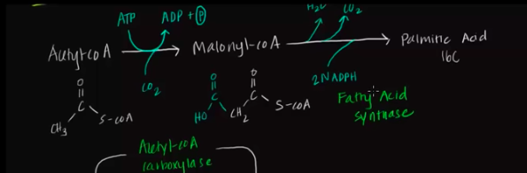
- Overview of fatty acid oxidation
  - 95% of energy that we can extract from triacylglyceride comes from the carbon hydrogen rich chains
  - Remaining 5% of energy comes from glycerol backbone
  - Oxidize the fatty acids to extract energy and produce ATP
  - Basically reverse of fatty acid synthesis
  - Break the long string down into 2 carbon subunits simultaneously oxidizing them to release energy
  - Breaking them down to acetyl CoA
  - Acetyl CoA can enter Krebs cycle helping produce more NADH and FADH₂
  - Net of 10 ATPs per acetyl CoA and we have 8 acetyl CoA’s so we’re producing 80 ATPs in the Krebs cycle and about 27 ATP produced in the direct oxidation into acetyl CoA -107 ATP in total oxidation of one 16 carbon fatty acid
- Fatty acid oxidation-part I
  - Enzymes for oxidation of fatty acids are located in mitochondria
  - Activation step-activate the molecule with another molecule so we can transport it into mitochondria
    - Reacts fatty acid with coenzyme A-get acyl CoA
    - Reaction is coupled to hydrolysis of ATP to AMP and PP_{i}
    - Acyl synthetase-catalyzes this reaction, located in outer mito membrane
  - Another molecule, carnitine, has an oxygen which forms a bond with the carbon on the acyl CoA and then the CoA can act as a leaving group
    - Carnitine acyl transferase-enzyme for this reaction, located on outer mito membrane
- Fatty acid oxidation-part II
  - Outer membrane contains porins that create pores for molecules to diffuse through
  - Acyl carnitine molecule can easily diffuse from the cytoplasm into intermembrane space via carnitine acyl transferase
  - Still have to get past inner mito membrane
  - Inner membrane has a protein transporter called acyl carnitine translocase
  - Also have carnitine acyl transferase (CAT II) on inner mito membrane-catalyzes reverse reaction of what happened in cytoplasm
    - Takes a CoA which will displace the bond formed earlier so we get carnitine back and our acyl CoA
  - For every acyl carnitine molecule pumped into mito matrix, one molecule of carnitine is pumped out-can be recycled to help another fatty acid
  - Then the acyl CoA undergoes 4 steps and we get an acetyl CoA and an acyl chain that’s 2 carbons shorter
  - Need the electron carrier molecules, NAD and FAD, since this involves oxidation
  - Insertion of water and additional CoA along the four steps
  - Beta oxidation-refers to the position of carbon being oxidized
  - Rate limiting reaction is catalyzed by carnitine acyl transferase
    - Allosterically inhibited by malonyl CoA
  - Synthesis and oxidation are mutually exclusive, either producing fatty acids or breaking them down
- How does the body adapt to starvation
  - In order to survive we need to maintain glucose levels in our blood
  - Rely on glycogen for about a day and then the body has to rely on metabolic pathways involved in gluconeogenesis
  - Breakdown products of fatty acids can’t be converted into glucose meaning they can’t contribute to gluconeogenesis
  - Breakdown products of the catabolism of amino acids can contribute
  - Krebs cycle involves oxaloacetate and we can turn pyruvate from glycolysis into oxaloacetate in gluconeogenesis
  - Breakdown of amino acids allows the breakdown products to be turned into some intermediates along the Krebs cycle
  - Amino acids eventually become oxaloacetate, but they can also be converted to pyruvate as well
  - Since we can’t go from acetyl CoA to pyruvate, the acetyl CoA can’t enter the gluconeogenesis pathway
  - Some fatty acids, specifically odd-chain fatty acids, that can contribute in some way to Krebs cycle
  - Some amino acids can directly be converted into acetyl CoA-can’t contribute to gluconeogenesis
  - Using all the amino acids and breaking them down is bad because proteins are essential in our body
  - Body saves protein during prolonged starvation
  - Many of the tissues that rely exclusively on glucose for energy are more flexible in times of starvation and start using a different fuel that the body switched to making days after starvation called ketones
  - Ketones can cross blood brain barrier and allow us to produce ATP
  - Ketone synthesis saves our proteins
  - After a few days of fasting levels of acetyl CoA begins to rise above the amount needed to maintain ATP levels
  - No type of product inhibition when it comes to fatty acid oxidation-inc acetyl CoA doesn’t tell fatty acid oxidation to stop
  - Enough fatty acid oxidationproduce enough and even plenty of ATPnegative feedback on ETCinc in reduced electron carrier molecules like NADHregulate and slow flow through Krebsacetyl CoA won’t want to enter Krebsbody shunts extra acetyl CoA into production of ketones
  - This happens mainly in liver and the ketones can leave the liver and go into bloodstream and other tissues can take ketones and convert them back to acetyl CoA which can enter Krebs cycle and contribute to production of ATP
  - Puts less pressure on body to do gluconeogenesis leading to less pressure to breakdown protein
- Overview of amino acid metabolism
  - Amino acid metabolism only accounts for 10-15% of total energy production
  - Essential amino acids-ones our body can’t synthesize, have to get them from diet
  - Fed-increased insulin due to higher blood glucose levels and decreased glucagon
  - Fasted-low insulin and raised glucagon
  - Proteins are broken down into amino acids in the small intestine and travel via blood stream to liver
  - Liver can use excess amino acids and convert them to glucose and/or fatty acids
  - Precursor for fatty acids-acetyl CoA
    - Acetyl CoA is in equilibrium with acetoacetyl CoA
  - Precursor for glucose-pyruvate and oxaloacetate
    - Oxaloacetate is in equilibrium with intermediates of Krebs cycle
  - Amino acids can be interconverted and metabolized directly into precursors
  - Ketogenic amino acids-converted to acetyl CoA or acetoacetyl CoA and ultimately fatty acids
    - Exclusively ketogenic amino acids-lysine and leucine
  - Glucogenic -convert to pyruvate, oxaloacetate, or intermediates of Krebs cycle
  - Liver can use amino acids for protein synthesis or other energy storage, but it can also send it off to other tissues where they can use it for their own protein synthesis
  - Fasted state
    - Amino acids are released from tissues, mostly muscles and sent to liver via bloodstream
    - Then they can enter diverse array of metabolic pathways
    - Potentially glucogenic amino acids can contribute to precursors of gluconeogenesis
    - Fatty acids comprise the bulk of the ATP production in body
    - The acetyl CoA contributing to ketone synthesis mainly comes from fatty acids and not proteins
  - Amino acids have a nitrogen group so in the breakdown of amino acids generally the first step is transamination where the amine group is transferred to another molecule for eventual excretion
  - The amino acid ends up becoming called an alpha keto acid
  - 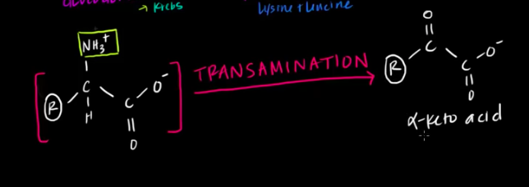
  - Common acceptor for the amine group is alpha KG and when it accepts the amine group it becomes glutamate
  - When glutamate reaches the liver it donates the amine group in the form of ammonia NH₃ which enters urea cycle where it’s converted into urea and excreted
  - Important to eventually excrete it because ammonia is toxic to our bodies in high levels
Cell membrane overview
- Cell membrane introduction
  - Membrane protects the cell from the outside environment and determines what enters and leaves the cell
  - Semi-permeable-some things can enter while others can’t
  - Main building blocks of membrane-phospholipids
  - Phospholipids have 3 major components-phosphate head group, glycerol backbone, and 2 fatty acids
  - Glycerol backbone holds the fatty acid tails to the phosphate head
  - Head group is hydrophilic or polar
  - Fatty acid tails are hydrophobic
  - Molecule that has both is amphipathic-hydrophilic and hydrophobic section
  - In water the tails face each other because they’re hydrophobic so we form a phospholipid bilayer which is the basic structure of a cell membrane
  - In actual cells there’s water inside and outside the cells but no matter where the cell membrane touches water it’s always going to be at the phosphate groups
  - Passive diffusion-can pass through the cell membrane as is-generally small nonpolar molecules like O₂ or CO₂
  - Small polar molecules and large nonpolar molecules can pass through but very slowly
  - Large polar molecules like glucose can’t pass through the cell-has to be absorbed by other means
  - Charged molecules like ions or amino acids can’t pass through

- Phospholipid structure
  - 2 fatty acids-basically carboxylic acid attached to a long carbon chain
  - 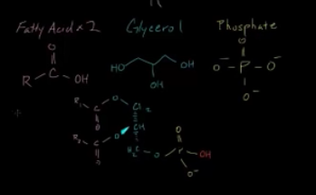
  - Fatty acid chains attached to glycerol through an ester bond with the phosphate group
  - Molecules could bond with several different molecules giving a diverse set of phospholipids
  - Serine, choline, ethanolamine, inositol, and glycerol can bind to the phosphate group through a phosphoester bond
  - 5 different lipids can occur when these things bind-phosphatidylserine, phosphatidylcholine, phosphatidylethanolamine, phosphatidylinositol, and diphosphatidylglycerol or cardiolipin
  - Carbons can form double bonds-either cis or trans
  - Trans double bond-fatty acid would be pretty straight
  - Cis-create a kink
  - These types of double bonds have significance on fluidity of membrane
- Cell membrane overview and fluid mosaic model
  - 3 mains things that make up the cell membrane-phospholipids, cholesterol, and proteins
  - Cholesterol has a lot of rings which gives it a stable structure
    - Inserts itself between phospholipids
    - Maintains fluidity of cell membranes-as temps becomes lower it helps increase fluidity and as temps become higher it helps reduce fluidity
  - Proteins take 2 major forms here-integral proteins or transmembrane proteins and peripheral proteins
    - Integral proteins cross the entire membrane and can occur throughout different areas of the cell
    - Peripheral proteins sit on top of the membrane
    - There are also rare proteins that go halfway through the membrane and some that are found inside the cell membrane
  - Proteins are big players in the function of cell membranes
    - Act as receptors-tell the cell what’s going on outside, act as communication
    - Can help transport molecules in and out of the cell-generally occurs in transmembrane proteins
  - Carbohydrates bind to the lipids or proteins-called glyco for short like glycoproteins or glycolipids
    - Play a big role in communication ex. They allow a cell to recognize another cell in the body
    - Glycoproteins can be on integral or peripheral proteins
    - The glycoproteins and glycolipids attach to the proteins and phospholipids
  - Fluid mosaic model-everything together forming the cell membrane
  - Called fluid because the pieces can move around
  - Movement is not just 2 dimensional, can move in different directions
- Cell membrane proteins
  - Most cell membranes have about 50% or less protein
  - Peripheral proteins attach and remove themselves from cell membrane or other proteins-generally there for different cell processes
  - Lipid bound protein-appears inside the cell membrane, very rare because it doesn’t serve a big function in terms of cell membrane performing its duties
  - 2 types of integral proteins that help maintain cell homeostasis
    - Channel protein-allows things to pass through the cell ex. Ions
      - Don’t require energy
      - Go with concentration gradient
    - Carrier protein-carries substances into cell
      - Protects substance so it can enter or exit cell safely
      - Can go against concentration gradient
      - Can sometimes use energy
  - Glycoprotein-chain of sugars attached to a protein and it can be on integral, peripheral, and channel proteins
    - Used in signaling, allows a cell to recognize another cell
- Cell membrane fluidity
  - 3 most important factors that affect membrane fluidity-temperature, cholesterol, and saturated or unsaturated fatty acids
  - Temperature
    - At low temp the phospholipids start clustering together really closely-don’t have a lot of energy to move around
    - At extremely low temps we call it a crystallized state
    - Low temp-low fluidity
    - High temps the phospholipids have more energy causing them to move around and create distance between each other causing fluidity to increase
    - High temps-high fluidity
  - Cholesterol inserts itself between phospholipids, not every single one but spread out
    - Increases distance between some of the phospholipids so fluidity increases-at low temps
    - At high temps the phospholipids are already far apart and the cholesterol inserts itself causing the phospholipids to pull themselves closer together so they can attach to the cholesterol decreasing the fluidity
    - Low temps-fluidity increases
    - High temps-fluidity decreases
    - Acts like a buffer
  - Saturated fatty acids-the chains stack together neatly
    - Stack close together making the fluidity low
  - Unsaturated fatty acids-the chains don’t stack together neatly
    - Can’t stack close together making the fluidity high
- Membrane dynamics
  - Phospholipids that border inside of cell-inner leaflet
  - Different types of movements for phospholipids
  - Uncatalyzed movement-no need for a catalyst
    - Transbilayer diffusion-flip flop-phospholipid on inner leaflet moves to outer leaflet or vice versa
      - Really slow and doesn’t happen that often
    - Lateral diffusion-phospholipid moves in any direction
      - Pretty fast and happens a lot in the membrane
  - Catalyzed movement-need a catalyst
    - Protein catalyst
    - Something on outer leaflet moves is flipped to inside kind of like transbilayer diffusion but this time it’s aided by a catalyst
      - Uses ATP
      - Catalyst is called flipase
      - Pretty fast compared to transbilayer diffusion
    - Something on inner leaflet moves to outer leaflet
      - Does opposite of flipase and is called flopase
      - Also uses ATP
      - Also pretty fast
    - Moves something from inner leaflet to outer leaflet and one from outer leaflet to inner leaflet
      - Called scramblase
      - Does not need ATP

Cell-cell interactions
- Cell junctions
  - Things that connect cells to other cells
  - Often occur in epithelial tissue
  - 3 major types of cell junctions-tight junctions, desmosomes, and gap junctions
  - Tight junctions
    - Like a glue that connect the cells really tightly together
    - Blocks out everything from both sides of cells so water and ions can’t get through gap between the two cells
    - Occur in things like the bladder, sometimes the intestines an kidneys-places where water really can’t go to other places
  - Desmosomes
    - Connections that hold two cells together
    - Attached inside the cytoskeleton
    - Water or ions can flow between cells
    - Tend to occur in tissues that experience a lot of stress-offer space for stress relief
    - Can be found in skin and intestines
  - Cell junctions can be scattered throughout the same type of cell
  - Gap junctions
    - Tunnel that exists between cells
    - Let water and ions flow through the gap between the two cells
    - Found in cells that spread action potential like cardiac muscle and neurons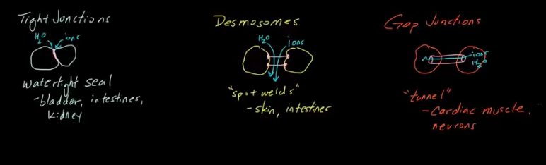
- Membrane receptors
  - Allow ourselves to communicate with the outside world
  - Without them our cells wouldn’t be able to work together
  - Integral protein that’s embedded in cell membrane that takes part in communication with outside environment
  - Extracellular signaling molecules-can be ions or molecules that bind to another chemical entity-called ligands
  - Ligands can be neurotransmitters or hormones or cell recognition molecules
  - Attach to membrane receptors and trigger changes inside the cell
  - Ligand receptor complex-ligand and membrane receptor have bound
  - Essentially then tell the cell what to do
  - A very bid percentage of pharmaceutical drugs target membrane receptors
  - Different cells might have different receptors which bind different things
  - Signal transduction-process of binding and telling cell what to do
  - After binding there’s an intracellular response
  - Receptor binding to protein causes protein to change conformation which then activates intracellular signaling proteins activating a cascade of protein signals that alter behavior the cell
  - Each specific receptor can only bind to a few types and often only one specific type of ligand
  - Membrane receptors let our body and cells transfer info and are very specific about it
  - Lock and key model-receptors have a very specific preference for certain types of ligands
  - Updated model is induced fit-ligand and membrane receptors can sometimes change conformations
  - 3 large groups of membrane receptors-ligand gated ion channels, G protein coupled receptors, and enzyme linked receptors
- Ligand gated ion channels
  - Transmembrane ion channels that open or close in response to binding of a chemical messenger like a ligand
  - Common place to find them is in electrically excitable cells like neurons
  - React quickly to binding of ligands
  - Ligand binds allosterically causing the closed channel to open up by altering protein conformation of the entire protein
  - Once the channel opens it lets ions move through the channel causing a change in the electrical properties of the cell
  - Converting extracellular ligand signal into an intracellular electrical signal
  - Allosteric binding site can be inside the cell but that’s very rare
  - Possible to have multiple allosteric binding sites for ligands
  - Not the same as voltage gated ion channels or stretch activated ion channels
  - VG ion channels depend on differences in membrane potential only
  - SA ion channels depend on cell membrane stretching
- G protein coupled receptors
  - Only found in eukaryotes and comprise largest known class of membrane receptors
  - Have 7 transmembrane alpha helices
  - 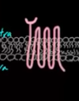
  - G proteins are specialized proteins which have the ability to bind to GTP and GDP
  - All the G proteins that associate with GPCRs are heterotrimeric-3 different subunits
  - Alpha, beta, and gamma subunits
  - Alpha and gamma are attached to the cell membrane by lipid anchors
  - When it’s inactive it’s bound to GDP via the alpha subunit and when it’s activated it’ll bind to GTP
  - Each receptor binds to usually one or a few very specific molecules
  - When it binds the GPCR undergoes conformational change which triggers a complex chain of events that ultimately influence different cell functions
  - Because of the conformational change the alpha subunit exchanges the GDP for GTP which causes the alpha subunit to dissociate and move away from beta and gamma subunit and then goes off to find the target protein to regulate
  - Beta-gamma dimer also regulate protein
  - Alpha and beta-gamma can interact with other proteins to relay messages
  - Targets proteins can be enzymes that produce second messengers or ion channels that let ions be second messengers
  - Some G proteins can stimulate activity while others can inhibit
  - Once alpha subunit activates target protein, the target protein can then relay a signal
  - This chain of events can happen repeatedly as long as this ligand is bound
  - GTP is hydrolyzed to GDP and then everything goes back to normal and the ligand leaves
  - RGS protein regulates G protein signaling and accelerates the hydrolysis of GTP to GDP
  - Ex. Epinephrine binds to GPC GPCR changes shape switches out GDP to GTP alpha subunit dissociates regulates another protein protein turns ATP into cAMP which is second messenger cAMP tells out body to do other things like increase heart rate, dilate blood vessels, and breakdown glycogen
- Enzyme linked receptors
  - In addition to receiving signals from chemical messengers they also function as enzymes
  - Binding of a signaling molecule activates receptor’s enzymatic activity
  - Also called catalytic receptors
  - Top part of receptor on the extracellular side has ligand binding domain and the bottom half on the intracellular side is the enzymatic domain or functional domain
  - Most common enzyme linked receptors are called receptor tyrosine kinases (RTKs)-regulate cell growth, differentiation, and survival
  - RTKs can bind and respond to ligands like growth factors
  - RTKs have tyrosine which is on the intracellular enzymatic section
  - Have the ability to transfer phosphorous from ATP to the intracellular proteins that activate them-that’s the enzymatic function
  - Phosphorylated proteins can carry out a message through signal transduction
  - RTKs occur in pairs which come together and act together
  - When signaling molecule binds to an RTK they cause neighboring RTKs to associate with each other and form a cross-linked dimer
  - Cross-linking activates the tyrosine kinase activity in these RTKs through phosphorylation
  - Each RTK in the dimer phosphorylates the tyrosines on the other RTK-cross phosphorylation
  - Aren’t always 2 tyrosines could be multiple
  - If we have ATP in the cell the tyrosines cause it to become ADP and phosphate
  - Tyrosine picks up free floating phosphate group
  - Once cross-phosphorylated the enzymatic section of the RTKs serve as docking platforms for different intracellular proteins involved in signal transduction
  - Proteins need to have special domain called SH2 to dock with the phosphorous
  - Multiple different SH2 containing proteins can bind at the same time allowing activation of multiple different intracellular signaling pathways at the same time
  - RTKs are famous for their role in growth factors and they can also bind hormones most importantly insulin
  - If they fail to function properly they can cause issues in growth and differentiation of cells
  - Many cancers involve mutations in RTKs
Transport across a cell membrane
- How do things move across a cell membrane
  - Cells need nutrients from outside the cell membrane and need to get rid of waste produced
  - Potassium leak channel
    - K has a large concentration inside the cells
    - Passive transport-flowing down its gradient with no energy used
    - Facilitated diffusion
  - Passive transport-don’t use energy
    - Diffusion-movement of solutes in space
    - Osmosis-relates mainly to movement of water
    - Filtration mainly occurs in kidneys
    - Facilitated diffusion-utilizes the help of a protein channel
  - Sodium potassium pump needs energy in the form of ATP-active transport because it uses ATP
  - Symport-two molecules are moving in the same direction
  - Ex. Sodium and glucose both moving into the cell-secondary active transport
  - Uses the energy from the gradient-indirectly using the ATP molecule
  - Antiport-two molecules are moving in opposite directions of each other
  - Vesicle, once it gets close enough to our membrane it fuses and creates an opening from the inside of the vesicle
  - Allows larger molecules like amino acids to enter the cell via the vesicles-called endocytosis
  - Exocytosis-something is inside the vesicle and it binds to the cell membrane and the acetylcholine is kicked out
  - Both endocytosis and exocytosis need a lot of energy
- Passive transport by facilitated diffusion
  - Proteins embedded along the cell membrane facilitate movement of things
  - Channel has a little pocked where the thing in this case our ion can sit
  - Channel snaps and changes the shape where it flips where the part holding the ion goes to the inside
  - Now protein shifts and goes back to normal
  - Ion can enter the cell without using energy just using the protein
- Diffusion and osmosis
  - Diffusion-spreading of particles or molecules from high concentration to low concentration
  - High concentration-hypertonic solution
  - Low concentration-hypotonic solution
  - If you have a semi-permeable membrane that can’t let the solute through the water is going to flow from a hypotonic solution to the hypertonic solution because hypo and hypertonic are referring to solute so it’s switched for water
  - Osmosis-water diffusing through a semi-permeable membrane
- Glomerular filtration in the nephron
  - First part of nephron is glomerulus which receives branches or arterioles coming off the renal artery
  - Afferent arteriole goes to the glomerulus
  - Efferent arteriole leaves the glomerulus
  - Glomerulus is the main site for filtration-take blood and turn it into filtrate and let rest of blood flow on
  - Efferent arteriole turns into capillaries and then it goes to venules and come out as renal vein
  - Fluid that leaks out of glomerulus is caught in the Bowman’s capsule
  - Arterioles are fenestrated-have a lot of holes that allow small things to leak through
  - Another layer-basement membrane-semi permeable and it prevents bigger proteins that may have leaked out from the fenestrated arterioles
  - Tubular cells-make up interaction point on the end of Bowman’s capsule
  - Hug the endothelial cells and have leg like projections-podocytes
- Sodium-potassium pump
  - Neurons get stimulated at dendrites and if we reach threshold an action potential is generate which travels down the axon and stimulates other neurons
  - Cells have more positive charge outside the membrane than inside the membrane
  - Have to put energy into system to create this electrical potential gradient
  - That’s done by the sodium potassium pump
  - Protein or enzyme pump has places where the 3 sodiums can bind to inside the cell
  - Then uses ATP-takes off a phosphate and it changes shape and now open in the other direction
  - Phosphates are released outside and sodium gets released outside the cell
  - 2 potassium ions then bind to the protein in its activated configuration
  - Pump changes shape to original and the 2 potassium ions are released back into cell
  - Net effect-more sodium on outside and more potassium on inside
  - For every ATP we’re pumping 3 sodiums out and bringing 2 potassiums in
  - Resting voltage different is around -70 mV
  - Still have some leaky channels which is how the threshold stabilizes at -70 mV
- Secondary active transport in the nephron
  - In the proximal convoluted tubule-glucose and amino acids and sodium are reabsorbed
  - Ascending loop of Henle-sodium, potassium, chlorine reabsorbed
  - Distal convoluted tubule-calcium and other things reabsorbed
  - Side facing lumen-apical side
  - Other side is basolateral membrane
  - Peritubular capillaries on sides of cells
  - When things are secreted or reabsorbed out of nephrons they go into those capillaries
  - Proximal tubule
    - Has little things that stick out-brush border
    - Inside is lumen and that is where the filtrate is
  - Proximal convoluted membrane-have sodium potassium pumps on basolateral side of cells
  - Sodium is pumped out while potassium is pumped in
  - The more sodium we pump out the lower the sodium concentration in the lumen
  - Cells use the sodium gradient and sodium wanting to come in to transport glucose in as well
  - In loop of Henle it’s the same thing except instead of glucose we’re trying to transport chlorine and potassium ions-have sodium-potassium-chlorine cotransporter
  - In the distal convoluted tubule we have antiporter-sodium coming in and calcium going out-still secondary active transport
- Exocytosis
  - Produce proteins in endoplasmic reticulum which bud off in their own vesicles
  - Then merge with Golgi apparatus where they’re further processed
  - Then bud off in new vesicles which go to cell membrane and merge releasing the contents
  - Vesicles can sit on tracks-structures that can be used for transport like microtubules, microfilaments, intermediate filaments
  - Motor proteins use ATP to actively push the vesicle towards the membrane
  - Exocytosis is also used in neurons to release neurotransmitters to trigger the next neuron

- Membrane potentials part 1
  - Potassium in the cell find anions to “sit next to” making the net charge neutral
  - Potassium leak channels only let potassium out no anions
  - Concentration gradient makes potassium move outside
  - When K moves out we’re left with negatively charged anions which create a big negative charge
  - This membrane potential makes the K want to go back in
  - K moves out over time and eventually we get to an equilibrium
  - No difference in terms of net movement of K is at about -92 mV which is equilibrium potential
- Membrane potentials part 2
  - You can do lots of things to the cell as long as you maintain the concentration gradient and permeability only to potassium
  - 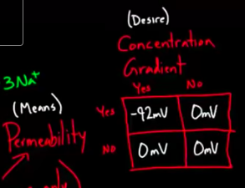
  - Where do we get the -92 from
  - 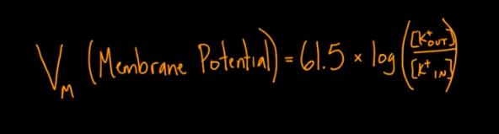
  - Sodium has a +67 mV potential, chlorine has a -86 mV potential, and calcium has a +123 mV potential
- Permeability and membrane potentials
  - Potassium wants to leave the cell and sodium, chlorine, and calcium want to enter the cell
  - These four contribute the majority to the resting potential
  - Potassium is the dominant ion in most cells regarding permeability-about 95%
  - Sodium is around 1%, chlorine is around 2%, and calcium is around 2%
  - Total membrane potential would be -85.9 mV regarding those exact percentages
  - 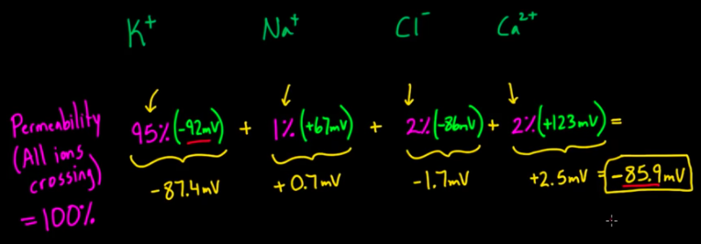
  - Change the percentages and make sodium’s permeability at 80% and we get a membrane potentials of +39.7%
  - 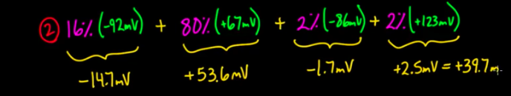
  - By changing permeabilities you can change the membrane potentials drastically
Cell theory
- History and development of cell theory
  - Anton van Leeuwenhoek was looking at dental scrapings under a microscope and discovered little things moving around which he named animalcules-actually bacteria but that hadn’t been discovered yet
  - Van Leeuwenhoek is referred to as the father of modern microbiology
  - Robert Hooke looked at a cork under the microscope and discovered remnants of plant cells and he thought they looked like little rooms so he called them cellula
  - First tenant of cell theory-cell is the basic unit of life
  - Looked at different things under microscope and discovered regardless of shape of bacteria they all had the same cell as their structure
  - Schleiden and Schwann discovered that all plants and animals are made out of cells, so all living organisms are made out of cells
  - Second tenant-all living organisms are made of cells
  - Predominant theory at that time was abiogenesis-life was spontaneously make from non-life
  - Rudolph Virchow saw bacteria dividing and forming identical cells-today it’s called binary fusion which is the mech by which bacteria reproduce
  - Some scientists were still unsure if that proved abiogenesis wrong
  - Louis Pasteur did swan-neck bottle experiment proved abiogenesis was wrong
  - Third tenant-all cells come from preexisting cells
Eukaryotic cells
- Characteristics of eukaryotic cells
  - Humans and all multicellular organisms are made up of eukaryotic cells
  - Two major types of cells-prokaryotic and eukaryotic
  - Eukaryotic cells are much larger than prokaryotic cells
  - E cells are found in multicellular organisms but there are single cellular eukaryotes like certain protists
  - E cells have compartmentalization-the cell is divided into different compartments, but the P cell doesn’t have as many
  - Different compartments allows them to have different functions
  - Compartments are called organelles
  - Nucleus with chromosomes inside the nucleus separates from the outside-defining organelle of a eukaryotic cell
  - Prokaryotic cell has its genetic material floating in one big space with everything else
  - Prokaryotes to divide make 2 copies of everything and split down the middle-binary fission
  - Eukaryotes divide via mitosis
  - Another important organelle-mitochondria-power house of the cell, where cellular respiration (glucose ATP) happens
  - Endoplasmic reticulum-dozens and dozens of folds of membranes, primarily the site of protein synthesis
  - Golgi apparatus-takes the proteins from the ER and send them to other parts of the cell
  - Lysosomes and peroxisomes-like recycling centers of the cell
    - Lysosomes-break down no longer functional cellular components into basic components that can be reused
    - Peroxisome-where reactive oxygen species like peroxides are reduced into nontoxic forms
- The nucleus
  - Most important function is to contain the genetic material of the cell
  - Surrounded by 2 membranes-outer membrane and inner membrane
  - Inside of nucleus is nucleoplasm-fluid inside the nucleus
  - Cytoplasm and nucleoplasm aren’t continuous
  - Interior of nucleus is where mRNA is produced
  - Transport of the mRNA out of nucleus happens at a special complex called nuclear pore
  - Nuclear pore spans both membranes and it’s very selective about what can go in and out
  - Recognized special signals on different proteins that can be transported into and out of nucleus
  - Nucleolus is the center of nucleus-dense and compact
  - Nucleolus is the site of ribosome assembly
  - Nucleus is associated with endoplasmic reticulum
  - Outer membrane is continuous with the membranes that make up the ER
  - Nuclear envelope-combo of inner and outer membranes along with the nuclear pores
- Mitochondria
  - Responsible for producing ATP
  - Outer membrane made up of a lipid bilayer
  - Inner membrane is also made up of a lipid bilayer, but it’s not permeable to small molecules
  - Inner membrane ha many folds-called cristae
  - Lots of different proteins on the inner membrane that are necessary for cellular respiration
  - Space between inner and outer membrane is called intermembrane space
  - Center of mitochondria is matrix
  - Glycolysis-when glucose 2 pyruvates, happens in cytoplasm
  - Pyruvate dehydrogenase complex-when pyruvate acetyl CoA, happens in mito matrix
  - Krebs cycle-acetyl CoA undergoes a series of reactions, also happens in mito matrix
    - Produce NADH and FADH₂
  - Electron transport chain-happens on the inner membrane itself, make ATP
    - Inner membrane has a bunch of enzymes involved in ETC
    - NADH gets oxidized so NADH NAD⁺ + 2H⁺ + 2e⁻
    - First enzyme gets reduced and it passes the electrons it gained to the next enzyme which is cytochrome Q which will pass on to the next enzyme
    - Finally those 2 electrons are used to reduce oxygen and make water
    - Electrons jumping from one enzyme to next they’re going from high energy to lower energy so they’re releasing energy
    - Enzymes use that energy to pump H ions out from matrix to intermembrane space making it more acidic
    - Intermembrane space now has high concentration so H ions want to go back into matric but inner membrane isn’t permeable so they can’t
    - They can only get back into the matrix via ATP synthase-when they do they cause axle to turn and we form ATP from ADP and phosphate
    - Chemiosmosis-hydrogen ions passing through the special channels in ATP synthase
    - Oxidative phosphorylation-ADP is being phosphorylated because of oxidation of NADH
  - Mitochondria have their own genome-one circular piece of DNA found in the nucleus allowing them to do a lot of things on their own
  - Self-replicating-replicated independently of the cell in which they are
  - Make their own rRNA and tRNA and some of proteins involved in the ETC and parts of the protein ATP synthase
  - Uses a different system than nuclear genes for transcription and translation
  - Has its own unique genetic code
- Endoplasmic reticulum and golgi apparatus
  - Nuclear envelope is continuous with lumen of the ER
  - Two parts to ER-rough ER which has ribosomes, and smooth ER which doesn’t have ribosomes
  - Smooth ER
    - Synthesizes lipids including those that end up being part of the cell membrane and those that are secreted from cell
    - Metabolizes carbohydrates
    - Aids in detoxification of drugs and other toxins
  - Rough ER
    - Site of protein synthesis-these proteins are different from the ones made in cytoplasm-these are either secreted into extracellular environment or they end up becoming integral proteins or they remain in ER, golgi, lysosomes
    - Site of post-translational modification of proteins
  - Proteins secreted or that become part of cell membrane follow secretory pathway-pathway a protein takes from when it’s synthesized until it leaves or becomes part of cell membrane
  - The proteins that need to follow secretory pathway have a signal sequence
  - Signal sequence is detected early on in translation and will cause the polypeptide being synthesized to be pushed into the rough ER
  - Golgi apparatus
    - Modifies proteins made in rough ER
    - Sorts and sends proteins to their proper destinations
    - Synthesizes certain molecules that need to be secreted from the cell
  - Cis stack-part of golgi that’s closest to the ER
  - Medial stack-middle part of golgi
  - Trans stack-furthest away from ER
  - Protein gets modified in cis and medial stacks and goes off in a vesicle at trans stack
  - Protein can take different paths from there
    - Can go to lysosome, cell membrane, or can be secreted
- Lysosomes and peroxisomes
  - Lysosomes-digest various molecules and substances
  - Autophagy-when lysosomes digest molecules that are part of the cell itself or other cells
  - Crinophagy-when lysosomes digest excess secretory products
  - After both the lysosomes release into the cytoplasm the building blocks it just formed
  - Broke the molecules down into most basic parts which will be put into cytoplasm to be reused
  - Enzymes in lysosomes are acid hydrolases-require an acidic environment-pH is 5
  - The low pH is a safety mech in case the lysosome burst they won’t be able to break down the organelles because the pH of the cytoplasm is around 7.4
  - Peroxisomes-responsible for a variety of metabolic activities
    - Lipid break down
    - Help liver detoxify chemicals and drugs
    - Isolate hydrogen peroxide and then enzyme catalase breaks down hydrogen peroxide that’s made as a byproduct from various enzymes
    - H₂O₂ H₂O + ½ O₂
- Epithelial and connective tissue
  - 4 different types of animal tissue made of eukaryotic cells-epithelial, connective, muscle, and nervous tissue
  - Epithelial tissue make up the outer layer or skin and organs and also lines the lumen of organs and inside of cavities
    - Also makes up glands both endocrine and exocrine
  - Simple epithelial tissue-one layer thick
  - Stratified-2 or more layers
  - Find simple where substances need to diffuse from 2 different places-alveoli of lungs
  - Find stratified in places that need to resist chemical or mechanical stress-esophagus
  - Simple epithelial-epithelium cells are attached to basement membrane which is made of different types of fibers
  - One type of fiber is collagen
  - Basement membrane is semipermeable
  - Epithelial tissue is avascular-no blood vessels
  - Get nutrients from underlying tissue-nutrients diffuse from underlying tissue through basement membrane to epithelial cells
  - Places we’d expect to find epithelial cells-outer layer of skin, tissue lining mouth, esophagus GI tract, tissue that lines blood and lymphatic vessels
  - Tissue that lines the vessels is called endothelium
  - Connective tissue supports and connects tissues and separates different types of tissues from each other
  - Examples of connective tissue-bones, cartilage, blood, lymph, adipose tissue (fat), membranes covering brain and spinal cord and other types of tissues
  - Connective tissue has cells, ground substance, and fibers
  - Ground substance and fibers make up a matrix which is usually produced by cells
  - Ground substance is usually a viscose type of fluid
  - Areolar tissue-common type of connective tissue, binds together different types of tissue and provide flexibility and cushioning
  - Adipose tissue does not have fibers like most other connective tissue
  - Fibrous connective tissue is pretty strong-provides support and shock absorption-found in dermis, middle layer of skin
  - Blood is also connective tissue but it doesn’t contain fibers
  - Matrix of blood is plasma
  - Bone tissue-matrix is bone mineral
  - Hyaline cartilage-cells are chondrocytes, found in surfaces of joints
Cytoskeleton
- Introduction to cytoskeleton
  - Skeleton of cell
  - Focus on cytoskeleton in animal cells in this video
  - Provides structural support
  - Helps with movement
  - Helps with transport of substances within cell
  - Microtubules-involved in mitotic spindle, make up cilia and flagella
  - Intermediate filaments-provide structural support to the cell, help resist mechanical stress and help cell retain the shape it’s supposed to have
  - Microfilaments-involved in movement of cell, help movement of entire cell from within
    - Ex. After mitosis moving away; also with amoeba moving
- Microfilaments and intermediate filaments
  - Microfilaments are made up of actin and lots of actins join together to form actin polymer
  - Actin polymers twist around each other to form actin filament
  - Microfilaments can lengthen and shorten very frequently
  - Become longer via actin polymerization and become shorter via actin depolarization-what helps move the cell
  - Microfilaments help make the pinched shape in mitosis
  - Intermediate filaments are made up of many different types of proteins that are strung together to make polymers
  - Polymers twist together to make intermediate filaments
  - Intermediate filaments are pretty much permanent
  - Provide structural support for cell-resist mechanical stress
- Microtubules
  - Made up of 2 proteins-alphatubulin and betatubulin
  - Join together to form dimer which form polymers which are put together into a sheet which is rolled up to form a tube
  - One end is anchored to the microtubule organizing center (MTOC)
  - At the other end, dimers can be added and taken off-dynamic
  - Different types of MTOC’s-focus on 2-centrosome and basal body
  - Centrosome and basal bodies are pretty similar in structure but the attached microtubules do different things
  - 2 rods found in centrosome-centrioles
  - Centrioles are made up of 9 triplets of microtubules
  - During mitosis, centrioles duplicate and a pair of centrioles land on either side of the cell
  - During metaphase we have chromosomes in the middle and right outside the centromere we have the kinetochore which is the anchoring line for the kinetochore fibers which turn into microtubules
  - Interpolar microtubules-between 2 poles of the cell, attached to centrioles
  - Astral microtubules-just come out of centrioles
  - Some interpolar microtubules are attached to astral microtubules
  - During anaphase microtubules become shorter to pull the chromosomes apart
  - 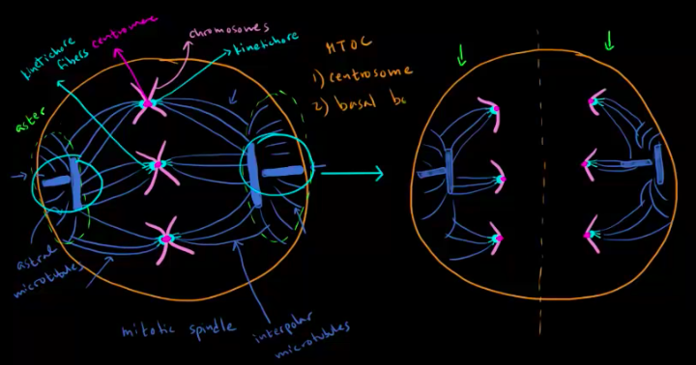
  - Basal bodies are the MTOCs in cells that either have cilia or flagella
  - Basal body has pretty much the same structure as a centriole
  - Flagella or a cilia is anchored to the basal body
  - Flagella and cilia are similar except flagella is longer
  - Made up of microtubules in a 9+2 arrangement
    - 9 pairs in a circle and one lone pair in the center
  - Between the pairs we have a protein called nexin which keeps the microtubules in their place
  - Coming out of microtubule we have protein called dynein which breaks down ATP and uses that energy to help microtubules move past each other
  - 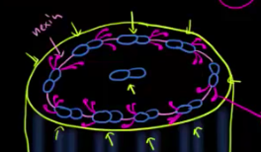
  - Microtubules play an important role in internal transport of neurons
  - Form a network that runs from soma to the synaptic terminal like a railroad track
  - Substances are moved along the track with the help of kinesin and dynein
  - Synaptic vesicles, proteins, lipids, and even organelles can be shuttled down the track
  - Axonal transport-transporting substance down track
  - Even help to transport nerve signals because of synaptic vesicles containing neurotransmitters
Prokaryotes/bacteria
- Overview of archaea, Protista, and bacteria
  - Unicellular organisms-protists, archaea, and bacteria
  - Prokaryotes came before nucleus so they don’t have one
  - Archaea are the oldest ones-pretty much first organisms to appear on earth
  - Used to extreme environments-extremophiles
  - Thermophiles-organisms that like extreme temperature
  - Halophiles-like extremely salty environments
  - Methanogens-make methane gas
  - Have different cell walls and cell membranes than bacteria and protists
  - Protista-kind of like a grab bag, any kind of eukaryote that’s not a plant, fungus, or animal, only thing they have in common is they live in moist or aquatic environments
  - Photosynthesizing protists-related to plants
  - Non-photosynthesizing protists-related to fungi and animals-fungi ones are called fungi-like and the animal ones are protozoa which includes amoebas
  - Bacteria can be found in diverse environments
  - Can both help us and hurt us
  - Capsule and in some bacteria there’s a slime layer instead-slime layers can be washed off but capsule can’t
  - Beneath that is a cell wall-different for gram-positive and gram-negative bacteria
  - Then we have plasma membrane and then prokaryotic flagella which help the bacteria move
  - Flagella are made out protein flagellin and help the bacteria get food via chemotaxis-sensing chemicals and moving towards or away from it
  - Fimbriae or pili-not all cells have them
  - Inside structures
    - Cytoplasm, ribosomes, nucleoid area for the chromosomes, some have plasmids, and inclusion bodies which store stuff for bacteria like nutrients
- Bacterial characteristics-gram staining
  - Circular shaped-coccus pl. cocci
  - Rod shaped-bacillus pl. bacilli
  - Squiggle shaped-spirochete pl. spirilla
  - Different colors-come from Gran staining which stains the outside of the bacteria
  - If it stains purple-gram positive
  - If it stains pink-gram negative
  - External layers are different between gram positive and gram negative bacteria
  - Gram negative bacteria have another plasma membrane and a much thinner cell wall than gram positive then a lipopolysaccharide layer and then a capsule
  - Peptidoglycan-long chains of sugars connected by proteins
  - Lipopolysaccharide layer-lipids and polysaccharides
  - Periplasmic space-next to plasma membrane space
  - 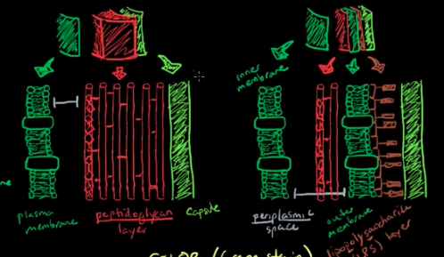
  - Left-gram positive and right-gram negative
  - For gram staining you first apply it and it stains the whole thing purple then you wash it off
  - Because the gram negative has a thing peptidoglycan layer in the cell wall it washes right off and then later they re-stain it and it’ll look pink
  - Because gram positive has a thick peptidoglycan layer it’ll stay purple
- Bacterial genetic recombination
  - Transformation-bacteria takes up naked DNA from the environment
  - Can do that in a lab by heating it or using electricity causing holes in the membrane which aren’t big enough for the entire bacterial chromosome but just big enough for the plasmid
  - Remove the heat or electricity the bacteria goes back to normal
  - Conjugation-bacteria that have the fertility factor (F+) create a sex pilus which is a hollow protein tube between it and the bacteria without the fertility factor (F-)
  - The plasmid then makes a copy of itself and moves across the sex pilus and form the full plasmid
  - Transduction-where a bacterial phage injects its genetic material into the bacteria and it’s either taken up by the plasmid or the chromosome
  - When the virus wants to leave the cell it repackages its DNA but it can pick up either the plasmid’s DNA or some of the chromosomal DNA
  - When it goes to infect the next cell it will bring that DNA with it
Viruses
- Virus structure and classification
  - Robot hackers of microbiology
  - Really small-about 1/100 of a bacterium
  - Some viruses are larger than others
  - Have a capsid-protein coat
  - Need capsomeres to build their shapes
  - Form 3 different shapes 3D shapes-icosahedral configuration, helical shape, and spherical shape
  - Some viruses have an envelope that covers the capsid
  - 4 different options for the genetic info contained in viruses-double stranded DNA, single stranded RNA, single stranded DNA, double stranded RNA
  - Packaged inside the protein coat
  - Don’t have organelles and they can’t make energy for themselves so they sneak into larger cells that have organelles and take over those to make copies of themselves
  - Obligate intracellular parasite-absolutely needs to be inside a cell
  - Infect different hosts ex. Bacteriophages, ones that infect eukaryotic cells, etc.
  - Bacteriophages have a special shape-nucleocapsid at the top with a head portion that contains the nucleic acid, sheath acting like a needle that the nucleic acid can be shot down and a tail that attaches to the host
  - Receptors on cells can’t tell the difference between normal cell and a viral cell
  - Viral cell signals to the receptors and tricks it into forming a pit which will bud off into an endosome and the virus enters via endocytosis
  - Direct fusion-use the envelope to merge with the cell membrane
- Viral replication: lytic vs lysogenic
  - 3 way of getting into a cell
    - Bacteriophages injecting genetic material inside the cell
    - Non-enveloped viruses trick the cell’s receptors into letting them in
    - Enveloped viruses directly fuse with the membrane
  - 2 ways of how the virus takes over
  - One way is it can take over cell’s machinery and start making copies of virus’s genetic material and its proteins for the protein coat
  - They will self-assemble
  - Eventually cause the cell to lyse releasing all the viruses into the environment to enter more cells
  - This is if there’s a lot of hosts around and the virus just wants to make lots of clones
  - Called lytic cycle
  - Other option is sneak in and let the bacteria do its thing while it’s waiting and then it’ll combine with the host’s genetic info
  - Quietly sitting there because there are repressor genes on the virus
  - Called a provirus or prophage and since it’s not doing anything it’s called a dormant or latent phase
  - A 1 in 10,000 chance-happens if bacteria is exposed to UV light or something
  - Something weakens the repressor gene so it’s no longer quiet and it try to repair its genome so it will cut out part of its DNA that is the virus and now it’s active and ready to make copies, lyse the cell, and continue infecting other cells
  - This is if there’s not a lot of hosts around
  - Called lysogenic cycle
- Retroviruses
  - Enveloped single stranded RNA virus, the envelope also carried 3 special proteins
  - In the case of retrovirus HIV it enters the cell via direct fusion
  - Once it’s inside the cells it undergoes uncoating where the capsid is dissolved
  - One of the proteins is reverse transcriptase-hop onto the RNA and form complimentary DNA
  - Make another cDNA strand it will combine with another cDNA strand to make double stranded DNA
  - Integrase cuts of 3’ ends making them slightly shorter and forming sticky ends
  - RNA gets degraded by normal ribonuclease
  - Integrase integrates HIV DNA with the hosts DNA
  - HIV retrovirus infects human cells which have a nucleus
  - Provirus stage-once it’s integrated with the host DNA
  - Like lysogenic cycle, but it’s not dormant or latent so it’s actively transcribed when the host’s DNA is transcribed
  - The host cell with make RNA-viral mRNA
  - The mRNA’s are translated into proteins-especially the 3 that we began with-reverse transcriptase, integrase, and protease
  - They’re missing the envelope so they’re immature viruses
  - They bud off and take the membrane as their envelope
  - Protease cleaves other proteins to make sure they’re fully functional before the virus enters another cell
- Subviral particles: viroids and prions
  - Subviral particle are smaller than viruses
  - Viruses and Subviral particles are all categorized as nonliving infectious agents
  - 2 type of Subviral particles-viroids and prions
  - Viroids-made up of a single strand of circular RNA which is thought to be catalytic RNA
  - Catalytic RNA-make or break catalytic bonds, it can self-cleave to create more viroids
  - Viroids are not the same as virions
  - Prions-have no genetic material, only made of proteins typically in a beta sheet conformation
  - Don’t know much about prions
  - When the beta sheet comes in contact with an alpha helix it changes the alpha helix to a beta sheet and as this continues happening we get protein deposits
  - Proteins deposits are already bad but when they’re removed in places like your brain they can leave holes in the brain causing disease
Cellular division
- Cell cycle phases
  - Cell cycle-lifespan of a cell
  - Not always dividing at every point, could just have points of growth
  - 2 phases of the cell cycle-interphase and mitosis
  - Interphase-where cell spends most of its time, have primary cell growth but not cell division
    - First part-growth phase G1-longest phase of the cell cycle and it’s where the cell produces extra organelles
    - If it wants to continue growing and move towards cell division it goes into S phase or DNA synthesis
      - Where we have DNA replication-take 23 pairs of chromosomes and end up with 46 pairs
    - Some cells go from G₁ to G₀ where there’s no more division because there are some cells that don’t like to divide anymore
    - After S we have G₂ which is more direct preparation for mitosis like making microtubules
    - Then we have mitosis
  - Cancer cells are the exception to most cells being in interphase
  - Mitosis-active cell division
- Cell cycle control
  - 2 key places where we have extensive regulation of the cell cycle-between G₁ and S phase and between G₂ and mitosis
  - Cyclin dependent kinases (CDKs) add phosphate group on other enzymes or proteins to activate or inactivate them
  - Always present, but their default form is to be inactive so they need to be activated by cyclin proteins
  - Specific cyclins are made at specific times
  - Only active when they’re bound to specific cyclins
  - In G₁ we have production of cyclins D and E and CDK2 binds to E and CDK4 binds to D which will both phosphorylate a protein called RB
  - Phosphorylated RB can’t inhibit DNA replicated
  - In the S phase cyclin A is produced and it binds to CDK2 to activate DNA replication
  - In G₂ phase cyclin B binds with CDK1 to activate mitosis
- Loss of cell cycle control in cancer
  - Control of cell cycle happens on a higher level with a couple of key proteins including RB
  - P53-“guardian of the genome”, binds DNA directly to produce proteins that block progression of cell cycle
  - P21-inhibits CDK so it won’t be able to activate DNA replication or activate mitosis
  - RB-produced from a tumor suppressor gene, like p53-if they have a loss of function, you tend to get cancer
  - Defect in RB leads to a tumor of the eye
  - P21 doesn’t lead to cancer defects-mice without p21 have the ability to regenerate their limbs
- Fertilization terminology: gametes, zygotes, haploid, diploid
  - Sperm cell and egg cell or ovum fuse together
  - Fertilization-process of them fusing and producing a cell that then differentiates into all the cells in our body
  - Each of the sex cells (sperm and ovum) are gametes
  - Each gamete has half the number of chromosomes as the body cells
  - 23 chromosomes in each gamete
  - Last chromosome is sex determining and the determining factor is from dad
    - Mom always gives x dad can give x or y
    - Xx-female and xy-male
  - Once the gametes are fused we have a fertilized eff or a zygote
  - Now we have 46 chromosomes in 23 pairs of homologous chromosomes
  - Homologous chromosomes code for the same things, but there are different variants of how they code
  - Haploid-half the full amount of chromosomes, for humans the haploid number is 23
  - Diploid-full amount of chromosomes, for humans the number is 46
  - In general haploid number=n and diploid number=2n
- Zygote differentiating into somatic and germ cells
  - Through mitosis the zygote keeps replicating
  - Cells differentiate into different parts of the body
  - Cells produced by mitosis are the body cells or somatic cells
  - Some cells differentiate into germ cells or the gonads-ovaries and testes
  - Differentiate into germ cells through meiosis
  - Female produces eggs and male produces sperm
  - Mutation in somatic cell does not affect the DNA make-up of what you pass on
  - Mutation in germ cell can be passed on to your children
- Interphase
  - During interphase chromosomes aren’t tightly bound
  - For most of a cell’s life the chromosomes are unwound in their chromatin form
  - G₁ phase-just growing
  - It’s still one chromosome even though it copied its genetic material
  - Each copy is a chromatid and they are sister chromatids but they make up one chromosome because they are connected at the centromere
  - Centrosomes duplicate
  - S phase-where all of the genetic info is duplicating, synthesis phase
  - G₂ phase-last growth phase before mitosis
- Mitosis
  - Process by which one nucleus turns into two nuclei that each have the original genetic information
  - After mitosis we have cytokinesis which will split each nuclei into a separate cell when we split the cytoplasm
  - Prophase
    - Chromosomes go from spread out chromatin form to a more condensed form
    - Nuclear membrane starts to go away
    - 2 centrosomes start to migrate to opposite sides of the cell
  - Metaphase
    - Nuclear membrane is gone
    - Chromosomes start lining up in the middle of the cells
    - Centrioles are part of the centrosomes
    - Microtubules from centrosomes extend to the centromeres of the chromosomes
    - Chromosomes line up in the middle
  - Anaphase
    - Microtubules start pulling on each of the sister chromatids
    - Now that they are apart we consider the chromatics each as an independent chromosome so now we have double the amount of chromosomes
    - Now the point at which the microtubules connect is called a kinetochore
  - Telophase
    - Cell membrane is starting to pinch in preparation for cytokinesis
    - Chromosomes start to unwind and nuclear membranes start to form around the DNA
    - DNA goes back to chromatin form
  - Cytokinesis
    - Gets fully pinched together and we have two separate cells
  - Each of the two cells now goes through the whole cell cycle
- Comparing mitosis and meiosis
  - Mitosis
    - Start with a cell that has a diploid number of chromosomes-2n
    - End with two cells that each have 2n chromosomes that continue going through the whole cell cycle
    - These are the somatic cells
  - Meiosis
    - Start with a cell that has 2n chromosomes
    - After meiosis I you end up with 2 cells that have n chromosomes
    - Then those two go through meiosis II which is very similar to mitosis and we’ll end up with 4 cells that have n chromosomes that don’t necessarily have the same genetic info anymore
    - In meiosis I you’re splitting the homologous pairs so each cell can get some of moms chromosomes and some of dads
    - For males it’s happening in the testes and for females it’s happening in the ovaries
    - Get gametes from this
- Phases of meiosis I
  - Prophase I
    - Nuclear envelope starts to disappear and the chromosomes go into their dense form-similar to mitosis
    - Unique about this is that we have chromosomal crossover-where homologous sections of the homologous pairs crossover
    - Sections tend to code for the same genes just different variants
    - Adds more variated as we get into sexual reproduction

  - Metaphase I
    - Just like mitosis nuclear membrane is gone and chromosomes are going to line up
    - Microtubules attach to kinetochores
  - Anaphase I
    - Chromosomes start getting pulled apart
    - In mitosis sister chromatids get pulled apart, but here the sister chromatids stay together and the homologous pairs get pulled apart
    - How they split is random
  - Telophase I
    - Analogous to mitosis
  - Cytokinesis
    - Homologous pairs start to unravel into their chromatin state
    - Nuclear membrane begins to form again
    - Microtubules are dissolving
    - Not our end product
    - Each of the cells are now haploid-each chromosome does have 2 sister chromatids
- Phases of meiosis II
  - There can be a rest period between the two phases of meiosis where you have interphase II and it depends on the type of cell and type of species
  - Prophase II
    - Dealing with 2 cells
    - Nuclear envelope dissolves, chromosomes condense, centrosomes duplicate and migrate to opposite ends of the cell
  - Metaphase II
    - Very similar to mitosis
    - Centrosomes have migrated to the poles, chromosomes line up, microtubules attach to kinetochores
  - Anaphase II
    - Chromosomes pull apart same as mitosis
    - Split the sister chromatids into daughter chromosomes
  - Telophase II
    - 2 cells become 4 cells
  - Cytokinesis
    - Chromosomes are starting to unravel into chromatid form
    - Nuclear envelope formed again, microtubules dissolving
    - Now have four haploid cells-gametes
  - Meiosis II is often compared to mitosis
  - Preserves number of chromosomes like mitosis
  - Not homologous chromosomes
  - 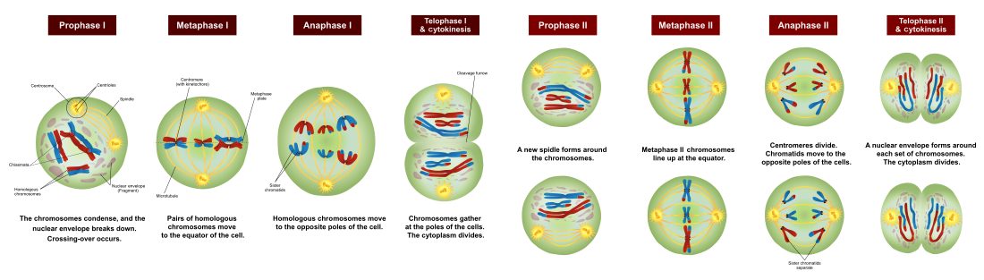
- Embryonic stem cells
  - Once sperm fertilizes egg we have a diploid zygote
  - After fertilization the zygote experiences cleavage, basically mitosis with no change in size
  - As soon as the zygote starts dividing each cell is called a blastomere
  - Cells keep splitting and then we have a mass of cells which we call the morula
  - Once we reach around 16 cells they start to differentiate into outer cells which are spherical and inner cells
  - Outer cells are called trophoblasts
  - Inner cells are called embryoblasts (also called inner cell mass)
  - Fluid starts filling in gap between embryoblasts and trophoblasts-fluid is called blastocoel
  - Blastocyst is the whole thing with the cells and fluid
  - Trophoblasts turn into placenta
  - Inner cells have differentiated themselves away from the placenta cells but still don’t know what they’re going to become so they’re now embryonic stem cells
  - They can turn into anything and they have plasticity-potential to turn into different things
  - Debate about using these to regenerate new cells that have been damage but if we try to extract one of the cells we kill the embryo
  - In our bodies we have somatic stem cells in our bone marrow to help produce red blood cells
  - Somatic stem cells are not plastic
  - Stem cell line-take a stem cell and put it in a petri dish and let it to keep duplicating and then someone takes one from that and put in another petri dish and keep going
  - In vitro fertilization-take eggs out of mother and fertilize them with semen and then they’re allowed to develop to the blastocyst stage and then they take the healthy ones and implant them into the mother
  - Can result in multiple births
  - The ones that aren’t put in are destroyed or frozen which basically destroys them
- Cancer
  - Contact inhibition-when the cells recognize there are other cells in the area and it’s getting crowded so they stop growing
  - When cells recognize they are defected the cells kill themselves-apoptosis
  - Talking about somatic cells here-doesn’t get passed on to offspring
  - Some cells don’t replicate that frequently and some replicate more frequently
  - We’re made up of 100 trillion cells
  - Once in while we have a mutation where the cell doesn’t eliminate itself and it also deforms the cell
  - Cell keeps making copies of itself making a group of defective cells-neoplasm
  - Most neoplasms form a big lump which is called a tumor
  - Benign tumor-not replicating a lot faster than neighboring cells and not harming the environment in any significant way
  - Sometimes it can start growing like crazy and become invasive
  - Keep passing on broken genetic info that makes it keep replicating like crazy and more and more mutations could appear and go to different parts of the body and take over-this means the cell has metastasized
  - Cells aren’t respecting cellular neighbors, they’re growing like crazy, they don’t experience contact inhibition, they’re invasive, they stay crowding out other cells and hogging the resources, they keep mutating really fast because they have so many genetic abnormalities, and eventually they may break away and infiltrate other parts of the body-these are cancer cells
  - Cancer is a whole class of mutation where the cells exhibit such fast growth and metastasis
  - Even plants have cancers
Cellular development
- Stem cells
  - Stem cells go from unspecialized to more specialized as they get older
  - In blastocyst we have inner cell mass which become the embryo so those are the stem cells
  - Pluripotent stem cells-can differentiate into several other types of cells
  - Embryonic stem cells are used to build our bodies and somatic stem cells are used as a sort of repair system for the body, can’t repair everything
  - Outside layer of skin is made of epithelial skin cells which we’re constantly shedding-lose about 40,000 per hour so we need a way to replace them
  - Takes a month for us to have completely new skin
  - Epidermal stem cells-layer of stem cells deep within our skin whose job is to keep dividing
  - Mature cells are not the same as stem cells
  - Mature cell is already specialized-has a specific function
  - Stem cells are unspecialized
  - To be a stem cell it needs to have 2 main properties
    - Ability to self-renew, divide and divide, but at least one of the cells remains a stem cell
    - Need a high capacity to differentiate into more specialized cells-degree of potency
  - Different types of stem cells-some can turn into more types of cells than others
  - Epithelial stem cells are one of the less potent types of stem cells-unipotent
  - Unipotent-can create only one type of cell
  - Multipotent-can give rise to many types of cells, but only within a specific family
    - Ex. Hematopoietic stem cells, neural stem cells, mesenchymal stem cells (bone and cartilage and adipose cells)
  - Stem cells maintain their numbers via 2 mechanisms
  - When stem cells divide they undergo asymmetric replication where the stem cells divides into a mother cell identical to the original stem cell and one daughter cell that’s differentiated
  - Daughter cell can go on to become more specialized while the mother cell replaces the initial stem cell
  - Stochastic differentiation-if one stem cell differentiates into 2 daughter cells instead of a mother and daughter another stem cell will undergo mitosis to produce 2 identical stem cells
  - Can introduce specific genes into already specialized somatic cells and they’ll revert back to pluripotent stem cells-big discovery for regenerative medicine
  - Stem cells express a few different genes that help keep them undifferentiated
  - Proteins in the cell that prevent other genes from being activated and triggering differentiation
  - Cord blood-blood taken from placenta and umbilical cord, contains lots of multipotent and even some pluripotent stem cells
- Cellular communication
  - Cells can talk to each other
  - Direct contact-cells have proteins stuck into their plasma membranes with lots of functions including communication
  - Ex. Macrophage ingest a foreign invader and display a little piece of it, an antigen, on its surface and another white blood cell can come along and grab that antigen and decide what to do
  - Direct cell-cell communication-when cells directly touch to communicate
  - Neural communication-neurons release neurotransmitters which diffuse and bind to the dendrites of the next neurons, over a short distance
  - One cell can talk to a group of cells locally as well
  - Cells release chemicals that travel around to cells in the area telling them something-called paracrine signaling
  - Endocrine signaling-cells to huge groups of cells at once
  - Ex. Cells in pituitary gland make hormones and they send it around the body via the bloodstream, it can potentially act on every cell but some cells don’t have the right proteins to bind certain hormones
- Cellular specialization (differentiation)
  - In each cell’s nucleus we have DNA which has genes which give our cell specific instructions on how to make different proteins which can change the way the cells look and act
  - Every single somatic cell in our body contains the same DNA except red blood cells which don’t have nuclei
  - They’re different cells because they’re using different genes to make their proteins
  - Gene being expressed is turned on and not being expressed is turned off
  - In order to differentiate into a certain cell like a muscle cell the cell turns on its muscle cell genes and turned off some other genes
  - Once they become specialized into certain cells they can’t differentiate into other cells and they can’t go backwards to stem cells
  - Cells decide what they’re going to become based on cues they get-can come from internal or external environment
  - Zygote has proteins called transcription factors floating around cytoplasm
  - Transcription factors activate certain genes and turn them on
  - Asymmetric segregation of cellular determinant-transcription factors are clustered around one area in the zygote so when it starts to divide the transcription factors aren’t distributed equally
  - Different genes get activated in different cells
  - Inductive signaling-usually a group of cells can induce another group of cells to differentiate by using some signals
  - Signals can be passed by diffusion, by direct contact, or passed through gap junctions (connexons)
  - Our limbs are formed partially through induction
- Telomeres and cell senescence
  - Different types of cells-ones that are actively able to divide, non-mitotic cells or post mitotic cells which don’t undergo mitosis
  - Post mitotic cells have a limited ability to repair or regenerate tissues that they’re part of-ex. Neurons, heart muscle cells
  - DNA has these little caps on the end called telomeres to prevent damage from happening to the DNA during the copying process
  - Telomeres don’t code for any proteins
  - Machinery that copies DNA doesn’t copy DNA all the way to the end so we lose a bit of the telomere every time the DNA gets copied
  - Telomeres become slightly shorter at the end of each DNA replication cycle
  - Cell can undergo 60 or 70 divisions before the telomeres get too short
  - Once they get too short the cell gives up its ability to divide so it doesn’t risk shortening the chromosome so it becomes a senescent cell
  - If a cell reached senescence because the telomeres become too short it’s reached replicative senescence
  - Number of times cell can divide before reaching replicative senescence is called its Hayflick limit
  - Senescence-change in cell’s state from happy active mitotic state to nondividing cell
  - Also starts expressing genes it didn’t before and starts looking a bit different and responds differently to the cells around it
  - Cells transform into senescent state to prevent impending DNA damage from happening and possibly being passed on to daughter cells
  - Anything that threatens integrity of DNA can make a cell become senescent
  - As we get older tissues have more and more senescent cells and can’t really repair themselves like they used to
  - Post mitotic cells can be induced to become senescent if their DNA’s at risk
  - Stem cells have a high cell division capacity regardless of the number of doublings because they have an enzyme called telomerase which adds back the little bit of telomere lost from replication
  - They never reach a Hayflick limit
  - Sometimes somatic cells can develop a mutation in the DNA that causes them to express telomerase so they escape senescence and this is one of the ways cancer occurs
- Cellular movement
  - Some cells can move around on their own
  - In development cells migrating from one part of the embryo to another is important in forming tissues and organ systems
  - In adult bodies cell movement is important for things like immune system function
  - Sperm cells move around via the flagellum which is made up of monomers of microtubule proteins and they work together with dynein to whip the flagellum back and forth
  - Flagella are also in bacteria and archaea but they’re slightly different
  - White cells like neutrophils move around in the blood stream until they get the signal that they are needed
  - Then they stick to endothelium and roll along it and then duck between two endothelial cells and continue moving along inside the tissues to get to where they’re needed
  - Can do this thanks to its cytoskeleton-2 mechanisms
  - Cytoskeletal model of movement-cell quickly polymerizes putting together actin protein filaments at the front of the cell pushing it forward
    - Microtubules in the back act like a rudder to steer the cell and also act as an anchor to stop the cell from moving
  - Membrane flow model-bits of the plasma membrane get internalized as vesicles from all parts of the cell and then move to the front of the cell and exocytose there
    - 2 types of endocytosed vesicles that get produced-ones made of just plasma membrane, ones with little flip proteins called integrins which anchor a piece of the cell membrane down

