Level9News
Posted: 09.19.2015


Targeted Electrical Stimulation of the Brain Shows Promise as a Memory Aid

Research could lead to therapies for wounded warriors and others with memory deficits caused by traumatic brain injury or disease
9/11/2015
DARPA's RAM Program
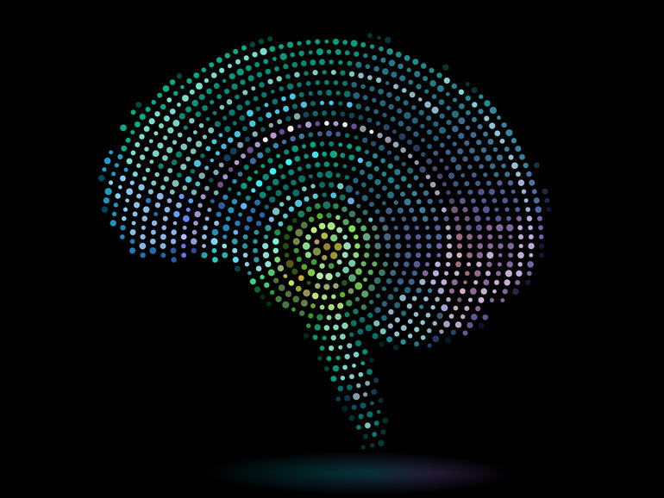
Electrical arrays implanted in the memory centers of the brain are showing promise for their ability to help patients improve their scores on memory tests, raising hope that such approaches may someday help individuals suffering from memory deficits as a result of traumatic brain injury or other pathologies. The preliminary findings, from DARPA’s Restoring Active Memory (RAM) program, were presented in St. Louis on Thursday at Wait, What? A Future Technology Forum, hosted by the Agency.
Just over one year into the effort, the novel approach to facilitating memory formation and recall has already been tested in a few dozen human volunteers, said program manager Justin Sanchez. The subjects in the study have neurological problems unrelated to memory loss, but volunteered to test the new neurotechnological interventions while they were undergoing brain surgery. In the study, small electrode arrays are placed in brain regions known to be involved in the formation of declarative memory—the relatively simple sort of memory used, for example, to recall lists of objects—as well as in regions involved in spatial memory and navigation.
The study aims to give researchers the ability to “read” the neural processes involved in memory formation and retrieval, and even predict when a volunteer is about to make an error in recall. The implanted electrodes also provide a means of sending signals to specific groups of neurons, with the goal of influencing the accuracy of recall.
Initial results indicate that it is indeed possible to capture and interpret key signals or “neural codes” coming from the human brain during memory encoding and retrieval, and improve recall by providing targeted electrical stimulation of the brain.
“Everyone has had the experience of struggling to remember long lists of items or complicated directions to get somewhere,” Sanchez said. “Today we are discovering how implantable neurotechnologies can facilitate the brain’s performance of these functions.”
Among other details, Sanchez said, the work is addressing the important issue of the ideal timing of electrical stimuli involved in the neural codes. “Should we provide electrical inputs when the lists are first being taught and memorized, or should we stimulate when the person is working to recall those items? We still have a lot to learn about how the human brain encodes declarative memory, but these early experiments are clarifying issues such as these and suggest there is great potential to help people with certain kinds of memory deficits,” Sanchez said.
Details about the early RAM results are being withheld for now, Sanchez said, pending peer review and publication in one or more scientific journal articles.
In related work, DARPA is about to launch a new effort to develop neurotechologies that may help individuals not just better remember individual items but learn physical skills. Complex skills can take people years to master, and it’s not just repetition of the physical movements that matters. The process also often involves the repeated mental and physiological “replaying” of the skill during wakefulness and sleep to solidify the skill. DARPA’s RAM Replay program, poised to begin in October, will aim to shed light on this replay process through a combined approach of studying direct neural and physiological interfaces, environmental cues, and the sleep-wake cycle. The selected performers will study the role of replay in the consolidation of episodic memories and newly learned skills, as well as how these memories are recalled and used by people during subsequent task performance.
Meanwhile, promising preliminary results also are coming out from DARPA’s Systems-Based Neurotechnology for Emerging Therapies (SUBNETS) program, Sanchez noted, which aims to provide relief for patients with post-traumatic stress disorder and other neuropsychiatric conditions.
Just one year into the SUBNETS effort, engineers at the Lawrence Livermore National Laboratory and Draper Laboratory have produced customized electrode arrays and miniaturized neural interface hardware, prototypes of which are on display at this week’s Wait, What? event in St. Louis. The prototypes include microfabricated electrode arrays that are flexible and can interface with large numbers of neurons; fully implantable hardware to amplify and interpret brain signals; and new circuitry to deliver precise, function-restoring feedback to the brain.
In the first clinical tests of some of these technologies, researchers at the University of California, San Francisco, placed arrays on the brains of seven patients and, by providing electrical impulses to a specific neuronal region, markedly reduced the patients’ anxiety levels.
“As the technology of these fully implantable devices improves, and as we learn more about how to stimulate the brain ever more precisely to achieve the most therapeutic effects, I believe we are going to gain a critical capacity to help our wounded warriors and others who today suffer from intractable neurological problems,” Sanchez said. “It is a very complex and challenging frontier, but one I am convinced we will learn to navigate and leverage to good effect in people who today have no effective therapeutic options.”
For more information about DARPA’s Wait, What? event, please visit: www.darpawaitwhat.com.

Level9News:
Reviewing DARPA's RAM program

The road to hell is always painted with good intention. The RAM program as presented is wetware technology. Furthermore, RAM boasts 'memory formation', in other words the creation of memories that never existed, not memory restoration as the reader may be led to believe.

This program further supports Obama's B.R.A.I.N. Initiative – a government funded endeavor to map your mind to ultimately be able to reprogram it. The ability to 'read' neural processess in order to determine if you're about to make 'an error' in a memory recall begs the question...are they talking about a natural or implanted memory recall. Can these targeted electrical signals also prompt synthesized memory recalls?

Why are the details of the RAM results being withheld? Is it because initial testing results reveal darker applications of this neurotechnology? DARPA's claim that RAM will help people learn 'new' physical skills amounts to overriding the natural programming of the human brain. The RAM Replay program scheduled to commence in October, 2015 is a spring board to creating bio-bots...humans that can be reprogrammed on the fly that will bypass the natural learning process...”Tank, download helicopter pilot program...” ~The Matrix.

DARPA's SUBNETS program promises an even more diabolical scope by essentially providing technology to remove emotion, stress and fear creating the ultimate biological automaton. How about removing some of the primary causes of PTSD and neuro-psychiatric disorders like war, state sanctioned murder, social engineering, invisible bondage and our ability to exercise free will, instead of developing artificial means to circumvent natural human reactions to these atrocities.

If you can't read between the lines, substitute 'function-restoring' with 'function-implanting' and the objectives they are not discussing will become clear. US DoD patent #3951134 and all of the patents associated with it and see how, for a very long time, they've been conducting resear4c to reprogram or 'spoof' the brain's neurological responses to outside stimuli. To what end does it serve to make someone dying of dehydration not feel thirsty; or someone who hasn't had any nourishment in weeks not feel hungry; or someone suffering from exposure not feel cold. There's a dark curtain behind every silver lining. How many lessons do we need to learn that technologies developed by these so called black projects never bode well for humanity. And now they are experimenting with neurotechnologies that can reprogram your mind. Once they've mastered wet and wearable tech on test subjects [which they already have], remote targeting via signaling frequencies is the next step.

DJ
Level9News

