Modern Bedroom Furniture - Clean and Simple Fun for Your Favorite Room
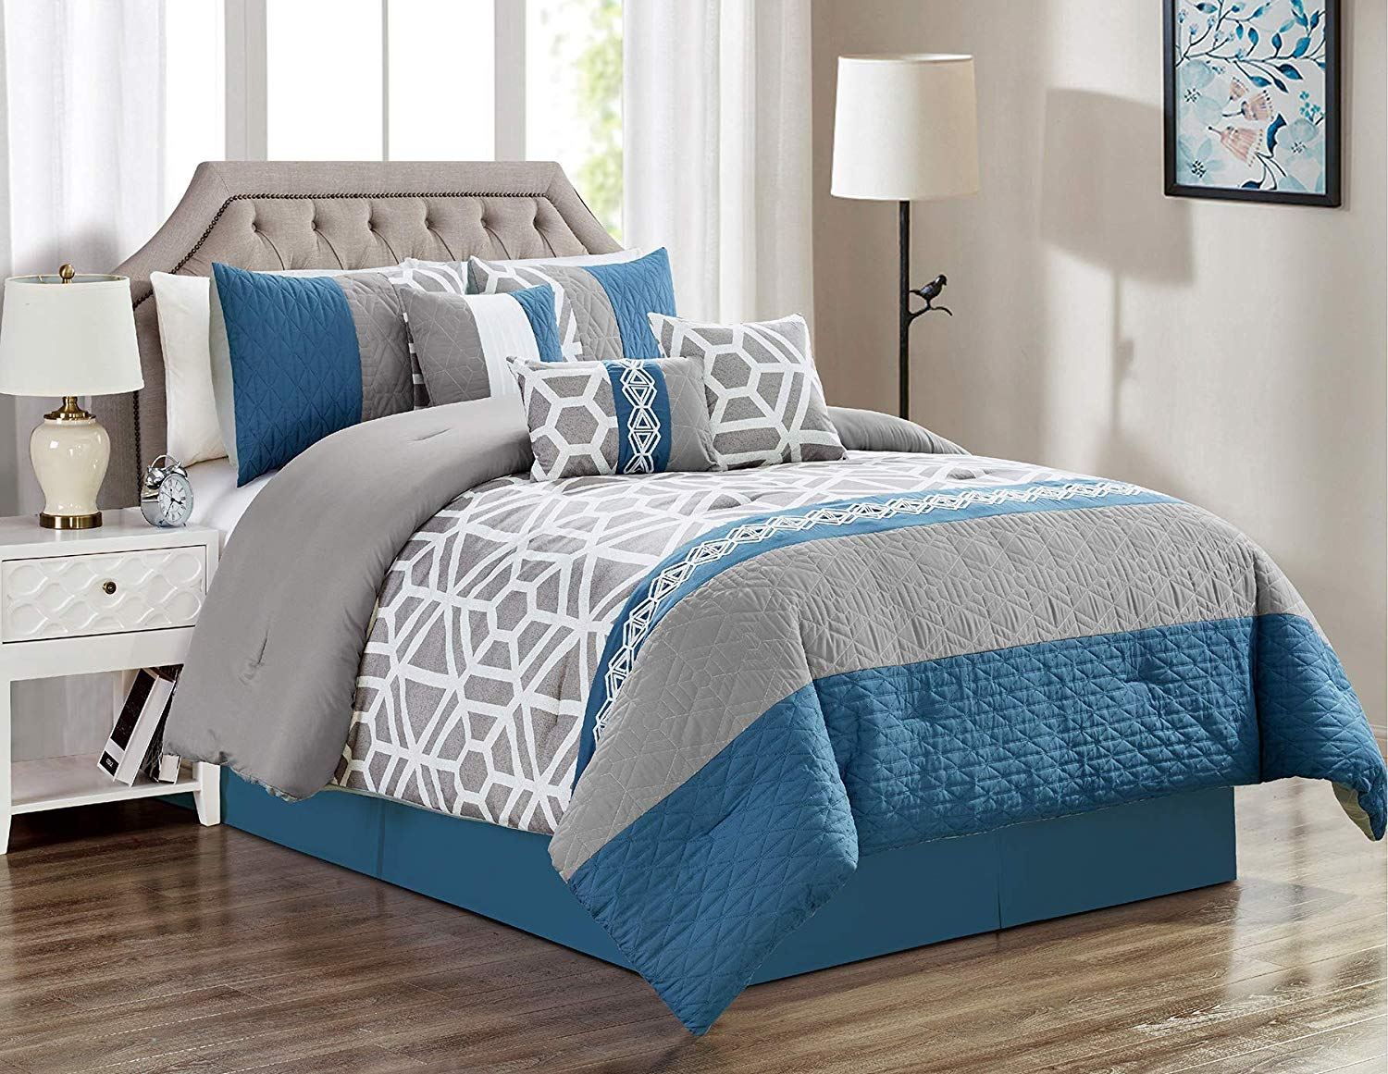
Streamlined and simple platform beds are classified as the rage. They are just longing to be dressed up with a really brightly patterned comforter and posh pillows. Throw in a related dresser and end dining room table and let their clean wrinkles and subtle elegance refill the room. Unlike traditional bedroom accessories which is usually made of real wood and embellished with complex carved designs, modern bedroom accessories is clean with no extras and usually made of wood as well as metal, especially aluminum. It can be lightweight and space saving, developing an open and inviting planet. Unlike traditional furniture, which will takes up more space and leads to a cluttered space for you to remainder in.
When shopping for modern bedroom furniture the best place to look is on the net. Depending on where you live you might find that a local furniture stores take more traditional furniture and are relatively lacking in the modern department. Consequently rather than trudging to several outlets only to be disappointed access all types of modern furniture from the safety of your own home. With the mouse click you can shop and compare and contrast prices with the click of a button. Who all knew furniture shopping can be so much fun? One of the most common fecal material modern bedroom furniture is the podium bed. Sophisticatedly simple that no frills design can take center stage in your bedroom. And many have nifty storage down below. Other pieces of modern bedroom accessories do double duty likewise such as an armoire that could hold clothes just as simply as it does a TV, or possibly a storage chest that can also generally be a bench. Hardworking in addition to clean looking it is easy to discover why this style is so common.
In fact this clean and style has been around since the 1940's proving the point that issues never go out of style. Performed era modern bedroom furniture will probably lend your home an sublte elegance. So show it off using neutral walls and a looking glass for light. Make the bed furniture a focal point by dressing the item in bright colors or maybe a bold pattern to get your eye. Then add a new dresser, end tables and perhaps an armoire to complete the looks. No matter if you start small having one piece of furniture or just invest in a whole set you'll have enjoyment transforming your bedroom into your peaceful sanctuary it was should be like that. After all, the average person spends 30 % of their life in bed. Which is 220, 000 hours with your bedroom. So make it a contented place.

