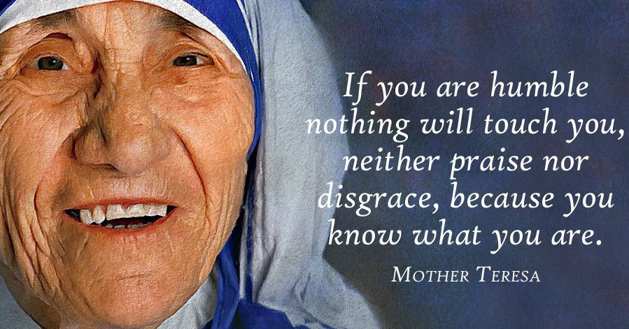

October 23, 2022, 10 a.m.
20th Sunday after Pentecost

Union Congregational Church
United Church of Christ
Elk River, Minnesota 763-441-1203 www.elkriverucc.org / churchoffice@elkriverucc.org

Liturgical Arts Panels

We are blessed to have the wonderful panels created by Paula Benfer. She has graciously written interpretations which we will be sharing in the bulletin as the panels are put on display. Thank you, Paula, for sharing your insight with us.

The Liturgical season is green. Green is the color of life and growth.

The white and red flag is a banner symbolic of Christ. The apostle Peter was commanded to build Christ’s church; the keys represent that. The mustard flower is a symbol of faith, as tiny as a mustard seed. The present church is symbolically represented as a beehive, and the bees are the workers who take the message of Christ into the world. The red cross is a symbol for martyrs; and each sheep in the flock represents one of the twelve disciples. The hands of all races are raised to volunteer for Christ, to say, ”Here am I Lord. Send me.”

Welcome!

Union Congregational Church, United Church of Christ welcomes everyone, no matter who you are or where you are on your faith journey.

We offer worship via Facebook Live broadcasts every Sunday at 10am. You can be here in person or participate virtually during, or any time after the service. Every Sunday, the service is recorded and broadcast on Facebook. You can contact the church at any time. See office hours below.

Please SILENCE cell phones during the service.
The wi-fi password is: stillspeaking1203

VISION
God has shown you, O mortal, what is good. And what does the Lord require of you? To act justly and to love mercy and to walk humbly with your God.
(Micah 6:8, (NIV))

Union Congregational Church, United Church of Christ Mission Statement
God calls us to minister to each other. This ministry goes beyond our congregation into the community, wider world, and to the earth itself. We seek to reach those in the margins of society, to empower the powerless, and to leave this earth a better place than when we each arrived

Worship October 23rd, 2022

LIGHTING THE CANDLES

PRELUDE

WELCOME

If you are in-person, we invite you to fill out the friendship pad to let us know you are here.

If you are worshipping virtually, we invite you to click a reaction button on Facebook to let us know you are with us.

The is located in the Vestry. (the room off of the sanctuary) Also, in the back of the sanctuary, is a table with items and bags for activities appropriate for the kids to work on and play with during the service. Children are welcome to sit at the table or bring the bag back to sit with parents.

WORDS OF CENTERING

"It is better in prayer to have a heart without words than words without heart."
- Mahatma Gandhi

* We invite you to stand as your spirit or body is willing.

* CHORAL CALL TO WORSHIP SPP 22 “Come, All You People”
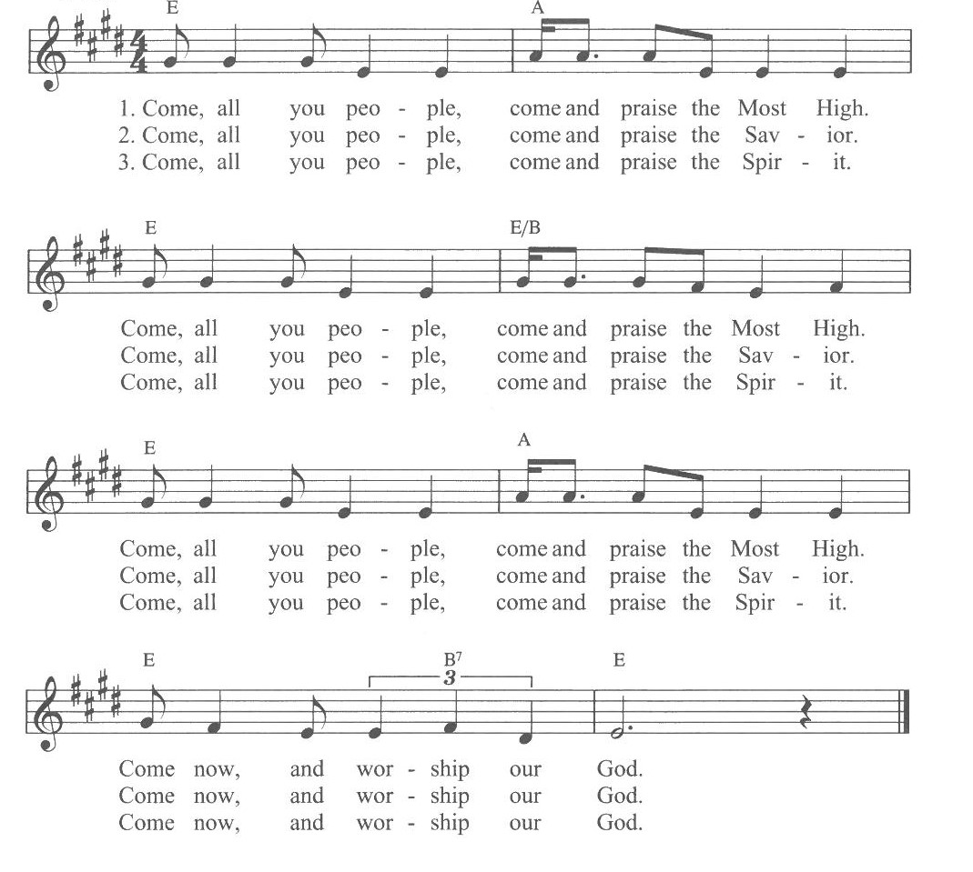

* RESPONSIVE CALL TO WORSHIP (adapted from Psalm 84)

One: Holy One, Spirit of Life and Love, you invite us into your dwelling places

All: and we are astounded by the loveliness of them.

One: Our soul longs to abide there with you where even the sparrow finds a home;

All: at your altars even the swallow may make a nest.

One: When we dwell in your house where all are welcome and all find sanctuary, we are nurtured and made strong;

All: and we can’t help but lift our voices in songs of worship and praise. Amen.

* HYMN 59: “Holy Spirit, Ever Dwelling” 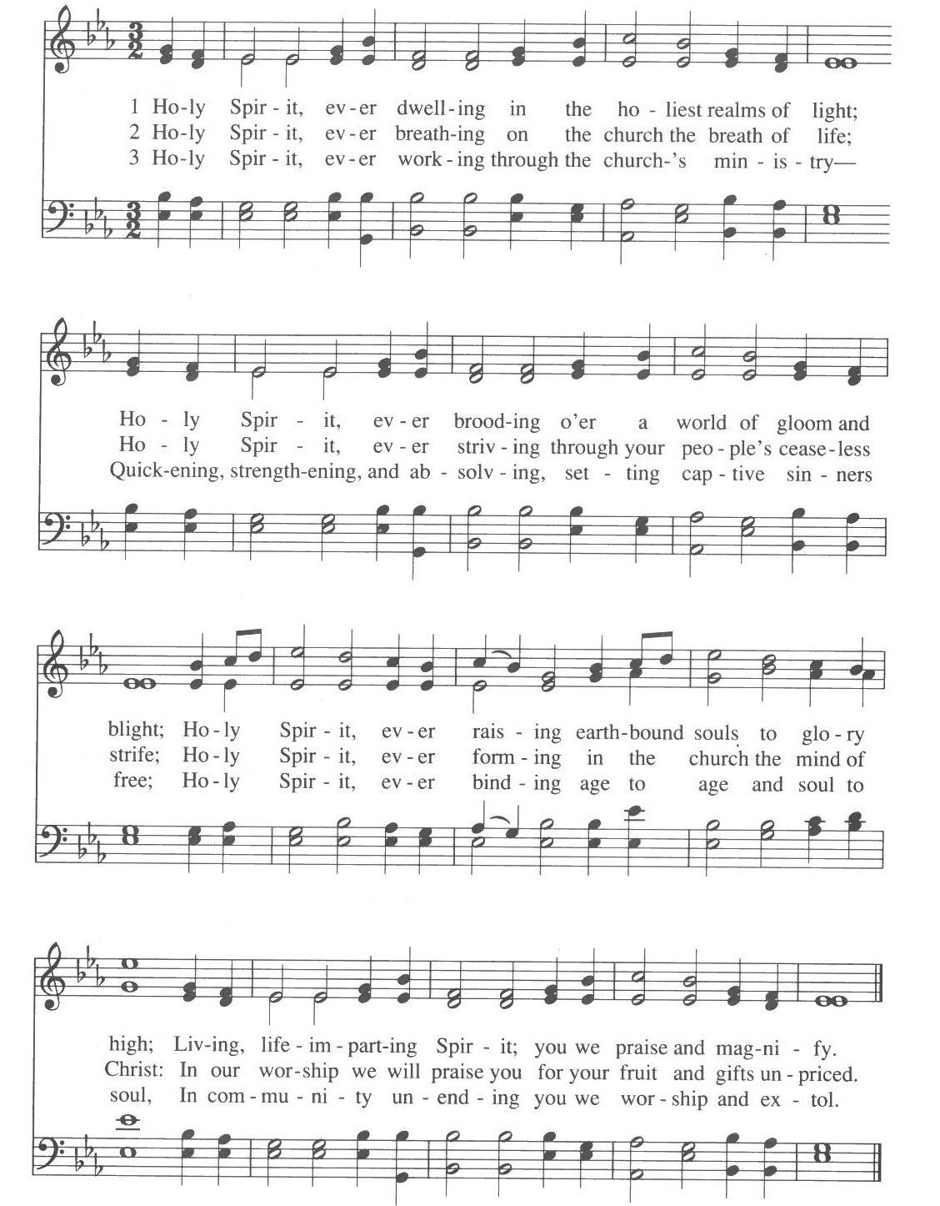

LIGHTING THE PEACE CANDLE

& PEACE PRAYER Laurie Lang

GREETING OF PEACE

In the same spirit in which we receive the unconditional love of God in Jesus Christ, let us offer to one another our own sign of peace.
One: The Peace of Christ be with you.

Many: And also, with you.

SPECIAL MUSIC Carson Schneider

TIME WITH CHILDREN

SCRIPTURE Luke 18: 9-14 (NRSV) Kelly Lundquist

[Jesus] also told this parable to some who trusted in themselves that they were righteous and regarded others with contempt.
“Two men went up to the temple to pray, one a Pharisee and the other a tax collector. The Pharisee, standing by himself, was praying thus: ‘God, I thank you that I am not like the other people—thieves, rogues, adulterers, or even like this tax collector. I fast twice a week; I give a tenth of all my income.’
“But the tax collector, standing far off, would not even look up to heaven, but was beating his breast and saying, ‘God, be merciful to me, a sinner!’
“I tell you, this man went down to his home justified rather than the other; for all who exalt themselves will be humble, but all who humble themselves will be exalted.”

SERMON “Humbling Prayer” Rev. Doug Federhart

* HYMN 521 “In Solitude”
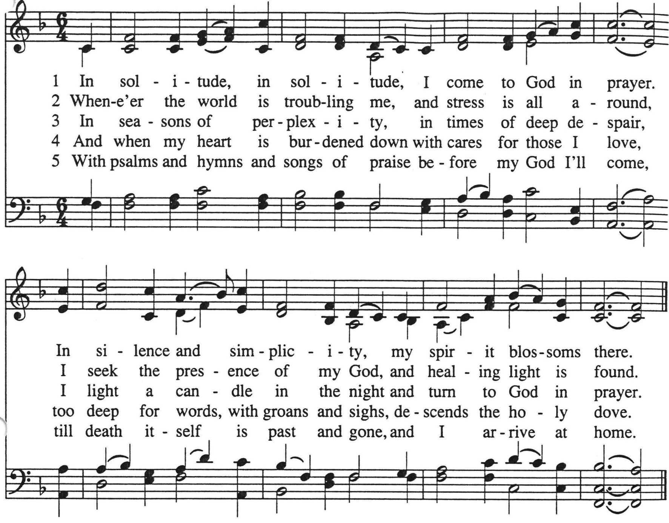

OUR TIME OF SHARING JOYS & CONCERNS, ANNOUNCEMENTS & PRAYERS OF THE COMMUNITY
Notes:

THE PRAYER THAT JESUS TAUGHT (adapted from Richard McCall)
Blessed One, our Father, Mother, Parent
Holy is your name.
May your love be enacted in the world.
May your will be done
On earth as in heaven.
Give us today our daily bread
And forgive us our sins as we forgive
those who sin against us.
Save us in the time of trial
and deliver us from evil.
For all that we do in your love,
and all that your love brings to birth,
and the fullness of love that will be,
are yours, now and forever. Amen.

INVITATION TO GIVE/RECEIVING OUR GIFTS

* DOXOLOGY SPP 143 “We Are Grateful”

PRAYER OF DEDICATION (let us pray together)

ALL: Accept these gifts, Holy One, given in thanks for all that we have received through your infinite generosity. May we in turn put them to good use towards our commitment to helping create a world where peace and justice abound. - Amen.

* HYMN 505 “Sweet Hour of Prayer”

BENEDICTION

POSTLUDE

All re-printed music is licensed under CCLI 11010370

Elk River Union Congregational Church, United Church of Christ: Visiting Pastor: Rev. Doug Federhart Deacon: Marce Ediger
Office Administrator: Giuliana Beckwith Liturgists: Laurie Lang & Kelly Lundquist
Piano: Carson Schneider Greeter/Usher: Jan & Larry Wick
Interim Senior Choir Children’s Time: …
and Handbell Director: Carson Schneider

Office Hours
Office hours for the church are Sunday 9:00am to 1:00pm before and after worship, Monday/Thursday 8:00am-2:00pm, and Wed 8:00am-3:00pm. Call the church at (763) 441-1203 if you have general questions. If you need immediate assistance outside of office hours, please email - churchoffice@elkriverucc.org.

Pastoral Emergencies
In the event of an emergency, an accident, or a death, please contact Patti Kubicka via text or call at 763-498-1196. You may also contact the church office though the response may take longer.

Church Materials
Copies of the Sunday sermon and bulletin are available in person or via Facebook, our website, and the UCC Squared Newsletter (email).

HOLDING IN PRAYER

(Cards and calls are appreciated)
Please keep in your prayers our congregation members: Nancy Hassett, Musz Bailey, Jim Babcock, Bobbie Berg, Susan Olsen, Joanne Burdick, Ruby Cawthra, Jane Houlton, Marion Marcott, Cheryl Wold, Judy Halgren, Bailey Rosdahl, Jimmy Stevens, Dee & Jim Stevens (Jimmy’s parents), Linda Fenton, Dave Halgren, Marv and Nancy Andersen, Laurie Lazaretti, and Jim Kopperud, Tony Rohs.

Reminder: Cards are available in the church office.

Member Directory:
The current online member directory is available on our website at https://servantkeeper.com/directory/elkriverucc/login.
The password is case sensitive: BeTheChurch

SCHEDULE FOR THE COMING WEEKS

Sunday, October 23, 2022
10:00 a.m. Worship Service In-person and live via Facebook with
Rev. Doug Federhart

Hospitality “Picnic in the Park”
Orono Park, Elk River
hosted by Congregational Life &
Stewardship

Tuesday, Oct 25, 2022
5:00 p.m. Congregational Life

Wednesday, October 26, 2022
3:30 p.m. SARI Vigil Sherburne
County Gov’t center
5:45 p.m. Handbell Choir
7:15 p.m. Senior Choir

Thursday, October 27, 2022
9:00 a.m.-2:00 p.m. Encore Ensembles
6:00 p.m. Girl Scouts
7:00 p.m Diaconate Meeting

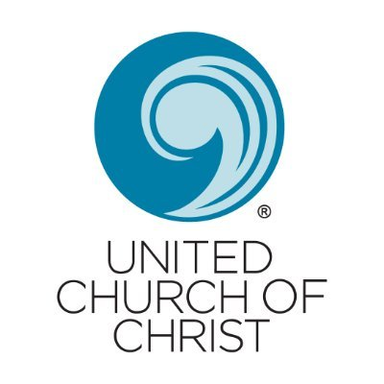

Sunday, October 30, 2022
10:00 a.m. Worship Service In-person and live via Facebook with
Rev. Lindy Purdy

Hospitality hosted by Stewardship
“Let’s Taco-bout Stewardship”

Wednesday, November 2, 2022
3:30 p.m. SARI Vigil Sherburne
County Gov’t center
5:45 p.m. Handbell Choir
7:15 p.m. Senior Choir

Thursday, November 3, 2022
9:00 a.m.-2:00 p.m. Encore Ensembles
6:00 p.m. Girl Scouts

Friday, November 4, 2022
6:00 p.m. Girls Scouts

Save the date:
Nov. 6th, 2022
All Saints Sunday

Nov. 10th, 2022
Council Meeting

