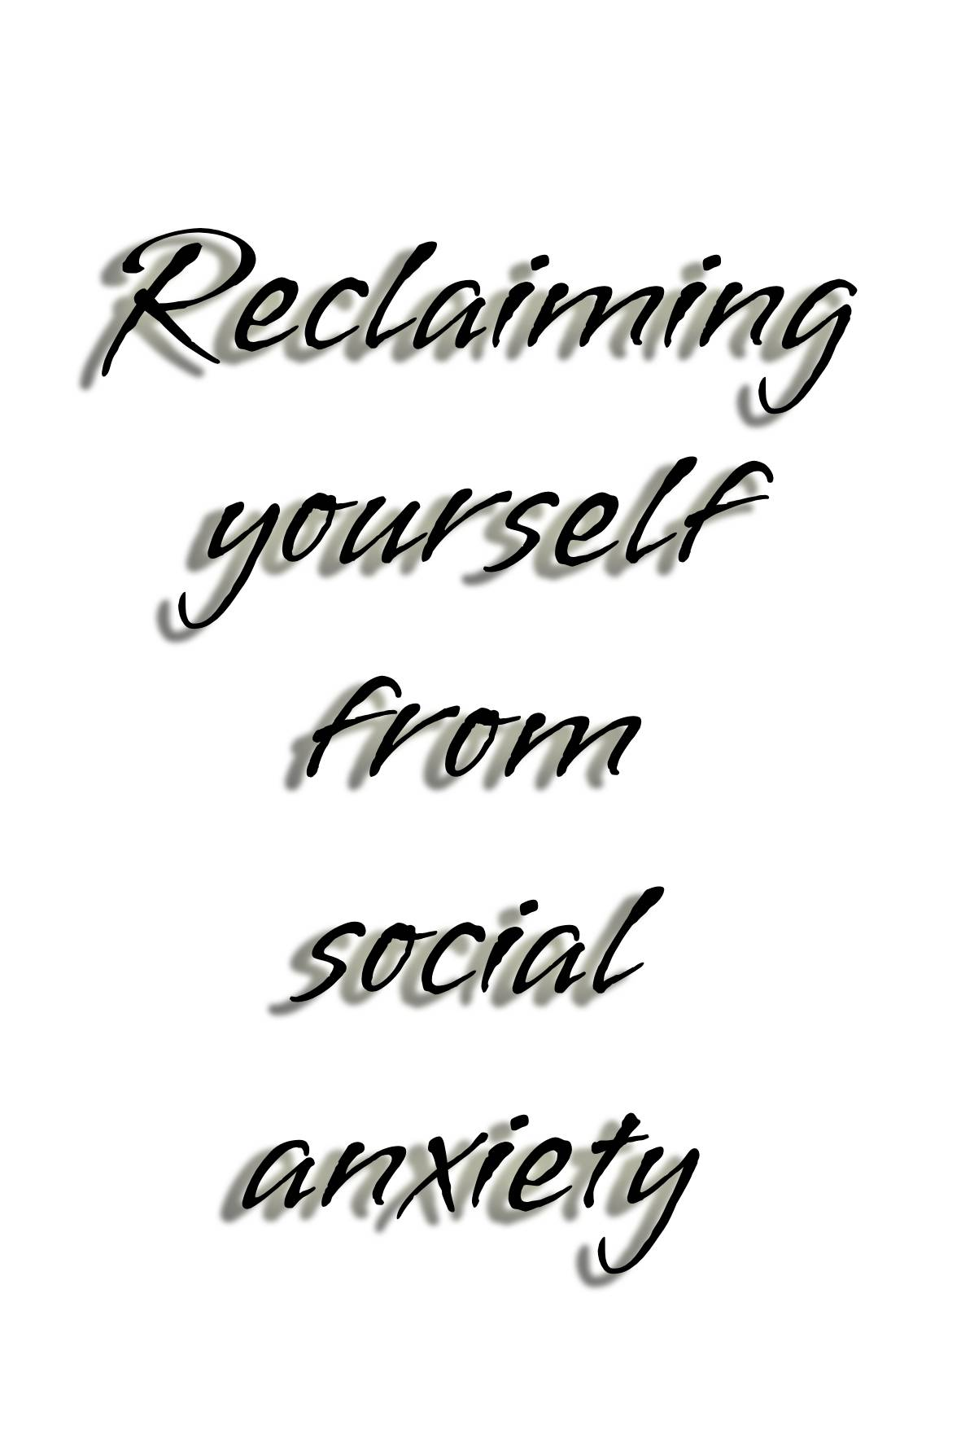

Introduction
Social anxiety coping methods and strategies is based on helping people manage their anxiety in everyday situations. This book is dedicated to help and assist those with social anxiety, which will provide them with ways on how to cope in social situations and how to manage it, no matter what the situation may be. These coping methods and strategies can be utilized to assist people of all backgrounds and all ages in overcoming social anxiety and managing a better life. No matter how severe your social anxiety is, this book will provide ways of coping with social anxiety.
I hope to achieve my goal in helping other people, whether you are a long-time sufferer or someone on the road to recovery to having better relationships, meeting new people and having a better social life in general.
This disorder is not very publicized, however with more recognition over the years with scientific studies, the term “social anxiety” has been more widely recognized as a legitimate medical condition that affects millions of people worldwide. By writing this book I also hope to raise awareness on the disorder, and to help as many people as I possibly can to overcome their social anxiety.
My personal journey as a long-time sufferer has not been an easy one, with its many ups and downs, but without the right help and support, I believe I wouldn’t have got where I am today, without my parents, friends and many other people that I must thank for helping me through this hectic lifelong journey. I believe that you can truly recover and eventually get to a better place. No matter how challenging or overwhelming the situation may seem, nothing is impossible.

Table of contents:
Chapter 1. Causes
Chapter 2. How It Feels
Chapter 3. Relationships
Chapter 4. Psychology
Chapter 5. Living with Social Anxiety
Chapter 6. Judgement
Chapter 7. Work Life
Chapter 8. Social Life
Chapter 9. Panic Attacks
Chapter 10. Depression
Chapter 11. The First Step
Chapter 12. Talking To People
Chapter 13. Moving Forward
Chapter 14. Taking Steps
Chapter 15. Challenging Yourself
Chapter 16. Trying New Things
Chapter 17. What’s The Worst That Can Happen?
Chapter 18. Getting Outside of Your Comfort Zone
Chapter 19. Exercise
Chapter 20. Social Groups
Chapter 21. Turning Inward Focus into Outward Focus
Chapter 22. Grounding Yourself
Chapter 23. Turning Anxiousness into Excitement
Chapter 24. 10 Seconds to Nirvana
Chapter 25. Self-pep talks
Chapter 26. CBT
Chapter 27. EFT (Tapping)

What is SA?

Social Anxiety disorder affects millions of people world-wide. According to studies, fifteen million people (around 7% of adults) in the US suffer from social anxiety disorder alone. One study has suggested that the 30-day, 12-month and lifetime prevalence of social anxiety disorder (SAD) are 1.3, 2.4 and 4.0% across all countries. Another study suggests that the global prevalence was slightly higher with more than 1 in 3 (36%) people meeting the threshold criteria for having SAD.
Social anxiety is classified as having an irrational and intense fear of being judged by people in social situations. Anxiety levels are elevated beyond the norm of what normal anxiety should be for the average person that is typically engaging in social situations. This irrational and intense fear can be triggered from a traumatic life experience, or it can be hereditary meaning it can be passed down from generation to generation.
There is no known cure for social anxiety, however there are ways to manage and cope with it throughout your life. It is not considered a life-threatening condition, but it can be troubling for those that have the condition and usually avoid social situations or interaction, to avoid the feeling of embarrassment or fear due to the symptoms they experience.
Symptoms may include clammy hands, heat flashes, excessive sweating, and elevated heart rate which can lead to hyperventilation and sometimes even panic attacks. These symptoms will persist or accelerate the more exposed to the social situation and even after exposure to the situation.
Eons ago, our ancient ancestors encountered many dangerous predators, which triggered a fight-or-flight response, which was an active defense mechanism vital for survival, to protect them from any danger that arose. In modern times however, this same fight-or-flight response for people with social-anxiety or hyper anxiety triggers this same defense mechanism but only with people, as a sign of danger. This irrational fear confuses our brains into thinking that people are a primal threat to our existence, and so avoidance of any social situation is inevitable.
People with social anxiety are also very inwardly focused on themselves, because of how they think they are being judged, so shifting this focus can be a challenge. This inward focus of oneself can only see the negatives because of fear of judgement and irrational thoughts perceived by other people. But, there are ways of shifting that inward focus outwards as well as other techniques to alleviate social anxiety.

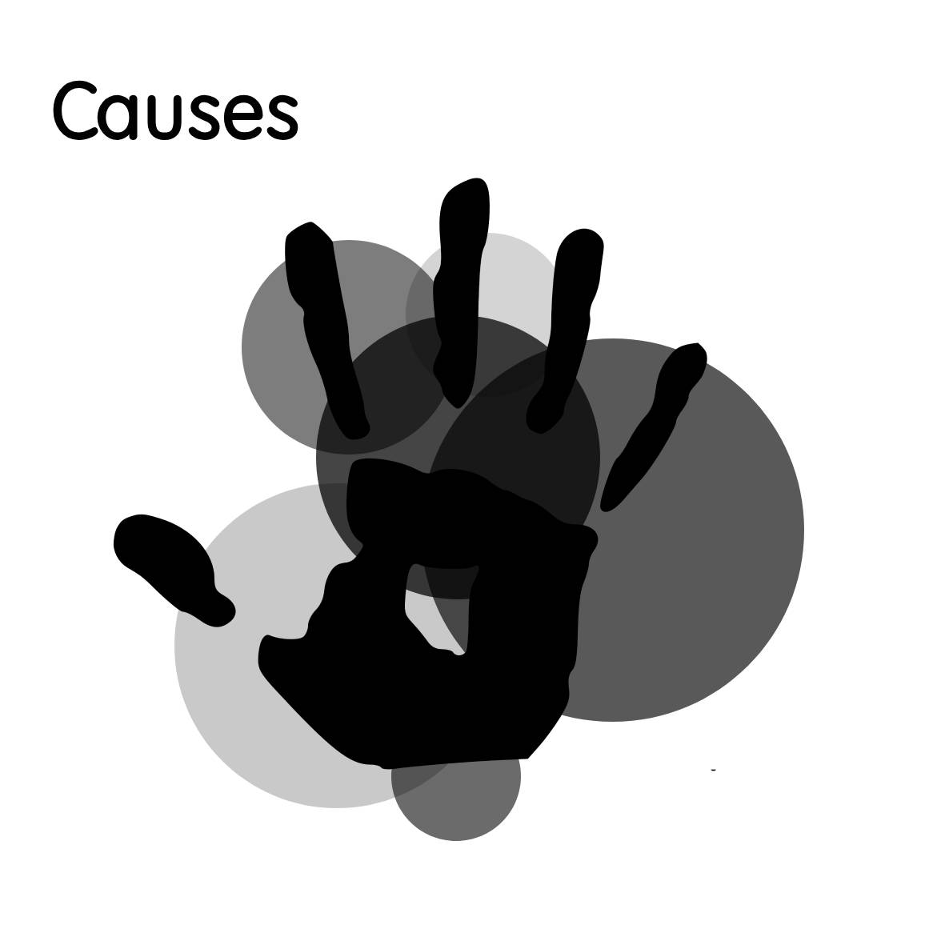

There are a number of causes that contribute to the development of social anxiety disorder which impact people differently. These causes that contribute to the development of social anxiety, may stem as early as childhood, from teens to even well into late adulthood, but can also be hereditary. Other factors that contribute to social anxiety may include certain conditions that are centered around physical and overall appearance particularly. However, no matter what the cause, the way people deal with social anxiety affects them differently. It can be easier to overcome for some or become a life-long hindrance for others.
Other causes include social or work experiences, environmental factors, societal and cultural influences, temperament, unusual brain functioning. In this chapter, we will get more into the main contributing factors and get more in-depth into why they develop.
Through research of how social anxiety develops, we can grasp a better understanding of some of the factors that come into play.
Environmental factors:
Parenting styles and the family environment have said to be one contributing factor to the development of social anxiety in children. Among the environmental factors include negative parental rearing practices. These include parenting traits where the parent is over controlling, has a lack of warmth, rejects the child as well as being over-protective. Other traits include neglect, anxious parenting, insensitivity, restrictiveness, social isolation, criticism, shame tactics, and concern over the opinions of others.
It has been studied that these environmental factors promote anxiety in a variety of ways. While over controlling a child can limit their ability to learn and develop new skills independently. A lack of warmth and rejection can create an insecure detachment of the child from their parent. Anxiety has also been evident in children that have had controlling parents, have been socially isolated, and have had anxious rearing from their parents.
While studies have been done based on the parenting style and relationship of the mother with children that have been impacted from social anxiety due to these environmental factors, studies have indicated that the father and mother share unique contributions in parenting styles. This may suggest that social anxiety could be contributed to children in different ways based on each of the parenting styles, but not enough data has been shown where one or the other parents have any more influence over the other with how they contribute to the child’s overall wellbeing.
Cultural impacts:
Cultural influences to do with a child’s upbringing have indicated this is another contributing factor to the development of social anxiety to do with parental behaviors and the role they play. Due to different societal conditions, rules and expectations in society with different cultures and different ethnicities within those cultures, this can lead to the onset of social anxiety.
Culture affects the way we think, feel and how we express emotions, and how anxiety is manifested within a culture, or cultures. Because of this, studies have indicated that people, particularly youths that have developed social anxiety are due to different cultural influences that have affected them. However, these influences can affect adults too.
Genetics:
It is believed that social anxiety can be a hereditary condition that is passed down from your parents through predisposition, if one or more have the condition, then the likelihood is greater of it being passed down to you. Although this may not be the sole cause for developing the condition, other factors may include environmental disturbances such as stress or negative impacts on mental health. One or the other (genetic or environmental) may have more or less vulnerability in triggering the disorder.
Appearance:
The way a person looks will also affect how they are, which is said to create social anxiety centered around their overall appearance, their body shape and the fear of being evaluated by others. This condition is also known as social appearance anxiety but can be correlated with social anxiety. “Social appearance anxiety is positively correlated with measures of social anxiety and negative body image” (Claes et al., 2012). This is understandable as how we look creates positive or negative emotions with how we see ourselves on the outside with the perception of what others may think of us.
This can cause someone that negatively sees themselves or with a negative evaluation to be very self-conscious and wants to avoid social situations in general as opposed to someone that does not have these negative emotions associated with themselves. However, this may not be a contributing factor, but could be a trigger, nevertheless.
Often, people that have a fixation with how they look would more likely be affected than those who don’t.
Negative Evaluation:
Negative evaluations of oneself are the fear of being negatively evaluated by others in social situations. One has “heightened” fears in which the individual may be evaluated. “The fear of negative evaluation (FNE) is considered to be a hallmark of social anxiety. Cognitive theories posit that this fear may result from biased information processing, particularly when anticipating a fearful event” (Clark and McManus, 2002). It is also noted that, “Socially anxious individuals exhibit maladaptive appraisal of social situations, which is characterized by the selective retrieval of negative information about themselves” (Rapee and Heimberg, 1997).
Traumatic experiences:
Traumatic events in a person’s life may lead to the onset of social anxiety. These events may include stressful situations particularly in the development of a child but may also affect those later in life. These traumatic life experiences will create adverse effects on a person’s mental health due to increased pressure which leads to stress.
These stressful life events can include anything from embarrassing social situations, family dysfunction, bullying and sexual and physical abuse.
Work or social demands:
Certain workplace situations or other social situations may lead to the onset of social anxiety (or chronic anxiety) due to anxiety or work induced stress. These situations may be demanding and become overwhelmingly stressful and create elevated levels of anxiety due to social pressure. It could be anything from a presentation, public speaking, a demanding work schedule, or stress in the workplace.
The impact of stress in the workplace that is both physically and mentally demanding with unhealthy levels of stress can create a major impact on one’s health. Productivity, among other things may be disrupted due to these stressful work and social demands.
This may also include other conditions besides social anxiety that are developed from work induced stress as well as other demanding social situations which may trigger PTSD which includes chronic anxiety.
Unusual brain functioning:
Brain functioning is another factor in which social anxiety may be more susceptible to those with abnormalities or with abnormal brain chemistry such as chemical imbalances.
These abnormalities may affect the neurotransmitters in the brain that collect and process information particularly for decision making. The amygdala is also responsible for the “fight-or-flight” response that is triggered when a perceived threat emerges due to physiological changes in the brain.
Temperament:
Temperament may lead to the onset of social anxiety. Temperament is one of many things that shape our overall personality and affects our behavior of how we react to the world and certain situations.
Early childhood development can be a precursor to how children respond to certain situations, either social or non-social. Different “personality traits” are then shaped, which can develop well into adulthood.
However, there is much discussion between personality and temperament, and how they are connected, but it is said that temperament is what you’re born with, and that personality is what develops over time.

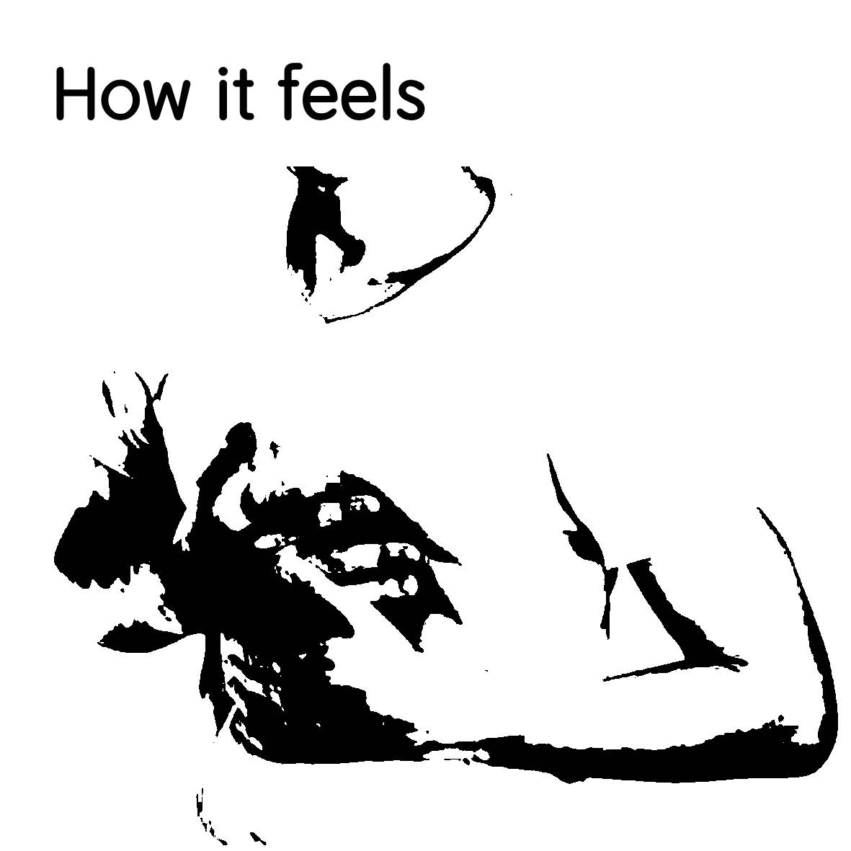

Developing social anxiety is different for everyone and can affect them in different ways. It can be an overwhelming experience, with confusion as you go through the changes. It is a process that may take place over a very short period or happen out of nowhere.
The different stages of social anxiety to most likely to develop is broken down into different stages. Before the situation that takes place, during the situation that you are exposed, and after the situation in which you have been exposed to.
To better understand the different stages, read below:
Stage 1 The anticipatory stage. This is the stage where you foresee the event taking place before it actually happens. Usually, you imagine a scenario where you don’t meet the expectations of others and are judged by not performing well. These negative thoughts of how you might be viewed or evaluated create a heightened sense of vulnerability. You may feel as if the situation will be challenging or even unbearable.
Stage 2: Exposure to the situation. This is where you have heightened anxiety about a situation that cannot be avoided, having worried about it beforehand. Your worst fears are now a reality. You are looking for perceived threats from external sources. At this point, your anxiety becomes consuming, and your thinking becomes illogical. Your fears of not being accepted are all too prevalent. You have heightened anxiety of being evaluated by others.
Stage 3: Processing the event after, or post-processing. This is the stage after being exposed to the situation that triggers the onset of anxiety, which create heightened levels of anxiety. The fear has not yet ended. You replay the situation over repeatedly in your mind, of everything that possibly went wrong due to an unbiased view of negative emotions of yourself and your performance. You count every minute and every detail of what happened during your performance. You start to feel shame and disapproval of yourself, and your anxiety increases. To avoid this feeling again, you want to avoid all future social situations.
Despite these different stages, this could also be the cause of an instantaneous reaction to the situation that happens unexpectedly without anticipating the actual event, which follows the post-processing of the event, without the anticipatory stage.

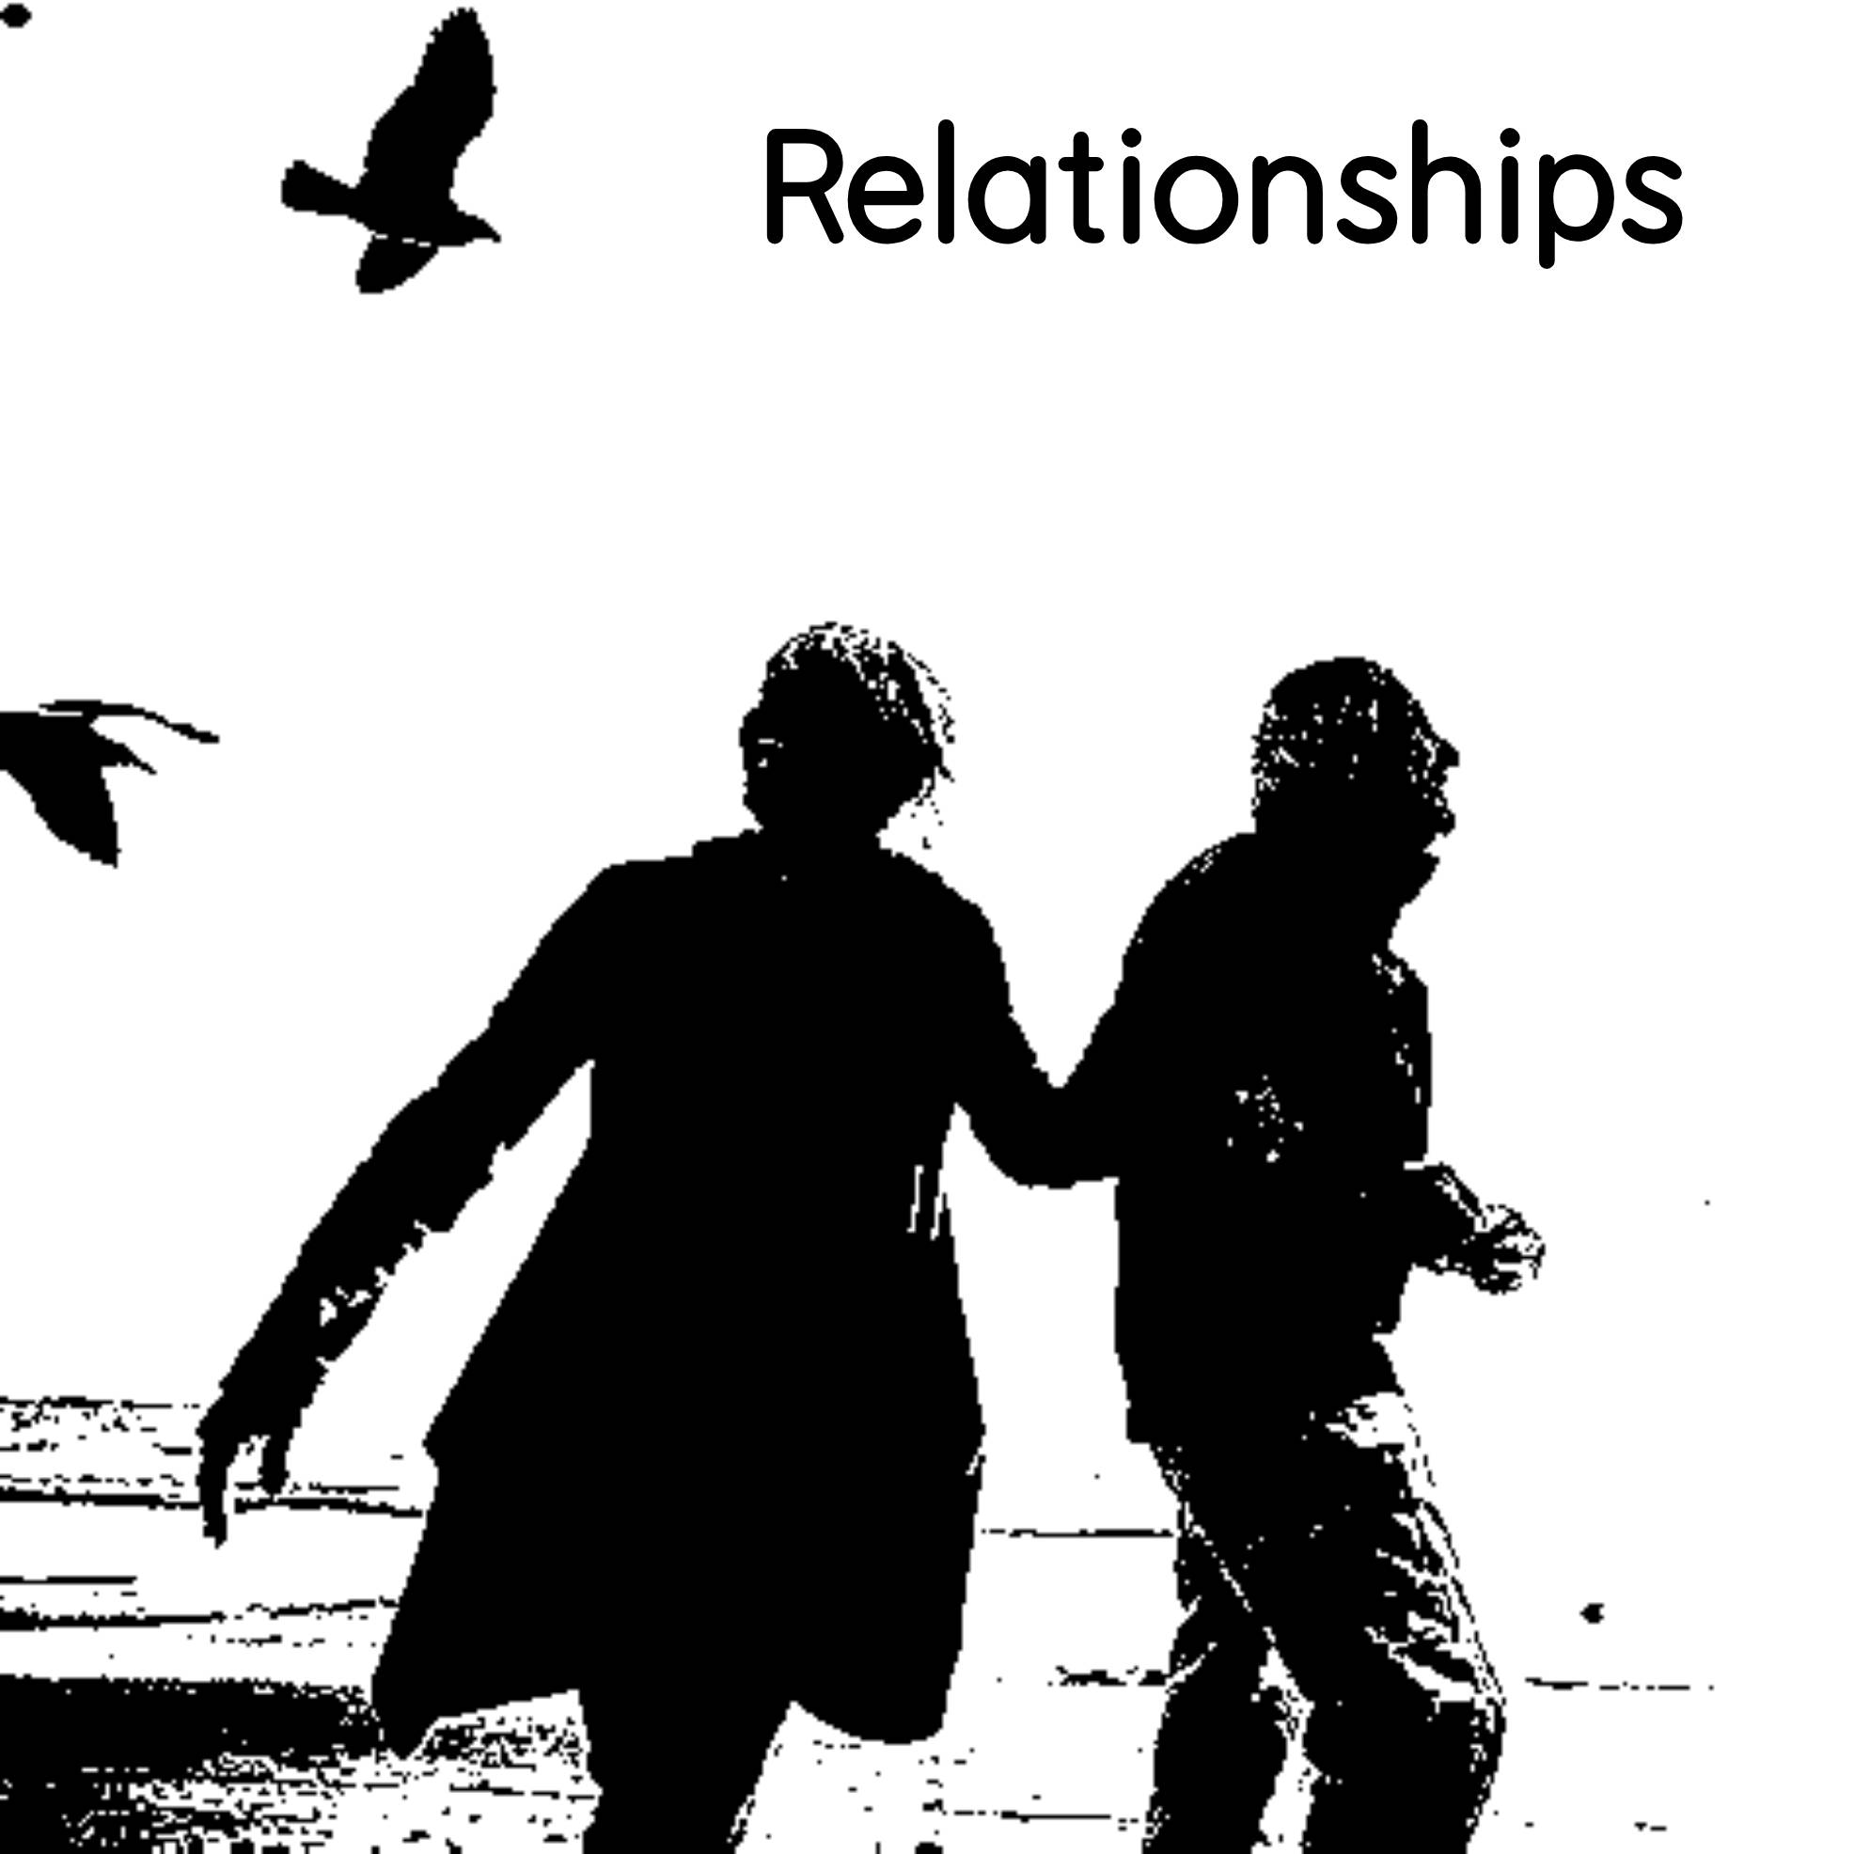

Social anxiety forces many people to take extreme measures in avoiding social situations in as many ways as possible in all aspects of life. These aspects may include all social activities related to family and friends, being around others such as peers or colleagues, and social media. Common repetitions and procedural patterns may become persistent over time, due to avoidance in these areas. These actions of consistently avoiding people and social situations of the individual may possibly lead to future implications – particularly with relationships.
For those that undergo the many changes faced with social anxiety may find it an incredibly challenging experience. Mainly those that have never experienced it beforehand. This experience that one will endure, may follow a process of these changes, whether sudden or gradual over time.
Although everyone is different, it is understandable that the way social anxiety affects someone mentally, may depend on their personality and character traits in how they handle certain social situations, since some people are more naturally reserved, and others are more outgoing. Because of this, some social situations may be harder to cope with than others.
Depending on the severity and state of social anxiety, it could cause someone to resort to certain measures, whether partial or extreme, such as becoming totally withdrawn from the world in complete and utter isolation, or becoming overly dependent on certain drugs or medications, as well as other people.
One major aspect that one may suffer is the loss of relationships due to anxiousness, which may slowly deteriorate, and become almost non-existent, resulting in isolation. This might cause people to create methods that are designed around avoiding communication, which can create serious issues, leading to a gradual breakdown in these relationships.
These issues may include ways of coping with other people, or in social situations such as a lack of eye contact, softness in voice and selectively talking to certain people to avoid being negatively viewed or judged by others.
Trust can be another factor that people with social anxiety tend to struggle with in relationships, particularly those in close relationships because of difficulty in trusting others. This can create unhealthy thoughts of anxiety, especially inadequacy towards a romantic partner in the belief that they may be unfaithful, want to cheat, or may want to leave. This is one of the hurdles that must be overcome, in the hope of maintaining a healthy, close relationship.
This unneeded anxiety can become emotionally draining, leading to unhealthy levels of stress, both physically and mentally because of being consumed by these thoughts and feelings that constantly persist.
People that don’t have close relationships, but want to pursue them, particularly romantic relationships tend to struggle in this area because of trust issues, resulting in avoiding or finding any sort of romantic partner from irrational fears and thoughts brought on by anxiety.

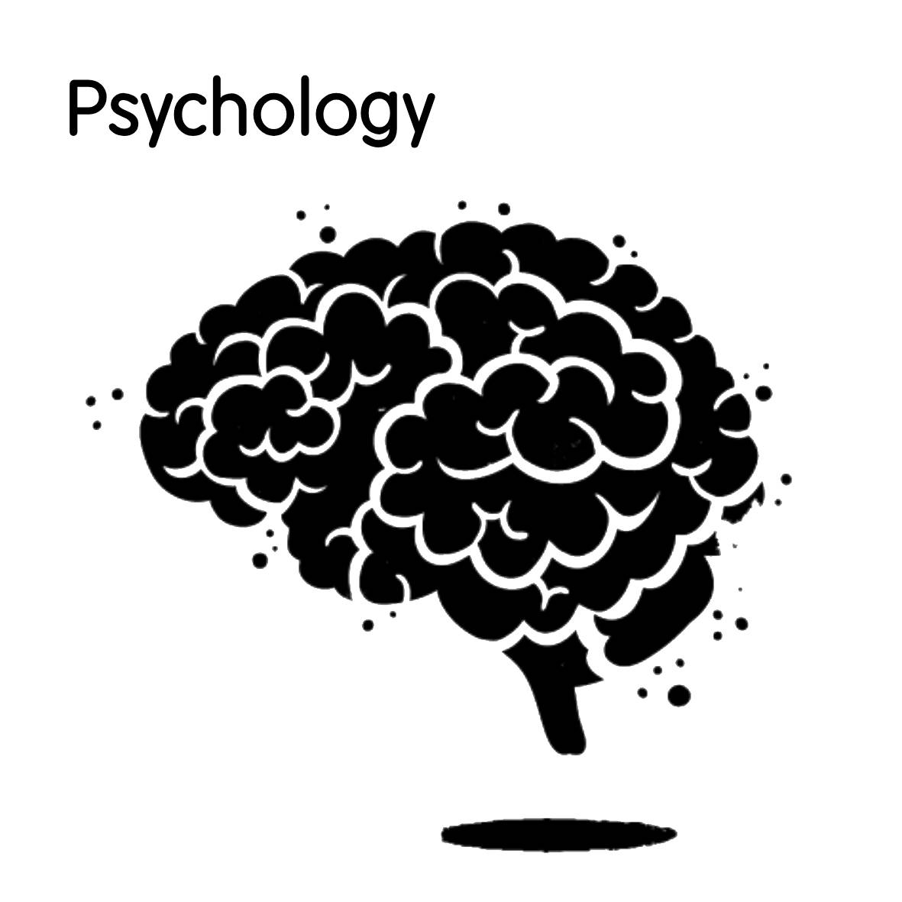

The psychological impacts of social anxiety can be incredibly distressing. It can be detrimental to one’s health, particularly because of how stressful it can be to cope with everyday situations. The amount of stress can often become debilitating and overwhelming when faced with a social situation, due to increased societal pressures. This may cause the individual to take drastic measures in trying to avoid situations altogether, or by escaping the situation by any means necessary. This may include leaving a speech mid-way, leaving a gathering early or hiding in the restroom during a social event.
A bad or traumatic experience can have lasting effects on the individual, which can control and ultimately dictate their life. The individual will become incredibly avoidant, to not want to engage in any future social situations because of the negative experience they once had. The extreme fear of being judged negatively or evaluated by one’s social actions, will persistently remain. The feeling of being judged or evaluated will create worry and embarrassment or feeling humiliated in front of others.
Vulnerability is another response that will kick the body into a fight or flight mode to mobilize the body to avoid any potential threat possible. This vulnerability will lead someone to overestimate the threat of the social situation, becoming overly hypervigilant and underestimate their ability to cope with the situation.
When experiencing this, the mental state will therefore trigger physical symptoms associated with social anxiety, which will lead to a combination of blushing, sweating, trembling, shakiness, lack of eye contact, increased heart rate and rapid breathing motions. These symptoms may become more than noticeable and apparent and may progressively get worse, the longer the exposure to the situation.
Compared to a person with normal levels of anxiety, most, if not all social situations do not interfere with their daily tasks and functioning. These daily social tasks or interactions do not negatively impact their life but may at the most create very mild to low moderate levels of fear or apprehension as well as mild to low moderate sensations such as muscle tightness and sweating.
This being said, people with social anxiety can have different levels of anxiety ranging from low, to mild, to even severe. People with low to mild levels of anxiety may attend and endure all social situations or attend certain social situations more than others with mild to moderate levels of anxiety. People with severe anxiety, tend to avoid as many social situations as possible due to adverse reactions such as the physical symptoms they exhibit.

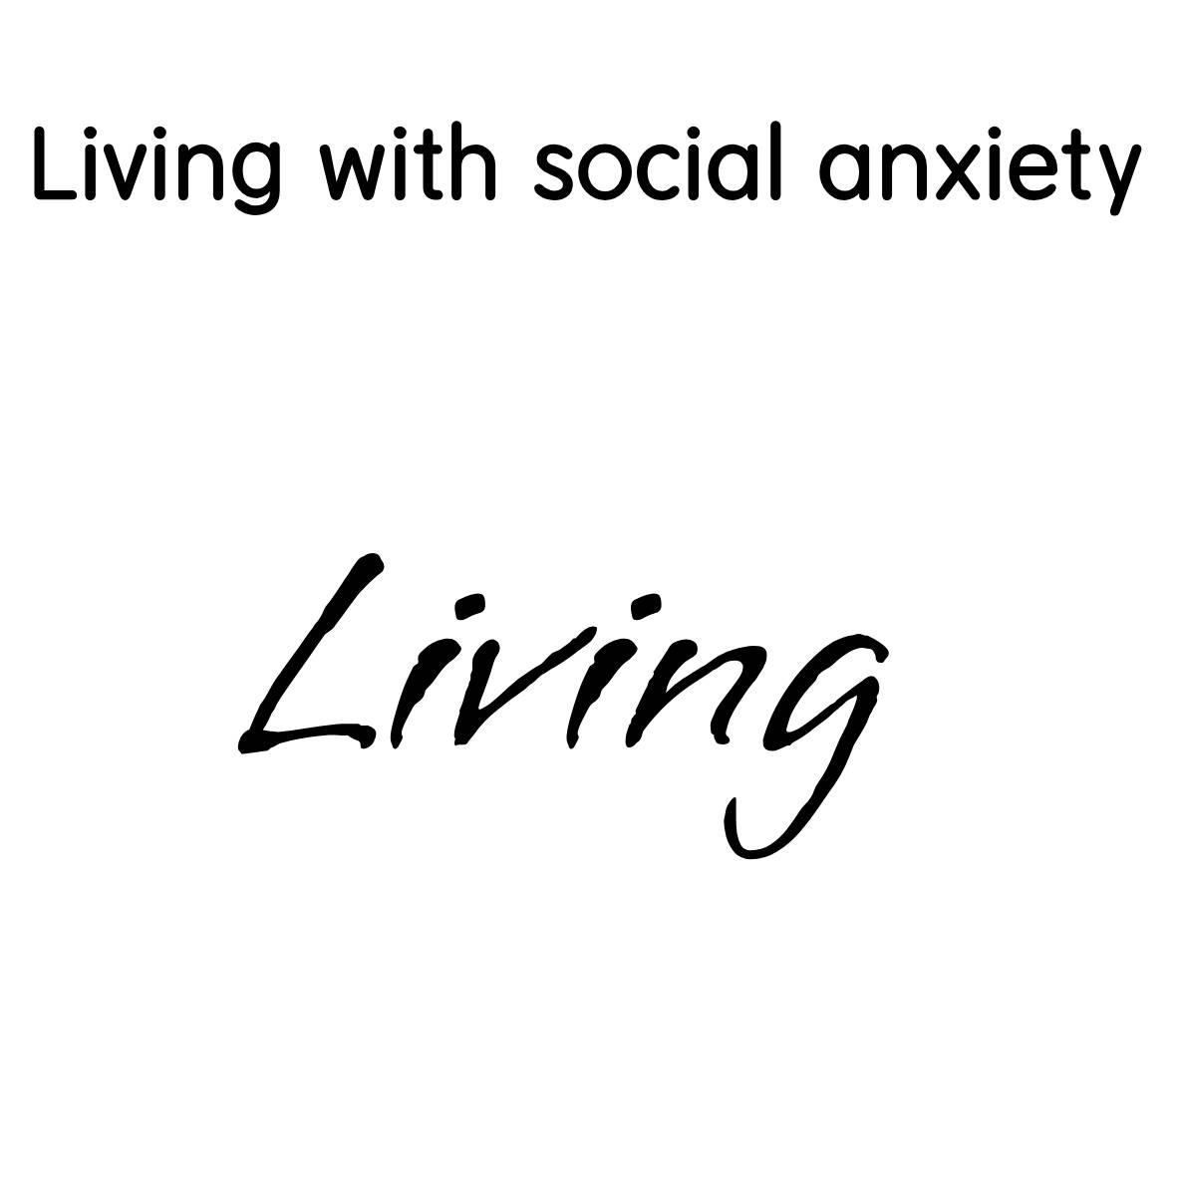

People that live with social anxiety from day to day, may find it a continuous struggle to get by, whether it is managing daily tasks, dealing with personal relationships, social gatherings and outings, or work-related activities. All of these, whether personal or interpersonal, can become very challenging and can be mentally and physically draining for the individual.
Due to societal demands, and a busy work schedule, people are more under pressure than ever before, to perform a certain way, act a certain way and conform to social norms, all the while trying to maintain a healthy balance in all aspects of life, such as work, fitness, relationships, health and emotional wellbeing. Besides finding this balance, people are expected to manage their personal responsibilities such as booking appointments, grocery shopping, making phone calls, running errands or anything that requires face to face contact or social interaction in a social environment or setting.
All these daily tasks and activities take up a lot of energy, which can lead to burnout or fatigue due to social exhaustion. This is typical for both introverts and extraverts, when faced with social overstimulation which can be both mentally, emotionally and physically draining particularly in socially demanding environments. However, people with social anxiety find it incredibly more demanding, because of the toll social anxiety takes on their emotional health. People that are faced with this overstimulation particularly those with social anxiety may experience increased tiredness, moodiness, anger, stress and irritability.
Since society encourages social interaction and stimulation, it is not surprising that these demands can impact someone with social anxiety so easily, both in and out of the workplace. Although this can happen to nearly anyone due to overstimulation. People that are overstimulated however due to burnout or fatigue will usually crash or be on the brink of a meltdown. This can lead someone to become more avoidant and not want to socialize because of a lack of energy, motivation, anxiety, feeling hopeless and helpless, detached and depressed. The individual will also feel the need to withdraw from society. Depending on the level of anxiety and the individual, this could become a regular occurrence, which may significantly last over time. Relapses are a common occurrence associated with social withdrawal, triggering the same symptoms, which is a complete return of the old ways of thinking and behavior due to anxiousness and fear of socializing.
This ever-demanding cycle of daily life takes its toll on one’s mental health. People may choose ways in which they communicate, through means of online communication and interaction, such as social media and online instant messengers, where they may find it easier to express themselves, rather than face-to-face interaction. It significantly reduces the fear of one being judged, since social anxiety is differently manifested through these means of interaction, limiting worry of displaying social cues, which remain absent in online environments.

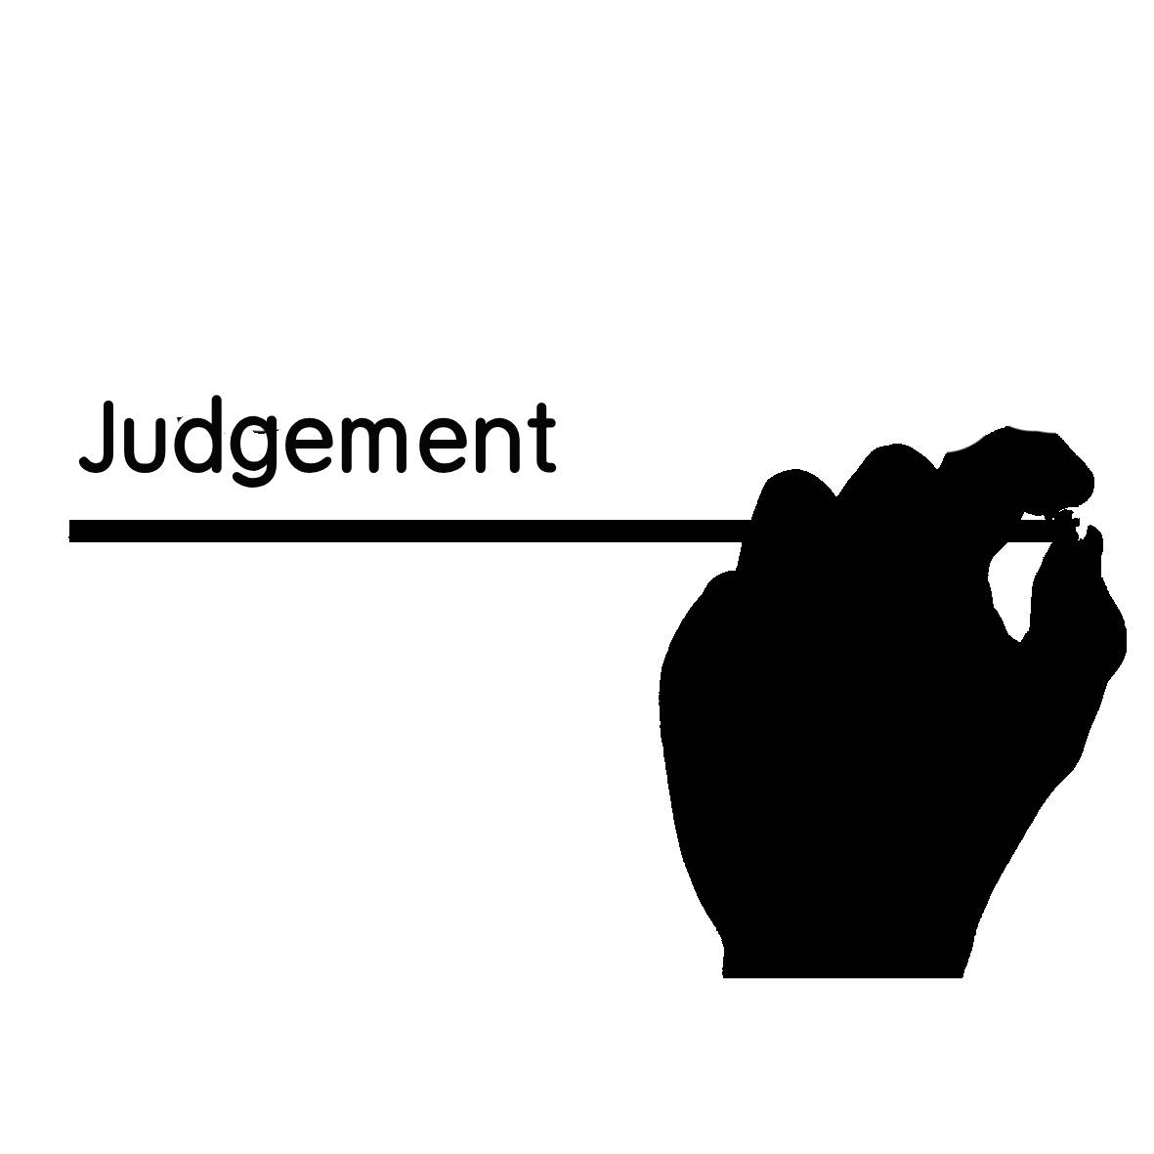

Judgement is a major problem for people with social anxiety. It is a relative term in society. Since birth, our experiences, opinions and inner thoughts shape our character. We may seek validation in society, by comparing ourselves with others. However, judgement is much like a reflection of ourselves, and how we compare other people. How we see a person, whether we criticize or negatively evaluate them is a form of judgement. Everyone judges someone for some sort of valid reason, and morally, it’s acceptable depending on the type of judgement.
However, people with social anxiety become increasingly insecure with themselves, and develop a negative conformation bias that consistently paints themselves or other people in a negative light. One’s beliefs may become so deeply engrained due to their negative experiences, that any new experiences become a prediction because of any prior experiences they once had, evoking the same emotions associated with those negative past experiences. Fear is the most frequent emotion that is remembered associated with these past experiences.
Self-doubt is another affirmation that affects those with social anxiety. This usually goes hand in hand with judgement and the affirmation of negative experiences create insecure emotional attachments such as that of being criticized. This creates a lack of confidence associated with these insecure attachments. This can create an unhealthy level of uncertainty, especially with one’s own shortcomings and ability to handle social situations. This hindrance prohibits a socially anxious individual from denoting social cues, because their judgment becomes clouded. This is due to misreading people’s emotions when entering the fight or flight state.
People without social anxiety, do not have this negative affirmation as nearly to the extent of a socially anxious person, and therefore negative past experiences have not usually affected them, and their overall ability to handle social situations and recognize proper social cues is not severely limited. As mentioned, this has a lot to do based with the experiences they once had, their inner thoughts related to those experiences and the personality traits they have depending on the individual.
It has been studied that people with social anxiety exhibit increased levels of reaction time of processing speed with processing people’s emotions related to social cues. This is to do with sensory overload and can affect judgement due to fight or flight as just mentioned. Anxiety levels to do with the amygdala kick off the feeling of fight or flight to these increased reaction times. The amygdala is the region of the brain for processing emotional responses such as fear, anxiety and aggression. Threat-based behaviors are then activated with these responses in perceived threatening or dangerous situations.
This fear-based response of being judged can also have lasting effects that can remain persistent over time. This can elevate cortisol levels, which can lead to chronic stress that can disrupt someone with social anxiety in all areas of life, such as work, school, and all other social activities. People may feel like they have a lack of self-esteem, due to low self-confidence of being judged – or criticized. This can create self-consciousness in an individual, that makes them critical of every move they make.

Self-affirmation or self-awareness techniques may be used to help manage this and reroute thinking patterns and thought processes that trigger these negative thoughts which lead to judgement. This can help train the mind to deal with negative emotions associated with being judged, making someone less reactive in fearful situations. For example, instead of feeling down about yourself or thinking that you are a failure or cannot achieve anything, you should use positive affirmations with the words, “I am…”, I can…”, or “I will…”.
An example of this is, “I am more than capable of achieving this”, “I can absolutely do this”, or “I will achieve this no matter what”.

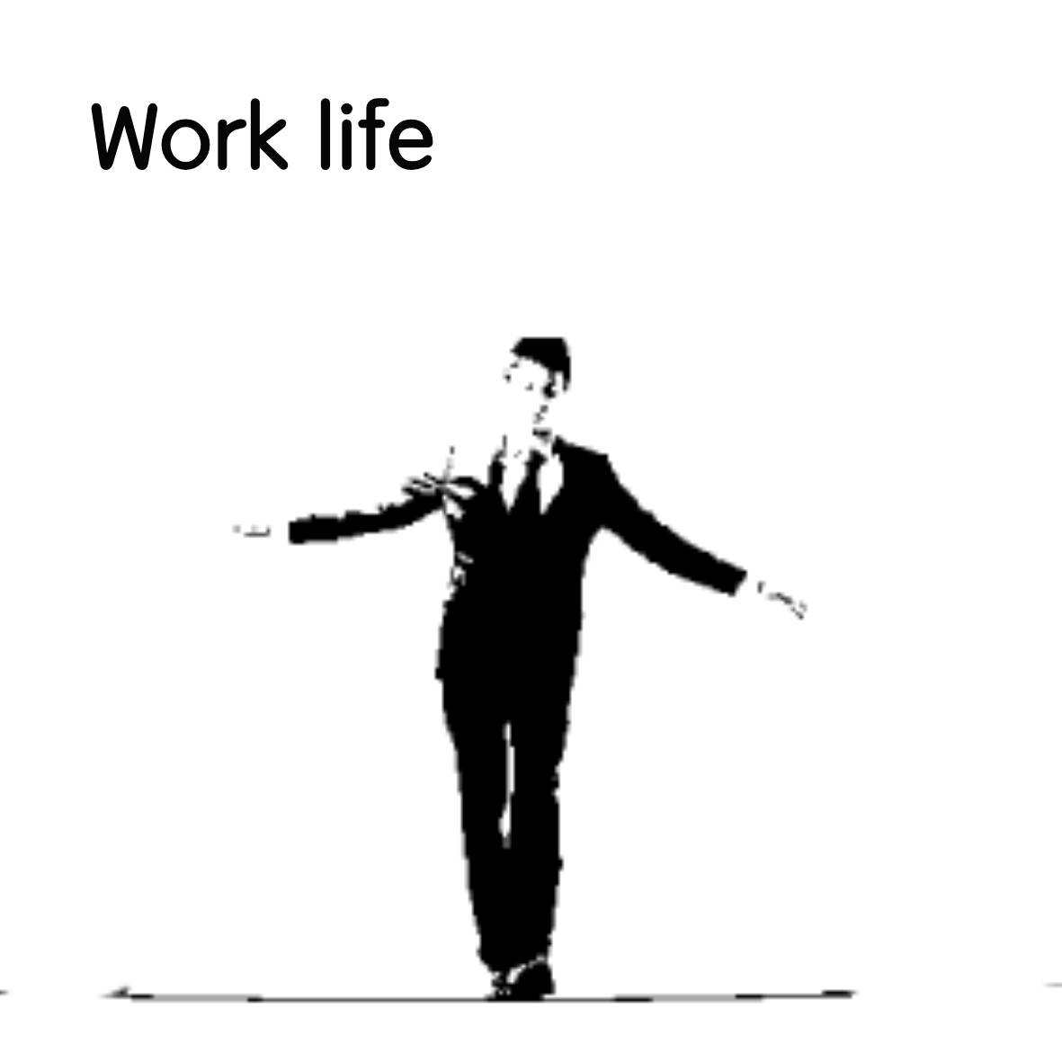

For people in the workplace that have social anxiety, there may be certain challenges with how one interacts within the work environment, whether it’s dealing with colleagues, clients, or following group norms due to peer pressure, or handling interpersonal skills. Unlike in the workplace, besides managing deadlines and a busy work schedule, managing tasks in daily life may become socially demanding, depending on the lifestyle one chooses. People with different personality traits, may have a slight advantage, especially those that tend to be more outgoing whereas people that are far more reserved on the social scale, may exhibit lower levels of social interaction than their colleagues making it far more demanding to maintain social interaction overall.
Those that do exhibit lower levels of interaction, often at times, may not appear to be socially anxious, and in more ways than often, can manage it well, but may find ways to mask it, as a type of adaptative safety behavior, to appear as normal and functional as possible, or to only display parts of themselves that they would otherwise not show in public. This method of only displaying certain parts or characteristics, may be used to avoid embarrassing themselves or to selectively compensate on how they communicate with others. One may also take on an adaptive role – like acting, where they display only the best version of themselves for the role or position they’re in, as a way of managing their anxiety. This is part of masking. When someone plays a role or a position, they create another version of themselves to fit that role.
People that are less socially reserved, may function quite normally in a work environment compared to socially anxious people, and are usually more comfortable in a more socially demanding environment, depending on the severity of their social anxiety. These types of people may seem quite outgoing at work as well as their personal life, compared to those that have certain safety behaviors, to avoid one or more situations over another because of the difficulty they have socializing. Because of certain situations in the workplace that may become unavoidable, such as work meetings or conferences, this still may be challenging to these types of people but can otherwise endure it.
Fear of authority is also quite prevalent in the workplace for those with social anxiety, because of a lack of confidence or inferiority around people like their managers or bosses. This may be deeply rooted from a childhood trauma, from overcontrolling or overbearing parents, as such authority figures in their lives, and may have negative feelings towards other people that have an authoritative role. The same feelings of being judged or scrutinized, or reluctant to express opinions or emotions towards these authority figures may result in feeling embarrassed, humiliated or looked down upon.
Because of certain limitations that one experiences with social anxiety in the workplace, may result in limited opportunities. One may get by with their daily tasks, but get stuck in the same rut, and just scrape by. This means never wanting, or avoiding getting promotions, which entails handling new responsibilities and by not excelling due to the inability to work effectively. One may also be limited by the number of contacts in their social network.
Someone with social anxiety may have difficulty in attaining the preferred job of their liking, as well as diminished job opportunities. One of many, or a variety of reasons may inhibit one with social anxiety with finding employment, because of a lack of education, skill set, motivation or lack of job aspirations could be determining factors. Another restricting element for one not seeking employment may be financial dependence, avoidance, or dependence on others.

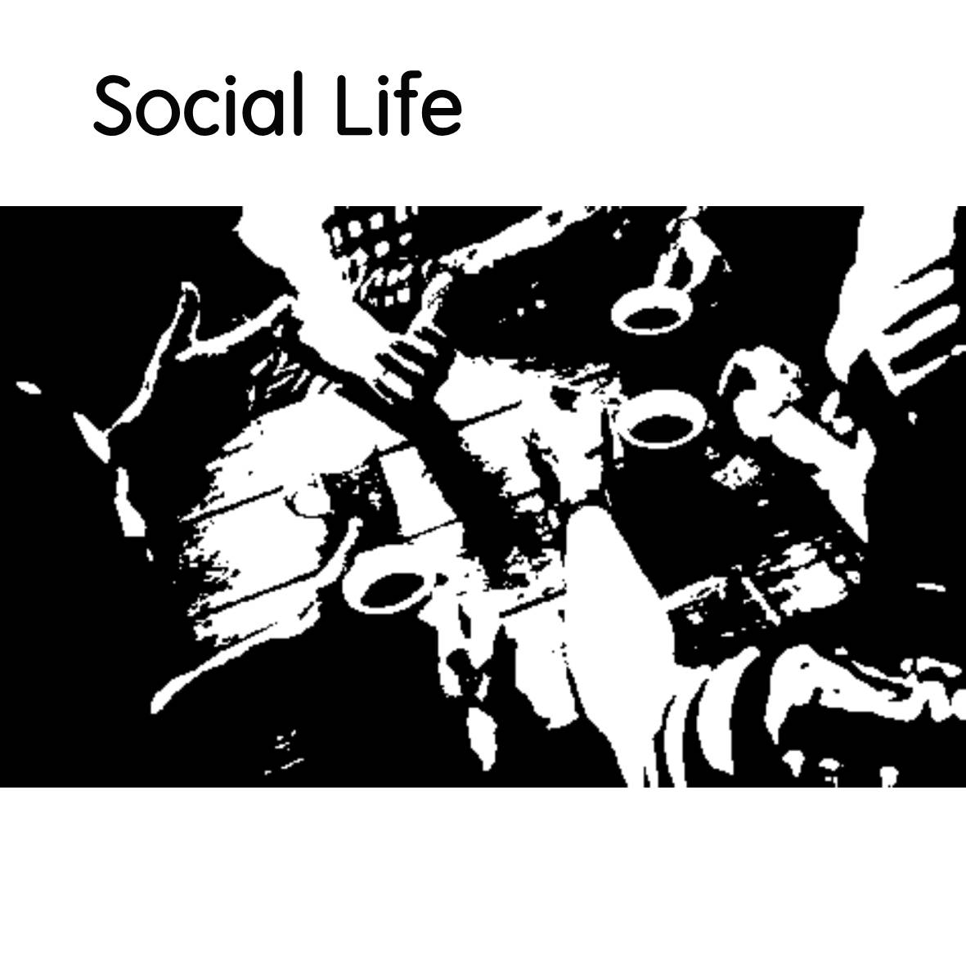

As mentioned previously, one’s social life may be crucially impacted by social anxiety, depending on their level of severity they have, which can influence their social lives in all areas of life. Living with social anxiety can be very limiting, constricting and debilitating for one to manage. Coping with it in can be unsettling for someone that feels uncomfortable in social situations, no matter what and where they may be. One may have had social anxiety beginning from a young age, and become very reserved and isolated over time, or may have developed it later in life, but whenever it has developed, one’s social life may be forever changed.
Social anxiety is a life changing condition, and cannot be cured, but can be managed over time, meaning one may still be able to acquire a certain degree of functionality in life, and not be crippled by it, and some stability in one’s social life may be still attainable. As social skills are important in the functionality of one’s life, and are considered as invaluable skills, the ability to socialize and communicate with others effectively comes with its benefits – such as, the ability to have meaningful conversations with others, form positive and fulfilling relationships and bonds with other people, develop body language skills, and communicate effectively with others. For kids, it is just as more or equally as important, as they learn how to play and socialize with each other, share, develop cognitive skills and abilities and supports overall positive mental health.
One may often have trouble making friendships, or maintaining friendships and relationships, but keeping these relationships may be harder for those especially with social anxiety. Some people may have no trouble making friendships but have trouble keeping these friendships or relationships going. It all depends on the person and the severity of the anxiety that they have, and how and when it is manifested.
Lack of or insufficient social skills and abilities can come with its consequences, but more so for those that suffer from the inhibitions of social anxiety. For the individual, social estrangement could result, which could lead to loneliness, isolation, depression, reclusiveness, substance abuse, lowered self-esteem and emotional distress. Work ethic may also be affected as well as academic performance and overall well-being.
Future success may impede those, due to the inability to interact and communicate, which may result in increased peer-rejection, decreased job offers and work opportunities. Whether inherent or not, social anxiety can act as a deterrent against success in these areas.
The impacts of these social limitations that inhibit one’s functionality of social skills, may cause a significant degree of stress related issues, change in temperament and overall wellbeing such as depression due to isolation and loneliness. Depression can also create a perpetual cycle that is linked to poorer social skills which lead to a degression of overall physical and mental health.
Because people with social anxiety are more prone to depressive disorders and are more susceptible to loneliness due to the lack of relationships they experience, inability to communicate, share common emotions and form meaningful relationships as basic human needs, can create a constant void of continuous stress and worry that never goes away. This void is always empty, and the stress related issues come as a result of never finding these relationships or connecting with other people.

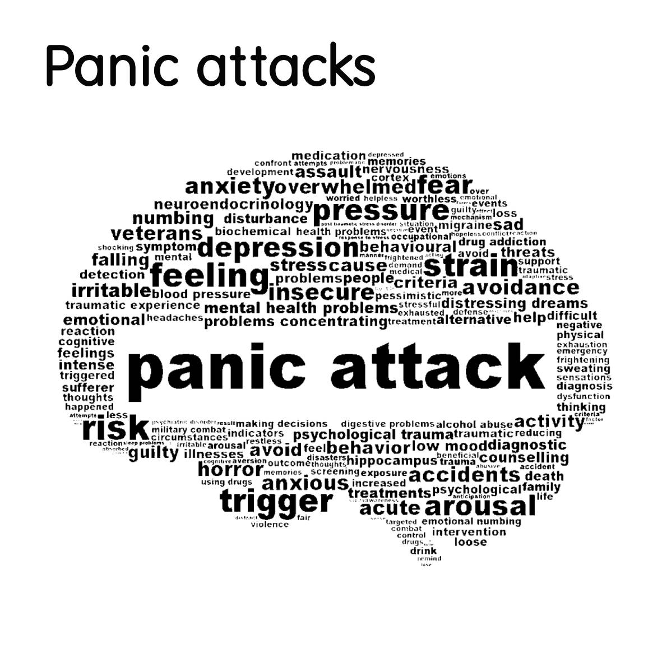

Nearly everyone can experience panic attacks and can be susceptible to it sometime in their life, no matter what the circumstances. They are usually sudden and can strike one without anticipation. It is described as a sudden onset from an undesirable situation from fear or anxiety taking place. This feeling can usually last from minutes to a half an hour or more, but usually not more than an hour at most. The physical symptoms may disappear shortly after, but the emotional symptoms may persist for days or even longer, until experiencing another panic attack in a never ending cycle. This experience may be very distressing for one that has experienced it for the first time and may experience it multiple times throughout their entire life. Remembering the event can really affect someone’s self-confidence as well, from the negative associations from the panic attack. It can cause lasting disruption with one’s mental state that can disrupt one’s daily life. Two types of panic disorder symptoms can occur:
- Anticipatory anxiety – Occurs when a person worries about a future event that may or may not happen. This is the fear of being afraid of a future event, due to a past event that happened. This can cause panic most of the time and can be very disabling and debilitating to the individual.

- Phobic Avoidance – Is a common behavioral reaction to a specific phobia that helps people cope with avoiding feelings of fear and anxiety. Certain environments or situations may be avoided consistently due to the belief that another panic attack will be triggered if placed in the same environment or situation. People often avoid places like these where they feel it might be triggered again or where escape may not be possible.
There are many causes for a panic attack to happen and the reasons for having one can be endless. Such causes that trigger one can range from a traumatic life experience or event, major distress in one’s life, relocating, having a divorce, having a baby, reaction from certain drugs or substances, or sexual assault.
They are very much related to social anxiety, because of the sudden surge of anxiety that one faces when exposed to a particular situation. It can suddenly onset, when an overwhelming sense of anxiety develops, which elevates the heartbeat, pumping adrenaline that overwhelms the senses with a fight or flight response. It is also described as a sudden episode of intense fear that can trigger the feeling of intense physical symptoms. People that describe this feeling, feel as if they are “lost in the moment”, and become disorientated because of the physical symptoms associated with it. People may even describe it as a feeling in which they “want to die” because of the sensory overload that one feels, putting them into panic mode (fight or flight), with worsening symptoms with an increased demand for oxygen intake which in turn leads to heavy breathing and tightening of muscles that become very tense.
One may also have the imminent need to escape as soon as possible, from the fear of being judged or embarrassed, and so to do so, the fear then escalates, becoming too great from the immediate fear that is present. You may start to lack awareness, that you become lost in an undirected manner, propelling your body to the nearest escape route wherever necessary. One may become impulsive and fixated on a clear path directing them away from the danger or perceived threat, from an enclosed space or a suffocating environment. One’s judgement will be clouded and the ability to make any rational decisions will be out of one’s control because they become disorientated from the sensory overload they experience.

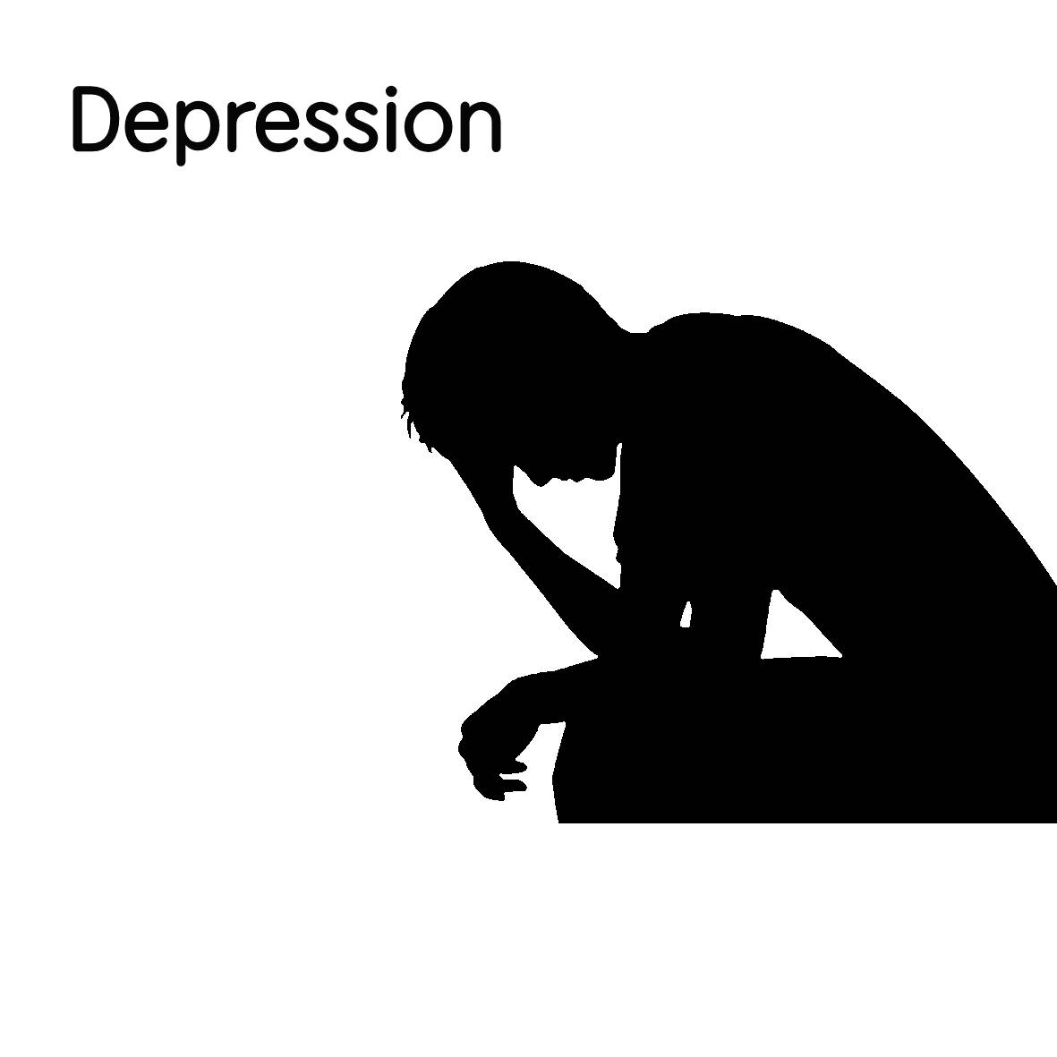

Like Panic attacks, depression is a common mental disorder, that can affect nearly everyone at some point in their lives, in one way or another. It can come about suddenly and unexpectedly, and virtually out of nowhere, for no reason at all. It is an overwhelming experience that gets you feeling down and makes you feel entirely hopeless. It can also be a lingering and persistent feeling that makes you feel sad, which can cause a loss of interest in daily activities and living. People often describe the feeling of depression as a dark cloud that hovers over them, and doesn’t go away.
Apart from that, it may feel like you are in a deep and endless bottomless pit that you can’t get out of, and are stuck inside. Depression is related to anxiety because they go hand in hand with one another and can go in cycles. Most commonly, it starts off with anxiety, then follows depression. Or it could be the other way round. This cycle can loop in a continuous pattern and can become increasingly worse over time. This may lead to the development of chronic anxiety as well as chronic depression (or one or the other) depending on how bad each one is. Clinical depression may be a result of long-term depression due to anxiety. Many people have a combination of the two – anxiety and clinical depression. They both may also be a condition of an underlying health disorder.
Due to social anxiety, depression may develop due to ongoing symptoms if present for an extended period of time, which can cause serious distress and interfere with one’s life and daily activities. Depression due to anxiety, can occur resulting from a stressful or traumatic life event, a divorce, an assault, bad experience, death of a loved one or any other difficult situation. Depending on the person and the experience for which it has caused, it may come on suddenly, or gradually. It may even develop due to bad lifestyle habits, or drug or substance abuse.
There is suggesting evidence that it may also develop in early childhood to adolescence, or even late adulthood, and can develop due to a combination of genetic, psychological, environmental and biological factors. With children, it can appear as having irritability and low mood, although irritability is more present. With teenagers to late adults, it can appear as having low mood, despair and anger. Adults may feel hopeless and struggle from day to day to get by maintaining daily fundamental tasks and relationships.
If both depression and anxiety are present, these common traits may be indicators, such as feeling a loss of appetite or change in eating habits – eating too much or too little, restlessness and moodiness, change in mood such as irritability, becoming cranky and feeling unsettled, loss of interest in daily tasks, irrational thoughts or worries that won’t go away, trouble remembering things and being absent minded and forgetful, feeling of hopelessness and despair, feeling fatigued, tired, unable to relax and live in the moment, rapid breathing, muscle tightness, abdominal pain and labored breathing as well as panic attacks and feeling as if you cannot maintain control of yourself.
Depression may be alleviated or reduced to a significant degree where it may no longer interfere with one’s life due to a change of lifestyle habits in one or more areas, or with the assistance of counseling, therapy and/or medications. Lifestyle changes that may need adjusting, can range from sleeping habits, nutritional adjustments, exercise, work schedule, and social support. Trying to maintain a balance of these may be beneficial for a well-balanced lifestyle, may progressively improve your overall mood.
Medications may be an alternative, or the last resort, if lifestyle changes may not improve, but may act as a bridge to alleviate depression symptoms. A combination of therapy, medication and different techniques may also be effective if done simultaneously, if needed.
Depression symptoms may become worse if lifestyle changes are counteracted by one or more drugs such as alcohol, tobacco use, or certain recreational drugs. These can irritate symptoms and disrupt treatment and should be avoided.

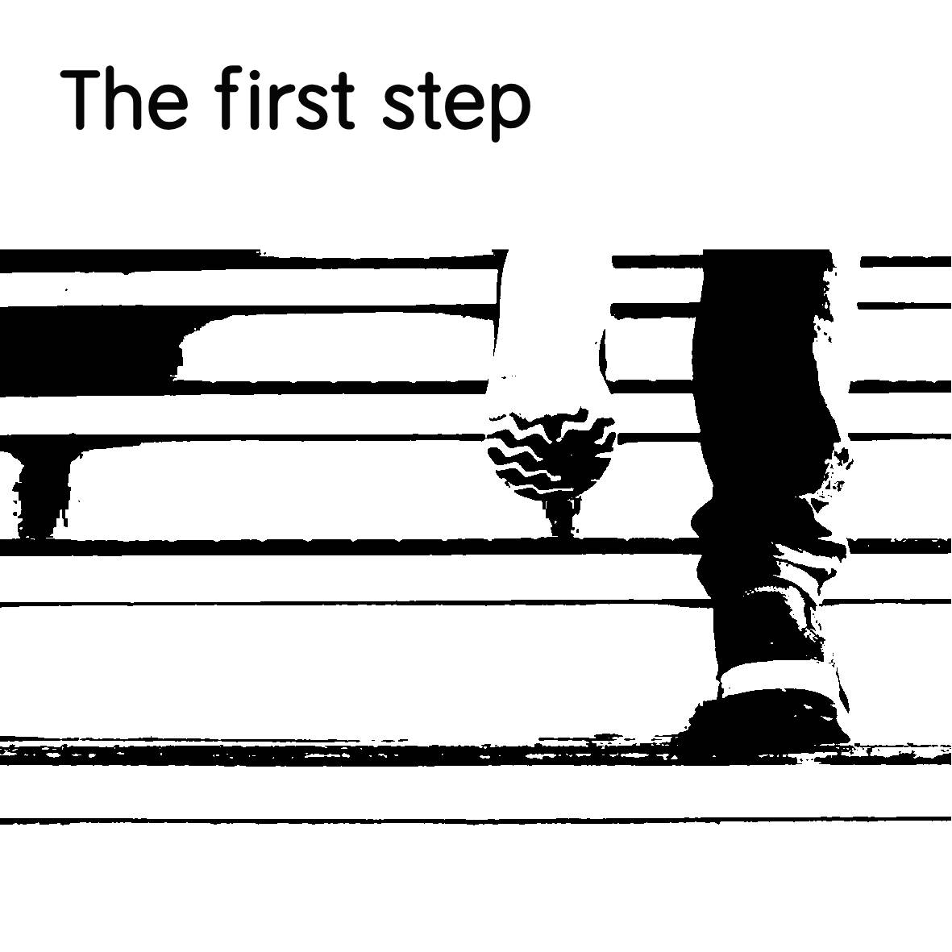

The biggest obstacle is identifying that you have a problem and that you need help. You may have identified through this book so far, whether you have the signs and symptoms of social anxiety and relate to the feelings and problems that arise whenever you are exposed to a socially challenging or impending situations. By reading this far, you have decided that you want to make a change, and the first step of making that change is deciding that you “want” that change to happen. You may have decided that you want more out of life, than being constantly held back because of your limitations.
Opening up about your problems and how you feel is extremely important. You should not keep things bottled up - this will only feed your anxiety, so you must express yourself. You may have a close family member, or a friend that you can relate to, that will listen. Since it’s hard for most people to understand exactly how you feel, you may not express yourself to the best of your ability. But you may decide that, because of your situation, that you want to make a change for the better.
You may feel unsatisfied with how you feel and feel frustrated with your life. Your social life may be abysmal. You feel that you require more connection. You may want a relationship, or something else. You may feel shunned for your inadequacy because of the negative connotations social anxiety has throughout society. Lack of self-esteem may be present, because you feel ashamed, and this differentiates you from others.
Because social anxiety is misunderstood, the subject about it is not widely publicized. Social anxiety may be recognized as shyness but is much more severe. Shyness does not impair you from socializing, whereas social anxiety does.
However, you must take the first step forward. It may seem scary and overwhelming at first, but you must start somewhere. Social anxiety may affect your life at school, work, at family gatherings and social outings, and if it is causing major problems in one or more areas, it could be an indication of change required. Making one proactive step forward at a time is all it takes. And eventually, all the small steps will add up to a giant leap forward.

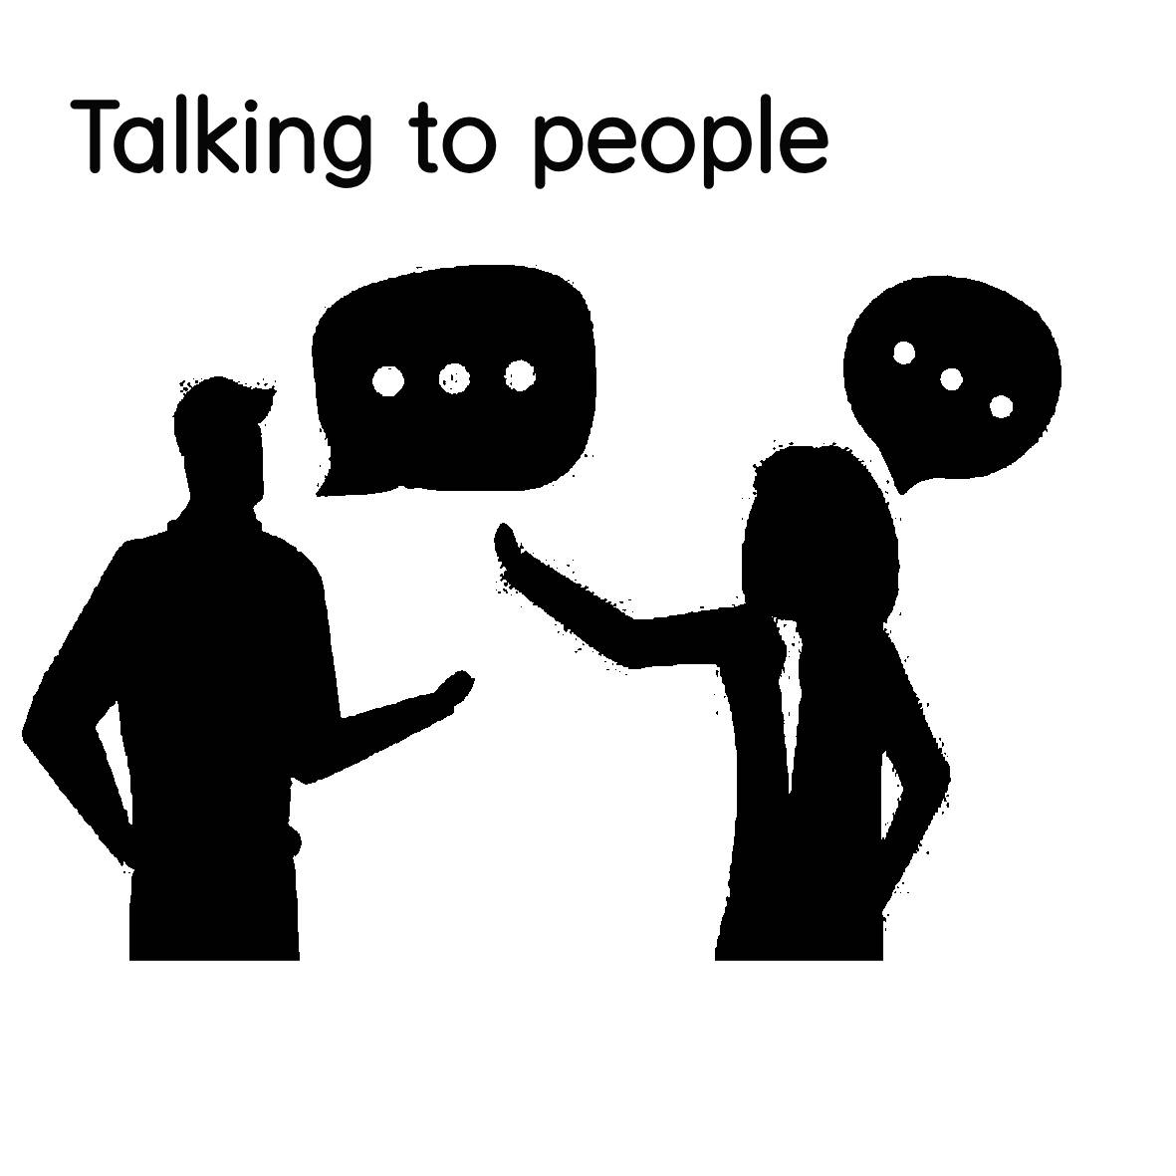

Once you realize that you have social anxiety, and it has been a problem for you for some time now, you may want to find other like-minded people as yourself that deal with it on a daily basis and share your thoughts and feelings about it moving forward. You may begin to seek specialized mental health groups for people with a specific disorder, if you haven’t already been referred to one of these groups by your general practitioner or by a specialist, where you can meet other people that cope with the same condition. These specialized groups may be arranged by a specialist that specifically deal with these types of mental health issues pertaining to social anxiety. These groups could be in a closed vicinity or a shared facility and are usually scheduled at certain times during the week or whenever possible.
These groups all, or mostly contain individuals that have difficulty with how they can socialize. They will meet a certain criterion where they are considered eligible to meet the threshold of having social anxiety. A certain threshold of social impairment must be met among all the individuals for it to be considered a disability that impairs you socially. These groups will contain certain exercises that will help ease you into social situations, in a safe and secure environment where you can meet people with the same condition.
These exercises may range from speaking exercises to interactions within the environment or in public areas. The process is used to ease you comfortably into social situations, and then the level of anxiety is increased to something that is more outside of the comfort zone of the individual and the same process is repeated, until the individual develops confidence where they can apply those same techniques into every day social situations, until it no longer becomes threatening to the individual. This method of easing is referred to as Exposure Therapy and is one of the most proven techniques for alleviating social anxiety.
Exposure Therapy can be beneficial and is one of the best ways for someone to gradually overcome social anxiety. This usually involves therapy, one-on-one or in a group with a therapist that can help expose you to different social situations where social anxiety is triggered.
A negative belief system of everything going wrong can also contribute to the feelings of anxiety, which can lead to an ongoing never-ending cycle of anxiety. This negative belief system becomes so engrained from a negative social experience, it replays whenever exposed to another social situation, creating the same negative feelings. Exposure Therapy can help you counter these negative feelings that you are faced with in social situations. A licensed therapist specializing in this area, may help you achieve a set of short-term goals, to overcome this.
Other methods include grounding techniques that utilize the five senses of what you touch, taste, smell, hear and see, where you practice focusing on one of each at a time in any sort of environment. This method helps you regain control of your senses from sensory overload rather than focusing on your anxiety and its symptoms. Because of a stressful situation that leads to anxiety symptoms, focusing on each one of your senses, can help ground you back to reality. Grounding techniques may be useful in situations such as having a panic attack.
It is important that you talk to everyone around you, whether it’s friends, family, teachers, doctors or anyone else that you can talk to and help you manage your social anxiety. Getting all the help you need will increase your chances of overcoming social anxiety.
Talking to as many like-minded people with similar issues to yours, can also help you manage. You can establish these connections wherever they are available such as in your local area, or in online forums and social groups.

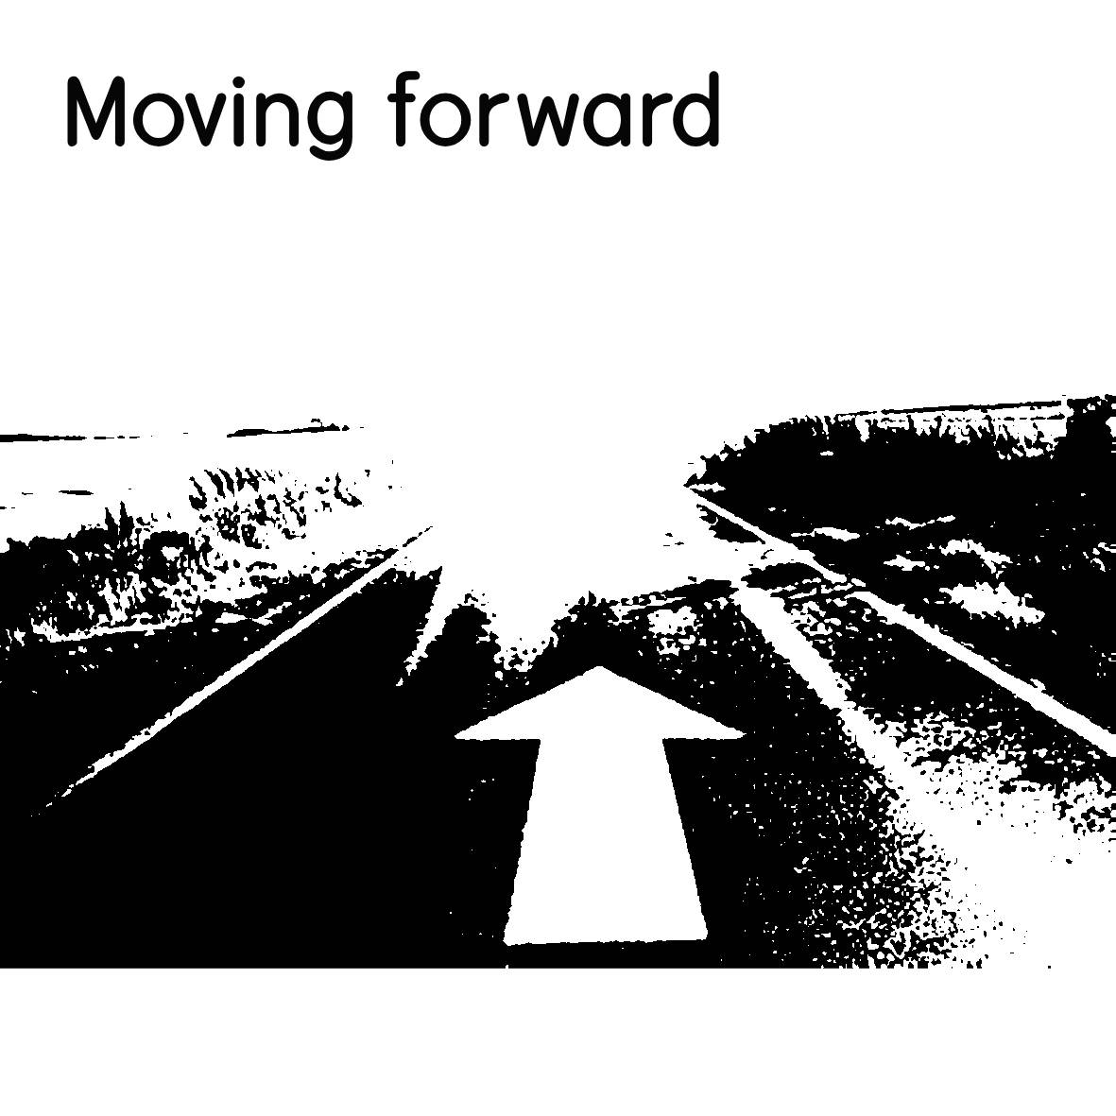

Moving forward with social anxiety can be a complex journey. No matter how long you’ve had it for, it takes time and patience to better yourself. It is a transformative and life changing experience. You accept what you have and move on. You do what you can to live your life. Every single day brings new and enduring challenges, with endless possibilities. It is up to you to move on with your life, without it dragging you down. Social anxiety can feel like being chained and constricted against your will, but you can break free. This is what it feels like with social anxiety without getting help. You so desperately want to break free of those chains, but you give in. But once you break free of those chains, you no longer feel held back or restricted. You just keep taking one step forward. You no longer become hindered by your own actions. You begin to make progress slowly and gradually. Surely, but ever so slightly, you begin to overcome your limitations and become boundless in your own actions.
Your own inactions no longer impede you. You no longer feel stuck beyond your capabilities. You may come across occasional speed bumps, but only temporarily. Each speed bump can be a minor setback. You will overcome these setbacks in a matter of time. These setbacks may slow you down, but not for long. You are the captain of your own ship, and you decide how far you want to go and which direction you take. Nothing is beyond your capability. You just have to take a leap of faith.
Moving forward can also seem like a major obstacle. This obstacle may obstruct your path and block your way to progress. It may seem like a mountain. In the same way, social anxiety can feel like a mountain, climbing your way up to the top of the summit. Along the way, it may seem overbearing, and sometimes treacherous and overpowering, but you continue climbing to reach the top. As you look down, it becomes higher and higher from the foot of the mountain, and closer towards the edge of the peak. Once you make it to the top, you can look down and bask in the glory. Life for social anxiety sufferers can often feel like many hills, or sometimes mountains. Depending on your severity of anxiety, it may seem like hills, and for chronic sufferers, it may seem like mountains. You may experience, both hills and mountains or one or the other over the course of your life, but you keep climbing them. We climb many hills and mountains over the course of our life that can be defeated. You just need perseverance and the will to carry on.
Social anxiety may seem like a challenge, on top of many challenges, and can be very tiring and mentally exhausting. It is no wonder that social anxiety can lead to burnout and chronic stress related issues. Unlike a regular burnout, of everyday life, this burnout can add to the list of other burnouts experienced by regular people. This is why it can be such a debilitating illness, which often is accompanied by other illnesses, both mentally and physically.
Finding people that can help you though, and be there to support you, can make all the difference. You must focus on the positives and not the negatives. The negatives will only weigh you down. The positives will keep you fighting on. You must keep looking up, and never look down.

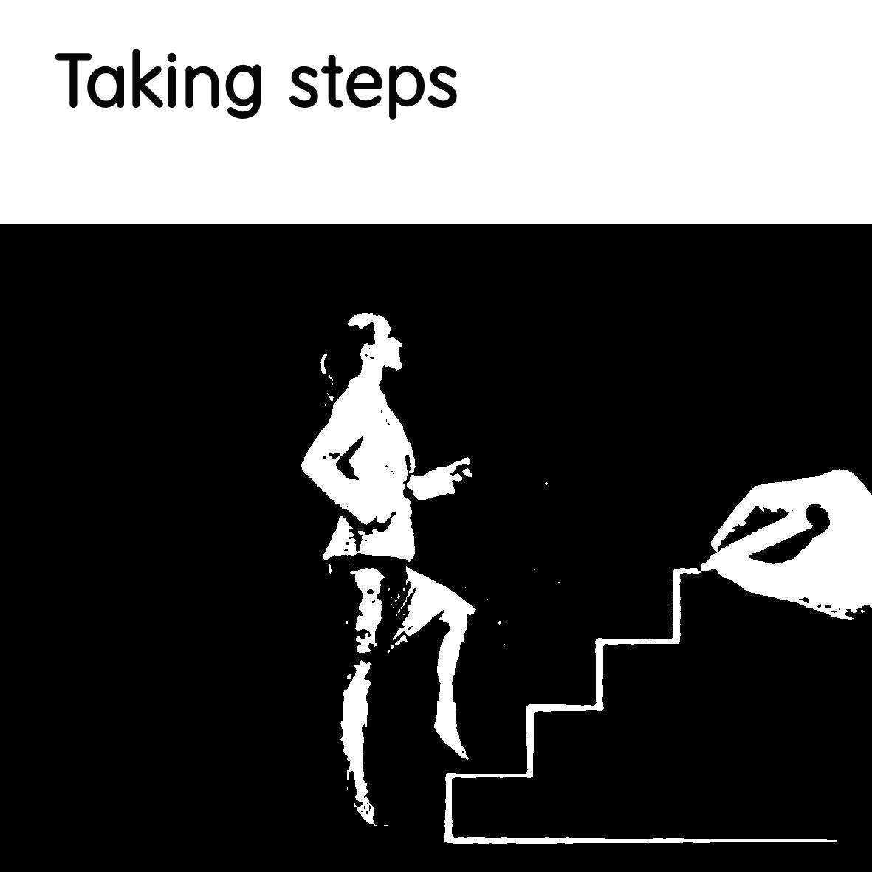

Social anxiety can be eliminated incrementally over a period of time. It takes a number of steps for it to be alleviated gradually. You won’t eliminate it completely, but you can make steps towards gradually improving yourself over time. There is a myth that you can cure social anxiety, but this is simply not the case. You will never be able to fully “cure” it, you can only make it easier to manage over time. The aim is to learn to manage your anxiety to make it easier to deal with, and to prevent the symptoms of social anxiety. Everybody has such a thing as a very mild form of anxiety, which is a normal form of anxiety which promotes general elevated levels of anxiety or worry in many different situations, but not nearly to the extent that it becomes a debilitating illness that affects you in all areas of your life. You must constantly work at managing your anxiety for some level of improvement over time. But it will require time, patience and effort.
You must build a pathway, or a steppingstone to progress, where you lay the groundwork, or a path of where you want to be. First you need to make a start before you lay the groundwork – that first step, and over time, the progress you have made will be accomplished, by as many steps as you need to take to get there. You can move as quickly or as slowly as you like, and to move from one step to another, will either be a discrete distance or sometimes a largely and uncomfortable one depending on your progress.
You must stay focused. Laying down that foundation is the most important though. Each step is a continuation of the next. To form a solid brick path. The foundation solidifies the progress you have made, with hard work. Progress is nothing if you don’t put in the work. You must be prepared to act. Action is the driver to progress after all. You must get up and face your anxiety head on.
You may make very small incremental changes or may make bold and brave moves where you jump ahead by throwing yourself in the deep end. Throwing yourself in the deep end is throwing yourself into a situation without any preparation beforehand.
Much can be said about starting a new job or being told last minute to arrange a dinner or throwing a birthday party by yourself, or going to war unexpectedly, joining the army, staring a new business alone or even a new endeavor without a clear-cut direction. No matter what it is, you will be without guidance, assistance or any preparation or without anyone by your side to help and assist you. Things could go well or not. But, sometimes throwing yourself in to the deep end can be either a very rewarding and triumphant experience or a bad and dismal failure, but you will never know until you try.
Saying this, there is nothing wrong with taking small, gradual and incremental steps towards progression. It really depends on how you feel and how accomplished you want to be, and how fast you want to get there. It may take weeks, months or even years to get to a point where you feel like you have made enough progress to succeed where you want to be.
You may come to a point where you even hit a brick wall throughout your progress, as this is only normal and temporary. The important thing is though, is to keep putting one foot forward in front of the other, keeping slow and steady momentum, or having leaps of progression.
You may become frustrated, and this frustration may lead to feelings of hopelessness. But this frustration will test your ability to endure difficult circumstances as they arise. But perseverance is what will get you over that finish line despite the difficult circumstances that you face along the way. You just have to have the will to get there.

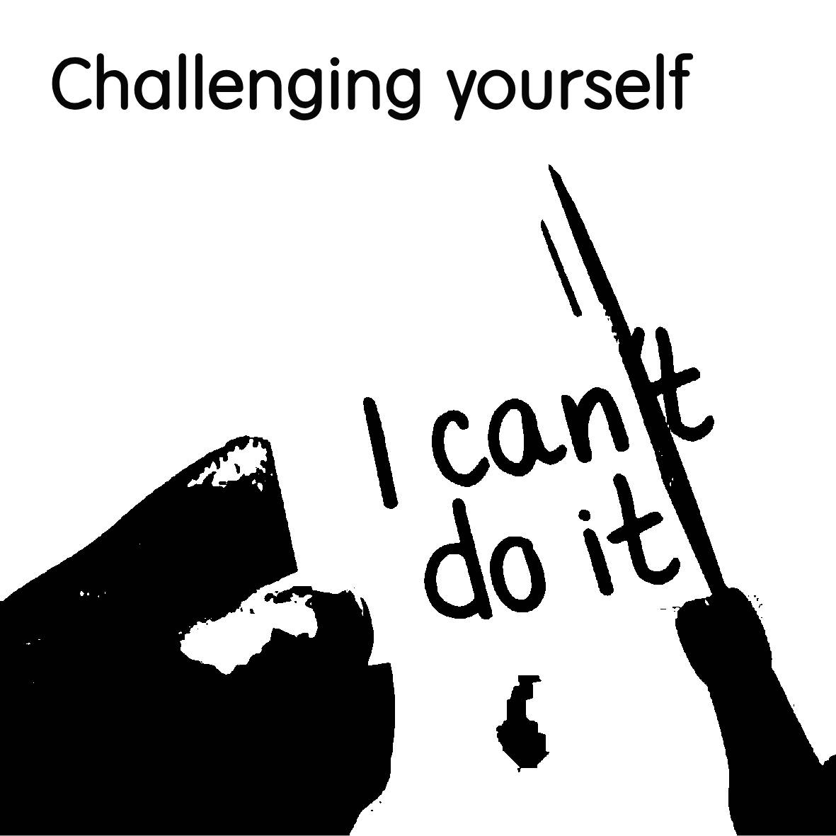

Challenging yourself entails testing your limits and your own ability to do something. In this case, testing yourself to overcome challenges and the ability to successfully complete those challenges that are set forth. There are many challenges to overcome with social anxiety that one will face, and these challenges will require a certain amount of willingness and determination to overcome. Challenging yourself is a natural and healthy way for you to grow as an individual by pushing yourself and your boundaries of what you are capable of. It promotes personal growth and as a result you will become more resilient, have increased satisfaction and become more confident in yourself. In order to overcome social anxiety, you must make changes and apply those changes to see a result. These changes may include anything from lifestyle changes, daily routines and activities, forming new habits and even physical changes contributing to your health. The environment may also play a part in the number of changes you make and how it affects those changes.
As I had mentioned with making steps towards progression, challenging yourself should be part of this progression which should be incorporated into your daily life in order to make progress. You should set yourself aside challenges or make it an occasional habit to set yourself goals to complete, whether it is multiple times a week, every month, or whenever possible. Getting into good habits can be extremely beneficial. The benefits of accomplishing something beyond your fears can be a very rewarding experience. It is knowing that you can achieve something that is not beyond your capability. It is more than possible to achieve something that you’re capable of. If you set your mind to something, you can truly achieve it. The power of the mind can both create positive and negative outcomes.
The enormous power of the mind is incomprehensible. This is because of what the power of the subconscious mind can do. It holds thoughts and beliefs that essentially make you who you are. It also holds every single one of your life’s experiences that define you and shape you. When a good or bad experience happens in your life, your mind stores this experience as well as the thoughts, feelings and emotions attached to it. However, when you have bad experiences, these can negatively affect you. This is because of something called cognitive bias and the mind remembers the negatives more than the positives. These negative thoughts can become so engrained in your memory, that it can create bad habits due to these negative thoughts that repeat.
Habits are defined as automatic behaviors that our brain produces to a specific repeated situation. For example, avoiding public areas whenever necessary or hiding in the bathroom to avoid social gatherings can create bad habits. However, good habits should be formed that will benefit our wellbeing. This is when you create positive associations with your thoughts and repeat a behavior until it becomes fully automatic in nature.
When you challenge your mind, you are challenging those thoughts that are associated with the experience/s you had. Such as a negative or traumatic experience which led to social anxiety. You will begin to develop new habits that are based on repetitive thoughts and behaviors. Thoughts turn into repetition and repetition turns into action. Once you begin to develop more positive thoughts over time, then you will begin to form new and positive habits.

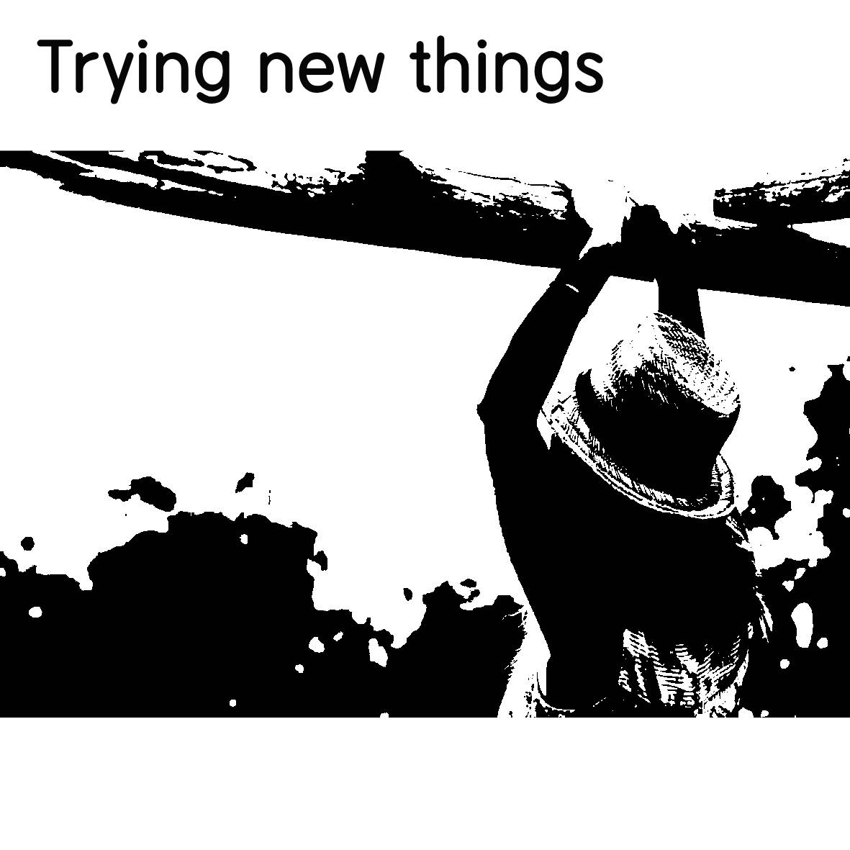

Trying new things can be a way for you to try something different outside of your comfort zone, or something that you would not typically do, or it could be something completely out of the ordinary. It can also be something that you’re usually not used to doing with social anxiety. It can be a way for you to test yourself, as well as your limits, of what works and what doesn’t.
Trying new things may seem scary at first, but the main thing is to give it a go. You may try something different that you may not necessarily enjoy, or you may come across something that you do. This could be something like going to the movies by yourself or with friends, hosting a dinner party for guests, going out on nature walks, going on camping trips, joining a club, going on a blind date or meeting someone entirely new. The possibilities are endless! It’s all about putting in the effort to try and see what works and what doesn’t, what you like and don’t like. You may find something beneficial that will impact your life in a very positive way - or not. You just have to get out there and see what happens!
In order to try new things, you must accept the fact that you will need to take the risk of success or failure. This can apply to anything such as trying something new or doing something outside of your comfort zone. Risk is necessary to succeed or fail, but without risk, there will be no outcome. As previously mentioned, the probability of an outcome, and depending on that outcome there will be a chance of failure or succession. The same thing applies when trying something new. There may be a chance that things do not work out – or they do. They will either benefit you or they won’t. It may even be scary, but regardless of this fact, the quality of your life may depend on the number of risks that you take.
This is why taking risks may accomplish an increased quality of life with social anxiety. If you routinely choose not to take risks and always play it safe, you may never accomplish anything. You may want to try new things to get out of the rut you are stuck in that’s holding you back. Asking someone out on a date or meeting someone new could eventually lead to better and greater things in the future. Taking risks to try new things may also improve yourself, your confidence and your self-esteem. You will become a better person for it. Facing the fears that hold you back will lead to more enjoyment and an increased level of overall satisfaction besides the confidence that you will gain from it. It doesn’t matter what it is – the end result could greatly improve your outcome in life.
Of course, there may be a chance that things will not go as planned. You could easily be rejected by your first date, or by a person you like, or a camping trip you took could turn out disastrous. You must have something to lose when taking a risk. The most difficult thing about taking a risk (which is why people avoid them), is that something bad may happen. This is true. But this negative factor is what prevents people from stepping out from making the moves that could lead to success, freedom and happiness.
Trying something new and taking on a risk could set you free. When assessing risks, always try and focus on the positives and never the negatives. Focusing on the negatives will only prevent you from ever making that leap forward which could lead to success.
We may be hesitant to put ourselves out there, or to be exposed to the fear of things not going well and as a result, fear and anxiety take hold of us. We follow our natural instincts, but if we let fear control us in every aspect of our lives, then it can become a burden. The goal is to not let fear completely take over our lives and our decision making, but to acknowledge it. Once we acknowledge it, we can reflect on it.
We must ask ourselves why we are hesitant to begin with and whether this fear and anxiety we have is logical or not. If it isn’t, we must carefully reconsider how we feel. We must ask ourselves logically why we have this fear as well as how we feel about it.
Also, not doing something at all is the worst thing you could do. This is worse than failure itself, because you have not given yourself the opportunity to succeed – or fail. But, if you accept that you could fail, then there’s a chance that you could succeed. This is why taking a chance and taking a risk is so important when trying new things, or you’ll never know the outcome. You’ll never know unless you try.

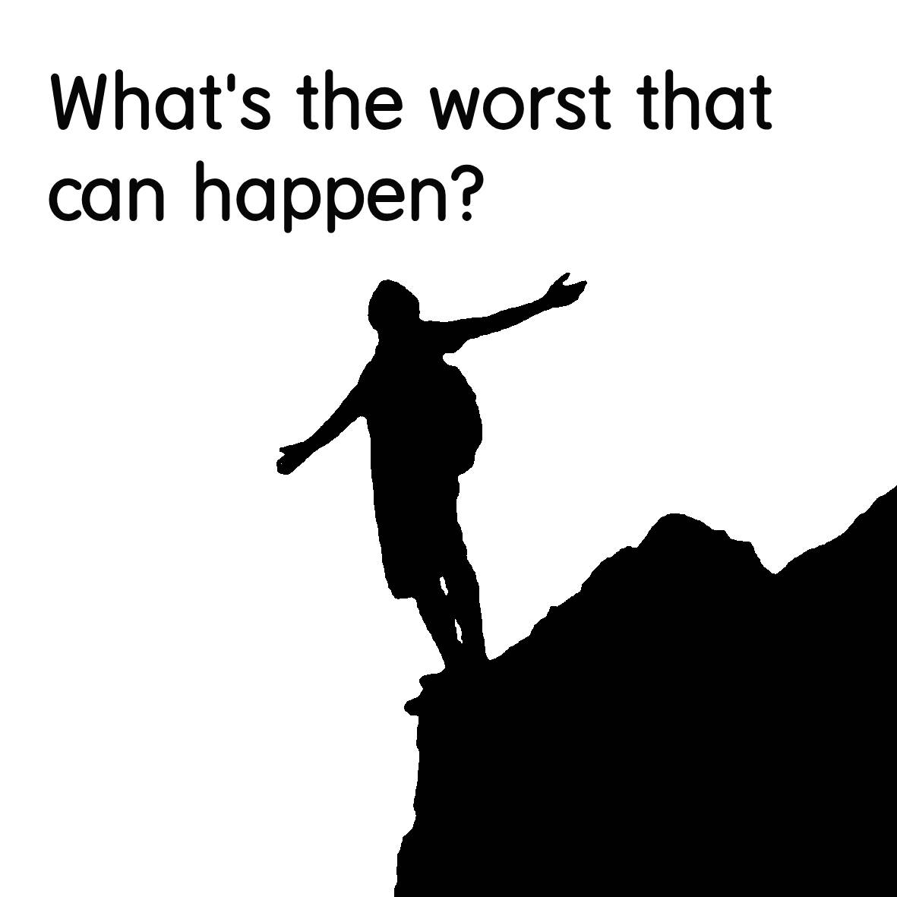

What’s the worst that can happen? A number of things could happen, but when you think about something that may about to go wrong, only the worst-case scenario could ever happen. Whenever you have thoughts about doing something, or are fearful of a particular outcome, having social anxiety can create feelings of impending doom. You may feel like you are about to die, or the world will end. A realistic scenario will only happen though. When you think of the worst-case scenario, your thoughts become irrational and nonsensical. You become flustered and jittery with anxiety. you may even start sweating profusely. Your cognitive or negativity bias takes over and you feel like you have lost all control and can’t get a grip on reality. Sometimes, you just need to slow down and step your foot off the gas to slow down before your mind derails off a cliff. Things may not be that bad in the end, and the worst-case scenario may never actually happen. Instead, you could have the best outcome with the best-case scenario. Like I mentioned in the previous chapter, positive thoughts have a real impact on you.
What’s the worst that can happen? is also a phrase that is used commonly to convince someone to take a risk. This usually implies that the negatives associated with the risk may not be as bad as you think.
For example, you go on a date and meet someone for the very first time. The worst thing that could happen is that the date will go horribly wrong and did not go to plan and you left a bad impression of yourself. Another example is that you go up on stage and do a public speech, but that speech went horribly wrong, and you ended up making a complete fool of yourself. That is the worst that could happen. These are both “realistic” expectations of what could go wrong – and what could happen, but nothing worse could possibly go wrong apart from that.
However, one trap that people fall into is catastrophizing about events or things repeatedly. This is the excessive worry of assuming that the worst will happen about everything and that things will always go wrong which can become all too consuming. This is a habitual and subconscious way of assuming the worst of everything that could go wrong and is an unrealistic way of thinking. This excessive worrying could also anticipate issues that end up playing out in the end.
This excessive worry could stem from childhood trauma or from a difficult upbringing, and you may have programmed yourself to think this way, but this way of thinking can be undone by having more realistic expectations.
Adopting the “what’s the worst that can happen” attitude is having a more realistic approach about everything. This attitude is about caring less about what you do, and what other people think about you. Because even the worst outcome may not be that bad at all.
The intention of this phrase is to assure you that nothing will kill you. Instead of avoiding the outcome, you should embrace the possibilities. Whether you say or do something dumb or accidental to embarrass yourself in front of someone or in public, it may not be significant enough for people to care about. Because at the end of the day, most people are just too concerned about themselves than anyone else and could really care less.
Think of all the things you have done in the past that you have worried about, and then reflect with how you feel about them now. So, embrace the possibilities, and don’t hold back. Live your life freely and don’t be afraid of what happens.

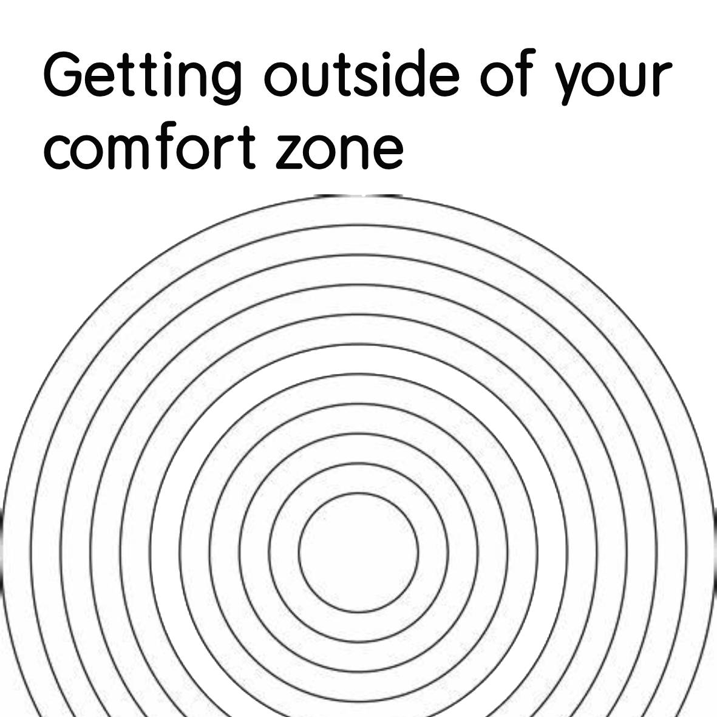

Getting outside of your comfort zone is most important to achieve greater heights and push yourself to your limits. You must break outside of the old normal and break into a new normal. For change to happen, it takes time, patience and perseverance.

You must have discipline and push yourself. When you push yourself, you train your mind and body to adapt through the vigorous changes. Since the mind and body are both interconnected with each other, we call that the mind-body relationship where both mental health and physical health are both intertwined. Breaking outside of your comfort zone will test both the mind and the body and may push you to your limits.

You can’t be too comfortable, or you’ll never bust out of your comfort zone. When you push yourself and break outside of your comfort zone, this creates mental resilience and robustness and expands your capacity mentally to achieve new things beyond your limits. This can also boost your confidence, reaffirm your ability to accomplish things you never thought you were capable of and gain personal growth from your experiences. You will also gain the experience you will need to move forward which will also reaffirm your ability and add to your confidence.
There are cons to staying inside of your comfort zone and there are pros of getting outside of your comfort zone. These pros and cons may benefit or become a detriment to the person affected.

1 some cons on staying inside of your comfort zone may be that you maintain your composure too much well within your boundaries. You may not achieve much from it, and you may never inhibit growth, due to too much of a relaxed lifestyle. To inhibit growth, you must step away from your comfort zone from time to time, to explore and try new things.

2 Holding back from trying new things may restrict you, because you are too scared or fearful of the challenge ahead. You will never achieve personal growth by doing this.

3 As I mentioned previously about trying new things, and the risks and rewards associated with challenging yourself, without risk there is no reward, or prize from getting outside of your comfort zone.

4 You will never gain new skills to succeed and add to your experience, which can negatively impact you because new skills add to your ability to succeed. They can help you accomplish tasks more efficiently and effectively and can enhance your personal and professional development.

5 another con is that by staying inside of your comfort zone, you may become too comfortable by not challenging yourself enough, which will make you complacent. By not challenging yourself, you will not boost your confidence by successfully trying new things and achieving new heights.

The pros in my opinion, certainly outweigh the cons.

1 Trying new things, as opposed to not trying new things can certainly boost your confidence. This is because by accomplishing something in the past, this promotes a healthy self-assurance of accomplishing or succeeding in new or similar things in the future. It gives you the recognition you need to grow with assurance.

2 Minimizing risk is another. By familiarizing yourself with past tasks that have challenged you, you will be more familiar with future events or tasks that will minimize the amount of risk you take. This is because when you are aware of the risks, you’ll know how to avoid them more.

3 Another pro is that it will help you enhance your creativity and your problem-solving skills by forcing you to think outside of the box and adapt to different situations.

4 Lastly, it can help increase your overall level of happiness and satisfaction by adding variety and excitement to your life.

In psychology, your comfort zone can be measured by different boundaries. These boundaries show how getting outside of your comfort zone can help you learn and grow.

First, your comfort zone is within your boundaries, which is complacency, feeling safe, secure and well in control of your limits. Nothing new or exciting usually happens outside of it. Then when you break outside of your comfort zone into a new boundary, this is what you call the fear zone. This is where you have self-doubt, make excuses and are fearful of what may lay ahead. You usually feel self-hesitant to want to try anything new that is outside of the norm for you. However, once you get past this boundary, you then fall into the learning zone. This is where you deal with new challenges, develop new skills and expand your comfort zone. Beyond this zone you can conquer nearly anything that you put your mind to.

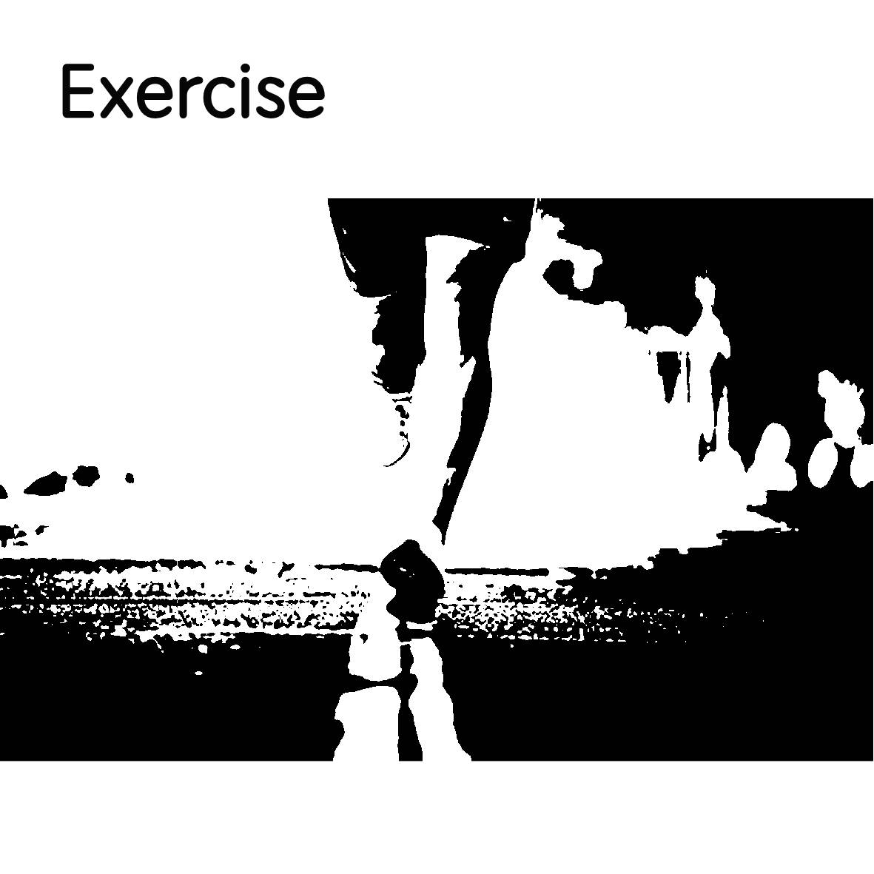

We all know the impact social anxiety has on daily life and how it can impact your quality of life, affecting your relationships, education, career and mental health. But this can often lead to depression, low self-esteem, drug or substance abuse as well as isolation. Fortunately, there are effective ways to help you cope and alleviate these feelings due to social anxiety. One of these is exercise. It is not only good for your physical health but for your mental health and emotional well-being.

The health benefits are tremendous in how it helps recoup the mind, helps increase mental clarity and reduces stress. Besides this, it is a natural booster for endorphins that can naturally enhance your mood and can reduce levels of overall anxiety.

These are just some of the benefits that help with anxiety, besides the health benefits of exercising regularly and maintaining it.
If anxiety is adding to the amount of stress that you endure on a daily basis, regular exercise may help with that. It also helps you sleep better overall by clearing your mind.

Exercise reduces stress and anxiety. It is known to decrease stress hormones while increasing dopamine and produces endorphins for positive mood and increases connections in areas of the brain that naturally calm anxiety according to studies. The endorphins are naturally produced and through exercise, endorphins are released. These act as natural pain killers and mood boosters. Endorphins can help you feel calm, relaxed and positive.

Exercise also lowers cortisol, a hormone that is associated with stress and anxiety. By lowering cortisol levels in your body, exercise can help you feel more at ease and reduce your anxiety levels, helping you cope better in social situations and feel more comfortable around other people.

It is said to also help reduce anxiety, depression and negative mood by improving self-esteem and cognitive function. Other studies have said that mood can be improved overall from physical movement by significantly decreasing anxiety and depression.

But, the physical aspects of exercise can not only improve your self-esteem, but your overall body image. Exercise can improve your fitness, strength, endurance and flexibility besides your body image which can boost your confidence and self-esteem making you feel more confident and attractive.

Exercise can help you develop a sense of mastery and accomplishment, helping you achieve your fitness goals. By increasing your self-esteem and body image, exercise can help you overcome your fears of being judged or rejected from others based on your appearance or abilities.

It is widely known to greatly alleviate symptoms of depression. Depending on the type of exercise that you do, the more vigorous the exercise the better. Even a daily brisk walk has tremendous health benefits for the mind and body.

Exercise can also help you enhance your social skills, by providing opportunities of social interaction such as participating with a buddy, a close friend, group class or even as a team sport. This can help you meet new people, make friends and have fun. It can help you enhance your social skills such as cooperation, communication and leadership. By enhancing your social skills, exercise can help you feel more connected and accepted by others.

Exercise may be difficult to maintain or even start, depending on your preferences. But finding the type of exercise that suits you and that you enjoy is important. There are many types of exercise that you can do, such as walking, jogging, cycling, swimming, yoga, martial arts, weightlifting or anything else that you might be interested in. You could also try different activities until you find one that you like. But the more you enjoy doing exercise, the more likely you’ll stick with it in the end.

All in all, exercise can be a fulfilling way for you to achieve your fitness goals and work towards alleviating your anxiety and achieve greater mental health and emotional wellbeing. It can become part of your daily routine and overall lifestyle if you stick with it. No matter what you do, whether it is a brisk walk or something more strenuous, it can have tremendous results and great long-term benefits especially for coping with anxiety.

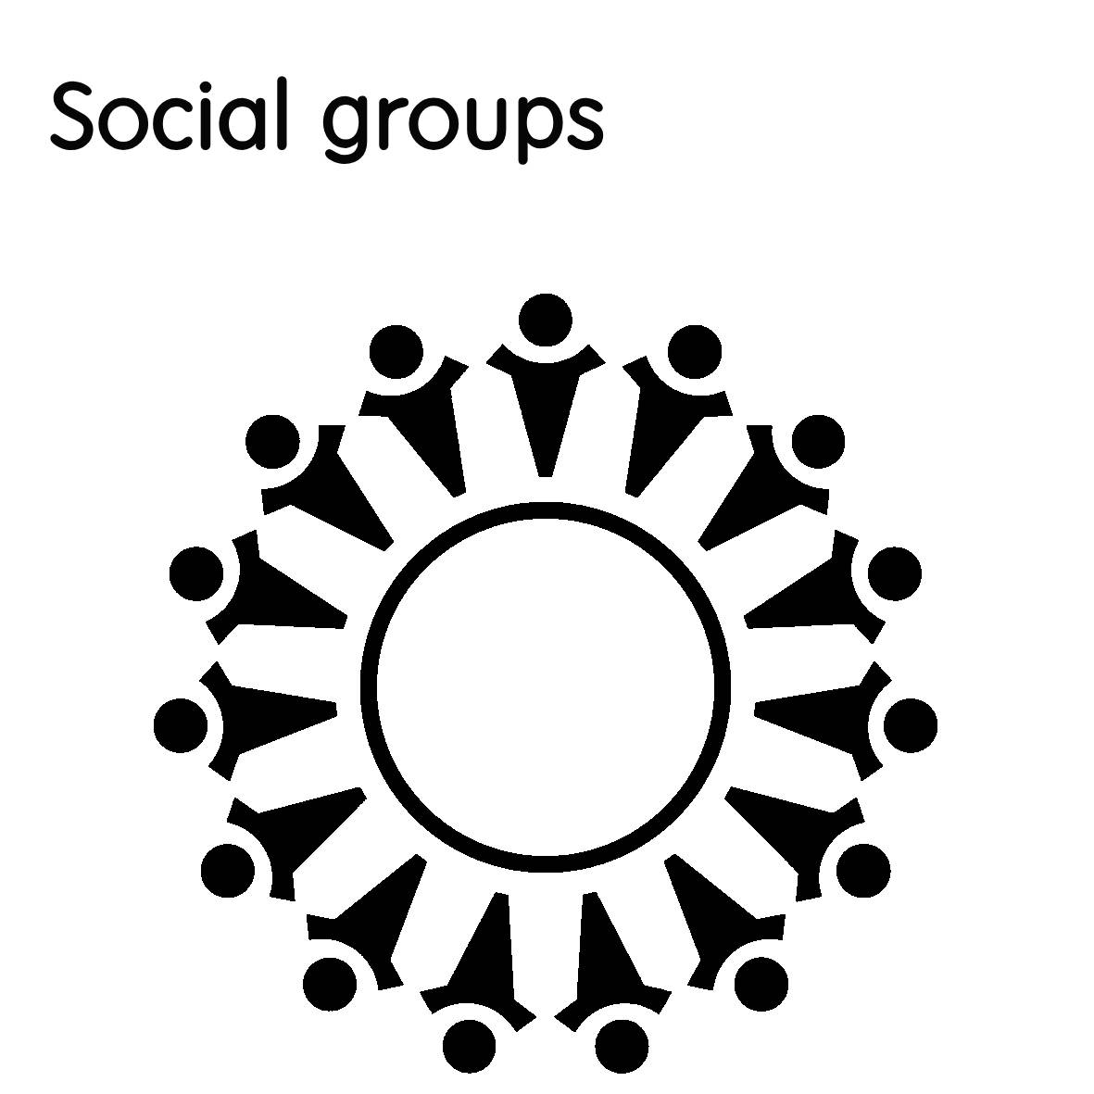

There’s no better way to enhance your social skills and to increase your confidence besides exercise than social groups. It can be an effective way for you to overcome social anxiety. You may want to join one or multiple groups depending on what they are. Social groups can be a way for you to boost your self-esteem, increase your communication skills, gain new friendships and meet new people. They can be based on things that you like, such as your interests or hobbies.
Joining social groups not only boosts your confidence and enhances your communication skills but it also has physical and mental benefits associated with it too.

When we are around the right people, socializing brings a sense of joy and excitement which can increase endorphins - the happy hormones which are produced in the brain. This can lower levels of cortisol which are associated with stress and anxiety. The feelings we get from being around others have lasting effects on the way that we feel which can ultimately lower depression.

By nature, humans are social animals, and we are not designed to isolate ourselves for a prolonged period of time. We crave human interaction by nature. We love to communicate with one another and be amongst other people and congregate. When we are around the right people and feel accepted, we have a sense of belonging and feel connected. When we have social anxiety, we tend to self-isolate ourselves away from other people, which leads to feelings of lower self-worth, feelings of hopelessness, lowered self-esteem, less confidence, increased stress and feel less connected to other people.

By breaking out of that cycle, we reap all the benefits of being around other people. This is why social groups are a good way to socialize and interact with others.

Feeling accepted by other people when we have a sense of belonging can have many benefits. It is a basic psychological need that can have a profound effect on our mental health and our emotional wellbeing. It makes us feel valued, validated, and supported in life.

Like I just mentioned, feeling accepted can reduce stress levels and anxiety and lead to an increase of endorphins. It can help us cope with negative emotions by allowing us to express them without fear of judgement or rejection particularly. It can also provide us a sense of safety and security by feeling accepted.

Our self-identify as well as our worth is reinforced through self-esteem and confidence that is built. This can help us when we feel accepted. It can also give us the courage to help us face challenges and overcome obstacles by developing resilience.

Besides this, our relationships can also be enhanced, as well as expanding our social network through connections. Through enhanced relationships can foster things like trust. It will help us seek new connections and encourage us to seek new opportunities.

Other benefits of joining social groups are that they provide us comfort and give us a sense of safety. They provide us support from harm or danger. They can be a great way to reach out to people in need. When we feel harmed or in danger, these are the people we will most likely reach out to besides family members for support. They give us support and comfort by knowing that they are there when we need them.

Our self-esteem is also strengthened by being part of a social group, because they give us a sense of belonging and importance in our lives. When we feel part of something, we feel included, and this inclusiveness reaffirms our worthiness. This makes us feel valued and important knowing that we are a part of something, rather than not.

They offer companionship and connection that can fight loneliness. When we are part of a group, we feel less excluded from others and we feel more connected to other people, which could lead to friendships and even deep meaningful relationships.

They also inform us about the world we live in as well as ourselves and share knowledge. They can offer us different perspectives and insights as well as provide us with information about worldly events and news and keep us up to date with what’s happening.

Saying this, social groups are essential for happiness and emotional wellbeing. They provide us with needs of fighting loneliness, depression and from feeling isolated from others. They can help us cope better with anxiety and manage it more manageable overall.

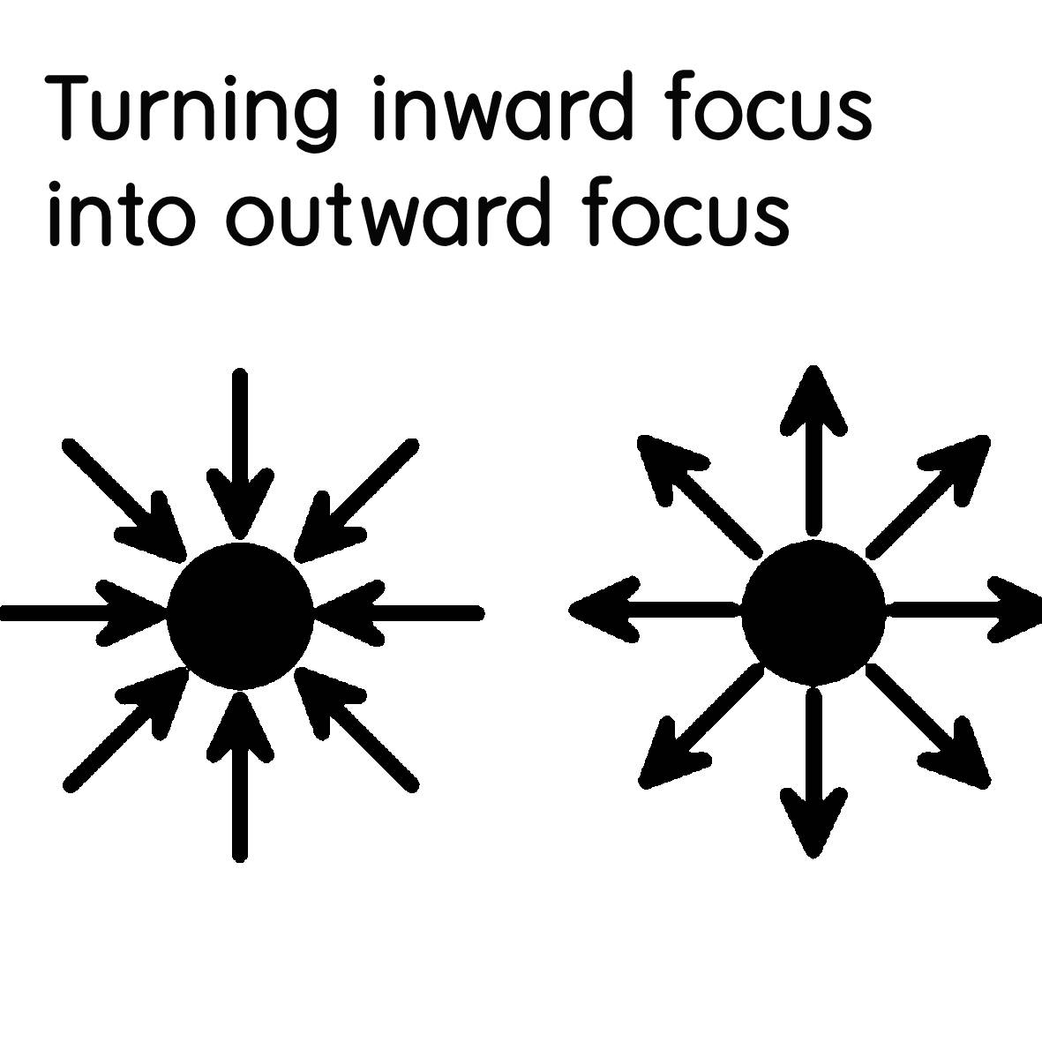

Social anxiety makes us feel self-conscious, judged, scrutinized and hyper-vigilant of ourselves in all social situations possible. This can make us feel extremely uncomfortable and focused on ourselves of how we act, think, look and feel. Social anxiety often makes us feel like the center of attention which is often how someone feels with social anxiety. Because of this, we tend to become too inwardly focused on ourselves. This inward focus is often constant and ongoing and never seems to cease. Instead of worrying about others and their actions, we often worry about ourselves. This obsession can become unhealthy to the point where it becomes detrimental to one’s health.
When we focus on ourselves, we may judge ourselves, and this judgement can lead to insecurities. No matter how this started, from past trauma, abuse, a difficult upbringing or from painful experiences, this can create insecurities early on, which can carry on later through life. We may tend to develop an inner voice of criticism that constantly critiques ourselves and our actions, and therefore turns into judgement.

We may feel that we are not good enough, not smart enough, not good looking enough or not competent enough and these feelings of insecurities can be projected onto others because of how we judge ourselves. When we project our insecurities onto others, this can temporarily make us feel better, but often leads to an ever-continuous cycle of judgement and insecurity.

Because we judge ourselves, we therefore judge other people to make us feel better about our shortcomings and our own flaws. But this can backfire badly. And like I just mentioned, this can lead to a nasty continuous cycle because we are constantly comparing ourselves because we fear judgement. This can ultimately limit our potential and growth because we are constantly beating ourselves down as well as others around us which can exacerbate how we feel.

When we, however, acknowledge our flaws, and accept our insecurities for what they are, we can stop beating ourselves down and stop judging ourselves, and instead, identity areas where we can improve. We can therefore seek guidance, support and get feedback on the areas that we want to work on to overcome challenges and meet our goals.

So, when we stop judging ourselves and others as well as critiquing others and ourselves, we can start to see the positives instead of the negatives. We can then start to pull that inward focus onto others instead, where we are less focused on ourselves and our insecurities and more focused on other people and the positives, without feeling the need to judge. The less we judge ourselves the less we will focus on the bad and enjoy other people’s company. Repetitive behavior and constantly sticking to this can pull you out of that nasty continuous cycle of judging others’ negatively and from ultimately judging yourself.

We can then start to enjoy being ourselves and feel comfortable, and more comfortable we will feel around others. Instead of judging everyone to make ourselves feel better and comparing everyone to yourself, you are less likely to see people’s flaws and imperfections. Instead, you see the positivity in being around other people and in different situations. This can also help you avoid conflict or unnecessary criticism towards others because you are less focused on the negative aspects.

Outwardly focusing on others can also distract yourself so your mind is not so focused on yourself. You can shift this attention away from yourself and instead focus on others.

So when you apply this and start to focus less on yourself and see the positives in other people, you will start to feel better and enjoy being around people more often. Shifting the focus from yourself onto a person can help alleviate feelings of uneasiness or self-consciousness and make you feel more at ease with yourself and others.

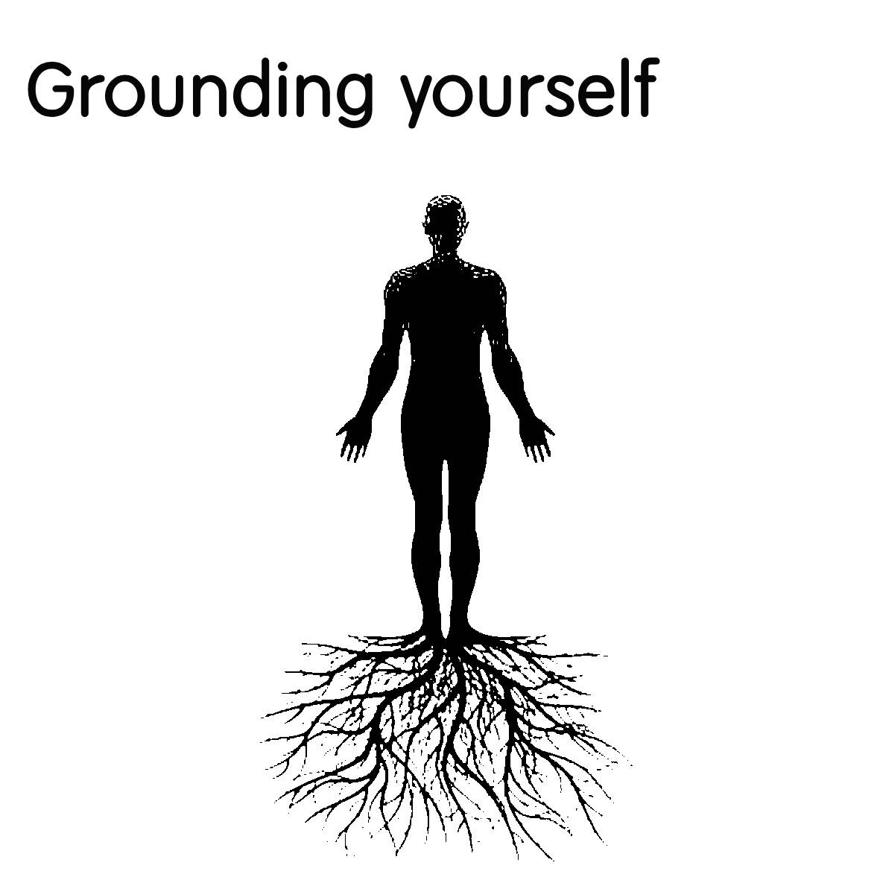

What is grounding yourself? Grounding yourself is when you connect with your senses and slow yourself down when you experience social anxiety. When you experience sensory overload and your senses go into overdrive, they become overstimulated which activates the fight or flight response. This essentially sends your mind and body into overdrive and hyper awareness when you feel like you are in dire threat or extreme danger. Social anxiety often exaggerates what we feel is extreme danger or a dire threat because our cortisol levels skyrocket out of control. As cortisol levels rise rapidly, we essentially go into survival mode - the fight or flight.

However, when cortisol levels remain elevated for a prolonged period, of time this can cause serious health issues. Over time, this can cause high blood pressure, impaired memory, heart problems, weight gain and a lowered immune response. This is where grounding yourself can help with that. What it essentially does is when you experience a fight or flight which is caused by extreme anxiety, you need to slow yourself down and essentially ground your senses.

Grounding entails focusing on each one of your five senses one at a time to slowly regain control of yourself. By focusing on one at a time, you can slow yourself down by gradually lowering your cortisol levels. As you slow yourself down, your cortisol levels begin to drop, which therefore alleviates stress and anxiety.
The way you begin to ground yourself is to focus on each one of your senses starting off with what you can see, what you can smell, what you can touch, what you can taste and finally what you can hear. As you work yourself down from all the five senses it is good to name at least two or three things of each. This helps you think and slow down your racing thoughts. When you focus on each one of your five senses, you distract yourself and take your mind off from what you are thinking about, that is causing you to feel stressed and anxious.

This can be handy in any stressful or anxiety provoking situations to put you at ease and ground yourself back to reality. Every time you feel like you need to slow yourself down, this can be a simple technique to help you relax. The more you practice it, the better. You just need to remember every time you get yourself into a situation that activates your fight or flight, remember the five senses.

Previously, I talked about panic attacks and how they make you feel. This will also work whenever you experience a panic attack which is caused when the body goes into fight or flight mode which triggers the false alarms from going off when the five senses are overstimulated.

The grounding technique helps alleviate symptoms with a perceived threat, not an existential threat. When your fight or flight response is activated with social anxiety, you perceive the threat to be a danger, even though it may not necessarily be life threatening, but an existential threat is something that will threaten you directly. Therefore, the five senses and grounding technique is useful for perceived threats.

The grounding technique is like bypassing your brain, like a computer that controls your body and regains control of it. If you apply this technique whenever you feel the need to do so, it will certainly help with that.

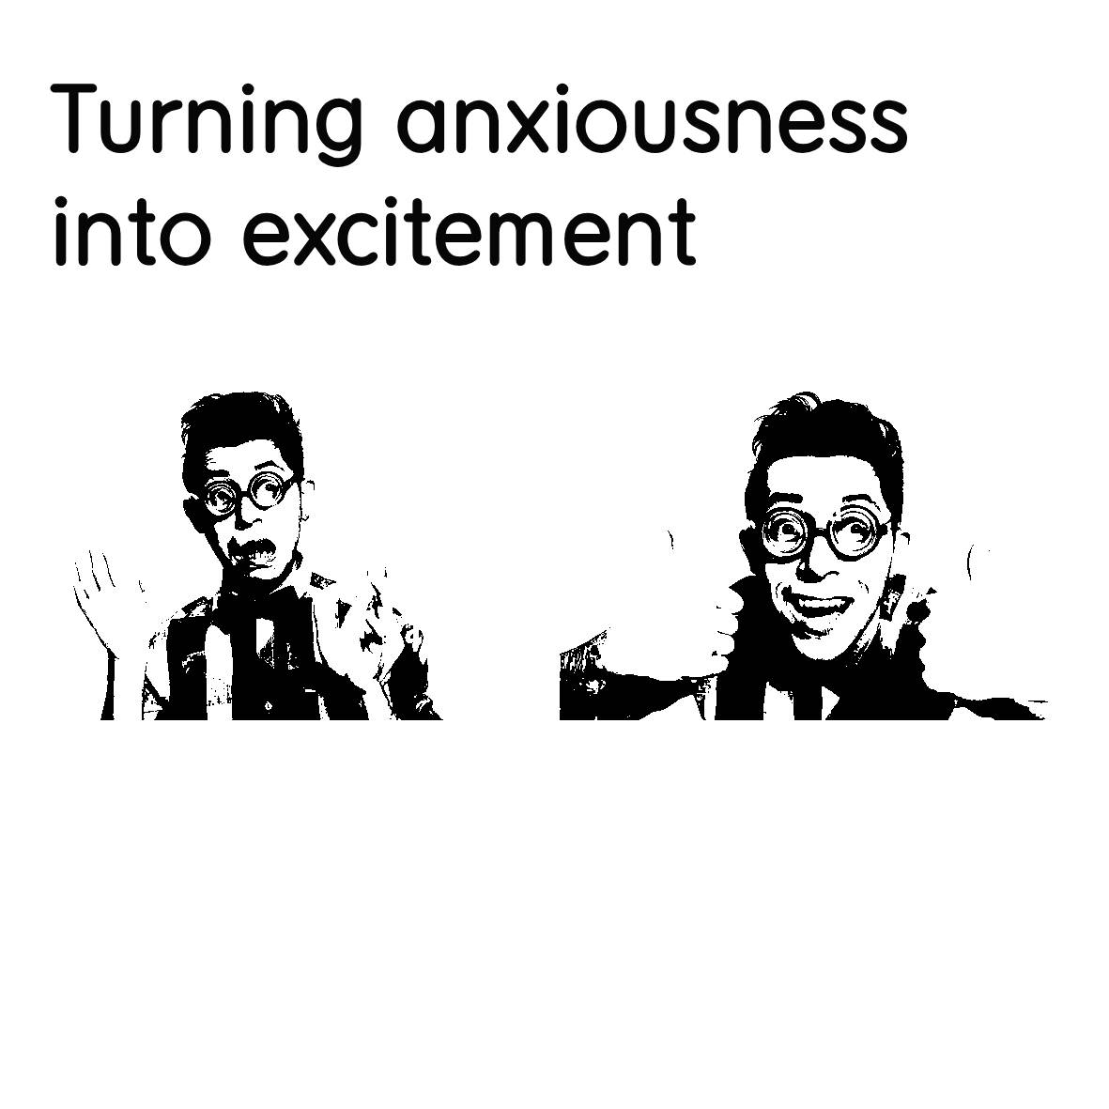

Did you know that there is a way to trick your brain into thinking that you are excited, rather than feeling anxious? This extraordinary secret is something that most people aren’t aware of. The common links that both anxiety and excitement share are both dopamine and adrenaline.
Whenever you feel anxious about something, your brain releases adrenaline from the adrenal glands and dopamine into the bloodstream. But, in the same way, whenever you feel excited, your brain also releases adrenaline and dopamine.

You could say that both anxiousness and excitement are cousins in a way. They both share characteristics that stimulate the body and the mind and prep it for whatever happens next.

I remember seeing this show many years ago where these two people did an experiment with each other. What they did is they set forth challenges and dares for each one to complete. Whenever they started to feel hesitant about the challenge or dare ahead, they “pretended” to be excited about it, and therefore no longer felt anxious. This is because they tricked their brains into switching around anxiousness into excitement.

See, your brain does not know the difference between excitement and anxiousness because they both respond with the same hormones and chemicals that are released into the blood stream that are both responsible for fear and excitement. So, if you are fearful of a situation your adrenaline will start pumping, and dopamine will be released, but if you are “excited” about something, this will also get the adrenaline going and release dopamine into the bloodstream.

Both dopamine and adrenaline are responsible for the fight or flight response, your body’s natural reaction to fear, stress, excitement, danger or to any threatening situation.

I have talked about how the fight or flight response can be harmful to the body for prolonged periods of time but can be beneficial in short bursts when you need it. It is healthy to feel a bit stressed and anxious, but when this exceeds normal levels for longer than necessary it can cause all sorts of problems. So, it is necessary to manage stress and anxiety at healthy levels to regulate your mood.

However, this is a useful hack that you can use to your advantage. It can turn something bad and fearful into something good and exciting at the flip of a switch depending on how you respond to it. It is like overriding the CPU of your brain that processes how you feel.

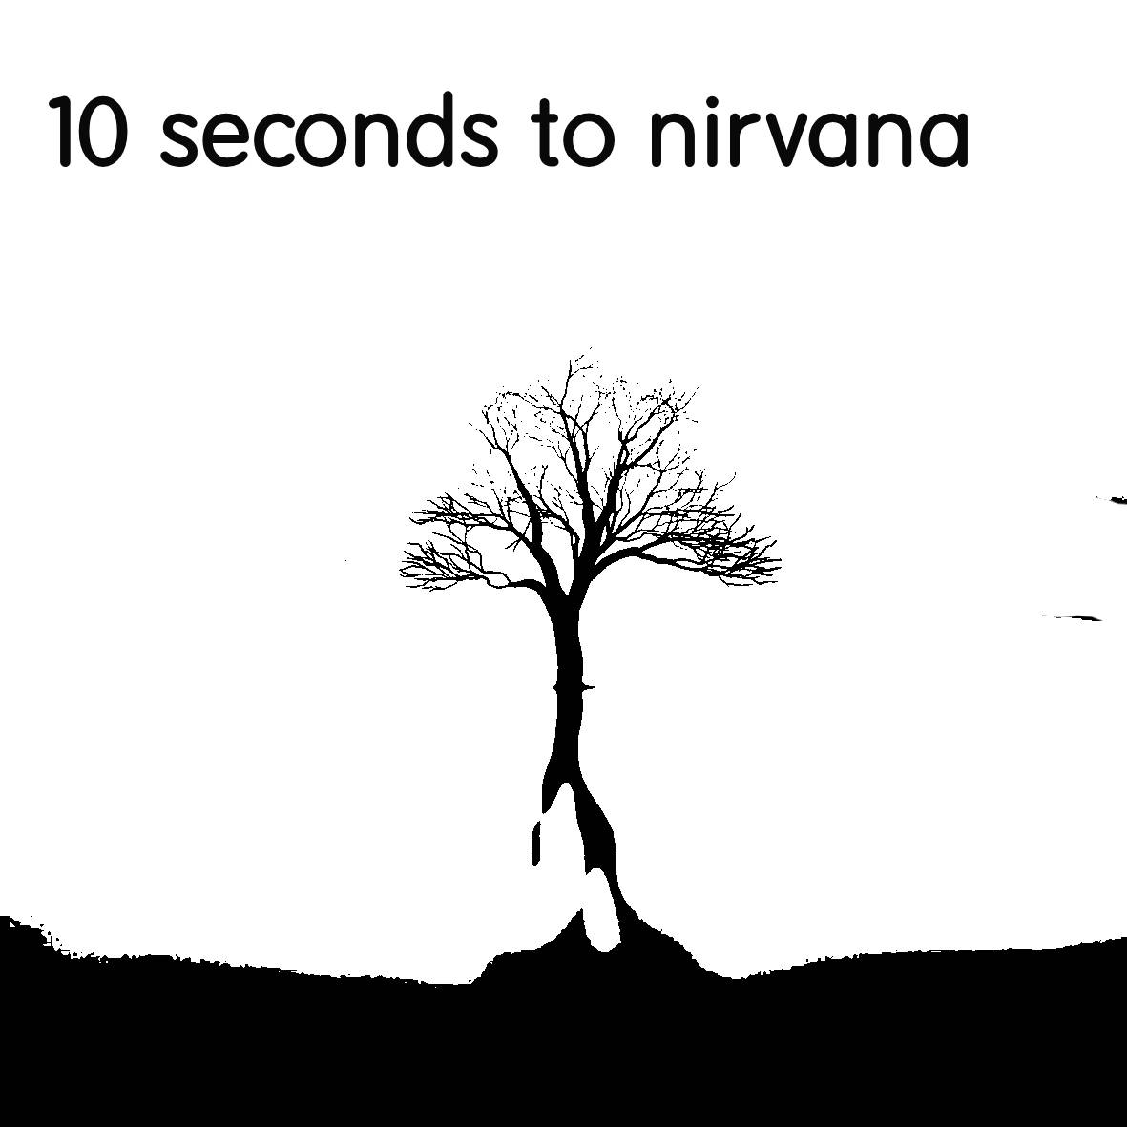

Nirvana or nir· va· na

: the final beatitude (see BEATITUDE sense 1a) that transcends suffering, karma, and samsara and is sought especially in Buddhism through the extinction of desire and individual consciousness.

OR

: a place or state of oblivion to care, pain, or external reality.

How do you reach Nirvana? According to Mariam-Webster dictionary, nirvana is a state of place that transcends suffering which is bliss. What is bliss? Mariam-Webster dictionary also says that bliss is described as:

: complete happiness.

When you transcend suffering to a state of nirvana, you are transcending into a state of complete happiness, or Nirvana.

What 10 seconds to Nirvana entails is to reach a state of happiness, by no more and no less than 10 seconds.

How you do this is quite simple. You breathe in through your nose for five seconds, and then exhale through your mouth for another five seconds. What you continue to do is repeat this process until you ultimately reach a state of calm and complete happiness, or a state of tranquility.

According to American-Webster, tranquility can be defined as:

: the quality or state of being tranquil.

And tranquil means:

: free from agitation of mind or spirit.

Whenever you are feeling stressed, angry, upset or fearful of something that is happening, this can cause many physical symptoms and can elevate your heartbeat. Even when you suffer from a panic attack, all of the physical symptoms persist.

A way for you to reduce these symptoms from persisting, is to calm yourself down. Much like a motor that gets over worked - your body is like a motor and needs to be maintained.

Make sure to breathe all the way in to completely fill your lungs before you breathe out again. Breathe out and completely empty your lungs and then breathe in again and repeat for an many times necessary.

What 10 seconds to nirvana essentially does is slow down your body, making it run smoothly again.

Because when we get panicky and anxious, we tend to breathe faster only utilizing part of our lungs, so we need to use our lungs fully. This increases oxygen to the brain to help calm us down. When we breathe in fast, we aren’t using our lungs fully. Most of our lungs are filled with stale air so we need to get rid of that air and replenish our lungs with fresh healthy air.

This helps calm you down and regain control of yourself. You achieve this by breathing in and then breathing out, as many times as it takes to reach a state of nirvana.

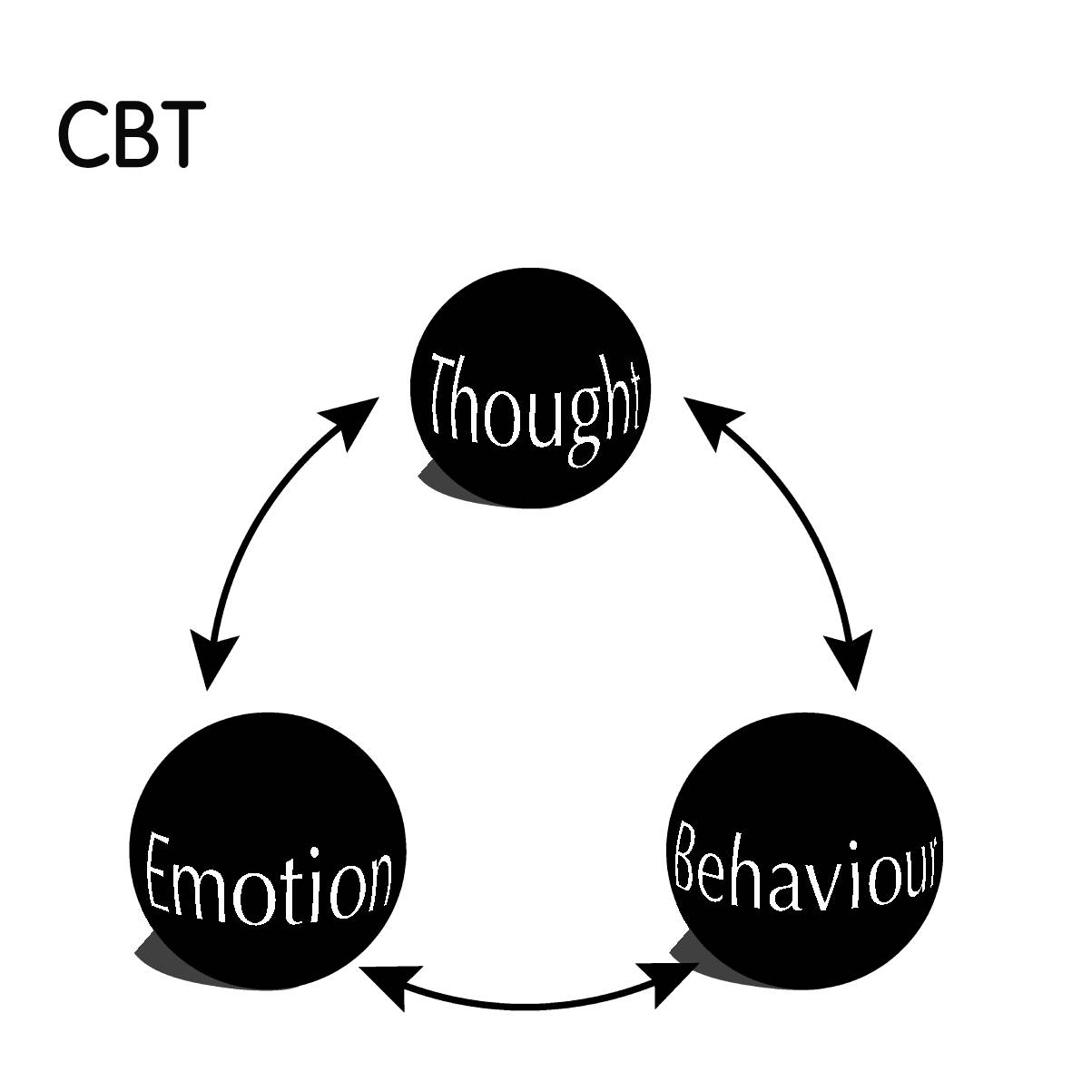

CBT (cognitive behavioral therapy) is a type of psychotherapy or talk therapy that teaches coping skills on how to deal with certain problems in your life. It teaches you skills particularly on how to cope with anxiety and depression. It helps people change their thoughts and behaviors. I briefly talked about this, but I would like to expand on what CBT is.

It challenges your thoughts, particularly negative ones and questions the validity of those thoughts. It can help you think more rationally about your thoughts in a much more realistic and balanced perspective.

Some of the things that might challenge you are the voices in your head that tell you certain things like:

“I want to meet new people but I’m afraid of what they’ll think of me”, “I’m so stupid and I’m not capable of doing anything right like everything else can” or, “I get panic attacks that come out of nowhere and I get really anxious thinking about them”.

These are the voices of depression and anxiety and sometimes they can get so bad and out of control that the only thing that can help is CBT. CBT is an evidence-based treatment that really works. This helps train our brain new and effective ways of thinking and practice how to think more positively to counter the negative thoughts in our head.

For example, you break up with someone and think that you will never meet anyone again and get depressed and lonely and think that you’ll never be happy again, or you feel so unattractive that you feel that nobody will accept you for who you are, and you get depressed and get anxious because you can’t do anything about it.

CBT can help challenge these thoughts that are getting you down. It can give you new ways of thinking such as going out to talk with friends instead of staying at home feeling down and depressed or join some social groups or meet someone entirely new.

You will think instead of “I will never meet anyone again”, that “I still have friends” and “in time I will eventually meet someone else again”. Or that “I am beautiful just the way I am” and “there is more to me than how I look”.

Thought challenging can be done with a licensed therapist that can provide you with the help that you need to counter these thoughts and turn them into more positive ones. This may be an effective treatment for you to alleviate anxiety and depression.

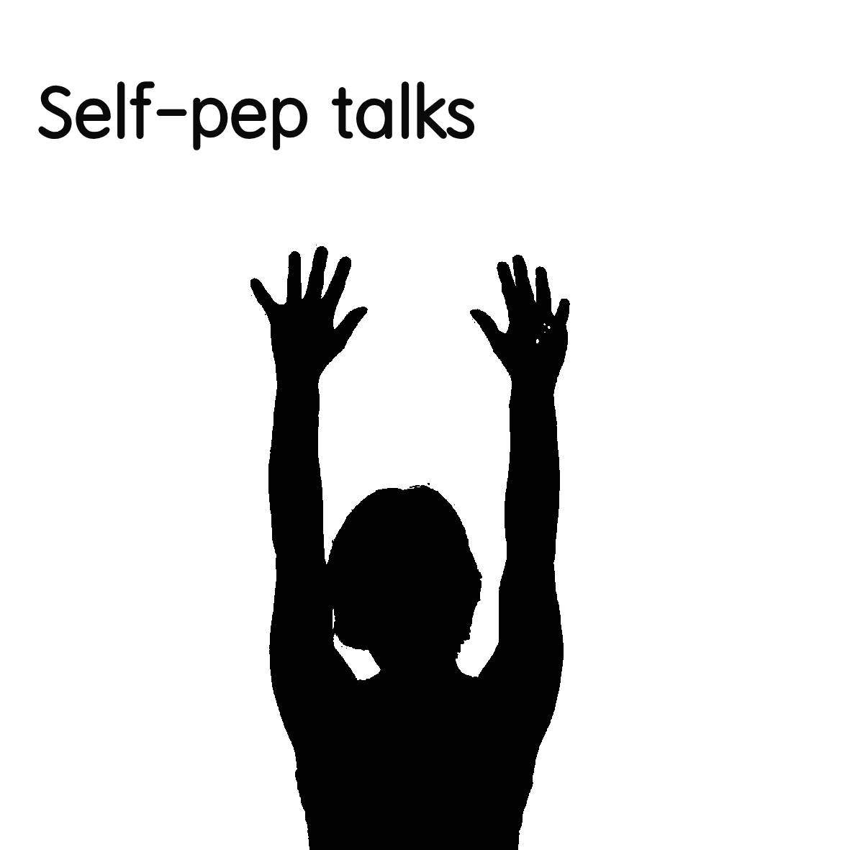

Self pep talks can be a way for you to motivate yourself in any particular situation. They can help motivate you and psych yourself up before doing something. They can also help boost your confidence and morale in a particular situation.

This can also be called positive self-talk, which is an internal dialogue that can help your mind process different situations and challenges. It can be an inspiring speech that you can give yourself to cheer yourself up, or to encourage yourself to do something.

These pep talks can either be done out loud or silently in your head, depending on how you feel. They can help you stay positive in difficult situations. Self-pep talks may give you the confidence that you need to strive ahead and reach your potential. You can think of these self-talks as your very own motivational coach to improve your performance and your will to do something.

This inner voice that you use, can help reaffirm your thoughts or actions when nobody else will.

Benefits of self-pep talks can help build your self-esteem, increase your perseverance, build your confidence and increase your overall willpower as well as eliminate stress. Self-pep talks tend to increase positive outcomes rather than negative ones more than people who don’t use them.

A few examples of self-pep talks can be the following:

“I believe in my abilities, and I am capable of winning and achieving my goal”

“I am thankful for the friends and family that I have to support me.”

“Even though I failed this interview I have learned from my mistakes and will do better next time”.

OR

“I am a great role model to those who I am admired, and I will continue to be a great role model for those in the future”.

These are just some of the very examples where self-pep talks can help be an effective way to boost your confidence and motivate yourself to do better.

Practicing this will help you stay more positive and increase your chances of a better outcome than someone who doesn’t. They are proven to be an effective way to improve your self-confidence and self-efficacy based on science.

Using this can be another effective way for you to cope with anxiety and give you the courage to succeed.



EFT tapping is a technique that involves tapping on specific points of the body while focusing on something specific, such as anxiety. It is a form of acupressure therapy that aims to restore balance to the energy system and release emotional blockages.

It has been authorized for war veterans with PTSD and has shown benefits for anxiety, depression, pain, insomnia, weight loss, and more. Several studies have proven its effectiveness for anxiety, finding significant reductions in anxiety levels and improvements in biomarkers and gene expression. EFT tapping is a safe and gentle technique that anyone can learn and use. It is characterized by acceptance and non-avoidance of anxiety.

To perform EFT tapping, you need to follow five steps:

1. Identify the issue or fear you have. This will be your focal point while you’re tapping. Focusing on only one problem at a time is purported to enhance your outcome.

2. Test the initial intensity of your issue or fear on a scale from 0 to 10, with 10 being the worst or most difficult. This helps you monitor your progress after performing a complete EFT sequence.

3. Establish a phrase that explains what you’re trying to address. It must focus on two main goals: acknowledging the issues and accepting yourself despite the problem. The common setup phrase is: “Even though I have this [fear or problem], I deeply and completely accept myself.”

4. Tap on the 12 meridian points of the body while repeating your setup phrase. The meridian points are top of the head, eyebrow, side of the eye, under the eye, under the nose, chin, collarbone, under the arm, wrist, side of the thumb, side of the index finger, side of the middle finger.

5. Test the final intensity of your issue or fear on the same scale from 0 to 10. Ideally, it should be lower than before. If not, you can repeat the process until you feel a shift.

EFT tapping can help alleviate social anxiety by helping you face your fears and negative emotions without avoiding them or judging yourself.

It can also help you rewire your brain and body to respond differently to social situations and reduce the stress response.

Looking back

The only time you should look back is at how far you have come. You may just be beginning your journey of social anxiety, or you may be on the road to conquering it. No matter where you are or how far you’ve come, there is always a way forward.
It does not have to be a life-long debilitating condition. It can be treatable and manageable at best. With the guidance throughout this book, hopefully it will provide you with ways of alleviating your anxiety and get you to a better place.

Everything mentioned throughout this book has personally helped me and has greatly helped alleviate my anxiety and manage it better over the years, and my aim is to help you too alleviate yours to a point that is much easier to deal with.

There is no simple cure to social anxiety, but through much perseverance and determination, you too can live a life that is more fulfilling without excessive worry and with anxiety controlling your life.

Take a step forward, act and only look back at what you have accomplished.

