5 Greatest Obstacles Separating You And Top Quality Used Cars

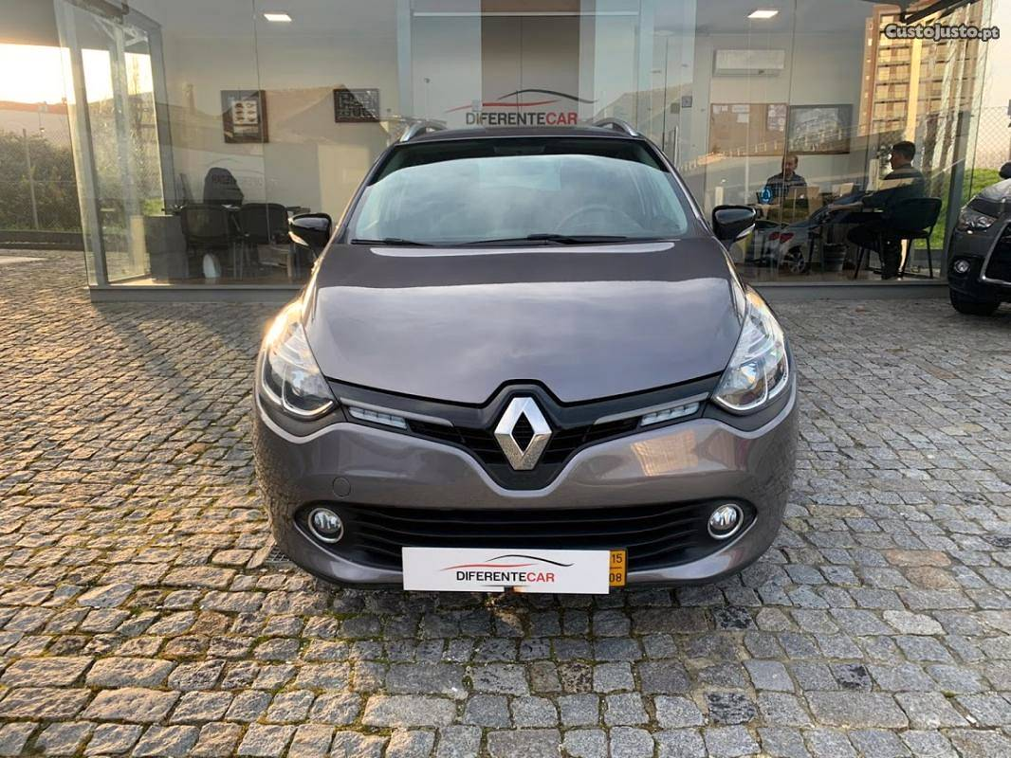

For high quality made use of cars Liverpool homeowners frequently go to the very first dealer they can find, and while that can equally as often as not go a couple of ways, it is not the greatest challenge to finding a top quality item to last for a lot more years and miles. Often, the drawbacks that stand between you and quality used cars, are avoidable and originate from within. With all of today's modern technologies that are in location, it is extremely difficult to conceal previous calamities in a car's past. With a little legwork and a commitment to the bargain, you can prevent getting a lemon fairly quickly, yet these challenges can still stand in the means of you and a pleased acquisition.

Negligence is possibly the greatest problem numerous car customers should overcome. The information is available and conveniently offered using resources to learn whether a used cars is the ideal one for you. Nevertheless, numerous purchasers do not such as to scratch the surface, deciding rather to "keep the enjoyable" in the cars hunt when in truth they are just setting themselves up for catastrophe and disappointment.

Lack of knowledge is what this results in, and is yet an additional obstacle in the initiative to find a high quality used car. Without finding out about the car's past, exactly how can you potentially understand if you're getting a good value, and what will you do when avoidable issues return? Just because an car's record shows previous damages and other troubles that does not immediately indicate that the car is a disposable. Understanding what the concerns are before you get enables you to do the work necessary to prevent future troubles.

Dishonest dealers can likewise be an obstruction in the search, as many pre-owned car dealerships will do and claim anything to relocate stock. That's why that you buy from is equally as essential as what you purchase. Look for dealers with a strong reputation. Ask about and speak with non-biased 3rd parties prior to signing on the dotted line.

As soon as you have actually made your purchase, you can still experience a lot of issues if you overlook reparable problems as they happen. Cars need maintenance. Even if one winds up in the shop, that does not imply it is a bad flight. However a car can go from small concerns to major ones in a hurry if you do not heed the cautions that it offers you and remain on top of regular upkeep.

The last challenge standing in between you and a high quality used car is giving in to gunshy. In other words, passing up the offers right before you. However with education, caution, and placing your faith in the right dealership, you can overcome all barriers.

