KINGOM OF SAUDI ARABIA …………………………………. Education directorate
MINISTRY OF EDUCATION ……………………………. Elementary school


SYLLABUS DISTRIBUTION FOR 3^{rd ,} 4^{th ,} 5^{th &} 6th ELEMENTARY GRADE
(WE CAN 3) (SECOND TERM)1445 H
4/2 _ 8/2 1st week From |  |  |  | Unit 1  It’s Nice to Meet You!
SB_P4 | SB_P3 | SB_P2 | Finding Out Time,Grammar | Unit 1  It’s Nice to Meet You!
2nd week From 11/2 _ 15/2 |  |  |  | Unit 1  It’s Nice to Meet You!
SB_P34 | SB_P6,7 | SB_P5 | Grammar, Rhythms | Unit 1  It’s Nice to Meet You!
3rd week From 18/2 _ 22/2 |  |  |  | Unit 1  It’s Nice to Meet You!
4 Skills Tasks | SB_35 | SB_P8,9 | Phonics & Phonics practice | Unit 1  It’s Nice to Meet You!
4th week From 25/2 _ 29/2 |  |  |  | Unit 2  Sea Animals
SB_P12 | SB_p36 | SB_10,11 | Finding Out Time,Grammar | Unit 2  Sea Animals
From 2/3 _ 6/3 5th week |  |  |  | Unit 2  Sea Animals
SB_P14,15 | SB_P37 | SB_P13 | Grammar, Rhythms | Unit 2  Sea Animals
From 9/3 _ 13/3 6th week |  |  |  | Unit 2  Sea Animals
Grammar & vocabs | SB_P16, 17 | إجازة اليوم الوطني | Phonics & Tasks | Unit 2  Sea Animals
From 16/3 _ 20/3 7th week |  |  |  | Unit 3  Sports and Activities
SB_20 | SB_19 | SB_P18 | Finding Out Time,Grammar | Unit 3  Sports and Activities
From 23/3 _ 27/3 8th week |  |  |  | Unit 3  Sports and Activities
SB_P38 | SB_P22,23 | SB_P21 | Grammar, Rhythms | Unit 3  Sports and Activities
From 30/3 _ 4/4 9th week |  |  |  | Unit 3  Sports and Activities
4 Skills Tasks | SB_24,25 | SB_39 | Phonics , practice & Tasks | Unit 3  Sports and Activities
From 7/4 _ 11/4 10th week |  |  |  | Unit 4  Chores
SB_P40 | SB_P28,29 | SB_P26,27 | Finding Out Time,Grammar | Unit 4  Chores
From 14/4 _ 18/4 11th week |  |  |  | Unit 4  Chores
إجازة مطولة | SB_P32 | SB_P30,31 | Rhythms and Reading, phonics | Unit 4  Chores
From 21/4 _ 25/4 12th week |  |  |  | Unit 4  Chores
Language use | SB_P41 | SB_P33 | Phonics,phonics pr & tasks | Unit 4  Chores
From 26/4 _ 30/4 |  |  |  | 13th  week
The Examination ( 4^{th ,} 5^{th &} 6th ) Grades .  Remedial Plans (3rd Grade) |  |  |  | 13th  week

إجازة مطولة إجازة اليوم الوطني

Teacher…………….… Headmaster………………. Supervisor ……………….

SB كتاب الطالب

توضيح مهم ل
Tasks المدرجة بالتوزيع
- هي مهام ادائية وانشطة داخل الحصة كأوراق العمل وحل كتب النشاط على المهام المطلوبة سواء كانت 4 skills اللي هي المهارات الأربع ( قراءة و كتابة و تحدث واستماع )

- او مهارات المفردات والقواعد grammar and vocabs
او مهارات استخدام اللغة وتكوين الجمل language use وهكذا

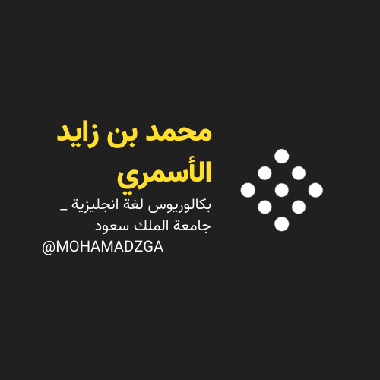



MOHAMADZGA M_zaid0

لا تنسوني من صالح دعائكم

