Does Hair Grow Back Thicker After Laser Hair Removal?
he short answer – NO, laser hair removal does not cause thicker hair to grow out, in fact it’s the opposite, laser hair removal cause the hair to grow out thinner.
Laser hair removal is one of those innovations that people who wish to remain body-hair free will forever be thankful for. After all, when you have a procedure that can free people of having to wax or shave regularly, you know it is going to be insanely popular.
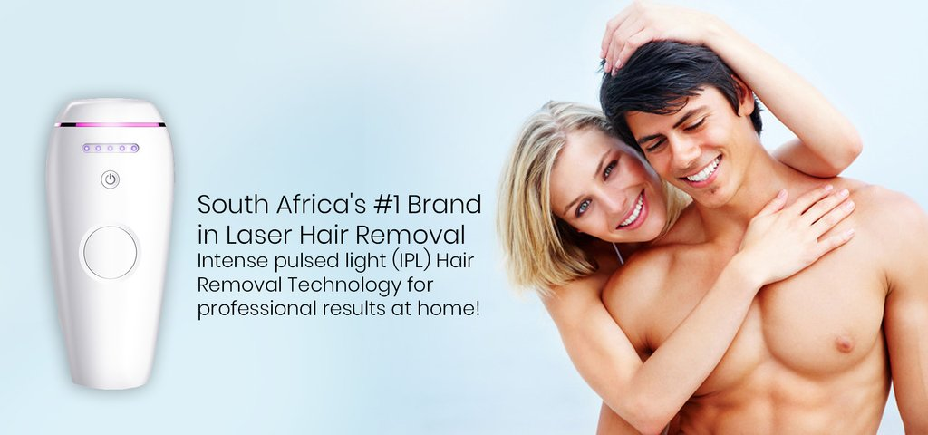
Laser hair removal as a technology and procedure has been around for some years now but there are still quite a lot of misconceptions around it. These misconceptions can range from hair growing back after pregnancy, it not being suited to darker skin, and even to hair growth being thicker after laser hair removal.

What is Hair Growth Like After Laser Hair Removal?
The goal to laser hair removal is ideally, no hair growth at all. This ideal scenario is the sum of many different factors such as the efficiency of the treatment, the person’s body reaction etc. In fact, people who have successfully completed their series of laser hair removal treatments often claim that hair growth is extremely minimal to none at all. A touch-up treatment may be required every few months but it is still a lot better than having to shave daily.

So what is it with the idea that hair grows back thicker after hair removal? This is a misconception. Laser hair removal will not cause hair to grown back more densely. People who have undergone treatment claim just the opposite effect as a matter of fact. Each treatment is expected to show a reduction at a range of 10-25% of growth. Not only that but there is also a marked reduction in hair density, thickness, and even growth rate per succeeding session.


Consider the Real Pros and Cons
If you have been thinking of getting laser hair removal but have hesitated due to worries of hair growing back more densely, rest assured this isn’t something you need to worry about. The best thing you need to do to ensure optimal results and safety is to look for a good clinic that has your best interests at heart and some ways to do that are as follows:
- Look for a clinic with good reviews and a reputable staff. It would be prudent to check for certifications and other qualifications. When going for your initial consultation, note how confident and professional they are with you.
- Check what types of lasers are used in their clinics. Different types of lasers suit different types if skin better and can also bring about different results. They will even affect how many sessions you will need before achieving permanent hair removal.
- Ask to see before and after photos and if possible, ask whether they can facilitate a chat with a former client.

Laser hair removal is a safe and effective method to achieve your goals of being hair free. Doing your research will help you free yourself of misconceptions that are holding you back. Also, by taking the time to learn more about the process, you are assuring that you get the best results.
Original article found at - https://www.bareskin.co.za/blogs/news/does-hair-grow-back-thicker-after-laser-hair-removal

