OCCUPIED CYPRUS WITH WEST PERMISSION, BY BARBARIANS TURKS.

A. OCCUPIED BY BARBARIANS TURKS OFCHERSONESE OF KARPASIA CYPRUS
B. Ghost Town Famagusta
C. SOME OCCUPIED VILLAGES OF FAMAGUSTA AREA
D. OCCUPIED NICOSIA AND KYRENIA DISTRICTS
E. MY NEIGHBORHOOD WITHIN THE WALLS OF OLD NICOSIA

A. OCCUPIED BY BARBARIANS TURKS OFCHERSONESE OF KARPASIA CYPRUS
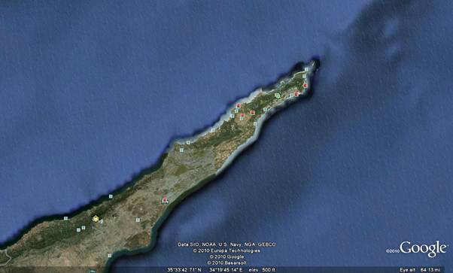

Ayios Philon - Over the ancient roman harbour
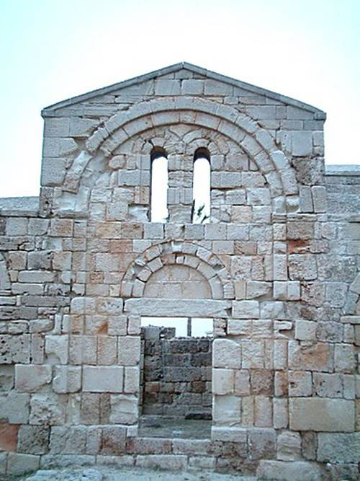

Ayios Philon. Karpasia.
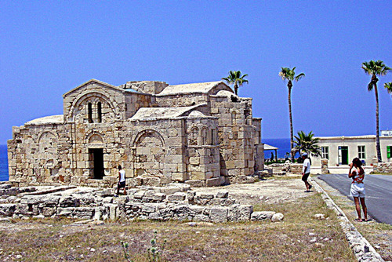

Ayios Philon. Karpasia.
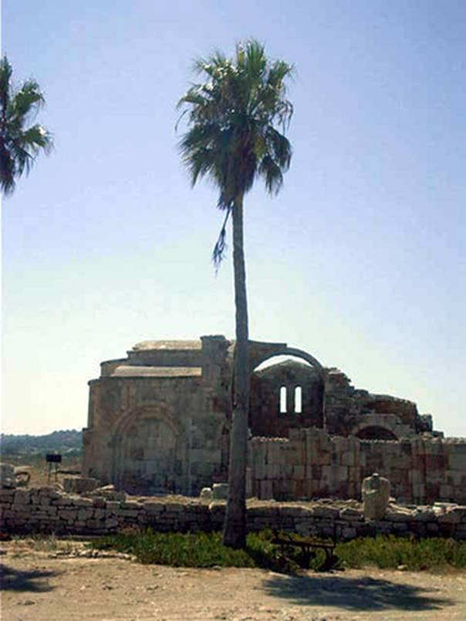

Karpasia area. Davlos Kantara. Ancient Church
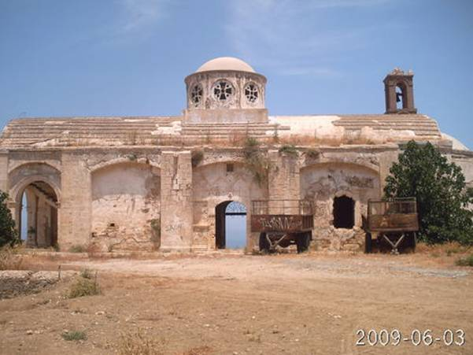

Lithragomi village. Occupied by the barbarians ancient Kanakaria monastery polluted architectonically by the new mosque
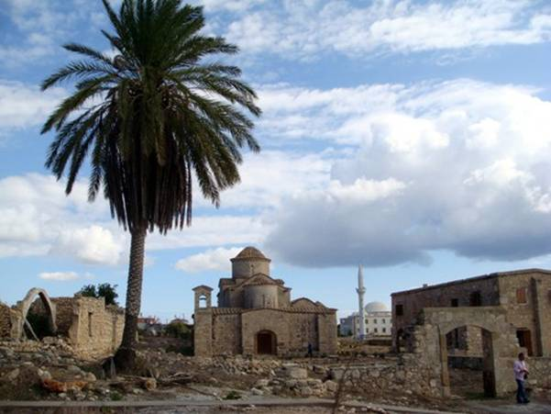

Vokolida village. Artemis
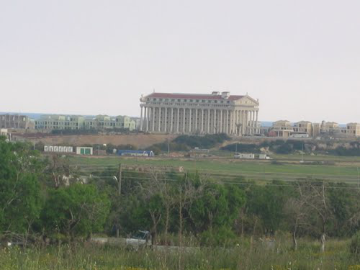

Karpasia. Bizantine Monastery
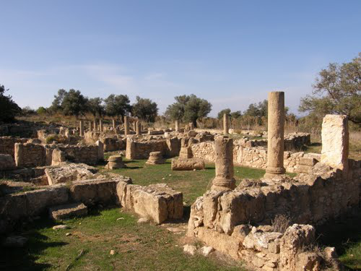

Karpasia. Bizantine Monastery
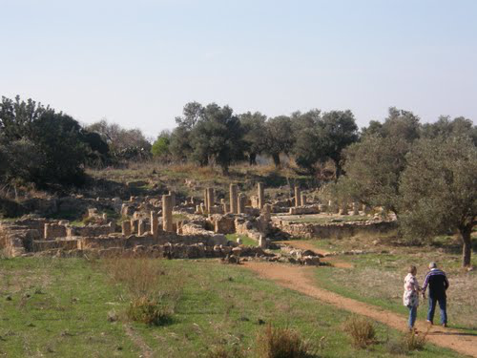

Eptakomi village. The Greek church and the new Mosque of the invaders.
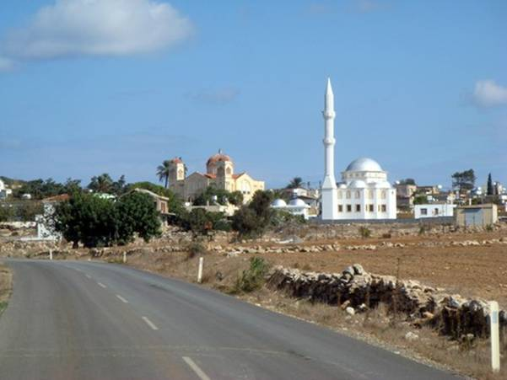

Eptakomi village. The added minaret to the church
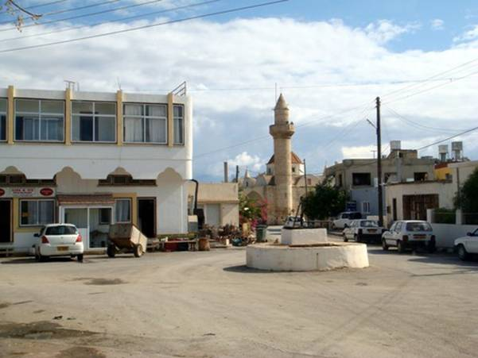

Gialousa and Agia Trias villages. 5th century basilica ruin, Ayia Trias
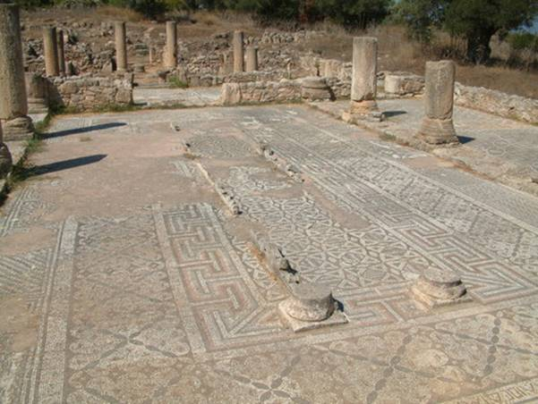

Karpasia area. Ardana village. The Greek cemetary
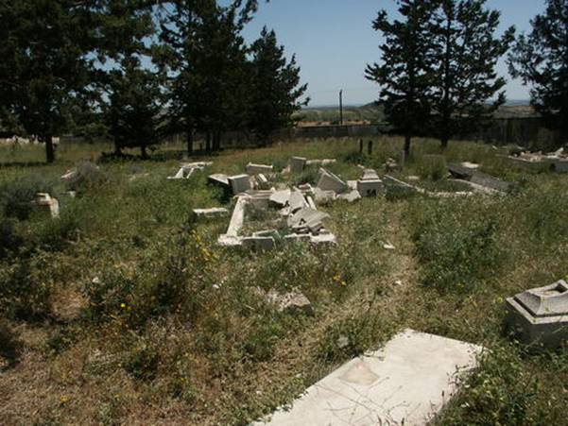

Karpasia area. Occupied old Carob stores
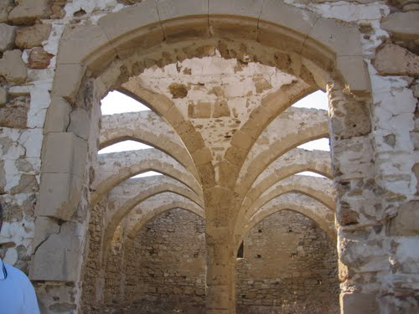

Rizokarpaso village. Cemetery catastrophe by the barbarians
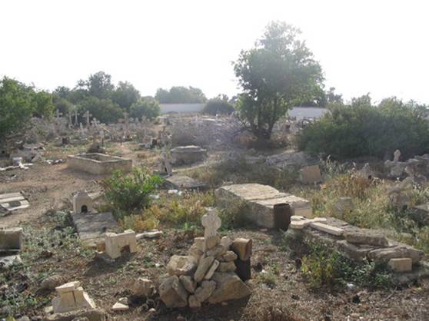

Rizokarpaso village. Pollution of the area
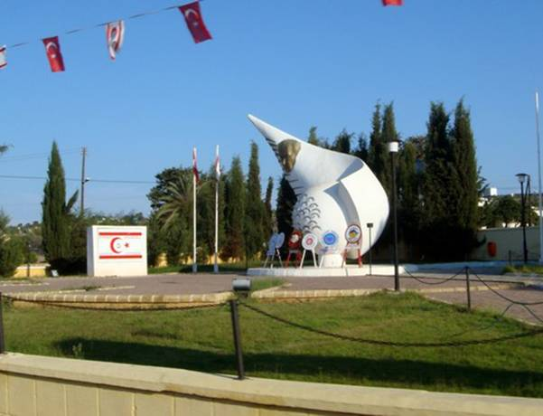

Karpasia area. Agios Iakovos village
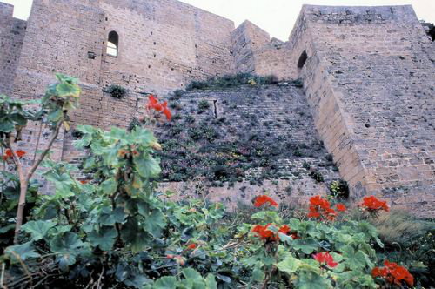

Karpasi village. Mossaic
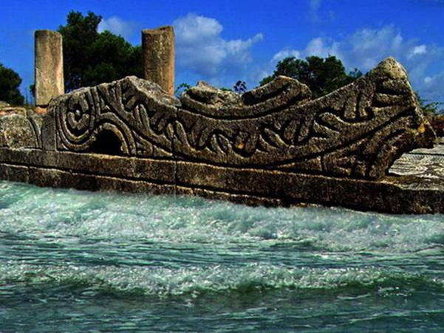

Karpasia area. Akanthou village. Birth place of tenor Zarmas. General view
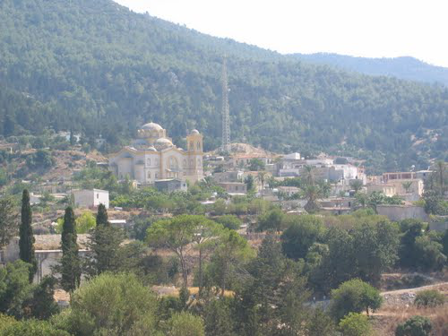

Karpasia area. Akanthou village. Panagia (Madona) Pergamiotissa
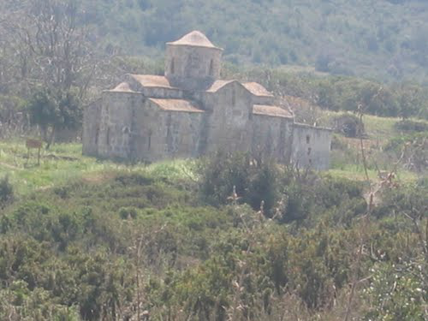

Patriki village. Family Greek tomb.
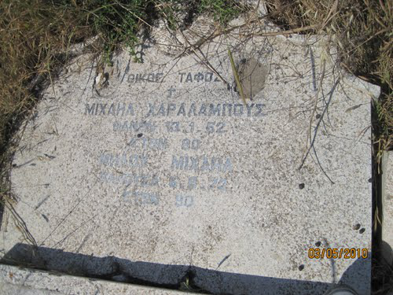

Agios Theoforos village. Anchient Greek theater
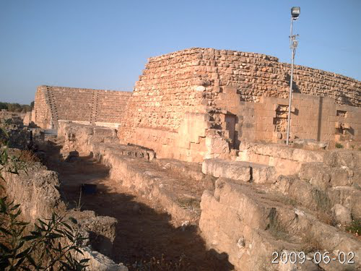

Same area. Environment pollution. Mehmetcik Mountains
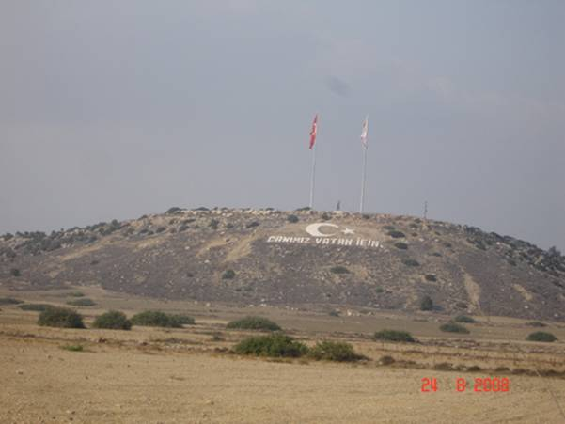

«My Home» wrote a Greek Cypriot on google earth. One of the ocupied Greek homes of Karpasia where all inhabitants before 1974 were Greeks
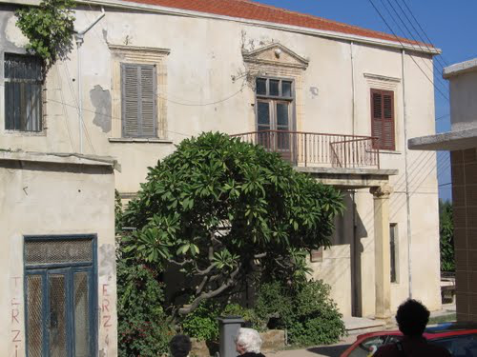

Afendrika medieval city
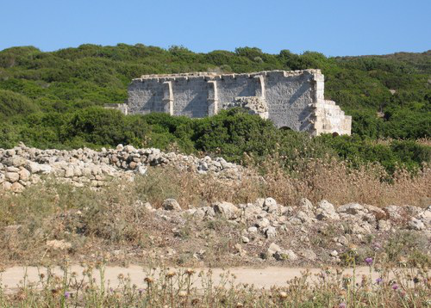

Occupied Apostolos Andreas Monastery. One of the holyest places of Greek Cypriots in the eastiest place of Cyprus
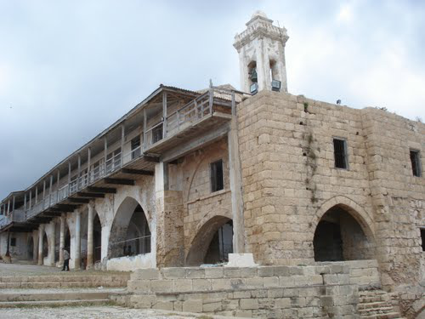

Occupied Apostolos Andreas Monastery
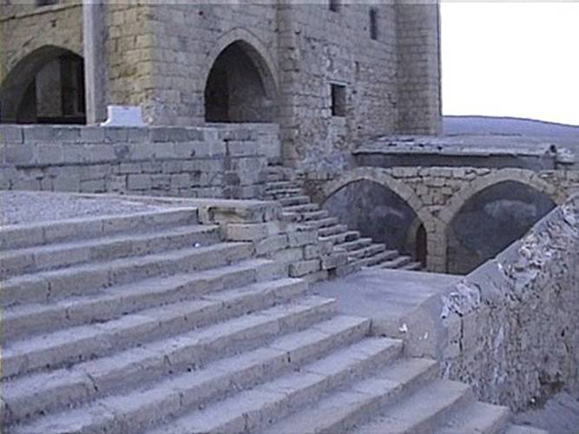

Inside occupied Apostolos Andreas monastery.
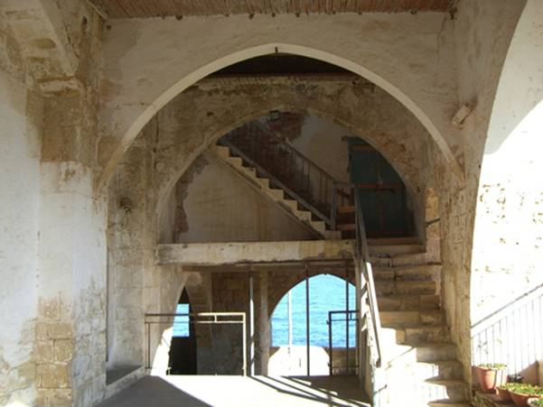

Karpasia area. The newest Agios Philon Church
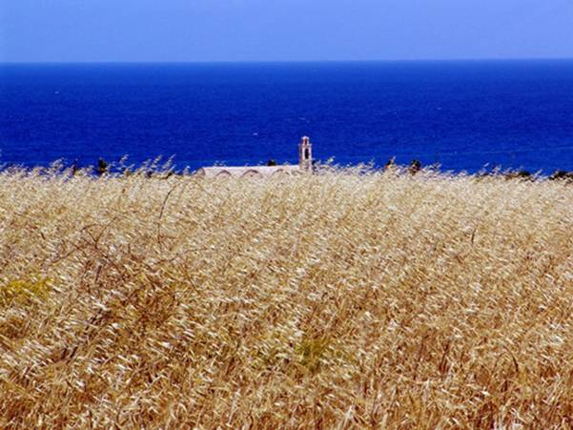

Karpasia near Apostolos Antreas Monastery. The symbols of occupation
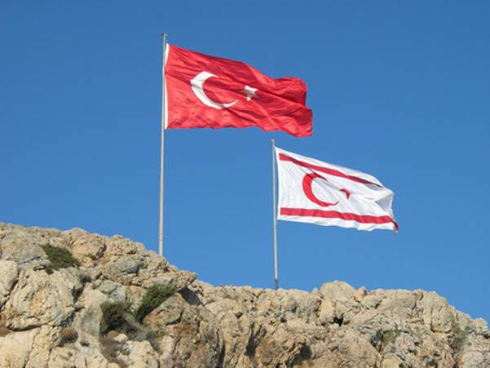

Chusch of Apostolos Andreas Monastery at the eastest Cyprus place.
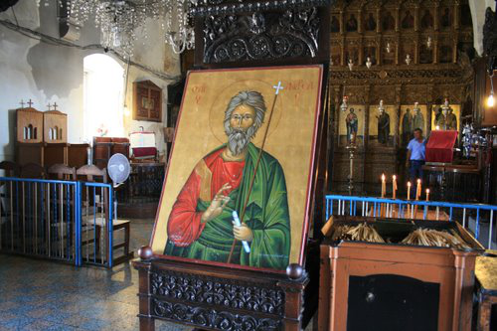

Gialousa and Agia Trias villages. Ocupied Church
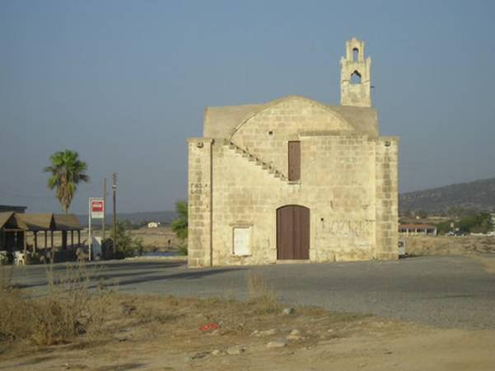

Karpasia area. Church
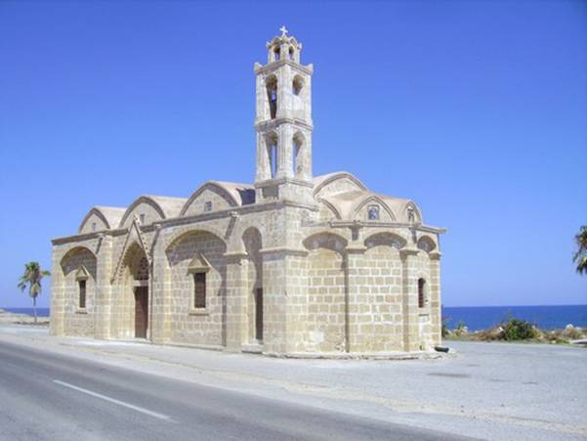

Karpasia area. Occupied old Carob stores
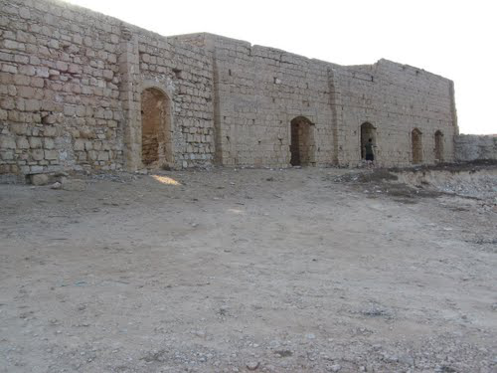

Karpasia area. Occupied old Carob stores

Occupied Karpasia area. «I diki mou thalassa (my sea)». Written by a Greek Cypriot
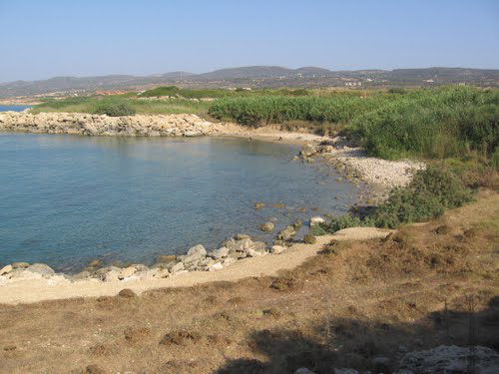

Komi Kepir village. The Church
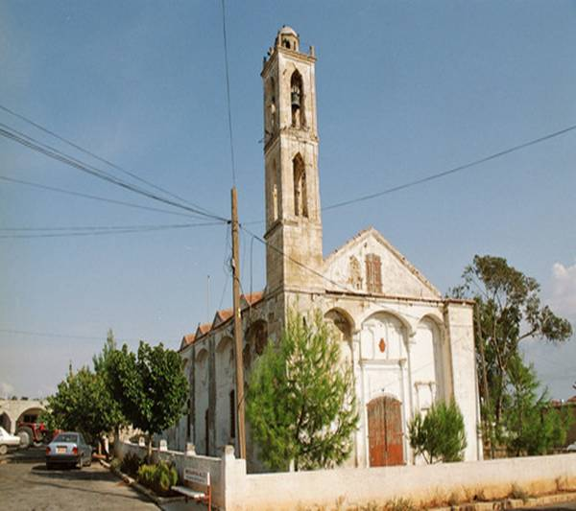

Karpasia area. Ardana village. A traditional Greek Cypriot house
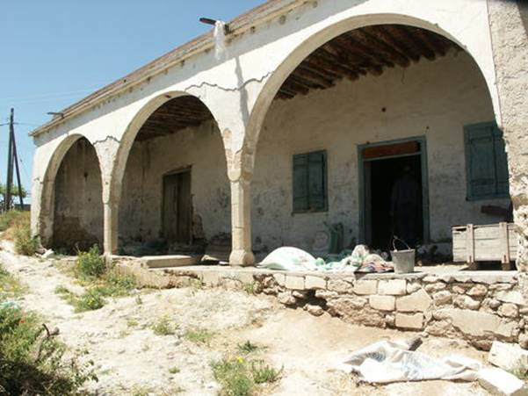

Karpasia area. Ardana village. The ex-Greek elementary school
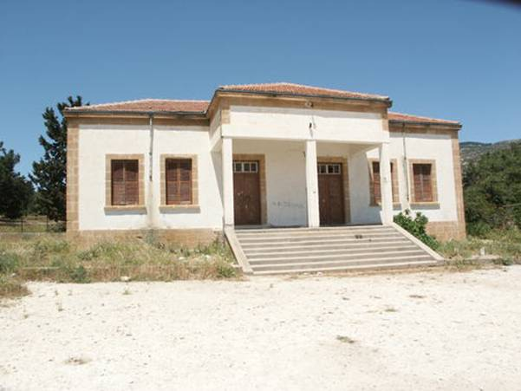

Karpasia area. Ardana village. Another symbol of the invaders
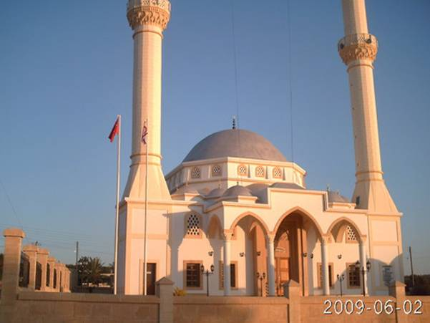

Karpasia area. Agios Andronicos village. Church with addwd minaret
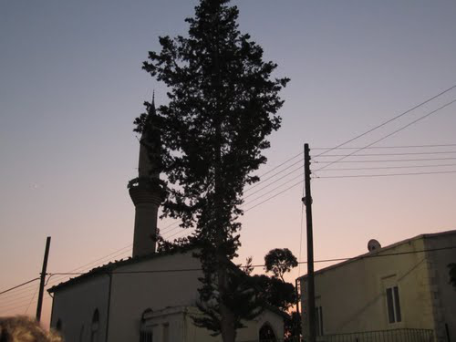

Karpasia area. Akanthou village. Chrisosotiros Church. Another view
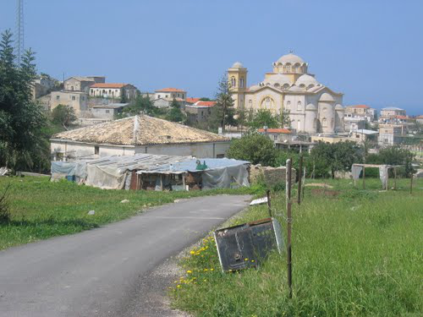

Karpasia area. Akanthou village. Agios Mikallos Church
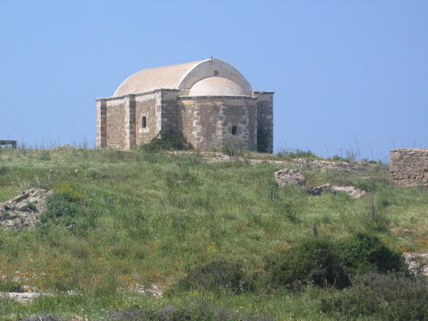

Karpasia area. Akanthou village. Agios Charalambos Chapel
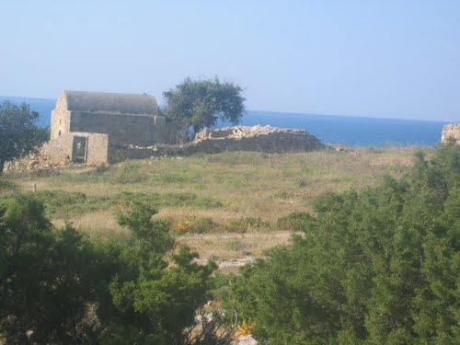

Karpasia area. Ayios Nikolaos Village
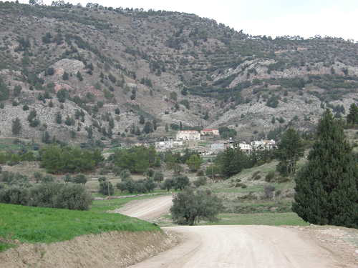

Trikomo village
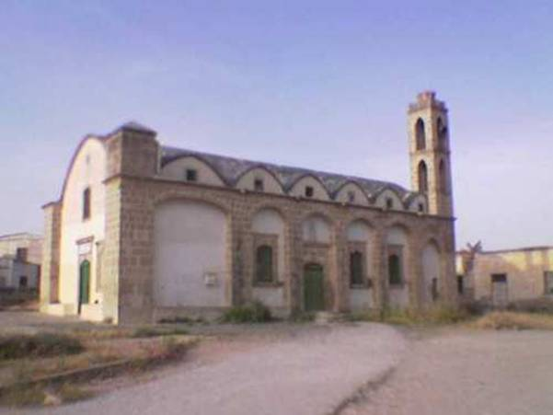

Trikomo village.
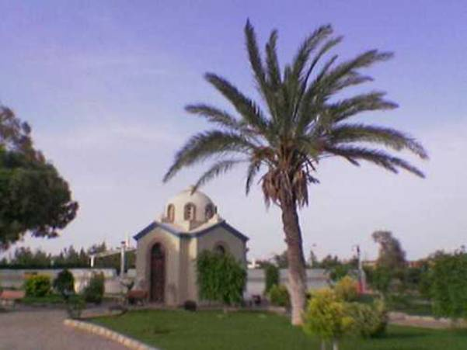

Ovgoros village.
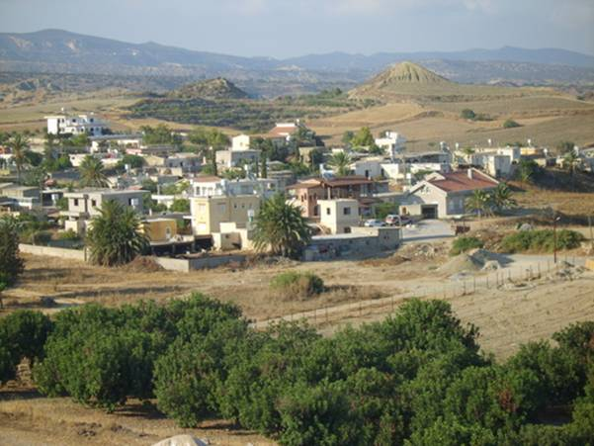

Ovgoros village. Agios Varnavas church
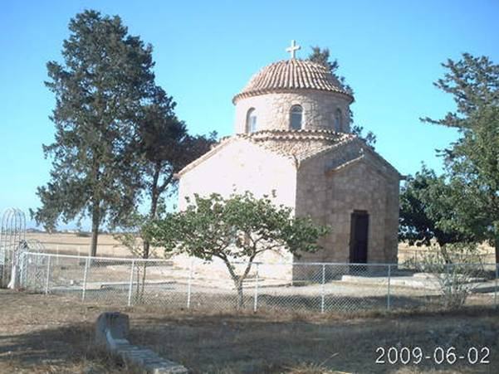

Gastria village. The church with cut cross of the campanile
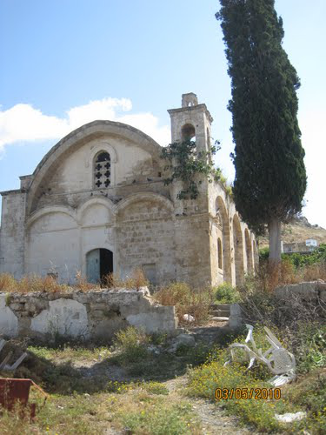

Agios Theodoros village. Agia (Sunt) Paraskevi Church with cut cross of the campanile
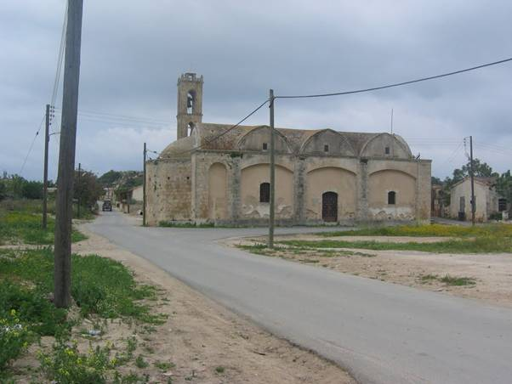

Tavros village. Church , now mosque
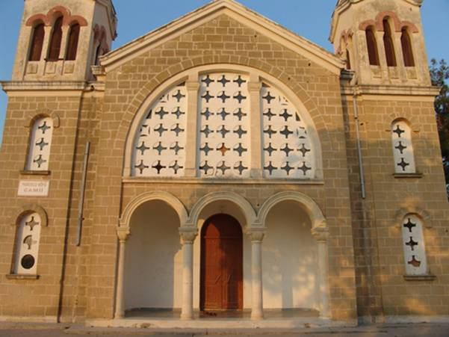

Tavros village. Traditional Greek Cypriot house ocupied since 1974
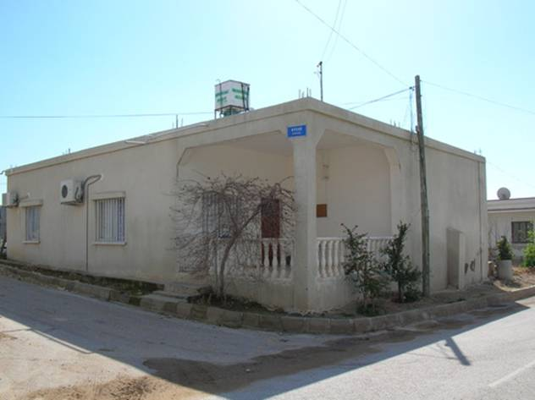

Koumiali village. The church converted to mosque without cross of the campanile
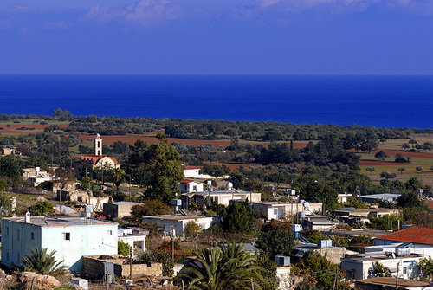

Karpasi village. Church converted to mosque ??
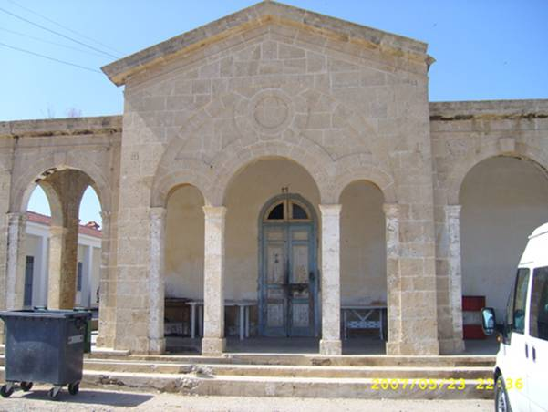

Leonarisso village. Agios ( Sunt) Dimitriops Church converted to mosque by the barbarians.
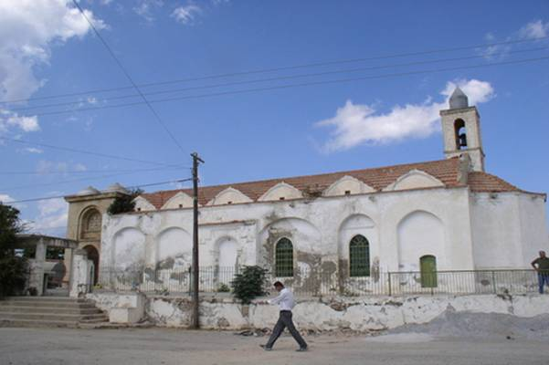

Koma Tou Gialou village. Church
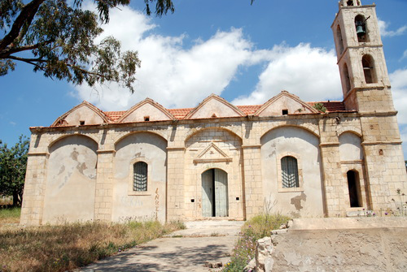

Melanarga village. Agios Polychronios Church with cut the cross of the campnile.
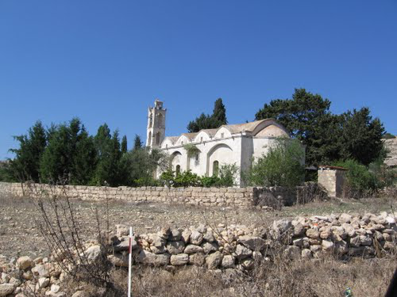

Bathilakas. St George Church with cut the cross of the campnile.
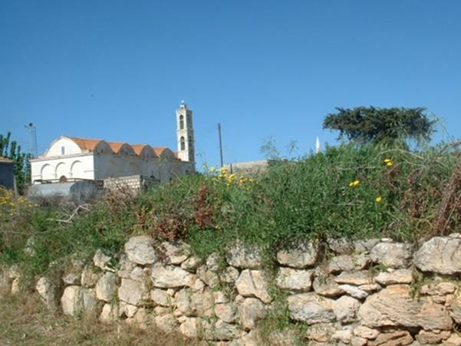

Neta village. Agios Sergios Church (after the invasion)
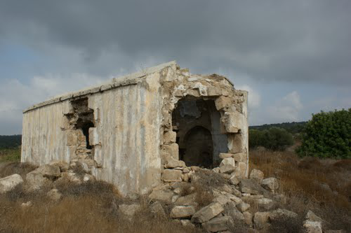

Karpasi village. Tradional Greek building
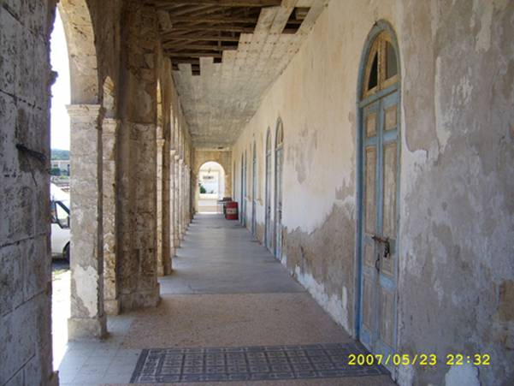

Agios Sinesis village. Agios Sinesis Church
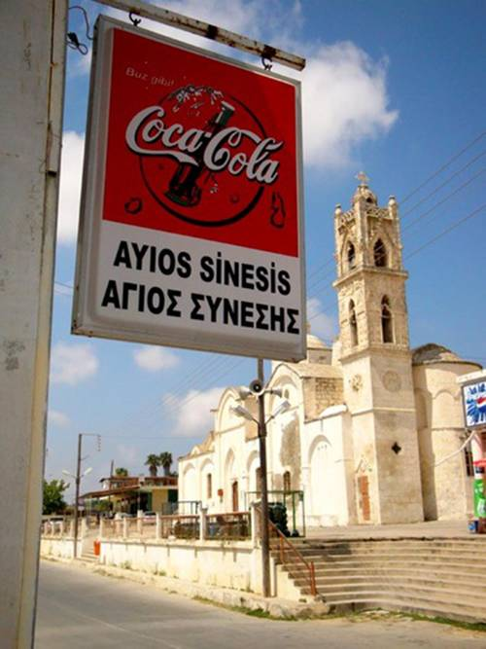

Galinoporni village. The symbols of barbaric occupation
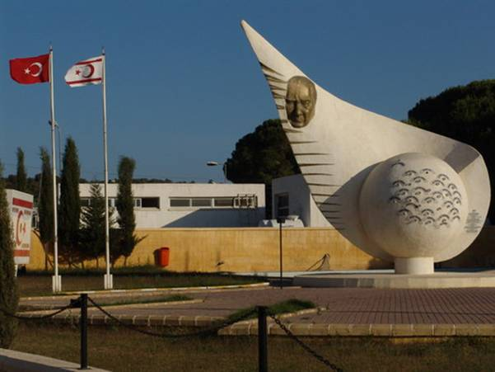

Korovoia village. The symbols of barbaric occupation
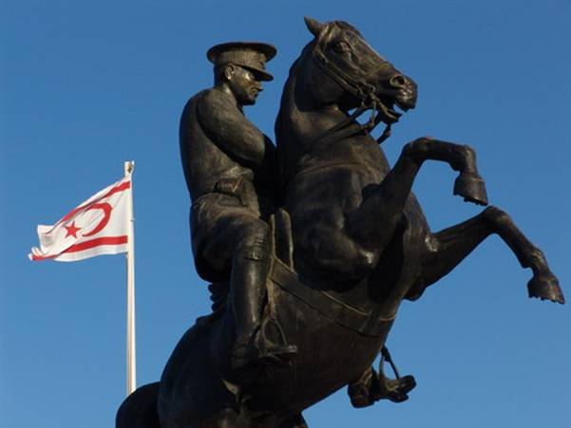

Rizokarpaso village. Traditional House - Rizokarpason
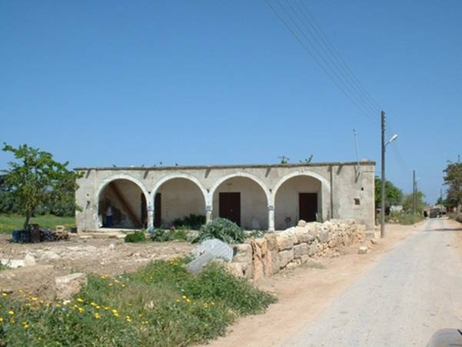

Rizokarpaso village. Agia Mavri Church
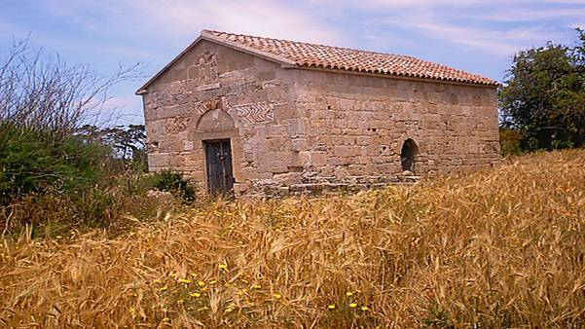

B. Ghost Town Famagusta
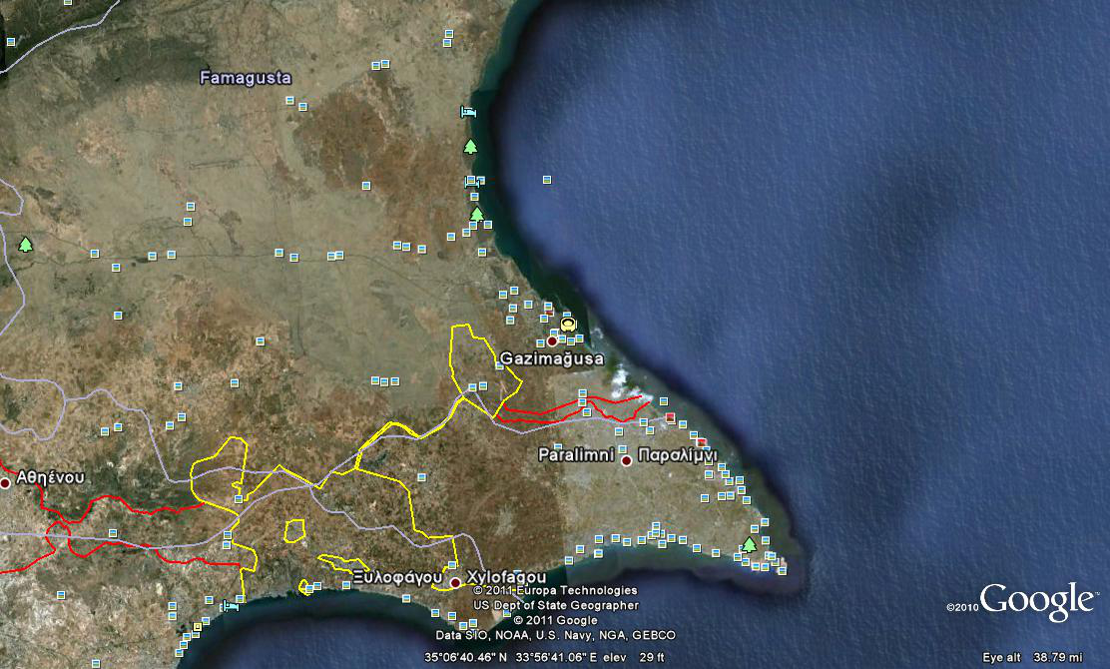
Famagusta (Before 1974)
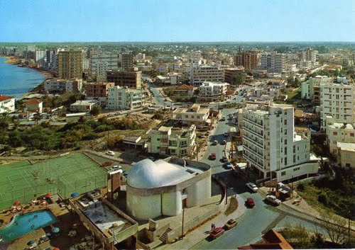
DIMOCRATIAS AVENUE,before 1974
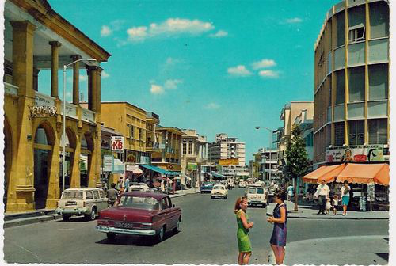
Ghost Town Famagusta - There is nobody living here
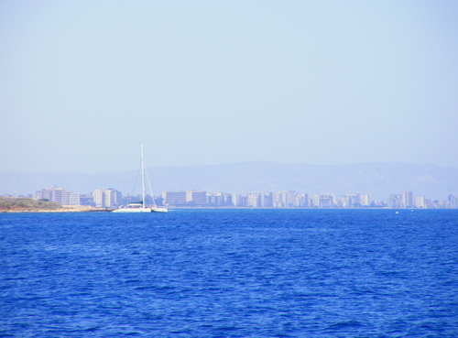

FAMAGUSTA DEAD CITY
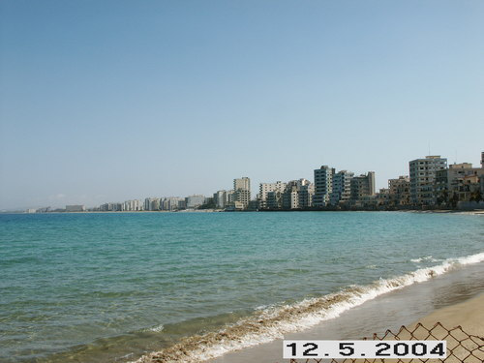

Famagusta. Church
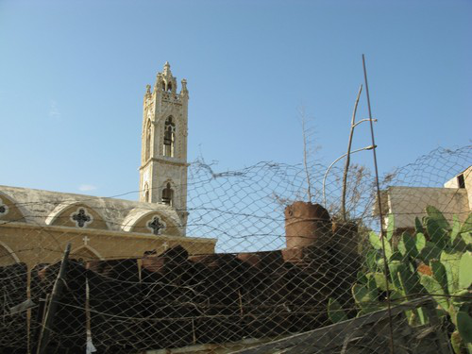

Famagusta Church (added minaret)
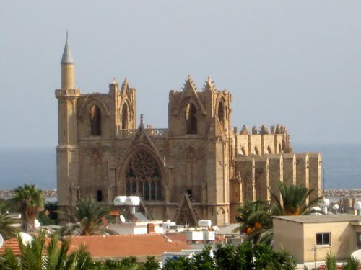
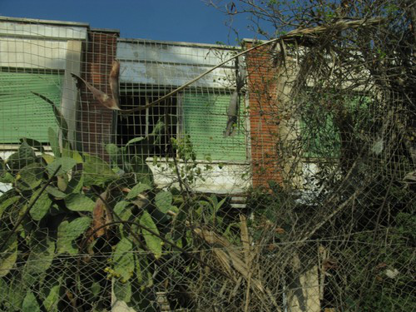

Famagusta. Greek Orthodox cemetery
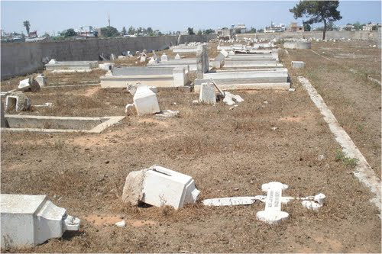

Famagusta. Church with cut cross of the campanile
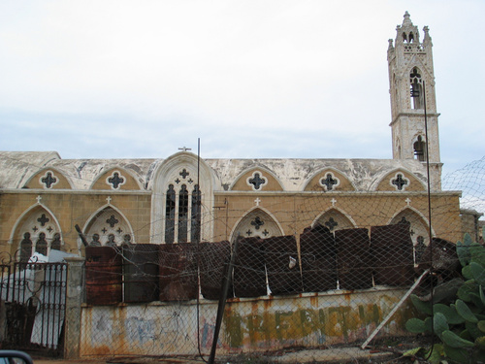

Once a busy side street of Famagusta
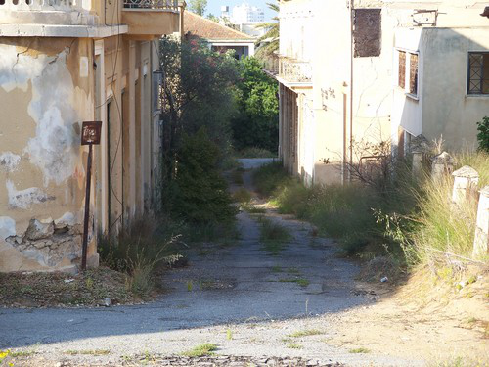

Salamis
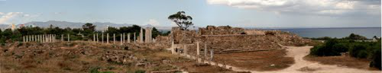
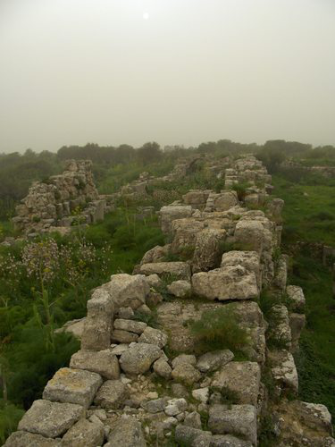
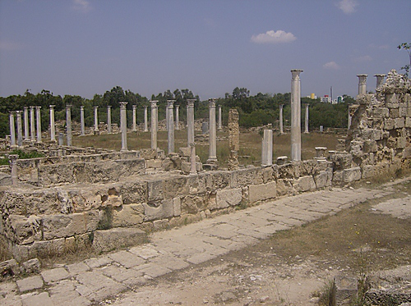
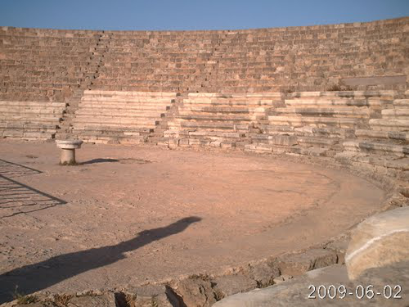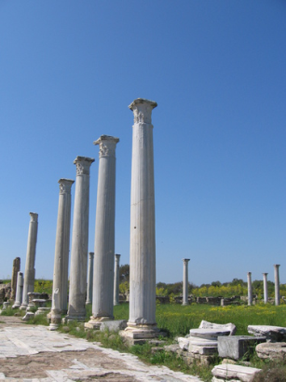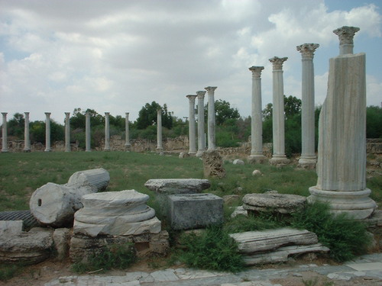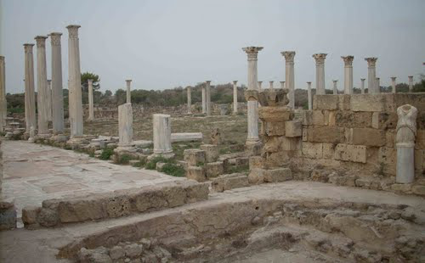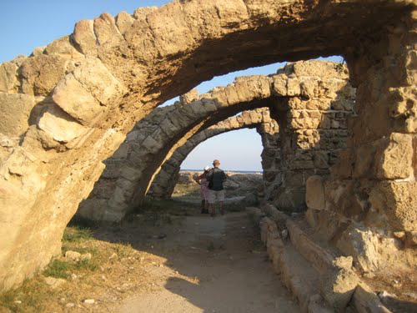
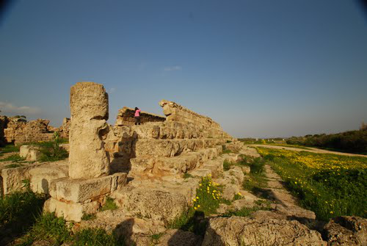
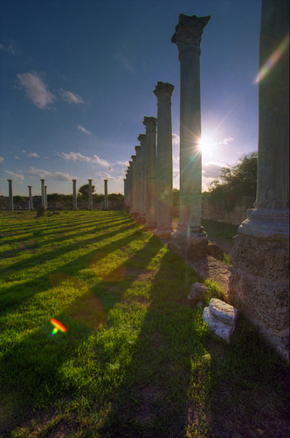
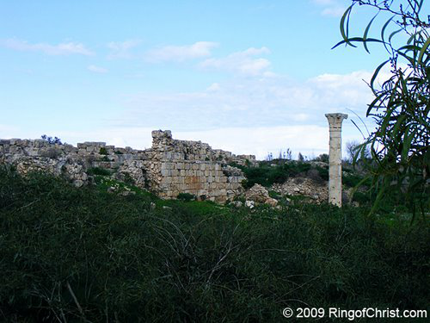
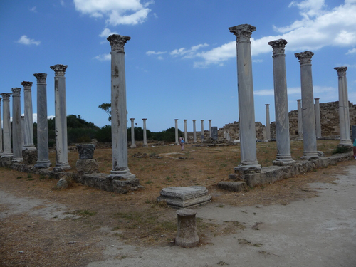
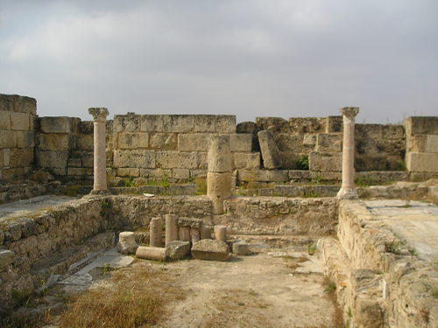
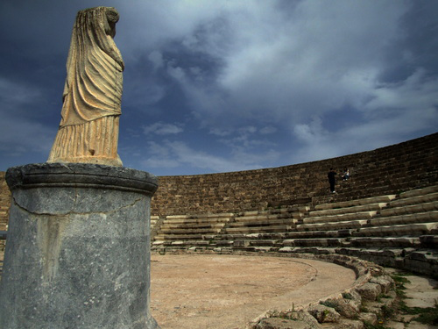
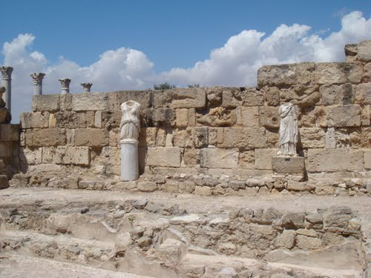

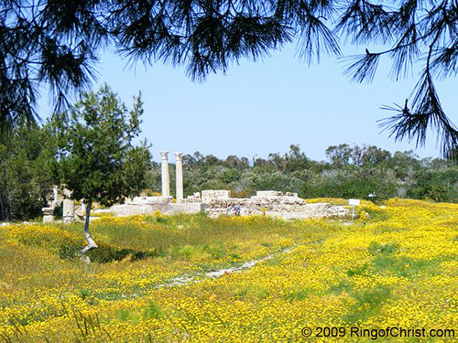
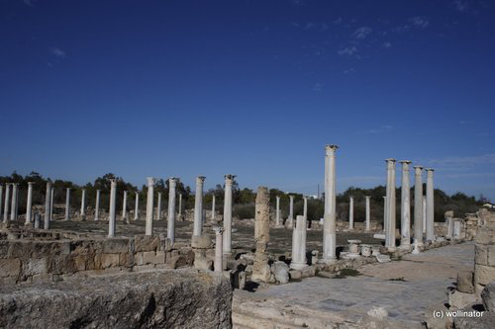
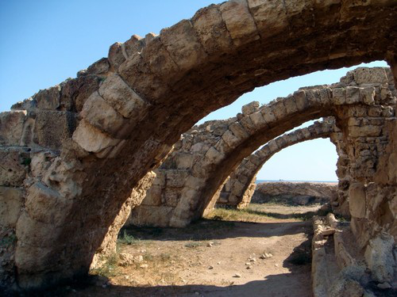
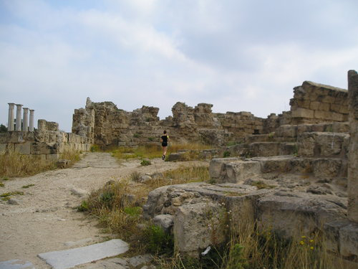

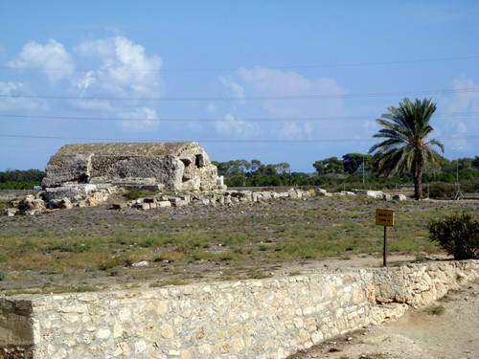
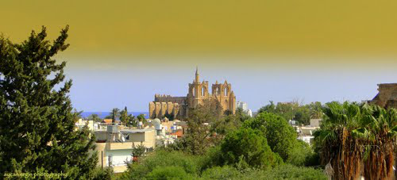

Church with cut the cross on the campanile
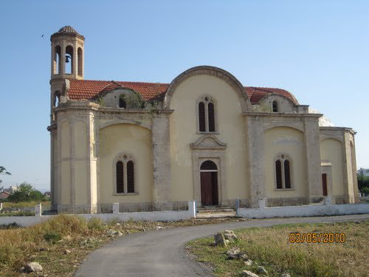

C. SOME OCCUPIED VILLAGES OF FAMAGUSTA AREA
Ayios Sergios village. Sunt Sergios Church
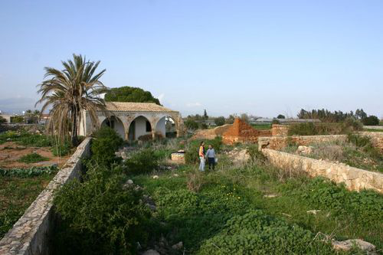

Angastina village. AGIOS THERAPON CHURCH-CEMETERY -MAY 2009
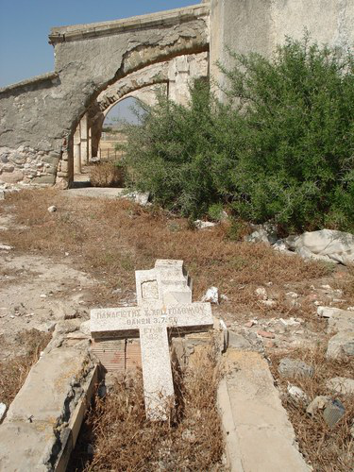

Singrasi village. Agios Prokopios church.
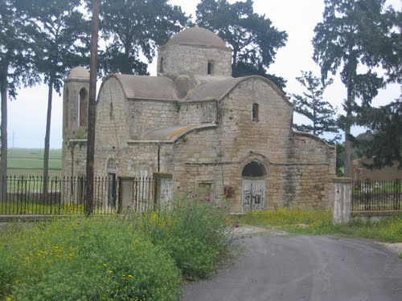

Agios Georgios village . Agios Georgios Church, with cut cross of the campanile
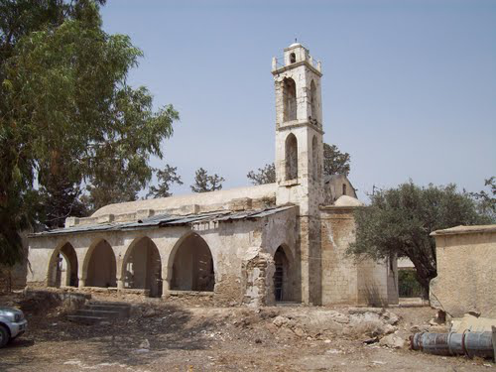

Egomi village (and ancient town)
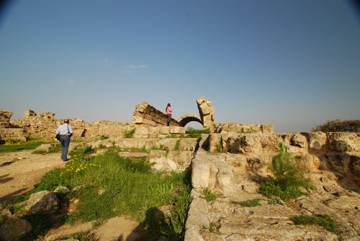

Stylloi village . Church of the occupied village with cut cross of campanile

Lysi village. . Church of PANAGIA (Mother Maria) of LYSI village with cut cross on the campanile
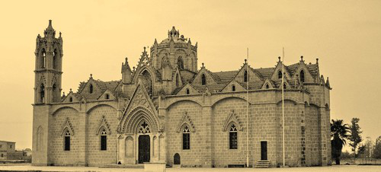

Pigi village. Church of the village with cut cross of the campanile

Arnadi village. Paradisi
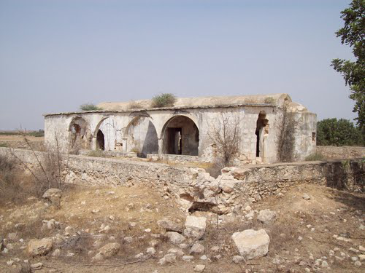

Lefkonoiko village. Lefkoniko Greek cemetery 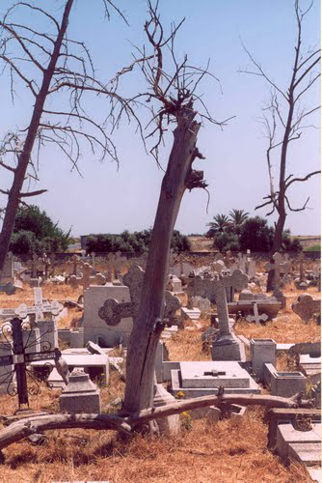

Lefkonoiko village. Occupied Church of Sotiros
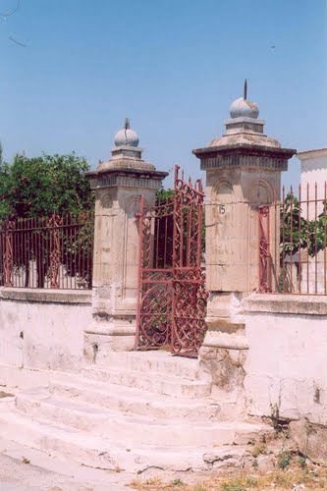

Gypsou village. St George's Church (with cut cross on the campanile)
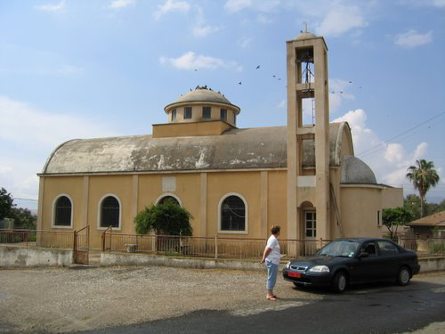

Trikomo village. Church with cut the cross on the campanile
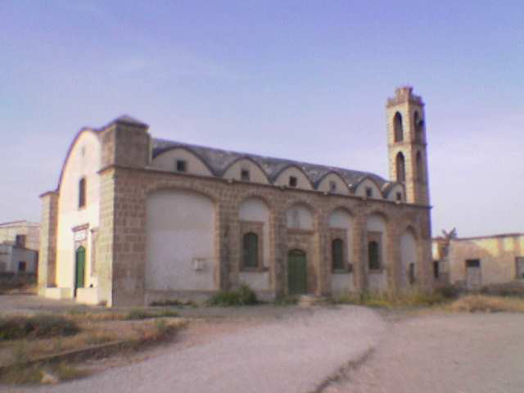

Stylloi village. Engomi. Monastero di San Barnaba
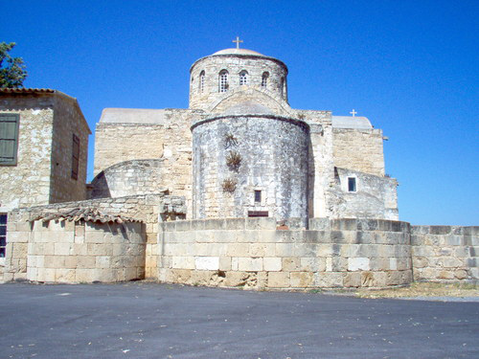

Trikomo village. Panagia Theotocos
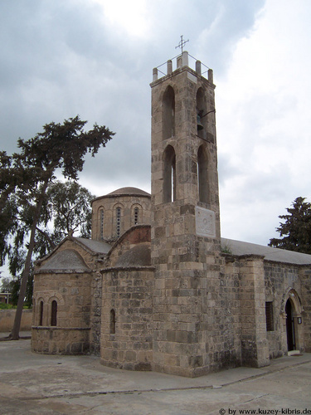

Paradisiotissa village Church (Paradise Church)
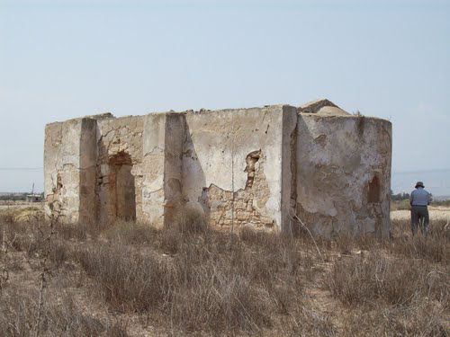

D. OCCUPIED NICOSIA AND KYRENIA DISTRICTS
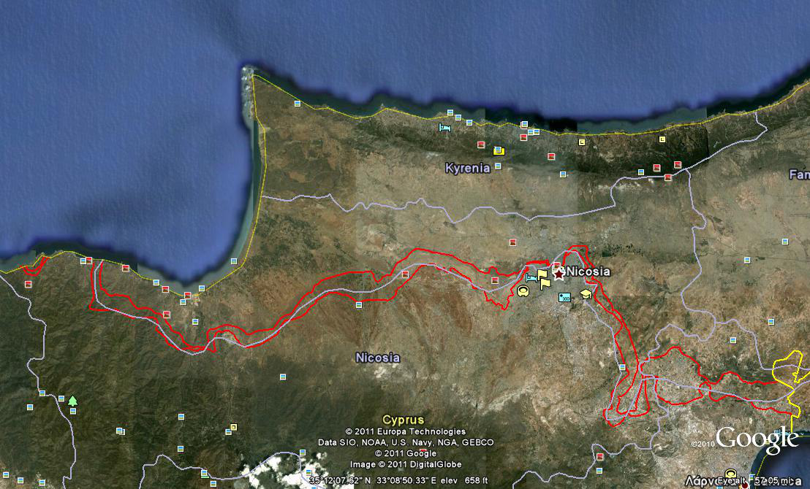

The invasion –excursion of barbarian Turks in Cyprus. Kissinger arranged to strand freely about 5 miles west of Kyrenia. According to existing documents there was a treason against Cyprus by Known Greek politicians
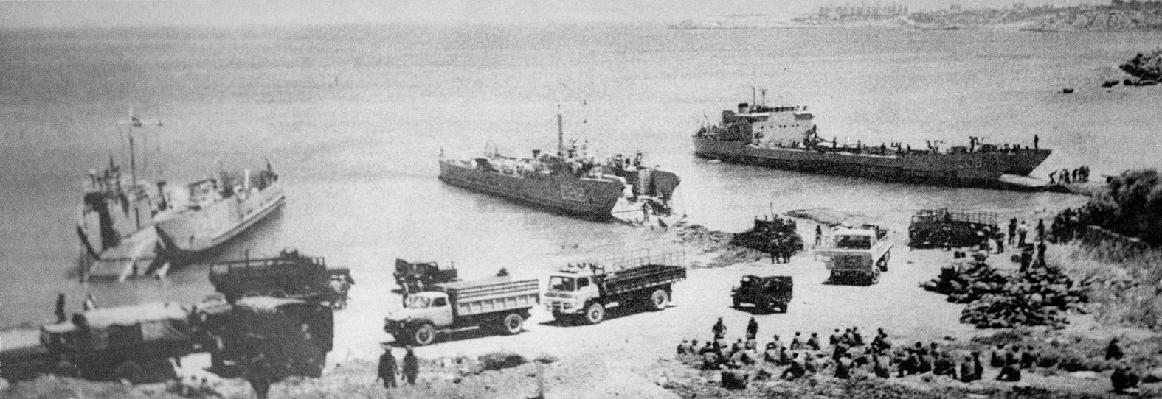
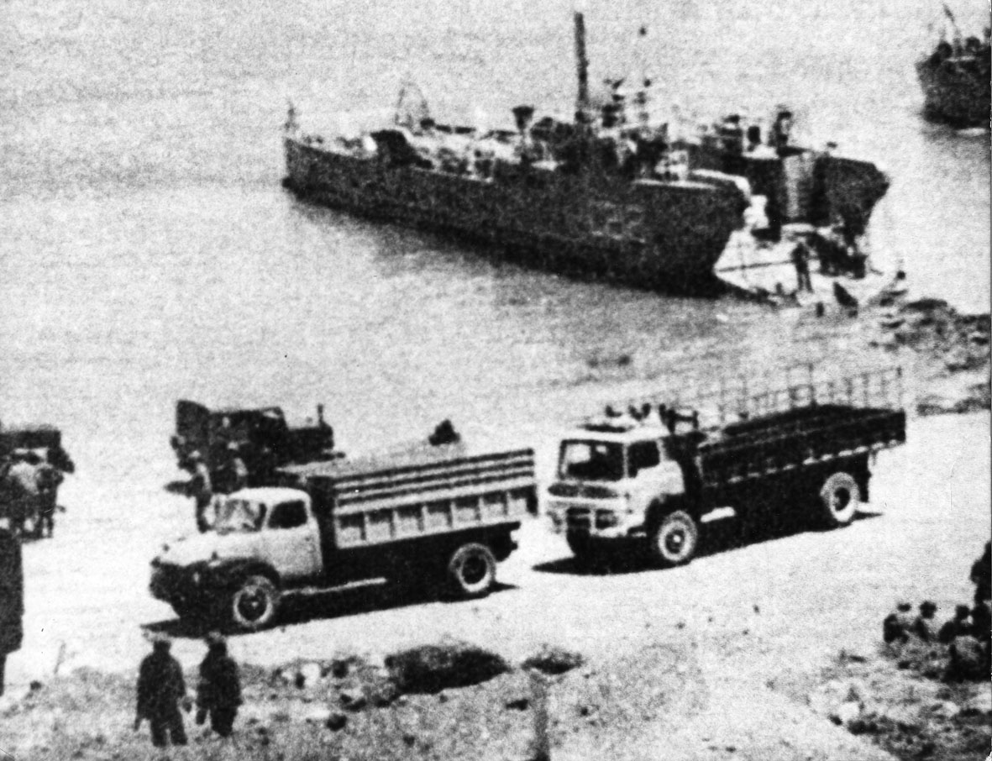
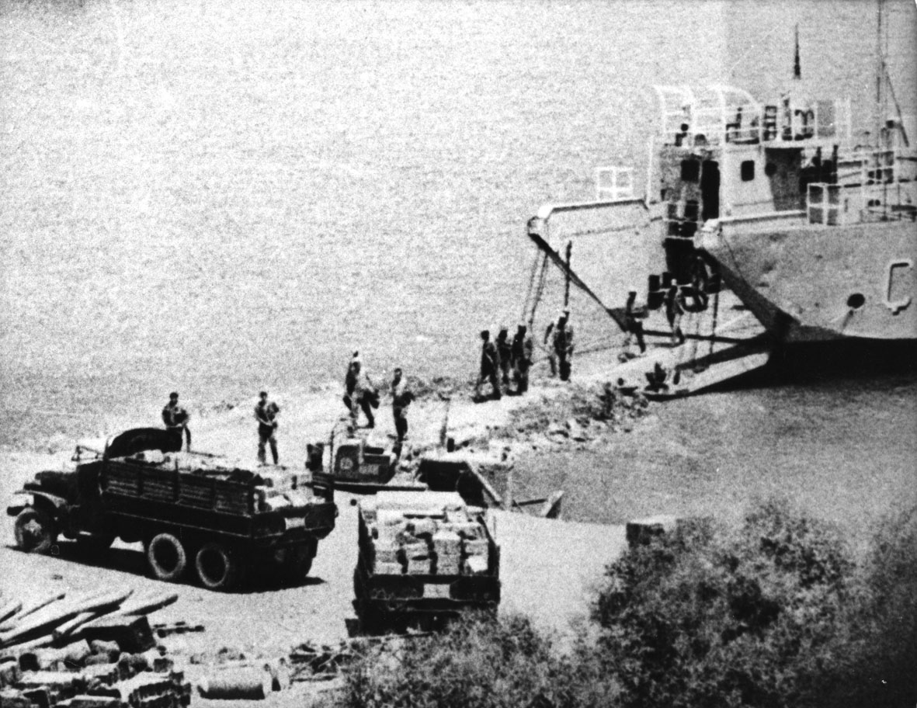
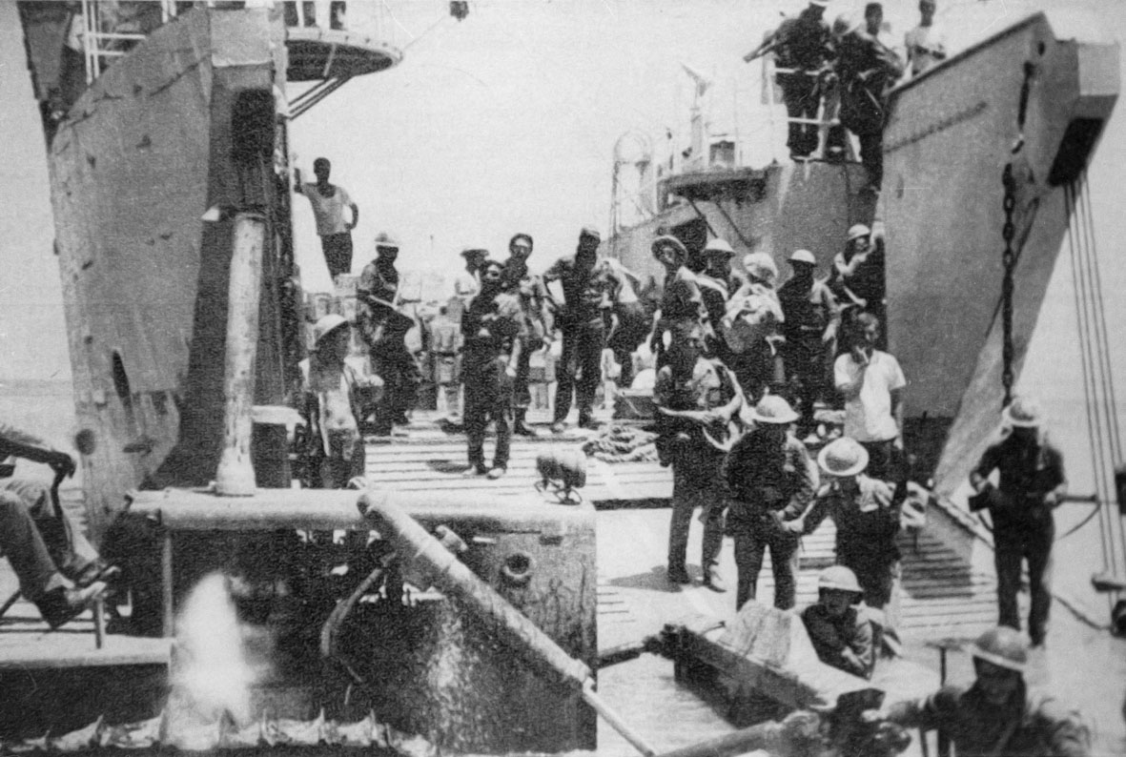

Kyrenia District. Occpied Greek vilage Kalogrea
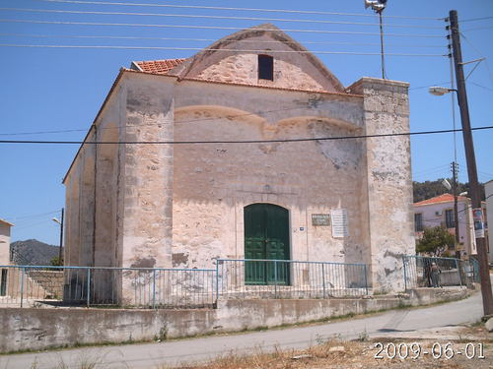
Kyrenia District. Antiphonitis Church. Destroyed inside by the Barbarians
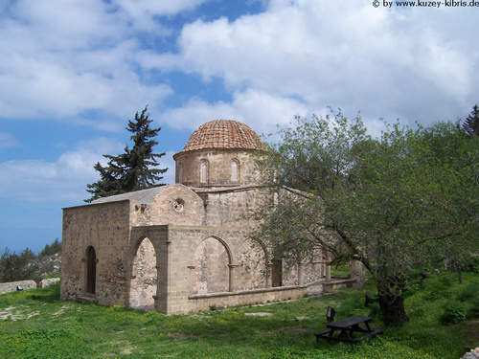

Kyrenia District. Antiphonitis Church. Destroyed inside by the Barbarians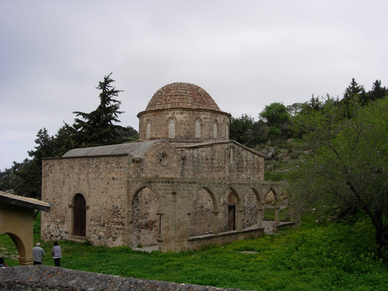

Kyrenia District. Antiphonitis Church. Destroyed by the barbarians
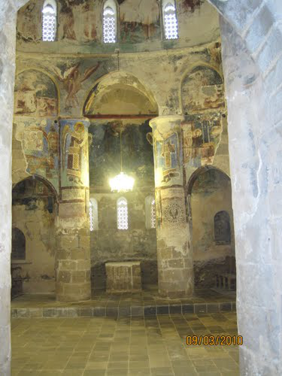

Kyrenia District. Antiphonitis Church. Destroyed inside by the Barbarians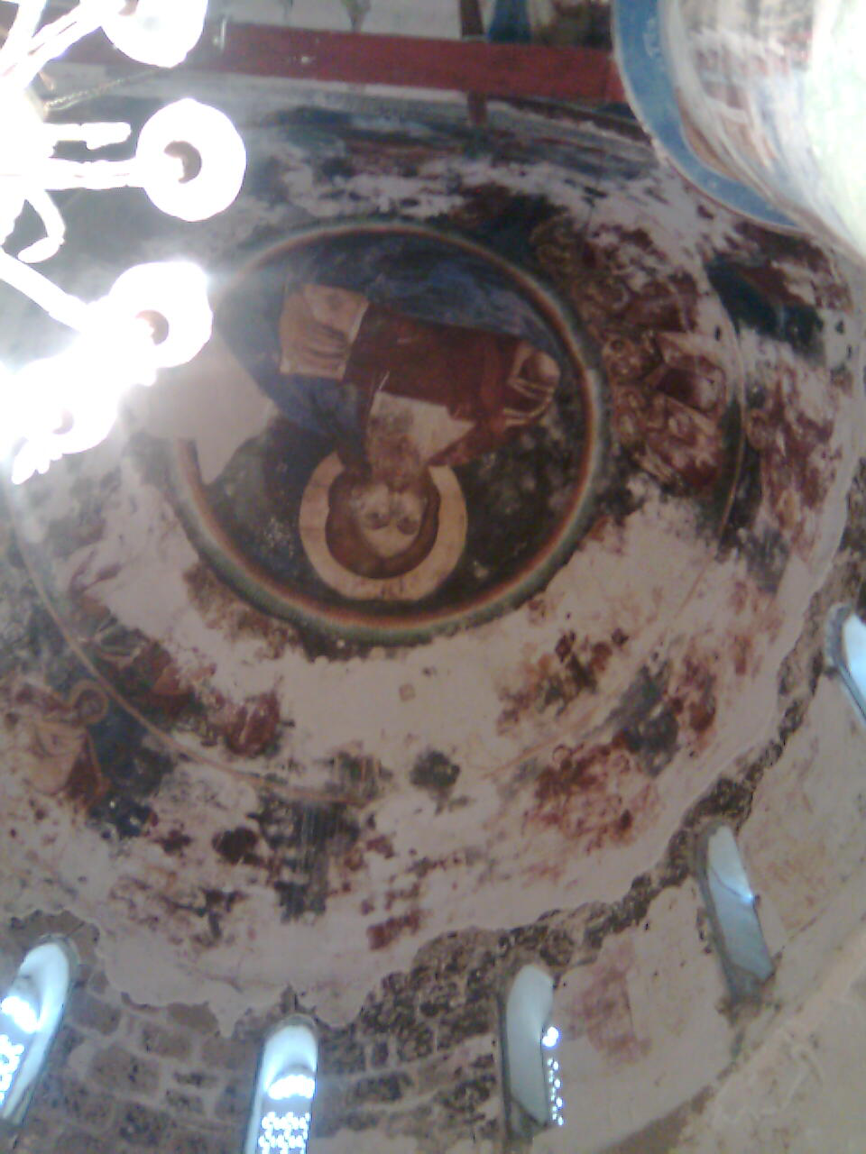

Kyrenia District. Ocupied Agios Ambrosios Greek school
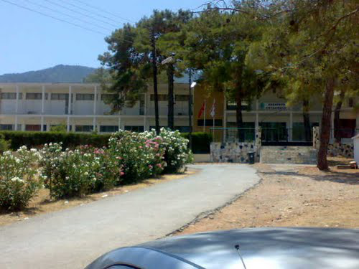

Kyrenia district. Armenian occupied monastery. Destroyed too
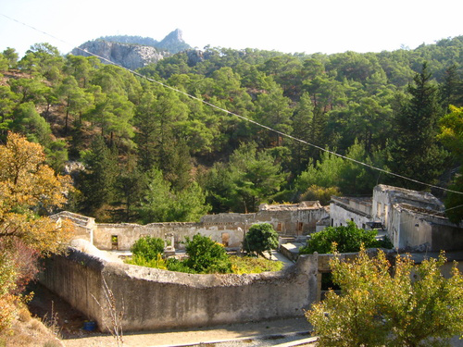
Kyrenia district. Occupied Church
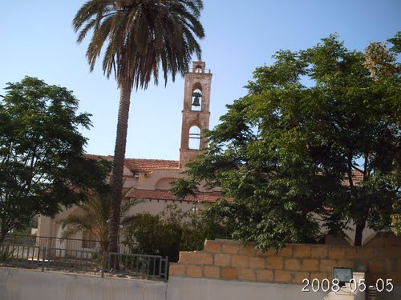

Kyrenia district. The Voufavento Castle
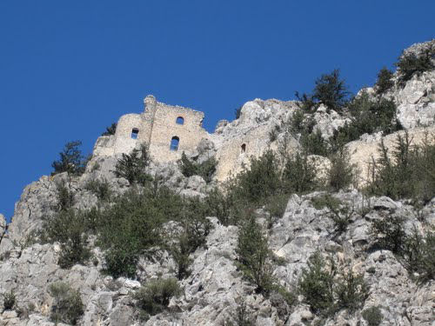

Pentadattilo (five finger in Greek) mountain. One of the names that did not change the Barbarians
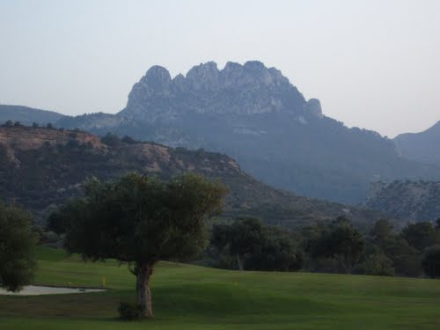

The occupation (near Kyrenia)
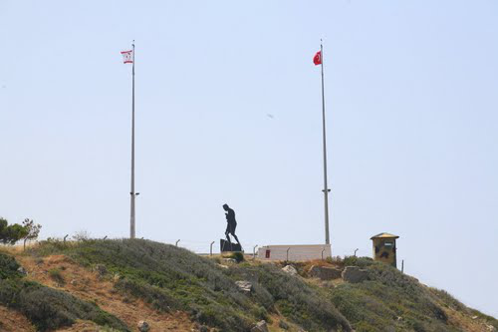
Occupied Greek village Agios Epiktitos. The barbarians changed its name to Katalkoy
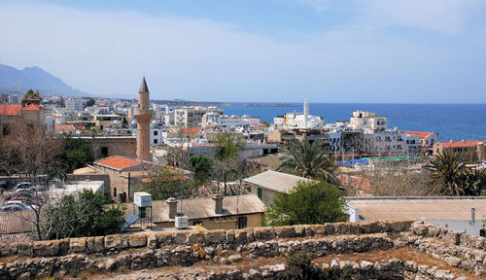

Occupied Bellapais
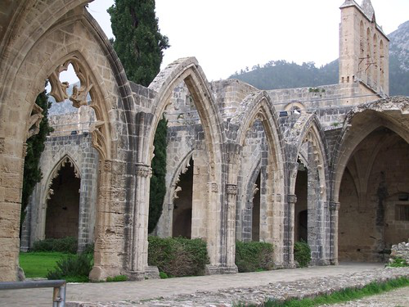

Occupied Bellapais
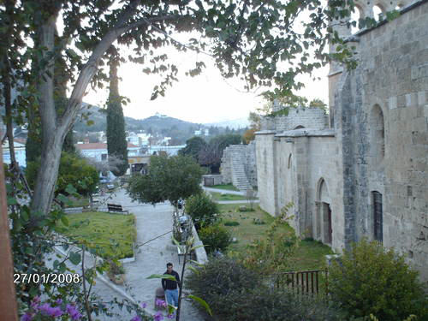

Occupied bufavento castle

Barbarians pollution of Pentadattilo mountain 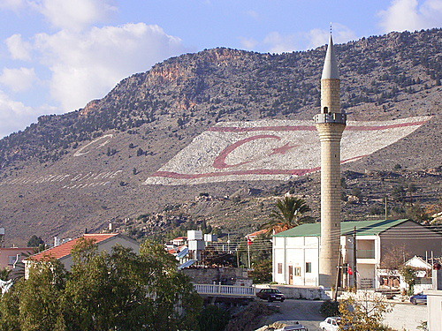

Occupied Church of Panayia (Mother Maria) Apsidiotissa 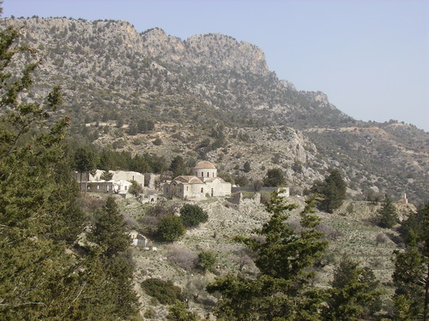

Occupied Church of Panayia (Mother Maria) Apsidiotissa 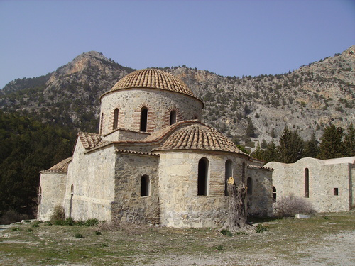

Occupied Church near Halefkasi area of o Pentadattilo mountain

Turkish architecture in occupied Greek village Dikomo
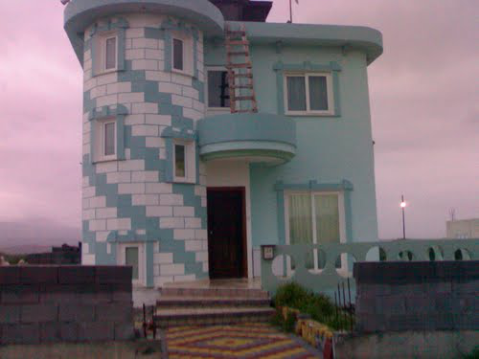

An old Greek Cypriot house polluted by a new barbarians house
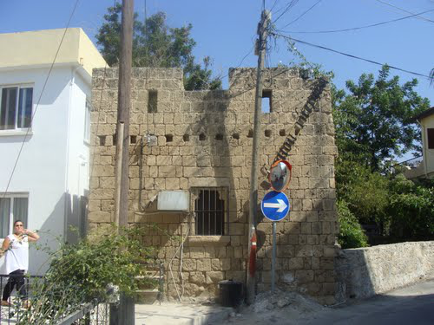

St. Hillarion castle
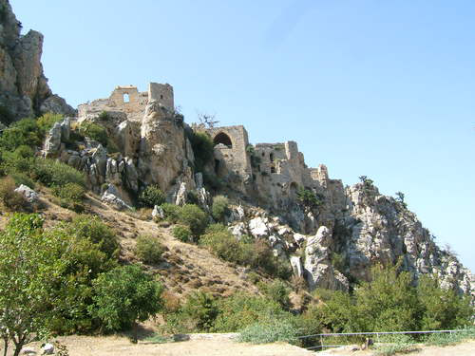

Occupied Greek city of Kyrenia
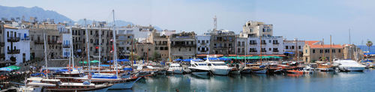

Occupied Greek city of Kyrenia
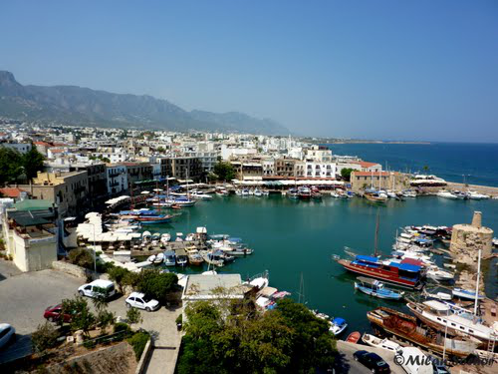

Arkhangelos Mihail in occupied Kyrenia 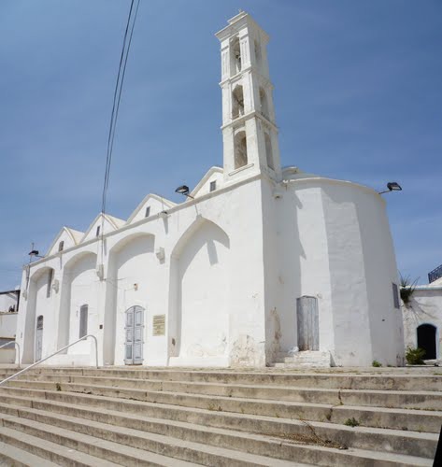

The occupied Kyrenia Castle 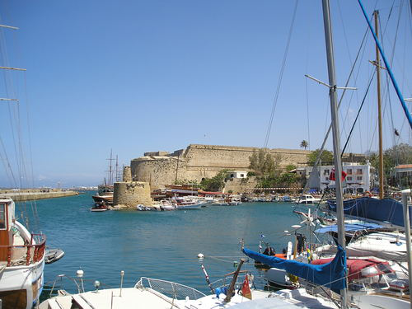

Occupied Kyrenia before barbarians occupation
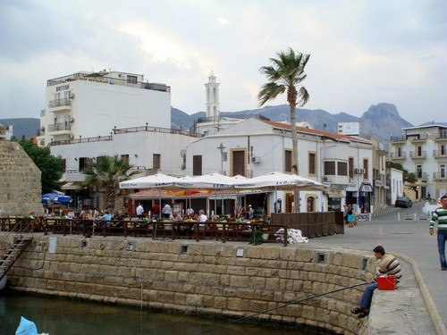

PANAGIA GLYGIOTISSA CHURCH very near to Kyrenia, turned by the barbarians to Mosque
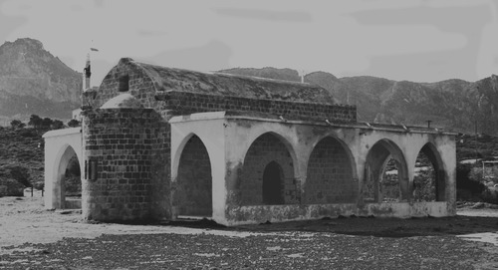

PANAGIA GLYGIOTISSA CHURCH BEFORE BARBARIANS “WEST” INVASION
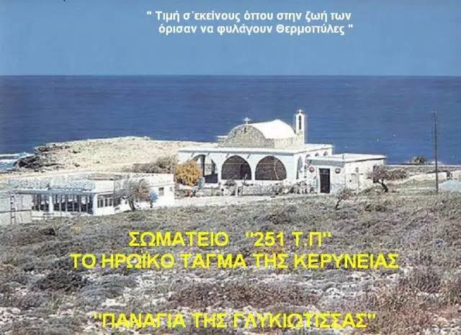

Occupied village Agios Georgios. The barbarians changed the name of the village to KARAOĞLANOĞLU to “honor” a Killed invader
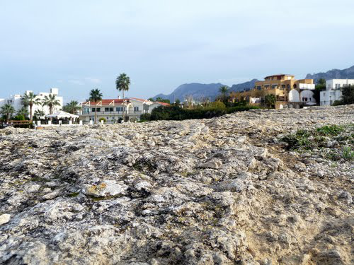
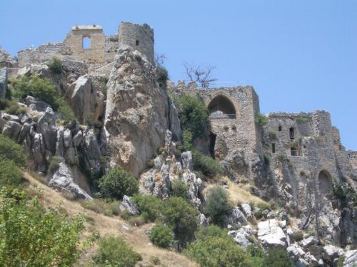

Christoforos kafeneio 1927
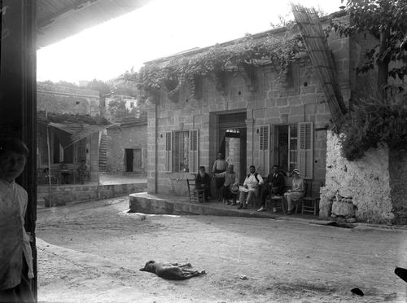

Greek old olive mill in Agios Georgios village 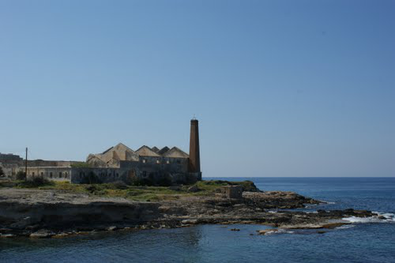

The “pente mili” (five mile) beach where turks were “allowed” freely to disembark . in the next fhoto you may see them resting in the same place on 20th July 1974
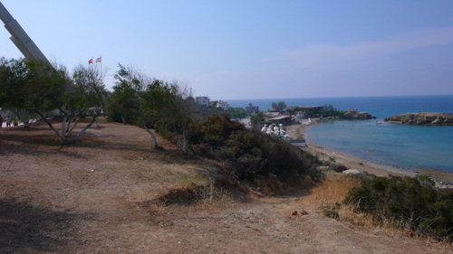

The eceint Greek city of Lambousa
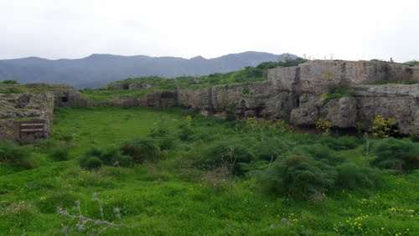

Agios Evlalios Church. Almost all Greek Churches encient monuments have been spoliated by the barbarians
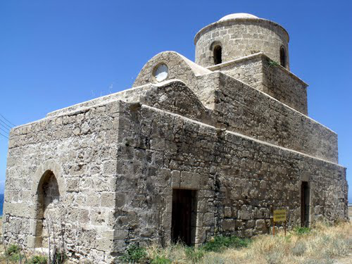

Church at Trimithi occupied village
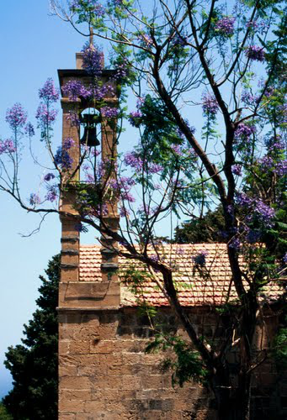

Occupied St. Hilarion Castle 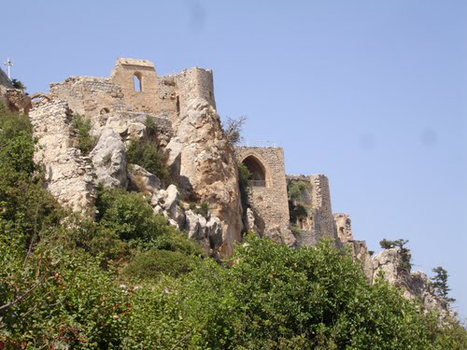

Near ocupied village FOTA (Dagyolou the cvhamged name by the barbarians)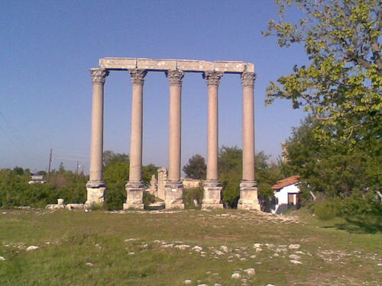

Elementary Greek school of Karava village, now ocupied by the barbari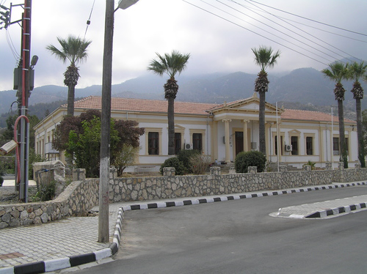

Evaggelistria Church of Grek Karavas city. Now under occupation by the barbarians
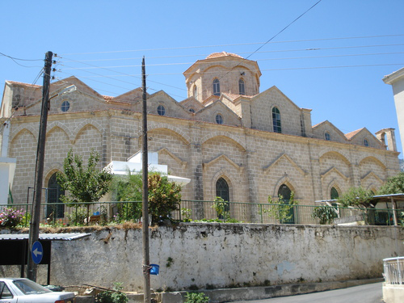

Occupied Greek city of Lapithos.
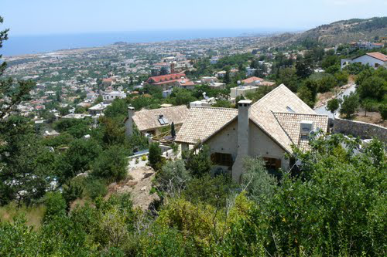

Ancient Greek Bronze age caves in Lapithos
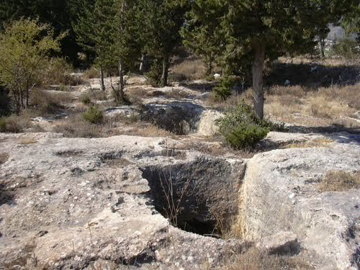

The Greek “Vrisi” (fountain) tou Barba (of the old man)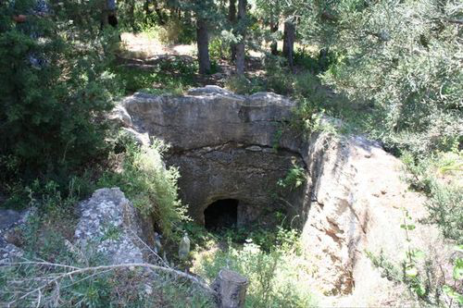

The invators barbaric monument
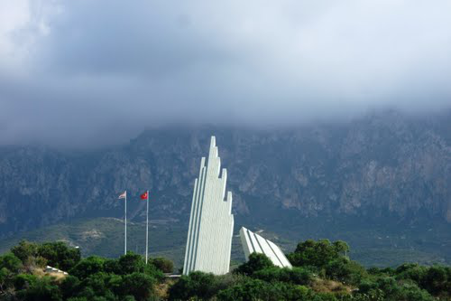

Thje Greek ocupied villages of Vavilas and Vasilia
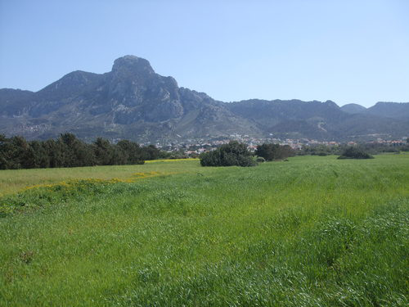

Occupied Vasileia Village (Karsiyaka the changed name by the barbarians) Monastery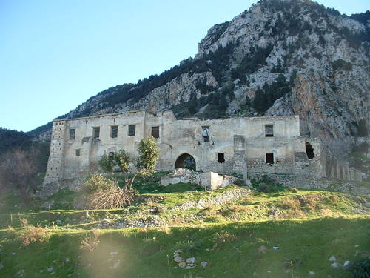

A Greek Cypriot wrote: My Dad's Lemon trees (Stolen afterTurkish invasion of Cyprus)
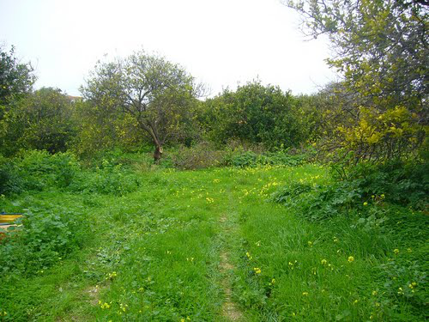

Occupied village Larnakas tis Lapithou ( changed name by the barbarians Kozan). Monastery of Panagia Ton Katharon.
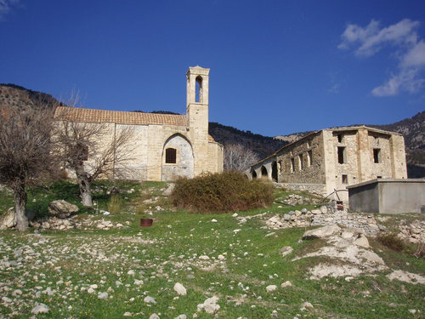

Occupied village Larnakas tis Lapithou ( changed name by the barbarians Kozan). Monastery of Panagia Ton Katharon.
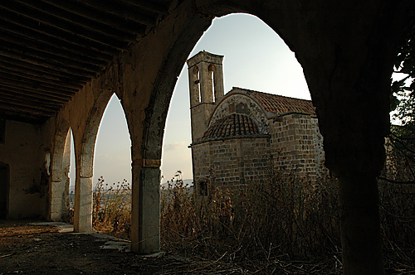

Vasilia occupied Grek village of which th barbarians changed its name to karsiyaka. A Greek Cypriot wrote : My Family House stolen after Turkish invasion of Cyprus
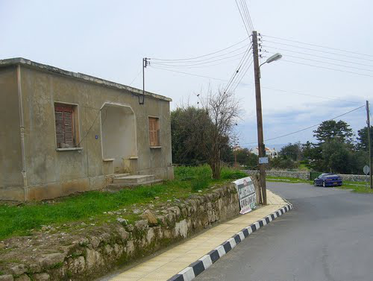

The encient Greek monastery of Sunt Panteleimonas of Mytrou destroyed by the barbarianas
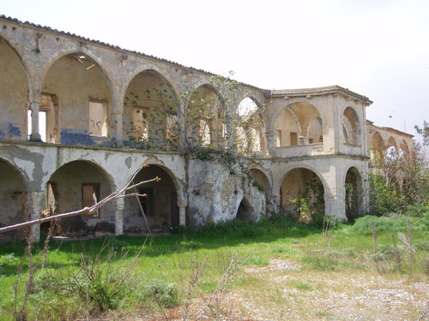

The encient church of Sain Panteleimonas ih the Occupiede Mirtou. Is in danger to be destroyed because the barbarians do not allow its repair
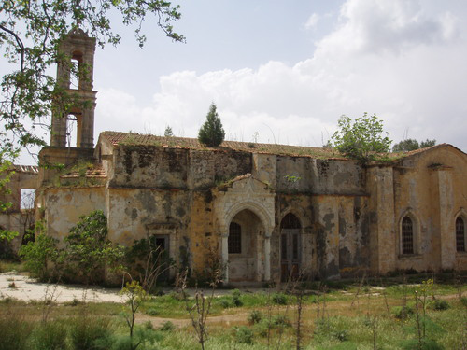

Broken Gravestone in Dioros village of which the barbarians changed its name to Tebebasi
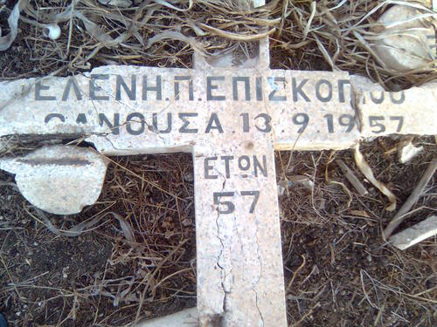

Occupied Kormakitis village. The barbarians changed its name to Gorugan.
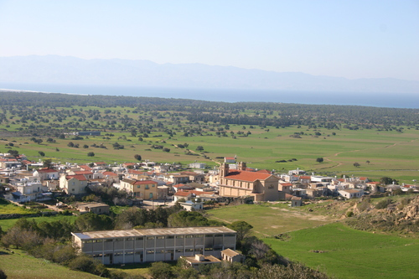

Occupied Kormakitis Catholic church

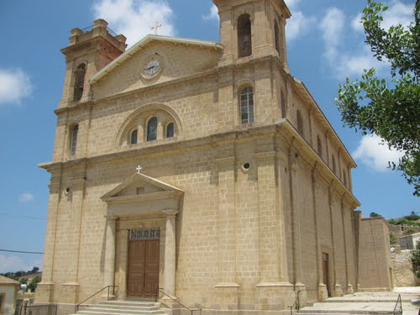

Occupied Pano Galata
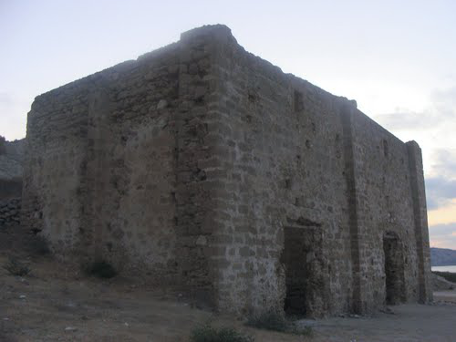

Uccupied Geek village Orga. The Barbarians changed its name to Kayalar
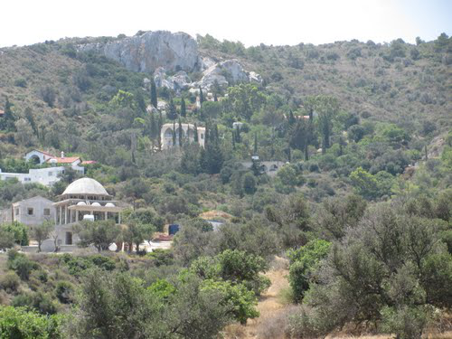

Area of the occupied Greek village Livera . The Barmarians changed its name to Sadrazamkoy
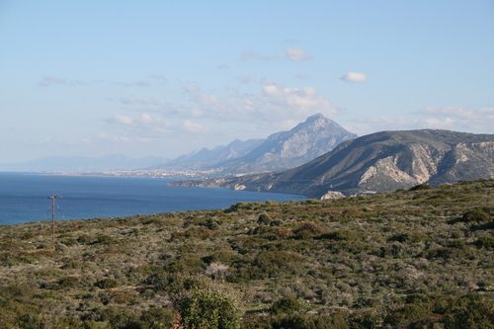

Occupied village Agia Irini (Saint Irini). The barbarians changed its name to Akdeniz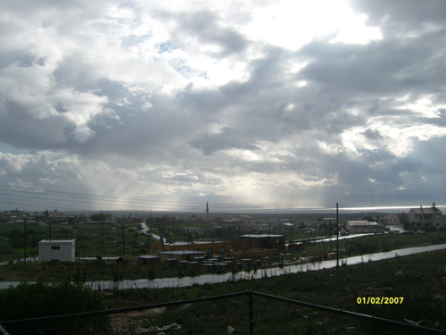

Occupied Kalo Horio (good village). The Barbarians changed its name to Kapouti. Agios Georgios (Saint George) Church with removed cross

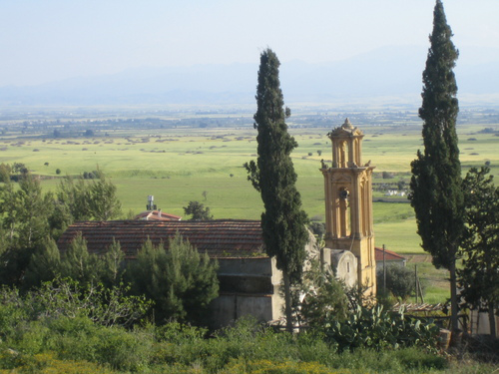
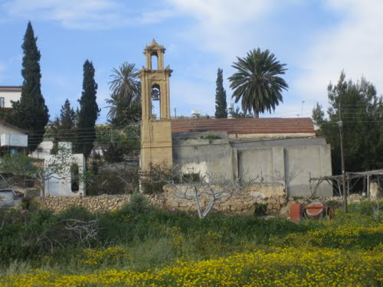

An occupied Greek traditional Fournos (furnace) in the occupied Greek village of Kalo Horio
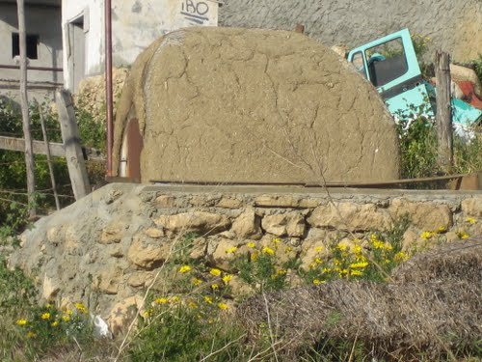

Agios Nicolaos (Saint Nicolas) in Syrianochori occupied Greek village
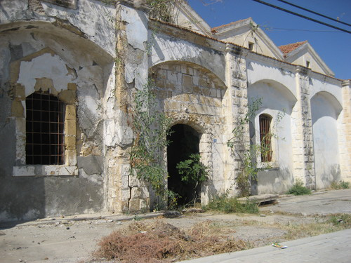

Occupied village Pentagia. The Barbarians changed its name to Yesilyurt. Agios Nicolaos Church

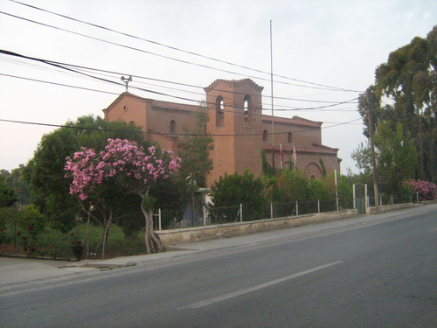

Xeros area. The Barbarians changed its name to Denizli. A Barbarian monument of the invaders
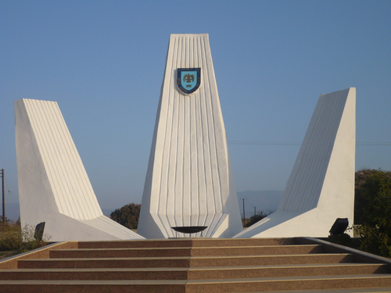

An encient chufch (?) near occupied village Dioros
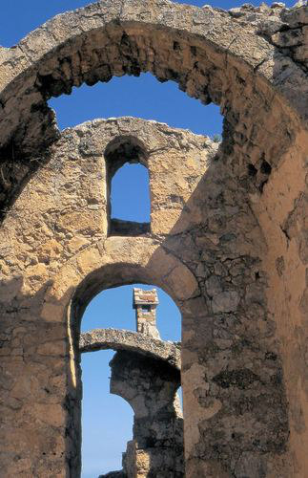

Church, now Mosque at Agios Vasilios occupied village (Turkeli the changed name by the barbarians)
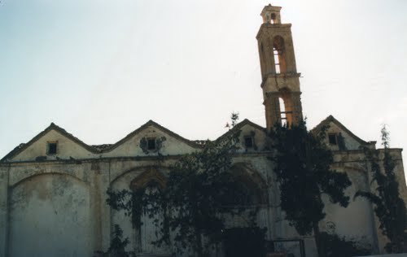

Occupied monastery of Agiou Georgiou Rigati. Near the occupied village of Kapouti
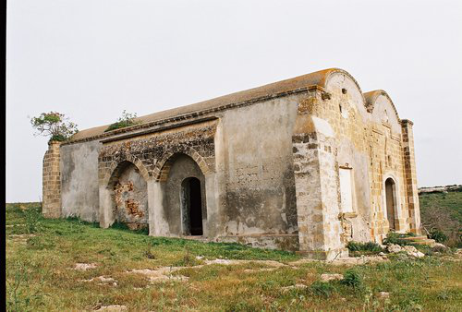

Occupied church of Skylloura village (Yilmazkoy changed name by the Barbarians)

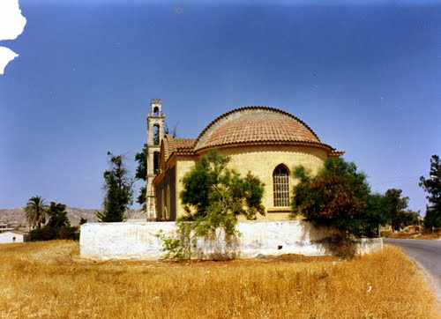

Occupied by the barbarians Soli Amphiteather of Ancient city of Soli (near occupied Xero village)
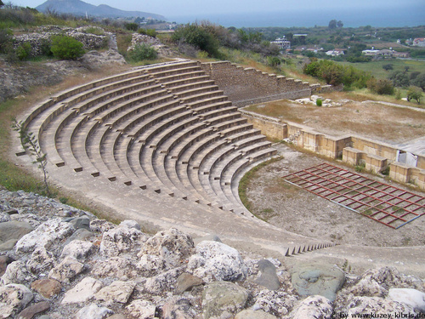

Ocupied by the barbarians Ancient Soli's Theater
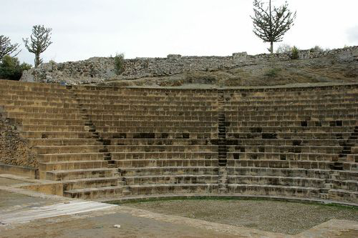

Ancient occupied Grek city of Soli

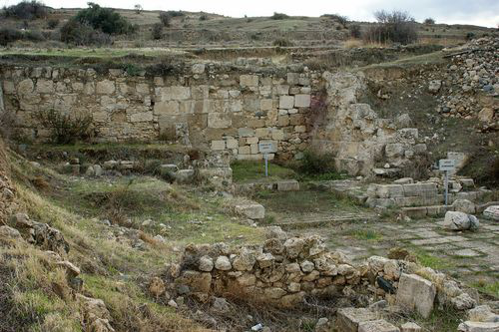

Soli's occupied Basilica 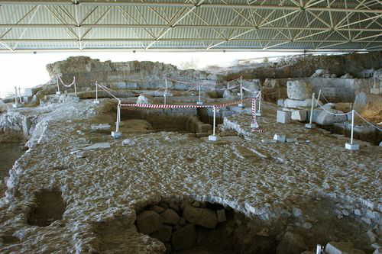

Soli's occupied Basilica
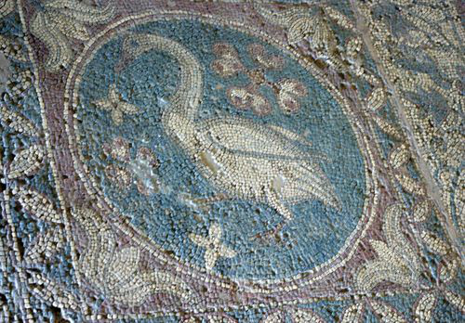

Occupied ancient Greek city of Soli poluted by the barbarians . (Soli North Cyprus) 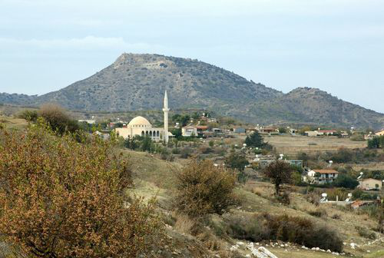

Vouni occupied encient Greek palace near occupieds Kefka and Karavostasi.

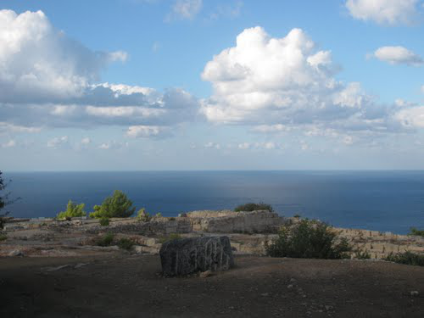

Vouni occupied encient Greek palace near occupieds Kefka and Karavostasi.
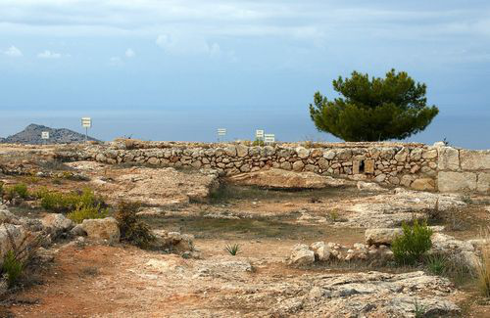

Vouni occupied encient Greek palace .
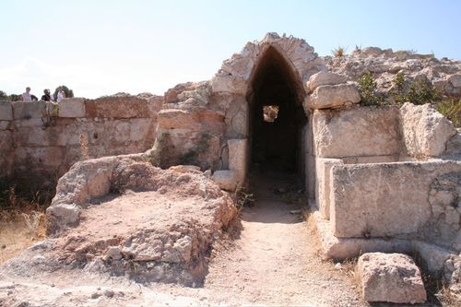

Vouni occupied encient Greek palace .

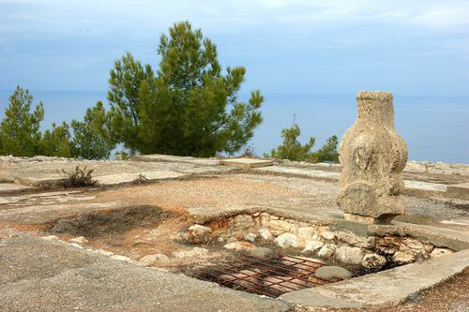

Occupied Arhaggelos Michail Church of ocupied village Zodia (Asagi Bostanci, the new basrbarian,s name)
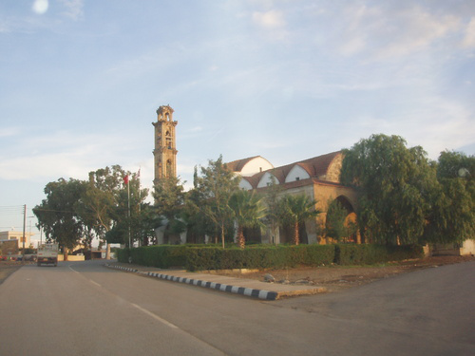

Occupied Church Of John The Forerunner & Baptist at occupied Arkagi village (changed name Akcay by the barbaruians)
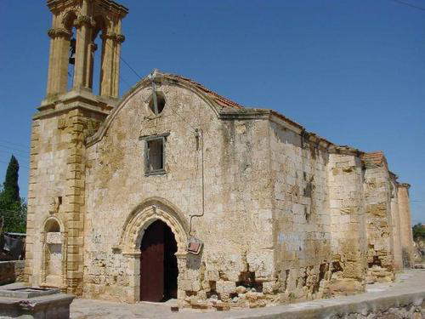

Occupied Church of Panagia (Holy Mother) hriseleousa (gold forgivnes) at ocupied village Katokopeia (changed name by the barbarians Zumrutkoy)
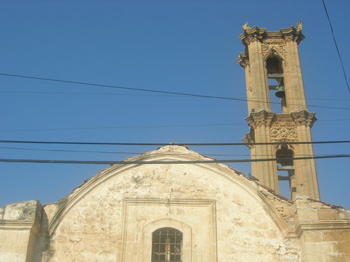

Ancient tenple at ocupied village Katokopeia (changed name by the barbarians Zumrutkoy)

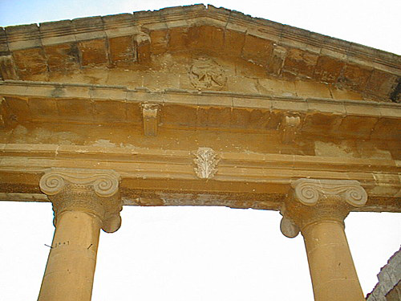

The new (before the invadion) Church of the ocupied village Katokopeia (changed name by the barbarians Zumrutkoy)

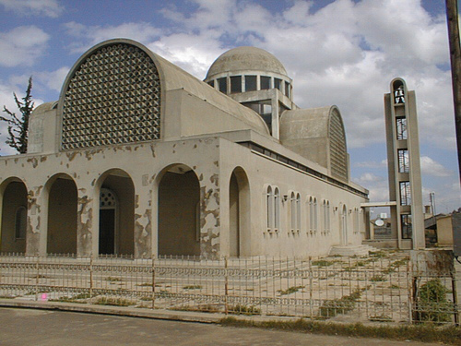

Prophet Ilias occupied Church at occupied villagw Filia (changed name by the Barbarians Serhatkoy)
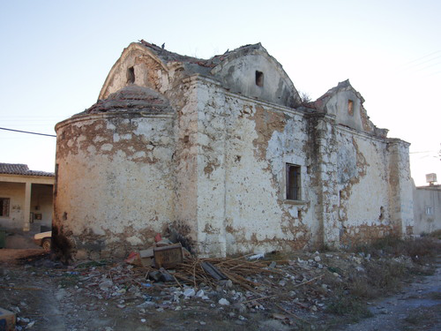

Occupied Prophet Elias Maronite Monastery, near the occupied village Agia Marina Skillouras (changed name by the barbarians, Gurpinar)
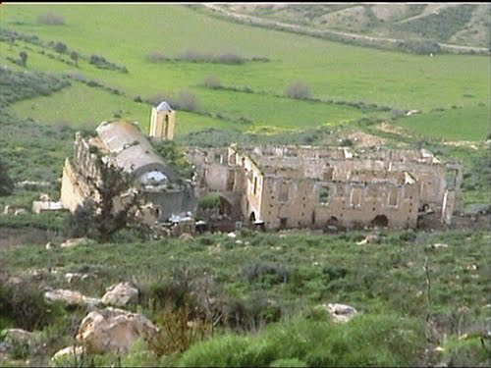

Occupied Prophet Elias Maronite Monastery, near the occupied village Agia Marina Skillouras (changed name by the barbarians, Gurpinar)
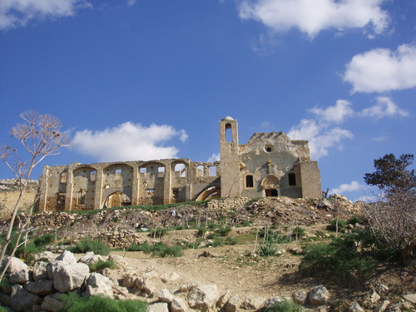

Occupied Church of St. Mamas, occupied Morphou city (changed name by the barbarians Guzelyourt)
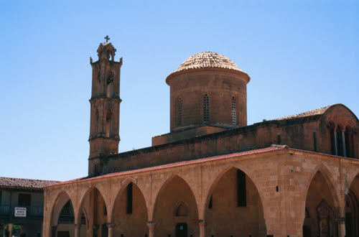

Occupied Church of St. Mamas, occupied Morphou city (changed name by the barbarians Guzelyourt)

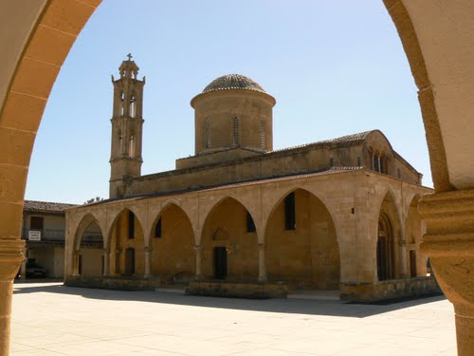

Church of occupied Morphou city (changed name by the barbarians Guzelyourt) made CAMİİ
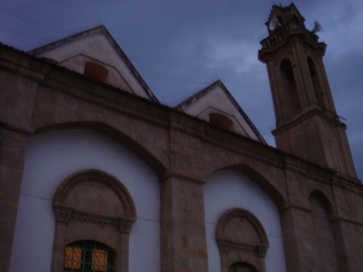

The pollution of the ocupied GHreek city of Morphou by the Barbarianas Statue of the genocider of Armenians, Greeks and Assyrians Atatürk,
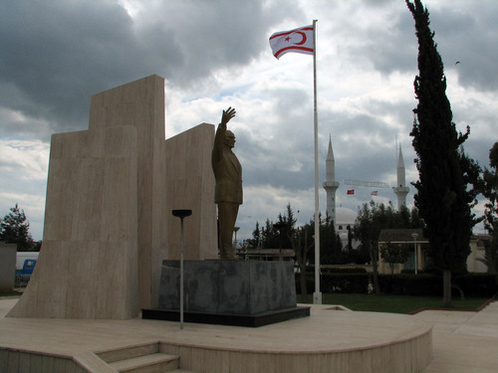

A Greek old ocupied house in Morphou
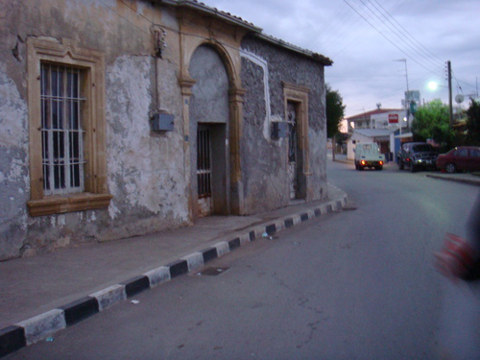

Ocupied Agios Efymianos Church.. at occupied village Lisy (akdogan the barbarians name)
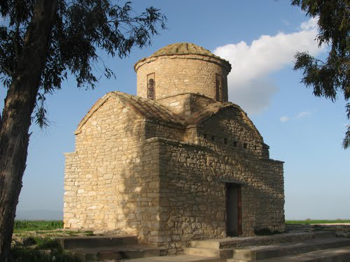

The Church of the occupied village of Askeia (Pasakoy the barbarians name)
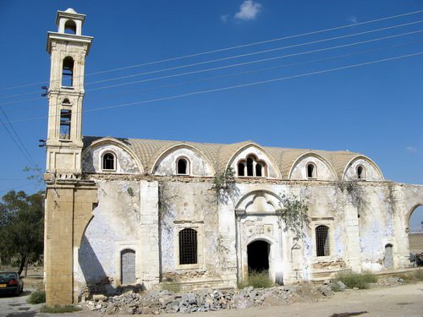

Occupied Greek Church at occupied Lisi village (Aktogan the barbarians name)

Occupied Panagias Church at ocupied Makarsyka village (Incirli changed name by the barbarians)
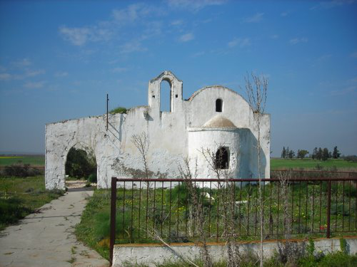

Desecrated Church in occupied Kontea Greek vilage (Turkmenkoy the changed by the barbarians name)
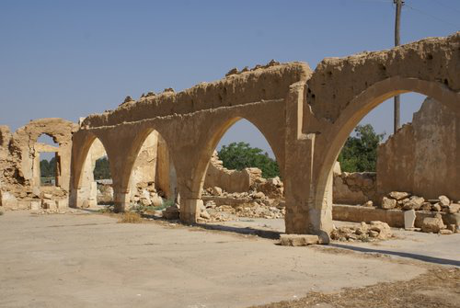

Occupied Church in occupied Greek Kontea village (Turkmenkoy the changed by the barbarians name)
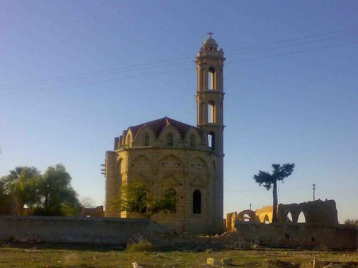

Occupied Church in occupied Greek Kontea village (Turkmenkoy the changed by the barbarians name)
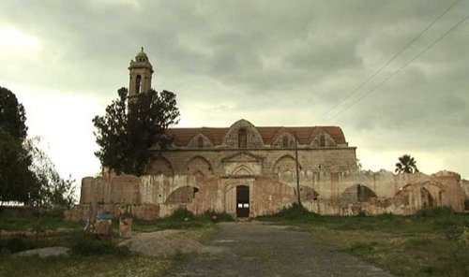

E. MY NEIGHBORHOOD WITHIN THE WALLS OF OLD NICOSIA
Συνοικία Αγίου Λουκά της Παλιάς εντός των τειχών Λευκωσίας. όπου υπό την ανοχή των άγγλων έγινε η πρώτη εθνοκάθαρση από τους Έλληνες κατοίκους τους, Για να δημιουργηθεί υπό την κάλυψη των άγγλων (μαζί με εθνοκάθαρση των Ελλήνων σε όλην την νυν τουρκική συνοικία καθώς και άλλων περιοχών πχ των Αρμενικών κατοικιών της οδού Βικτωρίας της παλιάς Λευκωσίας, η τουρκική συνοικία
Agios Loukas neibourhood of the Old Quarter within the walls of Nicosia. Where under the tolerance of the English the first ethnic cleansing of their Greek residents took place. So as to be created the today Turkish neibourhood under the cover of the English. As long also with the ethnic cleansing of the Greeks throughout all the current Turkish neibouhood of Nicosia. As well in other areas such as the Armenian residences of Victoria Street in old Nicosia.
Εκκλησιά του Αγίου Λουκά στην τότε ομώνυμοι ενορία τη παλιάς Λευκωσίας. Όπου κατοικούσαν Ελληνοκύπριοι και τουρκοκύπριοι. Μέχρι που με την ανοχή των άγγλων δολοφονήθηκαν ή εκδιώχθηκαν με την ανοχή των άγγλων από την τουρκική τρομοκρατική οργάνωση ΤΜΤ οι Ελληνοκύπριοι κάτοικοι της.
Church of Agios Loukas in the then homonymous parish of old Nicosia. Where Greek Cypriots and Turkish Cypriots lived. Until, with the tolerance of the English, its Greek Cypriot residents were murdered or expelled, with the tolerance of the English, by the Turkish terrorist organization TMT.
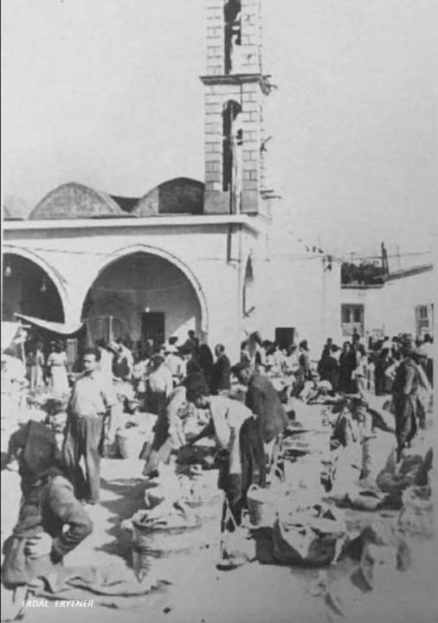

Η εκκλησιά του Αγίου Λουκά όπως την κατάντησαν οι βάρβαροι
The church of Saint Luke as the barbarians did it
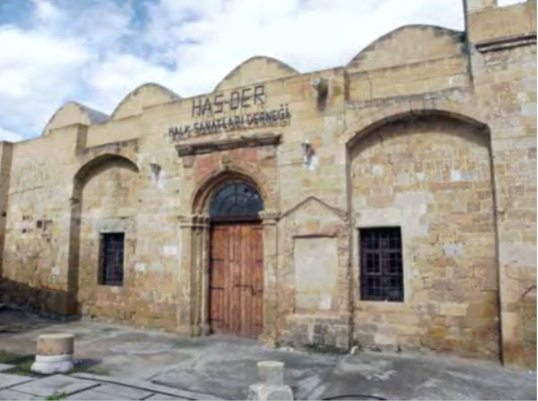

Το αρχαίο παρεκκλήσι του Αγίου Γεωργίου (του Ατταλιώτη που ιδρύθηκε το 1382 υπό κάτοικων της Ατταλείας) προ της βάρβαρης καταστροφής του. Όπου υπήρχαν εκτός από την εξαιρετικής αγιογραφικής τέχνης εικόνα του Αγίου Γεωργίου και πολλές άλλες αρχαίες εικόνας που ευτυχώς διεσώθησαν. Με την εικόνα του Αγίου Γεωργίου να βρίσκεται σήμερα στην Ιεράν μονή Της Παναγίας του Μαχαιρά
The ancient chapel of Agios Georgios (of Attaliotis, founded in 1382 by the inhabitants of Attaleia in Asia Minor, i.e. present-day Turkey) before its barbaric destruction. Where there were, in addition to the excellent hagiographic art, the icon of Saint George and many other ancient icons that were fortunately saved. With the icon of Agios Georgios located today in the Ieran monastery of Our Lady of Machiras

Ότι απέμεινε από ο αρχαίο παρεκκλήσι του Αγίου Γεωργίου μετά την βάρβαρη καταστροφή του.
What remained of the ancient chapel of Agios Georgios after its barbaric destruction.

Το δημοτικό σχολείο αρρένων του Αγίου Κασσιανού κατεστραμμένο (όπως και των Θηλέων) από τους Βαρβάρους
The destroyed by the Barbarians primary school for boys of Agios Kassianos (as well as the girls' school)
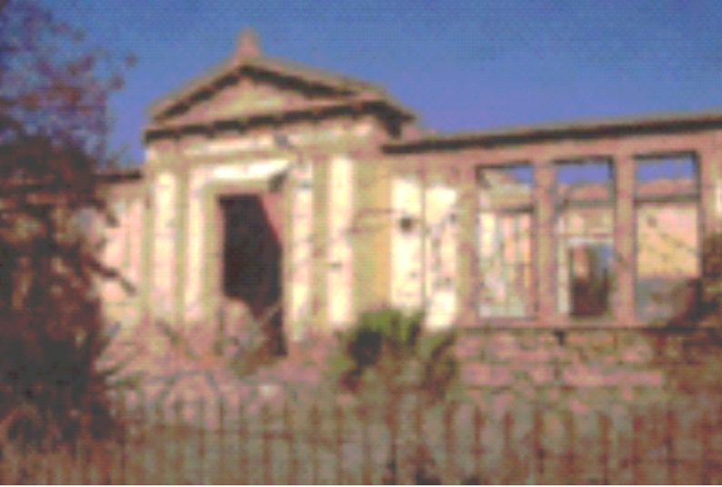
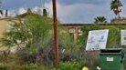
Δίπλα - αριστερά από το παρεκκλήσι, βρισκόταν το δημοτικό σχολείο Αγίου Κασσιανού Θηλέων. Έτσι τα δύο δημοτικά (σήμερα καταστρεμμένα από τους βαρβάρους) είχαν ανάμεσα τους το παρεκκλήσι του Αγίου Γεωργίου
Next to - to the left of the chapel of Agios Georgios, was the primary school of Agios Georgios Girls. So the two schools (today destroyed by the barbarians) had between them the chapel of Agios Georgios

Το σωματείο Ολυμπιακός φάρος πολιτισμού των συνοικιών Αγίου Κασσιανού και Χρυσαλινιώτισσας της παλιάς Λευκωσίας, καμένο από τους βαρβάρους υπό την προστασία των άγγλων στις 7 Ιουνίου1958
The Olympiacos beacon of culture association of the districts of Agios Kassianos and Chrysaliniotissa of the old Nicosia, burned by the barbarians under the protection of the British on June 7, 1958
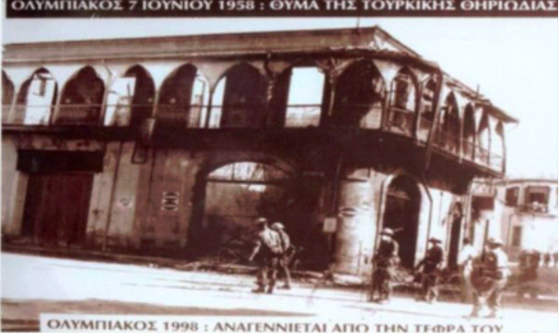

Η τότε χορωδία του Ολυμπιακού Λευκωσίας
The then choir of Olympiakos of old Nicosia
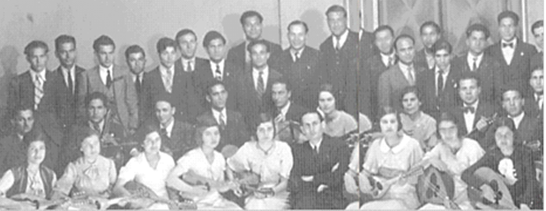

Η τάξη μου στο Δημοτικού Αγίου Κασσιανού Αρρένων . Στην κάτω σειρά τρίτος από αριστερά κάθεται αείμνηστος ήρωας Αυξεντίου. Αριστερά ο τότε Διευθυντής στου σχολείο λαογράφος Νέαρχος Κληρίδης . Και δεξιά ο εξαίρετος δάσκαλος μας ονόματι Χαβάς
My class at Agios Kassianos Primary School for Boys. In the bottom row, third from the left, sits the late hero Auxentiou. On the left, the then Director of the school, folklorist Nearchos Cleridis. And on the right our excellent teacher named Havas
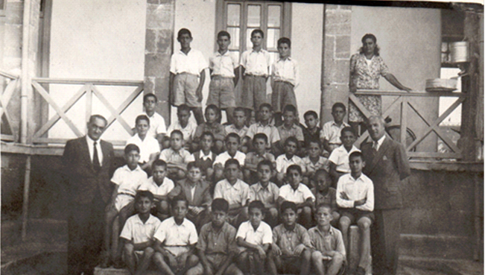

Στη φωτογραφία ο έλεγχος του γράφοντα της Γ» τάξης του δημοτικού Αγίου Κασσιανού.
In the photo, the score of the writer of the 3rd grade of Agios Kassianos elementary school.
