STD Tests For Use At Home: Privacy, Available Alternatives And Precision
Apart from stopping undesirable pregnancies, safe sex might also provide some protection against nasty STDs. However, regardless of how safe your safe sexual existence may be, you cannot always be certain that you may never develop any STD https://stdtestingcoupon.com/healthlabs-review/. Unlike before, now you can easily, shamelessly and rapidly check whether your predicament is really that which you suspect it's because of STD test for use at home.
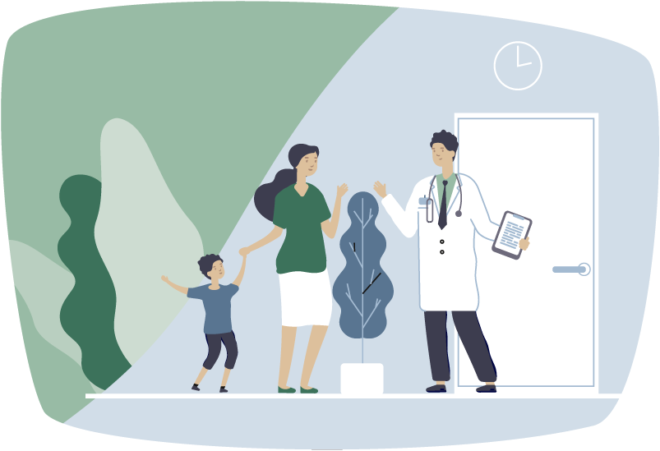
Shameless STD testing
The greatest reason you may still find many adverse installments of Health testing centers reviews, despite ongoing medical advances, may be the plain proven fact that most are just easily horrified through the humiliation that STD testing would bring. Many patients only achieve for medical attention when everything has gone too seriously. Nowadays, STD home test grants possible victims the right opportunity to check their reproductive health with no anxiety about getting stigmatized and dejected by others. Using the health testing centers coupon for use at home, any infected victim can help themselves as soon as the STD can simply easily be eradicated.
Available STD home testing options
Decades of research on STDs brought to the introduction of a minimum of one reliable STD test for each one of the most infamous STDs there presently are. We already have testing kits for that viral illnesses AIDS, Hepatitis B and herpes. There are also available tests for syphilis, gonorrhea, Chlamydia infection along with other microbial STDs. You just need to go to a local pharmacy or buy an Healthlabs reviews home test from the reliable online shop.
An average STD test package may need your bloodstream or urine sample. There are also tests that need swabs of the mouth or those of other impacted areas healthtestingcenters.com review. Typically, an STD home test could be completed in your own residence and with no need of any doctor. You just need to watch for couples of minutes to some couple of days with respect to the STD you’re testing. There are also some tests that need you to send your sample to some nearby laboratory. Your test results will later be given to you confidentially via text or email.
STD tests differ in prices with respect to the STD being tested, the way of testing and also the precision from the product. Typically commercial home test kits have a slightly hefty but completely reasonable cost. There are also some free STD tests like the free tests supplied by Johns Hopkins College in Maryland. Which are more truthful results, always choose the most accurate STD tests available.

