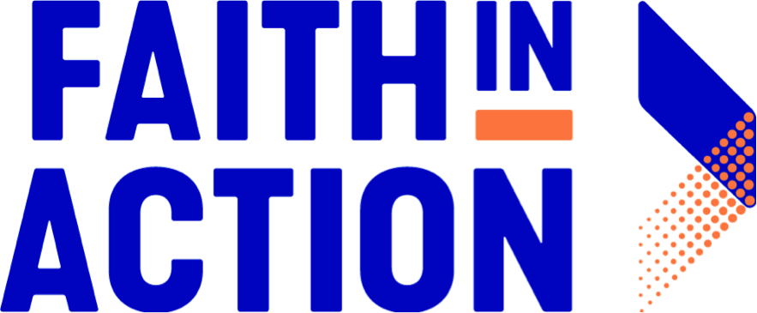

Mindful Vote 2018

How to Use Voter Pledge Cards

1. Click this link (and find the orange contact box) to sign up to become a "Mindful Vote" volunteer

2. Download, print, and distribute the voter pledge card (English and Spanish) to members of your community

3. Collect the completed voter pledge cards

4. Enter the contact information of voters into a central location, so that you can visit or call voters to hear about their hopes and concerns this election season, and to remind them to vote. Keep track of voters who have already mailed in their absentee ballots

5. (Optional): gather other "Mindful Vote" volunteers and create a "phone bank" to call all voters who filled out a pledge card the weekend of November 3rd

6. (Optional): call all remaining voters who have not voted on election day (November 6th) and make sure they get out to the polls!

