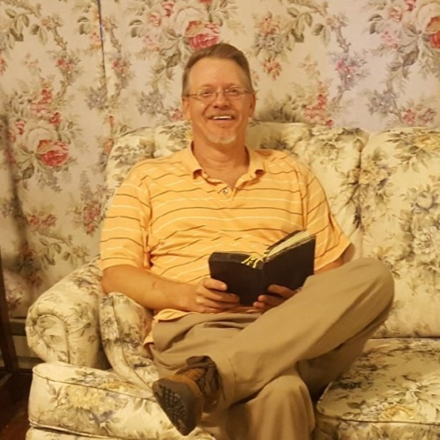
Hi my name is Matthew A. and here is my story.
I was born and raised in Ceredo, WV in a Christian home. I was saved in church but never followed through with my dedication to Christ. I started drinking and doing drugs when I was about 13 years old. I wanted to be liked and was trying to fit in with the “IN” crowd.
I never liked being told what to do so after high school I joined the Air Force to get away from here. I continued drinking/drugging, I ended up getting discharged for drug and alcohol abuse before I was 20 years old.
I didn’t know I had a problem, I thought I could quit whenever I wanted to. I came back home to Ceredo where family got me employment doing welding inspections. I met a girl and we got married when I was 22 years old. We had a child and somehow I managed to pay for a home as I continued to drink/drug. We became co-dependent and co-enablers and things got worse. We ended up getting divorced but I wouldn’t leave her I wanted to be a part of my daughter’s life and help to raise her. Our relationship ended after almost 25 years with her going to prison.
Shortly after that I ended up in my first treatment, a 28 day program but I only made it 10 days. In the next 7 months I managed to get fired from my job of 20 years, arrested by my employer, and by the recommendation from a magistrate who knew me get into long term treatment for my alcohol/drug addiction. I got into The Healing Place of Huntington September 2014. While there I learned about the disease of alcoholism, the 12 steps of Alcoholics Anonymous, the concept of accountability, and unconditional love. I was willing to do whatever it took to achieve sobriety and complete the program. I completed it in 13 months, the last 3 as a peer mentor, giving back what was freely given to me.
After leaving the program I had all the tools necessary to live life sober and become a productive member of society but I made the mistake of thinking that I would have power over some choices. I tried to resume my career in welding inspection but God shut that door of opportunity. Not being able to find gainful employment, not praying, not going to meetings, and not doing the daily things necessary for my recovery I eventually went back to doing what I knew best drinking and drugging. My family got me into detox at Recovery Point of Huntington. I still was not admitting that I was powerless. I kept getting high and got discharged.
A friend recommended that I contact Bobby B., Director of Advocate House, so I met him. He told me about his battle, his story, and his experiences with living life clean and sober. I made that connection with him. I accepted and surrendered my powerlessness and rededicated my life to God and Advocate House. I am grateful for the chance and opportunity Bobby B. gave to me. The structure at Advocate House was just what I needed and thanks to it I celebrated 1 year clean/sober on August 15, 2017.
Today I live life to its fullest by trusting God, cleaning house, helping others by working/living the 12 steps of Alcoholics Anonymous with my sponsor, and working/living at the Advocate House. I have gratitude, love, respect, and live a life I never dreamed imaginable.

