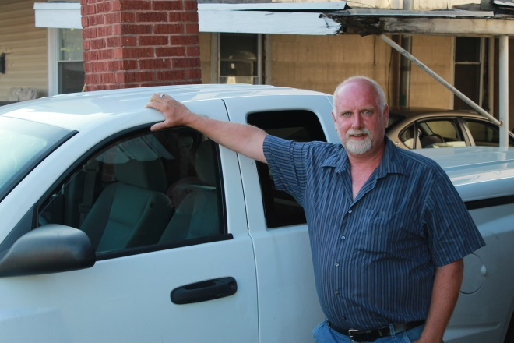
Hi my name is Mike B and here is my story.

I grew up in Ravenswood, WV and my dad left when I was 6 years old. I worked for my grandfather in the summers on his farm. After high school I went to work for Lowes and worked my way up to store manager. Then I went through a bad divorce and to cope, I starting drinking and doing drugs. I ended up leaving my job at Lowes after 15 years of working there. I started doing drugs all the time. After a while I started making and selling drugs. I ended up getting arrested and went to prison for 4 years. I was released on parole. When I got off of parole it took about 20 days for me to relapse. I got arrested again and was put on probation. I violated my probation and spent 2 more years in prison. When I got out I could not find work so I started doing/selling drugs again but on a much larger scale. Of course, I got arrested again and was put back in jail. Someone in the jail told me about the Advocate House and Bobby Borders. My mom called Bobby and asked if he would be willing to help me. Bobby said he would so after about 4 months I got out. Bobby picked me up at Home Confinement and all that I had to wear for a shirt was a trash bag. Once again I had lost everything. Bobby took me to Advocate House and I started their program. I did not know what to expect but I wanted something that I knew Bobby had. The first 3 months were rough, I didn’t have a job but Bobby continued to work with me. I kept going living at Advocate House and working their program. Then Bobby helped me get on a training program and I got a job! I continued to live at Advocate House and attend AA meetings; and just as Bobby said as time went by my highs/lows averaged out. I still had legal issues but Bobby stood by me and went to court with me twice to speak on my behalf. The Advocate House and Bobby helped me rebuild my life in so many ways Mentally, Physically, and Spiritually. Today I can truly say that I enjoy my life and being DRUG FREE. By the way the training program that Bobby got me on assisted me with the purchase of my truck. Life is truly good CLEAN and SOBER today.

