Editing Technique | Seen in | Effect on narrative, audience, meaning.
Shot-reverse-shot | 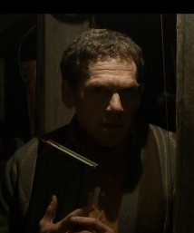  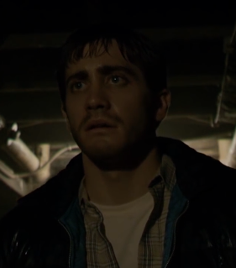  Zodiac | During this scene, the protagonist goes to the basement to further question a suspect. A shot reverse shot is used between the suspect and the protagonist, which highlights the fact they are binary opposites. It emphasises the difference between the accused and accuser and how the audience will form different opinions based on this.
Pacing and action match | 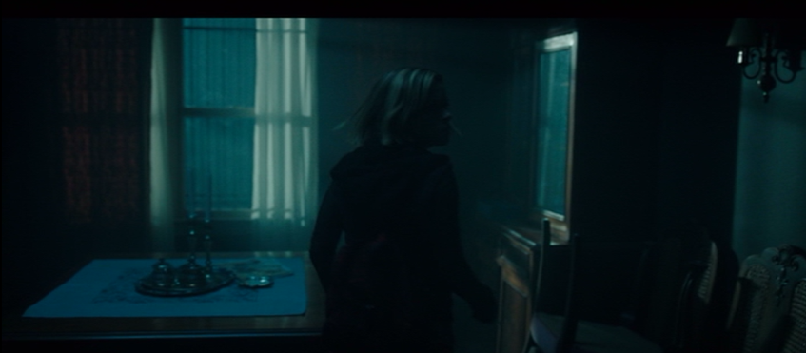  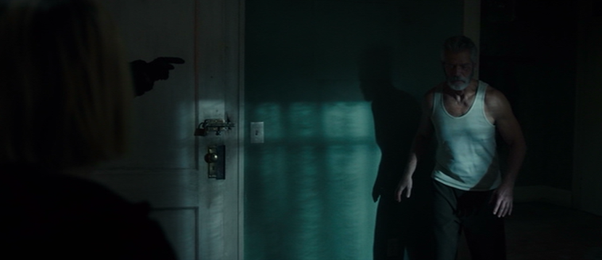  Don’t Breathe | During this scene the three robbers enter the blind man’s house to commit a robbery. Editing works side by side with camera movements in these scenes. We move from one long slow movement with no cuts as the characters move through the house, which provides us with a sense of reality as it is shot in real time. Then, as the tension climaxes as the blind man enters the scene we move to fast pace action-match editing allowing for heightened tension and conflict. This style of editing reflects the fact that the old man begins as a victim, shown by the slow long take editing, then he becomes a threat demonstrated through the fast-paced action match.
Eyeline match and shot-reverse-shot | 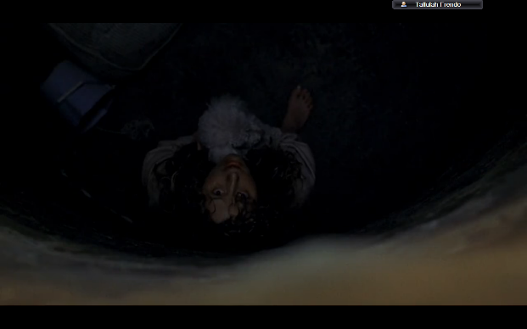  Silence Of The Lambs | In this scene the victim is about to be rescued from the well. Firstly an eyeline match is used when Clarice finds the victim to put the audience in the position of the protagonist as we are seeing directly what she sees. This shot then progresses into a shot-reverse-shot, with Clarice in low angle and the victim in high angle. This shows a significant difference in status, demonstrating that Clarice has high status and putting the audience in the victim’s shoes. This style of editing also makes Clarice appear heroic; giving the impression that she is coming to save the day.
Montage | 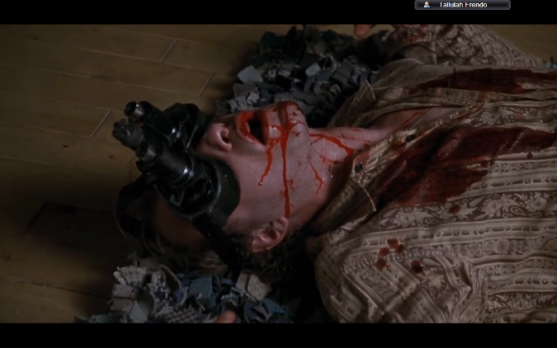  Silence Of The Lambs | At the end of the scene a sequence of images are edited together: a close up of the dead Buffalo Bill, a newspaper clipping about the murders, light shining through the broken window, a close up of the butterfly decoration. As an audience we could infer that these images could be a representation of what led to his death. The final image being the butterfly could reflect that the protagonist has fully completed her task, showing that her character has transformed from an insecure police officer into a strong heroine. This technique is a form of symbolism as it almost shows the end of a journey and gives the impression that death was the only way for him to be free.
Splitscreen | Carrie  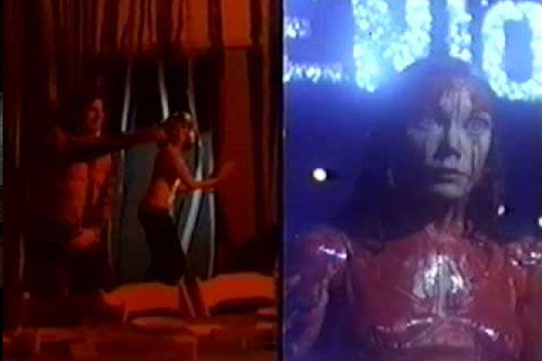  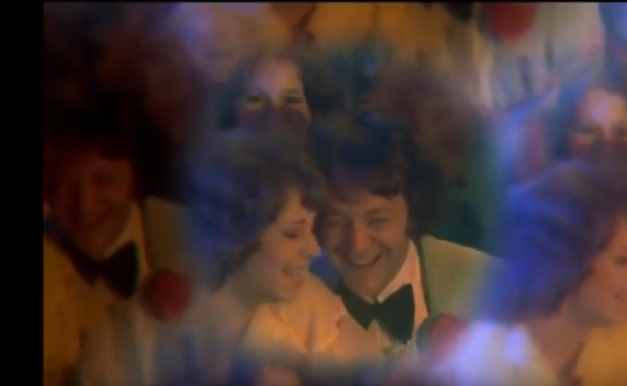 | In this scene, the main character gets humiliated at prom by bullies, then she burns the building down. Splitscreen is used to allow the audience that several things are happening at the same time. On one side of the splitscreen the audience see Carrie and on the other see the destruction that she has caused. This immediately gives her power and status and gives the impression that roles are reversed. A kaleidoscope effect is used after Carrie gets hit by the blood to demonstrate the humiliation that she is feeling. This effect is also used to show that Carrie’s head is being overloaded with negative thoughts, for example the effect zooms in to certain people in the crowd who all seem to be mocking her, reflecting that she feels that everyone has a negative perception of her.
Slow motion | Carrie  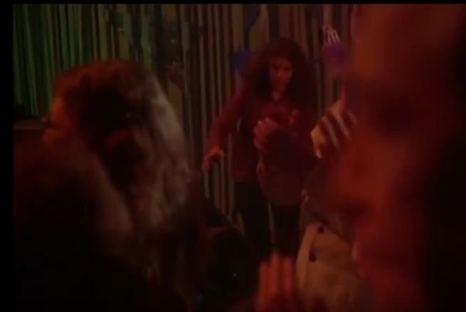 | In this part of the scene, Carrie’s friend runs to try and stop the bullies from sabotaging Carrie at prom. The technique of slow motion is used to mirror that the friend wants to move fast enough but feels incapable. The slow motion increases tension because the audience know she needs to move fast but she is moving abnormally slow. This reflects the fact that time generally seems to slow down in stressful situations as the people experiencing the stress take in more
Breaking 180-degree rule | Buffalo ‘66  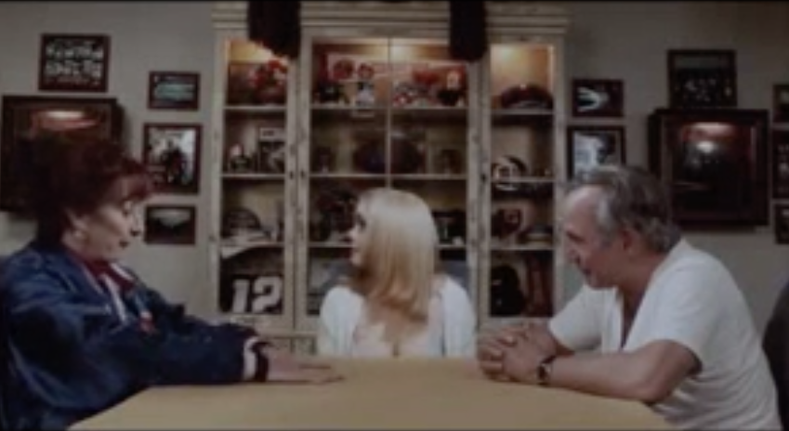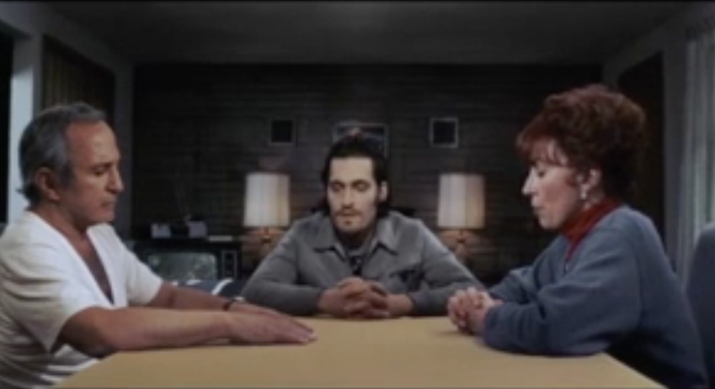 | During this scene the family are having dinner – the protagonist has brought his girlfriend who he has kidnapped, but the parents do not know so there is dramatic irony. The 180-degree rule is constantly broken throughout the scene as the camera moves to different sides of the table so the audience members become certain characters at the dinner table. When we are that character the character disappears. Breaking the 180-degree rule makes the audience feel unsettled, constantly on edge and waiting for something to happen. The fact that it moves from character means the audience can never relax as they almost anticipate the change before it happens.
Subliminal Imagery | The Exorcist  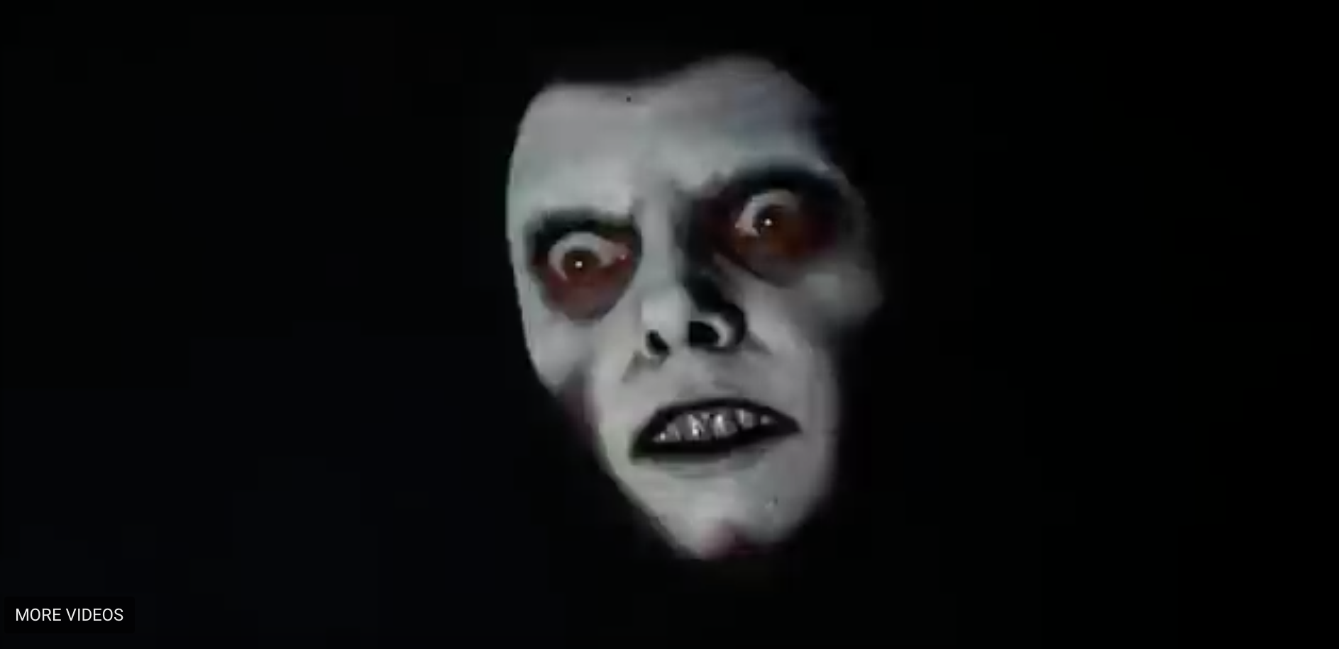 | This is an image of a ghost that will later on haunt the girl in the film. Subliminal imagery is when the audience see an image but they do not have enough time to process exactly what it is. This image appears for an eighth of a second. The effect of this technique is that it causes the audience to feel frightened as they are unsure about what they saw which allows their imagination to form a conclusion. This is often more brutal and would automatically heighten the level of tension and fear.
Graphic Match | Un Chien Andalou  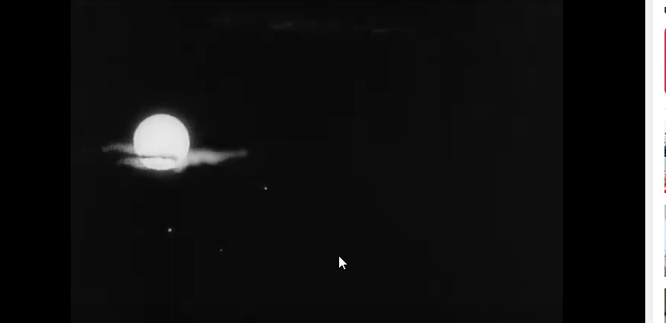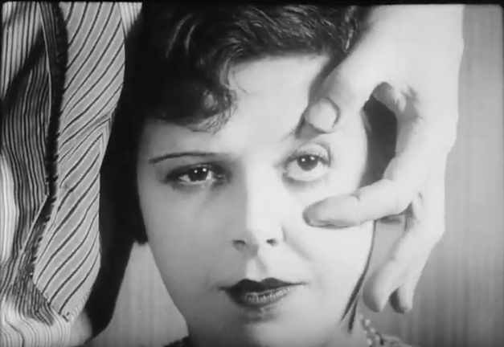 | In this shot, we see a man preparing to cut someone’s eye open. We then cut to the moon with a cloud running through it, and then cut back to the man cutting the eye open. This acts as a trick for the audience as commonly in graphic matches you don’t see the action. It is also used to symbolise the unstable mental stealth of the man cutting the eye as during the film he’s been looking at the moon, which is a sign of going crazy. The eye and the moon look uncomfortably similar which is highly unsettling.
Smash To Black | Final Destination  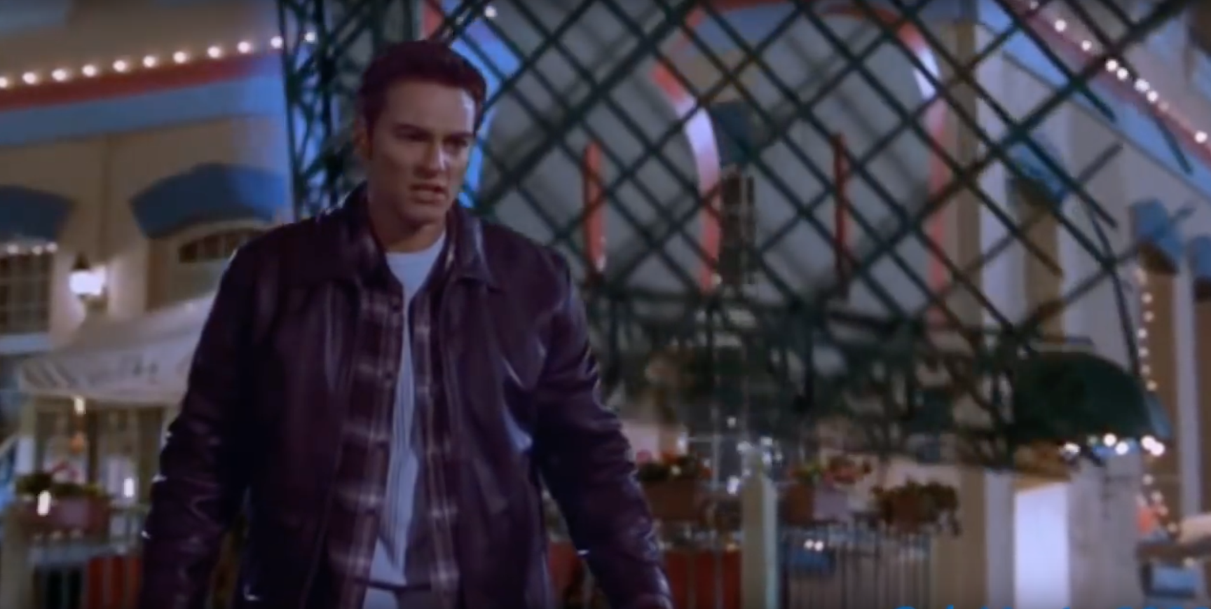 | During this scene the three characters are talking about how they have survived death hunting them. Then one of the characters panics that he would be next – but another character is next. An object is about to hit him when the smash to black happens. A smash to black is used to allow the audience to process what they have seen and for them to imagine the outcome. A smash was used instead of a fade as the nature of his death would be instant.
Cross-cutting | The Silence Of The Lambs  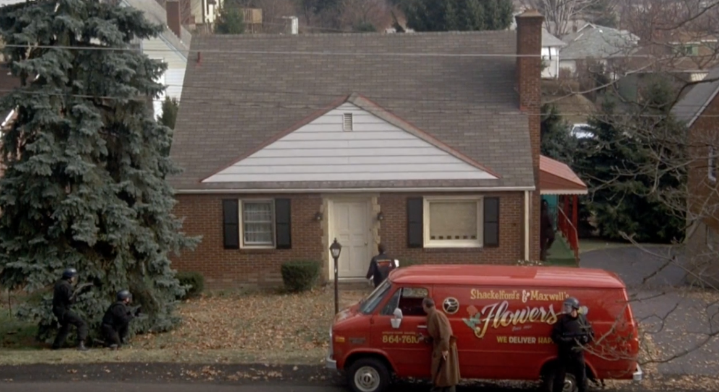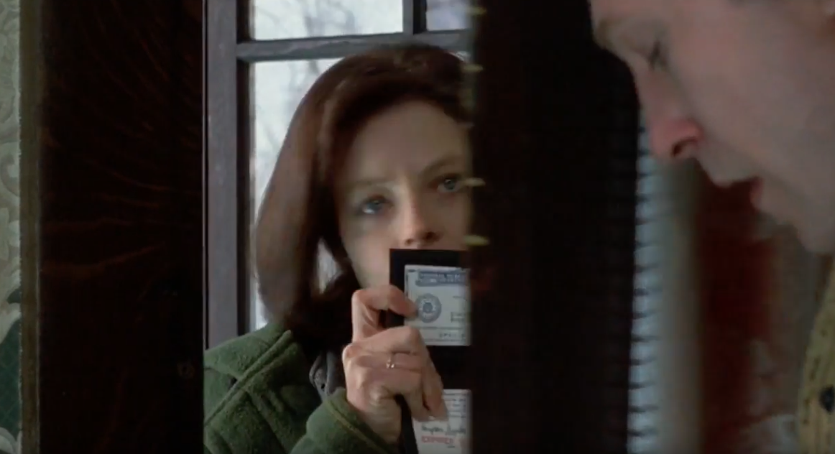 | In this scene, cross-cutting is used as the audience are led to believe the FBI are outside Buffalo Bill’s house, but later we learn that they are outside a different house. We see the FBI outside the house ring the doorbell, then we cut to inside his house then hear the doorbell. He opens the door and we see Clarice, then we see the FBI breaking into a house. This technique is effective as it is used to trick the audience which increases the tension. The fact that we hear the doorbell when the audience is positioned inside Buffalo Bill’s house allows the trick to be believable right up until he opens the door. This film would have deliberately chosen to use this method as the genre is designed to make the audience feel unsettled and never be entirely certain of an outcome. The fact that all of the FBI were outside the other house positions the audience to feel on edge for Clarice as there is no-one to protect her. This technique can also be referred to as parallel editing which is a sub-category of cross-cutting as both the actions are happening at the same time – the trick is that they’re not happening at the same place.
The Kuleshov effect | 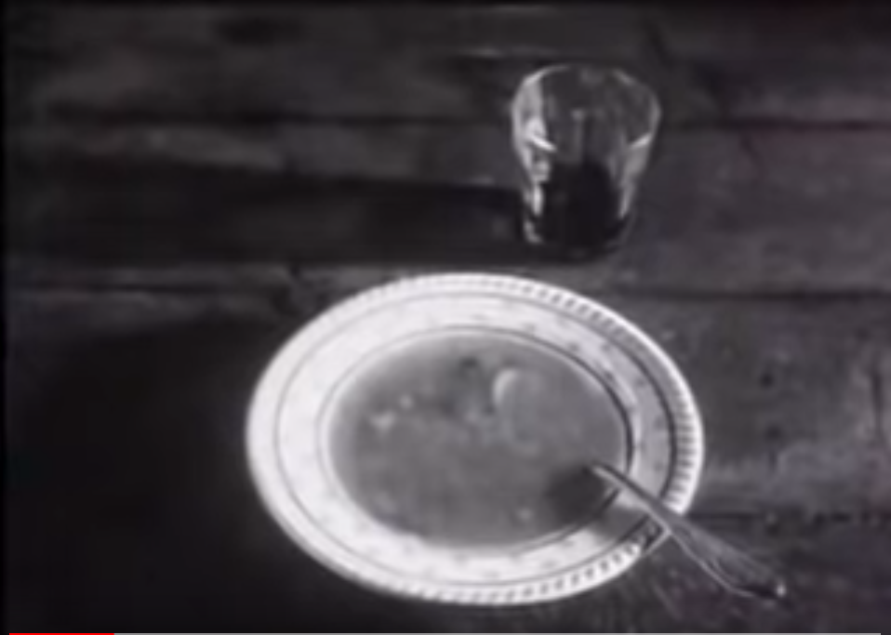  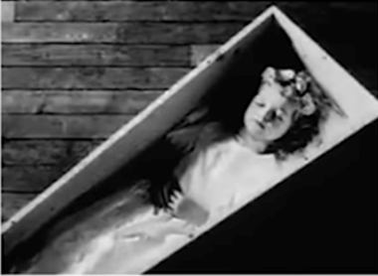  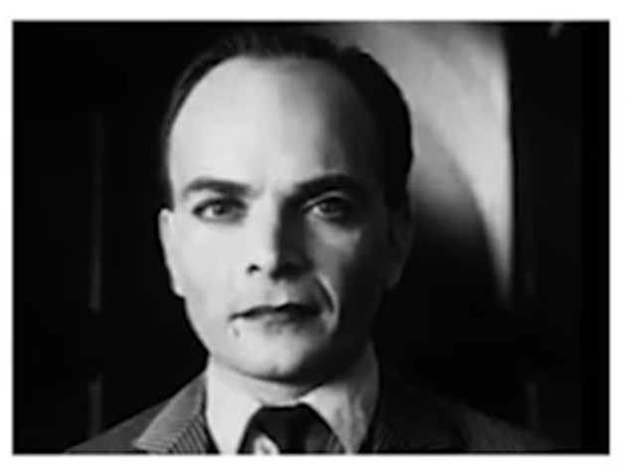  City Of God  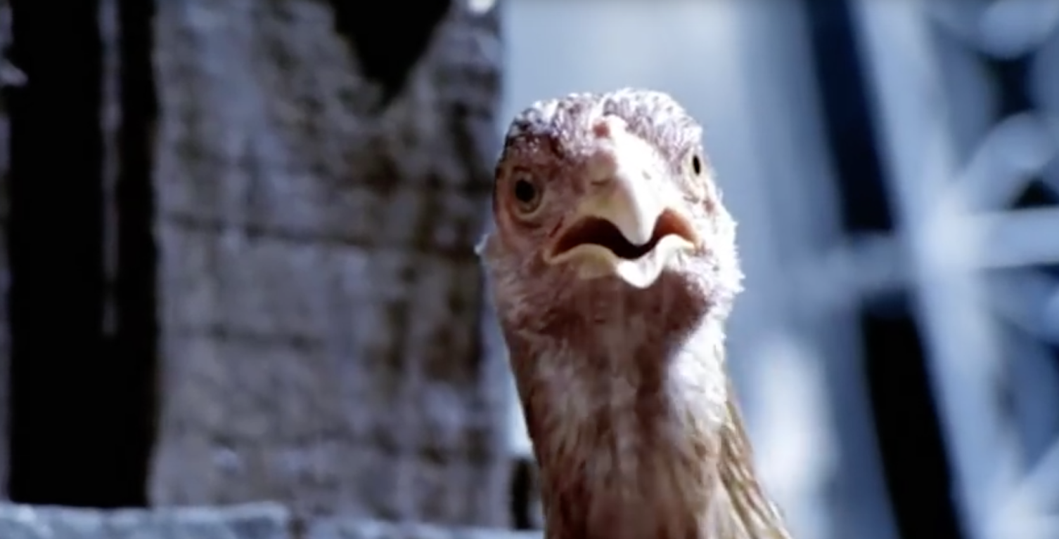  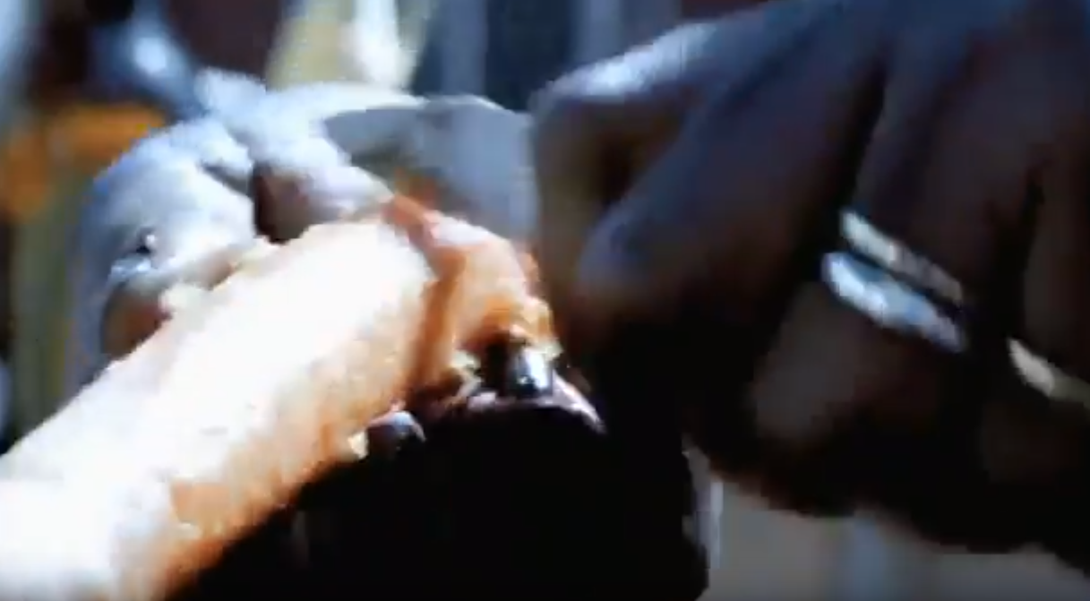 | The Kuleshov effect is used to create meaning. It is when a cut from one single image to another provides meaning for the audience. This technique was experimented with by Lev Kuleshov in the 1920s with an image of an expressionless man. Kuleshov’s example illustrates the range of emotions or meanings created for the audience. For example, the use of the image of the soup and then the cut to the image of the expressionless man may convey hunger to the audience. Whereas the image of the girl in the coffin which then cuts to the expressionless man may convey mystery, murder or grief. Thus explaining his theory of how images can used to create a range of meanings.  A more modern example is in City Of God, when we see a close-up of a chicken and an image of the people chopping the carrots, almost hints to the audience that the chicken is awaiting his death. Constant close-ups of the chicken are used throughout to emphasise the emotions it is experiencing, almost giving it human feelings. The editing in this clip is fast-paced to emphasise the fear and anxiety. In all circumstances the first shot is usually expressionless to allow the second shot to convey the appropriate meaning.
Intellectual Montage | North By Northwest  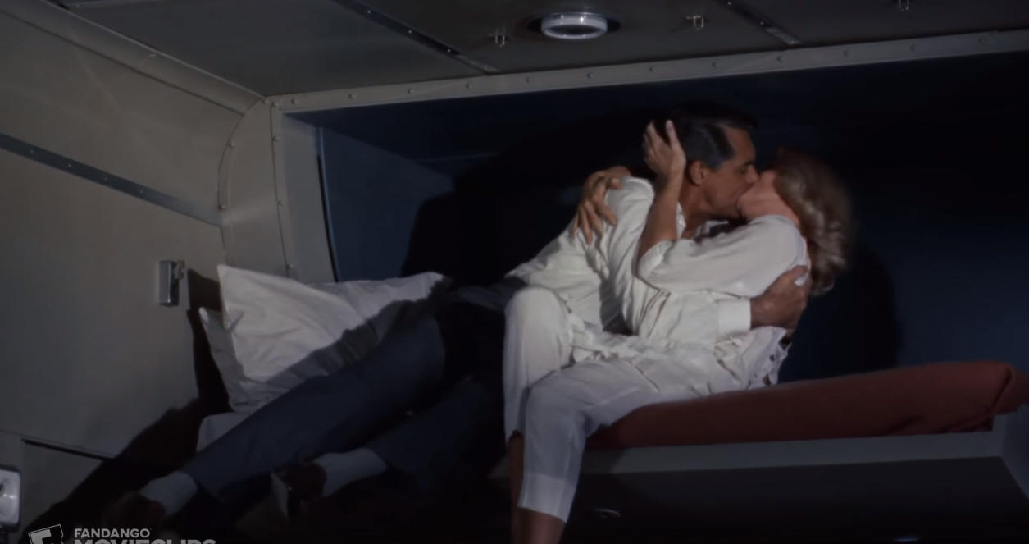  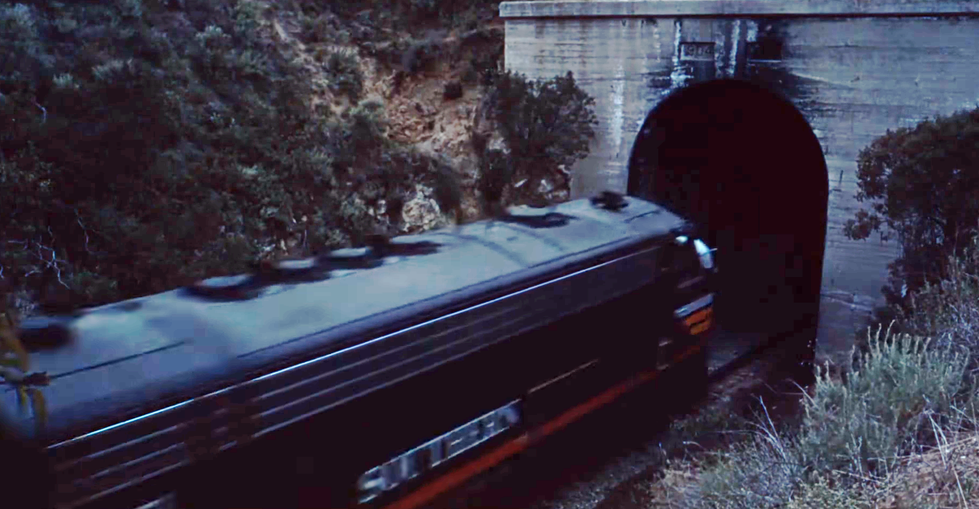  The Godfather  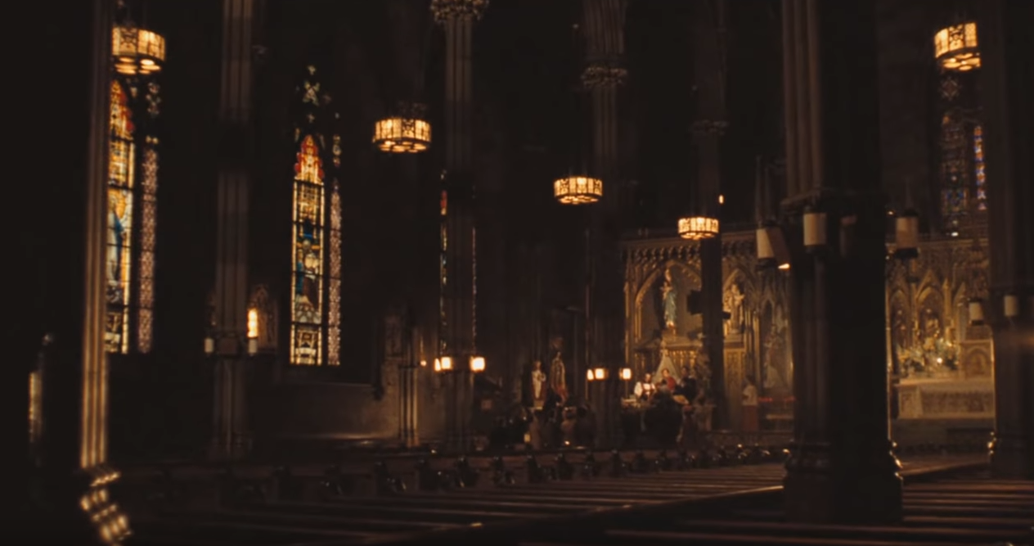  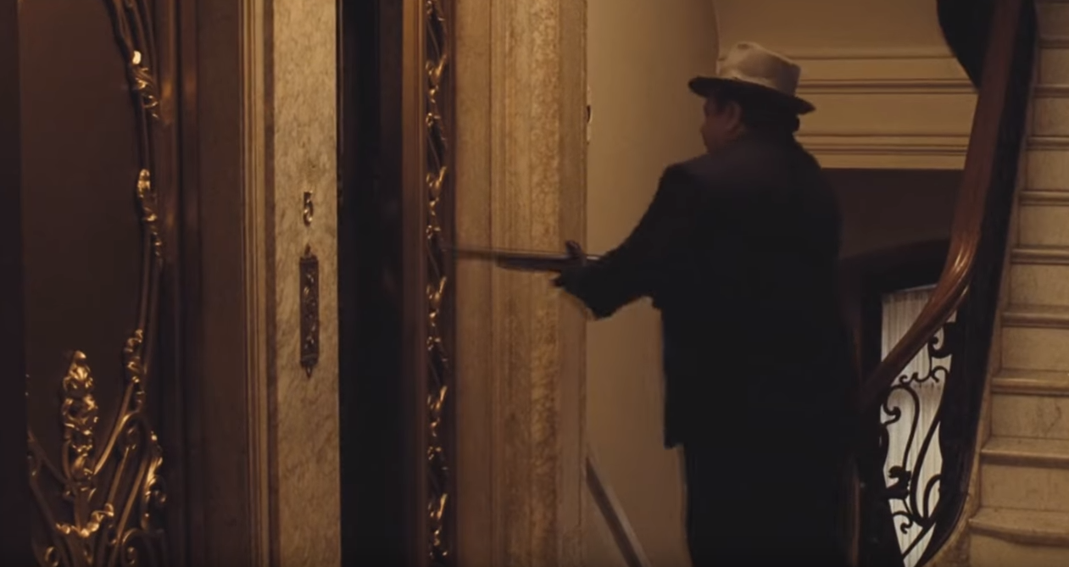 | This is a montage where it cuts to a symbolic, cultural or political image which allows the audience to use their knowledge to understand what happens next. For example, in this clip from North By Northwest a couple are on the bed and it cuts to a train going through a tunnel – which represents a sexual encounter. This is because the Hayes Code and its successor was in place which was the idea that morally unacceptable content could not be shown.  A more modern example is The Godfather, where on the one hand Michael is having his baby baptised and on the other hand the audience see several killings that he is responsible for. The image of the church is symbolic because it has connotations of innocence, purity – however it is clear from the juxtaposition that there are two sides to Michael’s character, and creates a hypocritical tone. Irony is also created in this clip as the purpose of baptism is to wash away a person’s sins however while this process is going on the audience are seeing several sins that he has committed.
Metric Montage | October: Ten Days That Shook The World  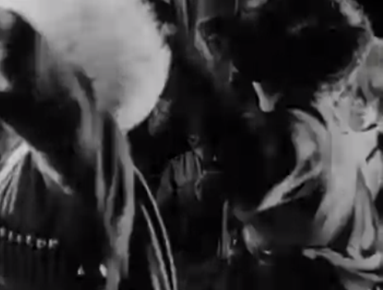  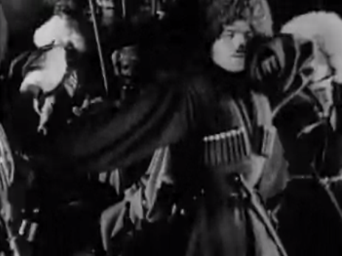  Requiem For A Dream  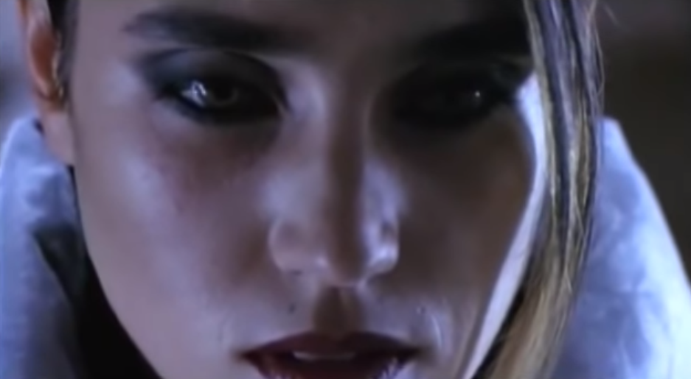  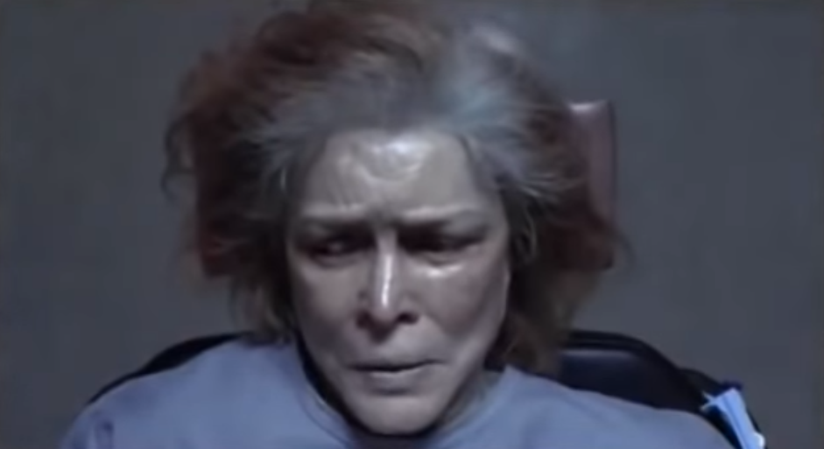  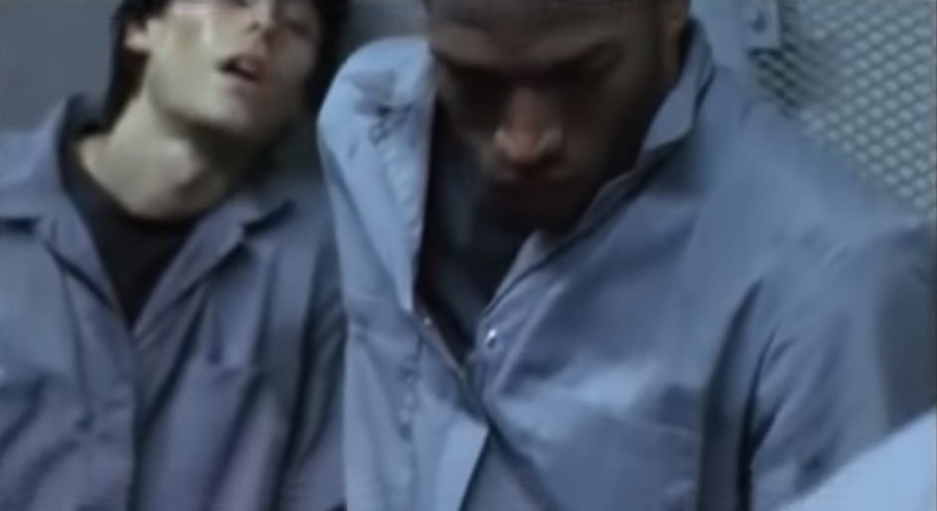 | Metric montage is a montage that has a series of clips that are the same length to create a certain rhythm. In the first clip it is a dance scene so naturally a certain amount of rhythm would be created making the audience feel the pace being created.  A modern more sophisticated example is Requiem For A Dream as all of the characters’ lives are in a bad state so a slow mundane rhythm is created so there is no hope – they are trapped. As the clip progresses the pace of the editing increases as the technique is developed to show that these people are becoming mentally unstable. A woman is getting electroshock therapy, the men are being taken into prison and the other woman is going to be a prostitute. The audience are made to feel as though they are in that situation with all 4 of the characters. The sound also has an effect on the atmosphere created as the audience can also hear a consistent, monotonous sound – which forces the audience to become immersed in the clip.
Rhythmic Montage | Battleship Potemkin  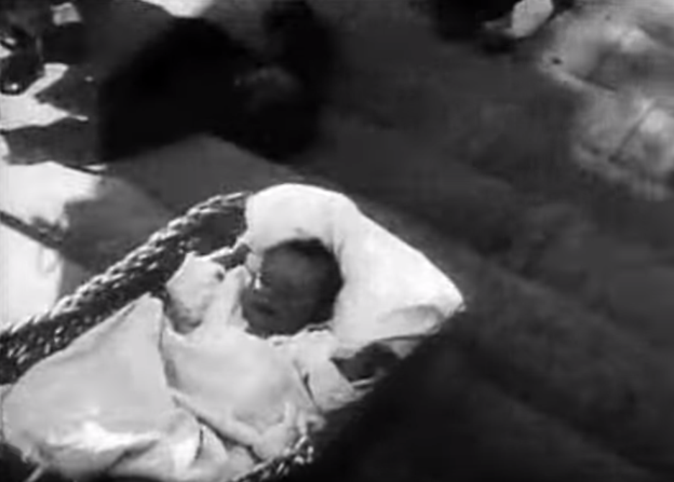  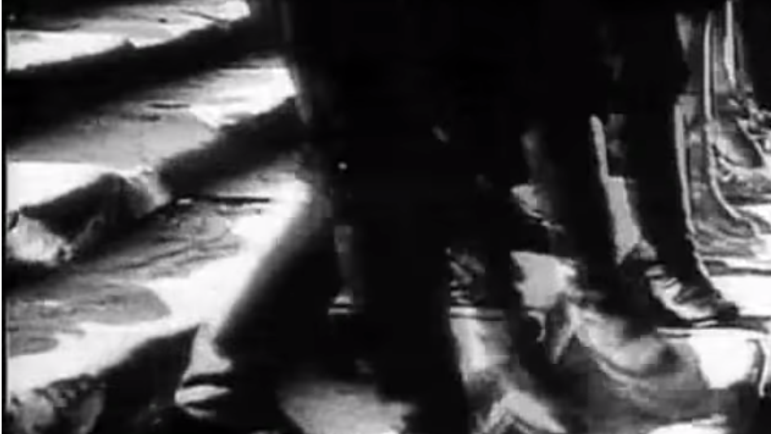  The Good, The Bad & The Ugly  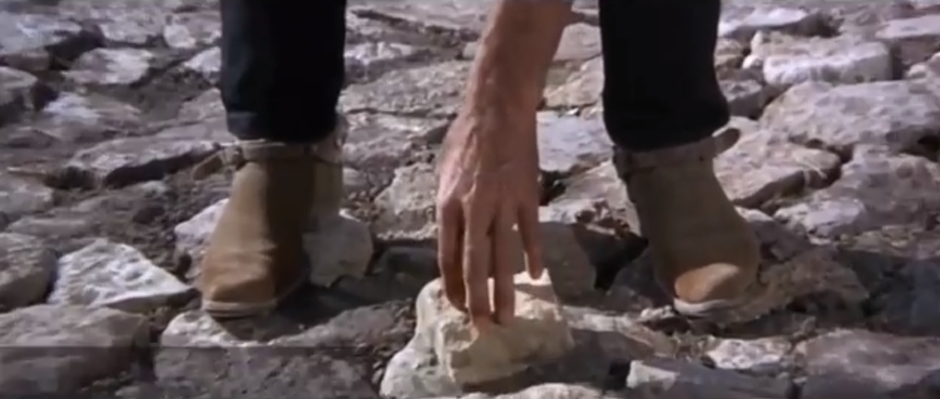  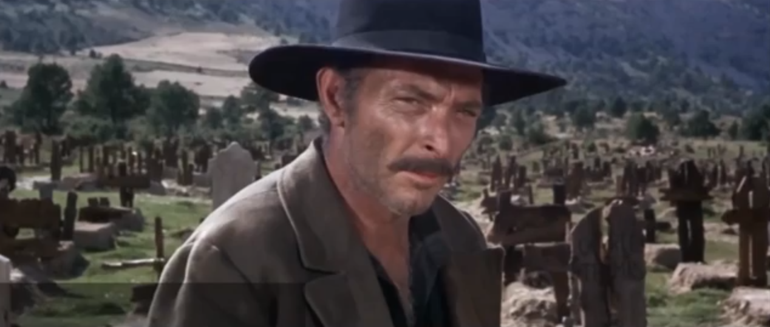  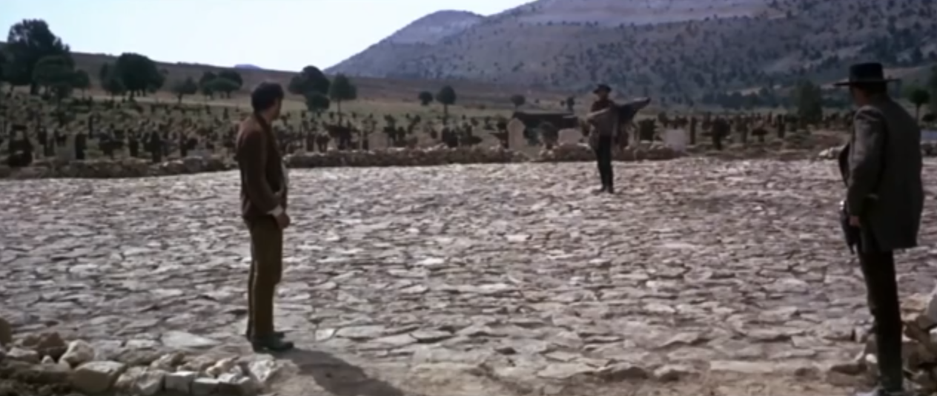 | Rhythmic montage is when the action in the shot determines when to cut – the action should feel complete. In Battleship Potemkin, two rhythms are created – one of the soldiers’ feet and another of the baby falling down the stairs. This rhythmic style creates more of a narrative as all the information is given to the audience, positioning them with the characters. In the part of the clip where the baby is falling down the stairs a rhythm is created in order to increase the tension and panic. When the soldiers are shown it creates order and shows how they are regimented. A soldier is quite controlled but the baby falling down the stairs is out of control.  In a more modern example, in The Good, The Bad & The Ugly where three characters are preparing for a battle, tension is also created, as the audience will be waiting for the action. In this case the rhythmic style has a different effect, as it does not seem chaotic, it is more controlled – as the event appears to be more planned, again positioning the audience with the characters and creating more of a narrative. The Good, The Bad & The Ugly has more of a slow rhythm and the cuts are more defined by the expressions of different characters rather than the chaotic atmosphere of the older example.
Tonal Montage | Battleship Potemkin  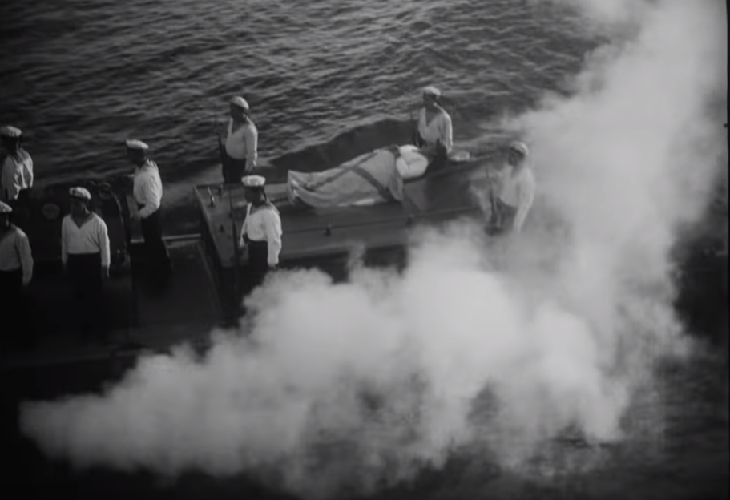  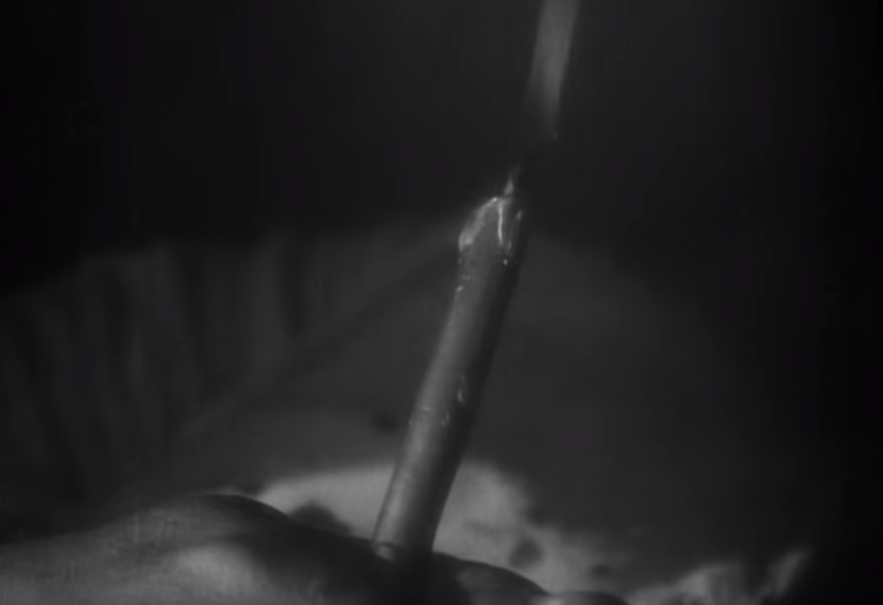  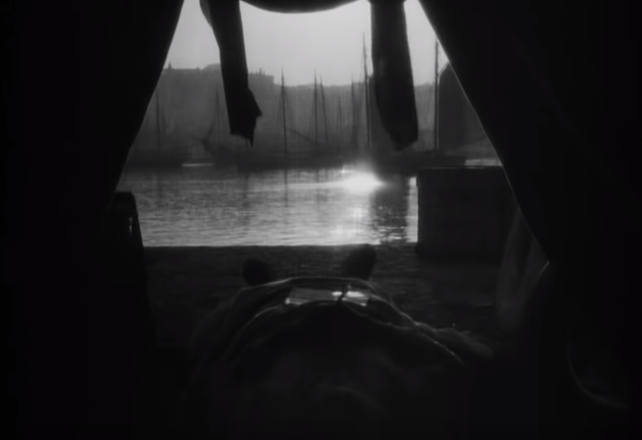  The Revenant  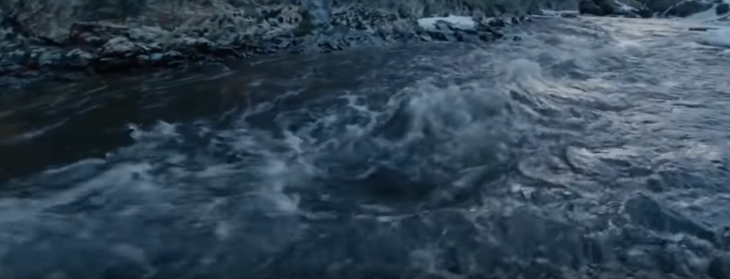  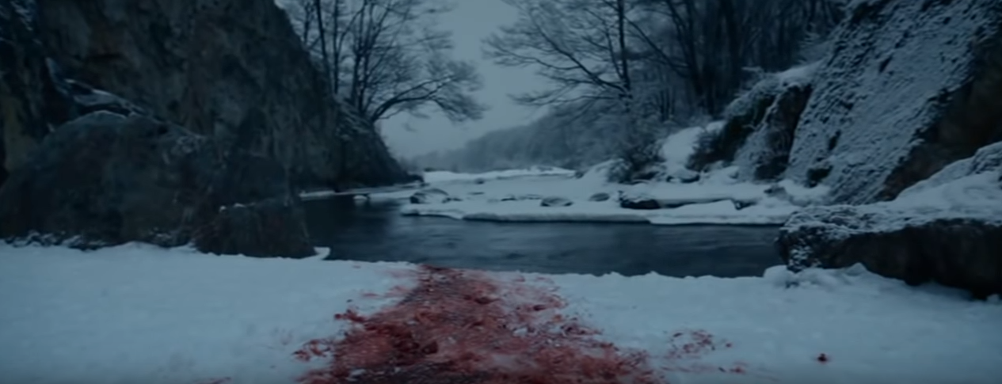  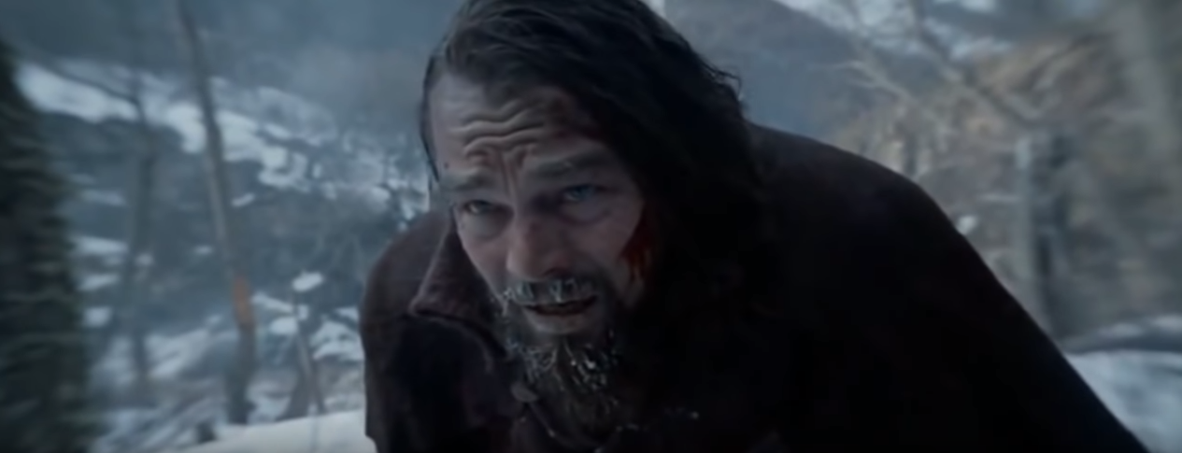 | A tonal montage that is used to create a certain atmosphere or tone, for example in this clip from Battleship Potemkin where a man dies and characters are grieving. A sad atmosphere is created as the fact that they are on the boat is symbolic of the journey of life and death, giving the impression that the man has reached the end of his journey. These three images together help to put together the end of a journey. For example, the burning candle again symbolises the fact that his life is coming to an end – it has religious connotations because a candle can show the light of God or can represent a human life. In the final image the audience are positioned with the dead man. We are experiencing the end of his life with him. The use of the shining light in the distance could be a representation of heaven.  In this clip the water is a recurring motif which is symbolising that his life is being washed away, as well as water being a common representation of life and death. The water also creates a calming atmosphere suggesting that the man is aware that death is approaching. The image of the blood is a visual representation of death because you can actually see him losing blood. Blood is the pain and it is being washed away by the water – him dying is going to take away the pain. The final image is used to show the final stretch of his life. Events have happened like him seeing the dead woman so he is more connected to death. His facial expression gives the impression that he has given into death and he can no longer live. Overall these three images have a blue tone, which has connotations of sadness, but also calm, showing two perspectives on death.
Cutaways | 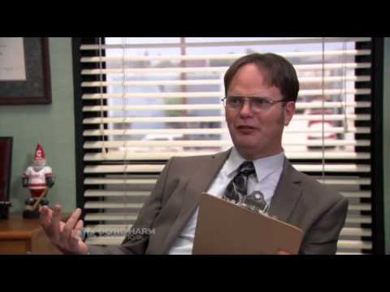 | In this scene from The Office we cut from a character in a scene to an interview-style shot with that character. This is effective as it helps to place the audience in this particular character’s shoes and provides them with a back-story on the scene from their point of view. The interview style is usually used to create comedy as it is the time where a particular character is the sole focus
Wipes & Dissolves | 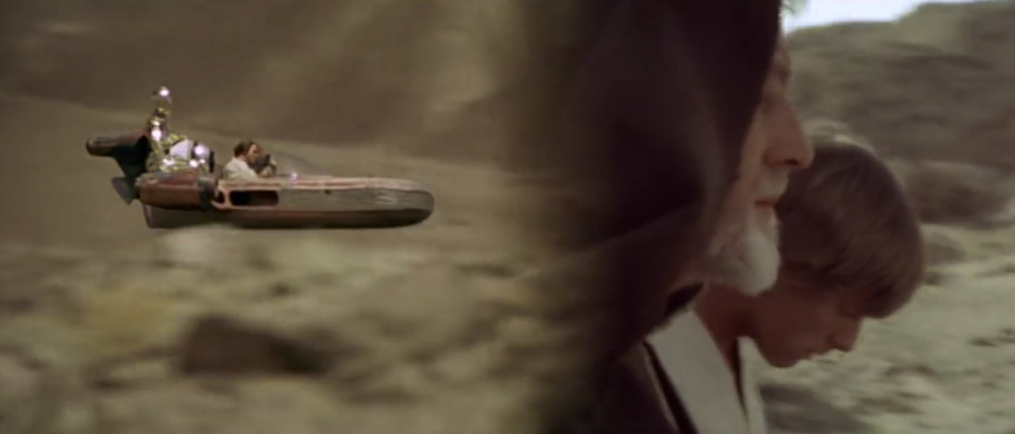  Star wars and eye dissolve clip  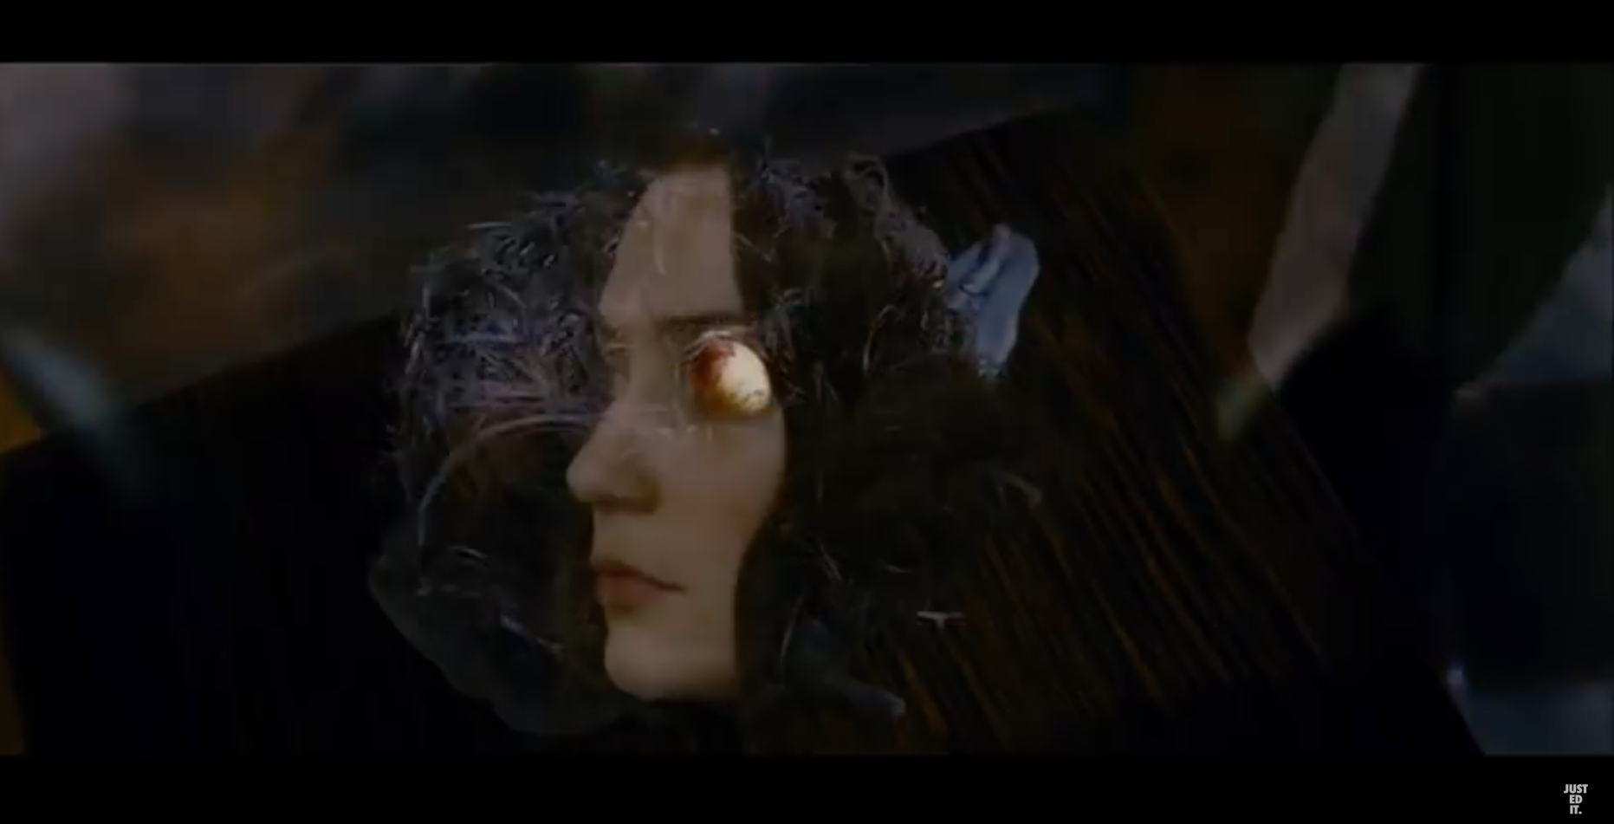 | In the Star Wars films several wipes are used to either show that time has passed, the scenes link to one another in some way, or to creatively switch to different locations. Wipes are commonly used in the action genre, as wipes require a lot of movement on the screen, which is a direct link to the chaotic movement style of an action film. For example, a wipe is used when Luke Skywalker sees that his home has been destroyed, we then wipe to the people who are responsible for it - to force an audience to make a connection between the two scenes.  Also from this clip we can see that dissolves can be used to back up a graphic match, as the egg is a similar shape to the eye, and it allows the audience to process the transition because it is at quite a slow pace
Continuity Editing | Lumiere Brothers - 1895  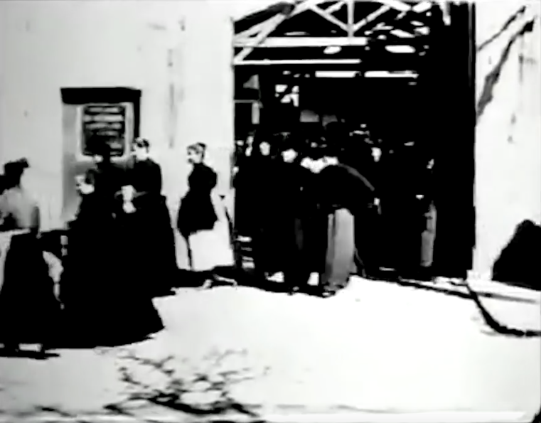  As Seen Through A Telescope - 1900  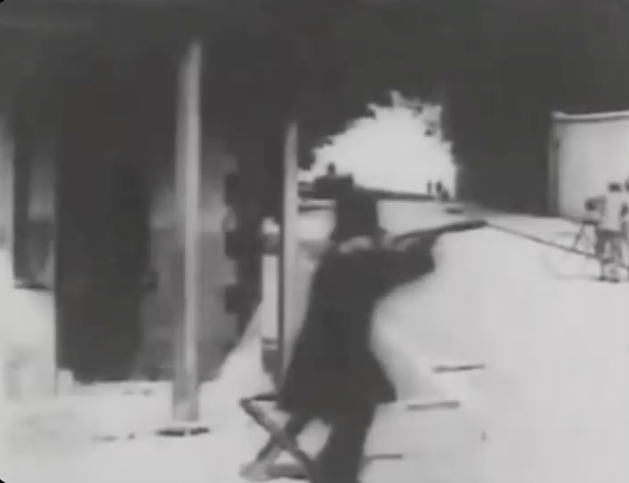  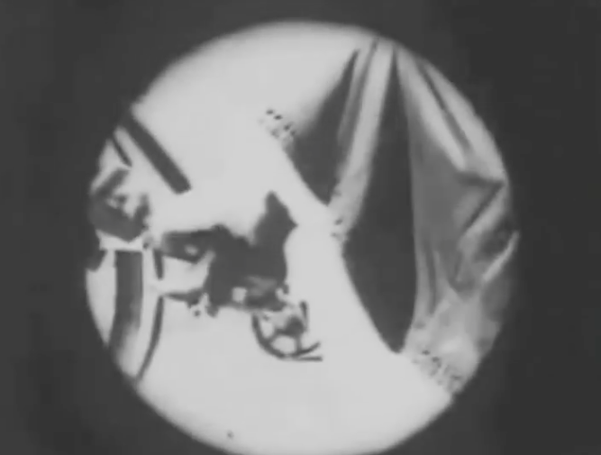  A Trip To The Moon - 1902  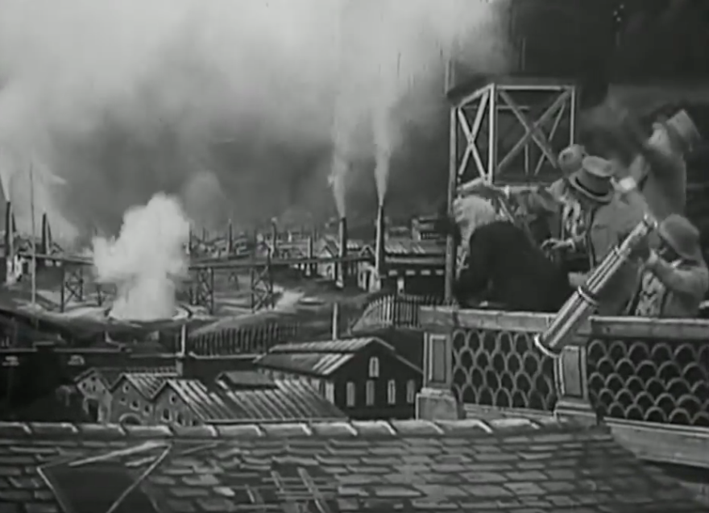  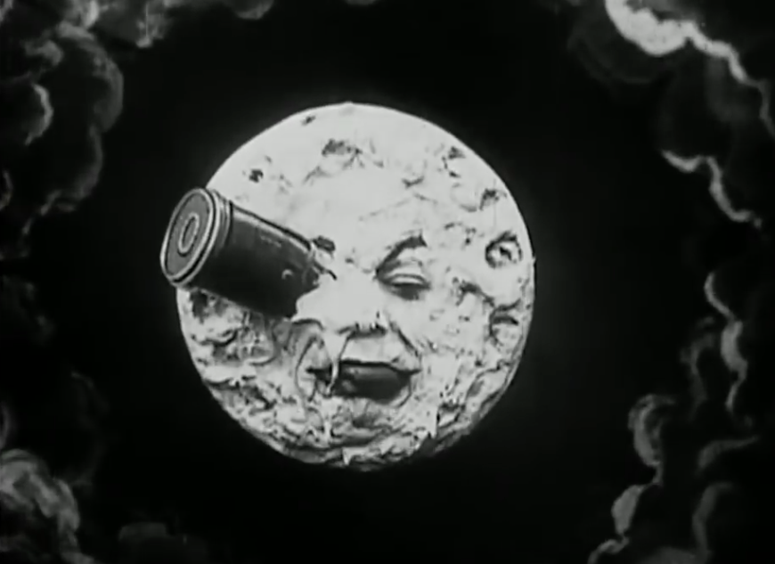  Life Of An American Fireman - 1903  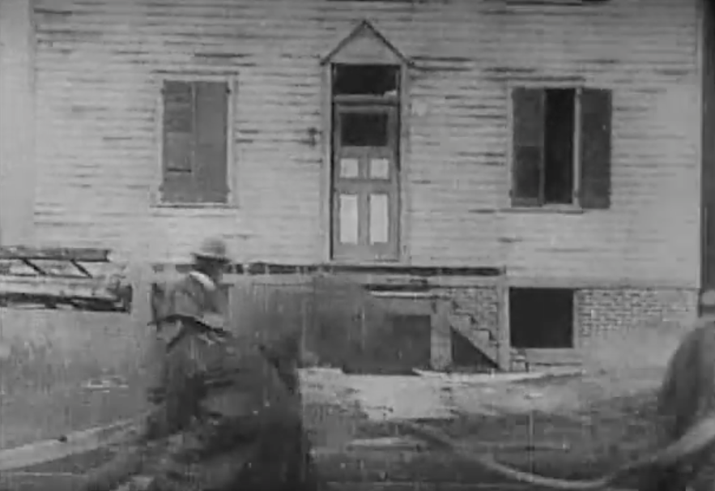  The Fast And The Furious - 2001  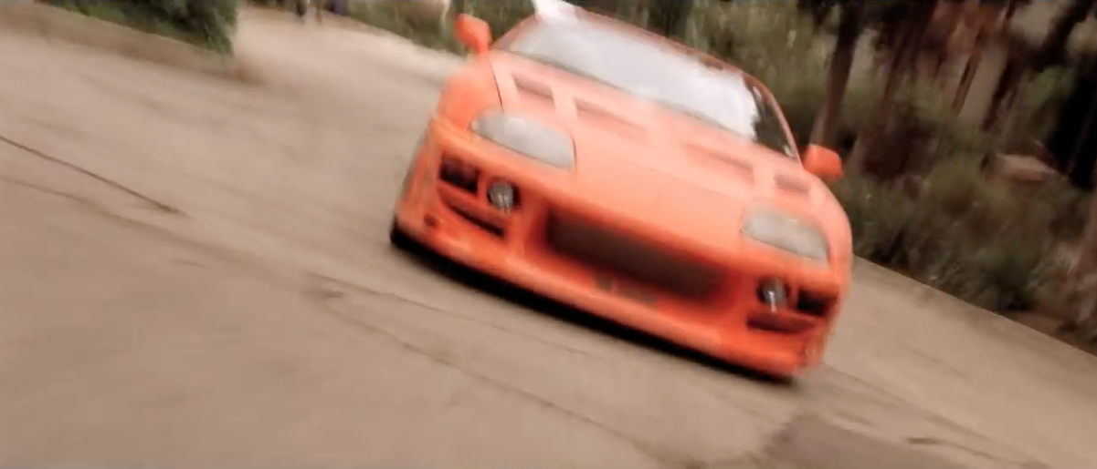  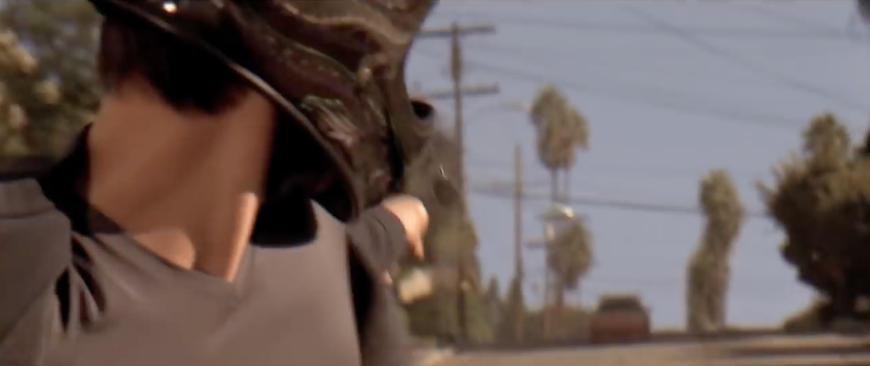  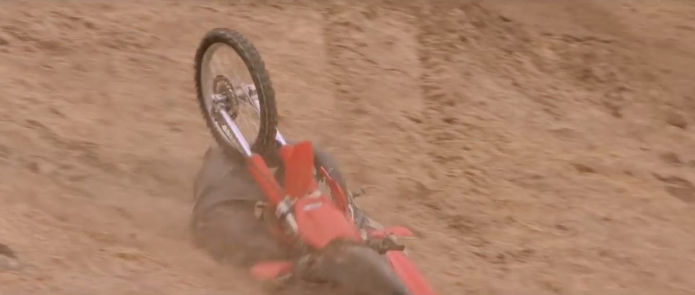 | Late 1800’s  Very little editing was carried out, movies were made up of scenes that consisted of footage that was sometimes over a minute long. Making the audience experience the film in as if it was happening in reality. Hence the contrast in editing of the 12st century where editing is used to convey that time has passed.  Early 1900’s  The amounts of edits were limited due to the lack of technology – film was used and then the person would have to physically cut the film and place it where they wished. However, there was an awareness of the effect of continuity editing on an audience member. As it progressed, we started to see shots following other that made sense for continuity. As show in ‘As Seen Through The Telescope – this allows the audience to start the make the first links between two shots and understand how that can create meaning.  1902 – A Trip To The Moon  This film was one of the first films to use special effects which shows that there was progress in the style of editing. It gives people the opportunity to experiment with the atmosphere they create through editing.  In terms of continuity, special effects are used to make scenes appear realistic, which would in turn to make them appear more natural.  1903 – Life Of An American Fireman  Within this clip we can see that further progress has happened, as there are more regular cuts, showing that the process of editing is becoming more advanced. However, when there is a cut it feels as though the clip is cutting from scene to scene rather than cuts within a scene, meaning that it feels more like a play. For example, plays only change during either an interval at the end of a scene. Edwin S Porter discovered that cutting two clips together helps to create a contextual relationship between them.  From a more modern perspective, techniques have been further developed in order to create more meaning and have a greater impact on audience members. There is a greater awareness of different techniques, and the process of editing is now easier to access because of software such as Final Cut and the fact that clips are now stored digitally.  The editing would be more seamless because the people editing the material are more aware of how to use the programs and have more opportunity to make it seems as real as possible. In more modern examples there are multiple fast-paced edits.  During this sequence we see several action match shots which help to make the narrative clear to the audience and create meaning because you’re put in the character’s headspace as an audience member. As he is chasing someone, which would be quite a fast-paced adrenaline-fuelled process, the editing reflects this, as the audience don’t have a lot of time to take in the shot because there is constantly a cut. In the first two minutes of the clip, there are 68 cuts which demonstrates that the pace of the editing has increased. Within these cuts, there are shot-reverse-shots, eye-line matches, action matches, and graphic matches, which again shows that several techniques are used today in the process of editing.

