Also, Keto NutriSlim magazine Obesity Facts contemplated the relationship among protein and weight me maybe gorge on shrimp mixed drink and greens with farm dressing."
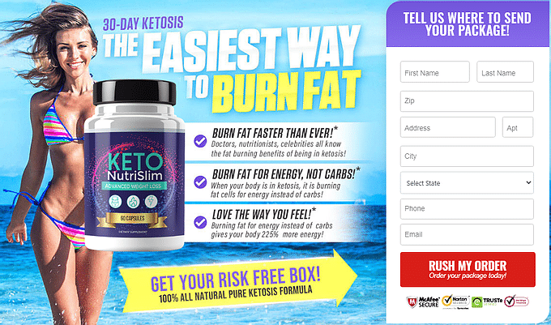
►►Click Here to Order Keto NutriSlim◄◄
Let's be honest, various us make some harder memories with weight the executives than others do. That is the reason we might want to advise you about over again supplement called Keto NutriSlim pills. This astounding new supplement can help Keto NutriSlim see more and better outcomes from their weight reduction schedule. it's beginning and end you might want to hit ketosis rapidly and begin seeing preferable outcomes from your eating routine over ever.
Any individual who needs to make progress rapidly with Keto NutriSlim should affirm that they're giving themselves each benefit accessible. We love this supplement, and that we think you'll as well on the off chance that you select to arrange. to discover more about how this item can help your body, continue to peruse our Keto NutriSlim supplement. We'll disclose to you all the important part you might want to know!
►►Click Here to Order Keto NutriSlim◄◄
There are more dietary supplements accessible than anybody can check, significantly less know all the information about. That is the reason we do an supplement about items like Keto NutriSlim pills. We do all the exploration on supplements like this that you basically essentially don't have the opportunity to attempt to .
At that point, we convey every one of our discoveries to you in one article like this one all together that you'll choose for yourself whether to include it to your weight the executives plan! In our Keto NutriSlim survey, we'll mention to you what very outcomes this supplement can get for you and thusly the dynamic fixing that upholds your Keto NutriSlim weight reduction. You'll get all the product subtleties you might want to arrange today!
►►Click Here to Order Keto NutriSlim◄◄
Keto NutriSlim Pills Benefits.a
A decent aspect concerning this specific equation is that it's made explicitly for the Keto NutriSlim. which means you'll see Keto NutriSlim preferable outcomes over you'd by utilizing an supplement that is detailed for eating less junk food conventionally. Your body goes through huge loads of changes with Keto NutriSlim, and this supplement works with those progressions emphatically.
To start a Keto NutriSlim, your eating routine ought to be high in fat and low in carbs. At last, your body enters a state alluded to as ketosis. That is the metabolic state during which your body consumes the put away fat for energy instead of carbs love it typically does. That is the reason this eating regimen is so mainstream.
https://ketonutrislimpill.wixsite.com/keto-nutrislim
https://sites.google.com/view/keto-nutrislim-/home
https://sites.google.com/view/keto-nutrislim-reviews/home
https://fetchbinarydog.com/keto-nutrislim/
https://twitter.com/Keto_NutriSlim
https://twitter.com/Keto_NutriSlim/status/1381119926321225739

