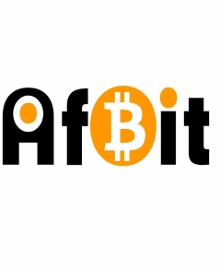

* Partner Cash out base in Africa buy and sell
* Mobile money, cash, bank operation
* Bitcoin supplier average of 3000$ daily limit given
* We could wave more liberty if we bring in our own money
* Rebate of 0.5% if we have our own money for limit trade( much more gain for AfBit)
* Application easy and user friendly
* We could copy their API if they have one to use for Africa platform by changing the currency rate
* Own back end and front end automate application( website or mobile app) for Africa
* We charge fees from 10$ to $50 depending on the volume sent
* We could add bank partners for payout and trade the bitcoin later we buy from liberty at high rate.
* Bitcoin trader in Africa and USA
* USA customers trade at LibertyX rate of 4% AfBit rate
* Africa customers Trade at Btc/Cfa rate buy 1$= 670cfa Sell 1$=570
* We could build an automate platform for Africa customers
* African USA resident for money remittance rate 1$=535Cfa or 540Cfa
* AfriExchanger trade with AfBit 1$btc=580

COSTUMERS