Laser Hair Removal - The Long-lasting solution to unwanted hair
We all know how frustrating unwanted hair can be. Some of us just want bikini-ready bodies, including clear and smooth legs. Some ladies are self-conscious about a visible moustache or chin hair.
Some men would also prefer to have less or no back or chest hair. Whatever the reason, hair removal is a desire for many people and laser hair removal has made this desire is easy to fulfil and also provides a longer lasting result than other options like shaving or waxing.
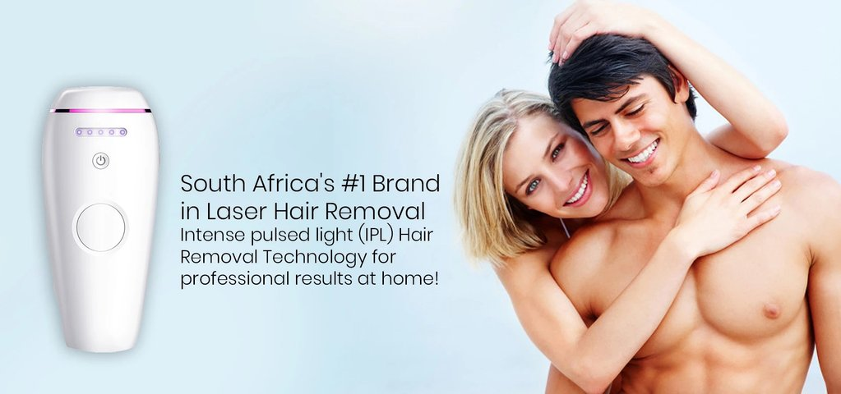

How does laser hair removal work?
Laser hair removal works by the laser emitting a concentrated light (of a specific wavelength and pulse duration) that removes the hair. The light from the laser is absorbed by dark material (your hair) and it is converted into heat.
The heat breaks down and destroys the hair all the way into its follicle. The laser doesn’t damage the surrounding skin as light matter doesn’t absorb the light. The damage to the hair follicle delays or stops the hair from growing.
More than one session of laser hair removal is required for optimal results as hair grows in a cycle and some hairs, that was in a resting phase, will still grow after the first couple of treatments. The number of required sessions can vary from two to eight and depends on the exact location of hair removal.
The potential problem with laser hair removal is fairly obvious. If hairs don’t have a large amount of melanin (the pigment in hair and skin) it will not absorb the laser’s light particularly well. People with darker skin will also find that laser hair treatment is not as effective for them as the higher levels of melanin in their skin causes less absorption by the hair.
A high contrast between skin and hair, specifically light skin and dark hair, provides the best canvas for effective laser hair removal. Some progress has been made to improve laser hair removal for people with darker skin where a longer wavelength is used.


Is laser hair removal effective?
The effectiveness of laser hair removal treatment depends on a number of factors, one of which is the wavelength of light used. Shorter wavelengths are the most effective but also hold the highest possibility of side effects.
The skin can be irritated and you might see red and raised bumps on the skin after a treatment but it usually goes away after a couple of hours. You might also experience some skin pigmentation, especially if you don’t avoid sun exposure before and after a treatment. This side effect is not permanent and also disappears after a time.
The longer wavelength of light is usually used on darker skin because its longer wavelength penetrates deeper into the skin and is not absorbed as well by the melanin in your skin. The decrease in absorption means that people with dark skin can safely undergo laser hair removal without running the risk of serious side effects like scaring, burns and pigmentation. A decrease of absorption by the melanin in your skin obviously also means a decrease in absorption by the melanin in your hair. The hair removal might not as effective as with the shorter wavelengths but it a good option for people with darker skin.

Is the hair removal permanent?
Regardless of the wavelength used for your hair removal the process does not permanently remove hair. With just a few treatments hair can be temporarily removed or the density of hair will be lower. With more treatment more hair can be removed and you can experience hair free skin for a very long time.
When the hair follicle is heated it does stop new hair from growing and puts the follicle into a dormant state for an extended period of time. This extended period of time can add up to a number of months and when the hair does eventually grow back it is lighter and finer than it was originally.
Over time and with repeated treatments the number of hairs that grow back will also become less and less. The different factors that influence the effectiveness of laser hair removal has already been mentioned but to recap, the hair color and thickness, the skin color, the type and quality of laser, and the knowledge, training and skill of the treatment administrator all influence the treatment success and effectiveness.


Can laser hair removal be done at home?
The simple answer to this question is, yes. A lot of effort has gone into producing laser hair removal devices that are safe to use. One such is Bareskin’s laser hair removal device. The device is incredibly easy to use at home.
As with laser treatments in a treatment facility you will need more than one session with the device to see major results and maintenance will need to be done every 4 to 8 weeks. This is far less of a hassle when compared to shaving every day and it far more budget friendly than visiting a treatment facility as well.
The same factors that limit hair removal therapies also limit the at home devices - the larger the contrast between light skin and dark hair the more effective the treatment with the at home device. It is also suggested that people with dark skin not use the device as there is too much melanin in the skin while people with red, light blond and grey hair also shouldn’t use it as there is not enough melanin in the hair. When using something like the Bareskin hair removal device, carefully follow the instructions to avoid any unwanted side-effects or complications.

Final thoughts
Getting hair removal treatments are definitely a good solution for getting rid of our unwanted hair, whether you be male or female. The treatment has been around for a long time and our understanding of it has increased.
For the most part it is very safe and the side-effects that might be experienced subside and disappear quickly. What’s even better is that we can administer this treatment in the comfort of our own homes. While the treatment doesn’t remove all hair until the end of our days it greatly improves the density of hair and new hair that grows back is less visible as it is finer and lighter.

Original article can be found at - https://www.bareskin.co.za/blogs/news/laser-hair-removal-the-long-lasting-solution-to-unwated-hair

