Is Just Casino the Best in the World?
Just Casino is a good option if you enjoy playing casino games online from the convenience of your own home.There are slot machines, video poker, and other games to choose from.If you're looking for a website where you can place bets online, this is a great option with a lot of fun extras.Products in this category all have limited-time deals, easy-to-use design, and support for a variety of payment methods.
Despite all its great features, it's crucial to mention that Just Casino, like all online gambling platforms, should be used responsibly. Players must set personal limits and be aware of the potential risks associated with online gambling. If you're scouring the internet for the best deals, make sure to check out justcasinobonuses.net your one-stop hub for all things related to online casino bonuses and promotions. Get the most out of your gaming experience today!
One of the key strengths of Just Casino lies in its commitment to ensuring a safe and secure environment for its users. It utilizes top-grade encryption technology to protect users' personal and financial information. Lastly, the customer service at Just Casino is commendable. The support team, reachable via live chat and email, is always ready to assist with queries, demonstrating their dedication to providing a seamless gaming experience.

Investigate Just Casino's Different Installment Choices for Consistent Gaming
A wide range of strategies for financing and pulling out reserves are accessible at Just Casino.Any significant Mastercard, check card, or computerized wallet will do.Doing these things is simple and fast.To guarantee that your involvement with our casino is both charming and rewarding, we give an assortment of rewards and extraordinary advancements.
With regards to client support, there could be no greater choice than Just Casino. Any season of day or night, a colleague accessible to help you. Accomplishment for our clients gives us pleasure, and we're generally glad to give some assistance.

Just Contest and Rules
Fair play and consistence with rules are just as essential to Just Casino as conveying a good time for its players. To ensure fair games, straightforward tasks, and client insurance, we are authorized and controlled by the world's driving gaming specialists. Every one of our games are evaluated and checked routinely to guarantee they are fair and legit.

Programming and Games We Offer
Driving programming engineers fuel our broad gaming library. Anything that your gaming inclination might be — the invigoration of openings, the methodology of poker, or the excitement of baccarat with a live seller — Just Casino has the game for you. You won't actually have to take off from your home to partake in our games; they're loaded with sensible audio effects and great visuals.

Playing the Game Securely
Capable betting is critical to us, and we believe our players should have a good time while they're here at Just Casino. Clients might control how long and cash they enjoy on our foundation with the guide of our implicit apparatuses. You might do this by laying out meeting impediments, betting cutoff points, misfortune cutoff points, and stores. The main thing is to leave nothing to chance so betting may keep on being a pleasurable distraction.
Feature | Description
Games | Variety of choices
Security | Top-grade encryption
Customer Service | 24/7 availability
Payment Options | Wide range offered
Software | Leading developers

The objective is to pick a computer game from a rundown
Just Casino offers a wide choice of games for players who need to play a scope of games.Our casino has in excess of 500 games, so everybody can find their favorite.Slot machines, tables, and, surprisingly, live vendors are accessible here.If you have any inquiries or issues whenever, our help base is accessible on the clock, the entire year.Therefore, holding up serves no use.In request to build your odds of coming out on top, join right away!
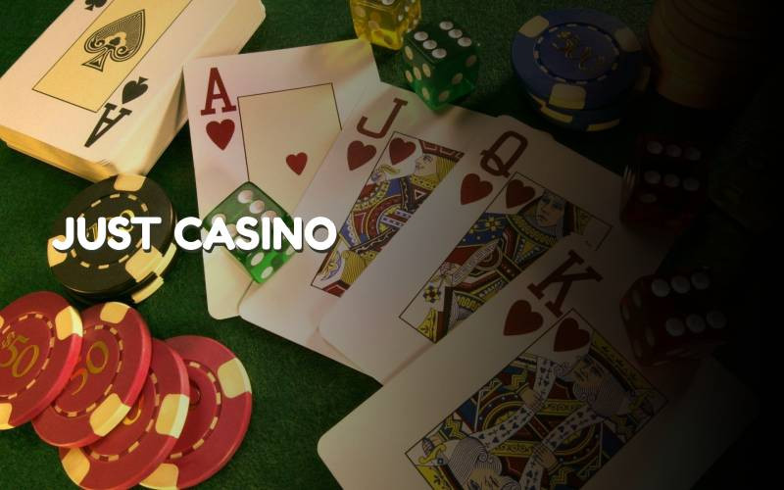

Top Online Gambling Sites Accepting the AUD
Just Casino is the best place to play if you want to gamble in Australian dollars.Our patrons can play video poker, slot machines, table games, and other well-known casino favorites.We also offer the best deals and incentives in the business.Why you're so wary, I have no idea.If you sign up now, you might start seeing results right away.
- You can wager in Australian dollars on video poker, slot machines, table games, and more at Just Casino.
- At Just Casino, both deposits and withdrawals are processed promptly.
- Any of the fantastic casino games offered by Just Casino can be played with the Australian dollar.
- You've staggered onto the ideal spot!
It offers all the standard casino charge and more.Everyone might find a game they love among our in excess of 200 titles.No matter your gaming inclination, we have something for you.Plus, you might arrive at our proficient and charming staff whenever, day or night, to respond to any inquiries you may have.To that end, kindly come in immediately and acquaint yourself.We guarantee with meet or surpass your assumptions.

Experience the Thrilling Experience from Anyplace
All the fervor and happiness regarding a genuine casino is readily available with Just Casino. Messing around moving has never been more straightforward than with our foundation, which is versatile advanced. Playing your number one games is essentially as simple as tapping a button, making them ideal for extended drives, trusting that gatherings will begin, or just unwinding at home. You might start a game on your PC first thing, get it on your telephone around lunch, and polish it off on your tablet before bed thanks to our games' cross-stage similarity. The fervor of the casino is available whenever and in any spot thanks to its versatility.
Related info: https://www.telegraph.co.uk/betting/casino-guides/poker/hand-rankings-chart-cheat-sheet/

