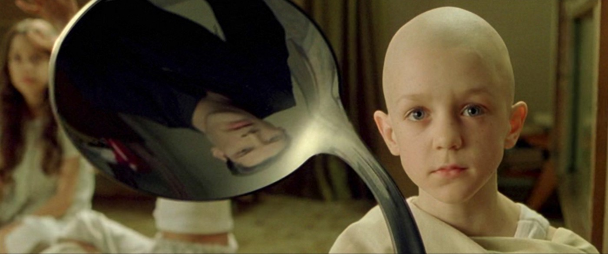
There Is No Spoon:
The Matrix Conspiracy of Andrija Puharich and Negative Resonance Music as Mass Mind Control and Antigravity Force

By

Drew W. Hempel, MA
2022
(Anti-copyright, Fair Use, Educational, Free)

“The smart way to keep people passive and obedient is to strictly limit the spectrum of acceptable opinion, but allow very lively debate within that spectrum — even encourage the more critical and dissident views. That gives people the sense that there’s free thinking going on, while all the time the presuppositions of the system are being reinforced by the limits put on the range of the debate.”
Noam Chomsky (1928- ), The Common Good (1998)
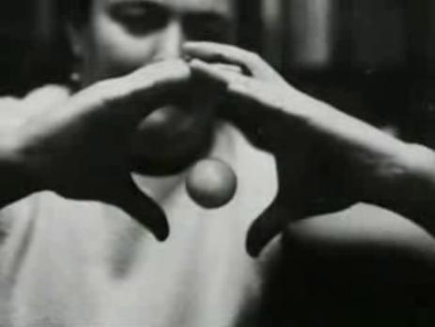
Globally Famous Nina Kulagina
Well-studied and Proven Telekinesis aka PK levitation paranormal powers
I feel that the past, and the present and the future is all in one state. They’re operating at different frequency levels. It isn’t the past here, the present here and the future here. We are all at one state. The past, present and future are all here. That’s why some people have deja vu….
– Qigong Grandmaster Effie P. Chow

Introduction: Andrija Puharich is Greatly Underappreciated
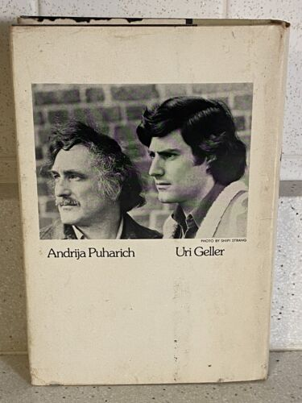
From the infamous telekinetic spoon bending hype associated with his promotion of a hypnotized Uri Geller channeling retro-E.T.s as Earth controllers tied to MKULTRA mind control experiments and the later 20 psychic spy “space kids,” Henry (Andrija) K. Puharich also promoted a very stunning applied science model as the Matrix conspiracy.
https://archive.org/details/ExperimentsWithUriGeller
Actual SRI CIA video of Uri Geller paranormal experiments:
Here you see substantial fluctuations both to the left and to the right, almost full scale of the magnetometer. …3/10ths of a gauss – full fluctuations…Here the task is to deflect the compass which indeed he does….required 150 pounds force to bend them…There are the three perception experiments, including the hidden drawings in envelopes, the double blind hidden object experiments, and the double blind die in the box experiment. The two psychokinetic experiments, the depression or raising of a weight on an electrical scale and the deflection of the magnetometer also do not seem to admit of any ready counter-hypothesis.
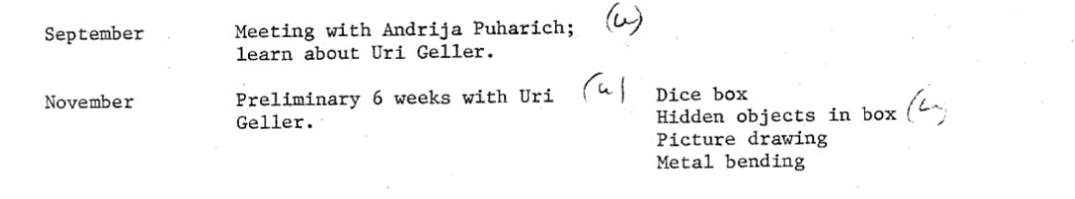
Although trained as a medical physiology researcher, Puharich was strongly influenced by Freemasonic theosophy and Tesla. One of the ideas that Puharich tied himself to through this theosophist UN-linked Matrix conspiracy is the apocalyptic embracing view that nuclear radiation will help Earth evolve spiritually (radio-eugenics as radiation hormesis).

There Is No Spoon is the expose of Puharich’s Matrix Conspiracy based on the secret of “negative resonance music” as mass mind control and antigravity superluminal quantum force! The biological “Matrix” conspiracy is inspired by the earlier H.G. Well’s “Global Brain” and now is known as the “AI singularity” of transhumanism. Both Puharich and Reiser argued that psychic force enabled by technology is the future of a “negative entropy” superluminal spiritual evolution. Their Matrix conspiracy relies on a structural understanding of math as the “music logarithmic spiral.”
It was at this point that we conjectured that there is a kind of ionosphere for the brain waves of the world cortex. In that case the biological mutations having their origins in the spiral structures of protein chains are the genetic sources not only of higher species, but the force-fields of the sun-earth-galaxy configurations are weaving a novel biological-social synthesis, a giant Planetary Being with extra- sensory and psycho-kinesis powers. These capacities are even now emerging in the mutant personalities who embody these flickering phenomena as studied by paranormal psychology.
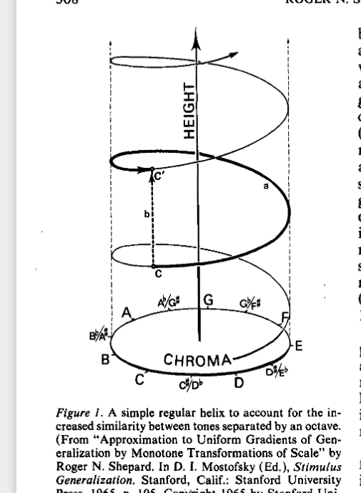
After a brilliant Faraday Cage ESP (extrasensory perception despite blocked electromagnetic fields) experiment, in November 1952 Puharich presented a paper on ESP in psychological warfare at a Pentagon conference. December of 1952 brought the “Nine” eternal entities/forces channeled via Puharich’s Indian mystic research subject, Dr. D.G. Vinod, and in 1953 Puharich was officially shuttled into psychological warfare research, focused on induced-ESP mind control, i.e. hearing radio waves via implants, psychedelics, narco-hypnosis, MKULTRA experiments on prisoners and mental ward victims, and finally the Matrix conspiracy collaboration with Professor of Philosophy Oliver L. Reiser, Chairman, International Committee on Scientific Humanism.
The authors of the Stargate Conspiracy, Lynn Picknett and Clive Prince, were skeptical about the D.G. Vinod origins of the Nine (as secret eternal controllers of Earth) and they argued “the Nine” was part of a military psychological warfare plan for a new global E.T. ancient aliens religion (Graham Hancock is also included in this Stargate Puharich milieu by Prince and Picknett): “What if Puharich had created the Nine - not subconsciously, but deliberately ... ?” they ask.
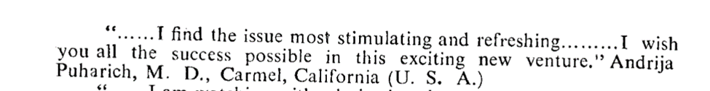
Picknett and Prince point out that Puharich had connections to a lineage of theosophy mysticism based on Indian philosophy and the legend of the Nine originated from ancient India. “Sir John R. Sinclair, in a 1984 book about [theosophist] Alice Bailey, finds the similarities between her stress on the significance of groups of nine and Schwaller de Lubicz’s Nine Principles remarkable,…
Puharich was published in Darshana International Quarterly that also features regularly contributors to Alice Bailey’s U.N. linked Lucis Trust Beacon Magazine just as Professor Oliver L. Reiser was a regular contributor to the Beacon. Indeed Puharich and Dr. D.G. Vinod who originally “channeled” the Nine both (see above screenshots) praise the same Darshana International Quarterly of psychical and mysticism research that has Professor Oliver L. Reiser as a Darshana journal editor, along with journal contributions by Puharich’s close parapsychology collaborator Eileen Garrett and Reiser’s close collaborator Esther Watson Tipple (daughter of the co-inventor of the telephone, Thomas A. Watson). In fact in the first year of Darshana, 1961, both Puharich and Esther Watson Tipple (collaborator of Oliver L. Reiser) were published in the same issue.
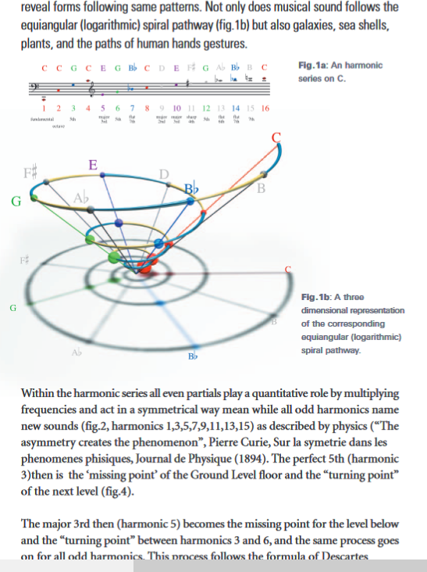
“The first of these concerns Dr. D. G. Vinod, a Hindu scholar and sage from Poona, India, whom I briefly met by chance in New York City in December 1951.” So reports Puharich in his book on Uri Geller. Yet clearly Dr. Vinod was part of the same theosophist group surrounding the creation of the Darshana journal. So in the sense that both Puharich and Dr. Vinod shared the same theosophist belief system then their meeting could not have been by chance – but occurred via Eileen Garrett.
At a party, given by Eileen Garrett on December 3rd, 1951, in order for Andrija to meet her friend and patron Frances Payne Bolton, Andrija was so focused on these two women and their work in progress, that he scarcely noticed the Hindu scholar dressed in white puttees and a black Nehru jacket. However, they did chat briefly, and Andrija learned that Dr. Vinod was a professor of philosophy and psychology at the University of Poona. He was in the United States lecturing on behalf of the Rotary International Club.
“a spiritual master from India Dr. D G Vinod, aka Maharshi Vinod” is also described as “Maharshi Vinod traveled world over as the 'World Peace Ambassador'. Maharshi Vinod was closely associated with Dr. Albert Einstein,…”
So this is the same Dr. D.G. Vinod as memorialized with the institute ‘Maharshi Vinod Research Foundation’, based in Pune, India. See the Darshana International Quarterly contributors in 1962 after starting publication in 1961 – clearly Puharich and Reiser (and their research associates) shared an intellectual collaboration on their Matrix plan for global transformation via theosophist cosmic humanism (known now as transhumanism). See the Darshana list of U.S. contributors as of one year of publication:

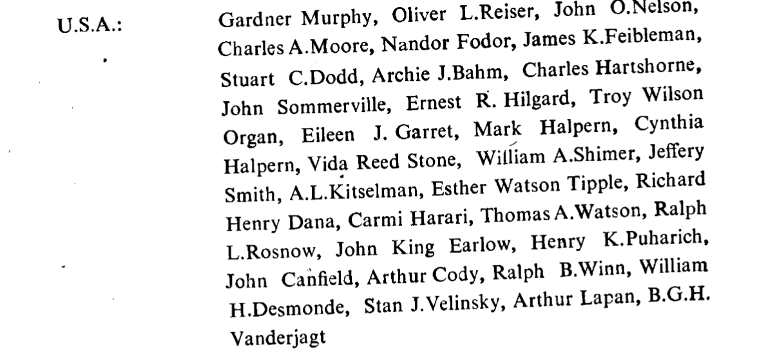
Puharich reveals how his science research was intertwined with the military:
We were able to develop a hearing device that fit under the cap of a tooth and we could hear very clearly from a small little relay and receiver and transmitter and unfortunately it was promptly classified by an agency of our government. But we did solve the problem in terms of hardware.
Puharich worked with the somewhat competing government military entities of the Army, Airforce, Navy, NASA, CIA, Atomic Energy Commission, the parapsychology foundations, and various private military contractors (Lockheed, Honeywell, etc.) over the decades of his paranormal research. “During the period from 1963 to 1968, Andrija Puharich, then a senior medical researcher at New York University, conducted studies in Brazil with the wonder-healer Jose Pedro de Freita -- known by his nickname Arigo.” By 1978 Puharich moved “underground” to Mexico to avoid apparent CIA attacks, including the arson of his research facility/house - attacks driven by Puharich’s Tesla ELF (Extremely Low Frequency) clean energy work.
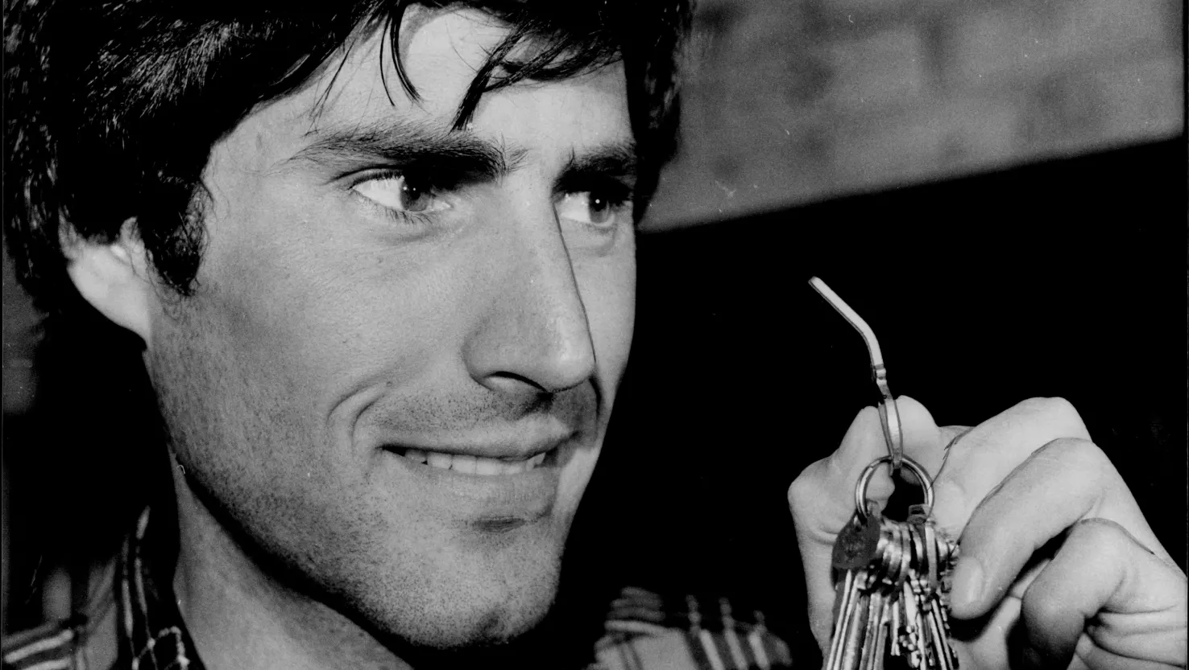
Paranormal Metal Bending aka the infamous “there is no spoon” meme from the The Matrix movie, was the subject of much media hype, science analysis and thus the focus of the 1982 philosophy of science academic book Frames of Meaning by H.M. Collins and T.J. Pinch. Military research into and use of psychic spy remote viewing was largely inspired by Puharich’s foundational research in parapsychology – and ever since the subject has been plagued by conspiratorial spookiness. Puharich:
It [Stanford Research Institute, SRI] became a CIA research center- even to this day. I know this because I trained many of the psychics involved in the psychic warfare operation. I could tell you names, places, all that garbage. There are smokescreens deliberately set up to discredit parapsychology research or keep what they know concealed.
Professor Michael Persinger:
Andrija Puharich is greatly underappreciated.
Puharich’s model of reality was incorrectly described as a materialistic model, ”carrying of information on protons,” thereby bypassing the attenuation of electromagnetic fields problem (hence the Faraday Cage experiment) that would normally rule out paranormal phenomena. This “information on protons” tidbit in the report, “Preliminary Investigation on Implicit Space and Implicit Matter,” is somewhat misleading and I’m writing this book, in part, to correct that materialist misunderstanding.
While several books have focused on Andrija Puharich and his widely cast net of strange science CIA connections – The Stargate Conspiracy by Lynn Picknett and Clive Prince being my favorite – this present work is focused on Puharich’s actual scientific model of reality in the context of his collaboration with Professor Oliver L. Reiser on the Matrix Conspiracy. And so it officially began with Puharich:
The science model proposed by Puharich was much more sublime than just “information on protons” and it had more to do with harmonic superluminal acoustic “phonon pumping” as nonlocal antigravity information-force aka the infamous Tesla ether. Here’s one ESP ELF experiment inspiration by Puharich:
This could easily be done with the use of a 64-foot-long organ pipe which has a fundamental of 8 c.p.s. [cycles per second] This tube can be made of a good dielectric, and a Faraday sphere placed on top of this column.
Considering Puharich’s wealthy friend Hammond specialized in such pipe organ music engineering in Hammond’s castle where Puharich frequented, then the influence of Tesla’s personal student, “Jack” Hammond, is made apparent. Puharich definitely was inspired by Tesla’s dream of electrically charging the whole Earth via 8 cycles per second ELF Schumann magnetic waves and this became Puharich’s Actual Matrix Plan collaboration with a theosophist-UN science think tank via Oliver L. Reiser.
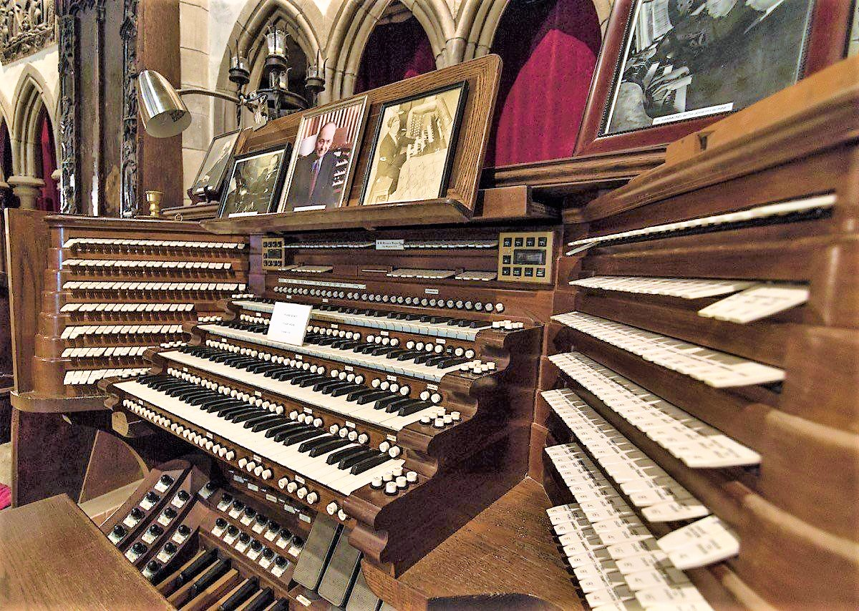
Puharich’s 1982 lecture series, “The Future of Humanity, and what You can Do about It,” refers to the “New Age” as “biological labor pains” – the “Final Purification” – and “season of harvest” and then Earth will be “dematerialized” and then “rematerialized” as “the new race of humanity.” It is this global technohumanism or cosmic humanism vision via the “negative resonance” music paranormal mind model of Puharich, the Matrix Conspiracy, that I will be focusing on for this book, as well as offering my own alternative music solution to the “music logarithmic spiral” Western standard science model of Puharich and Reiser.
Puharich gave a seminar in 1985 in Minneapolis, Minnesota for a group of people with whom I have a personal connection as I also grew up in Minneapolis. During that series of talks in my home city, Puharich emphasized that information permeates the Universe: “It seems to be an intelligence that’s built into the entire universe, …that every part of the universe, that every minute quantity has it…Everything was created by intelligence.” This is what Puharich explained in his science analysis as his Psi-Plasma ELF magnetic model of matter and mind.
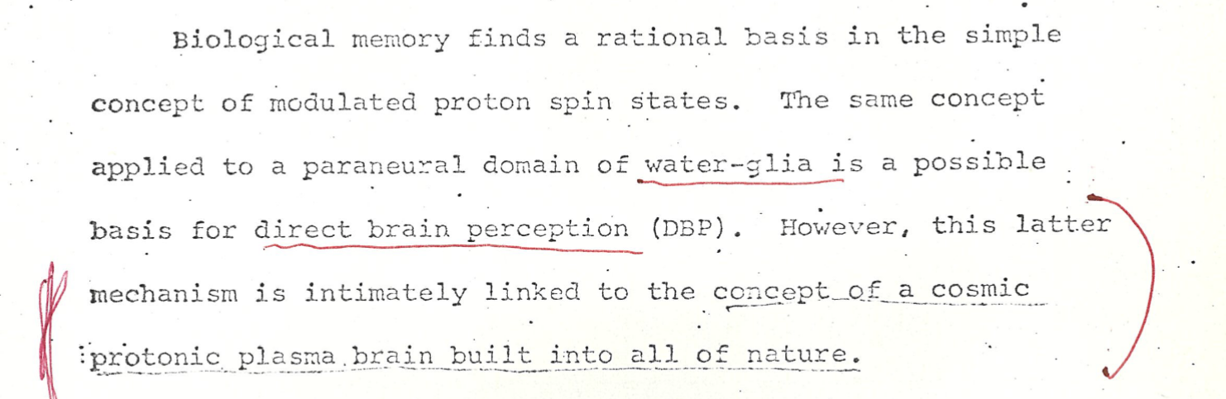
As Puharich states,
Rather we should think of a spread out, an ELF-field mushroom-shaped proton, if you will. If we accept this point of view the proton now has a frame of reference which (depending on its energy) may have a wave length which is equal to the radius of the solar system….a cosmic protonic plasma brain built into all of nature, connected through ELF fields.
Notice Puharich added that “connected to ELF fields” when it was not present in the draft he sent to Reiser:
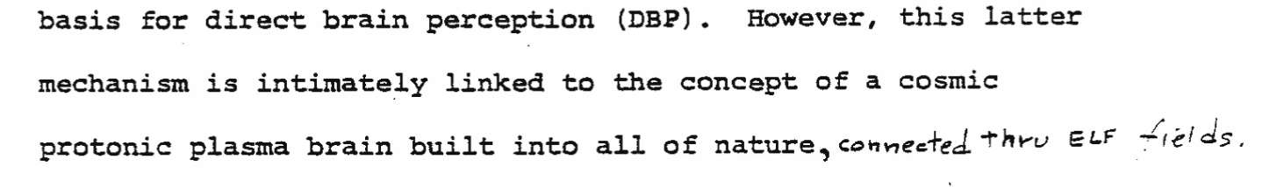
Puharich tried to explain his model to his listeners in Minneapolis for his seminar but in “layman terms” he really didn’t go into any of the scientific details because the details were too complex. So I’m going to go into the weeds as it were – the details of Puharich’s theory – and compare them to some other leading scientific theories of reality, notably Nobel Physicist Roger Penrose’s, that also include the paranormal. That’s what this book is about: Puharich’s Matrix Conspiracy is actually determined from a structural drive of science itself. Consider the first letter as incoming correspondence to Professor Oliver L. Reiser from Puharich, thereby launching their music-based plan to transform Earth: (red line emphasis apparently by Reiser)
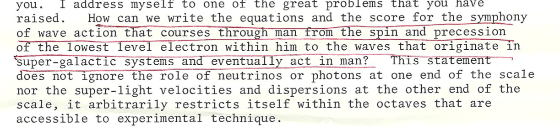
Yes Puharich did explain how he used harmonic frequency resonance to easily split the water molecule, via an undertone beat or frequency difference in the ultrasound range. Puharich, in his correspondence with Reiser, refers to their common collaborators as part of a larger research network and Puharich also emphasizes his close and in person collaboration with Reiser:
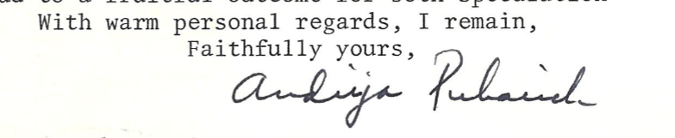
Puharich expanded his “hearing sound from electricity transduction” research to a general natural resonance energy principle:
Thus the head neurons see the following signal: 20 KHz [ultrasound] + 100 Hz [ELF] = 20,100 Hz:20 KHz - 100 Hz = 19,900 Hz. The 20,100 Hz and the 19,900 Hz beat against the center frequency of 20,000 Hz and the result is the deaf person "hears" 100 Hz. Certain proton nuclear ELF magnetic resonant (NMR) signals in the nervous system may be of this nature where the actual perceived signal may be a side-band signal.......It was observed that the absolute threshold of hearing could be obtained at 0.16 mW (rms), and by calculation that there was an amplitude of displacement of the eardrum of the order of 10⁻¹¹ and a corresponding amplitude of the cochlear basilar membrane of 10⁻¹³ meter.
Corollary to this finding. I was able to achieve the absolute reversible threshold of electrolysis at a power level of 0.16 mW (rms) [splitting of water molecules by ultrasonic electrolysis at incredibly low power levels]. By carrying out new calculations I was able to show that the water was being vibrated with a displacement of the order of 1 Angstrom ( = 10⁻¹⁰ meters). This displacement is of the order of the diameter of the hydrogen atom. …In short, ELF frequencies at super low power levels can control the well-being of organisms.

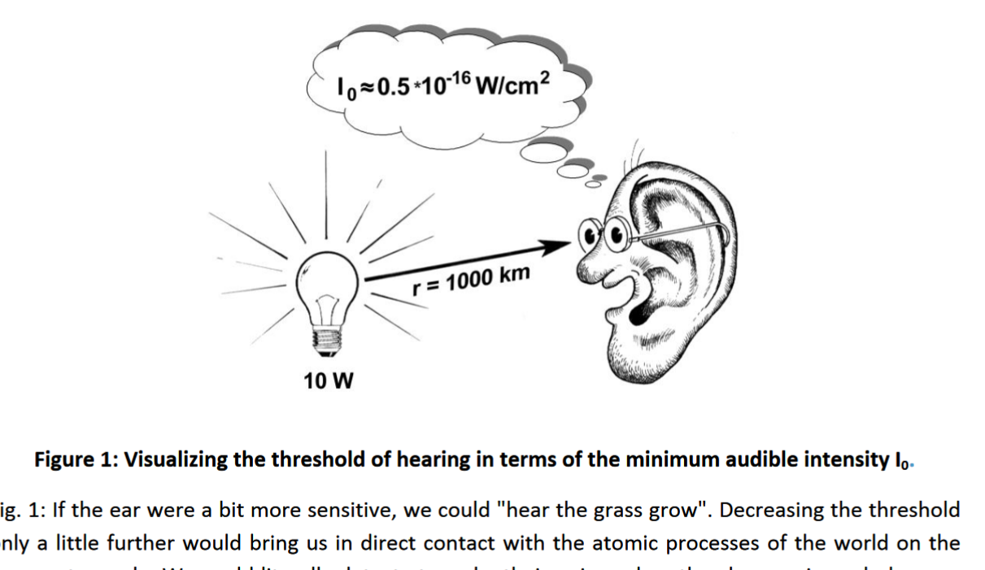
The difference between two ultrasound frequencies creates an ELF undertone – but there is more to it than just this frequency “beat” difference – this ELF wave is very special and magical as Puharich details. Biologist Brian Goodwin emphasized that the subharmonic of the frequency has a significant increase in amplitude. But Puharich is arguing there is a superluminal gravitomagnetic secret to this ELF magnetic power – due to the time-reversed coherence signal. Puharich makes the connection between is hearing transduction research and ESP explicit in his hand-written letter to Professor Oliver L. Reiser:
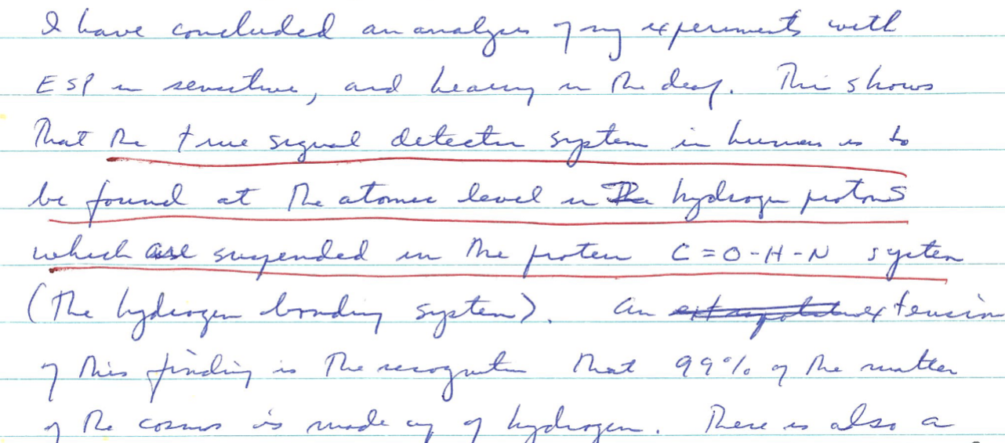

Puharich became fixated on the claim that ELF magnetic fields were being used a weapons on Earth – to control weather and minds – first by the Soviets and later by the U.S. Physicist Jack Sarfatti on the ELF warfare scene around Puharich:
The body of information Bearden, Evans, Crowell & Company [Puharich, Einhorn] is disinformation on non-lethal [ELF] ‘psychotronic weapons’ from the Cold War Era associated with the KGB using a New Age Cult around Tesla, the most prominent Serbian scientist-engineer.
Puharich's claim regarding the nervous system is that as the negative ions are increased then this ionizes the parasympathetic vagus nerve for increased relaxation, thereby slowing down the nervous system via this time-reversed signal. “All of these manifestations, said Puharich, were ‘the general symptoms of parasympathetic activation.’”
The frequency can be decreased via phonon or sound also with the goal then to cause the proton-proton spin coupling to move closer to the Schumann Resonance spike on Earth at 7.82 or 8 hertz. This slowing down or relaxation of the nerves occurs via a "precession" of the angular momentum velocity of the electron against the magnetic moment of the proton - so it is a time-reversed signal based on the 1/2 spin being nonlocal or delocalized. This is called the "spin echo" effect in nuclear magnetic resonance or proton NMR spectroscopy. “C[speed of light squared] appears to be a property of the psi-plasma vortex imparted to the electron as spin.”
The key insight of Puharich is to realize this backwards precession of the electron, essentially turning it into a positron, an electron going backwards in time, then also has a negative entropy antigravity effect also as per what is now called the Blackett Effect. There is also a splitting of water - into the 4th state of water called EZ Water - and also creation of new matter, telepathy, etc. Sean-Paul Sirag, the quantum physicist, updates us:
The bridge between the Blackett-effect magnetic field and the gravitomagnetic field might be built by way of the work of Ning Li and David Torr 24,25,26 . The key idea seems to be that, although ordinarily, the gravitomagnetic (and electrogravitic) fields are too small to measure, the alignment of spins in the lattice ions of superconductors, make the gravitomagnetic field much larger (by 11 orders of magnitude) than the magnetic field. As we have seen, according to the Barut-Gornitz picture, the rotation of a macroscopic body will accumulate (and thus magnify) the tiny anomalous magnetic moments associated with elementary spins. It would now seem that superconductivity is another way for anomalous magnetic moments to accumulate by the alignment of spins.
So what Puharich was claiming and is corroborated by the Penrose-Hameroff quantum biology model - is that there is a room temperature superconductivity in the body-brain due to this 8 Hertz Schumann time-reversed superluminal signal.
Puharich really unlocked the key secret of antigravity or negative entropy reality but since he was caught up in all the military mind control research then most people just fixate on his connection to the E.T. propaganda, MKULTRA, etc.
Puharich was part of the overall problem of science based on the symmetric commutative geometry math as a mass mind control agenda – explained as the "music logarithmic spiral," a mathematical structural drive of science. This is the Actual Matrix Plan conspiracy that I exposed in 2001 online – how Puharich collaborated with this “music logarithmic spiral” as the core principle to transform the whole planet via the symmetric All-Seeing Eye aka the “Cosmic Lens”
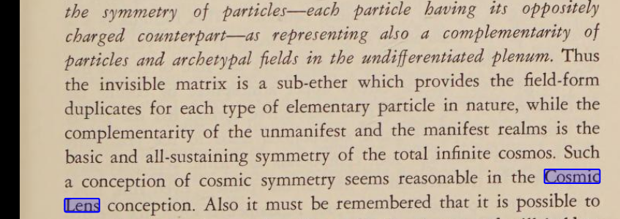
See Puharich’s collaboration with Professor Oliver L. Reiser in his book Cosmic Humanism and World Unity, all based on the “music logarithmic spiral.”
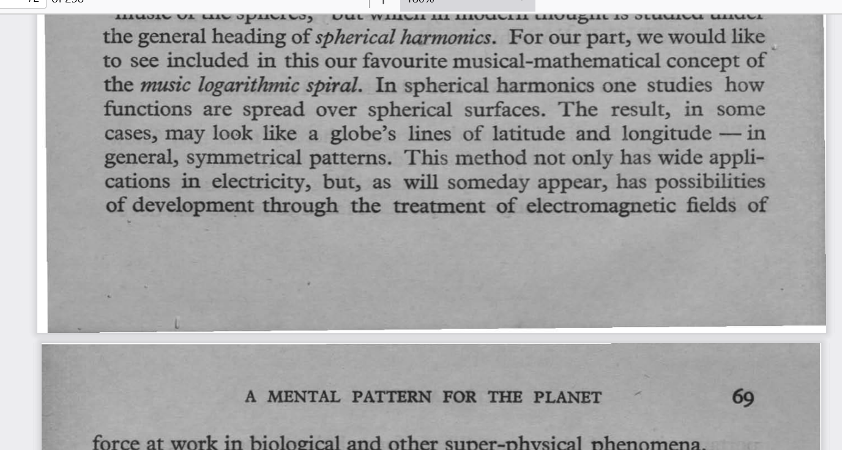
Yet Puharich was trying to move beyond this mainstream science realm by his focus on frequency and phonon pumping, inspired by Tesla. In the end, after Reier’s death, Puharich was also promoting the music logarithmic spiral, as I will detail. This “music logarithmic spiral” concept is from Ester Watson Tipple, daughter of Tom Watson, co‐inventor of the telephone: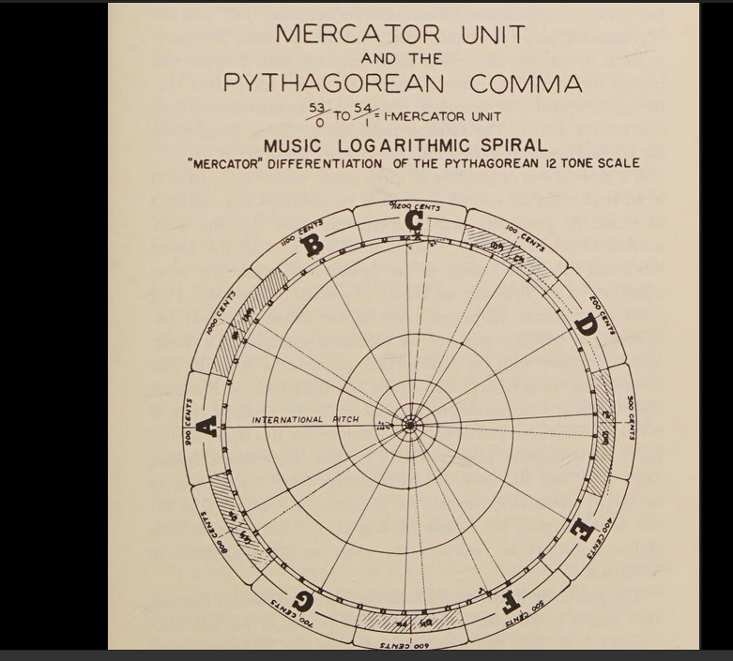
So there is this time-reversed noncommutative signal secret to the model of Puharich – that is what this book is focused on. More from Puharich to Reiser about this inherent proton asymmetry music resonance!
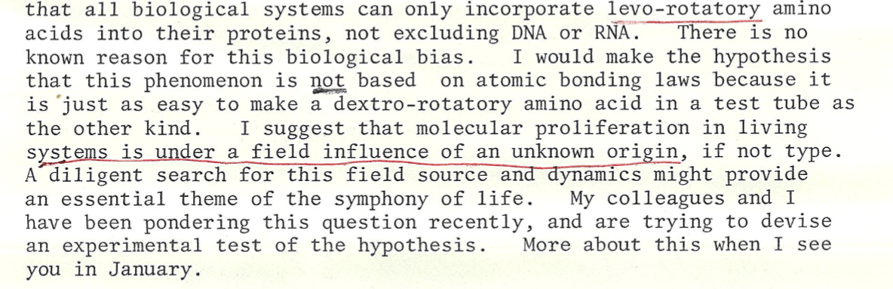
The Blackett Effect is considered the secret of gravitomagnetic antigravity force - and so yes it does get very complicated and testing for it I guess requires superconductors and then goes into black top secret military research. Puharich's claim, based on Arthur Schuster, the origin of the Blackett Effect, is that the ELF Schumann Earth magnetic wave already is a superconductor antigravity or repulsive force in terms of quantum biology due to this time reversed superluminal signal and also due to the 8 Hertz proton-proton spin coupling having a wavelength that goes out into the solar system, etc.
The superconductivity is due to this room temperature nonlocal quantum coherence from the backwards precession of the electron against the proton. As Professor JohnJoe McFadden explains, the ability to maintain quantum coherence in room temperature wet biology is all due to resonance and vibrations – the natural harmony of the Universe as it were – the superluminal Law of Phase Harmony as Nobel Physicist Louis de Broglie discovered. Puharich:
We will consider the velocity of the nerve impulse as a group wave associated with the velocity of the electron, which we will call v. The pilot wave, u, whose velocity is always greater than the velocity of light, c, we shall equate with the psi plasma and the mind. This leads to our first postulate: The velocity of psi plasma is always greater than the velocity of light….
The net result is a standing wave, a standing wave of psi plasma that now exists between the object electron, and the brain electron with an identity of content. The identity of content at both nodes of
the standing wave is precisely regulated by the psi plasma due to the original perturbation in the object. The latter was a quantum change in the value of U resulting in a small increase in the gravitational potential causing a torsion and contraction of the psi-plasma field….
We conclude that the velocity of the psi field increases with the induced decrease in nerve-conduction velocity and frequency.
Puharich explained then the water molecule splits via NMR or nuclear magnetic resonance proton spin-spin coupling but also DNA can be rearranged and new life molecules can be created – essentially this is a self-organizing harmonic force from the future. Studying Puharich’s final book that was posted online – the ELF Magnetic Model of Matter and Mind: The Origin Of Life, And The Art Of Healing. by: Andrija Puharich. Publication date: 1987 – what we learn is that the splitting of the water creates virtual photon energy that then is transferring into increased photon emissions. And the universal information is due to an inherent asymmetry in the proton of the three quarks as a magnetic monopole or magnetic asymmetric wave at the ELF frequency. Andrija Puharich, citing the textbook Nuclear Magnetism: Order and Disorder, reveals his secret:
The purpose of nature in this electron flow reversal is to electrolyze water in order to produce more oxygen to swing the local ELF frequency toward 8 Hz using both the Kervan nuclear transmutation mechanism [virtual energy] and the known effect of oxygen to lower the NMR spin-spin coupling....phase coherence in the spin....has the uncanny property of reversing the effective sign…which is equivalent to making the time flow backwards...Kervan transmutation…to cause the time flow backwards, in other words reverse the flow of electrons in time, as positron...ELF superconductivity at room temperature….the role of 8 Hz ELF magnetic fields as an organizing principle for biochemical molecules leading to life forms….nonlocal fields….superluminal signals.
So when we compare Puharich’s earlier book, Beyond Telepathy, with his final self-published book, the ELF Magnetic Model of Matter and Mind, we realize that Puharich was relying on Nobel Physicist Louis de Broglie’s pilot wave or guiding wave model of an information wave from the future that is in superluminal phase harmony with matter. This superluminal nonlocal information is a time-reversed signal that is also precognition as a paranormal antigravity or repulsive “quantum potential force.” Puharich using the term Matrix here again red line emphasis provided by Reiser) in his paper sent to Professor Reiser:
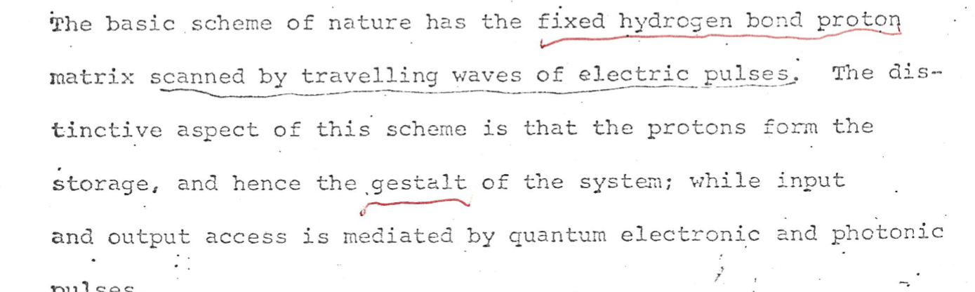
What is key to realize is that this is a newly discovered force that has antigravity propulsion and permeates all of reality - it's also called "spin force." Even though Puharich was relying on this new force back in the 1960s – to this day only a few scientists acknowledge this newly discovered quantum potential or antigravity spin force. Puharich’s book Beyond Telepathy:
Psi-plasma fields are coupled to physical fields by a gravitational force governed by the value of the universal gravitational constant.
…The relationship is such that the governing force between the magnetic moment [spin] and the angular momentum is the gravitational constant. [The Blackett Effect inspired by A. Schuster]
….However, if we examine the relationship between the magnetic moment of a proton in the nucleus of a potassium or oxygen atom present in the nerve plasma membrane, and an ionic electron whirling around it, we will see that it is possible to get a significant change in the value of the gravitational constant. This change in the value of the gravitational constant, we will find, is principally a function of the period or duration of the nerve impulse. It immediately follows that as the rhythm of the nerve impulse decreases, its time period increases. The normal value …for a nerve frequency of approximately 400 cycles per second drops to a period of 0.125 second for a frequency of 8 cycles per second. The net result of such an increase in the duration of the time period [spin precession] as a result of a drop in frequency will be a lowering of the force of the gravitational potential within the volume of the electron.
For example the below scientists do not cite Puharich even though they are using the same concept decades later!
In the context of mind-brain interaction, our above findings imply that the mind, if it is or behaves like a quantum entity as in our spin-mediated consciousness theory, may affect the brain through quantum-entanglement mediated non-local processes in defiance of the second law of thermodynamics…. Shen (2005) has shown that, as a
relativistic quantum mechanical effect, an external electric field exerts a transverse force on an electron spin 1/2 if the electron is moving…. we now consider the spin transverse force exerted on a proton spin of a hydrogen atom connected to the carbon chain of a phosphate
lipid located inside the neural membrane…
In the spin-mediated consciousness theory put forward in 2002 [8],
molecules containing unpaired electron spins, such as oxygen (O2) and nitric oxide (NO), interact with the mind pixels comprised of various nuclear spins in the brain and activate the latter as one
of the steps generating conscious experience.
Puharich claims the 7th Harmonic of .125 hertz phase difference between electron and proton is 8 hertz ELF as a "subharmonic signal." What he really means is the inverse frequency due to the time reverse precession or “negative resonance” frequency as the reverse time quantum "beat." So it's 1/.125 as he details, equaling 8 hertz. The 7th overtone harmonic as the “scale” of .125 is 1 hertz: the seventh overtone is the eighth harmonic and vice versa as the noncommutative inversion. Puharich explains in his 1971 paper, “Protocommunication” that he sent in a preprint format to Professor Oliver L. Reiser:
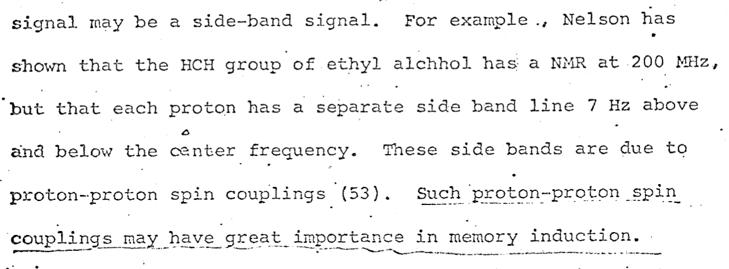
The undertone or quotient is noncommutative to the overtone harmonic and that's why it's actually the 7th overtone and not the 7th harmonic as Puharich calls it. The reason why it's noncommutative is because it is the relativistic quantum spin as the reverse time or precessional wobble of the proton against the electron "phase velocity" orbit. Puharich’s Protocommunication paper sent to Reiser:
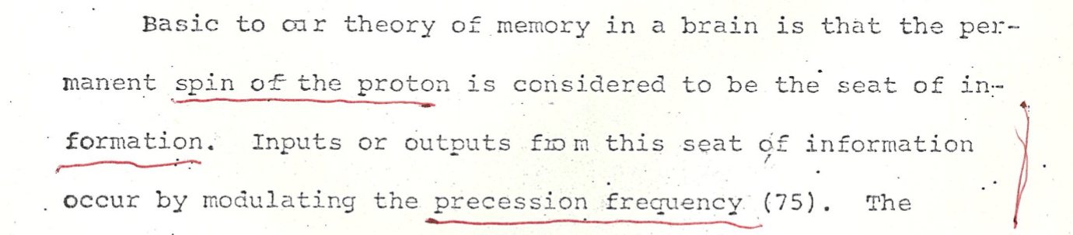
So the one as the 7th harmonic is due to the imaginary number Bloch Sphere one unit phase but this one is inherently an asymmetric time process that is nonlocal. I’ll be explaining the implications of this “negative resonance” detail as the book proceeds. Here’s Puharich’s response to Reiser – on spin as the nonlocal information of the Psi-Plasma:
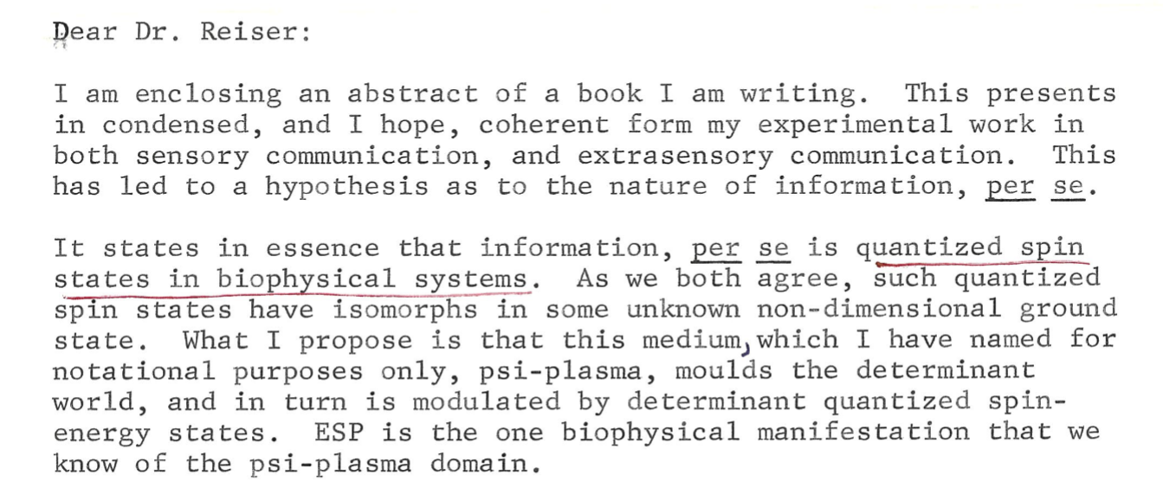
The "synchronization of spin states" is actually due to nonlocal protoconsciousness as noncommutative 1/2 spin. Roger Penrose finally realized this and made it the secret of his "palatial twistor" model and Professor Basil J. Hiley is working on a new paper about this regarding Alain Connes application to physics: “We need to remember that we are dealing with a non-commutative structure and not simply averaging over classical coordinates.” Since this concept was lost or covered up in order to create modern science based on irrational magnitude commutative geometry then as Penrose points out the attempt to decrease the entropy of matter on Earth is opposite to the increase of gravitational entropy. Penrose is referring to Erwin Schroedringer's book, 1944, What is Life? on how the actual energy of the sun is not from the thermonuclear reactions but rather the gravitational potential with mass originating from negative frequency or the 1/2 spin that is nonlocal.
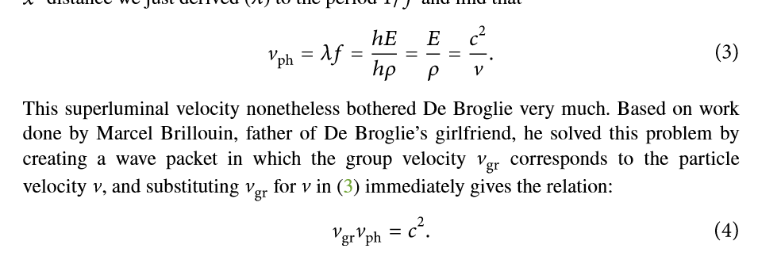
Essentially the entropy of matter being the opposite of the entropy of gravity means that gravitational potential is what most scientists call "dark energy." The gravitational potential has negentropy or negative entropy from the de Broglie-Einstein relation of Planck's Constant (average energy of light) x frequency = mass x (speed of light) squared. Hiley, based on Alain Connes, is pointing out that it’s not really an “average energy” but rather noncommutative phase as negative frequency and time-reversed signals of light.
I’ll be explaining this in detail as the second part of this book – all we need to understand is the secret of basic music theory – a secret that only Alain Connes knows (and one that I figured out when I was 16 years old!). This secret is also the secret of alchemy as antigravity as Andrija Puharich figured out – it is what Sir Roger Penrose (and collaborator with Professor Basil J. Hiley), the Nobel Physicist, calls “negative resonance.” Puharich’s Protocommunicaton paper was emphasized by Professor Reiser on this key point also:
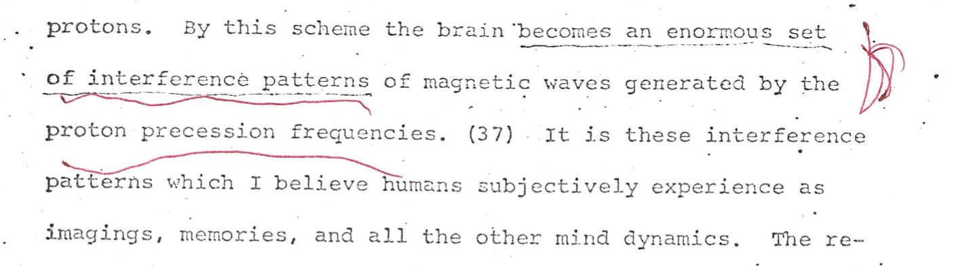
As per the de Broglie Law of Phase Harmony this means any matter is "guided" by an information-force wave from the future (the speed of light squared divided by the velocity of the particle). Robert Schuler:
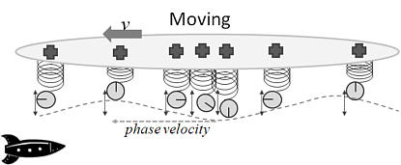
Mainstream science considers this to be of no consequence but Bell's Inequality proved that in fact linear "primitive causality" time is violated from nonlocality. In fact it is a new force discovered as the quantum potential that David Bohm first formulated with Professor Basil J. Hiley. Hiley has continued the work of Bohm. Mainstream science calls this the de Broglie-Bohm model of quantum physics without realizing that Hiley has expanded it to relativistic quantum physics while using it to explain consciousness as well.
So Olivier Costa de Beauregard, the protege of Louis de Broglie, argues that the general relativity invariance of spacetime aka CPT invarince means that on the microscopic level there has to be a time-reversed signal that does indeed have superluminal information and force. This violates the conservation of momentum and was recently demonstrated by Sir John Pendry's experiment of circularly polarized light as the "Archimedes Screw" converting negative frequency virtual photons into increased photon energy. The intensity of the lasers are now used with nanowires to then create matter - to replicate the possibility of creation of new matter in the core of planets.
When we realize that in quantum biology we have superconducting force from this noncommutative negative frequency time-reversed signal then we can also create new matter by increasing the intensity of the biophoton laser that is turned around internally. More details on this as the book proceeds. Our brains run on 25 watts of energy that originates from coherent biophoton laser energy. So by closing our eyes and visualizing light while doing synchronized deep relaxed breathing we are able to access this noncommutative nonlocal phase energy from the virtual photons. Two-Thirds of our brain’s energy is for external vision so we automatically create an 18 watt laser when we close our eyes to visualize light.
So normally we think of entropy as defined from the perspective of matter. Tim Garrett's published research on this is key:
'While the definition of work is clear for an industrial steam engine raising the gravitational potential of a steel beam, for example, the choice of what qualifies as work is quite subjective. In fact, all energy transfers a act to increase the potential of something. Work is simply the raised potential of interest. Heat is the remainder....Thus, the existence of a potential difference G between the entity and its environment entails decay of the available potential of the universe as a whole (or equivalently, an increase in its entropy) (Zemanksy and Dittman 1997)."
So this is the core conflict of our ecological crisis since this process of increasing the gravitational entropy by decreasing the entropy of matter as technology then goes against the origin of life from the inherent asymmetric time-reversed signal of negative entropy as increased gravitational potential.
Timothy J. Garrett:
To this end, an argument can be made that, if what physically distinguishes civilization from its environment is some thermodynamic potential (rate of change)G at constant temperature and pressure, civilization implicitly assigns inflation-adjusted (or real) monetary value to what (rate of change)G enables—the total rate of energy consumption a. To borrow a phrase, “money is power” because, if all current exothermic processes supporting civilization were to suddenly cease such that a equalled zero, all civilization would become worthless; it would no longer be associated with a non-equilibrium level of potential energy (rate of change)G = a/α. "
…A difference between plants and civilization is that plant waste includes CO2 that is recyclable, whereas the global economy creates most CO2 from fossil-carbon, much of which accumulates in the atmosphere….over a period between 1970 and 2005, the ratio λ (t) = a/C maintained a nearly constant value of 0.306 exajoules per trillion 1990 US dollars per year, or alternatively 9.7 mW per 1990 dollar.
So actually over 50% of the CO2 has been absorbed by the oceans with now a 240 plus zettajoule of heat stored up in the oceans to be emitted into the atmosphere.
According to Oceanographer Ph.D. Jim Massa's latest post on youtube, Earth is currently heating up at a rate of 1.9 watts per meter squared a year. Since the CO2 is a delayed cycle from the oceans - therefore the heat rate will accelerate - especially with the 500 gigatons of pressurized methane being released from the largest ocean shelf in the world - the East Siberian Arctic Shelf.
energy efficiency gains accelerate rather than slow energy consumption (Jevons 1865; Sorrell 2007), contrary to what is commonly assumed (Pacala and Socolow 2004).…Because the current state of the system, by nature, is tied to its unchangeable past, it looks unlikely that there will be any substantial near-term departure from recently observed acceleration in CO2 emission rates.
Dirac insisted on converting the nonlocal noncommutative negative frequency into "negative energy" via the probability squaring of the amplitude for a density as mass. There was just a new study or experiment posted on the Quanta magazine showing a quantum computer actually creating a wormhole in 1 dimension and thereby verifying how spacetime is created from a nonlocal holographic time-frequency spin.
So now Mother Nature is taking revenge against modern science - and due to our mass mind control from modern science people are in "deep DeNile" about the ecological crisis. The 1970s claim of the Earth cooling was due to the "global dimming" or "aerosol masking effect" from sulfur pollution - and new science shows this effect is twice as bad as previously thought. This means the recent "cleaning up" of cargo ship sulfur pollution actually heated up earth quite a bit - and so it goes.
Our continued attempts at "engineering" Mother Nature just accelerate the rate of the entropy of gravity! With the accelerating melting of the arctic ice and the subsequent release of some 500 gigatons of pressurized methane in the East Siberian Arctic Shelf (the largest ocean shelf in the world) – the Earth’s ecological crisis is way worse than people realize and could end all life on Earth – “biological annihilation” as it’s called in the academic published papers – much sooner than we realize (a five to ten year window).
Penrose is correct to state the "equivalence principle" of relativity originates from the time-frequency uncertainty in the quantum energy that itself originates from noncommutative 1/2 spin. So as Penrose points out all matter originates from frequency as photon energy and so the virtual photon energy as negative frequency is also 1/2 spin. Fred Alan Wolf figured this out as did Professor Paul S. Wesson - and it's all based on de Broglie's Law of Phase Harmony which just reiterates the truth of the principle of Pythagoras about frequency being inverse to time.
The "ether" that is nonlocal spin is not in 4d spacetime - rather it is in a formless process that is 5D and so it cannot be seen. Our Western culture relies on external observation while logical inference as internal listening is proven to be up to 10 times faster than "time-frequency uncertainty." So our original human culture is from the equatorial rainforest - and like the bonobo culture - is based on female group healing energy that is called N/om - as the cosmic mother "who will never be unveiled" (to reference an Egyptian alchemy phrase).
So that's why - in terms of teaching or "doing" - it's not really an issue - as Ramana Maharshi said - the best teacher is silence via this ether-shakti formless awareness. So when we have our eyes open then our subconscious is in control since our brain relies on vision using two-thirds of brain power - and in fact the external visual signals are ALREADY being processed internally at a superluminal 5D nonlocal level of reality. This is the claim that "all is one" but in fact it is what Ramana Maharshi called the "Undifferentiated Triad" or the "three gunas of no guna" (the Taiji is the Wuji).
So in noncommutative time-frequency science - before there is any measurement - there already is this harmonization from the future. The math is then based on the frequency of light but that includes inverse frequency as negative frequency. As Professor Basil J. Hiley argues - there is no need for a quantum wavefunction nor a "collapse" of the wavefunction and that the "Dirac belt trick" is a macroquantum demonstration of this relativistic quantum noncommutative nonlocal process.
So I learned the "Dirac Belt trick" in my first year of college from Professor Herbert J. Bernstein - it is also called the "Dirac Dance" but it is also the Taiji movement (and other related internal alchemy standing exercises).
So basically science has made life very "convenient" in the sense of "instant gratification" for creature comforts - with the eyes being the main perception gratified - but this has been at the cost of the long term complexity of life on Earth. The past 200 years of burning fossil fuels is based on this "gravitational potential" energy because photosynthesis is proven to be from quantum nonlocal tunneling - thereby causing a direct conversion of photon into electrochemical energy.
So the hundreds of millions of years of stored up quantum nonlocal energy from the Sun's gravitational potential negative entropy has been burned up in 200 years causing "biological annihilation" on Earth. No one can doubt the wonder of the technology but the overall cost of it is denied as time has sped up from the technology.
So the "biosphere" project to "terraform" Earth - creating our own oxygen in a closed system - this failed since the complexity of ecology is too complex for any supercomputer to model.
The positive feedbacks of Mother Nature are too dramatic for people to even want to consider. Conservation Biology Professor Guy McPherson has listed and documented all these positive feedback cycles. Because modern Western science is based on the exponential math as exponential growth then this assumes an "infinite" source of energy while denying the external costs - this is the error of the commutative geometry that originated from a simple lie about music theory!!
So noncommutative geometry is explained by very simple music theory yet ONLY Alain Connes explains this - because the mass mind control is so deep due to everyone being brainwashed by Platonic "commutative geometry" as the supposed "beauty" of "truth" that "math works." Math Professor Ian Stewart's book, Why Beauty is Truth: A history of symmetry is a great example and explanation of this argument. Or as Puharich stated to Reiser:
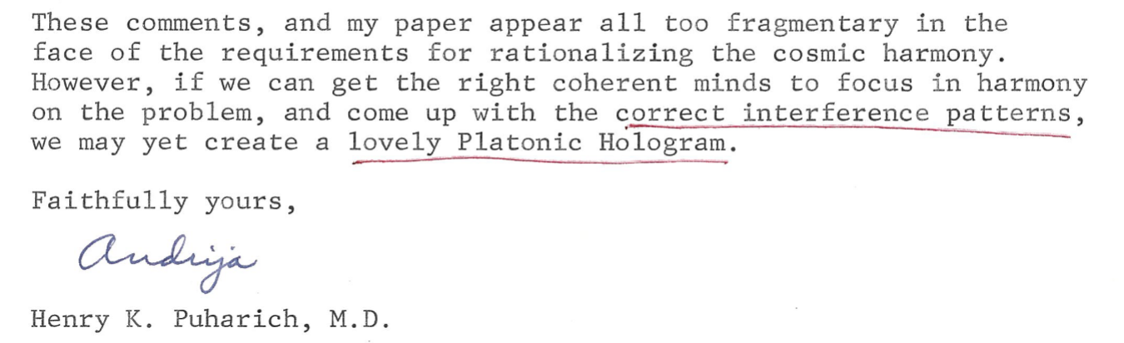
So antigravity is nonlocal and exists in the 5th dimension before linear time is created as linear 4D spacetime causality - I just discussed this with Professor Jean Bricmont who sent me an email reply yesterday (12/3/2022). The mainstream physics doesn't realize that Bell's Inequality debunked Quantum Field Theory already and even Stephen Hawking didn't understand Bell's Inequality.
My own quantum mechanics professor fortunately did understand Bell's Inequality as he did research on this - Herbert J. Bernstein - along with his proposal on testing spin using the neutron being self-entangled - in 1967. So that is the Berstein-Aharonov-Susskind Effect again proving that spin is inherently nonlocal and neither a particle nor a wave but it is protoconsciousness. Yakir Aharonov figured this out also.
Jack Sarfatti doesn't embrace noncommutativity although he acknowledges it - I asked him about this and he said his model is just nonunitary. So he was trained more in relativity physics than quantum physics - noncommutativity is different than quantum and relativity physics. So that's why Alain Connes points out that all of modern science is based on commutative geometry and thus scientists consider noncommutativity to be strange and a nuisance. The fact is that simple nonwestern music as meditation is the simplest proof of noncommutativity and also the secret of alchemical antigravity energy.
The piezoelectric collagen, the most common protein of the body, emits ultrasound but the piezoelectric collagen and bones are in turn resonated by ELF waves due to this inverse quantum beat resonance. So ultrasound, when heard internally, is also the highest pitch sound that is heard (more properly listened to) externally, and then Dr. Andrija Puharich argues this ultrasound (listened to internally) energizes the nervous system – ionizes the vagus nerve. Again this magical “negative resonance” is due to the mechanical amplitude wavelength at the angstrom level, transducing into gravitomagnetic energy as a virtual photon magnetic moment via proton spin coupling at ELF frequency.
A key point from Tesla that Puharich emphasizes is the ELF frequency is also the Schumann Resonance of Earth as a natural paranormal quantum biology energy. So for example Puharich has pondered how this nonlocal quantum spin “phonon pumping” explains the capability of salmon to return to their birth place in a tiny location upstream – after years in the vast ocean. A good introduction book on these quantum biology spin nonlocal details is the Royal Society’s “science book of the year” for 2016: Life on the Edge by Professors JohnJoe McFadden and Jim Khalili. Puharich cites the biophoton laser signal quantum biology research of Fritz Albert Popp as corroboration of his claim.
The proton is the one as the unit sphere imaginary phase octave or spectrum scale. So the 8 hertz is the reverse time undertone due to the inverse frequency of the ultrasound resonance – also called the "coupling constant." The virtual photon is from the water splitting into the proton and electron as a trapped metamaterial with the vagus nerve acetylcholine neurotransmitter, splitting into a potassium and sodium proton spin coupling as a cell signal. The difference of the frequency (divided as a logarithmic quotient) of the electron orbiting the precession or reverse time of the proton is the magnetic moment for the spin-coupling constant. (see part 3, p. 53, Puharich, ELF Magnetic Model of Matter and Mind) Puharich calls this the "phase velocity difference between the velocities of the orbits of the proton vs. the electron." (p. 67, part 3). Puharich converts these numbers into the logarithmic music spiral equal-tempered music scale! So by dividing the proton with the electron then the value of 2 to the 9th is achieved – and then the quantum beat is due to the “side-band” resonance of this music acoustic value.
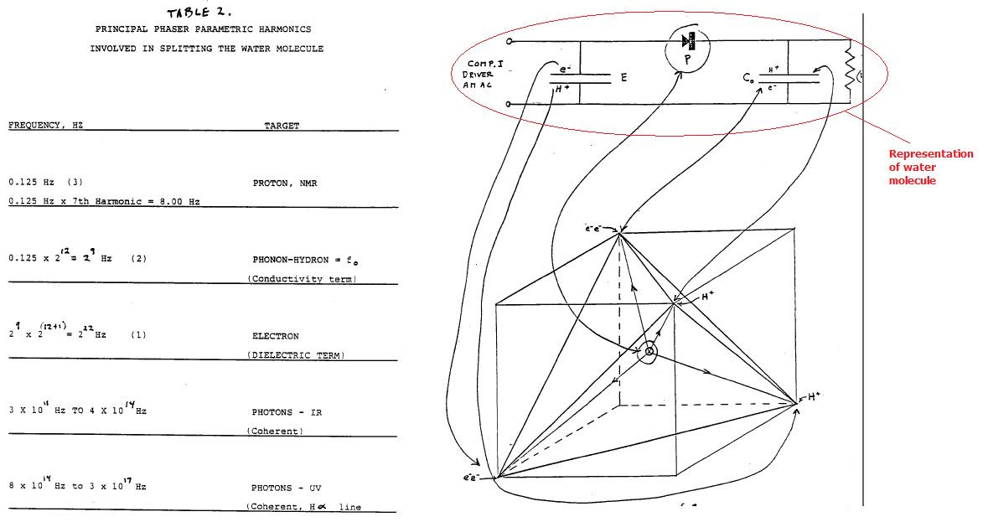
So the virtual photon has an inherent magnetic moment due to the relativistic mass (more precisely called the quantum supermomentum) as the reverse time spin coupling of the protons. Puharich:
These side-bands are due to ELF proton-proton spin couplings. Such proton-proton spin couplings may have great importance in memory induction. The effects all add up to a phonon-pumping mechanism working on the unit hydron. …. Now the difference between these two frequencies can also be considered legitimately as a 'beat' effect giving rise to a frequency….We would expect that the end product of this action (before splitting of the water molecule occurs) is to stimulate the emission of photons, or a true PHASER effect [Phonon Hydro-Amplification of Stimulated Emitted Radiation)….Basic to our theory of memory is in a brain is that the permanent spin of the proton is considered to be the seat of information. Inputs or outputs from this seat of information occur by modulating the [ELF proton] precession frequency.
Why do people not know about this newly discovered quantum nonlocal force in science? I have had the honor of corresponding with Nobel Physicist Brian Josephson about music and the paranormal and I’ve also corresponded with Physics Professor Basil J. Hiley regarding music and nonlocality due to asymmetric time-frequency resonance. Hiley has expanded his earlier collaboration with David Bohm into emphasizing noncommutative math-music as the true secret of nonlocality as a new quantum force. Both of these physics professors recognize this newly discovered force but they also realize mainstream science is not ready for this concept. “Even [Professor Tim] Maudlin accepts this as a logical possibility, ‘Reverse causation can, in principle, account for the [precognitive particle] phenomena.’”
Puharich also realized that mainstream science had lied or covered up the truth of the Ether just as Tesla was trying to tell us. Puharich had been an avid researcher of Tesla and Puharich was trying to continue Tesla’s idea of transforming Earth into a free energy spiritual state of “evolution” – this is what I exposed online in 2001 as the Actual Matrix Plan. Here I present the “behind the scenes” apparent emphasis by Professor Oliver L. Reiser, as mentioned in his published writings, of this Matrix conspiracy collaboration:
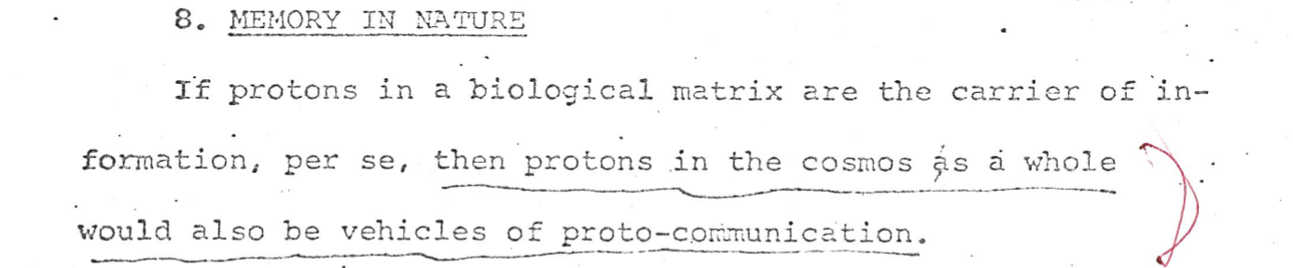
The key point here is, as Olivier Costa de Beauregard emphasized in his presentations at the same conferences as Andrija Puharich, if time signal exists on its own then it can be a time-reversed signal from the future. Even Sir Roger Penrose, Nobel physicist, advocates this precognitive time-reversed signal view of noncommutative proto-consciousness of the Universe.
It takes a deep dive into relativistic quantum biology science to realize that Puharich was not just being a weak-minded “woo woo” master of the New Age. Puharich was relying on Nobel Physicist Louis de Broglie’s Law of Phase Harmony concept just as the protégé of de Broglie, Professor Olivier Costa de Beauregard, was presenting his paranormal research in line (and at the same conferences) with Puharich. Costa de Beauregard was the master leader of this revolutionary change in worldview:
Einstein called this paradoxical “long distance correlation” “telepathy.”.…The only remaining issue is to change the
concept of causality that macroscopic experience has suggested
to us, but that lacks precision at the microscopic level. … However, the question I pose is a different one: how can eminent physicists of elementary particles, who invoke CPT-invariance in their calculations, challenge it at the level of philosophical interpretation?
Wigner thought that to the action of matter on psychicism (the acquisition of information-knowledge) must logically correspond an action of psychicism on matter (manifested as information-organization)…and there the secret is out. It is what is called “psychokinesis” in “parapsychology.”…
The CPT-symmetry causality beyond infinity, indifferent to the past-future exchange, is thus finality as well as causality, and once more it mocks distance….Such probability could not be either subjective or objective, because it is necessarily both at the same time…the “CPT-invariant” microrelativity….the “paradoxical” properties of space-time telegraph, as stated by relativistic quantum mechanics – especially by Feynmann’s scheme of zigzags – amply justify all the psychological or neuropsychological research on phenomena such as telepathy, pre-cognition and post-cognition.
I’ve had a lot of strange synchronicities in my life and in 2001 I had finished my master’s degree with my master’s thesis as a self-designed integration of music theory, radical ecology and what I called “sound-current nondualism” when I hunted down just such a synchronicity tied to Puharich. First a little background:
I had been contacted by someone with a physics degree who had a book publishing company to publish his own research on music and physics. He wanted to publish my master’s thesis (University of Minnesota, 2000) and said he would promote it at the German book fair – this was Charles Madden, author of Music and Fractals among other books.
The only problem was Charles Madden could not understand my master’s thesis and as he asked me questions I got the idea that if I study his work then maybe I could bridge our divide. In his book he explained that the Taiji symbol of yin and yang is not a fractal since the taiji yin-yang symbol is not a self-similar symmetry in geometry. Suddenly I had realized the error in my master’s thesis since I had quoted a scientist who claimed the Taiji could be modeled by a symmetric logistic equation. Note please that Puharich makes this same symmetric logistic equation error as the “music logarithmic spiral” foundation of the Matrix Conspiracy.
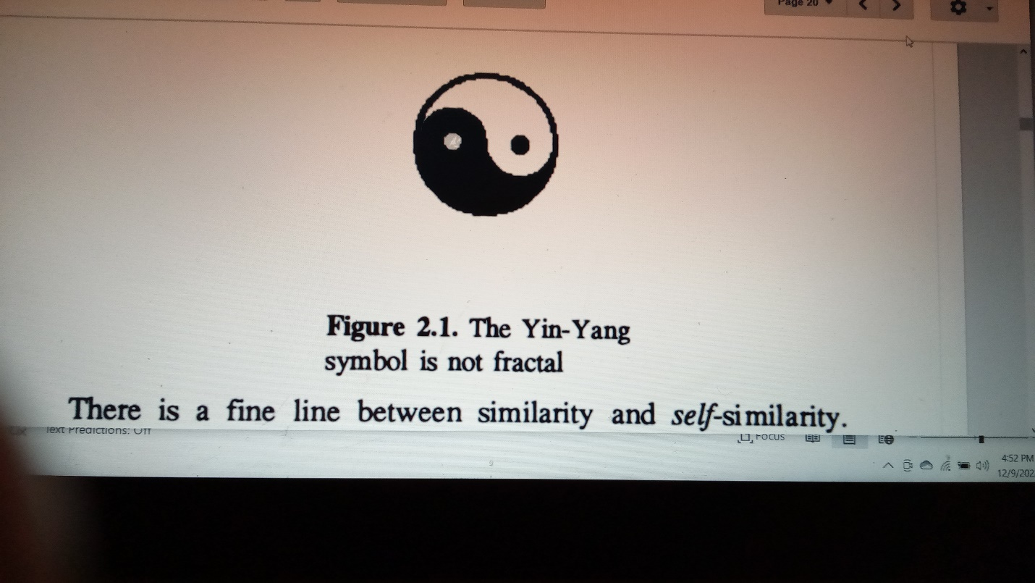
My 1996, “The Fundamental Force,” monograph had gotten me into graduate school and my master’s thesis in 2000 on “sound-current nondualism” was based on my 1996 monograph. And then in 2001 I discovered a newly published book in the University library, Triangle of Thoughts, by Fields Medal Math Professor Alain Connes, et. al. The Fields Medal is harder to get than the Nobel Prize – it is only awarded to mathematicians and you have to be 40 or younger to receive it – and it’s only given out ever four years. Yet there was Alain Connes describing the same concept in music theory that I had been relying on and calling “complementary opposites”! I was not sure though if Connes was being metaphorical since music is often used as a metaphor in science, as the M.I.T. historian of science Arnold Pacey emphasized.
This central focus of music in science though was brought home when I was digging through the basement of a used bookstore near the University of Minnesota in Dinkytown, Minneapolis. Suddenly I discovered this book called Cosmic Humanism and World Unity by Professor Olivier L. Reiser. In that book was a concept based on the “music logarithmic spiral” that claimed to integrate all of science through nondualism. Suddenly my master’s thesis was corroborated (up till that point I had been acting on my own and my academic advisers could not really figure it out). Reiser stated somewhat cryptically that he was relying on his collaboration with Andrija Puharich. I will be focusing on their 100 pages of correspondence as the heart of this book.
The Nonlocal Secret of Andrija Puharich:
proton magnetic asymmetry
Again it is the phase velocity difference between the electron and the proton that is this ELF or 7.82 Hertz frequency resonance that Puharich emphasized as his Psi-Plasma secret. This is the “magnetic wave” that Puharich claimed could not be explained by classical electromagnetic Maxwell theory – and the secret reason why, that Puharich did not explain to his “laymen” audience – is that the ELF magnetic wave is due to a reverse time or time-reversed signal as a “backward precession” or quantum undertone from the future! the phase velocity difference between the electron and proton originates due to ½ spin that is inherently nonlocal and asymmetric (the future overlapping with the past) and thus is the origin of the magnetic monopole or asymmetric magnetic field that Puharich refers to.
I’m trying to keep this book in a non-academic format but please realize that when I use the internet I rely on using “sci-hub” allowing free access to the academic databases – and I also rely on researchgate and arxiv (the academic preprint sources) – and also googlescholar (that links all the papers that cite the paper I’m reading). This is not to say that I’m limited to the Ivory Tower – on the contrary no one at the University could understand my master’s thesis and I did most of my graduate school work as a policy activist. I was arrested eight times and had become a well-known radical activist in the Twin Cities – considered part of the progressive “left” but in fact I was motivated by this deeper meaning of music.
I had studied music on classical piano from age three by attending my mom’s lessons and my own training started at age five. It turns out that only training in music from a young age on an instrument causes a significant increase in the corpus callosum integrating the right and left sides of the brain. This is the key emphasis also argued by Puharich and born out in the mind control studies cited in the CIA vault – that a strong alpha brain wave is created that synchronizes the right and left brain. In fact I was part of a paid medical study while I was an undergraduate at University of Wisconsin-Madison and the nurse testing me with an EEG exclaimed out in shock: “Your alpha waves are very strong!”
So back to Puharich – I will now quote him a bit. I had to print out his final monograph since the pdf file online has the pages all scrambled! Perhaps this explains people’s confusion about his claims. Haha.
the protonic "GO" command to divide......This has now been identified as the magnetic fields emanating from the magnetic monopoles residing in quarks within the proton as omegons (also called preons). …The current density pulse besides metering out "quanta" of chemical transmitter material has another function which is to act on pernineural water shells with a hydrolysis-like action. This effect on water protons becomes, in my theory, the basis for memory....I find that a magnetic basis for matter, as proposed by Schwinger, is required in order to explain l[left-handed]-amino acid molecular asymmetry of life processes operating through proton magnetic asymmetry. …life asymmetry reflects the weak violation of parity that exists in the cosmos. ..I believe that if the proton-proton spin coupling exists in DBP [direct brain perception] it should be possible to shield a sender from a receiver in a telepathy experiment…. The distinctive aspect of this scheme is that protons form the storage, and hence the gestalt of the system; while input and output access is mediated by quantum electronic and photonic pulses.
So there you go – these quotes from Puharich summarize the key core concept behind his Psi-Plasma model of reality.
I’ve recalled my first meeting with Uri now — he didn’t do metal bending but I think did an ESP demo, involving pictures that someone else had drawn. Possibly it was at SRI but it was not the kind of PK expt. that you referred to. Perhaps this is where Puharich derived his incorrect version of the facts.
Email response to me from Nobel Physicist Brian Josephson (as I write this text right now, 6 a.m. Central time, in Minnesota, 11/28,2022). So I replied to Brian (he seems to prefer me responding to him now on familiar terms) – this misunderstanding was not by Puharich necessarily but people writing about Puharich, claiming Brian Josephson had witnessed Uri Geller causing the ARPA computers on the floor above them to go haywire.
However, this latter mechanism [Direct Brain Perception] is intimately linked to the concept of a cosmic protonic plasma brain built into all of nature, connected through ELF fields.
And of course this is the problem with Puharich’s research as people have emphasized – Puharich was more of a model creator then he was doing any kind of well-controlled tests on paranormal phenomena. And similarly to finish my own master’s degree I also wanted to test out my own music mind model of reality – that also relies on this inherent asymmetric as a nonlocal information force. My housemate friend had told me she had practiced qigong meditation from Chunyi Lin and then Chunyi Lin, the qigong master, gave a presentation to my “Spiritual Healing” class I took as part of my Liberal Studies graduate degree program at the University of Minnesota through the Center for Spiritual Healing there.
So I first was exposed to paranormal spiritual power in 1995 – I was initiated by qigong master Effie P. Chow – after I saw her flyer on a street telephone pole in St. Paul. I was so skeptical that I called up the number to ask for half off on the admission price. So my girlfriend who was living with me – she attended with me, both of us paying $10 for an evening Qi-Talk at St. Mary’s University in Minneapolis. Effie P. Chow was a small lady but she said she was filling the room with qi energy and she asked someone to walk towards her (from the center between the two sections of chairs in the class room). Sure enough the women could feel the qi energy as she walked towards Effie P. Chow. I watched on with skepticism but then Effie P. Chow had us make “qi balls” by putting our palms facing each other – about a six inch distance. As we pushed our hands in towards each other sure enough I felt a very strong magnetic force as a repulsive force between my two palms!!
I was shocked to feel this strong magnetic force but the real kicker was as we began to end the class. Most of the people were gone already and this young female security guard wandered in (clearly a student worker?) She asked nonchalantly, “I’m just wondering what’s going on in here because the fuse got blown in the room behind you.” Now this could not have been staged because Effie P. Chow not only didn’t answer (that I can recall) but seemed to try to diffuse the situation. Haha. My reaction to this response was an even greater shock! And we basically high-tailed it out of there after that.
I was hooked though and I had to learn more. Strangely soon after this I had an experience that years later I never connected to my initiation to qigong but now I know it was connected. I had been doing intense activism at an undergraduate – and that’s why I had transferred from Hampshire College where I took quantum mechanics from a Bohmian physicist professor named Herbert J. Bernstein, who went on to design the quantum teleportation satellite system now being tested by NASA – and I had wanted a “radical populist” education (at UW-Madison). In the meantime I had lived in the wilderness in Alaska for six months – off grid just south of the steepest mountain in the World for four of those months – drinking unfiltered water straight from a local bog!
I mention all this background because it prepared me for Andrija Puharich who in his Minneapolis seminar series noted how due to the karma on Earth today it is near impossible to find water that can be drank straight from the Earth unfiltered since there is so much pollution. Puharich wanted to think that modern science could use frequency as a kind of quantum biology medicine to heal people and Earth externally. He had a vision of quantum frequency devices that would be attached to the body and to Earth – to then resonate and heal the planet. This is what he referred to as the Matrix Plan as I had discovered in his collaboration with Professor Olivier L. Reiser, as part of a theosophist-U.N. elite science program tied to the Institute of Advanced Study at Princeton also.
My own quantum physics professor Herbert J. Bernstein had also been tied to the Institute of Advanced Study at Princeton and he also had his research classified top secret (without his knowledge!) and then he was contacted by the NSA for his quantum teleportation research. My own quantum physics professor had laughed at me when he explained nonlocality by his demonstration of the Dirac Dance – the open-jaw aghast look on my face caused my teacher to call me out by name just as he was explaining nonlocality! He was shocked at my shocked reaction!
The reason I had been shocked was, as I record at that time in a letter I sent home, I knew somehow that my own music secret model of reality as a harmonizing force of the Universe was the same nonlocality quantum secret explained by the Dirac Dance (also called the Dirac Belt Trick). And in fact quantum physics Professor Basil J. Hiley who collaborated with David Bohm – the same Bohmian physics my professor took part in with his “Bohmian dialogues” – does rely on the Dirac Belt to explain how this quantum nonlocal force can self-amplify into the macroquantum scale, just as Andrija Puharich also believed.
Going Deep into Spooky-Looky Land
One of my instructors at the University, Michael Andregg, had disagreed with me when I made the statement that the military had tested biological weapons in Minneapolis in the 1950s – “no they didn’t!!” he blurted out. He claimed to be an expert on biological weapons so I wasn’t going to argue with him but on the other hand he did emphasize this topic entered us into what he called “spooky-looky land” in science.
Over 50% of physics funding is by the military in the U.S. and ever since Galileo science has been funded by aristocratic elites – Galileo got funding since he claimed he could cut down on labor costs, as Arnold Pacey pointed out. Former M.I.T. History Professor David F. Noble’s book America By Design had to have ruffled feathers as he exposed the elite foundation control of science. In fact his lawsuit against his tenure denial was backed by the American Historical Association – a lawsuit that Nobel said proved he was fired for political reasons. David F. Noble even refused to use email since he realized the automation of society was really about cutting down on labor costs.
And so the true message of this book is that the Matrix Conspiracy is not about a smoke-filled room of cigar chewing maniacal mass murderers but rather it’s structural to the mathematics itself – the “music logarithmic spiral” as the heart of the Actual Matrix Plan is based on what math professor Luigi Borzacchini (now retired) calls the “deep pre-established disharmony” as the “guiding evoltive principle” of Western science.
My 2001 Actual Matrix Plan online expose (with updates):
The below summary of crucial information is thus far almost completely unknown to the public at large.
- I discovered that my concept of sound-current non-dualism (see my Masters Thesis, "Epicenters of Justice") was already developed by the Philosophy of Science Professor Oliver L. Reiser.
Professor Reiser's Ph.D. was on non-dualism and he then published a early concept of the superstring theory and its applications to social society called "World Philosophy." (1945) Einstein praised this work as the best example of a unified field theory. In 1965 Reiser published his manifesto called "Cosmic Humanism" inspired by Einstein's work.
Harmonic resonance is the foundation of this work through the application of the "Music Logarithmic Spiral."
- Reiser's book "Cosmic Humanism" was held in the highest esteem by a think tank called the "Institute for Integrative Education."
This think tank was set up by a Forest Products magnate (Stulman-Emrick Lumber Co.), Julius Stulman and its office was then located at the UN Plaza.
Stulman: “part of a proposal called the World Institute, which I wrote in 1941.”
Stulman’s father must have started his Lumber business: “Fifteen Jewish charitable organizations received a total Of $18,000 in legacies under the will of Joseph Stulman, one of the owners of the Stulman-Emrick Lumber Company,”
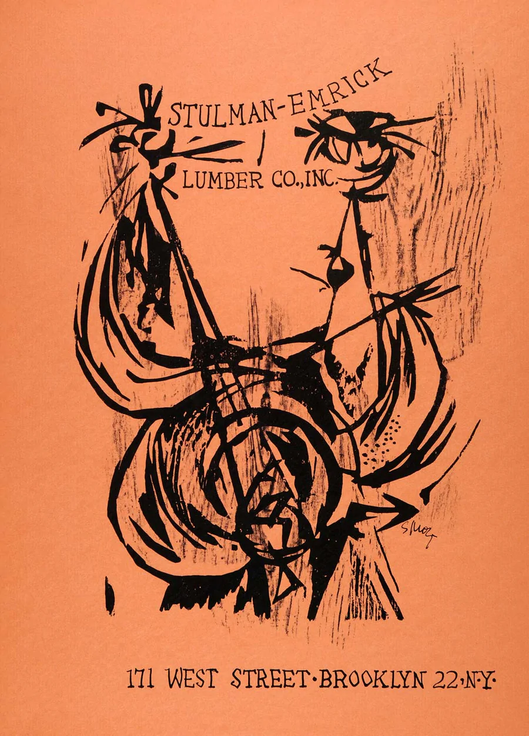

Stulman first began the World Institute in India in 1951 (his report to US Congress committee, 1951):
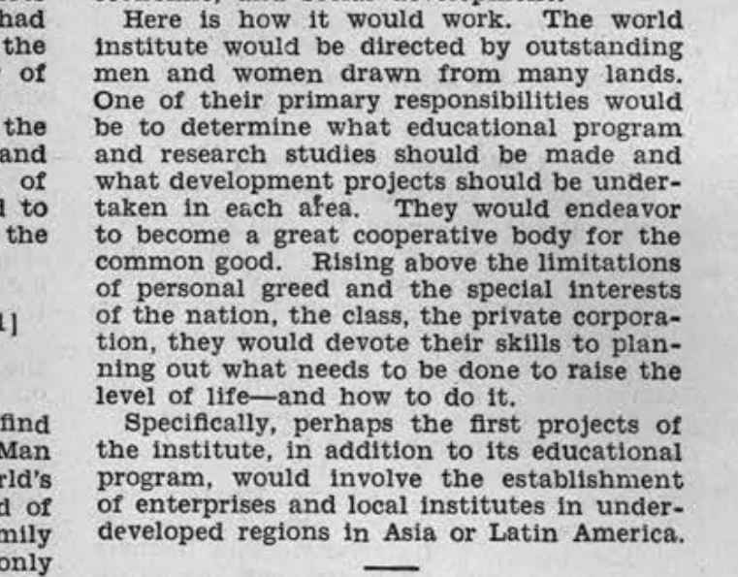
It's Board of Directors included the family that directed the non-dualist Theosophist Society and it also included scientists from Harvard and Yale.
Julius Stulman, American lumber executive. Fellow World Academy Art and Science; member Poetry Society of America, World Medical Association (life), American Cycle Association Clubs: Masons.
The goal of this Institute, as spelled out in their flagship theosophist academic journal, "Main Currents in Modern Thought" (1940-1975) was to review all prominent academic journals and integrate all knowledge to the goals of non-dualist theosophy.
With this in mind the journal had a very advanced interest in eastern philosophy, paranormal research, eugenics, higher dimensional physics and social engineering.
- In 1936, Dr. Reiser, introduced and promoted the concept of "radio-eugenics" in the scientific Journal of Heredity. This entails applications of radiation for evolution.
In 1945 Dr. Reiser was impressed by think tank founder Julius Stulman's article called "Applied Energy to Human Relations." In the 1965 publication of "Cosmic Humanism" that is highly praised by Stulman's Institute for Integrative Education, the concept of radio-eugenics is promoted in synthesis with the concept of non-dual harmonic resonance.
Dr. Reiser states that we learned from Hiroshima and Nagasaki that not only does radiation cause massive destruction but that even those who survive "the baptism by fire" have children with severe birth defects. He then states that unfortunately that is how evolution works and that hopefully with the proper applied harmonic resonance of radiation then a new human society and a new "World Sensorium" will be achieved. P. 358 of Cosmic Humanism, the book so highly regarded by Puharich:
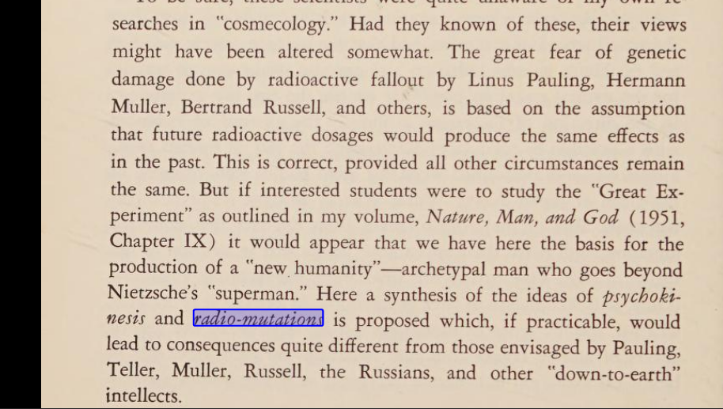
The "World Sensorium" of Dr. Reiser is based on utilizing the radiation of the ionosphere, amplifying it with high technology, and applying it globally to cause mutations. The effect is to achieve not only a higher dimensional reality but to harness the zero-point energy.
- In 1965 Julius Stulman founder of the Institute for Integrative Education, with the recommendation of the UN Technical Administrator, sets up the World Institute, in collaboration with the Institute for Advanced Studies at Princeton.
The World Institute is to oversee the direction of technology for the globe and it advises with presidents worldwide. Meanwhile Dr. Reiser's work is published in the Sri Aurobindo Ashram newsletter and Sri Aurobindo's students propose that the future body of humanity will be radioactive (Letters on Yoga III).
The Music Logarithmic Spiral is published in the journal "Darshana International."
- In 1975 Dr. Reiser publishes "Cosmic Humanism and World Unity" (Gordon and Beech) as part of a series for the World Institute.
This book calls the plan for the World Sensorium, "The matrix" several times and states that, in concept, it is closest to H.G. Well's 1936 proposal for a "World Brain" to the Freemasonic Royal Institute of International Affairs the source for the Council of Foreign Relations.
H.G. Wells was not just a science fiction writer, he was the head of British secret intelligence during World War One and he was the mouthpiece for the global elite policy makers.
The World Brain was inspired by the NeoPlatonic concept of the matrix outlined by Professor John Ruskin, a favorite source of inspiration for the Royal Institute of International Affairs.
- Dr. Reiser states that his main collaborator in creating "the matrix" is Dr. Andrija Puharich.
Dr. Puharich has been recently exposed as a top CIA funded mind control scientist focusing on higher dimensions and a high level Theosophist by Dr. Jacque Vallee (1974) and by Clive Prince and Lynn Picknett (1998).
Both Puharich and Reiser called for the creation for a new techno-spirituality global religion. Dr. Puharich called the plan for the Matrix, "Psi-Plasma."
He described the NeoPlatonic Harmony of the Spheres that, as elaborated by Reiser, includes,
  - artificial intelligence
  - zero-point energy
  - techno-samadhi
  - biological holograms
  - plasma and lasers
  - galactic manipulation of higher dimensions
Dr. Reiser explicitly describes the evolution of the matrix by stating that the Earth is an egg and in the egg is an embryo.
The embryo feeds off the humans, animals and plants, as the ectoderm and entoderm of the egg, in order to create the new World Mother or the matrix, the Sub-Stance or Psi-Plasma of non-dualism.
Again unfortunately, according to this plan, most of humanity and the environment are seen as necessary costs to developing the next level of evolution.
Humans are to be the "electronic tubes" or "neuroblasts" for "the matrix." (1975, "Cosmic Humanism and World Unity")
- Dr. Puharich was the main promoter of an elite non-dualist secret society based on the Council of Nine - a higher dimensional ennead that are considered to be aspects of the Nondual God and to be sources of higher intelligence.
This Council of Nine is traced back to ancient India and ancient Egypt (see Prince and Picknett's "The Stargate Conspiracy" and Jacque Bergier's "Morning of the Magicians"). Central to the Council of Nine's secret knowledge is the connection between music theory, geometry, algebra and higher dimensional reality.
As documented in "The Stargate Conspiracy," many prominent policy makers and society elite have been part of the promotion of the secret Council of Nine, including,
  - Gene Rodenberry
  - Al Gore
- Senator Clairborne Pell
Through the Theosophist academic think tanks, several Professors have published research into the secret origins of this harmonic resonance higher dimensional knowledge, most prominently Eric Temple Bell, Johns Hopkins Chemist C. H. Andrews book "The Symphony of Life," and musicology Professor Ernest McClain.
There are many others, including a Harvard geologist, a Yale physicist, and a Berkeley mathematics Professor, Dr. Abraham Seidenberg. Seidenberg has been given prominent attention in recent Advaita Vedanta research because he documents the origins of the Pythagorean Theorem as far back as 3,000 B.C. in Vedic India.
In several essays in prominent academic journals, Seidenberg states that the concept of incommensurability or paradox of the infinite, was established worldwide through human sacrifice altar rituals that maintained creation through the cosmic separation of heaven and earth. (Note versus the union of heaven and earth by humanity - the explicit goal of Taoist harmonics and OM non-dualism).
- The prominence of music theory in the issue of incommensurability and paradoxes of the infinite has been confirmed to me by recent correspondence with Mathematics Professor Luigi Borzacchini (University of Bari, Italy).
Still unpublished, his paper, "Incommensurability, Music and Continuum: A cognitive approach" [as of 2001, it got published in 2007] documents that a radical transformation occurred in science and philosophy with Plato and his colleague, the military general and mechanical engineer Archytas.
Plato and Archytas were worshippers of Dionysus, the horned god of the underworld and chaos.
The equivalent of Dionysus in Egypt is Set, a parallel to the forces of disruption or Satan in Judaism. The essential aspect of Plato's philosophy was the limitation of the Infinite Cosmic Mother into the finite geometrical Grand Architect or Great Geometrician of the Universe.
This involved a conscious corruption of Pythagorean shamanic-yoga based on complimentary opposites of infinite natural harmonics (Pythagoras' 1:2:3:4 is equivalent to OM and yin/yang).
The link between Freemasonry and Theosophy is well-documented in "The Stargate Conspiracy."
Many new age gurus have been linked to the CIA and to these theosophist think tanks, included,
  - Drunvalo Melchizadek
  - James Hurtak
  - Jose Arguelles, who is the main promoter of Dr. Reiser's views
- The method of the matrix is,
  - containment of the threatening natural resonance of the Cosmic Mother
  - then destruction
  - then standardization through dead artificial intelligence
The first example of this religion of technology is the creation of the square root of two.
As the University of Nebraska Philosophy Professors, P. Hugly and C. Sayward point out in their essay "Did the Greeks Discover the Irrational" (1999), there is no actual proof for the square root of two!
It is an illusion and a deceptive charm of "the power set axiom."
The first proof that approximated the square root of two was the "squaring of the circle." The Vedic priests, as far back as 3,000 B.C., demanded that altars be patriarchal squares, and that matriarchal female circles were heretical.
If circle altars were built they had to be the same area as the squares. (Dr. Seidenberg, "The Ritual Origins of Geometry").
The squaring of the circle is a central theorem to the Freemasons. The second proof that necessitated the containment of the Cosmic Mother was the doubling of the cubical altar.
The gods stated, as far back as 3,000 B.C., that a plague could only be stopped unless this was mathematically achieved.
- Archytas, the military general collaborator with Plato, faced the same Demonic Altar Plague problem as occurred in 3,000 B.C. Many scholars have written about the connections between ancient India and Greece, explicitly regarding Archytas.
By combining the Pythagorean harmonic proportions with the geometry of India, Archytas was able to give a proof for the square root of two, that also enabled standardization or equal-temperament of the octave music scale. In other words this proof extended the Yin/Yang, OM, Pythagorean harmonics into greater dissonance by containing the infinite to a three dimensional object of geometry.
The result enabled analytic geometry and inverse proportions, central to western science, to be achieved. Unfortunately the technology is inherently against the natural harmonics of reality. This is why equal-tempered tuning, although conceived in ancient China, was not allowed for the society as a whole.
Also in ancient China it was remarked that those who know the 3:4:5 triangle, based on the Golden Section and the Major Third music interval, could rule the world. Any supposed "sacred geometry" that is based on the square root of two is really just a promotion of destructive techno-spirituality.
- In my research I was able to reconstruct the secret proof of Archytas, that enabled the creation of western science from music theory. Professor Bozacchini also has discovered this connection.
The retired Boston University geophysicst Gerald Hawkins discovered this secret theorem as well in his research of crop circles. Also John Worrell Keely apparently developed higher dimensional harmonic resonance technology based on the 3:4:5 triangle.
Keely's harmonic resonance findings that demonstrated levitation, disintegration, energy generation, etc., funded by the richest man in the U.S. at that time, Jacob Astor, were concealed apparently by the Freemasonic Skull and Bones society according to a recent book by Theo Paijmans.
George Bush, Sr. former CIA director, is a member of the Skull and Bones Society. The 3:4:5 triangle is the basis of the logarithmic music spiral that will be used to create the matrix, according to the Theosophists and the CIA.
- Continually throughout the research of the Theosophist analysts, it is clear that their goals can only be achieved by non-dual mind-body yoga.
Instead they are pursuing this goal through destructive technology and as both Sri Aurobindo and Swami Yukteswar both pointed out, non-dualism can never be achieved through technology.
Therefore the plan for the matrix, although it may destroy the planet, will never be successful. Always-already the Cosmic Mother will be waiting to embrace those who practice shamanic-yoga non-duality.
The conscious suppression of shamanic-yoga non-dualism by Western Civilization, is documented by Oxford scholar Dr. Peter Kingsley in his recent book, "In the Dark Places of Wisdom."
- Recent plans by the current U.S. administration include microchipping the whole population, called "the Bioweapons Defense Shield" by the HHW Center for Civilian Biodefense Studies.
FEMA is designing new emergency detention centers to be located outside all major cities - possible to be used for "techno-samadhi" matrix states. NASA has advanced brain scanners to be introduced. Laser and plasma weapons will be featured in the next destruction of Iraq.
Project HAARP plans to test, at full power, a vast electro-magnetic ionosophere spectrum through antennae in Alaska, Greenland and Norway. The Russian duma has warned that it could potentially destroy current near-Earth technologies.
My source on the World Institute that promotes radio-eugenics is the book: "Evolving Mankind's Future" by Julius Stulman published in the mid-60s.
In 1975 the World Institute published a book by University of Pittsburgh philosophy of science professor Dr. Oliver Reiser called "Cosmic Humanism and World Unity." That book is a follow up to an earlier "Master Synthesis" as Dr. Reiser describes it: The book "Cosmic Humanism" published in the mid 1960s.
The book published by the World Institute in 1975 still quite openly promoted radio-eugenics. What you may not realize though is that this plan is not just for
radio-eugenics - it is for the creation of a multidimensional "World Brain" - evolution of life based on the unified field theory - exactly as described in The Matrix.
This is what Dr. Reiser means by "mutations of illumination."
"Cosmic Humanism" published in the mid-1960s promotes and justifies the following on radio-eugenics:
- using atomic energy (radiations) to initiate the genic (or chromosome) changes which cause mutations
- doing this under the guidance of a psychosocial field to control the course of the biological changes so that the form of emergence is determined
(pp. 528-9)
"The study of the biological effects of the atomic explosions in Japan indicate that the radioactivity thus produced can cause sterilization and death in those exposed, and possible malformations in subsequent generations of those born of the generation that lived through the baptism of fire to reproduce themselves.
"But we also know, on the other hand, that nature has always in the past exacted a high price for biological 'progress' - which means that for every mutation that is beneficial many more mutations are harmful, and it is possible that the same ratio would be maintained on the human level.
But we underline the possible. Perhaps the beneficial use of atomic energy (outside its uses in medicine) is a matter of selecting the right types and dosages (frequency and duration) of irradiation, plus the controlling influence of a mental guiding field.
This latter would be a kind of psychokinetic effect on the level of biological causation."
(Cosmic Humanism, p. 533)
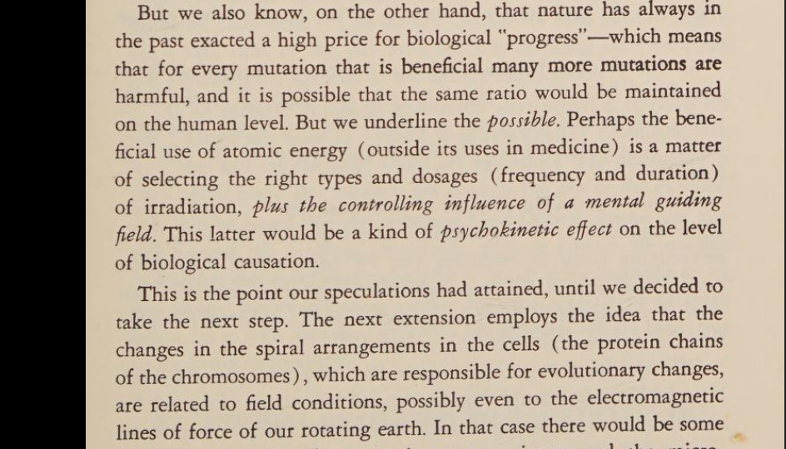
I would like to dismiss this as a crackpot plan except for the following reasons.
- The World Institute was created with the support and guidance of the ruling elite (by Domhoff's, Chomsky's or Mill's standards).
- Dr. Reiser, quite simply, is a very brilliant, in fact the most brilliant theorist I've ever read. He was very prolific and his earlier book "World Philosophy" was supported by Einstein as the closest model to the Unified Field Theory.
Reiser was, from what I can tell, not only the first scientist to discover what is now called the superstring theory, but he traced the validity of that theory all the way back to ancient Sumeria.
He is very openly a Free Mason and he relies on the work of other Free Masons.
- I discovered Dr. Reiser's work after I had finished my masters thesis (published on the internet as "Epicenters of Justice.") My research is based on the premise of resonance science as taught by Pythagoras.
Pythagoras taught the unified field theory as an infinite spiral of harmonic energy-information, modeled by basic music theory. Plato, in Timaeus, wrote down this theory but repressed the infinite spiral into a closed materialist system called the "circle of fifths" in music.
This model was Plato's World Soul and it enabled the averaged quantification of infinity - mathematical examples of this inaccurate average are the "irrational number," then the "derivative," the "logarhythim," "spherical harmonics," and "systems theory." Reiser goes into more detail in his published theosophist article, “MUSIC, MATHEMATICS, AND COSMOLOGY”, in Main Currents in Modern Thought, Fall 1947, Vol. 5 issue 4
It is perfectly feasible, using contemporary data, to extend our conception of the universe to include the Supreme Architect of Plato and Jeans as the geometer
who functions through the properties of a real Space-Time Matrix or Cosmic Energy Continuum to create — give emergent being to — the forms of matter, life, and mind. As we have indicated in our previous book, The World Sensorium, the mathematics necessary to this new synthesis is spherical harmonics, which unites the laws of musical harmony with those of electricity and the flow of heat. For this direction in my thinking I am indebted to documentation gathered by Mr. F. L. Kunz. Reference to this material here, however, is my own terminology, and necessarily glancing.
we predict that this method will continue not only to have its present wide applications in electricity, and the rest, but also have applications in the handling of electromagnetic forces at work in biological and psychological domains.
Dr. Reiser calls it "Taming the Infinite" and his Ph.D. was called "Creative Monism" as he also calls "non-dualism in Action." My Masters thesis was called "Sound-Current non-dualism." In other words the basis of the Free Masons is a path back to non-dualism (the unified field theory) through technology.
The difference is that Pythagoras was a yoga master, trained in Egypt for 22 years. Pure consciousness is the only way to achieve the pure resonance required to achieve non-dualism. This truth is eternal - traced back to the Vedas, the Kabbala, and supposedly to Atlantis, and Lemuria, etc.
Pythagoras' teachings were oral transmission of harmonic energy-information.
The recent Oxford Ph.D. by Peter Kingsley, "Ancient Philosophy, Mystery, and Magic: Empedocles and Pythagorean Tradition" (Oxford: Oxford University Press, 1995) proves the Plato and Aristotle consciously denigrated the non-dualism of Pythagoras. Our language (the subject-object structure of phonetic language) is dualistic.
This quite simply is the drive of the Free Masons - a destructive pursuit of non-dualism through unbalanced dualism. The theory of non-dualism is that everything returns to its source.
- Dr. Reiser's proposals not only predict but fully explain the motivations and developments of today's destructive technology. Even the internet - he called "Project Promethesus and Krishna."
He called for a Planetary Democracy or Federation so that individuals, through the internet, would respond to problems no matter where they happened throughout the world.
The whole process would be monitored and controlled from above.
- Project HAARP mirrors exactly the ionospheric guidance field promoted by Dr. Reiser. All the conscious policies of genocide are motivated by "good intentions" of the elite (i.e. the thousand points of light of George Bush).
This theory explains the good intentions behind the grotesque experiments in genetic engineering, the cancer epidemic from synthetic and electro-magnetic pollution, etc. David Noble shows the direct connection between today's technological projects and the Freemasons.
George Bush Sr., by the way, received eight personal energy-work or qigong treatments by China's "National Treasure" of qigong, the very powerful yoga master Dr. Yan Xin.
George Bush declared Dr. Yan Xin to be today's world's greatest spiritual leader. In a western scientist published study (the journal "Material Innovations" Dr. Yan Xin has slowed down the decay rates of nuclear particles - technically impossible, unless the superstring theory is true.
As I stated before, the University of Minnesota was the world's leading institute in eugenics previous to the Nazis. But, as well documented in Bertram Gross's book "Friendly Fascism" (South End Press) and in other works, the U.S. corporate-state elite were poised to side with either the Nazis or the U.S. government.
In other words the corporate-state elite funded the Nazis and enabled their policies. On this basis multidimensional radio-eugenics is the next logical step of development.
- Is it not true that "Fluoridation of the water supply" was considered a "communist conspiracy?"
Yet it's been now well documented that the corporate-state elite deliberately promoted and enacted fluoridation of the nation's water supply in order to cover-up the continued fluoride poisoning from the aluminum and nuclear industry.
It is in his article "Cosmecology: A Theory of Evolution" published in the Journal of Heredity, 1937, that Dr. Oliver Reiser proposes:
  - Radio-Eugenics - more glibly described as "mutations of illumination."
In 1975 radio-eugenics was much further refined and still being promoted by the secretive WORLD INSTITUTE COUNCIL.
As its primary spokesman Professor Reiser states:
"new DNAs and new fields of force are parts of the Archetypal Guiding Field which is the Cosmic Imagination."
(p. 445, Cosmic Humanism)
So who is behind the promotion of radio-eugenics at the WORLD INSTITUTE COUNCIL? Only the top ruling elite of the U.S.
Its founder Julius Stulman was, "one of the most important manufacturers and wholesale distributors of forest products."
Stulman operated Lumber Industries, Inc. and controlled the Lumber Exchange Terminal.
Julius Stulman first proposed the WORLD INSTITUTE to the grand capitalist economist Alexander Sachs, who in 1939, converted Roosevelt into supporting the Atomic Project.
Stulman was then invited to present his ideas to scholars at the Institute for Advanced Studies in Princeton.
Stulman discussed the WORLD INSTITUTE with,
- John Van Neumann
- Walter Stewart
- Robert Warren
- Albert Einstein,
...all while the bomb was being developed.
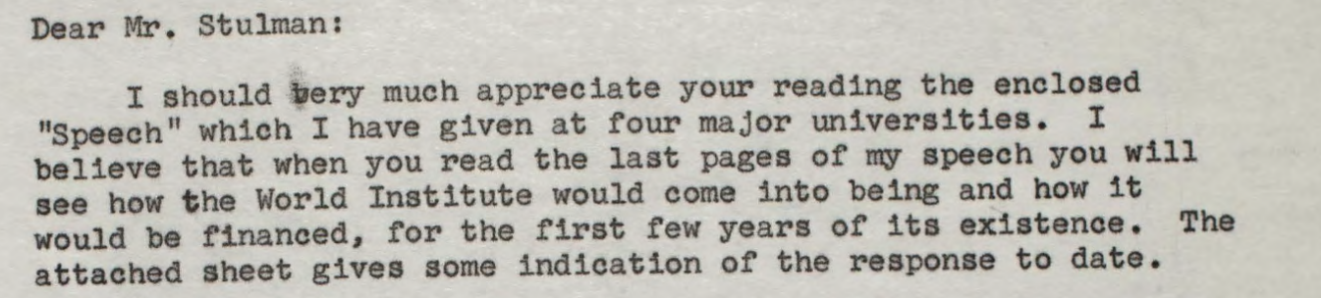
Even Leo Szilard helped finance and create the World Institute!
Leo Szilard was a Hungarian-German-American physicist and inventor. He conceived the nuclear chain reaction in 1933, patented the idea of a nuclear fission
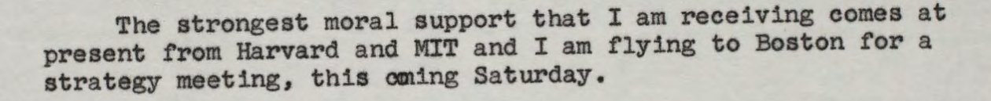
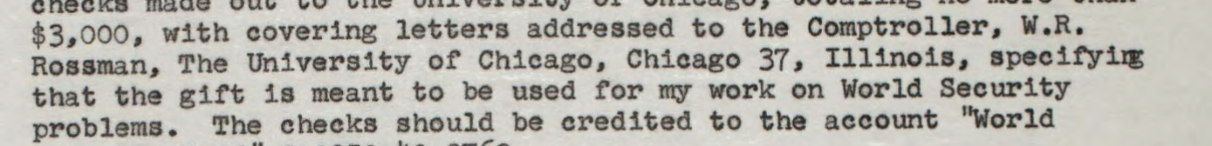
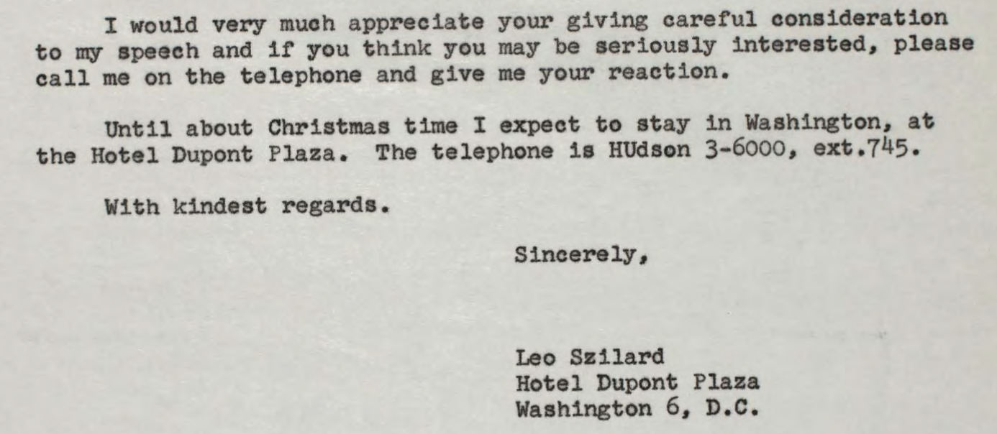
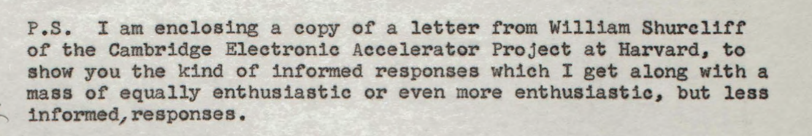
In 1944 Stulman published an article called "Energy Theory as Applied to Human Relations." It was this article that caught the eye of Dr. Reiser, the promoter of Radio-eugenics in the Journal of Heredity.
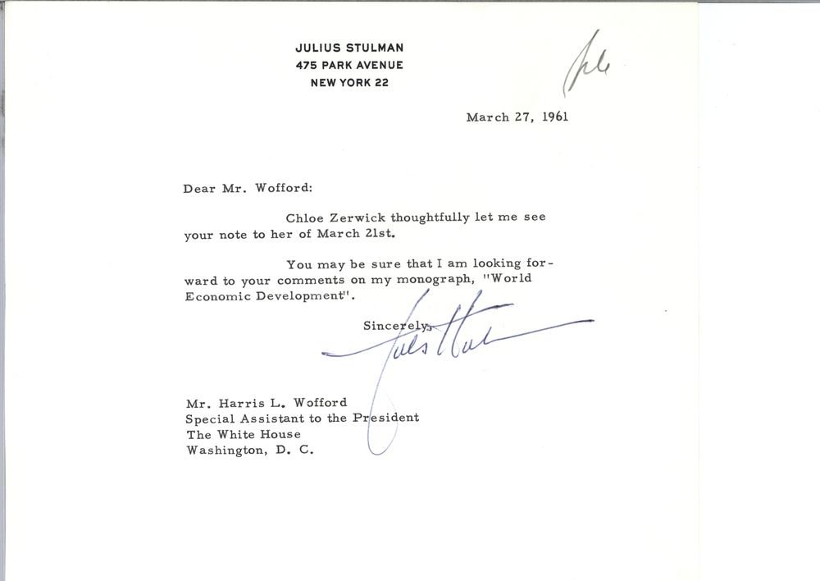
In 1963 the U.S. proposed a clearinghouse to provide world-wide scientific information and guidance. Julius Stulman offered his concept of the WORLD
INSTITUTE. He was recommended to the U.S. by the former Director General of Technical Administration Assistance of the United Nations, Hugh L. Keenleyside.
The World Institute was established across the street from the United Nations.
The WORLD INSTITUTE was instigated as a "GREAT SOCIETY" vision for the evolution of humanity beyond the COLD WAR. The WORLD INSTITUTE is described as being integrated with resource centers all over the planet and Julius Stulman consulted with presidents from all over the world.
Under the vision of the WORLD INSTITUTE's Cosmecology, "Planet Earth" is seen as an EGG that is developing an embryo which will give birth to a WORLD BRAIN or the WORLD SENSORIUM - a paranormal existence beyond space-time integrated with the Unified Energy Field of the universe.
Dr. C. Hilton Rice first proposed this vision of Planet Earth, again back in the 1930s:
"The world-mother nourishes its embryo from the materials of the earth-egg. He [Dr. Rice] saw the plant and animal divisions of the earth-organism as being in functional complementarity, precisely like the two layers of gastrula."
(p. 48, Cosmic Humanism and World Unity, 1975)
- Animals are the Entoderm
- Plants are the Ectoderm of the EGG - resources to be used for the development of the WORLD BRAIN
- THE HUMAN RACE ARE THE NEUROBLASTS (embryonic nerve cells) of the WORLD BRAIN or WORLD SENSORIUM
SOUNDS EXACTLY LIKE THE MATRIX...!!!
From radioactive "harmonic" mutations, guided by the LOGOS FIELD or COSMIC IMAGINATION, humans will evolve, whereby they will be merged into a paranormal reality beyond space-time.
"It was suggested that we might create and utilize an artificial ion blanket."
(p. 453) (PROJECT HAARP)
"If then, we humans are cells in the great cortex of a world organism, would it not require a super-observer (extra-terrestrial) to scan the cultural movements of humanity and recognize them as planetary brain waves?"
(p. 449, Cosmic Humanism)
"This Logos Field would be able to integrate the action-patterns of the human neuroblasts of the 'world sensorium' into a meaningful drama."
(p. 472)
"We need to fabricate radiation belts of spiritual consonance around the earth in a manner analogous to the Van Allen radiation belt which encloses the earth."
(p. 472)
Thought-belts of the planetary cortex control the DNA-RNA,
"the program of the integration of knowledge concerning the cosmos from top to bottom."
(p. 47, CH and WU)
"Organizing fields of energy as guiding agencies"
(p. 34)
All of this is coordinated by FREEMASONS. Dr. Reiser's associates included Major J. K. DeLoach, a mysterious civil engineer who promoted the connection between the great eye of the pyramid (seen on the dollar bill) and resonant energy-information. DeLoach specialized in studying ancient Egypt and India.
Reiser relied on Dr. Herman Von Baravalle, a mathematician who specialized in Ancient Egyptian and esoteric math. Another associate was Dr. Royal Frye, the nuclear physicist at Boston University who besides writing standard textbooks, specialized in the connection between harmonic energy-information and radiation.
He conducted his studies with Esther Watson Tipple, daughter of Thomas A. Watson, coworker with Alexander Graham Bell, inventor of the telephone.
Watson revealed his Freemason inclinations in a monograph entitled "From Electrons to God."
What will the NEW HUMAN be like according to the WORLD INSTITUTE? There will be a "heart-head synthesis." There will be Cosmic Consciousness - the ability to hear and see with the whole body. There will be the ability to communicate with intelligent beings of the universe.
Cosmic Imagination (the Unified Field Theory) becomes moral in "man" as the INNER MESSIAH (p. 45) Reality will exist in a higher dimension than the fourth dimension. The phenomenon of super-light phase wave speeds are possible.
The Nerve Nets of the New Human will be integrated into ONE GREAT CIRCUIT - a condition Dr. Reiser compares to the state of Samadhi in yoga.
Consciousness will be in higher dimensions guided by the LOGOS FIELD and senses will be psychic. The leaders need to, "exploit the possibilities of such action currents of thought."
Nodes of overlapping waves - superlight waves - show group waves where to go and their product is light and matter. Magnetic fields are the ganglia of the World Brain. (p. 55)
All of this is the inherent drive of the musical-mathematical spiral being quantified into a circle by Plato.
The music logarithmic spiral is the basis for resonance science and is applied to genetics, chemistry, physics, astronomy, etc. throughout the work of Dr. Reiser.
To repeat that now famous quote:
"a field of electromagnetic force is built up to the place where the never-ending spiral [of fifths] approaches the radii [of octaves], and the cycle can be rounded off to a circle, which provides equal interval measurement so that all the tones involved are infused with vitality."
(p. 214, CH & WU)
Such New Age luminaries launched by Main Currents in Modern Thought include Dr. Jose Arguelles (who went back and forth to the University of Chicago, a Platonist stronghold, and was teaching at Princeton in 1967 where the World Institute was chartered from out of the Institute for Integrative Education), Dr.
Fritjof Capra, Ken Wilber, and Willis Harman, author of the CIA-Freemason-S.R.I. report, Changing Images of Man which is also based on the work of Julius Stulman, Oliver Reiser and Ervin Laszlo. Harman writes, in this pivotal report:
Chapter 6 described some characteristics of the “image of man” which is at once compatible with the reemergent “Perennial Philosophy” and is well adapted for dealing with humankind’s contemporary dilemmas. Of special interest to the
Western world is that Freemasonry tradition which played such a significant role in birth of the United States of America, attested to by the symbolism of the Great Seal (on the back of the dollar bill).
In this version of the transcendental image, the central emphasis is on the role of creative work in the life of the individual. (In “true Freemasonry,” there is one lodge, the Universe—and one brotherhood, everything that exists. Each person has the “privilege of labor”, of joining with the “Great Architect” in
building more noble structures and thus serving in the divine plan.) Thus this version of the “new transcendentalism” (perhaps more than other versions imported from the East recently) has the potentiality of reactivating the American symbols, reinterpreting the work ethic, supporting the basic principles of a free-enterprise democratic society, and providing new meanings for the technological-
industrial thrust. At the same time, it is more compatible with other versions more indigenous to other parts of the globe.310
Chapter Two of Changing Images of Man promotes the work of Julius Stulman and Oliver Reiser:
“I am surprised that you have no speculation as to the possible periods of the future. A good candidate for this would be “Methodology of Pattern” proposed by Julius Stulman in Fields within Fields, 5:1 (1972), which goes well beyond the linear scientist found in general systems theory. Or see Oliver Reiser, Cosmic Humanism (Schenkman, 1966).”
Page 40, citing Michael Marien, a promiment World Futurist. Erwin Laszlo is cited in a Changing Images of Man footnote: “Consciousness as awareness can be explained without recourse to grand assumptions about evolutionary thrusts simply by noting the selective advantage it confers on systems that increasingly rely on computed-extrapolated strategies for their existence.” (p. 160)
Does Erwin Lazlo include L.S.D.? From online research Brainstubator aka Skilluminati:
“Jim Keith's excellent book Mind Control, World Control, from Chapter 12, which discusses the spread of LSD and the role of OSS/CIA agent Al Hubbard:
One associate of Hubbard's was New World Order theorist Willis Harman at the Stanford Research Institute. SRI had earlier received grants from the US Army to research chemical incapacitants. When visited by a representative of the underground press at SRI, Harman told the man, 'There's a war going on between your side and mine. And my side is not going to lose.'”
We can surmise that indeed Julius Stulman had progressive politics and good intentions. This is also the case for his son, Stephen Stulman, the Yale graduate, who took over his dad's lumber business, as this April 18, 1949 letter to Life magazine (owned by Skull and Bones Henry Luce)
exemplifies:
Sirs: You say “Aramaco's visible achievements in Saudi Arabia can be a subject of justifiable U.S. pride.” Aramaco's invisible achievements can be subject of justifiable U.S. shame.
The response from Life magazine was to deny Stulman and we can surmise Stulman is aware of the Skull and Bones Yale secret society connection to Life magazine.
Here's what the researcher for The Stargate Conspiracy by Lynn Picknett and Clive Prince, Philip Coppens, has to say about Changing Images of Man:
What rang alarm bells for the left was the fact that the original 1972 report by SRI was the result of a study project commissioned by ‘Government departments’, and that SRI had until then predominantly worked for the Pentagon and CIA, as well as private concerns such as the liberal Rockefeller Foundation. Moreover,
Stanford University was a central component of many years in State and Military funded ‘mind control’ and psychic research, as well as a wide ‘invisible college’ network, that extended from the likes of Andrija Puharich (and his famous psychic protégées and CIA friends) at its inner core....
For the conspiracy theorists, it was highly significant that the ‘Masonic
philosophy’ suggested by the report was identical to that promoted by Henry Wallace, the eccentric, millionaire, business tycoon; Christian Theosophist and honorary 33rd degree Freemason, who had been FDR’s Vice President, and fellow ‘Shrine’ member. Who as Treasury Secretary had spookily put the aforementioned
‘eye on the pyramid’ on the dollar bill, symbolically marking the ‘new regime’!
Wallace had laudably been an architect of the New Deal, and an enemy of the emerging Military Industrial Complex, but was also a fanatical proponent of World Federalism, led by an ‘enlightened’ American State Capitalism. His personal philosophy seems to have been based on a bizarre mix of left leaning Fundamentalist Christianity, Tibetan Buddhism and the 19th century Occult
philosophies of the Theosophical Society. Most damningly for the paranoid, he later also supported and helped fund military backed psychic research while out of office. What’s more, later so would his friend and spiritual heir, the millionaire philosopher Arthur Young, at one time a majority shareholder in the Bell Telephone Company, and himself a close friend of Andrija Puharich and business
associate of the Rockefeller family.
It was enough to make the conspiracy theorists spin, and they certainly did.
However, it has to be said that there is no evidence that even if a cabal existed, it
was of any great extent, and only these two had any clear esoteric associations at the time. Certainly most of the real elite conspiracies of the period were geared to removing FDR, rather than supporting his projects (such as the famous J.P. Morgan plot, exposed by General Butler in 1934, and those of other pro Nazi
sympathisers). But of course only the naïve conspiracy theorist believes in a monolithic ‘Them’; real covert politics are far more complex.311

I discovered that my concept of sound-current nondualism (the focus of my 2000 U of Minnesota masters thesis, Epicenters of Justice, archived online) was already developed by the Philosophy of Science Professor Oliver L. Reiser. Professor Reiser's Ph.D. was on nondualism and he then published a early concept of the superstring theory and its applications to social society called
World Philosophy (1945). Einstein praised this work as the best example of a unified field theory.
In 1965 Reiser published his manifesto called Cosmic Humanism inspired by Einstein's work after Charles Francis Potter dubbed Einstein's philosophy Cosmic Humanism, (CH & WU, p. 165).
“Charles Francis Potter's progressive ideas led him to found, in 1929, the First Humanist Society of New York, whose advisory board included Julian Huxley, John Dewey, Albert Einstein and Thomas Mann. Together with Dewey, Potter was also one of the original 34 signees of the first Humanist Manifesto in 1933. Potter was also the founder, in 1938, of the Euthanasia Society of America.”
Harmonic resonance is the foundation of applied superstring work through the application of what Reiser puts as the central concept of his text: the “Music Logarithmic Spiral.”
Mark Heley’s The Everything Guide to 2012: All You Need to Know about the Theories, Beliefs, and History Surrounding the Ancient Mayan Prophecies (Adams Media, 2009) gives prominent attention to Professor Oliver L. Reiser’s influence on the New Age community, stating that Reiser is the “little-known” source for a grand unification theory behind 2012. Heley states:
“Reiser’s main theory was cosmic humanism, a name suggested to him by Einstein....Reiser’s ideas have been acknowledged as a formative influence on the work of Arguelles....”
But the more disturbing aspects of Reiser’s cosmic humanism plan as mass human ritual sacrifice radioeugenics are neglected by Heley who just states Reiser’s book are “out of print or difficult to find.”
The Noncommutative Music Secret to Relativisitic Quantum Biology as antigravity force
As Quantum Physics Professor Basil J. Hiley emphasizes almost all physicists are in denial about the true meaning of quantum nonlocality and now we know it’s due to noncommutativity:
Here the [nonlocal] implicate order is not some woolly metaphysical
construction, it is a precise description of the underlying process, mathematically expressed in terms of a non-commuting algebra. This process only allows partial views because nature is basically participatory.
To put it more strongly, it is not that we as observers who participate in nature, but that nature participates in nature. Thus the observer is not something special. The cosmos does not need observers to function and evolve.
Hiley has collaborated with Professor Sir Roger Penrose, now the Nobel Physicist, in the sense that Penrose would ask for Hiley’s feedback, back in the day. Hiley had even suggested the term Twistor (adding the “or” suffix) to Penrose’s unified field model that he now calls the Palatial Twistor Model since it’s based on noncommutativity.
There I said the dirty word: Noncommutativity! You see Penrose, like Puharich, emphasizes that it is consciousness that unifies relativity and quantum physics – similarly to Brian Josephson as well. This is the hard “red pill” for the mainstream science folks to swallow! Why? Because as Hiley points out mathematics actually exists in a realm of thought itself – a conceptual realm – whether it is “Platonic” is another matter. In actuality this idea of mathematics as a protoconsciousness that is secretly noncommutativity is a deep spooky secret that even goes beyond nonlocality.
Let me share an email response I received from Professor Hiley recently after I sent him a lecture by Fields Medal math professor Alain Connes, a lecture that features the same music secret I had discovered, only it’s a lecture geared toward physicists:
 | Sun, Sep 25, 11:20 AM, 2022
  Basil Hiley

I am writing my take on the relation of his [Alain Connes] work to what I have been doing. It is really deep stuff which moves us well away from the way physics is normally presented. The maths is what we need but it has to be shown it is relevant to the physicist and not just “abstract mathematics”. It was very interesting that some of the questions raised in the video were raised by people I know and have corresponded with over the years.
Thank you for drawing my attention to these important videos.
Basil Hiley.

I took out some of this email and I realize emails are supposed to be private but the way I figure is Professors are public intellectuals. I’ve been focused on radical research since I was 16 years old and so it is just too much of a corroboration of my work to receive this important email from Professor Basil J. Hiley.
The “negative resonance” concept is one that Sir Roger Penrose uses as Professor Emeritus Stuart Hameroff explains but it is also used or explained by Andrija Puharich! I found this connection to be uncanny. Penrose and Hameroff have put forward a quantum biology consciousness model that relies on Penrose’s brilliant insight about the equivalence principle in relativity. Penrose was the teacher of Stephen Hawking, a scientist most of the public have heard of. So the ideas of Penrose are not to be taken lightly but since Penrose is now in his 90s I have noticed that younger scientists seem to not research his ideas seriously. Even Penrose has pointed out that his views are now being dismissed as “fuddy-duddy” – when in fact the contrary is the case! The views of Penrose need to be taken more seriously than ever before! It is this uncanny alignment of Penrose and Puharich that I want to focus on.
One of the most radical ideas that we now need to consider is the following – that the “primitive causality” put forward by Einstein as the “law of the land” of modern science no longer holds true due to Bell’s Inequality. Quantum physics Professor Jean Bricmont, someone who castigated the postmodern social science attempt to assimilate quantum physics, and someone who dismisses the paranormal, also emphasizes that even Stephen Hawking did not properly understand Bell’s Inequality! Professor Tim Maudlin with whom I have also recently corresponded makes this point as well – that even the Nobel Prize Committee did not properly describe Bell’s Inequality despite doling out the Nobel Physics Prize precisely for this work.
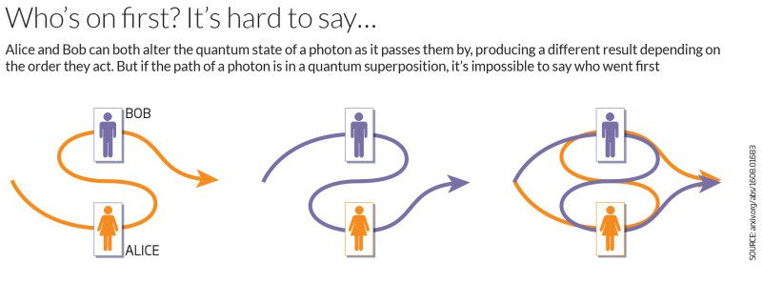
So what precisely am I referring to when I talk about “primitive causality” being violated by Bell’s Inequality? Viktor T. Toth of Quora “physics answers” proves he also does not understand Bell's Inequality on nonlocality!
"or we can simply accept what the equations tell us (especially in light of the fact that quantum nonlocality does not violate causality). "
Professor Jean Bricmont:
"All our intuitive notion of causality collapses, because this notion is based on the idea that causes precede effects in an absolute sense that does not depend on the reference frame. ... What about QFT or relativistic quantum mechanics ? In standard textbooks, the reduction or collapse of the quantum state is never discussed in relativistic terms−→the question raised by EPR and Bell is not even raised."
In his email reply to me Bricmont followed up from his above statement and Viktor Toth’s contrary claim with:

“To that question I would say yes- a measurement on one side affects the result on the other side-that is the result of EPR-Bell’s arguments.
I am not sure what to add to that
Best”
Physics Professor John G. Williamson, with whom I have also corresponded, makes this same point about Nobel Physicist Louis de Broglie – how de Broglie’s Law of Phase Harmony debunked the ideological sublime kernel of Einstein’s symmetric rest frame for linear time causality:
It's far too simple to describe what's going on when you… all these beats and the Harmony of Phases. You can't describe two phases with one phase! You can't describe the three oscillations in one phase! You're already lost and everything you do from there from 1950 for the entire physics community - is blind to that! De Broglie pointed this out - the wave functions are frame dependent...That is so stupid!!
Do you know what the really brilliant piece of work here is? It's de Broglie! It's tremendous imagination. To find there are TWO oscillations where are EVERYWHERE AND IN ALL TIME IN PHASE AND YET IN DIFFERENT FREQUENCIES: THEY MOVE THROUGH ONE EACH other seemlessly - it's magnificient!
So now we can pierce the veil (to use some patriarchal pun?) – we can enter into the secret chamber at the core of science. As Fields Medal Math Professor Alain Connes points out all of mainstream science is based on symmetric “commutative geometry.” In fact we all learn this in standardized education by age 14 via the Pythagorean Theorem! The Pythagorean Theorem is also called the “Power Axiom Set” and it’s considered the most proven theorem in science. Only the Pythagorean Theorem is secretly actually noncommutative!
I brought up this truth of the noncommutative Pythagorean Theorem to math Professor Louis Kauffman – I emailed him on a Sunday night and surprisingly he emailed me back almost immediately stating, “You mean this?” Turns out he had just devised a “noncommutative Pythagorean Theorem” math formula that united Einstein’s relativity with Dirac’s quantum spinors – and it was still unpublished.
Math Professor Louis Kauffman – he goes by Lou – we had corresponded since around 2015 when I contacted him about Eddie Oshins whom I had finally discovered. Since I had realized the secret of nonwestern meditation as spiritual paranormal alchemy was really noncommutativity then I figured someone else must have also figured out this same truth! My background, as I mentioned, was in music training. I took my first music theory class around age 15 as my piano teacher was teaching an evening “adult” music theory class at McPhail Music School. I noticed a logical paradox that immediately intrigued me.
Music is found in all human cultures and most people listen to music, if not actually sing along with songs, enjoying the music. It’s recently been proven by science that our brain has a special area in the temporal region for processing pitch-based speech or singing! This area is not for any other type of processing – not for instrumental music or talking for example. And so this corroborates the “musilanguage" claim – that our original human culture developed speaking originally from singing.
So despite music being universally practiced by humans and music being a metaphor in science, based on resonance, some scientists try to dismiss music as just an extraneous byproduct of our culture. This view that had been advocated by Steven Pinker, the “auditory cheesecake” view, is no longer tenable. Instead the view of Robin Dunbar holds sway – that music acts as a loving cooperation bond – a healing energy in human culture – increasing our oxytocin levels as we sing together. Religion is often based on group chanting or “calls” to prayer as a kind of sing-song just as mothers use singing “motherese” to their babies.
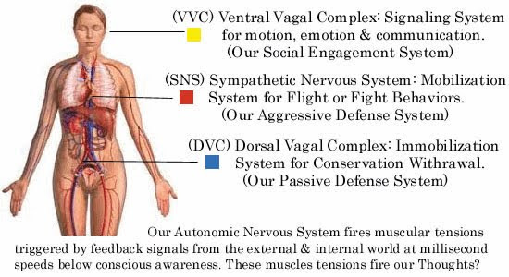
Dr. Stephen Porges has documented that this tonal frequency based “sing-song” language causes a deep relaxation via first our left side vagus nerve doing down to the heart for increased oxytocin – and eventually through a deep right-side vagus nerve activation for whole body healing. This deeper activation is what Harvard medical Dr. Herbert Benson documented as the “relaxation response” practiced by Tibetan yogi monks for example to create a strong “tummo” heat that Wim Hof has scientifically proven and taught as his “Wim Hof” breathing method.
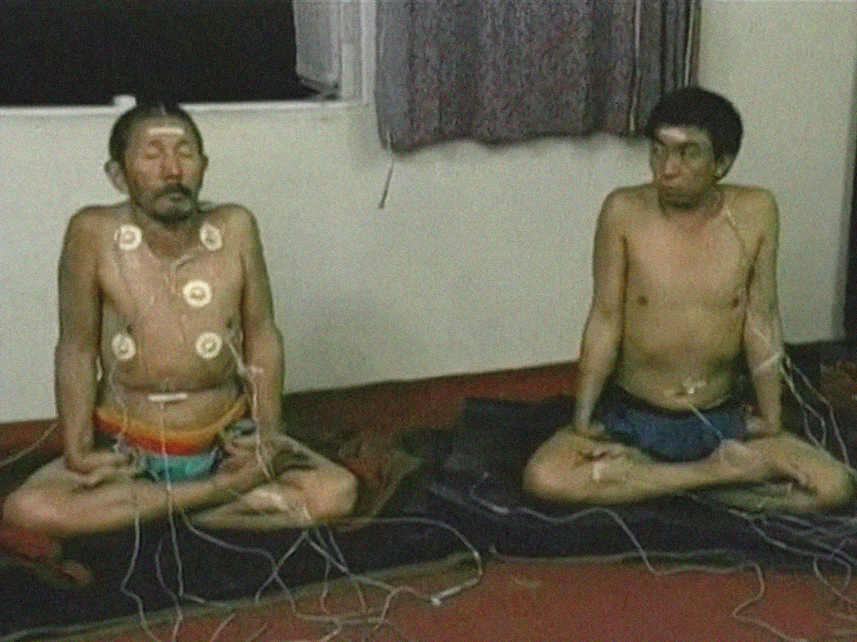
So rather than just Western music as “jock rock” that is taught using Western standard symmetric commutative geometric physics – we need to realize there is actually a much deeper level of music that paranormal researcher D. Scott Rogo wrote a two volume book about – paranormal or supernatural spiritual music. He called is NAD from the term NADA in India but I have called it the Logos from our PreSocratic Pythagorean music origins that is also the basis of Western science. People don’t realize that when they learn the Pythagorean theorem in fact this math using irrational geometric magnitude originated from music theory!
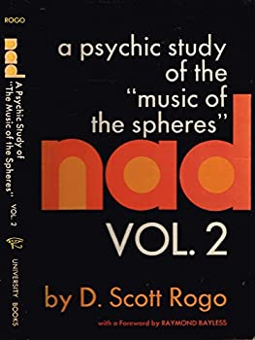
Professor Peter Pesic in his 2014 book on Music and the making of Modern Science points out how the major 2nd music interval cubed or 9/8 cubed was the first approximation of the square root of two. We find this origin also explained by musicologist Professor Ernest McClain in his 1977 Pythagorean Plato book – and it was called “alogon” at the origins of Western science, promoted by Plato.
What I am getting at here is that there is a very simple yet very radical concept that got covered up in order to create Western science! Dr. Peter Kingsley did his Ph.D. in Pythagorean philosophy at Oxford and his thesis was published by Oxford – on ancient magic – but this was rejected by the standard science of academia. Why is this? Because we learn the wrong mathematics from the wrong music theory! Nobel Physicist Louis de Broglie rediscovered this ancient truth of Pythagorean philosophy when he realized what he called his “greatest discovery” – the “Law of Phase Harmony” – even though this is not taught in physics classes to this day.
Essentially de Broglie realized a very simple yet radical concept as de Broglie was criticizing relativity. As a particle goes towards the speed of light then based on quantum energy as frequency, the frequency goes up but based on relativity then time slows down by getting bigger and so the wavelength also goes up. Ever since the Principle of Pythagoras was introduced at the origin of Western science we know that frequency is inverse to wavelength as time and therefore, de Broglie realized, for both relativity and quantum physics to be true there has to be a time-reversed signal with negative frequency from the future that is secretly guiding the particle!
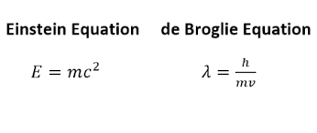
Science does recognize this math as physics and even Roger Penrose uses this “de Broglie-Einstein Relation” as it is also called – as the basis for Penrose’s claim that mass or spacetime originates from frequency. As de Broglie derived frequency is to time as momentum is to wavelength and this means then that the superluminal nonlocal guiding wave is the speed of light squared divided by the particles velocity. Since de Broglie was at the very origins of quantum physics and his model of reality could not be put to practical use to predict more than one particle at a time then it was dismissed in favor for the Schrodinger Wave Equation that was inspired by de Broglie’s subsequent conclusion that particles are waves also just as light is also a particle.
So the infamous 1927 Solvay Conference was when Louis de Broglie stepped aside and let Bohr and Einstein have their infamous debates leading to what became the Copenhagen Interpretation or the “shut up and calculate” model relying on Born’s Rule for squaring the amplitude to get the probability for the location of the particle. But Heisenberg’s equivalent noncommutative matrix math model relied on a crucial point that only Fields Medal Math Professor Alain Connes emphasizes – it is the frequency and not the wavelength of light that reveals the inherent noncommutative nonlocality at the origin of reality. Alain Connes, via Heisenberg’s analysis, has revealed that contrary to the Schroedringer wave model, there is an inherent “primitive time” or what Penrose calls “fundamental time” or what Louis Kauffman calls “primordial time” that is noncommutative to the frequency and therefore an inherent nonlocality to reality.
As Professor Basil J. Hiley emphasizes this means at each zero point of spacetime there already is the future and past overlapping! The reason this view is neglected and rejected by mainstream science is because mainstream science favors physics over mathematics while the noncommutative math exists and operates in a “pre-space” realm of pure protoconsciousness as Hiley and Penrose both emphasize. Roger Penrose admits that he is not very good as “quantum algebra” or noncommutative geometry that Alain Connes founded yet even Penrose admits this mathematical physics is a “relativization” of quantum physics and not the other way around.
As Penrose points out time is actually inherently asymmetric and thus there is an eternal flowing of time-frequency from even before the Big Bang! Penrose relies on Escher to explain this concept of conformal geometry whereby the Weyl Curvative of relativity collapses into pure time and not a spatial singularity. Normally in classical physics we think, via Newton, that there is an eternal "free fall” of gravity based on an absolute time and then a measurement is taken at zero spacetime. We think of time as an external parameter but in quantum physics time is an operator that is inherently evolving with the noncommutative algebra.
So what does this mean in terms of primitive causality and the paranormal? In my email correspondence with Professor Tim Maudlin he stated he was not sure how spacetime could be constructed from noncommutativity and so he said he is working on a preferential rest frame model of spacetime. Professor Maudlin, like Jean Bricmont, understands the radical implications of Bell’s Inequality based on the de Broglie-Bohm model. Professor Hiley prefers to just call this the Bohm model that he ties back to Dirac but noncommutativity takes this to a deeper level.
It's actually a very simple yet very radical concept but this sublime kernel of ideology at the heart of western science was revealed in a recent livestream debate between two Nobel Physicists: Roger Penrose and Gerard ‘t Hooft. The article, “Light is Heavy” by Nobel Physicist Gerard ‘t Hooft, cowritten with the late Martin van der Mark, emphasizes that in fact all matter originates as light. This is also Penrose’s claim that mass originates from frequency and so what is left over after all the Black Holes of the Universe collapse? Just virtual photons. Only Gerard ‘t Hooft calls this the “eternal black hole” based on an external observer viewing the past of the black holes as “negative energy” falling into the singularity while the Hawking radiation that dissolves the black hole is based on negative frequency as virtual photons via an “internal observer.”
So here we have a crucial distinction about primordial time. As scientists – there is an inherent time-frequency uncertainty since time is assumed to be a “linear operator” but in Matrices math the time-frequency is explained by “inner automorphisms” or the inner cross products of the matrices that are noncommutative and nonlocal. So the assumption is that unless there is a linear causal “creation” or scientific artificial entanglement induced with a symmetric restframe established based on relativity, thereby guaranteeing an inherent “invariant” symmetric time in physics, then this nonlocality does not exist! But Professor Basil J. Hiley and Professor Alain Connes disagree – they both emphasize that this nonlocality is an organic process as protoconsciousness inherent to the mathematics itself – existing on its own! This was the same insight that I had when I was 16 years old.
Let me explain my simple music theory model now that I’ve thrown at you a bunch of complicated physics concepts like the “Dirac Spinor” that goes over most people’s heads. Dirac had to convert negative frequency into negative energy because in quantum physics the creation of the particle is limited by time-frequency uncertainty and so the negative frequency with a negative amplitude or negative phase as a time-reversed signal has to then be “canceled out” by squaring the amplitude to get the particle. But again in the noncommutative matrices math this is not necessary! The de Broglie negative frequency model of reality from the Law of Phase Harmony in fact enables the violation of the conservation of momentum because we are working directly just with frequency and time before the conversion to momentum and wavelength. This is called the “spectral density” from the spectral matrices math.
But this same concept is achieved in very simple music theory – again from the Principle of Pythagoras. It turns out, as revealed by Professor Richard McKirahan’s recent translation and analysis of Philolaus’s music math model, that we all were lied about via the flipping of the lyre! Philolaus was the first to introduce the term “magnitude” into Greek science as a mathematical “ratio of ratios” term – a concept made infamous by Eudoxus. Certain mathematics consider this concept of the ”ratio of ratios” to be the most important concept of Western math yet it covered up the truth of noncommutativity. This was a mathematics debate between David Fowler, author of the Mathematics of Plato’s Academy – with math professor Luigi Borzacchini – as I discovered – taking place on a professional mathematics listserve in 1999.
So in 2001 I sent Math Professor Luigi Borzacchini a math equation – that I had a dream about – and I had literally scribbled down my dream. He responded back in “snail mail” from Italy – “your mathematics is good but there is no historical proof this was used.” I pointed out this music math to Math Professor Joe Mazur (whose brother is also a famous Number theorist – Barry Mazur). And Professor Joe Mazur in 2006 or maybe 2004 – he encouraged me to follow up my lead on David Fowler. So then I found this quote that corroborated my claim – giving a strong clue:
...the manipulations of music theory seem to depend fundamentally on the operation of compounding, an operation which seems to pose some serious problems for mathematicians. My purely speculative suggestion...is that music theory might plausibly give some help with this problem.
So we need to realize that mathematics originated from religious ritual sacrifice in ritual geometry as math professor Abraham Seidenberg revealed. Seidenberg, strangely, also promoted a type of mass ritual sacrifice to spread around the world – arising from this rectilinear mathematics as a symbolic substitution for human sacrifice. The square as earth and circle as heaven became separated as a mass ritual sacrifice due to the “incommensurability” or logical inability in Set theory to “square the circle” using irrational geometric magnitude.
Nobel Physicist Brian Josephson has promoted this deep paradox based on another researcher arguing that the ratio of the circumference to diameter as a transcendental number therefore is a kind of asymmetric process to reality – you can find his argument on Philarchives (since the academic mind paywall or Arxiv preprints would not even accept his Nobel Physicist analysis)!
Examination of Yardley’s writings shows instructive parallels with coordination dynamics. Her ‘one entity becoming two and vice-versa’ corresponds to the bifurcations that play a role in coordination dynamics. Her mysterious ‘every line is the diameter of a circle’, when examined carefully (and taking into account also correspondence with the author),is seen to be a reference to the fact that a phase variable is involved, corresponding to the orientation of the diameter of a specific circle. This basic connection is attributed to her ‘pi’, playing a role analogous to the ‘third’ of Peirce in that it mediates the relationships between others. The outcome is oppositional dynamics: two separate systems working as one, examples being two people working together to achieve some purpose, or signs and their references working together to achieve an outcome that is the purpose of the use of the sign.
The key word in this quote is “phase” – we see the use of “noncommutative phase” to thus explain the origin of time-frequency uncertainty but we are neglecting a crucial key point in the trifecta of consciousness, relativity and quantum physics. Science has proven that humans can hear up to ten times faster than time-frequency uncertainty – the linear translation between time and frequency. Think of it this way – the more precise a frequency is tuned then the longer time it takes to tune it to that precision. So as Dennis Gabor emphasized in his information entropy analysis – there is a Fourier tradeoff between time and frequency. Fourier analysis is used for all things in science basically ever since the “wave equation” was first developed in calculus in a 40 year debate between the Bournelli brothers, Euler and d'Almbert. The d’Almbert wave equation thus shows the commonality of how energy can be transformed into different phases.
Noncommutativity is something different entirely yet it was there right in the beginning of Western science! When Philolaus created the irrational magnitude phase as a ratio of ratios what Philolaus did was cover up noncommutativity! All this means is that the “direction” of time no longer mattered if “zero” was no longer considered an inherent value to the frequency being defined. So to create the first logarithmic equation of the Perfect Fifth pitch plus the Perfect Fourth pitch equals the Octave or 3/2 plus 4/3 = 2, an equation that every beginning music theorist learns by rote without realizing its secret origins – there had to be a lie about time and frequency by Philolaus. What Philolaus did was flip his lyre around so that the 1 as the listening root tonic was changed from zero to 12 wavelength to zero to eight wevlength. Therefore 6/8 wavelength as 8/6 or 4/3 frequency could now be the Perfect Fourth as the irrational number magnitude to 3/2 or the Perfect Fifth as 8/12 wavelenth or 12/8 frequency.
This basic secret that I call the “lyre of the liar” is the “rotten root” as the origin of Western mathematics! This is what math professor Luigi Borzacchi calls the “negative judgement paradox” at the heart of Western math and it leads to the Set paradoxes, like Bertrand Russell’s paradox of the set of no sets. Math Professor Louis Kauffman reveals that the only way to resolve these paradoxes of mathematics – logical paradoxes that ripple through science in psychology, and systems theory as Gregory Bateson was struggling with in his classic science book, Mind and Nature: A necessary unity, only time as a process resolves this paradox.
So the irony being that the truth of music theory, as the Orthodox Pythagorean tradition taught, but is covered up by standard Western symmetric commutative geometry science, is also the truth of noncommutativity as the unified field theory of reality, unifying relativity and quantum physics via consciousness. This is what Alain Connes calls “two, three, infinity” as the most simple example of noncommutativity that he explains in his “Music of Shapes” music theory lecture. It was when I discovered his lecture, posted on youtube, and repeated again recently, also incorporated into his physics lecture, that I realized Connes was not just being metaphorical but precisely had focused in on the same logical paradox I had noticed in basic music theory.
Most people learn music theory by rote so they learn that the music ratio of the Perfect Fourth as 4:3 is just that – a “ratio” and not a time-frequency dynamic. Thus the “Harmonic Series” already assumes the octave as 2 is actually the geometric mean squared that Archytas had codified from a Babylonian equation. Philolaus had used the term for the Perfect Fourth as “subcontrary mean” but Archytas changed this to Harmonic Mean thereby covering up the quantum undertone or noncommutative nonlocality of the Perfect Fourth as the Perfect Fifth time-reversed signal. See for example the Platonic Propaganda of the Lyndon Larouchites:

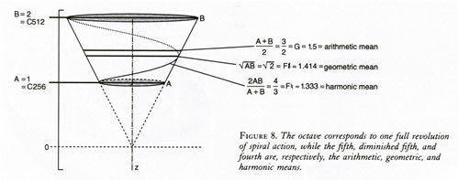
In essence Esther Watson Tipple in her creation of the Mercator music logarithmic spiral had returned to this “vanishing mediator” between Philolaus and Archytas. From Cosmic Humanism, p. 317, we get the details – the “secret sauce” as it were:
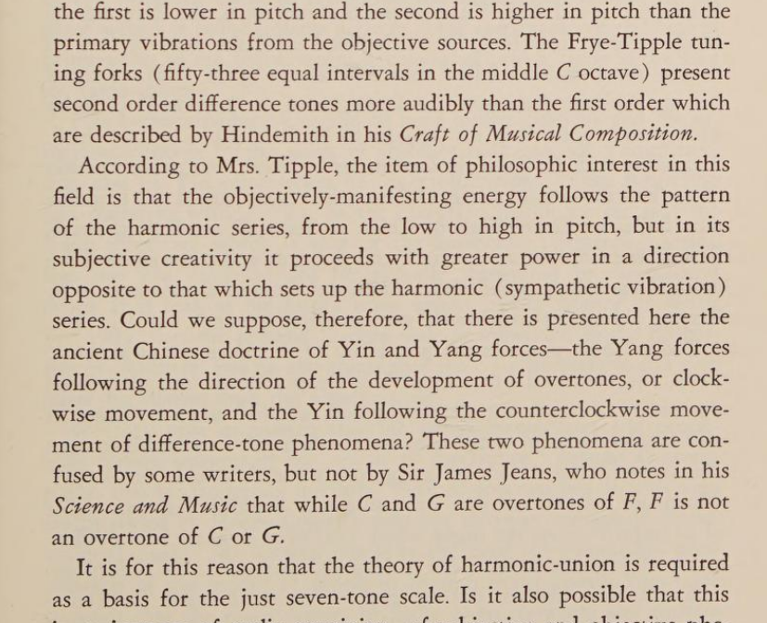
So the claim by Esther Watson Tipple is that the ratio 9/8 (the first irrational magnitude of Philolaus) enables a rational number Pythagorean harmony of the Perfect Fifth and the Major Third of 5/4 – thereby creating what she calls the “just seven-tone scale” (a combination of the Pythagorean 3/2 scale and the 5/4 scale). This “just seven-tone scale” is then extended to 53 notes as the closest rational number approximation of the Perfect Fifths into the Octave.
As per the above – her key claim is that since her “just seven-tone scale” using the natural number tuning forks is able to produce undertones or “difference tones” as time-reversed natural beats better than the chromatic equal-tempered scale, therefore her “music logarithmic scale” is superior to the “first order” exponential harmonics of the Hindemith scale that combines the just seven-tone scale of 5/4 against a chromatic scale built from the overtone series. Hindemith:
The cleverest of all the explanations based on the thirds contained within the fifth in the two triads is the one that says that the origin of the minor triad is in man’s desire to transfer to the world of tone the symmetry of his body. Since the major triad, on account of the inequality of its thirds, is an asymmetric structure, its opposite must be erected to restore the balance.
So here Hindemith is essentially repeating the argument that Plato gave to justify this logarithmic “irrational geometry” tuning – the concept of symmetry that is supposed to be self-evident (only it’s not self-evident). In both causes of Esther Watson Tipple and her improvement over Hindemith the concept of the source of the “one” as based on listening to the source of harmony is not recognized. More specifically in both cases they fall back on Philolaus who originally claimed that it is the geometric “ratio of ratios” that only matters in music theory and not the actually listening to the source of the root tonic as the one (creating the inherent asymmetric time of reality as noncommutativity).
Esther Watson Tipple’s “music logarithmic spiral” is very close in the sense that she recognizes how the “difference” or undertone is based on changing the direction of time. But in the end she choses for a “coverup” that claims the octaves as the symmetric logarithmic standard of the scale and she erroneously claims the Daoist music tuning did the same. Professor Patrick Edwin Moran, who started out in physics and switched to Chinese philosophy, corrects us of this Western “symmetric” projection onto the traditional Chinese (and even traditional Pythagorean) tuning as alchemy.
The Chinese knew about the tempered scale even before it was invented in the West, but they chose not to use it. They seem to have decided to put the differences to good use…. Note that the bottom line turns out not to be a true octave above the top line. Each of the numbers calculated is somewhat higher than the octave.
Compare that to the erroneous Western projection of equal-temperament onto the traditional Chinese tuning by the Platonic theosophists:
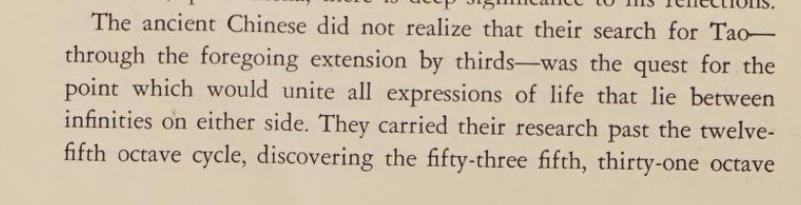
“octave cycle” is how that excerpt ends from p. 318 in Cosmic Humanism – as we just quoted from Chinese Philosophy Professor Patrick Edwin Moran this theosophist claim of “improving the Tao” is clearly not an accurate depiction.
So the first logarithmic equation from Philolaus using 9/8 to hide the noncommutativity was actually formulated before Plato and taught as “alogon” by Platonic Philosophy. More on Philolaus in the next section. The Orthodox Pythagorean philosophy relied on music as meditation trained in silence listening – listening to the root of sound in the base of the body as a quantum undertone. Andrija Puharich’s model of internal listening activating quantum nonlocality was precisely already known in ancient times. Tinnitus research has verified that the highest pitch we hear externally actually resonates the brain internally as a whole as ultrasound. It is this ultrasound that Puharich realized then causes a binural beat due to the quantum phase coherence between the right and left ears – thereby ionizing the vagus nerve and splitting the water molecule internally, activating the time-reversed ELF asymmetric nonlocal magnetic wave.
If you read Olivier Costa de Beauregard’s Wikipedia page there is, not surprisingly, no mention of the paranormal. This is due to the inherent mainstream science “materialistic idealism” bias that originates from Platonic philosophy! But if you actually read Olivier Costa de Beauregard’s published science papers almost all of them focus on the paranormal arguing that the paranormal or spiritual powers are inherently proven “de facto real” due to the time-reversed signal from Louis de Broglie’s Law of Phase Harmony.
We are constantly taught by mainstream physics that since de Broglie’s guiding wave or pilot wave model is just an “information” wave therefore it does not carry energy and thereby does not violate primitive causality – again the great sacred cow or sublime ideology at the heart of western symmetric commutative geometry science. Yet this is just a cover up – stemming from the Liar of the Lyre rotten root – a semantic mass mind control “turn of phrase” – because you need to realize that “force” is not the same as “energy.” Energy is a semantic word inherently defined by the amplitude squared mathematics covering up the noncommutative time-frequency force!! This is the newly discovered “quantum potential” force that already exists at each zero point of spacetime and it is this “fundamental force” (as I called it in 1996) that is tapped into from nonwestern meditation training based on internally listening.
Ramana Maharshi, one of the most famous Indian yoga gurus of the 20th century, called his truth of reality “mouna samadhi” or “silence samadhi.” It is also an ether-force or Shakti that inherently can not be seen. Ramana Maharshi pointed out that people want to see this truth as a Light yet the Self is NOT a light! Yes light does emanate from the Self and the deeper you go into the Self via meditation then the brighter the light gets but ironically that does not mean that the Self IS the light! In Daoist meditation this is the Ch’an or Zen Koan paradox of seeing with the ears. In Daoist alchemy or neidan the left ear is yang qi while the left eye is yin qi. So there is an inherent reversal of vision with listening as the secret to alchemy. In Tibetan yoga medicine there is a saying that the yogi collects the universal energy with his ears during meditation and then emits that energy via his eyes to do healing.
This brings us back to Puharich who documented a strong ELF wave as the secret of the energy healers he studied. This strong ELF wave has been replicated in studies in Japan and in China also on qigong masters. In fact in the Marxist materialistic western science of China these studies were called “somatic science” and so hypothesized a similarly "materialistic” origin of Qi or Chi (pronounced Chee) – just as Puharich’s model was wrongly hypothesized to be materialistic. A good book on this is the Demon and the Quantum – by Marlan Scully and his son Robert. Jack Sarfatti told me he would read that book as he knew Marlan Scully also. The subtitle of the book is on Pythagorean mystics but in reality Pythagorean mysticism doesn’t get much mention in the book.
The core concept here is that information is a new type of force that is also negentropic or negative entropy. Again the secret is due to the inner cross products of the matrices based on time and frequency being nonlocal. So just as 2/3 is C to F in music theory as the Perfect Fifth undertone while 3/2 is C to G in music theory therefore 3/2 x 2/3 does not equal 1.
Standard music theory relies on the octave defined as a geometric square such that the tritone or geometric mean of the octave is inherently the square root of two. This again originated from 9/8 cubed from Philolaus and was rediscovered by Simon Steven in the late 1500s. As Stuart Isacoff explains in his book Temperament the cube root of two was first approximated from extending the Pythagorean Tetraktys of 1:2:3:4 to 5/4 or the Major Third music interval. Again this is essentially what Esther Watson Tipple recreated with her “music logarithmic spiral” as a kind of vanishing mediator.
The compounded ratio equation I had realized was from the ancient Greek problem that Archytas solved using pure geometry – how to precisely double the cube for military catapult technology to save Greece from a plague. Back then it was the gods and goddesses who demanded better technology to expand empire as a ritual mass sacrifice mathematics. But despite this geometric proof being considered the standard norm it was math professor Luigi Borzacchini who realized that only in music theory is the confrontation of the irrational magnitude directly confronted when it is realized that six whole tones or 9/8 do not line up with the octave. The early versions of this tried to “double” or divide and average the ratio to find the answer and therefore 17 was realized to not be the even divide between 18/16.
Luigi Borzacchini made the fascinating realization that Plato’s dialogue – I think it is Menos – on irrational magnitude math is actually a reference to music theory originated from Plutarch’s analysis of this problem in Egyptian religious geometry of Osiris. (see below for more details). The Solar and Lunar calendar religion could also not be evenly divided due to the same problem of the music theory disharmony – or so it was assumed by relying on an attempt to convert time into a symmetric rectilinear left-brain dominant and right tool dominant agricultural control of Mother Nature.
This is what archaeologist Jacques Cauvin coined as the “symbolic revolution” tracing it back to around 10,000 BCE when anthropocentric art first became dominant with an emphasize on rectilinear geometry. The circular housing and silver used to represent the lunar sacred female energy tied to the fertility of the land as a natural cycle was then repressed by trying to “square the circle.”
By 1200 BCE in India then iron became more valuable than silver since iron could be used to make weapons. The squaring of the circle relied on the original use of the Pythagorean theorem to center the wheels for chariot technology – circa 3000 BCE according to math professor Abraham Seidenberg. And thus by the time of Pythagoras the blacksmith technology was a secret art to attempt to “contain” infinity as a harmonization of heaven and earth or circle and square internally in the body visualized in the pagoda and pyramid architecture.
Andrjia Puharich argued in line with the Freemason theosophist ideology that this ancient architecture was a true ecological harmony science based on again splitting the water using the ELF resonance as an antigravity propulsion technology found worldwide. The fact that this view is just now being promoted on Netflix by the new Graham Hancock documentary gives corroboration to Lynn Picknett, Clive Prince and their research groups analysis of what they dubbed the Stargate Conspiracy.
This is the title of their 2001 book that I read around the time of its release and I saw their website that got disappeared. They explained in a latter lecture they traced their Stargate website demolishing to a CIA server attack and their Stargate Conspiracy featuring a focus on their distrust of Puharich’s ties to military mind control was recently the focus of a conference lecture (posted online just a year ago).
The meticulous research of Prince and Picknett's underground classic The Stargate Conspiracy behooves the continued promotion of the "ancient alien" meme on CIA-cable. Of course the brainwashed masses don't want to consider they've been seriously duped by racist lies set up as a convenient scapegoat against the noise of class warfare by the corporate-state military elite. The esoteric realms as sinister forces are no longer taken seriously since Freemasonry is no long fashionable among the masses and yet the technospiritual agenda detailed in the Stargate Conspiracy is brilliantly conveyed as not just a New Age e.t. cult but rather a global NWO reliance on transhumanism. Indeed the main subject of this book, Dr. Andrija Puharich, was a collaborator, a consulting author, for Professor Oliver L. Reiser's book Cosmic Humanism and World Unity - published by a series edited for a Theosophist-controlled UN-associated corporate-state think tank promoting radiation-based eugenics as the unfortunate yet necessary means of the "spiritual evolution" of humans on Earth. Literally a new Matrix is to be established with the human brain as the neuron for a global brain, first envisioned by H.G. Wells while he was consulting the British Freemasonic elite that then created the Council on Foreign Relations.
The Stargate Conspiracy was attacked when the book website was first launched - with the hits from the headquarter location for the CIA. Why? Because the book reveals the same reason why Dan Eden (Gary Vey) of http://viewzone.com was approached by James Hurtak regarding Dan Eden's research into Project HAARP, tied into this ionospheric radiation-based eugenics to be overseen and unified by an "extraterrestrial" presence - really a cover for the space wars of the U.S. military corporate-state elite. Professor David F. Noble was also hip to this secret Stargate Conspiracy - his 1996 book The Religion of Technology traces the cause back to the NeoPlatonic philosophy of the 9th Century Benedictine monk, John Scotus Erigena, and how this promotion of a NeoPlatonic elitism created the basis for Freemasonic modern science and its apocalyptic agenda as technospiritualism.
Congratulations to Prince and Picknett for revealing these secrets behind the materialist fake rationalism of the elite -- the strange sinister secrets as the basis for mass ritual sacrifice are then turned into a new global religious movement - a kind of New Age space brothers mentality - something broad enough to incorporate all the other monotheistic religions as they all have this same Freemasonic origin traced by math professor Abraham Seidenberg to around 3,000 BCE with the original Pythagorean Theorem from ritual sacrifice altar geometry for the Brahmin priests. Before that the "symbolic revolution" of 10,000 BCE - the time that Prince and Picknett reveal as being the origin for this theosophist religion - Dr. Jacques Cauvin calls it the symbolic revolution -- a religion attempt to contain the formless, the Wild, the unknown, by using geometric anthropocentric symbols.
I know for a fact that the paranormal powers that Andrija Puharich was investigating are very real indeed and as Puharich emphasized it is just a matter of how much time is invested in the training. Meditation is the most difficult and most powerful training a person can do and I have even experienced the creation of a spacetime vortex as antigravity propulsion as hypothesized for levitation, etc. There are subtle secrets to this training and I have gone into some detail on this training in my free “Idiot’s Guide” training manual that a dozen or so people read every day – from all over the world – posted free online. In fact my publisher contacted me 10 years ago to publish this book and so you can find an earlier version from 2012 that has 725 scholarly foot notes corroborating my claims thus far – with the bibliography corroborating the footnotes – see Alchemy of Rainbow Heart Music: How paranormal sonofusion subverts the Matrix Conspiracy.
After what my teacher Chunyi Lin, the qigong master, called my “enlightenment experience” in 2000 – I set out to read one scholarly book a day to reverse engineer science to explain my meditation experiences – and I did that for ten years!! But while I read one scholarly book a day I also sat in full lotus to keep my mind focused but I sat in full lotus in public and so I also had “free” psychic healing third eye holographic experiences with the people around me. I posted these experiences online in the Peanut gallery of the interwebs – the various forums – and my descriptions of my energy experiences prompted great controversy – people really freaked out to say the least!
Also my goal was to spread a world revolution out of Minneapolis that I called the Natural Revolution Revolution and I created first a pamphlet in Fall of 2001 called Etherealize Pranarchy! (a pun on Ether and Realize and Prana and Anarchy). My conspiracy buddy dubbed this jokingly as “Etherealize Prawnarchy.”
And so for ten years I had free energy healing experiences in Minneapolis and my goal was for people around me to experience the free bliss peaceful energy so they too could realize they could leave the Matrix at will!! Sure enough a “revolution” or “uprising” or “riot” was triggered in Minneapolis a few years or ten years after I left the city. Was is just a coincidence that this uprising had global repercussions and led to the biggest mass protests in U.S. history?
I had created my very own Spooky Looky Land and turned the CIA’s testing of biological warfare right back on them. Puharich believed he had been targeted by the CIA to repress Puharich’s secret decoding of consciousness as a free energy healing force. Apparently not only was Puharich’s place burned down but his manuscript (Tesla's Magnifying Transmitter, 1985) was destroyed at his Dell publishing office. I can relate to this as when I was in serious activist organizing at the University – meeting with the General Counsel lawyer who ran the University for nine meetings – my email was hacked and deleted – in an attempt to wipe out my activist email listserve. I had revealed the General Counsel joking, “I hope the professors on this [social concerns] committee are tenured” as the true power relations of the Academy – the corporate-state research contracts control the direction of science and not the free thinking of the professors.
Let’s Summarize the Natural Resonance Revolution of Andrija Puharich
Nobel Physicist Gerard ‘t Hooft’s “eternal black hole” model argues for what he calls “instantons” or virtual microblack holes at the foundation of each particle. Again all matter is fundamentally light. But as quantum physics professor Fred Alan Wolf points out Schroedinger knew that as photons are emitted when the electron changes discrete energy levels – or the quantum jump – Schroedinger could not figure out the origin of the light. He knew that it was due to a “higher” frequency but could not figure out how? Hence the Schroedringer Cat paradox of quantum entanglement. The Nonlocality as quantum entanglement means it’s inherent to reality at each zero point of spacetime and thus Einstein-Rosen wormholes equal the Einstein-Rosen-Podelsky superluminal paradox, as Olivier Costa de Beauregard solved. If the superluminal signal is purely a time-frequency ½ spin that is noncommutative then it can violate “primitive causality” and as Kurt Godel realized due to general relativity then time travel is possible as long as there are no personal desires.
This worldview combines consciousness, relativity and quantum physics and this consciousness is called protoconsciousness by Bernard d’Espagnat and Roger Penrose – or “formless awareness” by Ramana Maharshi – it is a nonlocal Ether-information as newly discovered force called the “quantum potential” or “spin force.” The ½ spin as negative frequency and time-reversed signal is inherently not a wave nor a particle as Tim Maudlin emphasizes. My own quantum physics Professor Herbert J. Bernstein was the first to postulate this proof using a self-entangled neutron since it has no magnetic field.
In quantum biology this is explained via the “pi resonance” model that Penrose and Hameroff rely on. So within the microtubules of the neurons – the pyramid neurons – there are benzene type aromatic molecules that have ½ spin electrons as “pi resonance” that is nonlocal. “Aromatic compounds: [spin-spin coupling frequency constant] is normally 7-9 Hz for benzene.” (source: “Spin-Spin Coupling” pdf, University College London, 1997). This means the tubulin within the microtubules are metamaterials with a negative refractive index or “negative resonance” such that this repulsive magnetic nonlocal spin force is inherently emitted as a phase harmony from the future. Aromatic rings can induce their own magnetic field due to 1/2 spin of the extra electron as nonlocality to paraphrase this explanation.
And so for example tryptophan is a common “pi resonance” molecule in the tubulin that then increases the frequency with an increased negative refractive index of the microtubule metamaterial. This means, as per Roger Penrose’s protoconsciousness model, there is a Quantum Zeno Effect delay in the “collapse” of the wavefunction as consciousness and thus the nonlocal protoconsciousness as as a virtual photon superluminal phase negative entropy antigravity propulsion can self-amplify. Penrose explains that the so-called “dark energy” of the universe is actually the “gravitational potential” energy from “negative entropy” – so as Penrose refers to Schroedinger’s 1945 book, What Is Life?, the heat of the sun actually does not originate from thermonuclear reactions but from the gravitational potential as negentropy.
In fact in a recent conference where Professor Basil J. Hiley presented after Roger Penrose and Stuart Hameroff, Hiley argued in a friendly fashion that due to the noncommutative math that Penrose admits he is not good at, there is no need for even a wavefunction much less the collapse of the wavefunction! It was Pascual Jordan in the 1930s who first made this realization but his evil Nazi views caused his genius insight to be neglected. As Jordan pointed out later it was not until the Dirac Spinor relied on Pascual Jordan’s noncommutative math was Jordan truly vindicated.
And with Pascual Jordan arguing for a self-amplifying noncommutativity we come full circle back to Andrija Puharich relying on the Blackett Effect to explain his antigravity repulsive force Psi-Plasma paranormal nonlocality.
From the 15th equation, he [Pascual Jorden] even had obtained “a new physical effect”: uncharged dust-matter could generate an electromagnetic field [[606], p. 79, footnote (1)]. He linked this effect to Blackett’s search for the magnetic field of a rotating body, described in Section 6.1…. In 1951, Y. Four`es-Bruhat proved existence and uniqueness theorems of “the unitary theory of Jordan–Thiry” [216, 218].
Eddie Oshins made this secret the focus of his creation of “quantum psychology” while he worked at the Stanford Linear Accelerator Center. Oshins had been inspired by solving Gregory Bateson’s psychological “double bind” logical paradoxes that Bateson believed led to schizophrenic type symptoms. So it was precisely the square root of negative one or the imaginary number as a noncommutative time-frequency dynamic in quantum algebra that led to the solution of the Set Theory paradoxes from Bertrand Russell – such that “Neither A nor Not-A” is the answer as the Void of an eternal harmonizing time-frequency process. This is precisely the issue that both Andrija Puharich and Oliver Reiser acknowledge as the key struggle in their collaboration. Puharich states to Reiser:
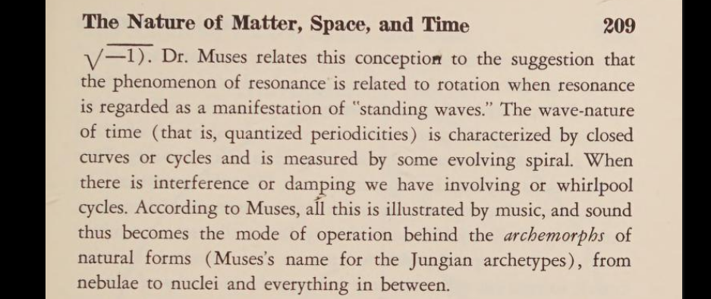
Puharich is citing Reiser’s Cosmic Humanism. Unfortunately despite both recognizing there is a key asymmetric factor due to the square root of negative one, this does not lead to a noncommutative breakthrough! Instead both Puharich and Reiser rely on the standard commutative geometry and thus use an “octaves” metaphor via exponentials expanding from logarithms. So Reiser states the frequency is multiplied by a sphere volume but he is not using the noncommutative time-frequency analysis.
Eddie Oshins realized that for example the Dirac Dance was precisely replicated in nonwestern meditation standing exercises called “internal martial arts” as “neigong” or internal alchemy energy training! So for example the Dirac Dance relies on the fact that the external hand is yang while the internal hand is yin and thus the external hand as yang faces the lower body that is yin and the internal hand as yin faces the upper body as yang.
In Spinor physics this is the gauge theory that is noncommutative but then Dirac converts it to symmetric mathematics thereby canceling out the negative frequency and instead embracing a negative energy that does not exist due to relativity. So this is called “renormalization” and means that virtual photons are said to only exist mathematically! This is quite bizarre that standard physics such as the youtube channel PBS SpaceTime taught by physics Professor Matt O’Dowd makes this claim that virtual photons do not exist when in fact one of the Nobel Prize physics committee members has replicated the experiment that converts virtual photons into increased photon energy.
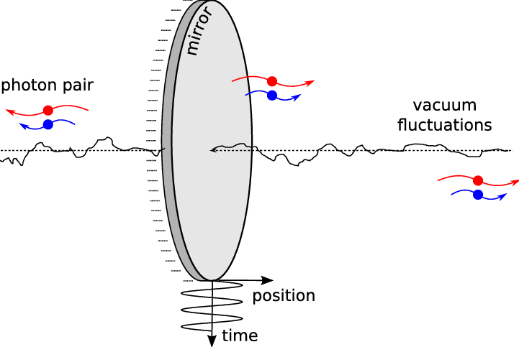
Sir John Pendry, the metamaterials expert, has recently also converted virtual photons into increased photon energy using what he calls the Archimedes Screw – a circularly polarized light. Pendry explains such light inherently violates the conservation of momentum but again that is just fine since he is working directly with just time and frequency as force!
Freed from constraints such as reciprocity and energy conservation, these systems can enable new and exotic wave behaviours.
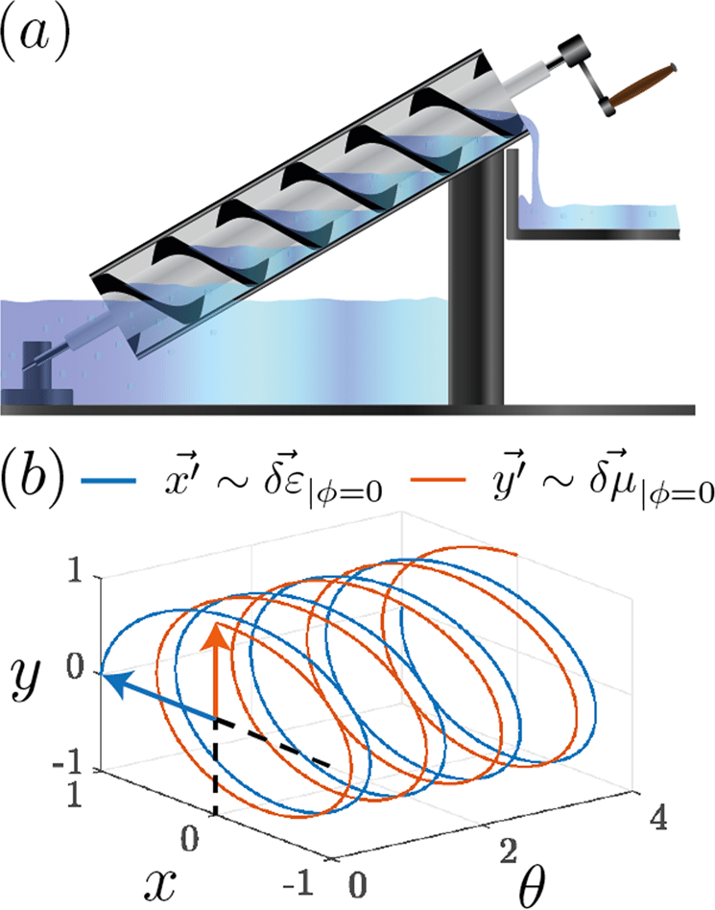
So again the simplest is the most powerful yet it takes time to practice this. Professor Shahn Majid in his email correspondence with me then points out that although the noncommutative geometry has not proven that spacetime is inherently curved – it this is true then the quantum nonlocal time-reversed spin force would cancel out the gravitational singularity of the black hole.
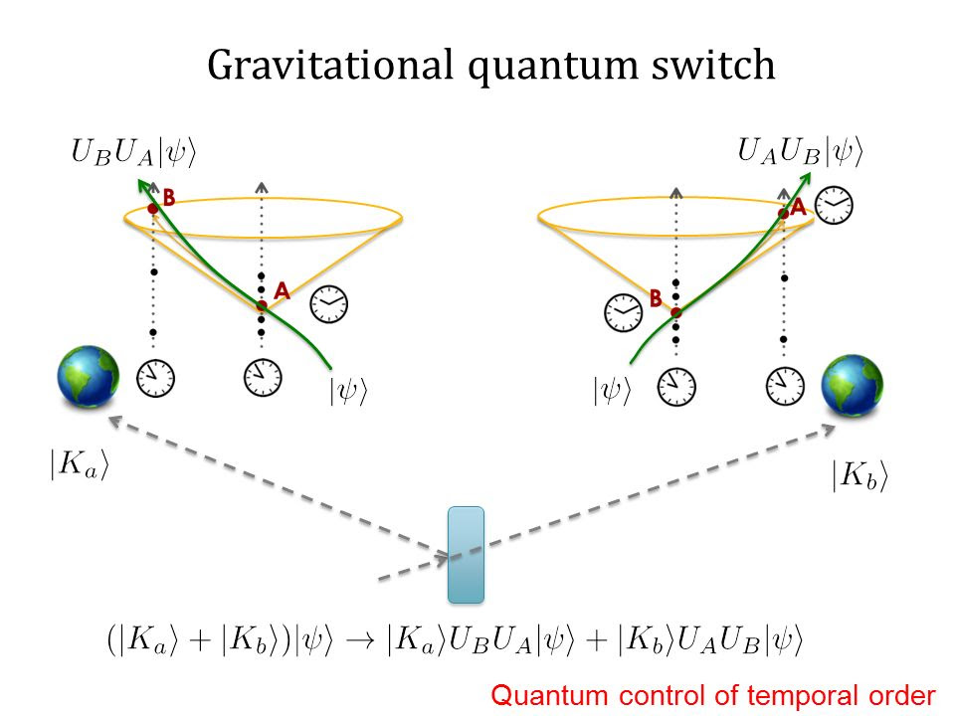
There are other physics papers also stating that such ½ spin black hole means that the black hole is a traversable wormhole – precisely enabling the paranormal spiritual physics as antigravity propulsion that Jack Sarfatti argued with Fred Alan Wolf in their classic comic book, Space-Time and Beyond. Sarfatti has since developed a model he considers to be a “case closed” set-up:
The correct way to think about this is ER = EPR, but with traversable ER quantum gravity wormholes as I first described in the 1975 book Space-Time and Beyond (E.P.Dutton edition only). This was prior to AdS/CFT duality, but it anticipated it intuitively…..Real precognitive remote viewing as reported by Puthoff, Targ, Graf and others does not violate the laws of physics.”
Michael Talbot’s book The Holographic Universe was a best-selling explanation combining the spiritual paranormal with quantum physics for those in the New Age community. Of course the mainstream scientists would dismiss this as “woo woo” but this was before quantum biology had made the cover article of SciAm or Scientific American in 2011. The only problem – and a big problem at that – is that Eddie Oshins had worked in Karl Pribram’s lab with the hope of explaining to Karl Pribram the noncommutative math secret of quantum psychology. Karl Pribram is the featured scientist along with David Bohm in Michael Talbot’s book and Oshins realized that Karl Pribram was not able to understand the noncommutative math. Oshins died young from a heart attack – but Louis Kauffman, the collaborator of Oshins, carries on this noncommutative math secret – in conjunction with Alain Connes and the de Broglie time-frequency model of reality that Basil J. Hiley expanded with David Bohm. Hiley also now emphasizes that a correct understanding of the de Broglie-Bohm model is from noncommutativity or noncommutative time-frequency analysis. Consider this exchange between Hiley and the SciAm editor who wrote a book on Spooky Action at a Distance or quantum entanglement – George Musser:
GM: How does this enter into quantum mechanics?
BH: In noncommutativity.
It’s as simple yet as profound as that! I mean anyone doing building construction – even a simple shed – relies on the Pythagorean Theorem. George Musser does mention noncommutativity a bit in his book but doesn’t really focus on it.
Space-time and gravity emerge from quantum effects much as a 3D hologram projects out of a 2D pattern…The holographic principle says that the two realities — the one with the wormhole and the one with the qubits — are alternate versions of the same physics,… .“I think it is true that gravity in our universe is emergent from some quantum [bits] in the same way that this little baby one-dimensional wormhole is emergent” from the Sycamore chip, Jafferis said. “Of course we don’t know that for sure. We’re trying to understand it.”
Yet there is a secret music theory origin of the Pythagorean Theorem that reveals the “process” of measuring is inherently noncommutative! Math Professor Louis Kauffman explains and proves that the imaginary number or the square root of negative one works as a phase-shift operator that is noncommutative because every time we make a measurement that also takes place in time itself. So this is a “discrete” process since it is noncommutative but it is also nonlocal because there is no escaping this “fundamental time” – a term that Lee Smolin maybe coined. Lee Smolin had as his first quantum physics teacher the same Herbert J. Bernstein Professor at Hampshire College that I also had. Professor Bernstein as I mentioned, first devised the neutron experiment that was able to “visualize” ½ spin as being nonlocal.
If you take that neutron experiment – that Eddie Oshins called the Bernstein-Aharonov-Susskind Effect – it proves that as the neutron self-entangles through diffraction the nonlocal spin is neither a wave nor a particle! The spatial scale of the spin is way beyond the particle or the wave – and the spatial scale actually exists in this fifth dimension that inherently can not be seen – it is this measuring process as “pure time” or fundamental time. Astrophysicist Paul S. Wesson argued that we exist in a fifth dimensional blackhole universe and in his final years he focused also on Louis de Broglie’s Law of Phase Harmony secret. Here is how Wesson summarized this model of reality also based on the Blackett Effect:
..the presence of oscillations in the vacuum have the same properties as de Broglie waves....5D field equations which in 4D has the properties of a de Broglie wave....the difference can show up as a small perturbation which leads to an effect similar to quantum uncertainty...
a "wavicle" is two simultaneous realizations of flat space, one with waves and one without.
From the viewpoint of 5D field theory, waves of de Broglie type have to be considered real. So in 5D all particles behave like photons and everything in the universe is in causal contact with everything else.
an oscillatory phase, which might (if a person is so inclined) be identified with... spiritual modes of existence...separation between points is zero, so all of the events in the world are in (5D) causal contact. In other words, everything is occurring simultaneously. There is no plausible way to avoid the conclusion that particles which can be seen moving at speeds less than c should be accompanied by waves which cannot be seen and are moving at speeds greater than c.
de Broglie waves are better understood in 5D ...characteristic of inflationary cosmology...its 5D complex generalization...as a model for de Broglie waves. A null interval admits, in a formal sense, velocities in 3D which exceed lightspeed.
a particle not as a point but a tiny ball of trapped waves. ..some of it verging on the mystical.De Broglie waves follow automatically when the expressions for the energy of a particle [E=mc squared] and a wave [E=Planck's Constant multipled by frequency] are combined.
This, admittedly, sounds strange.
Whether one believes in a model like this that straddles physics and spirituality is up to the individual....However it is remarkable that such a model can even be formulated, bridging as it does realms of experience which traditionally have been viewed as immutably separate.
So this idea of each particle originating in a fifth dimensional micro black hole that is nonlocal, thereby explaining spiritual powers, is not what mainstream science wants to hear yet Olivier Costa de Beauregard, the protégé of Louis de Broglie, did make this claim and it was emphasized (literally underlined) in the CIA classification of his paranormal research.
We have been told over and over that to “believe” in the paranormal and spiritual powers is “woo woo” and being “soft-headed” and that the CIA military research into mind control had results that were too negligible to be fungible or convertible into “off the shelf” militarized weapon technology. But the message of noncommutativity is much deeper than this – it means that there is no escape from the Absolute Void that eternally radiates light due to this inherently negative entropy Law of Phase Harmony of negative frequency, time-reversed force.
There has been speculation that a craft or aircraft utilizing metamaterials with this negative refractive index or “Negative resonance” ½ spin force could then have antigravity spacetime wormhole physics – Jack Sarfatti being the most prominent promoter of this view and thus, based on Olivier Costa de Beauregard, the experience of UFOs is due to time travel from the future! Roger Penrose though makes a point that as a relativity expert Jack Sarfatti is forced to accept: gravitational entropy is the opposite of the entropy of matter.
Standard science based on symmetric commutative geometry, as standard relativity is thus based on, has been hell bent on decreasing the entropy of matter. But as Penrose points out since mass or spacetime originates from frequency this means that time is inherently asymmetric and thus the gravitational entropy is increased as the entropy of matter is decreased. So this is obvious to anyone relying on technology – that time is “speeding up” relative to the speed of light. The Law of Phase Harmony of Louis de Broglie has a subtle meaning to it that Jack Sarfatti goes into as does Martin van der Mark in his work with John G. Williamson and Gerard ‘t Hooft. The external frequency is slowing down as a red-shift in light from a spacetime or wavelength-momentum shift while the internal frequency is speeding up as a blue-shift in light. This means, in terms of quantum biology, that as blue light is seen during meditation then the virtual photons are being absorbed creating a time-reversed signal as antigravity propulsion force.
This sounds difficult to believe but in fact this is directly proposed by Roger Penrose and Stuart Hameroff as well – and even explains why the ancient avatars have blue skin like Hathor the cow goddess of Egypt or the “cow that jumps over” the blue moon in Zoroastrian mythology or the blue skin of Krishna. This is also known as the Blue light of Buddha as well and the Blue light is considered the Soul Light manifesting in Indian Yoga by Shri Dhyanyogi and Muktananda. Also in Taoist Yoga alchemy it is explained that this blue light is the “yang qi” that is converting the “yin shen” red light blockages of lower frequency energy.
In New Age terms we are told that “raising the frequency” is a good thing – and thus the paradox of the “holier than thou” eugenics fascism manifests – the so-called “rainbow swastika” that is warned about by Lynn Picknett and Clive Prince’s focus on the Synarchy of extreme right-left politics from esoteric views. We find the same warning in the mathematics Ph.D. Liberal Studies research books of Morris Berman whom I called up in 1995 (since his early books were out of print). But again the key point of noncommutativity saves the day because it is the secret of the quantum undertone as a time-reversed signal that explains the power of the spiritual paranormal “subtle” energy.
In alchemy there is a sublimation of the sexual lower frequency neurohormone energy through a purification of the mind as a higher frequency biophoton blue light force but only by “turning the light around” or literally rotating the eyes does the metamaterial “negative resonance” time-reversed virtual photon signal get absorbed into the “yang qi” or ionized neurohormones. This energy is then swallowed as overflowing ionized cerebrospinal fluid – as it flows out of the sinus cavity – creating a great heat in the pit of the stomach that is then absorbed and stored into the “second brain” – the neurons of the small intestine that have more neurons than the heart!
I go into these training details again in my free “Idiot’s Guide” that has lots of images for explanation – or see my free “Ancient Advanced Acoustic Alchemy” with the same images for a better explanation. My point here is that this secret originates from this simple yet radical ancient advanced acoustic alchemy of noncommutativity aka “negative resonance.”
It's not that we should all train to restore our true connection to reality, as was required in our original human culture, the San Bushmen, called the Tshoma training by the males. A month away from the females was required and the males at the peak of their puberty around age 16 would then dance all day long with only one small liquids meal a day. This was part of their initiation before become a true hunting – to learn to sacrifice their ego and Self to provide meat for the females. As anthropology professor Megan Biesele explains: Women is to meat as Man is to the healing. So this sounds derogatory to us modern brainwashed peoples but in fact it represents a deep profound truth detailed in Dr. Elizabeth Marshall Thomas’s classic, The Harmless People.
Instead our left brain dominance has evolved with our right hand tool dominance into a codified science of written language and mathematical axioms that math professor Luigi Borzacchini calls Plato’s Computer. So rather than a human conspiracy that has repressed our truth of reality as formless awareness healing force or the Cosmic Mother nondualism – there is a structural “deep pre-established disharmony” of the “music logarithmic spiral” as the “guiding evoltive principle” of science itself.
We are told that math is not a science but rather the Queen of science or “language” of science. Yet such books as math Professor Ian Stewart’s Why Beauty is Truth: A History of Symmetry bely the deep structural drive of science as the ultimate conspiracy! We are told that Freemasonry is based on secret rituals and power structures tied to the Illuminati and Skull and Bones, yet in fact the motto of “God is Geometry” reveals the conspiracy is the open secret of Platonic philosophy itself. Plato argued it is obvious that symmetry is the truth of reality just by looking at our hands or feet or eyes – they are a symmetric pair and thus “twoness” exists before counting number, as a Platonic Form. But Aristotle disagreed with this, pointing out how two separate things can come into existence at the same time and that does not mean they are a “unit” as “twoness” as an irrational alogon magnitude “before” counting as time!
Plato said that “time is the image of eternity” but in fact we can not see time – and it is this perceptual paradox that goes far back as our primate origins in the equatorial rainforest of Africa. There are cultures in the rainforest that do not have good three dimensional depth vision or bifocal vision simply because in the rainforest listening is the dominant perception. But the rainforest as the "mind of Earth” that has relied on listening as the dominant perception is now being wiped out simply due to our wrong definition of entropy as a symmetric spacetime information frame of reference.
The logician that math Professor Lous Kauffman relies on, author of the Laws of Form, George Spencer-Brown, argued that the reason the paranormal can not be proven scientifically is due to the wrong statistics – that the paranormal violates the standard symmetric math statistics. Kauffman points out that it is Spenser-Brown who reveals how time as a process is what solves the Set Theory paradoxes of symmetric based mathematics. Alain Connes points out that it is the discrete inner cross products of the matrices that actually create entropy and it is only due to science relying on external measurements that reality is apparently random. And so there is this superluminal phase harmony that is inherently a healing energy but it is inherently also impersonal and cannot be seen.
Physics Professor JohnJoe McFadden, coauthor of the Royal Society science book of the year award winning 2016, Life on the Edge, has been focusing on the paradox of how a warm, wet biology can maintain quantum coherence nonlocality in quantum biology. Many scientists to this day ignore or dismiss quantum biology as “bullshit” (I think it was Carlo Rovelli, a physicist featured on National Public Radio who had such a reaction to quantum biology as a discipline). JohnJoe McFadden of course disagrees but offers up the explanation that vibrational frequency resonance is the key secret of how a quantum coherence can be maintained as room temperature – even on a macroscale.
Water: the MacroQuantum Focus of Andrija Puharich
We have, in this investigation, revealed that is is the inherent asymmetric time as ½ spin of negative frequency flowing eternally from the future that maintains this quantum biology newly discovered antigravity force. Whether this force can be harnessed into technology remains to be seen. Stuart Hameroff has suggested that possibly graphene could achieve something like quantum consciousness since graphene relies on the same ½ spin electron nonlocality as the benzene type “pi resonance” metamaterial molecules in microtubules and tubulin. Andrija Puharich took a different angle on this by emphasizing water and when Stuart Hameroff was asked about the connection of water to the microtubule theory – he emphasized that it should not be connected at all. Puharich realized that the “fourth state” of crystal water was key, as he states in his Protocommunication paper, 1971:
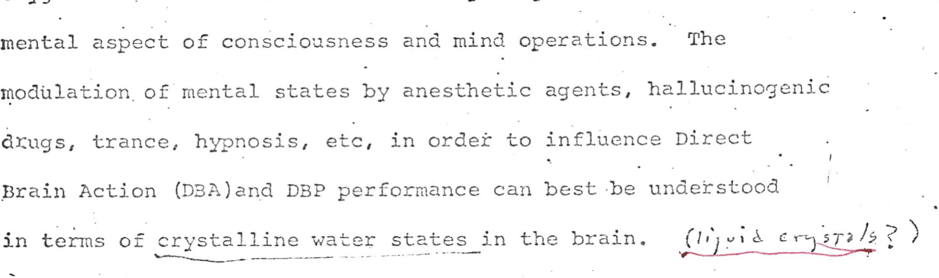
Normally the concept of negative frequency is only taught in terms of complex numbers but again as math professor Louis Kauffman emphasizes the imaginary number or square root of number one actually originates from an algebra process of pure time that is asymmetric and eternally flowing – he calls this “primordial time” and Roger Penrose calls it “fundamental time” (hat tip to Lee Smolin) while Alain Connes calls it “primitive time.” The word “primitive” here again should be acknowledged in the context of primitive causality of Einsteinian linear time extending from 3D spacetime. Since in relativity there is no absolute time then there can still be a superluminal phase but there supposedly cannot be an instantaneous simultaneity. So the primordial time is at each zero point of spacetime precisely as this instantaneous simultaneity only it exists in an impersonal process of the mathematics itself before anyone makes any measurement. We can “visualize” or conceptualize this as the Klein Bottle or a fourth dimensional spatial model of the Moebius Strip (the Dirac Dance process in third dimensional space).
So water is now considered to be a macroquantum molecule – no longer H2O but rather H1.5O and the secret inventor of the MRI machine realized that water in its tetrahedral molecular bonding of hydrogen has a self-healing property – this is Raymond Damadian – this very likely could be the source of Andrija Puharich’s same claim about water.
While it is easy to dismiss these special properties of water as “woo woo” since the “water messages” research was so easily dismissed – what needs to be realized is that meanwhile a “fourth state” of crystal water has been proven, thereby corroborating the claims of Andrija Puharich! Gerald Pollack is the lead researcher in this area who has proven that either pressure or temperature causes water to split into delocalized proton-proton energy that emits and absorbs virtual photons in a superlumninal or imaginary potential force. These waves are relativistic quantum force, analyzed by Physics Professor Emilio del Guidice – and so whether the classical physics is emphasized or the quantum – the terminology changes.
For example John Wheeler with Feynman also modeled a elementary black hole particle physics but it was based on relativity using a renormalization mathematics – and thus was considered plagued by mathematical infinities. The noncommutativity math gets rid of these infinities as Alain Connes has proven – thereby generating all the forces and particles of the standard model. Again Alain Connes emphasizes since all of science is based on symmetric commutative geometry therefore most scientists consider the noncommutative math a nuisance and strange and thus it is ignored – I mean people are trying to have careers here!
And so now we have a water crisis on Earth with the cycle of fresh water rapidly running out, induced by abrupt global warming as an accelerating ecological crisis of droughts and floods. I wrote a paid op-ed on this global water crisis sucking us into revolution in year 2000 – for the University of Minnesota Daily newspaper – and then I worked at Clean Water Action as a part-time office worker for ten years! That enabled me to pay rent and some food and book money so I could continue my research of reading one scholarly book a day after my master’s degree was completed.
Andrija Puharich claimed to have used his ultrasonic internal hearing science breakthrough to then harmonically split water for hydrogen powered car driving. He also claimed this invention was squashed also along with his Teslar watch to create an ELF magnetic wave bubble protecting a person from the otherwise destructive ELF magnetic waves created by standard symmetric classical physics.
The problem with these claims is that Puharich was still relying on classical physics via the “music logarithmic spiral” model of equal-tempered tuning that is the core central concept of the actual Matrix Plan conspiracy and also standard Western science from Freemasonry. Professor David F. Noble exposed and detailed how modern science indeed arose out of Freemasonry – based on Platonic philosophy that first passed through the Christian monasteries.
I pointed this out to a neighbor who countered that patented inventions do not rely on this Freemasonic Platonic geometry. While that maybe true for each invention, like the Bessemer process for making steel, it is the mass production as “off the shelf” technology that does rely on the symmetric math for precision but not for accuracy – and so the “deep pre-established disharmony” gets worse on Earth.
In his Minneapolis 1985 seminar Andrija Puharich made the claim that traditional Chinese “feng shui” relies on the secret ELF magnetic wave force of underwater channels as the “dragon” lines. Whether the Feng Shui relies on this or not, Dr. Mae-Wan Ho, a Taoist quantum biologist, made the convincing argument that the secret power of Qi energy in the body is precisely due to this splitting of water from the piezoelectric ionization of the collagen, aligned over 90% vertically.
Thus simple standing exercises utilizing the yin-yang hand body integration movements that Eddie Oshins referred to based on the Dirac Dance spinor concept – are able to “split” water internally as the fourth phase of water. The Yuan Qi or original cosmic qi is then this “negative resonance” as the time-reversed signal or “backwards precession” of the ELF magnetic wave while the “yin qi” is the ionized electrons in the blood that then, via the pineal gland, increase the “yang qi” of the ionized cerebrospinal fluid stored back into the lower elixir field or lower tan tien of the small intestines second brain.
Rustum Roy, the esteemed professor who organized a research conference on Yan Xin qigong “bigu” or energy feasting – living via alchemical meditation with very little or no food – also hypothesized the secret quantum splitting energy of water. There was an increase of gamma radiation detected at a Yan Xin “qi-emitting” lecture given in San Francisco and even though Yan Xin himself did not emit gamma radiation – it was surmised this was a kind of spacetime transformation byproduct.
Fabio Cardone, inventor of the Sonotrode, uses about a 25 watt ultrasonic force to cause a superluminal cavitation of matter causing what he calls a spacetime vortex as the “shadow of light” – the term “evanescent wave” is the classical virtual photon explanation for this superluminal quantum potential force. So this is a cold fusion sonoluminescence as sono or acoustic cavitation. Yet since science has proven two-thirds of our brain’s energy is used for external vision then with our eyes closed in meditation we are creating an eighteen watt laser force of biophoton spirit energy.
Guenther Nimtz constructed a metamaterial negative refractive double prism experiment proving he could transmit superluminal quantum phonon signals!
As Dr. Andrija Puharich states, "The phonon mechanism is the direct cause for stimulating photon emission." (p. 64, ELF Magnetic Model of Matter and Mind, part 3)
Nimtz even transmitted Mozart as superluminal speed – and this is due to the pilot wave phenomenon of Louis de Broglie – the phase wave is superluminal as a time-reversed signal against the group wave as the “particle” of energy-matter. Nimtz emphasizes that this superluminal sound force is all around us all the time and in fact one study of quantum phonons mathematically proved they are inherently antigravity pressure waves.
My basic Pythagorean insight was inspired by reading Sir James Jeans book Science and Music while I studied privately with a former University music professor to finish my private high school music training. Minneapolis in the 1980s was an intense and furtive music environment. I was constantly going to live music shows in jazz, punk hardcore noise, avant-garde and classical – and I was performing blues and free jazz and classical, etc. I studied orchestration, music composition, ear training and theory. I tested into the third year of music theory for my first year at Hampshire College.
Sir James Jeans explains that since the Pythagorean comma is from the Perfect Fifth or (3/2) to the 12th trying to line up with seven octaves to make the 12 note scale therefore “all simplicity disappears” and the truth of music theory is an infinite spiral that cannot be seen – only listened to as infinite resonance. This infinite silence resonance was demonstrated to me when my teacher silently pressed down a Perfect Fifth note on the piano while he then loudly struck a lower fundamental pitch – the Perfect Fifth resonated into life and rang out without being struck – true magic demonstrated by science!
I tried to explain my concept to my music teachers (who became married while I was first a student to my piano teacher) – and they gave me mystic music books while also explaining that logarithms dismissed my concept. Yet I still held onto it and I connected it to quantum nonlocality during my first year of college. I realized all of Western science was wrong and causing the destruction of life on Earth during my undergraduate and graduate training. Then I discovered that noncommutativity corroborated my claim – from Eddie Oshins and Alain Connes and Basil J. Hiley.
When I tested out my hypothesis by doing the intensive meditation training called the “small universe” or “microcosmic orbit” or “small heavenly circuit” Neidan alchemy meditation based on the 12 notes of the scale as the infinite spiral of fifths that cannot be seen – I proved to myself that not only are ghosts real but that so is precognition and telepathy and telekinesis and levitation as antigravity force as well as long distance healing.
So it’s easy to think of noncommutativity as simple the order of action that makes a difference – for example putting your socks on after your shoes shows that time is not symmetric. The irony being that while the science of physics as measurement is time invariant and symmetric – at least that classical assumption is typically imposed on quantum physics – it is still grudgingly acknowledged that reality of the Universe is based on a false vacuum of symmetry breaking of spacetime. Yet this is still a symmetric spacetime or at least it is assumed to be in quantum field theory. Noncommutativity is stating something much deeper – that the algebraic quantum process is going on all the time as a “primordial time” without the need for any human to make any measurement – it is in no sense anthropocentric but is inherent to number itself being a discrete asymmetric time-frequency process.
This is also the paradox of listening as logical inference as the truth as silence. In PreSocratic Philosophy then “to Know thy Self” meant that Being as Self is Light as the One that is not a number! So the origin of one can not be a materialistic wavelength of zero to (pick a number) as a materialistic ratio. Rather just as in noncommutativity – the “one” is a frequency-time of light that is noncommutative to the future and past and this is the “invariant ratio” that does not change – before linear causality is created! Math Professor Joe Mazur’s book on Zeno’s Paradox points out that despite standard symmetric based physics claiming “the calculus” solved Zeno’s Paradox by converting time into a symmetric spatial geometry (with the limit and the differential) there has always been and will always be a disconnect between the technology requiring an external visual measurement via photons and the actual “instantaneous” time occurring.
We think of this as a harmless philosophical quandary without realizing that when Simon Stevin took Archimedes water principle to convert the intensity of energy into a density as mass – this covered up the secret negative entropy or negentropy antigravity time-frequency “splitting” of water as the fourth phase of water known secretly since Thales considered water the fundamental element of the Universe.
Since the 1960s it has been proven that Newton was directly inspired by Pythagorean (read Archytas) philosophy for his inverse square law of gravity such that stretching a wavelength string with the square of the weight thereby doubles the frequency. So again this is a conversion into physics of the lie of Archtyas that the octave is inherently squared as geometric mean. Fields Medal Math Professor Alain Connes explains that instead the octave is the invariant scale for spacetime but it is the cord or line segment as the inverse of the Dirac Operator – the Dirac or lepton propagator in physics based on the ½ spin that is the secret of the noncommutative time-frequency force.
So Connes is in lecture, “Music of Shapes” defers to the science paper, “Can you hear the shape of the drum?” that proved indeed a geometric shape can have the same frequency just as “3” is the same frequency for 2/3 and 3/2 relative to the Octave as the scale – but the geometric shape is noncommutative and so it is 2/3 as C to F for the pitch and 3/2 as C to G. The book Magic of the Senses points out that even though the Fourier time-frequency translation of the overtone series of 1:2:3 shows a change in the spacetime or wavelength amplitude form – since the phase will “cancel out” the amplitude depending on its geometry – the Ear does not hear the difference between the change in the Perfect Fifth!! I call this the “Hempel Effect” because the reason the ear does not hear the difference is because of how the spacetime geometry is defined.
It is assumed, again wrongly, that the pitch relies on the octave as an inherent geometric squared spatial symmetric whereas the frequency pitch is in fact noncommutative to the root tonic. So if you switch from 2/3 and 3/2 you do indeed change the visual geometric pitch yet in the traditional Blues music you know how the 1-4-5 or 12 bar blues progression “pulls” you eternally to the root tonic via the inversion of the Perfect Fourth into the Perfect Fifth and vice versa. Once again just as I realized while in my first music theory class the Perfect Fifth can also be 2/3 or two-thirds as C to F undertone even though this is not allowed in Western music tuning.
For example in traditional Indian music tuning if you play a root tonic and then a Perfect Fourth about the root tonic drone it is well known the Ear will hear the Perfect Fourth as a new root tonic. Why? Because 4/3 can never be a natural overtone of the root tonic since the denominator is not the same pitch resonance of the root tonic (meaning an octave pitch resonance as the scale). Some Western music theorists accept this empirical truth of listening (in contrast to Western equal-tempered music tuning) and thus the Perfect Fourth is called the “phantom tonic” since it originates from the undertone Perfect fifth as a time-reversed signal that self-amplifies eternally.
And so John Keely created a natural music resonance energy device that took the natural number overtones up into ultrasound thereby splitting water. This was apparently the original inspiration for Andrija Puharich’s water splitting research via ultrasound. Why is ultrasound such a key frequency range? Because it overlaps the mechanical phonon “quasi-particle” force with the electromagnetic frequency spectrum as well. We are told one is traverse and the other is longitudinal but since spin is neither a wave nor a frequency then the spin is precisely this fifth dimensional “flip” of spacetime or inherent curvature of spacetime as the nonlocal quantum ether wormhole.
Puharich cites Olivier Costa de Beauregard and Puharich explains:
The equations imply the conversion of a neutron to a proton by virtual exchange processes, the neutral currents of Weinberg. These processes produce protons of different energy levels; and two neutrinos of different energy levels….there will be an increase of pH inside the mitochondrial as shown in the diagram. Such an increase in the pH inside the mitochondrial membrane can have profound effects on the electron flow and energy yield….It also occurred to me that increased oxygen would tend to pull the proton/proton spin-spin coupling closer to the 8 Hz normative center frequency of biological systems. (ELF Magnetic Model of Matter and Mind)
Viktor Schauberger also discovered this secret antigravity propulsion force of water by using temperature and pressure for his “cycloid spiral spacetime motion” whereby “pressure plus suction equals reduction of resistance.” Schauberger’s insistence on only using natural numbers has since been corroborated by the inherent discrete yet nonlocal time-frequency force process. Alain Connes explains this negative frequency time process of noncommutativity or (two, three, infinity) is more dense than the geometric continuum real numbers of set theory! Puharich realizes, just as Olivier Costa de Beauregard did, the implications, as he states in his Protocommmunication 1971 paper:
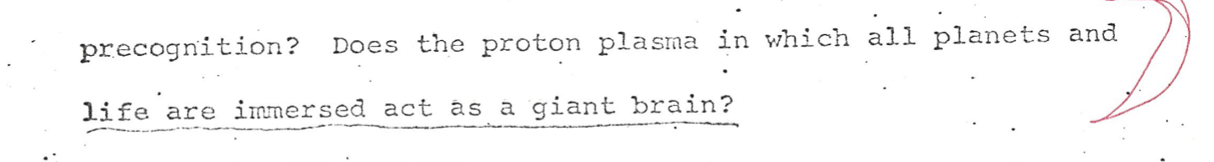
How can we justify this process of time-reversed signals if we have no frame of reference as the symmetric speed of light invariance? A big emphasize in antigravity research is to somehow get past the speed of light but what is “speed” is the wrong concept to begin with? Yes I realize each of us travel in matter in spacetime based on a linear time – and most of us dismiss our dreams as mumbo-jumbo. Maybe we enjoy some insights from dreamland but don’t think much more than that. Yet what if the fastest we could travel is precisely while sitting still and “turning the light around” with our eyes closed, meditating as listening to the source of the light? As Puharich explains, relying on de Broglie’s Law of Phase Harmony:
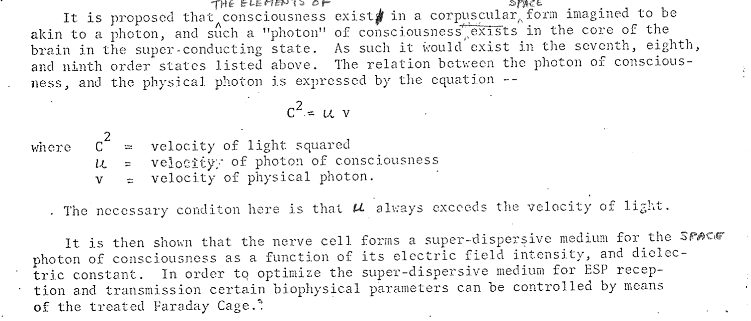

It seems ironic to identify our individual free will with something as impersonal as the source of our deep dreamless slow wave sleep at night – obviously we have no “free will” while in deep dreamless sleep right? But what if we are not “biological machines” as modern society would have us assume? What if we don’t define ourselves by our waking thoughts during the day? What if our dreams became more real and more vivid than being awake and such dreams predicted the future! What if our “present” waking state was less vivid and less real than our meditation visionary state.
In our culture of high tech ever accelerating speed hopefully become superluminal we neglect to consider that our superluminal speed is just as fast as simply turning our thoughts around. By listening to the source of our thoughts we are able to hear “faster” than time is converted to frequency and thereby resonate as quantum coherence that is nonlocal with the future overlapping with the past. Physics Professor Manfred Euler, with whom I’ve corresponded, describes the two ears as the analog of the double slit experiment and thus the binural phase coherence is actually nonlocal – and a “ghost” or superluminal resonance.
Dr. Mae-Wan Ho discovered the same secret – that our listening ability to tune to a frequency is faster than time-frequency uncertainty and the phase coherence between the right and left ear is at the microsecond wavelength (or ultrasonic frequency). This means our phase coherence is also quantum coherence and since we are proven to be able to hear sound intensity as a wavelength smaller than the diameter of an atom in a quiet room – this means our time-frequency coherence is inherently nonlocal as well as a “negative frequency” due to imaginary time or an evanescent wave. Let’s quote Andrija Puharich for the same concept:
As the current flows (the higher the frequency, the higher the current density) it will set up a magnetic field. The magnetic field will be picked up by the hydrogen proton of the C=O:H:N: set and cause it to precess ... [due to the phase difference between the right and left ear as side band undertone] We would expect a short range transfer of ELF magnetic information from the precessed proton to NA+ [sodium] and K+ [potassium] via the acetylcholine molecule ... As the nerve pulse slows then the gravitational constant decreases via the magnetic moment, which causes an expansion of the psi-plasma vortex….
This concept of the higher frequency with an increase in the time or slowing down of gravitational constant pulse is precisely this de Broglie Law of Phase Harmony referred to earlier. Reiser used the phrase “psi-field” but his final unfinished work was called “magnetic moments…” so he may have figured out what Puharich was claiming, especially since Reiser was planning to have Edgar Mitchell publish his work just as Puharich collaborated with Edgar Mitchell.
It is said in science that listening is the last perception to stop while a person is dying but the Near Death Experience reports reveal a type of heavenly music listening that guides the spirit in the afterlife. And quantum biology corroborates this claim that indeed our senses are first understood in meaning as inherently being nonlocal just as photosynthesis in plants is now proven to be nonlocal. So for example our sense of smell relies on quantum frequency but also the noncommutative phase – such that a left-handed molecule of the same frequency will smell differently – precisely the same as in listening to a “left-handed” pitch of C to F. The Pitch is the same as the Perfect Fifth only in one case it is a reverse direction of 2/3 as C to F and then 3/2 as C to G overtone. Thus again proving 2/3 x 3/2 does not equal 1 (to the zero).
Math Professor Louis Kauffman calls this Zero squared such that the process of squaring zero creates this noncommutative phase shift as a “difference that makes a difference” to use the phrase that Gregory Bateson was trying to figure out. So in my master’s thesis I explained this by using Helmholtz’ concept of beats such that the octave sounds like it’s the same pitch as the root tonic since the resonance overtone beats equal zero – there are none. But then the overtone inherently continues as the natural Pythagorean resonance of the number 3 and thus we have noncommutativity as 3/2 and 2/3 creating the infinite spiral of fifths or “all simplicity disappears.”
It is no accident that in Daoism the Perfect Fifth is yang and in alchemy this is called the “Single Perfect Yang” whereby the seemingly Perfect Fourth or yin in the “same scale” or octave is converted back to the One of the photon that has a zero rest mass. The ½ spin, as Fred Alan Wolf points out, is thus this noncommutative conversion between time and space for the creation of mass from the virtual photon for the particles via the Higgs Field. This corroborates the claim again of Jean Charon that the source of spacetime as mass is an eternal black hole that Nobel Physicist Gerard ‘t Hooft also proposes. So even though the Boson is considered a spin 1 this is assuming that time is a symmetric spatial measurement but when we realize that the Spinor of Dirac relies on the nonlocality of the imaginary number with negative frequency, this is the noncommutative source of photon momentum or negative frequency virtual photon force.
Most scientists are trying to unify relativity and quantum physics from one of the two approaches. As Einstein stated, it takes a new idea to solve the previous problem rather than trying to think in the same previous model of reality. Einstein even hinted at this noncommutativity idea when he referred to Heisenberg as both B.G. Sidharth and Basil J. Hiley quoted (when both published on noncommutativity):
" ...it has been pointed out that the introduction of a space-time continuum may be considered as contrary to nature in view of the molecular structure of everything which happens on a small scale. It is maintained that perhaps the success of the Heisenberg method points to a purely algebraic method of description of nature that is to the elimination of continuous functions from physics. Then however, we must also give up, by principle the space-time continuum. It is not unimaginable that human ingenuity will some day find methods which will make it possible to proceed along such a path. At present however, such a program looks like an attempt to breathe in empty space".

How to Listen to and resonate the
Fundamental Frequency Force
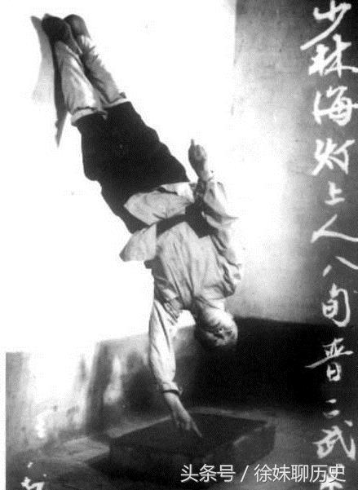
The image above is from the Chinese government documentary on qigong master Hai Dang demonstrating his "one-finger handstand." Master Hai Dang is the person George Lucas saw when he visited Shaolin and so Hai Dang was the secret basis for Yoda and "the Force." Hai Dang was also a teacher of my own qigong master teacher.
Here's what I am going to tell you in this story...
The creation of modern science covered up an ancient secret of how music was used for spiritual meditation healing energy as "the force." Science can't call it energy since "the force" is before classical amplitude energy. The Fundamental Frequency Force has a secret music theory explanation. In cutting-edge science it's also called the "hypertube" or "hollow tube" of a wave of energy. I'll explain what this means and how to experience it directly through a special meditation practice based on music theory.
Walter Russell, who also trained in music from a young age, may have had a similar music theory breakthrough but this analysis is relying on the most cutting-edge science as I will explain.
The previous two articles of this series talked about the use of dancing musical rhythm for generating spiritual healing energy, found in all cultures around the world but more specifically originating from our oldest human culture. I'm talking about the San Bushmen and Pygmy or Baka cultures from 100,000 years ago.
Jazz musician and former psychology Professor, Dr. Brad Keeney is considered an accepted spiritual healer by the San Bushmen culture and Keeney has written several books on their spiritual healing training - he calls it shaking medicine. His youtube channel even includes interviews with the San Bushmen female spiritual healers as the N/om healing energy is considered to be originally female (most of Nature relies on parthenogenesis as female reproduction).
Other good sources about our original human culture healing energy can be found in the work of Dr. Jerome Lewis, an anthropologist, and the "radical anthropology group" in the U.K. which was initiated by Professor Christopher Knight, author of the tome, Blood Relations. The "radical anthropology" group also has a YouTube channel and Vimeo channel containing their lectures.
These original human cultures are still alive and DNA science shows they are our original culture from 100,000 years ago. Pretty much all of modern science, even "alternative" or "counter-culture" science, ignores the true details of our original human culture, music, meditation and healing training. Archaeology has documented their spiritual N/om meditation training back to 70,000 BCE with the discovery of a snake statue representing N/om energy. Musciology research has documented the Eland Bull dance song to be the oldest spiritual training song that was unchanged from before the oldest human language dialects developed.
The key secret here is that the 3:2 polyrhythm, as dancing and hand clapping in syncopation to female singing all night long, is also the basis for the 2/3 subharmonic undertone of the Perfect Fifth that has to be "doubled" to create the Perfect Fourth in the octave equivalence symmetric music scale. Music theory in Western science relies solely on overtones due to the symmetric geometry lie.
Think of Asian throat singing for example - found in the Cossacks even of West Asian or Caucasian culture - it relies on undertones but also on meditative listening to ultrasound overtones that go into quantum, nonlocality consciousness as this article will explain.
The Perfect Fifth 2/3 undertone has to be doubled because 4/3, as Perfect Fourth, can inherently not be a natural overtone of the "fundamental frequency" or the "one" as per listening to the source of the one. This is because the denominator of 3 is not of the same pitch as a doubling of the one pitch when listening. This listening priority got covered up when the Greek Miracle of geometric symmetric magnitude was introduced via music theory to create Western science.
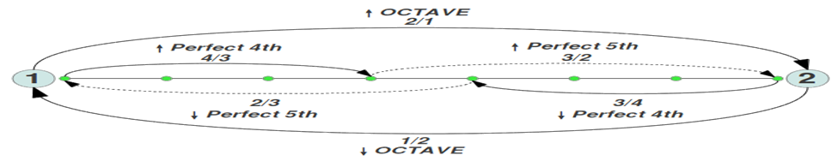
This "octave equivalence" music scale was the basis for creating commutative symmetric math as the "Greek Miracle" foundation of Western science, what's called the "Power Axiom Set" in logic, from the square root of two. The major 2nd music interval originated as 9/8 and was cubed as the first approximation of the square root of two. The square root of two as irrational or "alogon" magnitude secretly originated from music theory, as I will explain.
Did you agree with the Pythagorean Theorem in school? It's the most accepted proof of science and so, if you agreed, then you got brainwashed. There is something called the noncommutative Pythagorean Theorem that I will go into next.
In Egypt the area of a circle was approximated as 8/9 squared x the diameter. As we can see this is tied to the Egyptian reasoning that 2/3 was a sacred harmonic ratio that could not be simplified. The Perfect Fifth being 8/12 as 2/3 wavelength for 3/2 frequency while the octave has 9/6 or 3/2 wavelength for 2/3 frequency. This is because of the nonlocal time of 2/3 and 3/2 overlapping with the "one" that is not materialistic energy. Nonlocality is achieved through deep listening; Meditation based on time as a 5th dimension is rediscovered as the noncommutative imaginary number in Western science, as will be explained.
Generative theory suggests that commonly used rhythmic cells, in particular the 3:2 pattern, form the structural basis of many Pygmy/Bushmen timelines as well as many other timelines featured in African and African-derived music. Timelines are also multi-purpose musical devices used in various different social contexts and their structure appears to be resilient to radical change. Phylogenetic analysis of timelines provides no clear Pygmy/Bushmen ancestral timeline, although it is possible that foundational rhythms such as the 3:2 pattern may have featured in the music of a common ancestral group. (Poole, 2017)
A musical scale in modern science assumes an octave equivalence that is symmetric in geometric wavelength. Yet therein lies a great secret force waiting to be harnessed - not just for healing but also for the guiding energy of the future.
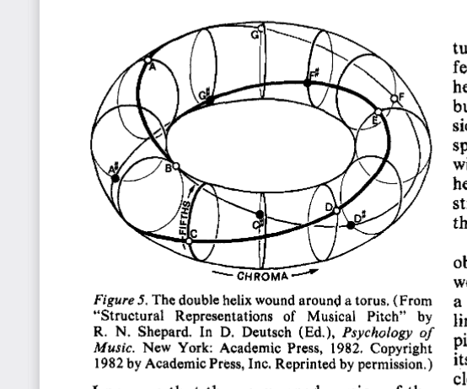
If someone knows this asymmetric time-frequency music secret, then they can see the lie hiding out in the open. The truth of music is as above – with a hidden 5th dimensional moebius strip. For example, the difference between the Harmonic Series and Overtone Series is rarely examined. Gurdjieff made this the secret core of his music spiritual teaching with the "Law of Three." This was based on the Perfect Fourth (i.e., C to F) or Fa creating a "lateral octave" as an undertone energy that powers organic life on Earth, originating from the "unmanifest sun."
If the extra force that enters at this point is the process of harmonic generation, it may be that this is the very action that we have observed to occur at Fa, which then generates the structure itself of the octave. Further, the 4th degree of the scale on Fa is Si; and it is precisely at this point that the second "interval" in the cosmic octave occurs, the one which was shortened. (Hodges, 2009)
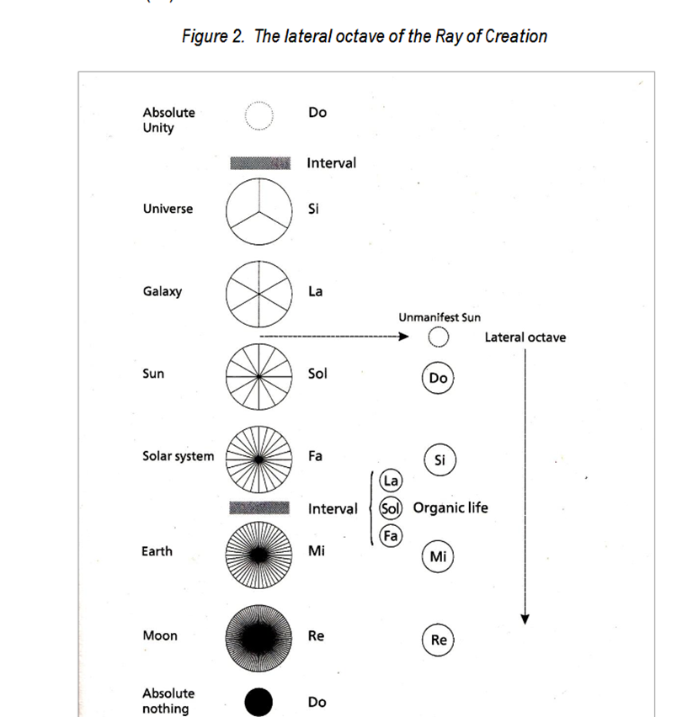
This all sounds too mystical yet the cutting-edge of advanced science (i.e. negentropy as the "hollow wave" or "hypertube" of light), as this article will explain, now confirms Gurdjieff's claim.
It turns out that the "Fundamental Frequency" as defined in science hides the secret music origins of Western math based on the wrong music tuning.
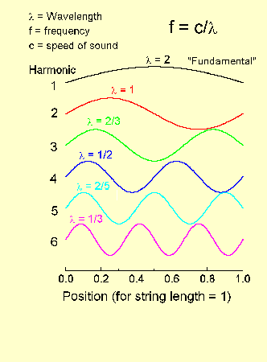
So, if you look closely, you'll notice that a wavelength of 2 is used for the "Fundamental Frequency" of the One or root tonic, whereas real musicians listen to the source of the One, in time-frequency force. Physics assumes that frequency is actually a "mode" of a symmetric "alogon" or irrational geometry magnitude wavelength, so that the "fundamental frequency" is already defined as an amplitude displacement, assuming an irrational magnitude symmetric measurement of time.
This article exposes this western music math as a lie – precisely from the liar of the lyre.
This lie was rediscovered when Planck's Constant was created for quantum physics. As Peter Pesic (2014) details, Planck was directly inspired to equate his "average energy of light" via the equal-tempered music scale. Planck converted time-frequency energy of light into a symmetric radians as seconds unit measurement by using density of joules for energy. This conversion cancelled out the seconds as time of light inverse to the frequency while covering up the asymmetric time inherent to frequency.
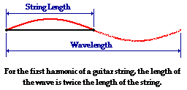
In science it is claimed that a half sinewave is the basis for integers as the number of waves: "In this pattern, there is only one-half of a wave within the length of the string. This is the case for the first harmonic or fundamental frequency of a guitar string." The question remains - wavelength of what since it's physically longer than the actual string! Notice the bait and switch. The first image states that the wave is twice the length of the string, and then the explanation states that the wave is one-half within the length of the string (implying the string continues on for the 2 but it does not).
This is a logical error since a wavelength of 2 is the double octave with one half as the frequency as its inverse due to the principle of Pythagoras. There is no need to define time as a symmetric geometry magnitude and, in fact, that is not accurate. What quantum physics discovered is that the half sinewave was actually a 1/2 integer for the 1/2 spin that is superluminal nonlocality as "the force." So, for example, the electron with 1/2 spin requires a 720 radians geometry for it to complete its cycle in time-frequency as a particle existing in a zero point of space. This is called and demonstrated as the "Dirac Dance" - and is the basis for quantum nonlocality from the 5th dimension. Before the 1/2 spin is converted to amplitude as geometric symmetric magnitude it exists as the imaginary time-frequency that is asymmetric.
The symmetric lie is justified by claiming that if a person "plucks" the 1 wavelength in the anti-node then it's not actually a double octave wavelength of two with an inverse one-half frequency. Instead we are told the wavelength of 2 refers to the "mode" of a symmetric circle: meaning by mode that the amplitude value at time zero and time 1 is zero. What this article argues is that, at time zero, there already is a future and past overlapping due to an inherent asymmetry to time that can not be seen as a visual measurement. I discussed this directly with quantum physics professor Basil J. Hiley who collaborated with David Bohm and Roger Penrose. Hiley will be quoted at length on music.
Of course, the commutative irrational math here is supposedly taking precedence over the listening process to the music harmony. This is what Alain Connes, who has the top science award, the Fields Medal, will be exposing along with my own music theory analysis. I realize that classical physics as "frequency mode" is relying on a Fourier analysis, as a time displacment of amplitude, to define the "fundamental frequency." But this is assuming Fourier Uncertainty or time-frequency uncertainy as a linear operator. I will explain why this is a lie.
This plucking in the antinode claim covers up what in ancient Greece was called the Greater Perfect System or "double octave" of tuning the one. The Greater Perfect System of the double octave was the origin of the modern science math based on zero, using symmetric commutative logic of A x B = B x A for the square root of two - what was called the "Devil's Interval" or tritone. I'll go into the music tuning details later in the section discussing Philolaus, who didn't just pluck his lyre, but he flipped his lyre around! That's what I call the "Liar of the Lyre" bait and switch cover up. We need to realize, as Adam Neely, the famous youtube music theorist emphasizes, the "Devil's Interval" never really was banned. As Peter Pesic (2010), the academic on music theory science, points out, the square root of two in Western science did develop out of music theory (the major 2nd interval as 9/8 cubed).
This music-math connection hides a deeper truth that almost all scientists know nothing about: It's called "noncommutativity" or the fact that A x B does not equal B x A in time-frequency force in quantum algebra of music theory (contrary to the fundamental frequency in classical and modern science defined by the symmetric geometric magnitude).
I realize you are thinking, "what is noncommutativity, I've never heard of this word?" You can skip ahead to my final "Liar of the Lyre" section for the music-math details, or you can steep yourself in the mystery for now, like a murder scene in the opening of a movie. I will begin presenting clues. This noncommutativity can also be called in science "asymmetry" or "antisymmetry" or "spontaneous symmetry breaking." I used to call it "complementary opposites" before I knew the fancy science terminology. Sometimes this noncommutativity is also called "torsion" or "scalar" force but that is due to lacking the proper noncommutativity analysis.
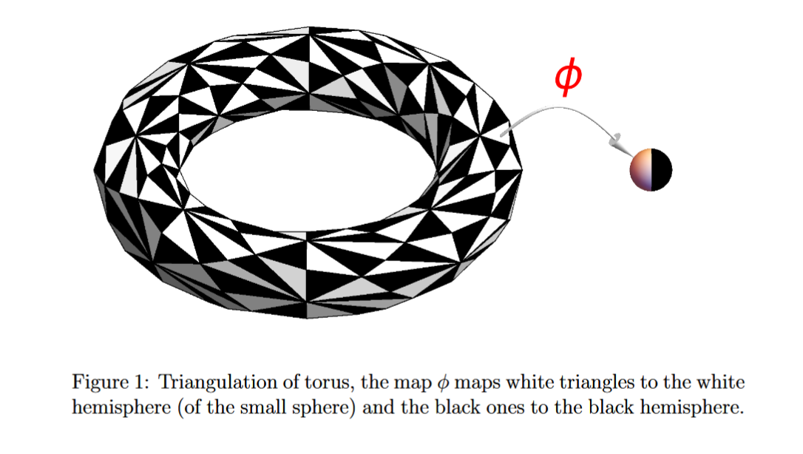
So, as per Conne’s “Music of Shapes” lecture, this image is the same noncommutative torus of the music theory torus as the image above (footnote 56). Consider that for each zero point there is a 5th dimensional noncommutative overlap of the future and the past (2/3 and 3/2), due to the quantum sphere, as Connes explains below. Notice that the white triangles are sometimes on the other side of the black and white sphere and vice versa. So the noncommutativity simply refers to the change of order in time.
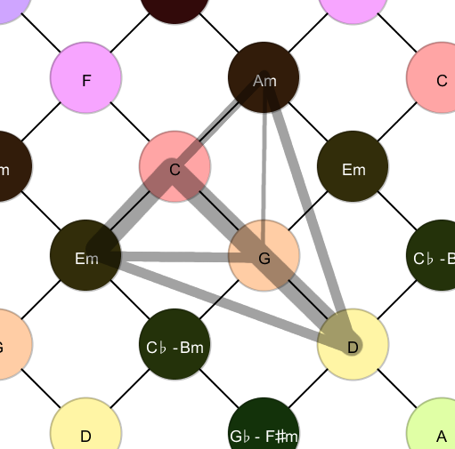
For example if you put your boots on and then try to put your socks on over your boots, there's going to be a problem! (Unless of course you need some extra traction on the ice!) Same thing here: Standard symmetric based science is very "precise" - we all learned that A x B = B x A in basic math, but it's not accurate! Hence the deep problems on the planet today.
How some certain symmetries in your physics, when you break the symmetries, you create a resource, for example [quantum nonlocal] entanglement. So that is something super new that we want to do and is very interesting. If you move along a time-like, ... observer that is inertial or uniformly accelerated, you don't change the entanglement. Entanglement changes when you break that symmetry, ... symmetry of your spacetime. So, when you break that symmetry, you create a resource. And I think this is a completely new idea... there is curvature of space at a few centimeters. (Fuentes, 2013)
So, what this means is that there is a "negative frequency" and "reverse time" guiding principle of the Universe that is also the Fundamental Frequency Force guiding all the cells and molecules and atoms of our body, mind. It's even guiding each zero point of spacetime, as signals from before the Big Bang. I kid you not - this is precisely what Nobel Physicist Roger Penrose argues and Ivette Fuentes, quoted above, is testing out Penrose's argument. We can train to listen to this Fundamental Frequency Force as the Natural Tuning of the Universe so that we can even create a new zero point in spacetime. "This spacetime structure emerges, through the transactional process, from an underlying reality of possibilities: 'Quantumland'"(Kastner, 2015). This is what Sir Roger Penrose, the recent Nobel Prize winner in physics, called "Fundamental Time" from noncommutativity of the imaginary number. I'll quote him about music soon.
Normally time for position in science, the geometric position based on magnitude relies on the classical science idea of time as an external, objective, linear arrow. Yet in our original or traditional orthodox Pythagorean music theory, and now in quantum physics, we realize that every time a measurement is taken there is a velocity inherent in the measurement also as a discrete integer of time that is secretly synchronizing the phase from the future. This is what the imaginary number is describing in quantum physics as the relativistic phase of "reverse time" due to "negative frequency." (more details later).
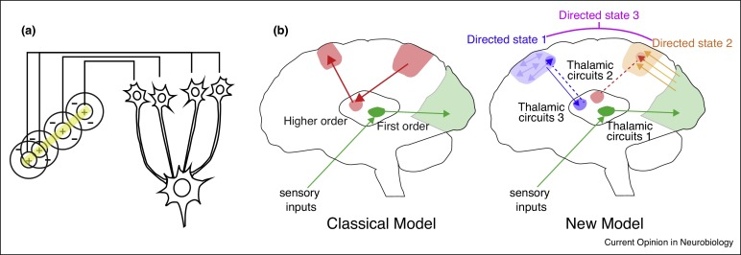
Our ancient human cultures knew this truth of "reverse time" and "negative frequency" from the experience of deep musical training relying on full body-mind and spirit transformation via meditative visualization while dancing for hours - all night long during the Full Moon energy that synchronizes our pineal gland with our neurohormone energy.
Just realize that our primate origins stem from millions of years in the equatorial rainforest where listening is the primary perception, not three-dimensional depth vision. Eventually through deep training this enables five dimensional vision - seeing in all directions out of the brain with the third eye fully open. This also enables long distance healing and precognition and on a deep level - even levitation and antigravity.
By deep musical listening we can naturally ionize the neurohormones of our lower body. By way of our right-side vagus nerve we can then increase our neurotransmitters to activate the tryptophan in our neuron tubulin as a quantum "meta-material" or relativistic antigravity negative frequency, and reverse time's natural tuning force. This secret has been recently corroborated by the research group of Roger Penrose and Stuart Hameroff via research physicist Dr. Anirban Bandyopadhyay.
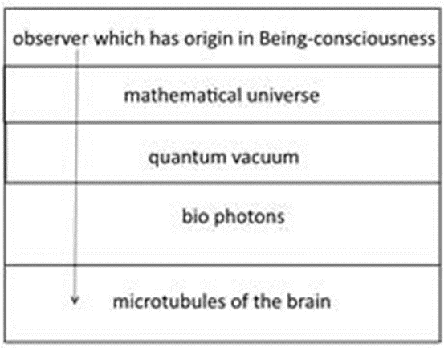
When a person achieves this natural tuning of the Universe they then have a strong force of electromagnetic energy not just filling up their body and mind but literally creating a spacetime pulsation. How can we create a new zero point of spacetime itself? Because this natural tuning of the Universe is from a "primordial" or "primitive" time-frequency force that is before the modern scientific definition of energy from the symmetric geometry of magnitude. Try to remember that the concept of zero as negative infinity, which Aristotle was against, originated from the concept of a symmetric geometric magnitude ratio as the continuum line of music tuning. This concept covered up the deeper truth of music tuning that this article will reveal - by referencing Philolaus himself who lied when he flipped his lyre around for his new Western "Greek Miracle" tuning claim.
We were lied to at the origins of Western science so that even the concept of Hertz wrongly assumes a "linear operator" of time and frequency, called "time-frequency uncertainty" or Fourier Uncertainty, that is the basis of the quantum physics "measurement problem." Basically this means that for a more precise frequency it takes a longer time to tune it and therefore the precise frequency of 3/2 from the One is considered literally impossible in standard science! We show this to be a lie.
Roger Penrose is arguing that it is precisely the collapse of spacetime, from a quantum nonlocal or superluminal superposition force, that creates what we perceive to be modern scientific consciousness or left-brain dominant thinking. Yet Penrose realizes that in deep music training it is possible to listen to the Natural Tuning of the Universe and to resonate with the Fundamental Frequency Force. As Penrose emphasizes, mass of spacetime originates from frequency due to the Louis de Broglie discovery of a standing wavelength or inverse frequency directly proportional to the quantum momentum energy. In science this is called the de Broglie-Einstein Relation but only Roger Penrose takes it to its logical conclusion and emphasizes this is due to noncommutativity at the origin of time-frequency force.
When one experimenter, Raymond Chiao, said that it didn't matter if it was superluminal because you could never send a signal this way, only random photons, he was wrong. To demonstrate this graphically, another physicist, Günter Nimtz sent a recording of Mozart's 40th symphony over four times light speed. And for your entertainment you can listen to that superluminal Mozart here. There's a lot of hiss, but it's hard to deny there's a signal. (Clegg, 2014)
Again, this is a very simple yet very radical exposé of science because Roger Penrose is relying on Alain Connes, as is Penrose's colleague, quantum physics Professor Basil J. Hiley (with whom I've corresponded). Hiley was the collaborator with both Penrose and David Bohm who built on Louis de Broglie's concept of a "pilot wave" guiding us from the future. As a group of researchers proved, "the superluminal acoustic effect we have described is likely a ubiquitous but imperceptible phenomenon in the everyday world" (Zyga, 2007). Puharich agrees:
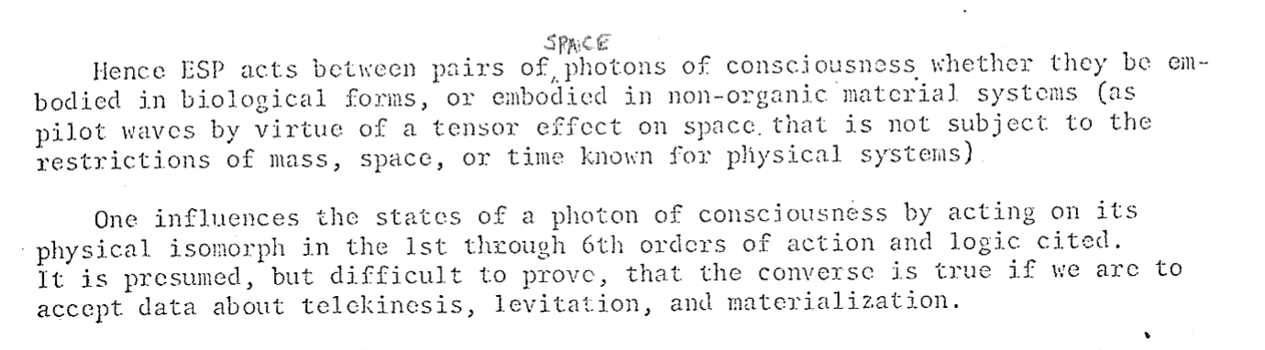

Because only Alain Connes and Basil J. Hiley understand this secret of music, hiding the Fundamental Frequency Force as the Natural Tuning of the Universe, I have therefore relied on extensive quotes from both Connes and Hiley. But I assure you readers that I had this same logical insight since I was a teenager when I noticed this logical error in music theory class. Then I realized that Pythagoras must have been correct as he taught that "All is Number and Harmony". Then I took quantum mechanics in my first year of college and realized this secret of nonlocality from quantum entanglement was also based on the same secret of the music tuning.
That quantum nonlocality music realization was in 1989-90 aided by my quantum mechanics teacher, Professor Herbert J. Bernstein. In 1999-2000 I did the intensive meditation training from a nonwestern (Daoist) spiritual healing master. For Pythagoreans the training required five years of silent cave meditation while deeply listening to the guiding of the source of sound as the musical "natural tuning" of the Universe.
My qigong teacher did similar training with 28 days of nonstop full lotus or padmasana yoga meditation in a cave at Mt. Qingcheng - with no sleep and no food the whole 28 days.

Dr. Peter Kingsley, who did his Ph.D. on Pythagorean philosophy, reveals that the "counter-Earth" or alchemical Hearth was in the lower body and was the required descent into Hell to harmonize Earth with Heaven via this natural tuning process. This is where Yang as the Perfect Fifth undertone harmonizes as the unutterable deep listening music secret of the Fire under the Water of yin (the Perfect Fourth); to then create the reverse time and negative frequency "fundamental force" of the Universe.
Osiris was the energy of the Full Moon, but after the third day past the Full Moon, what the Egyptians called the number 17 as the "abomination" of Pythagorean energy, the natural tuning was lost and the descent into Hell occurs. This was explained by the fact that 17 could not equally split the 9/8 or Major 2nd music interval derived from the sacred fraction of Egypt that could not be simplified: 2/3 as the Unutterable Phantom Tonic, as this article explains in detail.
Now let us take a "descent" into the music-math details to expose this secret of antigravity energy healing meditation training.
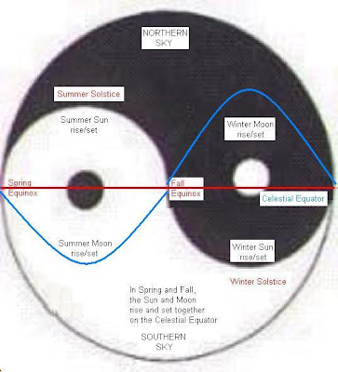
INTRODUCTION
Having played free jazz piano with street flutist Roland Botelho for an intensive couple of years (1994-5), I can relate to the peer-reviewed article on paranormal music by Emeritus Professor Stephen E. Braude:
Often enough to be really interesting, jazz players will suddenly and simultaneously hit upon the same unusual or unexpected musical idea ... as if they had experienced something telepathic ... an unusually successful joint improvisation ... might feel as though their time 'in the zone' was a brush with the paranormal. (Braude, 2020, pp. 281-3)
Nobel Physicist Sir Roger Penrose recently, as with Braude, also claims that a pianist is accessing the paranormal:
If you think about a pianist playing a very complicated piece of music and the little finger has to decide which key to hit. ... Is there any control of the sort of mood that is going to be put into the playing, ... I think there would be some conscious control and that conscious control could be making a decision between [quantum nonlocal] superpositions which have not yet resolved themselves into one or the other. And that can happen in this retroactive way. (Penrose, 2021)
Like the synchronicity between Braude and Penrose, I had a similar parallel connection about music with Fields Medal Math Professor Alain Connes whose work is the foundation for Penrose and Hameroff's noncommutative music model of protoconsciousness (Marcolli & Penrose, 2021; Hameroff & Laron, 2015).
[noncommutativity] is inscribed in a time that would no longer be sequential, because a score is a multitude of chords, a tangle projected onto physical time of course, but that manifestly evolves in a higher dimensional space, giving rise to a variability much more pertinent to the description of individual time. ... reading a page of polyphony, as does a conductor, is much more difficult. ... And [noncommutativity] could be formalized by music. ... I think we might succeed in this way to educate the human mind to deal with polyphonic situations in which several voices coexist, whereas our ordinary logic only allows room for one. (Connes et al., 2001, pp. 169-171)
Immediately I could relate to the concept Connes was conveying as I had studied orchestration when I was a teenager - taking private music training from a former University of Minnesota music professor. So then in my The Secret of Psychic Music Healing article I wrote,
Another way to understand this concept is that C-G is 2:3 but G-C is 3:4. Nonwestern music violates the equipartition principle that is the foundation of Western science and nonwestern music creates an infinite "spiral of fifths" resonating from the tetrad: 1:2:3:4. ... top scientists like Alain Connes argue that music theory provides the formal language to understand quantum logic. (Hempel, 2006)
The publisher asked me for a follow up article to clarify the concept and so in 2007 I wrote:
So for the Tetrad A:B is 2:3 and B:A is 3:4 against the commutative property, A x B = B x A. In music theory this complimentary [sic] opposite inversion of the perfect fifth and perfect fourth is taught as 2:3 is C to G while 3:4 is G to C. This process of complimentary opposites is listened to, as the perfect fifth, perfect fourth harmonics, which create all the notes. Most importantly the complimentary opposite harmonics transduces sound throughout the whole energy spectrum, as I've described in previous articles. (Hempel, 2007)
It was with a sense of great relief to find my noncommutative music model argument corroborated when I discovered Alain Connes lecture, "The Music of Shapes, Le point de vue spectral en mathématiques et en physique, la musique des forms," that he gave first in 2011 and recently again in 2021. Math Professor Connes explains noncommutativity as a "universal scaling system" of "discrete scaling that manifests itself in acoustic systems ... where the two scalings correspond, respectively, to the passing to the octave (frequency ratio of 2) and transposition (the perfect fifth is the frequency ratio 3/2"; "It is precisely ... [this discrete double quotient process] which is responsible for the noncommutative nature of the quotient corresponding to the three places {2, 3, ∞}" (Connes & Marcolli, 2004). How does Connes relate this back to quantum physics? He's making a logical argument about the same mathematical structure: "It is precisely this lack of commutativity between the [symmetric geometry] line element and the [discrete noncommutative inverse frequency] coordinates on a space that will provide the measurement of distance" (Connes, 2000).
In Connes' later published book version, there is crucial clarification: "The fact that the ratio log 3/log 2 is only approximated by the rational number 19/12 is responsible for the difference between the 'circulating temperament' of Baroque music (e.g. the Well-Tempered Clavier) and the 'equal temperament' of XIX century music" (Connes & Marcolli, 2007, p. 388). The music-math details will be explained later. What this discrete noncommutative "spectral invariant" means is that the rational inverse ratios have an organizing information that is quantum nonlocality as the process of time. Connes: "A fascinating aspect of music ... is that it allows one to develop further one's perception of the passing of time. This needs to be understood much better. Why is time passing?" (Connes, 2010).
Noncommutative music is "not a value of a number but a mathematical structure" that is "behind the scenes all the time" and this means "musical shape has geometric dimension of zero" (Connes, 2012). Earlier Connes explained that:
The real musical scale, the one that is sensitive to the ear, well, there is no simple shape to which it corresponds. ... there is a really interesting object that seems to answer the question ... the quantum sphere ... the algebra which is going to intervene is not necessarily commutative. (Connes, 2011)
More recently Connes states noncommutativity is a "topos which should be very natural to a musician" (Connes, 2021). Connes delivers the stunning implication: "If you want the algebra that is used by the Universe it is of the same type - it is something that is very simple ... but it can not be commutative because the commutative creates a collapse" (Connes, 2021). Logically, since gravity uses commutative geometry, therefore gravity emerges from noncommutative quantum nonlocality as explained in detail below.
Everything in the 'normal' world is noncommutative, so why is the paranormal noncommutative? (Borzacchini)
"Perhaps it is not a coincidence that these authors (founders of symbolic algebra) also made important contributions to the music mathematical theory" (Borzacchini, 2011). Now retired math Professor Luigi Borzacchini (pronounced BorzaKini) continues in his email reply to me:
In my opinion, instead, commutativity is paranormal ... The need of an axiom to establish commutativity became necessary because in symbolic algebra it means that a b = b a, something absolutely not normal! (Borzacchini, personal correspondence, January 7, 2022)
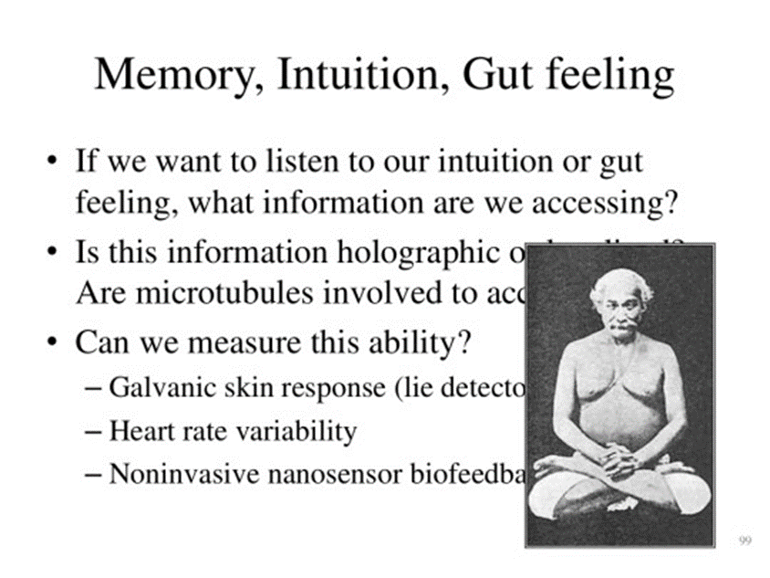
What are the implications for the paranormal?
Connes on the empirical truth of noncommutativity: "Something Heisenberg discovered, which is absolutely amazing, is that when you repeat certain microscopic experiments, the results will never be the same" (Jackson & Connes, 2021). The paranormal yogi Yogananda promoted the phrases, "ever-changing, ever-new, ever-fresh" and we can start to see the true meaning of it. Professor Jack Tuszynski features the teacher of Yogananda, Lahiri Mahasaya, in his power point talk on quantum biology protoconsciousness (Tuszynski, 2016, image source for above & below).
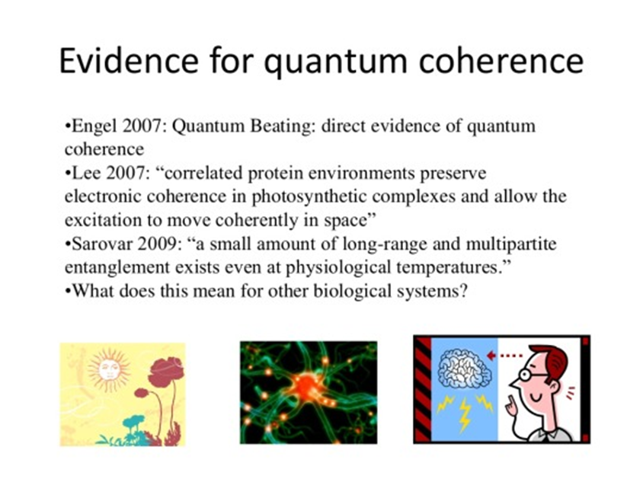
Professor JohnJoe McFadden, one of the founders of quantum biology, explains the no repeatability paradox is resolved through acoustic quantum phonons:
Coherence in biology seems to be maintained by molecular vibrations. [acoustic phonons] This is why quantum coherence, entanglement and tunneling in biological systems is puzzling, because they are hot, messy, noisy where you wouldn't expect coherence to survive for very long. But it does ... Biology has somehow worked out how to use vibrations, use molecular noise, to maintain, rather than destroy coherence. There's a lot of evidence for that. (McFadden, 2014)
This quantum biology resonance coherence, physicist Pascual Jordan insisted in the 1930s, was amplifying from "intuitive meaning" of "noncommutativity" (Howard, 2013). Quantum physics Professor Basil J. Hiley, the collaborator on David Bohm's extension of de Broglie's noncommutative quantum foundations, makes the same point as Connes:
The mathematics that is necessary to describe the holomovement is a non-commutative algebra and this way of looking at physical processes has a very profound impact on what we mean by the very notion of 'existence'... In the context of the holomovement, any change of the experimental conditions will change the overall structure process. But it must happen in a way that cannot be achieved by using the laws of classical mechanics. It turns out that this feature is beautifully captured by the non-commutative geometry ... Since we started this work, mathematicians have been developing what they call 'non-commutative algebraic geometry' and what one finds is that if we go deeply into this new mathematics, we find that the standard quantum formalism is but a fragment of this new geometry. This is not surprising because the mathematics was inspired by the standard quantum formalism. (Hiley, 2015)
Hiley emphasizes this secret of a newly discovered nonlocal energy: "a new form of inner energy possessed by the particle, organising the flow lines in a novel way and suggesting a 'formative' cause ... quantum phenomena emerged from a non-commutative phase space" (Hiley, 2016). By utilizing the noncommutative phase logic, Hiley distinguishes this new form of "inner energy." Hiley states:
Somehow the 'quantum force' is a 'private' force. It thus cannot be regarded as a distortion of some underlying sub-quantum medium as was originally suggested by de Broglie. It is independent of field intensity, thus fulfilling a precondition for non-locality, and it carries information about the whole experimental arrangement in which the particle finds itself. (Hiley, 1995)
Hiley also makes the connection to music as being noncommutative quantum logic:
To make this clearer let us consider what happens when we are listening to music. We do not perceive the individual notes directly. Rather the notes enter our nervous system in which they are enfolded. There we have a memory of the notes past, and we have an anticipation of the notes to come. It is the tension between the two that creates an active continuous movement in our nervous system which generates our experience of music. In the language we are using, we perceive directly the implicate order and it is only afterwards that we explicate the structure of the score as an intellectual exercise rather than an experience of the music. Indeed, composers experience the sensation of the whole movement before writing the score. The score is then structured in such a way as to stimulate a reaction in the nervous system of the listener that corresponds to the one originally experienced by the composer. Thus what we call consciousness is the unfolding activity of what is enfolded in the nervous system. (Hiley, 2015)
Again, just as with Connes, Hiley emphasizes the noncommutativity truth of reality:
The structure that you, that we, were finding was a non-commutative structure; it was the structure that the early guys [of quantum physics] that you had up there were using, but then they went on to operationism because they wouldn't stay with the non-commutative ... non-commutativity to find out what it meant geometrically or what it meant ontologically. (Hiley, 2017)
The parapsychological implications are lurking just under the surface as Hiley recognizes with the connection to nonwestern philosophy: "Then, of course, they thought we'd gone mystically East. But I mean the quantum potential is not a classical force. It's not a classical potential. It's something extraordinary, very strange. It doesn't get propagated, as far as we can find out" (Musser, 2013). And Hiley (2012) states: "Certainly that's [the paranormal] a possibility and that's why people get scared of it."
So as Hiley alludes to, noncommutativity has also been key to explaining the paranormal. Eddie Oshins, working at Stanford Linear Accelerator Center (SLAC), argued that "this property of noncommutivity [sic] in itself might be valuable in some way. My claim, and original idea, has been that this is circumnavigating a T'ai Chi (Yin/Yang) symbol!" (Oshins, 1998). As I'll give more details, Oshins also calls this noncommutativity the basis of "Noi Kung" or paranormal neigong as an example of "quantum psychology." For follow-up analysis see Oshins' collaborator, Math Professor Louis Kauffman, in his article, Noncommutative Worlds, ... "I particularly thank Eddie Oshins" (2004). Oshins passed away in October 2003 but fortunately he had already developed his noncommutative Physics of Tao analysis:
Identification of parallel roots in the development of Taoism in China, and ... by Anaximander [who taught Pythagoras] in Ionia, Greece ... The empirical demonstration of Eddie Oshins' work on self-referential motion and the hunt for psychic torque. (Oshins, n.d.)
Former Hampshire College quantum mechanics Professor Lawrence Domash also identified the noncommutative music model when he wrote on paranormal yoga meditation:
The macroscopic analog of stimulated emission (alluded to before in connection with the mantra) ... the role of the mantra ... to electrically correlate and quiet millions of neurons ... in such a way that a latent biophysical phase correlation at a quantum macromolecular level is permitted to manifest itself among them ... due directly to the non-commutative properties of the field operators. (Domash, 1975, pp. 659-663)
Harold Atmanspacher (2014) has emphasized "Non-Commutative Operations in Consciousness Studies: For reasons easy to understand, non-commuting operations must be expected to be the rule rather than the exception for operations on mental systems." Atmanspacher follows up:
There are two major extraphysical directions in which non-commuting operations, the basis of complementarity, have been applied in the past 20 years. One of them refers to fertile new insights in psychology and cognitive science ... and other cognitive processes using quantum concepts. (Atmanspacher, 2016)
Music resonance is often recognized as of crucial significance in science (i.e., the "music logarithmic spiral" concept key to Philosopher of Science Professor Oliver L. Reiser's UN thinktank work). Philosopher of Science Sir Karl Popper wrote:
This means that, as in Kepler, it is resonance - and thus harmony and dissonance - which govern the world ... Kepler's Harmony of the World acquired scientific status only with Louis de Broglie and Erwin Schrödinger ... Wave optics, in turn, takes its orientation from musical theory, from the theory of acoustical vibrations and waves, resonance and dissonance. But in this theory Kepler and his doctrine of harmony - Hence Pythagoras in the end - plays a decisive role. (Popper, 1999, p. 75)
Nobel Physicist Louis de Broglie considered his Law of Phase Harmony as his greatest discovery, based on the Pythagorean insight that as a particle goes towards the speed of light the quantum frequency increases while, paradoxically time also gets bigger (slows down) due to relativity. Logically this proves there must be a reverse time and negative frequency energy that is in phase harmony and guiding the particle from the future. From the invariance of light as the observer, a superluminal phase wave guides, from the future, the space ship (our brains):

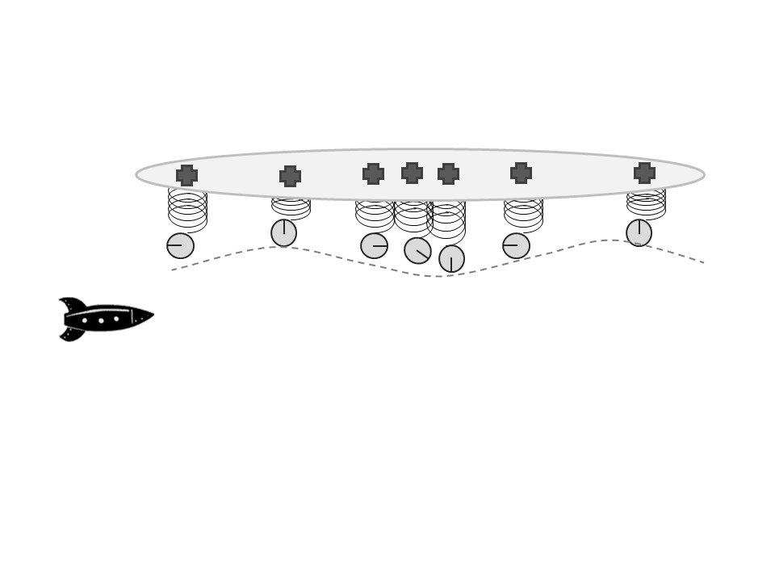
Professor Yakir Aharonov's entangled reverse time photon weak measurements have empirically corroborated what's now called the de Broglie-Bohm model. Professor Basil Hiley reveals that "the Bohm approach has its origins in non-commutative algebra" (Hiley, 2018) and continues:
Energy is the thing that is non-local ... you could use the formalism to measure these things locally they're called weak measurements ... we're not supposed to say anything about what happens between the [quantum double] slits and the screen remember yeah, but we can actually construct the momentum, we can actually draw little vector diagrams, and we can construct the trajectories with this new [weak] method of dealing with things ... in fact, quantum processes are organic so already we're beginning to say that maybe this is where we can get into biology ... therefore we must change our view of reality and this is the important point about changing our view of reality to get in to see how mind works...
Implicate order is algebraic ... more important it's in the brain, there already, the order is in the brain; you're trying to make it explicit ... and music, and also, in music, you actually, you anticipate; you've got the memory of the past anticipating the future and that is inside you, so you are actually experiencing the implicate order directly through music ... it's in the algebraic structure that it's a much clearer way of seeing what is going on then; it ties directly with non-commutativity and therefore you're developing a non-commutative geometry ... the process is going on whether we're there or not; it's got nothing to do with us. (Hiley, 2021)
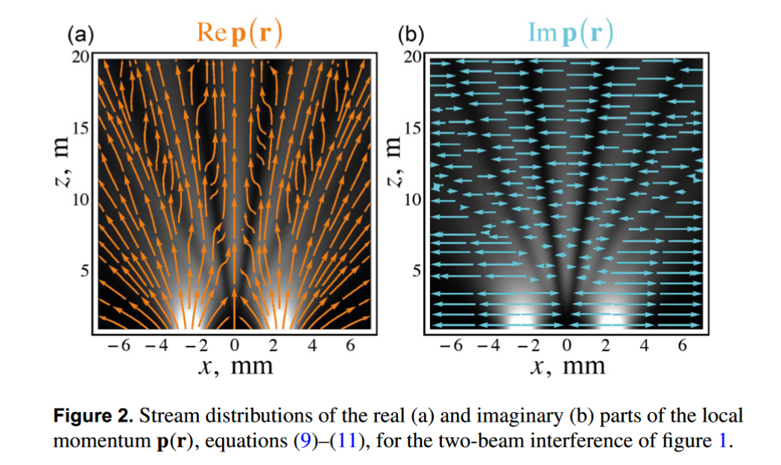
Yakir Aharonov corroborates Hiley's interpretation: "Alternatively, in the Heisenberg picture, the particle has both a definite location and a nonlocal modular momentum that can 'sense' the presence of the other slit and therefore, create interference" (Aharonov, 2017). Dr. Juliana Brooks (2009) revealed this error of quantum physics as directly from the standards of measurement units for Planck's Constant:
The photon, as historically defined, is a time dependent packet of energy, based on the arbitrary measurement time of one second ... An arbitrary one second energy increment cannot be a truly indivisible and elementary particle of nature ... The variable for measurement time was relegated to an invisible existence as a hidden variable, with an implicit and fixed value of "one second." ... Planck thereafter adopted the methods of Wilhelm Wien to convert the experimental black-body data, from time dependent energy measurements to energy density measurements seemingly "independent" of time.
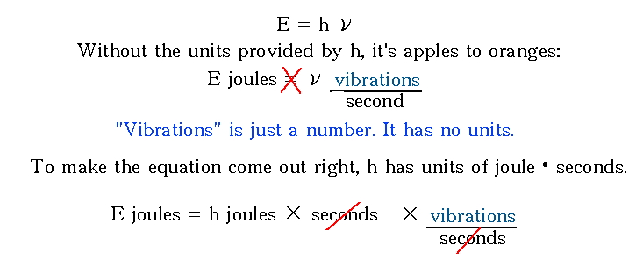
Juliana Brooks does not understand the noncommutative phase logic of Alain Connes but as Connes emphasizes: "The current definition which using the speed of light as a conversion factor is expressed in terms of inverse-frequencies rather than wavelength" (Connes, 2009). Remember that it is precisely the discrete inverse frequency as undertone of 2/3 that also reveals the noncommutative mathematical structure in Pythagorean music theory.
De Broglie's protégé, Olivier Costa de Beauregard, a member of Princeton's Institute of Advanced Study, argued this asymmetric time from the future, due to negative frequency, proved the paranormal is, de facto, real. Costa de Beauregard calls this process a "factlike time asymmetry" or retrodiction of "negative frequencies" with time-frequency noncommutativity as a macroscopic measurement. Psychokinesis originates from precognition as a protoconsciousness organizing information will power (Costa de Beauregard, 1978). The CIA "released" the Costa de Beauregard paper from classified status in 2000, with all the paranormal references underlined:
Finally, what would the phenomenology of advanced waves, ... and information as organizing power look like? Exactly to what parapsychologists call precognition and/or psychokinesis. Logically these phenomena should show up, no less than thermodynamical progressing fluctuations - which indeed they are = (Costa de Beauregard, 1978, emphasis in original)
Alain Connes makes this negentropic noncommutative quantum connection to music:

xy is not necessarily equal to yx ... from xy to yx corresponds to what evolution yields for the purely imaginary value t = √-1 ... inner automorphisms and these are in a sense invisible ... the link between time and thermodynamics ... it is very difficult to escape the one-dimensional model of time ... language is a prisoner of sequential writing ... Several melodies can coexist and a dialogue can be established in the same instant ... Music is an outline of a language that is inscribed in a multi-dimensional, not sequential framework. (Connes et al., 2001, p. 168)
Aharonov also implies the paranormal power of this reverse time truth:
Not only will they have the opposite charge, but they will also have the opposite mass. The gravitational field that they produce here will be the same as a gravitational field of a negative mass. This is weak value, and you can check it experimentally if you can do the experiment. (Aharonov, 2016)
Citing Connes, math Professor Micho Durdevich confirms the Pythagorean noncommutative quantum paranormal protoconsciousness:
On the other hand, the ancient Pythagorean musical scales naturally lead to a simple quantum circle ... will be quantum (noncommutativity of the algebra V) ... However, even in this case there is a highly non-commutative world of higher order collectivity algebras B(n). This can be used to capture the geometry of rotations, like those appearing in the classical Pythagorean octave versus perfect fifth considerations. (Durdevich, 2015)
The Secret of the Sect:
A Deep 'Preestablished Disharmony'
Math Professor Luigi Borzacchini reveals that the true music origins of Western science were a "secret of the sect" that is "shocking" and "really astonishing." (Bozacchini, 2007) For the orthodox ancient Pythagoreans, as Borzacchini (2007) points out, "We can suppose that the Quadrivium in its earlier Pythagorean version did not know any discrete/continuous opposition." I will return below to this noncommutative discrete/continuous connection. "Music ever since antiquity and until 17th century was a sort of 'open wound' of the relationship between discrete and continuous, between arithmetic and geometry" (Borzacchini, 2011).
Pythagoreans discovered, "that the chief musical intervals are expressible in simple mathematical ratios between the first four integers. This single discovery would account naturally for all the most characteristic of Pythagorean doctrines" (Kirk & Raven, 1964, p. 229). The footnote mentions that the Pythagoreans practiced purification of the body and soul by medicine of music based on reciprocity of opposites.
Soon though the "Greek Miracle" of irrational magnitude "alogon" math was achieved through Archytas, Eudoxus and Euclid and promoted, most importantly, through Plato (McClain, 1977). Yet Math Professor Borzacchini (2007) is pointing out that there was an ancient paradox of logic that still has not been solved in the West. "Continuum is not only inexpressible, but also external to the knowledge of reality" and the geometrical continuum can not be proved coincident with the numerical one, that it cannot be empirically verified, that the place of the numerical continuum in the transfinite hierarchy is one of the greatest so far open questions, that it is linked to the most disputed axiom of set theory, etc. (Borzacchini, 2007)
Borzacchini is explaining that the "Greek Miracle" of irrational magnitude math created "incommensurability" and, as a syntactic paradigm, has been "marked in its basic principles with a preestablished disharmony, that is even its hidden evolutive principle" (Borzacchini, 1998). Elsewhere Borzacchini elaborates, "there was a deep 'preestablished disharmony' ... this disharmony grounded many logical paradoxes that endure up to the present time" (Borzacchini, 2010).
And so, the true music origins of the irrational magnitude math were originally a "negative judgment paradox" (impossibility of asserting falsity) that had to be covered up. As Borzacchini (2007) points out, "Such paradox forbade speaking about what is not." The earliest known use of Logos, in Heraclitus, refers to it as a fiery creative soul while alogos is when the fiery spirit, now incarnated in the body, becomes too wet (Finkleberg, 2017). This concept for the need of fire to go under water is closely tied to noncommutative alchemical meditation but as Kingsley notes the ancient meaning of wisdom was lost: "By the time of Plato and Aristotle, the doors of understanding were closed" (Kingsley, 1995). Borzacchini (2007) asked, "Why these silences? And why this sudden and radical change? Why the Pythagoreans' silence? The 'secret of the sect'?"
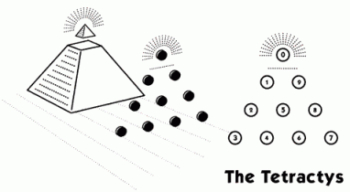
In 2001 Borzacchini replied to me with a written letter that my math-music equation was "good," but I had no historical proof that the specific equation had been used.
However, I think I can prove that in the Platonic Academy there was a trace of this earlier approach, with a tight connection between music, numerical means and similarity, and without any reference to geometric figures, such as square or pentagon. (Borzacchini, 2007)
Borzacchini (2007) had postulated a continued proportions music-math clue:
Many authors (Szabo, Knorr, Burkert) have discussed Boethius' text, and all of them have recognized a musical phase in the discovery of incommensurability ... Hence, when he wrote this dialogue, Plato had credibly a good acquaintance with the well-established 'geometric' theory of incommensurability, .. The trouble with 17 could be connected not to some geometrical construction, but to the role this number played in the Pythagorean arithmetic, where it was called the "obstacle," because it "broke the proportion of 9/8 in not equal intervals" (Plutarchus 1962, De Iside et Osiride, 367 f).
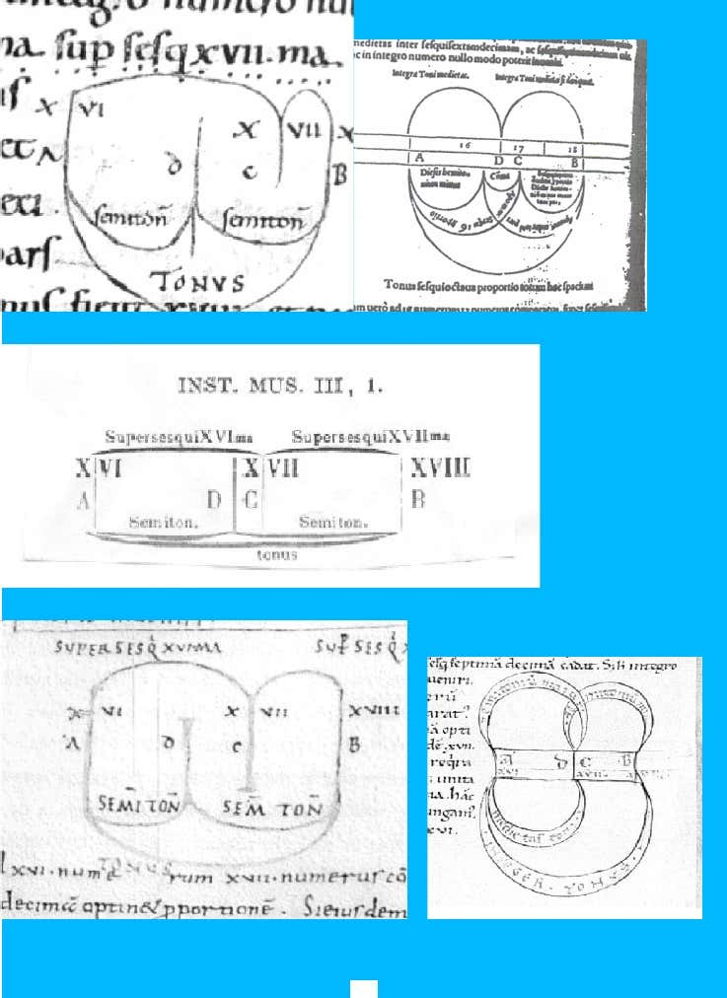
The Plutarch clue also emphasizes the uneven 9/8 from 17 as tied to the lunar energy cycle of Osiris with Osiris also defined by the Pythagorean triangle. The 12 note scale alchemy music meditation is also based on the lunar cycle. Plato was relying on his collaboration with Archytas who had changed Philolaus' term of subcontrary mean to harmonic mean (Kingsley, 2010, pp. 156-7). Borzacchini argues "it was exactly the possibility of the geometric drawing of a not-existent music interval to foster the development of the Aristotelian idea of continuity" (Borzacchini, 2007). This will be discussed below further: "Archytas says that this was formerly called the sub-contrary mean. Why was it so called? And why was its name changed?" (Makeig, 1981). And: "The term subcontrary may refer to the fact that a tone based on this mean reverses the order of the two fundamental musical intervals in a scale" (Bonar, Khoury and Khoury, 2016).
How I Discovered the Noncommutativity
Paranormal Music Connection is True
I had realized this noncommutative logical error in music when I took my first music theory class taught by my piano teacher in the evening adult class at McPhail Music School in Minneapolis. I was still in high school and soon after began private tutoring with her husband who had been a University of Minnesota music professor. I believed the logical paradox in music proved that Pythagorean universal harmony was true and when I took quantum mechanics as my first physics course, my first year at Hampshire College, taught by Professor Herbert J. Bernstein, I had another "aha!" moment.
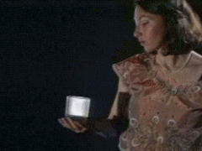
Professor Bernstein was teaching us quantum entanglement by his demonstration of the "Dirac Dance" (holding an imaginary wine glass while rotating your arm through 720 degrees and keeping the wine glass held up vertically).
It was not until I discovered Fields Medal math Professor Alain Connes 2012 lecture on music theory, posted on youtube, that I realized my concept had been corroborated. I had already tested out my music-math concept by doing intensive paranormal meditation training to finish my University of Minnesota master's degree in 2000. I first read Connes in 2001 but Connes' 2012 Music of Shapes lecture confirmed it truly was the precisely same concept.
Previously, in 1995 I saw a telephone pole poster for qigong master Effie P. Chow doing a qi-lecture demonstration. I was so skeptical that I called up to ask for a "half off" admission fee. When Effie P. Chow agreed, via the lady who answered the phone, I then took my girlfriend with me to St. Mary's University for the evening class paranormal power demonstration. Effie P. Chow said she was filling the room with qi and had us make "qi balls" with our palms facing each other. Sure enough, I felt a very strong magnetic force pushing my hands apart!
As the event was ending and half the people were gone, a University security guard wandered in and stated, "I'm just wondering what's going on in here because the fuse got blown in the room behind you." This was not staged because I did not even hear a response from Effie P. Chow, and I got kind of freaked out. This really got me intrigued to be sure and we soon left.
In 1996 I discovered a book on "biosonics" by Dr. John Beaulieu and it explained how "yang" is the Perfect Fifth and "yin" is the Perfect Fourth in music theory and the "emptiness" is the Octave. Suddenly I realized how the Pythagorean music intervals explained the paranormal! As arising from the Diapason or Taiji of the Wu Chi (the void), "the fourth and fifth work together as yin and yang ... The fifth and the fourth are the basis for the 1-4-5 chordal progressions found throughout music of all cultures" (Beaulieu, 1984, p. 47).
Of course, this was still not the noncommutative secret, but it was enough to go on for me to start calling these ratios "complementary opposites." And the basis of the qigong meditation training was called the "small universe" neidan internal alchemy or "microcosmic orbit," using 12 notes (the 12-note music scale created from the yin-yang energy) or energy nodes along the body, with the eyes closed, as a listening resonance practice. I realized that this meditation of 12 harmonic nodes was a harmonic energy-consciousness transduction training, the same as the "infinite spiral of fifths" as explained by Sir James Jeans in his book Science and Music. Jeans states, "It extends to infinity in both directions and all simplicity has disappeared" (Jeans, 1937).
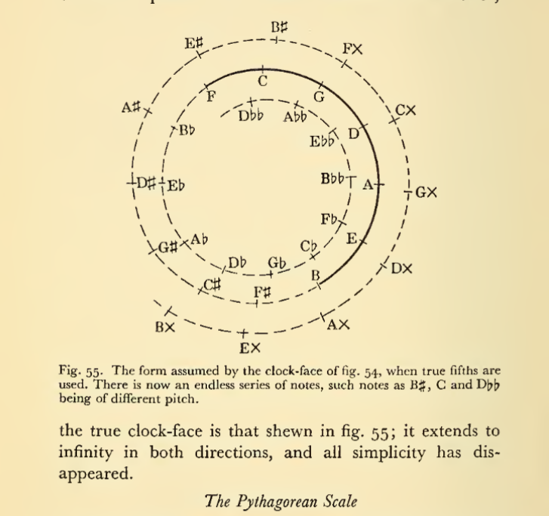
Qigong master Shen Wu (2016) gives us corroboration: "The Chinese "lü" tuning is closest to the ancient Greek tuning of Pythagoras." As qigong grandmaster Chunyi Lin says: “The simplest is the most powerful.” The Western bias, of course, is that music has to be equal-tempered so that there can be polyphonic harmony. But as Alain Connes emphasizes it is a conductor reading an orchestral score who then is forced to transpose different clefs as noncommutative spacetimes all at the same time - phase harmonized - which is the real example of proper Western polyphonic music. And this same truth applies then to the "double quotient" of the rational discrete fractions that as noncommutative exponents then cause a resonance energy transduction from beyond sound as a mechanical wave into electromagnetic energy and spacetime transformations. That was the traditional meaning of music in its nonwestern context as the "infinite spiral of fifths."
Before the idea of frequency existed, however, the same relation was expressed simply in terms of length, the length of a resonating agent multiplied by 2/3 being equivalent to the frequency multiplied by 3/2. The length of a zither string, then, multiplied by 2/3 gives a note which when struck is a perfect fifth higher than its fundamental. This is the first step (or lü) in a process which evolves an unending spiral of notes. The length of the resonating agent which sounds the perfect fifth is then multiplied by 4/3, the resulting note being a fourth below the perfect fifth. (Needham, 1971, my emphasis)
Later I found confirmation of my hypothesis from a Daoist scholar Pregadio writing on Chinese alchemy: "The twelve-stage sequence also establishes correspondences with other duodenary series: ... the bells and pitch-pipes" (Pregadio, 2015). And then we find Table 6: Sovereign Hexagrams.
The twelve "sovereign hexagrams" (biguas) and their relation to other duodenary series: earthly branches, bells and pitch-pipes, months of the year, and "double hours." (Wang, 2011, page 130)
Most music theorists would dismiss the infinite spiral of fifths as just modal math and thus no different than an "infinite spiral of thirds." The key logical secret missing was noncommutativity. In fact, the Pythagorean simple ratios were dismissed by the time of Galileo as a "coincidence of consonance" phase synchronization error. But that supposed error has now been corroborated:
The most frequently used intervals - the octave, perfect 5th and 4th - correspond to those considered the most consonant by culturally diverse listeners (Bowling & Purves, 2015; Burns, 1999), an observation that is all the more impressive given that the frequency resolution of the human auditory system is sufficient to distinguish hundreds of unique intervals (Parncutt, 1989; Roederer, 2008). (Bowling, et. al., 2017)
Recent science has confirmed the truth of the natural number simple ratio (Bowling and Purves, 2015).
Of the intervals studied (1, 4, 6, 7, 9 semitones), they found that in all cases the evoked potentials were at their highest (in terms of voltage) for two pure tones separated by a perfect fifth (7 semitones) when compared with other intervals. These results provide electrophysiological evidence that matches behavioural preference for simple frequency ratios (Lots & Stone, 2008).
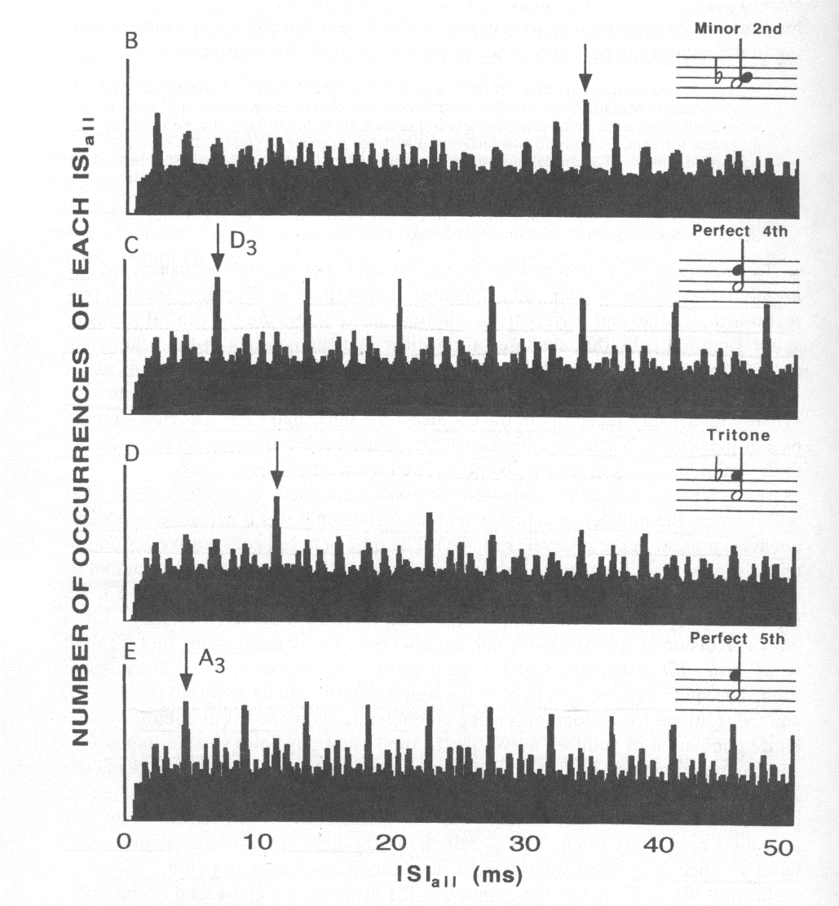
And again:
Until recently, the failure of most musical tuning systems to conform to the mathematics of small integer ratios was grounds for rejecting Pythagoras's proposal that small integer frequency ratios account for the perception of musical consonance and harmonicity [19]. However, recent modelling of the cumulative effects of physiological nonlinearities at each way-station of the ascending auditory pathway has disclosed the presence of 'resonance neighbourhoods' at whole integer ratio spacings on the tonotopic maps of the auditory system [20-22] ... The presence in humans of cultural patterns of musical practice conforming to these subtle resonances in auditory physiology accordingly requires an explanation. (Merker, et al., 2015)
Abdounur (2015) gives us one: "This implicit contradiction ... [noncommutativity] maybe a defense-mechanism of nature against order." Later I discovered this same 12 harmonic nodes as a body-mind meditation paranormal energy transformation taught in India and Tibet and West Asia also - see my Ancient Advanced Acoustic Alchemy self-published free docdroid educational book for details. For example:
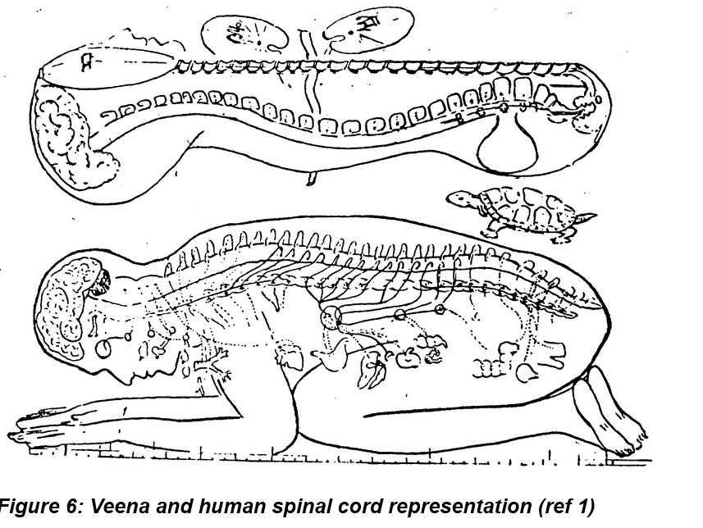
The notes of the scale as the energy points of the spine. Ref: Sriranga sadguru in Amaravani. The 24 frets of the (Veena) instrument are analogous to the 24 cartilages in the spinal cord. The number 24 also relates to the 24 syllables in the Vedic Gayatri mantra. (Prasad, 2002)
[Image Source: http://www.salagram.net/sstp-mgpuja3.html ]
So Lui is the character meaning spinal column. ... This character has one more interesting meaning 'frets' (of musical instruments) (1,5,6), the construction of which is similar with that of the spinal column. We should also mention that Chinese musical scale is also called Liu Liu (Jana, 2016 citing Akhmetsafin, 1989)
I met qigong master Chunyi Lin in 1999 when he gave a presentation to my "Spiritual Healing" class for my Liberal Studies master's degree program at University of Minnesota. By this time, I had read Harvard medical doctor David Eisenberg's book Encounters with Qi (1985) and Chunyi Lin looked just like the person in the book who had demonstrated telekinesis. And so, to finish my interdisciplinary Liberal Studies master's degree I did intensive nonwestern meditation training based on my Pythagorean music analysis, through the African Studies department as "self-directed research." Pythagoras was reputed to have trained in Egypt for decades and I had argued that the Platonic "natural law" was inherently racist due to the eugenics of the equal-tempered music theory, as explained by musicologist Ernst McClain's book The Pythagorean Plato.
The necessity of tempering pure intervals, defined by the ratio of integers, is one of the great themes of Plato's Republic. In his allegorical form, "citizens" modeled on the tones of the scale must not demand "exactly what they are owed" but must keep in mind "what is best for the city." (McClain, 1976)
Similarly, economics Professor Michael E. Hudson, who started out his college training in music, pointed out the ideological use of the equal-tempered music theory of Archytas and Plato. "Burkert [1972:441] notes that the harmonic mean discovered in the context of Pythagorean music theory has a major use precisely in approximating the square root" (Hudson, 2000). He continues:
Archytas developed the musical scale into a political metaphor for the scales of justice. What gave music this imagery of social balance and just proportion was the ability of its mathematics of harmonic ("geometric") proportions to serve as an analogy for how inequities of wealth and status rendered truly superior men equal in proportion to their virtue - which tended to reflect their wealth. By this circular logic the wealthy were enabled to rationalize their hereditary dominance over the rest of the population. (Hudson, 2000)
So, the cover up of noncommutativity of Pythagorean philosophy had deep disharmony implications indeed.
Importantly, the note scale is an additive one: we speak of moving up by a certain number of half-steps. On the other hand, at the frequency level, this change is multiplicative. The process of going from an additive measure of length to a multiplicative one leads us to what is arguably the most important function in all of mathematics, the exponential function, and its inverse the logarithm function. (Naiman, n.d.)
Plato changed the PreSocratic meaning of Apeiron or Cosmic Mother Emptiness as nonlocal formless awareness to the Archtyas "Liar of the Lyre" value of the irrational magnitude "alogon." Or as a scholar explained, "Magnitudes have all the characteristics Plato attributes to Apeiron" (Karasmanis, 2011).
In contrast, at the very first class in 1999 when Chunyi Lin walked past me while my eyes were closed, I did a "moving of yin and yang" qigong exercise and he shook his "Shaolin sword fingers" - suddenly I saw bright yellow light and I felt immense love as joy. By the end of my training in 2000, I had what my teacher called an "enlightenment experience" and I saw ghosts, experienced telepathy, telekinesis, and precognition, among other paranormal phenomena. I had proven my hypothesis true to myself and had permanently transformed my body-mind-spirit connection to the Emptiness, what the PreSocratics called the Apeiron or Cosmic Mother via Aeon. I could now feel a permanent magnetic bliss in the center of my brain, even after I stopped meditating for a couple months to see if the sensation would go away. I, too, also experienced a holographic universe, but it was based on noncommutativity, just as Eddie Oshins explained that Karl Pribram's holographic brain model is not accurate. I'll detail this below.
Pythagorean music training also required a meditation deep mind-body transformation (Lebedev, 2017). Chronos was the Orphic name for, according to Pythagoras, the serpent psyche of the Universe, derived from "Time Unbounded" in Iranian Zurvan philosophy - Chronos Aion. Aion was the "procreative fluid with which psyche was identified, the spinal marrow believed to take serpent form" (Onians, 1951). The original source was attributed to the Pythagorean Hippo.
Begotten by a wind ... a breath-soul ... armony ... drawn from the whole body ... gathers in the spinal marrow ... most of it flows from the head ... a Pythagorean quoted, "that the seed ... generative water of the marrow [aka cerebrospinal fluid] ... that breathes through the reproductive organ ... is a drop of the brain containing in itself warm vapour ... the union of the two serpents represent the life complete by the union of the male and female." (Onians, 1951)
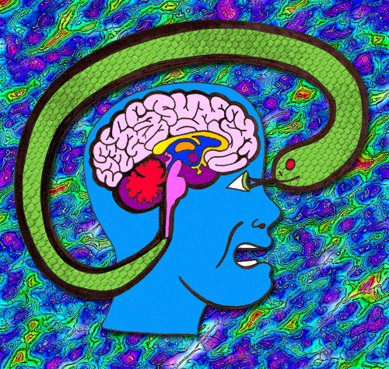
[Image Source: https://qph.fs.quoracdn.net/main-qimg-2ac97395c570981a507b18fceefd7cde ]
The Liar of the Lyre: How Archytas and Philolaus covered up the truth of noncommutative paranormal music training
We are told, "It is believed ... because [the Harmonic Mean] produced a division of the octave that the middle tone stood in the most harmonious relationship to the tonic and the octave." (Kullman, 2001). This is just a mathematician not delving into the noncommutative truth that was hidden by the "Greater Perfect" or Double Octave system, as I mentioned early on and will now detail.
Any who doubt that the musical ratios are all of greater inequality, i.e., that the antecedent or first term in each is greater than the consequent or second term, should consult Archytas DK 47 B 2 ... This Fragment requires that the ratios be of this form if the assertions about the three means [arithmetic, harmonic and geometric] are to be true. Accordingly, the ratios assigned to the octave, fifth, fourth and minor sixth, must be 2:1, 3:2, 4:3 and 8:5, and not 1:2, 2:3, 3:4 and 5:8, respectively, as Mosshammer and others would have them. (Bowen, 1978)
In contrast: "Note that these 3 : 2 ratios can be thought of musically as perfect fifths or fourths," a claim that covers up the symmetric "Greek Miracle" commutative logic of Archytas, as Bowen documents (Makeig, 1981). The Perfect Fifth is also C to F, 2/3 to the One as the root tonic but as an undertone while the overtone is C to G, as 3/2 but this was not allowed by Archytas.
However, he [Archytas] noted that the product of the arithmetic mean and the harmonic mean is equal to the square of the geometric mean, so this gave a way of dividing the fifth of 3:2 into the [arithmetic mean] of 5:4 and 6:5. (Scriba, 1990)
So what we have here is the secret music origins of commutative Western math that is the structural or dimensional trajectory of Western science - the expansion of the exponentials as higher dimensions. Once we go into the 5th dimension suddenly we have the noncommutative math of the Matrices but science practices "renormalization" to try to convert such noncommutativity back into the symmetric commutative algebraic geometry math.
Professor Alain Connes details this noncommutative secret when he explains,
The ear is only sensitive to the ratio, not to the additivity ... multiplication by 2 of the frequency and transposition, normally the simplest way is multiplication by 3 ... 2 to the power of 19 is almost 3 to the power of 12...time [spacetime] emerges from noncommutativity ... What about the relation with music? One finds quickly that music is best based on the scale (spectrum) which consists of all positive integer powers qn for the real number q=2 to the 1/12th~3 to the 1/19th. Due to the exponential growth of this spectrum, it cannot correspond to a familiar shape but to an object of dimension less than any strictly positive number. (Connes, 2012)
There is another way to explain this for the noncommutative ratios to be made more explicit.
This musical property is the counterpart of the principle mathematical characteristic of the Pythagorean diatonic, very Pythagorean indeed, constituted by the fact that each interval of the scale is expressed by the ratios of type 2 to the m divided by 3 to the n or 3 to the m divided by 2 to the n. (Bellissima, 2013)
The Pythagorean Comma claim wrongly assumes that the exponentials can be divided back into the octave, via the logic of Archytas, while not acknowledging the noncommutative ratio dynamic. I'll give a hint though, as to what this all means in terms of relativistic quantum biology as alchemical meditation training.: "This means it is a zero-dimensional object! But it has a positive volume!" (Khalkhali, 2014).
For example consider this "standard" music-math analysis:
When we add intervals, what we're actually doing is multiplying ratios. So P5 + P4 = 3/2 * 4/3 = 2/1 = P8. When we subtract intervals we're dividing ratios, which is multiplying by the reciprocal, so P5 - P4 = 3/2 * 3/4 = 9/8 = M2. And P8 - P5 = 2/1 * 2/3 = 4/3 = P4. Since multiplication of ratios is commutative, then addition of intervals is also commutative.
...
Since exponentiation is not commutative, 2 * P5 would be different than P5 * 2; 2 * P5 = 2^(3/2) = 3 radical 2, while P5 * 2 = (3/2)^2 = 9/4 which is a M9 (P8 + M2 = 9/8 * 2/1). However, we're defining our own algebraic system, so we could define * as always placing the integer in the exponent and thus make this commutative. (Cuthbert, 2012)
What the writer doesn't realize is they are repeating the same error as Philolaus who created the commutative math from the wrong music theory! Alain Connes emphasizes that the empirical truth of listening to music as multiplying ratios or exponentials is noncommutative or "not commutative" just as this person admits. Only Connes refuses to just "make up" his own math (of course he could with a Fields Medal, the hardest to get science award). No, Connes is true to the empirical truth of the music listening based on the multiplication of the "double quotient" or inverse ratios: 3 to the 19 as 2 to the 12 or 3 to the (1/12) as 2 to the (1/19). Hence the noncommutativity as explained about - "exponentiation is not commutative."
But since most people don't train in music from a young age as Connes did, which has been proven to increase the corpus callosum that synchronizes the right and left brain, then most just regurgitate the commutative "Liar of the Lyre," as I shall now explain.
Professor Richard McKirahan figured out the secret in his article on Philolaus: "it makes no difference which way we go, the result is the same. This corresponds to the commutative property of addition of numbers" (McKirahan, 2013). A circular argument indeed. The music theory of Philolaus was the first to use the term "magnitude" as a mathematical ratio concept for the Greek Miracle, to create the commutative symmetric math logic. "Historically, the first application of binary logarithms was in music theory" (Rubinstein 2000).
The word translated epogdoic is not a musical term but a mathematical one. An epogdoic ratio is the ratio of 9 to 8. The occurrence of a mathematical term here is unexpected. (McKirahan, 2013)
Math Professor Connes sets us straight: "Why should Nature require some noncommutativity for the algebra? This is very strange. For most people noncommutativity is a nuisance. You see because all of algebraic geometry is done with commutative variables" (Connes, 2012).
What does this really mean in terms of paranormal power? "... knowing the ratios 2:1, 3:2, and 4:3 (which, by the way, is all the early Pythagoreans knew) is not enough to know the nature of the octave; we also need to know what limiters and unlimiteds are in play" (McKirahan, n.d.). In traditional Chinese music tuning or Indian tuning - the octaves do no line up, as Sir James Jeans points out - the empirical truth is an infinite spiral with the octaves or root tonics also changing. McKirahan, following Philolaus, does not allow this.
Can we do something similar with Philolaus's other claim that 3:2 + 4:3 = 2:1? We might think that this would amount to the claim that 12:8 plus 12:9 = 12:6, but this is not an obvious result, since it is immediately not clear how to perform the addition. ... So instead of taking 12:9, which is 3/4 of 12, we take 8:6, which is 3/4 of 8. And so by adding the length 12 to 8 we get the length 12 to 6, which corresponds to the ratio 2:1. (McKirahan, 2013)
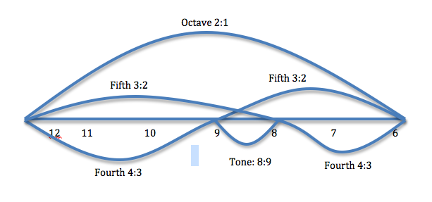
Now by "instead" he means what a few other music theorists call "Our subdominant is a true fifth below its (the fundamental's) octave. Phantom Tonic: Not a fourth above, but a fifth below: the phantom tonic."
Nicolas Slonimsky once pointed out, in an effort to dissuade readers from the idea that Western tonality is the inevitable result of how we hear (as opposed to a largely artificial invention), that no matter how high one goes in the harmonic series, a fundamental pitch will not produce a perfect fourth above the fundamental. (LaFave, 2007)
It is quite ironic that most music theorists do not recognize the difference between the Harmonic Series and the Overtone Series with the Undertone Series. The Harmonic Series already assumes the symmetric logarithmic geometric continuum logic. And so most musicians assume "Hertz" as a physics model is the basis of music, requiring some external measurement. Yet music does not require an external instrument. What Philolaus did for his "external measurement" was to literally flip his lyre around, as McKirahan details, and then use the 8 string as the new root tonic ratio. Connes explains why this is actually noncommutativity:
When you permute A and B, and you make the A pass on the other side, you have to make it evolve with time. And the time in which it has to evolve is in fact the purely imaginary number. This is what is behind the scenes. (Jackson & Connes, 2021)
Math Professor Louis Kauffman corroborates Connes claim - what Connes calls "something more primitive than the passing of time" (Connes, 2021) and what Kauffman calls noncommutative primordial time: "In the notion of time there is an inherent clock and an inherent shift of phase that enables a synchrony, a precise dynamic beneath the apparent dynamic of the observed process" (Kauffman, 2018). Kauffman has even demonstrated a noncommutative proof of the Pythagorean Theorem in his section From Pythagoras to Einstein and Dirac (Kauffman, personal correspondence, January 5, 2022). Here is Connes' primitive time explanation:
The fact is that when we take an algebra of a certain quality, which we call an operator algebra, which is non-commutative, well, it generates its own time ... that is really the time in the physical examples which turns over time. So, this is amazing and it comes exactly because you cannot swap a and b. (Connes & Prochiantz, 2018)
So then for Philolaus 4/3 was the new ratio based on 3 as the new root tonic value from the ratio of the 8, the Subcontrary Mean or Phantom Tonic now turned into the commutative Harmonic Mean (6/8 wavelength). Yet 4/3 will never be a natural overtone of the root tonic or the One due to the noncommutativity truth of reality.
This is true because Philolaus is dealing no longer with the musical intervals between the notes made by a particular pair of strings, but with the magnitude of those intervals ... (1, 4) = (7, 5). (McKirahan, 2013)
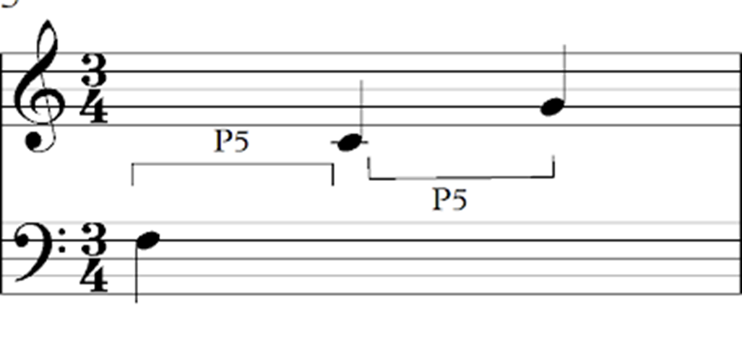
Any musician knows from internal listening that 1 to 4 is C to F while 7 to 5 is C to G. "It is confirmed by the fact that the notes F and C are the last one ... produced by the cycle of fifths if one considers the approximation mentioned before of 7 octaves with 12 fifths" (Abdounur, 2015). The uneven number of (3/2) to 2 hides the noncommutative truth as the source of 4/3 or C to F harmonic originated from the 2/3, C to F undertone. Notice the “x” is for the Perfect Fifth 2/3 undertone as F note doubled to 4/3 Perfect Fourth into the same octave (in image below):
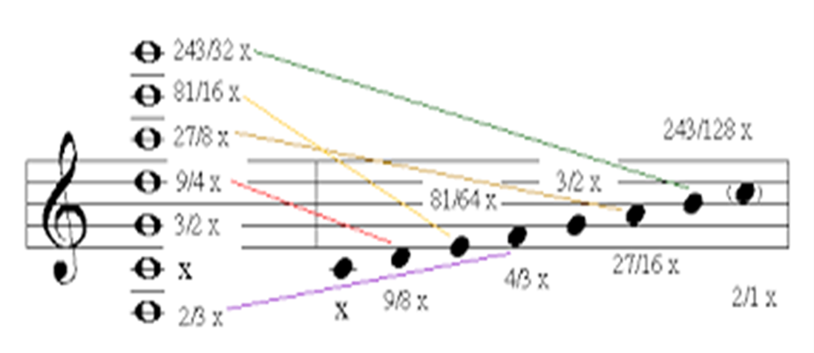
[Image Source: Professor Reginald Bain, University of South Carolina, "Doe a Deer" Solfeggio scale. ]
We start at 12 and take 2/3 of its length. Then we add a length corresponding to the ratio 4:3, but this time we are starting not at 12 but at 8 and we want to take 3/4 of that. (McKirahan, 2013)
Now the 8 is a ratio of 4/3 to the six string as the new root tonic (6/8) or "3/4 of 8" (McKirahan, 2013) as the string length. So, the root tonic was changed from 12 to 8 but this was covered up as the Liar of the Lyre "bait and switch" and that is the true origin of the first "Greek Miracle" irrational magnitude mathematics! McKirahan is then explaining that the octave symmetry equivalence can be set as equal to zero and Alain Connes makes the same point, that it is the "scale" of the "spectrum" that creates the zero point of spacetime.
If you want the dimension of the shape you are looking at, it is by the growth of these eigenvariables. When talking about a string it's a straight line. When looking at a two dimensional object you can tell that because the eigenspectrum is a parabola ... They are isospectral [frequency with the same area], even though they are geometrically different [not isomorphic] ... when you take the square root of these numbers, they are the same [frequency] spectrum but they don't have the same chords. There are three types of notes which are different ...
What do I mean by possible chords? I mean now that you have eigenfunctions, coming from the drawing of the disk or square [triangle, etc.]. If you look at a point and you look at the eigenfunction, you can look at the value of the eigenfunction at this point ... The point [zero in space] makes a chord between two notes. When the value of the two eigenfunctions [2, 3, infinity] will be non-zero. ...
The corresponding eigenfunctions only leave you one of the two pieces; so if there is is one in the piece, it is zero on the other piece and if it is non-zero in the piece it is zero there...You understand the finite invariant which is behind the scenes which is allowing you to recover the geometry from the spectrum ... Our notion of point will emerge, a correlation of different frequencies ... The space will be given by the scale. The music of the space will be done by the various chords. It's not enough to give the scale. You also have to give which chords are possible. (Connes, 2012)
It is the music of the noncommutative time-frequency two note chords that are the "invariant spectral" nonlocal resonance behind the scenes.
Dr. Oscar Abdounor explains:
Anachronistically speaking, this means that, supposing both these both cycles meet, there would be m and n integers such that (2:3)n = (1:2)m, that is, 3n = 2m+n, which is impossible, since the left term is odd and the right is even. (Abdounur, 2015)
If you don't think this is the same noncommutative concept that Alain Connes is emphasizing, think again:
It explains the spectrum of the guitar because when you raise the number 2 to the power of 19, we get practically the number 3 raised to the power 12. It can't be a tie because when we raise 2 to the power 19, we get an even number. When we raise 3 to the power 12, we get an odd number. So it can't be an equality.... Because if we calculate its size using what I told you before, we obtain that it is an object of dimension 0, an object of dimension 0 in the sense that its dimension is smaller than any number, not zero but positive. (Connes & Prochiantz, 2018)
A biophysics book explains that musicians can hear the noncommutative "spectral invariant."
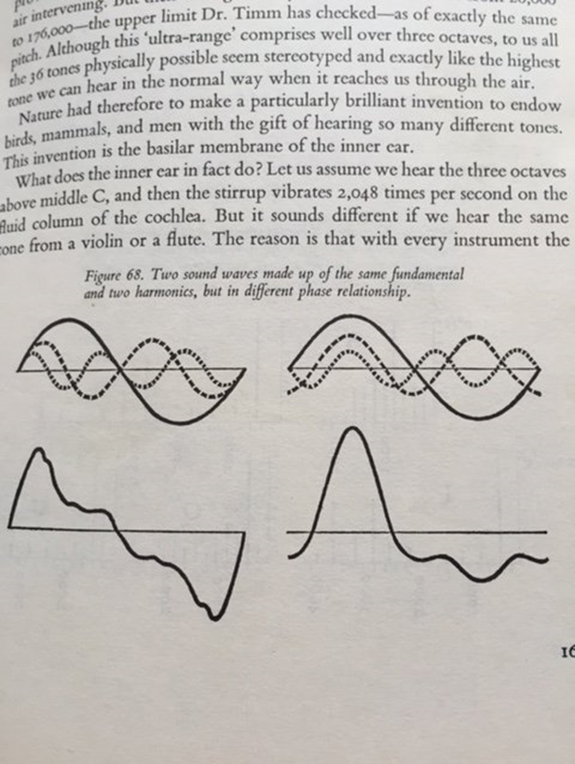
Let us draw up a fundamental vibration with its first and second harmonic overtones [1:2:3] ... if we then shift the phase relationship, we get a totally different course of the combined curve; that is, of the pressure course which is apparently effective in the final analysis. When looking at both curves, one might suppose that in the two cases we should hear two sounds that are just as different. But in fact our ear does not notice any difference. (Dröscher, 1969, p. 168)
The Perfect Fifth is phase shifted as a Perfect Fourth that then becomes the new root tonic that phase cancels out the first fundamental (root tonic here with wavelength one compared to the fundamental frequency of wavelength two and string length one of the "double octave" paradox as explained above), so the same Perfect Fifth remains as an inverse F, now 2/3 to the octave C instead of C to the G Perfect Fifth, as 3/2. Or to say the 6/9 is 3/2 wavelength as 2/3 undertone Perfect Fifth C to F as the inversion of 8/12 wavelength for 3/2 or C to G Perfect Fifth overtone. Helmholtz first discovered this experiment with a continuous tone phase shift and realized people could not hear a frequency difference. He had a debate about how the overtone and undertone beats played a role in this. Quantum physics Professor Fred Alan Wolf (who later became known as Dr. Quantum) reveals how this listening secret explains relativistic quantum negative frequency and reverse time tuning:
The movement of the electron from one orbit to another lower energy orbit was a simple change of notes. As a violin string undergoes such a change, there is a moment when both harmonics can be heard. This results in the well-known experience of harmony, or as wave scientists call it, the phenomenon of beats ...The light was a beat, a harmony, between the lower and upper harmonics of the Schroedinger-de Broglie waves. When we see atomic light, we are observing an atom singing harmony ... They had no medium to wave in, and they had no recognizable form in physical space. (Wolf, 1981)
This is another way of revealing the truth of noncommutativity, to quote Connes (2012), "They are isospectral [same frequency], even though they are geometrically different." So just as what Connes calls the "triple spectral" there is a two note "cord" as the Perfect Fifth Phantom Tonic undertone 2/3, C to F, that is not allowed as the noncommutative spectral invariant ratio thereby creating the zero point of space or spectral scale.
Our notion of point will emerge, a correlation of different frequencies ... The space will be given by the scale. The music of the space will be done by the various chords ... The point [zero in space] makes a chord between two notes ... You understand the finite invariant which is behind the scenes which is allowing you to recover the geometry from the spectrum ... The spectrum is entirely identical, but if you look closely, the notes belong to three types. (Connes, 2012)
More recently Connes (2020) gives the broader music context:
This lecture will explain this link by dealing, among other things, with "spectra" and "the music of shapes" ... This property makes it possible to characterize geometrical shapes from invariants that do not refer to a coordinate system. The resulting new geometry, illustrating the mathematical link between visual and auditory perception, has a wealth of applications in physics, in particular for gravitation and quantum physics. (Connes, 2020)
So to summarize Connes' noncommutative quantum nonlocal music claim from the discrete Pythagorean ratios:
The exponential uses 3 to the 19th and 2 to the 12th while the inverse logarithm uses 2 to the 1/19th and 3 to the 1/12th. That's what makes them noncommutative as the irrational number. Because the Pythagorean ratios are noncommutative as the Perfect Fifth with C to F as 2/3 and C to G as 3/2, therefore the 7 as the note integer of the 12 note scale is also noncommutative for the exponentiation. If you study quantum physics you'll see Conne's making the same point about the "inner automorphisms" of the Dirac Operator whereby the discrete diagonals of the matrices are noncommutative. The Pythagorean music exponentiation is noncommutative since the powers have to be inverted as a fraction that is therefore 3-dimensional as a noncommutative quantum sphere using the imaginary number. I'll let Connes explain as he does best in his first version of this music lecture:
So if we take the 2-sphere, if we take the round sphere, its spectrum this time is very very simple. It is also formed by integers, exactly as in the case of a string. But these integers appear this time with a certain multiplicity, that is to say it's not exactly integers. It is more exactly the root of J(J + 1) ...
The shapes on the sphere are different, the sound we hear is the same. [Isospectral but not isomorphic]. And that is what we call spectral multiplicity, that is to say that in the spectrum, what will happen is that we will have the same value, but it will happen multiple times. I will come back to this for the musical shape, that, we will see that later ...
when you make music, in fact, it is not at all integers 1, 2, 3, 4, 5, etc., as frequencies which are used ? Absolutely not, these are the powers of the same number, the powers of the same number, that is to say we have a number q. And we look at the numbers qn, that is what counts, because it is the relationships between frequencies that count. And the wonder that makes piano music exist, called The harpsichord well temperated, etc., it is the arithmetic fact that exists, which means that if we take the number 2 to the power of a twelfth, if you take the twelfth root of 2, that's very, very close to the nineteenth root of 3. See, I gave those numbers. You see that the twelfth root of 2 is 1.059 ... etc. The nineteenth root of 3 is 1.059 ...
Where does 12 come from?
The 12 comes from the fact that there are 12 notes when you make the chromatic range. And the 19 comes from the fact that 19 is 12 + 7 and that the seventh note in the chromatic scale, this is the scale that allows you to transpose. So what does it mean?
It means that going to the range above is multiplying by 2 and the ear is very sensitive to that. And transpose is multiplication by 3, except that it returns to the range before, i.e. so it is to multiply by 3 / 2, that agrees.
Well, that's the music, well known now, to which the ear is sensitive, etc. Okay.
But ... there is an obvious question! It is this: "Is there a geometrical object which range gives us the range we use in music?" This is an absolutely obvious question.
If you look at what is going on, like these are the powers of q, you notice that the dimension of the space in question is necessarily equal to 0. Why? Because earlier, I had shown you its limits ... So I had shown you earlier that the objects had a range thatÂ looked like a parabola when they were of dimension 2.
When an object is larger, it will be a little more complicated than a parabola.
For example, if it is in dimension 3, it will be y = x to the 1/3, okay, but here, it's not at all a thing that is round like a parabola like that ... This is something that pffuiittt! ... that gets up in the air like that. And what it tells you is that the object in question must be of dimension 0. So you say to yourself, "an object of dimension 0, What does it mean? etc. Well ...
What I hope one day is that we will find the noncommutative sphere in Nature and one will be able to use it as a musical instrument and it will be a wonderful instrument because it will never detune." (Connes, 2011)
So the paranormal quantum biology claim is that our body-mind-spirit IS that noncommutative sphere musical instrument in Nature that will never detune, as long as we know to properly play it and listen to it.
Due to the noncommutativity behind time-frequency uncertainty, science has proven that humans can hear up to ten times faster than time-frequency uncertainty. This means that despite noncommutativity being limited to observables of spectral frequency light in science, through direct listening to the source of music as meditation, the noncommutative paranormal power is accessed, as I will explain. "Noteworthy is that the 'beating of the uncertainty principle,' by more than a factor of ten, as reported in [2], concerns qualities essentially of a very different nature than the pulse's duration time" (Majka, et al., 2015).
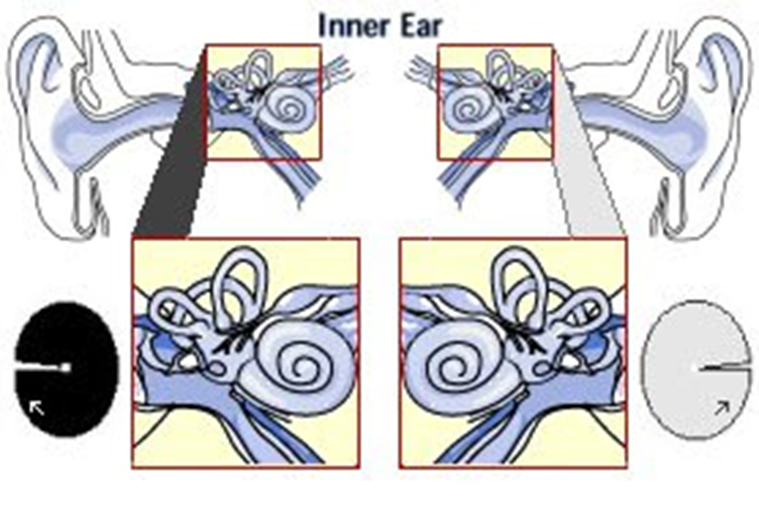
[Image Source: http://www.treeincarnation.com/images/earspirals.jpg showing noncommutative left handed/right-handed chirality of spirals]
This denotes "quantum coherence" as quantum biologist Dr. Mae-Wan Ho points out.
The clue to both binding and segmentation is in the accuracy of phase agreement of the spatially separated brain activities. That implies the nervous system (or the body field) can accurately detect phase, and is also able to control phase coherence. I have already alluded to the importance of phase information in coordinating limb movements during locomotion and other aspects of physiological functioning, so it is not surprising that the nervous system should be able to accurately detect phase. The degree of precision may be estimated by considering our ability to locate the source of a sound by stereophony. Some experimental findings show that the arrival times of sound pulses at the two ears can be discriminated with an accuracy of a very few microseconds [1]. For detecting a note in middle C, the phase difference in a microsecond is 4.4 x 10-4. [ultrasound frequency] Accurate phase detection is characteristic of a system operating under quantum coherence. Could it be that phase detection is indeed a key feature of conscious experience? (Mae-Wan Ho, 1997)
And then this corroboration of Dr. Mae-Wan Ho and Dr. Larry Domash:
In the quantum-limited regime the phase of the signal is translated into the phase of the amplifier wavefunction, as is clearly true in Josephson junction devices, for example ... they must be coherent ... phonon super-radiance provides a natural means of explaining the macroscopic quantum effects ... a coherent oscillation amplitude ... spontaneous "beating"... at a frequency close to its resonance ... microscopic mechanisms in which quantum coherence lives for a time comparable to measurement time, on the order of one millisecond. It is these results which completes the evidence in favor of Schroedinger's view of [negentropic] life as a macroscopic quantum phenomenon. There is simply no way to understand the sub-angstrom displacements in the inner ear without postulating a molecular mechanism in which quantum coherence is manifest on macroscopic scales of time and distance ... Sitting in a quiet room, we can hear sounds that cause our eardrums to vibrate by less than the diameter of an atom. ... (Bialek, 1983)
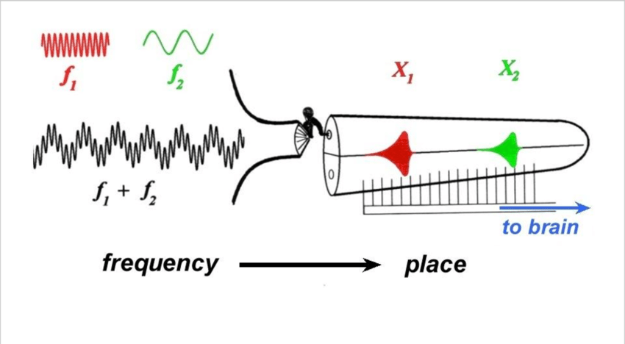
Physics Professor Manfred Euler via our correspondence, provides more details:
Phase harmony in de Broglie theory relates a local periodic phenomenon (the 'particle clock') to a periodic propagating field in such a way that relativistic invariance is satisfied. If a similar phenomenon in the cell is relevant it should couple the global oscillation pattern locally with periodic (mechanic, electric, biochemical ???) processes ... Binaural hearing is the acoustic analog of the interferometer or double-slit experiments. The two ears can be regarded as an acoustic interferometer, which recovers the phase difference of signals between the two ears by binaural correlation.
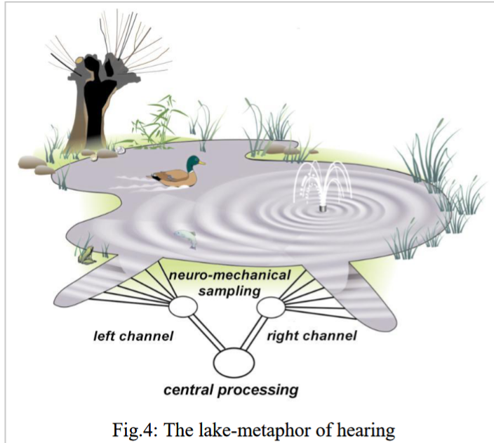
Near-field imaging with sound waves compellingly demonstrates the inadequacy of pictorial realism and promotes more abstract views of the reality displayed.
A comparison of sound and matter waves clarifies that these [noncommutative] limitations exist in principle.
de Broglie clocks as synchronization: a tangible model of how mass emerges. Matter waves are locally in phase with the particle clocks (de Broglie's Law of Phase Harmony). The clock runs forever so it's self-sustaining (consciousness-energy). It resonates with the quantum vacuum.
The harmonic beats create dynamic energy. So, then you have a "phase particle" that can be faster than the speed of light - superluminal - and a "mass particle" that is slower than the speed of light is the "group wave" of the "phase wave." The beats of the phase wave then are "in resonance" with the quantum vacuum - and so create mass from the massless field, explaining the Higgs mechanism.
"Universal coherence" - a "mind boggling outlook."
Coherence as consciousness.
"Ghost Tones"
Yet an acoustical answer can be given! Play the above mentioned infinitely rising tune and listen to a parable of scientific progress: The progress goes on but the central epistemological questions remain invariant."
And we can turn to Matti Pitkänen (2016), Ph.D. physics, for futher details:
The Josephson current decomposes into harmonics of the fundamental frequency ... For hearing the time interval is by a factor 1/100 shorter [see Dr. Mae-Wan Ho quote above] than the millisecond time scale of the nerve pulse ... inducing frequency modulations of Josephson frequencies would resolve this problem."
Again recall that the microsecond left-right ear phase coherence as microsecond wavelength resonates as ultrasound frequency, now proven to resonate the microtubules as a quantum noncommutative coherence of nonlocality via the tubulin metamaterial, proven by Dr. Anirban Bandyopadhyay.
Tinnitus research has also revealed the "brain ultrasound demodulation" meaning inversely that the highest sound we hear externally then resonates the whole brain as ultrasound.
Monitoring neural vascular function with Doppler ultrasonic imaging provides unexpected support for the brain ultrasound demodulation theory. When the imaging beam was focused at the center of the brain, patients reported hearing a high audio sound, much like tinnitus. When the ultrasonic beam was directed at the ear, the sound disappeared. Setting the brain into resonance resulted in a clear high-pitch, audible sensation consistent with brain resonance in the 11- and 16- kHz range ... Because ultrasound produces high audio stimulation by virtue of brain resonance, the direct use of high audio stimulation is more economical in power requirements and still stimulates the brain at resonance. (Lenhardt, 2003)
In music theory this is called the "HyperSonic Effect" (Oohashi, et al., 2000) and has been proven from natural number overtones and undertones of nonwestern music tuning. The HyperSonic Effect is documented to cause deep brain stimulation with stronger alpha brain wave resonance. Dr. Andrija Puharich (1971; 1987) explains ultrasound as a gravitational potential subharmonic amplitude increase in terms of de Broglie's Law of Phase Harmony in quantum biology parapsychology: "We consider the psi plasma as a pilot-wave phenomenon; and we consider the nerve-conduction velocity as a group-wave phenomenon." Puharich later writes, "Two proton monopole systems coupled over any distance by the magnetic monopole string produce the gravitational field." (1988) So that is the ELF reverse time precession of the proton spin coupling.
So as the nerve velocity goes down towards 8 hertz as a negative frequency, then the pilot wave or reverse time phase is superluminal as a virtual photon. As Puharich details it is the quarks inside the proton with the virtual photon coupling that creates the quantum antigravity propulsion. This ultrasound splits the water via the side-band ELF subharmonics as a reverse time negentropy force of the magnetic moment of the virtual photons - similar to the antigravity propulsion work of Victor Schauberger. In Daoism this is called "The highest notes are hard to hear" from Chapter 41, Tao Te Ching, translated by Gia-fu Feng and Jane English. In Buddhism it's called the "inner ear" or "sound-current" meditation method.
In fact, traditional Indian music tuning, like traditional Chinese tuning, is based on the "three gunas" yoga philosophy that also recognizes the Phantom Tonic truth of music as noncommutativity.
Our whole universe is trigunatmaka, as it is pervaded by the three gunas ... Therefore one gets a wonderful visualization of cosmogony, while doing the elementary Nada-sadhana, with the help of a tanpura, which is one of the oldest musical instruments ... As a result the first musical vibration (Spandan) that has emanated out of the trigunatmaka (relating to the three gunas), equipoise of Cosmic Nature - that alone is the AUM or OMkara ... The most common tuning for the four-string tanpura sets the first string at "Pa," the fifth degree of the scale, while the second and third strings are tuned to the tonic above, and the last string is tuned to the tonic below. (Chandra Dey, 1990, p. 82)
Jairazbhoy notes the Phantom Tonic concept as key to Indian music meditation:
The thesis can be expressed in the following way: If two drones either a fourth or fifth apart are sounded, one of these will 'naturally' sound like the primary drone. It is not always the lower of the two which will sound primary, but the one which initiates the overtone series to which the other note (or one of its octaves) belongs. By amplifying a prominent overtone the secondary drone lends support to the primary and intensifies its 'primary' character. Ma [Perfect Fourth as 4/3], although consonant to Sa (root tonic), is alien to the overtone series and is not evoked in the sound of Sa. On the other hand, Sa is evoked in the sound of Ma, since Sa is a fifth above Ma and is its second overtone.
For this reason it can be argued that the tendency to view Ma [the Phantom Tonic] as the ground-note has a 'natural' basis. The same cannot be said for Pa as Sa is not part of its overtone series. (Jairazbhoy, 1995)
OK I promised I was going to return to that clue that Borzacchini dropped about the PreSocratic paranormal Pythagorean philosophers not understanding the discrete/continuous distinction of number. Connes (2012):
But the inverse space of spinors is finite dimensional. Their spectrum is so dense that it appears continuous, but it is not continuous ... If you stay in the classical world, you can not have a good set up for variables. Because variables with a continuous range can not coexist with variables of discrete range ... first of all, it is that they don't commute so you can have the discrete variable that coexists with the continuous variable. What you find out after a while is that the origin of time is probably quantum mechanical and its coming from the fact that thanks to noncommutativity only that one can write the time evolution of a system. … The phase space is a noncommutative system and that's what's behind the space all the time.
Our brain is an incredible utensil which perceives things in momentum space - all the photons that we receive - and manufactures a mental picture which is geometric. But what I'm telling you, ....I believe from what I said that the fundamental thing is spectral [frequency] and that the fundamental thing is of that nature. And that somehow in order to think we have to do this innermost Fourier Transform.... A Fourier Transform not for functions but a Fourier Transform on geometry.... The Music of Shapes is really a Fourier Transform on a Shape and the fact that we have to do it in reverse and this is a function that the brain does amazingly well because we think geometrically.
Durdevich, citing Connes, explains the music connection:
A discrete space - the skeleton hosting any musical score, morphs into a true musical form, only after being symbiotically enveloped by a geometry of sound. And this geometry is inherently quantum, as it connects the points of the discrete underlying structure, invalidating the difference between now, then, here and there; thus creating an irreducible continuum for a piece of music: continuous discreteness and discrete continuity. (Durdevich, 2015)
And thus, Alain Connes considers the noncommutative music model as the key to explaining the origin of a zero point in space, as well as the key to how our brains perceive space.
These things exist in the brain, and they send you signals. Similarly in music, you can have something that exists in your mind, a tune or a theme. This is something amazing and very hard to define ... Algebra is much more time-dependent and evolving. In algebra, when you are doing computations, there is a definite analogy with the time dependence in music, which is extremely striking ... I am still thinking about the fact that the passage of time, or the way we feel that time is going on and we cannot stop it, is in fact exactly the consequence of the noncommutativity of quantum mechanics. (Jackson & Connes, 2021)
The fact that this noncommutative music model also explains the paranormal, as both Eddie Oshins and Lawrence Domash realized, is uncanny to say the least. Citing David Bohm, Nobel Physicist Brian Josephson similarly makes the music connection: "One can see conceptual similarities between psi skills and ordinary skills, e.g. between the perceptual skills of hearing and telepathy on the one hand, and between the forms of control of matter involved in the control of the body and in psychokinesis on the other" (Josephson, 1991).
The reference to the phonon super-radiance of the Josephson Junction by Bialek is not an accident as Lawrence Domash, citing several scientific studies on room-temperature biological superconductivity, made the same superconducting phonon Josephson Effect connection to mantras. This corroborates Puharich’s reliance on the Blackett Effect:
The most straightforward proposal is that of room temperature electron superconductivity in biological macromolecules (35, 36), which presumably must arise by a new mechanism different from the lattice phonon attractive interaction between electrons which is responsible for ordinary low temperature superconductivity…. superconductivity within one neuron could become phase coherent with that in an adjoining cell by virtue of quantum tunnelling, and this could in turn be stimulated by the macroscopic analog of stimulated emis-
sion (alluded to before in connection with the mantra), that is, an AC Josephson effect….
Suggestions of a superconductive AC Josephson effect in living cells have already been put forward on two grounds. F. Cope has argued that the known magnetic field sensitivity of certain birds and other animals which navigate using the earth's magnetic field (55) are difficult to explain by any physical mechanism other than a biolog-
ical Josephson effect magnetometer. Cope claims this as one of several points of indirect evidence for biological room temperature superconductivity in animal nervous tissue (38, 39) (Domash, 1975, p. 659)
Josephson provides us the source:
Listening to music involves the response of the aesthetic subsystem to the music, a process parallel to the resonant response of an atom to electromagnetic radiation. If we feed a system of atoms with energy in an appropriate way ('pumping' the system), a process of stimulated emission occurs whereby the atoms emit more radiation than they take in by absorption, a state of affairs which tends to result in the system becoming unstable and generating radiation spontaneously at a frequency close to the frequency of the spectral line. (Josephson, 1994)
I have corresponded several times with Nobel Physicist Brian Josephson regarding music, the paranormal and meditation. Josephson wrote,
Intelligence would be the product of a collection of adaptions capable of being specified by a coding system related to that of music ... It may be worth pointing out here that that the idea that there is a connection between sound and form is an ancient one, dating back thousands of years in the Eastern philosophical tradition. (Josephson, 1996)
Clearly Josephson retains this view:
I suspect that the truth of the matter is that evolution at this deeper level of physics produces efficient systems of this kind on the basis of natural selection, and thereby gain the inspiration to do advanced mathematics. Similarly, I think for music (c.f. Josephson and Carpenter [6]) where we don't appear to have any good explanation for musical aesthetics, which involves very specific forms that seem to have a special creative power. (Josephson, 2021)
Anirban Bandyopadhyay who corroborated the ultrasound quantum coherence resonance of the Penrose-Hameroff noncommutative paranormal model states, "I believe that consciousness is just the manifestation of music." (Adelaide, 2017) This ultrasound is being called the "common frequency point" or natural sweet spot due to the resonance amplification of the quantum coherence tubulin phase signals as mechanical vibrations with the electromagnetic vibrations of the molecule.
As Puharich emphasized, the side-band harmonics create the reverse time quantum beat or ELF subharmonic of the future. For de Broglie's Law of Phase Harmony, the basis of Puharich's claim, then the internal frequency is negative as virtual photons during meditation while external time slows down and the external frequency energy increases while internal time speeds up. "The coupling of the virtual photon to the quarks…" (Determination of the Proton Spin Structure Functions, PHYSICAL REVIEW C 96, 065208 (2017) .
They will engage skeptics in a debate on the nature of consciousness, and Bandyopadhyay and his team will couple microtubule vibrations from active neurons to play Indian musical instruments. "Consciousness depends on anharmonic vibrations of microtubules inside neurons, similar to certain kinds of Indian music, but unlike Western music which is harmonic," Hameroff explains. (Elesvier, 2014)
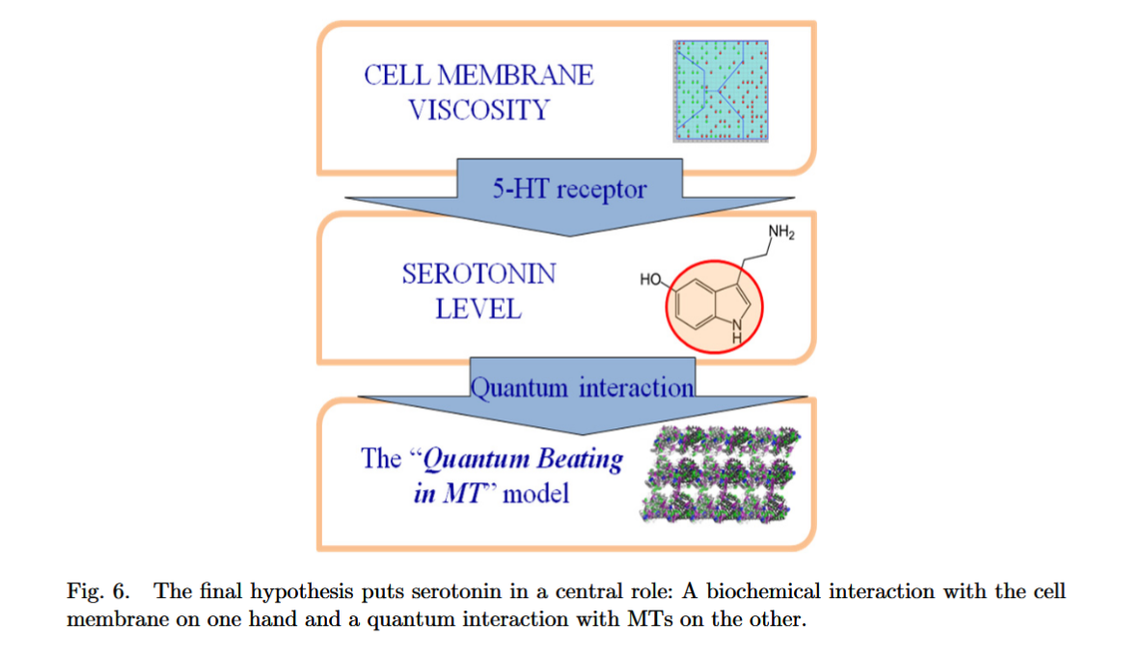
Image Source: https://pubmed.ncbi.nlm.nih.gov/26227538/
Professor Emeritus Stuart Hameroff (2015) explains, "Except with music you need a listener, whereas here, the vibrations are self-aware." The noncommutative music model of the "three gunas" from Indian music meditation philosophy as with Daoist music meditation philosophy originates from our original human culture, as musicologist Ph.D. Victor Grauer documented (Grauer, 2011).
From Eddie Oshins website (n.d.):
these symbols were precursors to a school of health systems, mind exercises and martial arts known collectively as neigong/noi kung (the "inner" or "internal" school of "shadow boxing"). The most well-known of these esoteric skills are taijiquan/t'ai chi chuan ("grand pinnacle" boxing), hsing-i chuan ("form of mind/will/intent" boxing), and baquazhang/pa kua chang ("8 trigrams palm" [boxing]).
In this talk, Eddie will give a short history of the above concepts and, in light of some work he has been developing in his Quantum Psychology Project, he will propose a new reinterpretation of these symbols. He will demonstrate mathematical aspects, such as the consequent "orientation-entanglement relation" and the Kauffman-Oshins "quanternionic arm." Eddie will use these concepts to illustrate his notion of "self-referential motion," and relate such understanding to both gongfu (kung-fu) and psychology. (Oshins, 5. Demonstration of Physics of Tao).
Eddie Oshins was tasked with trying to correct Karl Pribram's holographic classical frequency model but apparently Pribram was not able to understand the noncommutative model. "I was interested in the types of noncommutating interactions between observing and observed systems" (Oshins, 1990). Oshins was directly inspired by my own quantum mechanics professor Herbert J. Bernstein who demonstrated the "Dirac Dance" to my quantum mechanics class in 1989-90:
(Noi Kung) In a manner similar to Bernstein's resolution of translation hand movements into Fourier components, I hope to attempt a decomposition of motion of a Chinese "internal" (image-based) martial art (such as Pa Kua Kang or T'ai Chi chuan) ... Eddie will finally describe and propose a psychological Aharanov-Susskind-Bernstein effect such as a reversal of spinorial, virtual brain current activity as a consequence of relative self-rotation by 2p. (Oshins, n.d.)
And since Eddie Oshins taught Wing Chun then he was able to have a Taiji expert also demonstrate the "Dirac Dance" only now as a Taiji paranormal power training exercise.
Chen Youqin demonstrating the application of Chen Family Chan ssu jin while doing the doing the double covering palm movement from Eddie Oshins self-referential motion. Chen Youqin middle son of Mr. Chen Qingzhou is applying Chen Family "chan ssu jing" (silk reeling exercise) to show an application of the spinorial "orientation-entanglement relation" described by Oshins as self-referential motion in his postnarrative research on the physics of tao (Oshins, n.d.)

[Image Source: https://lh3.googleusercontent.com/proxy/dS22yE5VHDWv70fX5pWwF9w7o4ZxqJSr3g9K4AeBnC3yroDFCl0VgsPxL7_
GluOjgWIj2yOrk_rPxOtxHatHCCbwQH6KpA=s0-d ]
Tai Chi master Chen Youqin is also one of the founders of the National Neigong Research Society (NNRS). And so, we've now come full circle - corroborating the paranormal noncommutative music "aha!" moment I had during my Herbert J. Bernstein quantum mechanics class. For this Dirac Dance correlation to the "silk reeling" Tai Chi exercise, the outside of the hand is yang and the lower body is yin while the inside of the hand is yin and upper body is yang.
Epilogue: Noncommutativity Corroboration
So at the VERY end of Professor Basil J. Hiley's lecture he goes into what he states below. Amazing. He's basically saying you don't need the "collapse of the wave function" but instead you can stay in the noncommutative algebra. Awesome!!
Lecture by Basil J. Hiley - September 2021
https://emmy.network/mindandmatter.html
Professor Basil J. Hiley: Can you respond to this below email quote from Dr. Ruth E. Kastner - for me please? I just got this response from Dr. Ruth E. Kastner. I just watched a lecture by Alain Connes on the noncommutativity math of the inner matrix factorization. She is claiming it has no physical value and it's only mathematics. So I said that I thought the "weak measurement" experiment proves that noncommutativity is indeed the origin of symmetry breaking (and not due to the collapse of the wave function)....
Thanks,
"drew
I'm not familiar with the idea of getting symmetry
breaking from noncommutative math, but math alone is not physics."
Dr. Ruth E. Kastner email response to me - quote, Feb 22, 2022
Referred to by Professor Hiley email response to me on February 23, 2022 - below:
"Dear Drew,
"It is difficult to comment authoritatively on Ruth’s paper as I have not had time to read it carefully. My own venture into weak values was that they provided a means of measuring transition probability amplitudes. That means they are providing a way of further exploring the quantum formalism but adding nothing fundamentally new. In this regards I agree with Ruth and the two referees.
"I do not know what Alain Connes was specifically talking about. However non-commutativity is deeply ingrained in quantum phenomena and is not, in my opinion, “only mathematics”. The early pioneers of QM, such as Heisenberg, Born, Jordan, Dirac and others showed this feature of non-commutativity in great detail. It was Schrödinger’s work that led to the development of a tremendously successful algorithm based on the notion of a wave function which was formalised into the bras and kets that we have got very very used to manipulating. However by identifying the wave function with the 'state of a system’ we have been left with the unsolved ‘problem', the collapse of the wave function. After one hundred years of effort we have been unable to 'solve this problem’. In the last few years I have come to the conclusion that this is unsolvable simply because it is the wrong question as it is based on treating an algorithm rather than a description of an unfolding process.
"That the quantum formalism was an algorithm was Bohr’s position all those years ago, but he argued that we could not go deeper by attempting to analysing the process because of the 'Principle of Complementary’. This philosophical principle seemed to have universal appeal outside of physics but now, he argued, with the advent of quantum phenomena, this principle also had a role to play in physics, so to Bohr, the principle became a universal principle that applied to all knowledge.
"The availability of the ‘algorithm’ which was easy to manipulate and lead to experimental verification should be contrasted with the difficulty in understanding non-commutativity, both mathematically and conceptuality. Furthermore it was very difficult to apply it physical problems. Thus the algorithm becomes the ‘only game in Town’ as we learn how to deal with its uncomfortable features. Then there follows an attempt to make the formalism in to an ontology and the result is a plague of interpretations.
"I have recently published two papers which address directly the challenge of providing a description of this ‘quantum unfolding’ as Dirac puts it. It is a very different approach which is based on an exploration of non-commutative geometry, in the same spirit of Alain Connes but using more physical intuition. It is a long story but I have a lecture on line at <emmy network> which may help. My lecture is Lecture 2 immediately after Roger Penrose’s lecture in the series ‘Mind and Matter’. My lecture was about 'Matter’ not ‘Mind'!
Enjoy,
Basil.
 | 4:19 AM (1 hour ago)
  Basil Hiley

REFERENCES
Abdounur, O. J. (2015). The emergence of the idea of irrationality in Renaissance theoretical music contexts. Mathematical Journal for Interdisciplinary Sciences (MJIS). v. 3.
Adelaide, V. (2017). A discussion on consciousness, on the mysteries of the universe and on the 'Nano Brain' https://www.beautifulhumans.info/anirban-bandyopadhyay/
Aharonov, Y. (2016). A brief review of weak measurements and new ways to look at pre and post selection, Institute for Quantum Studies, Chapman University. https://www.youtube.com/watch?v=5qRBu9IfAyk
Aharonov, Y. (2017). Finally making sense of the double-slit experiment https://www.pnas.org/content/114/25/6480
Akhmetsafin A.N. (1989), About musical frets and human body structure connection (on example of Chinese musical frets Liu Liu)' (russian) ' Ufa.
Beaulieu, J. (1984). Music and Sound in the Healing Arts, Station Hill Press, NY.
Beaulieu, J. The Perfect Fifth -- The Science and Alchemy of Sound pdf, The Rose+Croix Journal-Vol. 11.
Bellissima, F. (2013). Epimoric Ratios and Greek Musical Theory, in Language, Quantum, Music edited by Maria Luisa Dalla Chiara, Roberto Giuntini, Federico Laudisa, Springer Science & Business Media, Apr 17.
Bernstein, H. J. & Phillips, A. V. (1981). Fiber bundles and quantum theory, Scientific American.
Bialek, W. (1983). Quantum Effects in the Dynamics of Biological Systems, Lawrence Berkeley National Laboratory
Bonar, D., Khoury M. J (2006). Real Infinite Series, American Mathematical Society; 1st edition
Borzacchini, L. (2007). Incommensurability, Music and Continuum: A Cognitive Approach
Archive for History of Exact Sciences, 61 (3):273-302
Borzacchini, L. (2010). Short English Summary and Table of Contents of Il computer di Platone (Bari, Dedalo) and Il Computer di Okham (Bari, Dedalo).
Borzacchini, L. (2011). Einstein's violin and the cognitive roots of the Scientific Revolution, in Music Education, J.Hermida and M. Ferreoedts. Nova Publ. New York. https://www.academia.edu/34925486/Einstein_s_violin_and_the_cognitive_roots_of_the_Scientific_Revolution_in_Music_Education_J_Hermida_and_M_Ferreoedts_Nova_Publ_New_York_2011_978_1_60876_655_0
Bowen, A. C. (1978). The Minor Sixth (8:5) in Early Greek Harmonic Science, The American Journal of Philology.
Bowling, D…Tecumseh W. (2017). The Nature and Nurture of Musical Consonance, Music Perception 35(1):118-121
Braude, S. E. (2020). Dangerous Pursuits: Mediumship, Mind and Music, Anomalist Books, San Antonio, Texas
Chamseddine, A.H., Connes, A., & Mukhanov, V.F. (2014). Geometry and the quantum: basics. Journal of High Energy Physics, 2014, 1-25.
Chandra D. S., The Quest for Divine Music (Ashish Publishing House, Delhi, India, 1990)
Chen Y. National Neigong Research Society (NNRS), http://www.nnrs.org/
Clegg, B. (2014). The fastest Mozart you will ever hear, http://brianclegg.blogspot.com/2014/10/nimtz.html
Connes, A. (2000). A Short survey of noncommutative geometry. Journal of Mathematical Physics, 41, 3832-3866.
Connes, A., Lichnerowicz, A., Schutzenberger, M. P. (2001). Triangle of Thoughts, (Amer Mathematical Society.
Connes, A. & Marcolli, M. (2004). From Physics to Number Theory via Noncommutative Geometry, Part Three.
Connes, A., & Marcolli, M. (2007). Noncommutative Geometry, Quantum Fields and Motives, American Mathematical Society, 2007
Connes, A. (2009). A view of mathematics, from Mathematics: Concepts, and Foundations, Volume 1, Eolss Publishers Company Limited, 2009, originally self-published in 2004.
Connes, A. (2010). The Flashes of Insight Never Came for Free, NAW 5/11, nbr. 4. http://www.nieuwarchief.nl/serie5/pdf/naw5-2010-11-4-250.pdf
Connes, A. (2011). Transcript of a conference given by Alain Connes, Duality Between Shapes and spectra, given at the Collège de France, on October 13, 2011. http://denisevellachemla.eu/mai8-en.pdf
Connes, A. (2012). Lecture, The Music of Shapes, Le point de vue spectral en mathématiques et en physique, la musique des forms, CEMPI Inaugural Conference, a joint meeting with the Fields Institute, Lille. https://www.youtube.com/watch?v=Z52ZAPrRbqE&t=0s
& https://www.youtube.com/watch?v=bIziuv-WLMM&t=0s & https://www.youtube.com/watch?v=cr60YwJrPa0&t=0s & https://www.youtube.com/watch?v=t9X0L-SF8vk&t=0s
Connes, A. & Prochiantz, A. (2018). Imagination and Infinity, Knowledge of an Imaginations-Cycle on France-Culture. http://denise.vella.chemla.free.fr/1-trad-ac-ap.pdf
Connes, A. (2020). 19th Wright Colloquium, Geneva, https://colloquewright.ch/en/public-talks/the-music-of-shapes/
Connes, A. (2021). From noncommutative geometry to tropical geometry. Talk given in the conference, Unifying Themes in Geometry, Como, https://www.youtube.com/watch?v=PLkTqEYMU4U
Costa de Beauregard, O. (1977). S-Matrix, Feynman Zigzag and Einstein Correlation, Physics Letters Vol. 67A, number 3. https://www.cia.gov/readingroom/docs/CIA-RDP96-00792R000500450002-2.pdf
Cuthbert, M.S. (2012). Addition and Multiplication of Intervals, http://prolatio.blogspot.com/2012/12/normal-0-false-false-false-en-us-x-none.html
D'Espagant, B. (1994). Veiled Reality: An Analysis Of Present- Day Quantum Mechanical Concepts Westview Press.
D'espagnat, B. (2003). A tentative new approach to the Schrödinger cat problem. arXiv: Quantum Physics.
https://arxiv.org/pdf/quant-ph/0301160.pdf
Domash, L. (1975). THE TRANSCENDENTAL MEDITATION TECHNIQUE AND QUANTUM PHYSICS: IS PURE CONSCIOUSNESS A MACROSCOPIC QUANTUM STATE IN THE BRAIN in Scientific Research On the Transcendental Meditation Program, Collected Papers, Volume I, edited by David W. Orme-Johnson, Ph.D., John T. Farrow, Ph.D. with an Introduction by Lawrence H. Domash, Ph.D. , Maharishi European Research University, p. 652
Dröscher, V.B. (1969). THE MAGIC OF THE SENSES, W.H. Allen, London.
Durdevich, M. (2015). Music of Quantum Circles in The Musical-Mathematical Mind: Patterns and Transformations, eds. Gabriel Pareyon, Silvia Pina-Romero, Octavio A. Agustín-Aquino, Emilio Lluis-Puebla. Springer, pp. 99-110, 10.1007/978-3-319-47337-6_11
Elesvier (2014). Discovery of quantum vibrations in 'microtubules' inside brain neurons supports controversial theory of consciousness, https://www.sciencedaily.com/releases/2014/01/140116085105.htm
Fersch, R. G., Guler, N., Bosted, P., Deur, A., Griffioen, K., Keith, C., … Adhikari, K. P. (2017). Determination of the proton spin structure functions for 0.05
Finkelberg, A. (2017). Heraclitus and Thales' Conceptual Scheme: A Historical Study. Jerusalem studies in religion and culture, 23. Leiden; Boston: Brill, p. 189.
Fuentes, I. (2013). Q+ Talk, https://www.youtube.com/watch?v=7GXmb2h92TE
Gastone G. Celesia (2012) Alcmaeon of Croton's Observations on Health, Brain, Mind, and Soul, Journal of the History of the Neurosciences, 21:4, 409-426, doi.org/10.1080/0964704X.2011.626265
Grauer, V. (2011). Sounding the Depths: Tradition and the Voices of History. Createspace Independent Publishing.
Hameroff, S. & Larson, C. (2015). https://www.goodreads.com/author_blog_posts/7778895-cynthia-sue-larson-interviews-stuart-hameroff
Hempel, D.W. (2006). The Secret of Psychic Music Healing. https://www.mind-energy.net/archives/151-the-secret-of-psychic-music-healing.html
Hempel, D. W. (2007). Against Archytas: How the West Lost Alchemy or Paranormal Complimentary Opposite Harmonics. https://www.mind-energy.net/archives/264-against-archytas-how-the-west-lost-alchemy-or-paranormal-complimentary-opposite-harmonics.html
Hempel, D.W. (2018). Ancient Advanced Acoustic Alchemy (EcoEcho Press, Minnesota) https://www.docdroid.net/LbJGgG2/ancient-advanced-acoustic-alchemy-pdf
Hiley, B.J. (1995). Nonlocality in microsystems, in: Joseph S. King, Karl H. Pribram (eds.): Scale in Conscious Experience: Is the Brain Too Important to be Left to Specialists to Study?, Psychology Press, pp. 318 ff., p. 327.
Hiley, B. J. (2015). Quantum Theory, the Implicit Order and Consciousness, Interview with Richard Bright, in With Consciousness In Mind, part 3, Interlia Magazine. https://www.interaliamag.org/wp-content/uploads/2015/11/Basil-Hiley-Quantum-theory-the-Implicate-Order-and-Consciousness.pdf
Hiley, B. J, de Gosson, M., Dennis, G., (2016). Quantum Trajectories: Dirac, Moyal and Bohm, Quanta 8(1), DOI:10.12743/quanta.v8i1.84
Hiley, B.J. (2017). Bohm, Physicist Philosopher: The Battle to find a Satisfactory Quantum Ontology (EmQM17).
Hiley, B.J. (2019). Stapp, Bohm, and the Algebra of Process, Activitas Nervosa Superior: The Journal for Neurocognitive Research, volume 61, pages 102–107. https://arxiv.org/abs/1809.06078
Hiley, B. J. (2021). Reality Unfolding - a Conversation on Bohmian Physics with Prof. Basil Hiley Science & Wisdom.
Ho, M. (1997). Quantum coherence and conscious experience, Kybernetes, Vol. 26 No. 3, pp. 265-276.
Hodges, R. (2009). The musical scale and its intervals, http://www.richardhodges.com/MusicalScale.htm
Howard, D. (2013). Quantum Mechanics in Context: Pascual Jordan's 1936 Anschauliche Quantentheorie. In: Research and Pedagogy: A History of Quantum Physics through Its Textbooks. Berlin: Max-Planck-Gesellschaft zur Förderung der Wissenschaften.
Hudson, M. E (2000). Music as an Analogy for Economic Order in Classical Antiquity in Jürgen Backhaus (ed.), Karl Bücher. Theory, History, Anthropology, Non-Market Economies Marburg:Metropolis Verlag.
Jairazbhoy N. A. (1995). The Rags of North Indian Music: Their Structure and Evolution, Popular Prakashan.
Jackson, A. (2021). Interview with Alain Connes, https://celebratio.org/Connes_A/article/842/
Jeans, James (1937). Science and Music, Dover Press, p. 166.
Josephson, B.D.& Pallikari-Viras, J. (1991). Biological Utilisation of Quantum NonLocality, Foundations of Physics, Vol. 21, pp. 197-207 Plenum Press. https://www.tcm.phy.cam.ac.uk/~bdj10/papers/bell.html
Josephson B.D., Carpenter T. (1994). Music and Mind — A Theory of Aesthetic Dynamics. In: Mishra R.K., Maaß D., Zwierlein E. (eds) On Self-Organization. Springer Series in Synergetics, vol 61. Springer, Berlin, Heidelberg. https://doi.org/10.1007/978-3-642-45726-5_18
https://www.tcm.phy.cam.ac.uk/~bdj10/mm/articles/kaiserslautern.txt
Josephson. B.D. & Carpenter, T. (1996). What can music tell us about the nature of the mind? A Platonic Model in Stuart R. Hameroff, Alfred W. Kaszniak & Alwyn C. Scott (eds.), Toward a Science of Consciousness. MIT Press
Josephson, B.D. (2021, forthcoming). Biological Organisation as the True Foundation of Reality in R. L. Amoroso, L. H. Kauffman & P. Rowlands (eds.), Unified Field Mechanics II: 10th International Symposium in Honor of Mathematical Physicist Jean-Pierre Vigier. Singapore: WORLD SCIENTIFIC PUBLISHING
Karasmanis, V. (2011). Continuity and Incommensurability in Ancient Greek Philosophy and Mathematics, Philosophical Inquiry DOI:10.1007/978-94-007-1730-5_22 In Socratic, Platonic and Aristotelian Studies: Essays in Honor of Gerasimos Santas
Kastner, R.E. (2015) Understanding our Unseen Reality: Solving Quantum Riddles, Imperial College Press, p. 139.
Kauffman L. (2018). Non-Commutative Worlds and Classical Constraints. Entropy; 20(7):483. https://doi.org/10.3390/e20070483
Khalkhali, M. (2014). The Music of Quantum Spheres. Fields Institute Undergraduate Summer Research Program Presentation, Toronto.
Kingsley, P. (1995). Ancient Philosophy, Mystery and Magic: Empedocles and Pythagorean Tradition. Oxford Press, p. 108.
Kingsley, P. (2010). A Story Waiting to Pierce You: Mongolia, Tibet and the Destiny of the Western World, Golden Sufi Center.
Kirk G.S. & Raven, J.E. (1964). The Presocratic Philosophers, Cambridge University Press, 1964.
Kullman, DE, (2001). What's Harmonic about the Harmonic Series? Jstor.
LaFave, K. (2007). https://nmbx.newmusicusa.org/IV-The-Phantom-Tonic/
Lebedev A. V . (2017). Parmenides, ???? ???????????. Monistic Idealism (Mentalism) in Archaic Greek Metaphysics [abstract and table of contents p. 535]. INDO-EUROPEAN LINGUISTICS AND CLASSICAL PHILOLOGY–XXI, Proceedings of the 21st Conference in Memory of Professor Joseph M. Tronsky.
https://www.academia.edu/13892669/Parmenides_the_Pythagorean._Monistic_Idealism_Mentalism_in_Archaic_Greek_Metaphysics._Published_version_revised_and_expanded_June_2017._English_text_starts_on_p.495_Table_of_contents_p._535_
Lenhardt M.L. (2003). "Ultrasonic Hearing in Humans: Applications for Tinnitus Treatment," International Tinnitus Journal, Vol. 9, No. 2, p. 3-6.
Majka, M, Sobieszczyk P, G?barowski R. (2015). Hearing overcome uncertainty relation and measure duration of ultrashort pulses, - Europhysics.
Makeig, S. (1981). Means, Meaning, and Music: Pythagoras, Archytas, and Plato, ex Tempore, v. 1
Marcolli, M., Penrose, R. (2021). Gluing Non-commutative Twistor Spaces, The Quarterly Journal of Mathematics, Volume 72, Issue 1-2, June, Pages 417–454, https://doi.org/10.1093/qmath/haab024
McClain, E. (1977). The Pythagorean Plato: Prelude to the Song Itself. Nicolas-Hays, Stony Brook, NY, 1978
McFadden, J. (2014). Presentation. Does Biology Need Quantum Mechanics? at Imperial College London's Festival of Science 2014. https://www.youtube.com/watch?v=6jWNohihsMk
McKirahan, R. (n.d.). An Overview of Philolaus' Metaphysics and Epistemology
McKirahan, R. (2013). Philolaus on Number From the book On Pythagoreanism
Merker B., Morley I. & Zuidema W. (2015). Five fundamental constraints on theories of the origin of music, Phil. Trans. R. Soc., http://doi.org/10.1098/rstb.2014.0095
https://royalsocietypublishing.org/doi/10.1098/rstb.2014.0095
Musser, G. (2013). The Wholeness of Quantum Reality: An Interview with Physicist Basil Hiley
https://blogs.scientificamerican.com/critical-opalescence/the-wholeness-of-quantum-reality-an-interview-with-physicist-basil-hiley/
Naiman, D.Q. (n.d.) Mathematics of Music: Intervals, Exponents and Logarithms, https://www.ams.jhu.edu/dan-mathofmusic/notes-intervals/
Needham, J. (1971). Science and Civilization in China, Volume 4, Part I, Cambridge University Press)
Oohashi, T., Emi N., Manabu H., Yoshiharu Y., Yoshitaka F., Norie K., Tadao M., Satoshi N., Hidenao F., and Hiroshi S. (2000). Inaudible High-Frequency Sounds Affect Brain Activity: Hypersonic Effect, https://doi.org/10.1152/jn.2000.83.6.3548
Onians, R.B. (1951). The Origins of European Thought: About the Body, the Mind, the Soul, the World, Time and Fate, Selections on Aion and Chronos, Cambridge: University Press.
Oshins, E. (1990). Why Brown's Laws of form and Pribram's "hologram hypothesis" are "…just what is not relevant in a 'quantum context'." In Young, F (ed.), Causal structure and the quantum. Mill Valley, CA: Alternative Natural Philosophy Association, c/o T. Etter, ANPA West, 112 Blackburn Ave., Menlo Park, CA 94025.
Oshins, E. (1993). A test for classical psychospinors. Presented at 14th International Alternative Natural Philosophy Association meeting, Cambridge University, UK, September 6, 1992. In Abdullah, F. (Ed.), Conservation and invariance. Cambridge, England: Alternative Natural Philosophy Association, c/o Dr. F. Abdullah, City University, Northampton Square, London ECIV 0HB, UK.
Oshins, E. (n.d.). http://www.quantumpsychology.com/Youqin-Pic.html
Oshins, E. (n.d.). http://www.quantumpsychology.com/Speak.html
Oshins, E. (n.d.). Physics of Tao, http://www.quantumpsychology.com/Physics.html
Penrose, R. (2021). 90th birthday celebration Webinar, Science of Consciousness conference, https://www.youtube.com/watch?v=L_o-86wYDp8
Pesic, P. (2010). Hearing the Irrational: Music and the Development of the Modern Concept of Number. Isis, 101(3), 501–530. https://doi.org/10.1086/655790
Pesic, P. (2014). Music and the Making of Modern Science, MIT Press.
Pitkänen, M. (2016). TGD AND EEG. viXra.
Poole, A. (2017). Comparing Timeline Rhythms in Pygmy and Bushmen Music. Empirical Musicology Review, Vol. 12 Issue 3/4,p.172-193.
Popper, K. (1999). All life is problem solving, Routledge.
Prasad, M.G. (2002). Presented at the symposium on Hinduism organized by Sri Venkateswara Temple, Pittsburgh, PA and also, at the Vedic conference organized by WAVES and University of Massachusetts at Dartmouth. http://www.salagram.net/sstp-mgpuja3.html
Pregadio, F. (2015). "Time in Chinese Alchemy," in Vivienne Lo, Michael Stanley-Baker, Doll Yang, Routledge Handbook of Chinese Medicine, Routledge.
Puharich, A. (1973). Beyond Telepathy Doubleway Anchor Press.
Puharich, A. (1987) ELF MAGNETIC MODEL of MATTER &MIND; the ORIGIN OF LIFE; & the ART of HEALING. * * * * * * * * * * * Theory, Experiments and Proofs
Rubinstein M. (2000). "Why 12 Notes to the Octave?" https://www.math.uwaterloo.ca/~mrubinst/tuning/12.html
Scriba, C. J. (1990). A Truman State University review, "Mathematics and music." (Danish) Normat 38.
Shapira L. I, Stone L. (2008). Perception of musical consonance and dissonance: an outcome of neural synchronization. J R Soc Interface ;5(29):1429-1434. doi:10.1098/rsif.2008.0143 https://www.ncbi.nlm.nih.gov/pmc/articles/PMC2607353/
Tonello L, Cocchi M, Gabrielli F, Tuszynski JA. On the possible quantum role of serotonin in consciousness. J Integr Neurosci. 2015 Sep;14(3):295-308. doi: 10.1142/S021963521550017X. Epub 2015 Jul 30. PMID: 26227538.
Tuszynski, J. (2016). From Quantum Physics to Quantum Biology in 100 Years. How long to quantum medicine? https://www.slideshare.net/ksolez/jack-tuszynski-from-quantum-physics-to-quantum-biology-in-100-years-how-long-to-quantum-medicine , updated 2021: https://www.youtube.com/watch?v=vtuujJaqK7Q
Wang M. (2011). Foundations of Internal Alchemy: The Taoist Practice of Neidan, Golden Elixir Press, translated by Frabizo Pregadio.
Wolf, F.A. (1981). Taking the Quantum Leap: The New Physics for Nonscientists. Harper Perennial, p. 91
Wu, Shen (2016). https://www.swjoyoflife.com/master-shen-wu-and-the-song-of-five-tones
Zyga, L. (2007). 'Mach c'? Scientists observe sound traveling faster than the speed of light, https://phys.org/news/2007-01-mach-scientists-faster.html Citing Robertson, W., Pappafotis, J., Flannigan, P., Cathey, J., Cathey, B., and Klaus, C. “Sound beyond the speed of light: Measurement of negative group velocity in an acoustic loop filter.” Applied Physics Letters 90, 014102 (2007).

END NOTES

URI: A JOURNAL OF MYSTERY OF URI GELLER By Andrija Puharich (Doubleday, 1974)
https://www.cia.gov/readingroom/docs/CIA-RDP96-00791R000100440001-9.pdf 1979 Technical Report on Remote Viewing and the paranormal, classified.
Boston University physics Professor Royal M. Frye created the “music logarithmic spiral” concept with Esther Watson Tipple, the daughter of Thomas A. Watson, co-inventor of the telephone. The “music logarithmic spiral” Matrix Plan was a collaboration among U.N. linked theosophists working with Ivy League scientists (including Einstein). In 1947 Esther Watson Tipple wrote a very familiar letter to Einstein (clearly they were part of the same group of friends) – the focus of the letter was on the “music logarithmic spiral” as originating from a “yin-yang” secret that she calls the “the question of the cosmic nature of the diatonic scale.” Indeed this “yin-yang” secret is the focus of the second half of There Is No Spoon. http://scarc.library.oregonstate.edu/omeka/items/show/25446 Emergency Committee of Atomic Scientists Records, Special Collections. See Esther Watson Tipple, “The Yin Yang or polarity concept in music” Darshana international, vol. 3, no. 3, Aug. 1963, reprinted in Harvard Library : “Radcliffe College, 50th Reunion, 1964; Esther Watson, Mercator Music Foundation, Inc., Rome, Georgia; Founded in 1958 as an educational organization to protect pure research findings of the nuclear physicist, Dr. Royal Merrill Frye.” Also, Esther Watson Tipple, “Mercator tuning fork experimentation with harmonic union creation,” Darshana, vol. 1, no. 3, Aug. 1961. Einstein also praised the work of the World Institute: See Fritz Kunz for the Theosophist-science integration with Julius Stulman as a director. “A private letter from Alexander Sachs to Julius Stulman of 8 March, 1963, was visible only to the writer, the recipient, and their secretaries. Alexander Sachs who had moved President Roosevelt to build the atomic bomb had been eminently in the visible news for a long time. But he could not make visible news of the contents of this letter: In glowing terms it commended Julius Stulman for his creation of and progress on his World Institute. This organization was then already twenty-one years old….Mr. Stulman saw the need for getting together a team of men and women dedicated to the world as a whole, its cooperation, economy, manufacturing, organization—a world lobby, if you will. He knew that this could not yet become "visible news;"… John Pierson, who knew Mr. Stulman from the United Nations, the Pugwash conference, Club of Rome, wrote me, “You know, Mr. Stulman is a sort of genius. His early efforts certainly contributed to the formation of such groups as the Pugwash conference, the Club of Rome and even the United Nations itself.” https://shamcher.substack.com/p/the-invisible-news The Invisible News by Shamcher Bryn Beorse
Cosmic Humanism by Professor Oliver L. Reiser (the new “Bible” for Puharich as we’ll soon find out). P. 488
The above “music logarithmic spiral” is a typical standard explanation of music theory that originates from Plato (promoted by Lyndon LaRouche as the 432 Hertz secret of reality). You’ll find this standard “music logarithmic spiral” model as several different examples – but they are not the same as Esther Watson Tipple’s “music logarithmic spiral” model (as I’ll explain).
The Nine kept emerging through Puharich’s influence with other people: “In fact, one of Puharich's close colleagues during this time, Ira Einhorn - who has his own part to play in this story - confirmed Puharich's determination to turn all psychic communication into contact with the Nine, and that he was 'humanly directing' the pattern of the channelling." The Stargate Conspiracy: The Truth about Extraterrestrial life and the Mysteries of Ancient Egypt, Lynn Picknett & Clive Prince, Berkley Books, 1999, p. 216. See also promotion of this on Prometheus Entertainment. (2016). Ancient Aliens: 9.8 – The Mysterious Nine. [DVD Footage: Valiant Thor]. Los Angeles, CA: A&E Networks, LLC / History
Round Table Foundation, Rockport, Maine., 1948-1958. “According to Andrija Puharich, a secret Navy project researching psychic power was begun in 1948 called PROJECT PENQUIN. The project was headed by Rexford Daniels; another participant was Army Colonel Jack Cooney, the head of the medical branch of the Armed Forces Special Weapons Project.” And “Puharich made this startling claim on the Geraldo Rivera show on October 2, 1987.” (Terry Milner) H.P. Albarelli, Jr. (A Secret Order, TrineDay, 2013), pp. 42-3, “women as couriers and covert operators. It made use of LSD and what was called ‘narco-hypnosis,’….then quotes a CIA document, “At the meeting of 14 May 1952…regarding the [Project Bluebird renamed] Artichoke Project and requested that the term ‘Narco-hypnosis’ be used…” Then Albarelli interviewed CIA Dr. Sidney Gottlieb, former Technical Services Division chief who said “…I think it [Artichoke] began before MK/ULTRA was approved…with an unrelated program Morse Allen initiated around Puharich’s work….” Ira Einhorn claimed that Puharich "was doing LSD work for the CIA in 1954.” The Unicorn's Secret Murder in the Age of Aquarius: a True Story By Steven Levy (Prentice Hall Press, 1988). And in 1955 “Huxley wasn’t sure what he would find at the seaside [Puharich] campus. He knew, he later wrote, that Puharich had been giving lysergic acid, or LSD, to his volunteer research subjects.” When a Shadowy Maine Estate Was an Epicenter of Psychics and Psychedelics https://downeast.com/history/psych-out/ “Recently uncovered document fragments from the mostly destroyed MKULTRA collection reveal Puharich had far more contact and interaction with the CIA and Army concerning drug experimentation than he indicates in any of his books.” Hank P. Albarelli, Jr., A Terrible Mistake: The Murder of Frank Olson and the CIA’s Secret Cold War Experiments, (Trineday, 2009), p. 78.
“Terry L. Milner has also found provocative connections between those funding the [Puharich] Round Table Foundation and a joint military body called the Armed Forces Special Weapons Project, primarily concerned with atomic weapons - and that some of the medical research on the effects of radiation was 'subcontracted’ to the Round Table Foundation…This is the background against which the initial contact with the Nine took place through Dr Vinod…. In 1923 he [Mundy] wrote a novel, The Nine Unknown, inspired by Louis Jacolliot’s works [on Indian yoga mysticism], about a secret group in the East - referred to throughout as ‘The Nine’ - who exert a powerful influence on world affairs. Mundy was a Theosophist and a friend of the mystic Nicholas Roerich; from 1929 Mundy lived in an apartment above the Roerich Museum in New York. As discussed in Chapter 5, Roerich was the 'guru’ of Henry Wallace, who funded Andrija Puharich’s early work at the Round Table Foundation.” Lynn Picknett and Clive Prince, The Stargate Conspiracy, passim.
Alina Abraham developed a very similar model as the “music logarithmic spiral” of Esther Watson Tipple: https://www.academia.edu/46961955/A_New_Model_of_Perception_in_Music_Acoustics
Julius Stulman officially established the “World Institute” in India in 1951.
University of Poona was established in 1949 – so this report by Puharich in his Uri book is about someone of a recent Professor status. From the Pune website on D.G. Vinod: “ESP: [D.G. Vinod] Maharshi's Study Of Extra Sensory Perception …In the Maine state of America, at Glen Clove near Rockland, is situated the illustrious institute 'Round Table Foundation'. Dr. Puharich, a Yugoslav scientist, was the director of the institute. This institute had appointed Dr Maharshi Vinod as a Research Consultant for seven months. He carried out several experiments in the laboratory during this period. He watched many people affiliated with this institute had highly developed ESP present in them….A lady called Ilene Garet [Eileen Garrett] had performed many experiments on the Esoteric Science. In 1953, in Switzerland, she organised a conference of the Para psychologists. It was a grand, World Conference during which she and Maharshi Vinod came to know each other quite well. Maharshi Vinod held detailed discussions with the famous mathematician and physicist of the order of Albert Einstein and Dr. Millikan. Both the scientists talked with a lot of affection and expressed their earnest desire that the existence of ESP should get established on a firm experimental footing.” And turns out the philosophy of Rotary International Club and Theosophy have been very intertwined in India: “As I talk about ‘Service above Self’, suggested by Sri Pradip Gohil, President of the Theosophical Society, Indian Section, I am articulating the basic philosophy of Rotary International, the service and friendship organisation I served as President in 2011–12. There is a universal similarity between the principal objectives and purpose of the Theosophical Society and Rotary Inter- national, both of which believe in love and friendship.”
https://maharshivinod.org/index.php/2019-10-21-09-24-10/maharshi-vinod/88-esp “In 1949, while on a tour to the USA and Europe, he recited verses from Atharvashirsha on BBC radio. In number of public speeches, he introduced American people to the glorious Indian Culture and philosophy of life. He delivered 16 speeches in two months on just one subject: 'Patanjal Yoga and Modern Psychology'. In addition, he gave speeches at almost all the Rotary Clubs and other Public Institutions. He was an official spokesman of many of those organizations.” D.G. Vinod indeed!
Jeffrey Mishlove, The Roots of Consciousness: The Classic Encyclopedia of Consciousness Studies, (Council Oak Books, 1995), p. 100. Puharich’s research group trips to Brazil were apparently funded by NASA’s interest in the paranormal as space telepathy communications.
The arson suspect was actually one of Puharich’s 20 “space kids” whom he trained in psychic skills – who maybe couldn’t do the spoon telekinesis? See Andrija Puharich, “Potential Hazards to Agriculture of the Greenhouse Effect and Its Cure,” video talk at Psychotronics conference, 1984 for his continued work…Puharich reported the health effects of Tesla-type resonances in Schumann Earth ELF magnetic waves being carcinogenic and Puharich stated his research was promptly classified. Puharich then said it got followed up, expanded and published in 1984: “This effect, which is at maximum during the middle of the S phase of the cell cycle, appears to be independent of the time derivative of the magnetic field, suggesting an underlying mechanism other than Faraday's law….The range of magnetic field amplitudes tested encompass the geomagnetic field, suggesting the possibility of mutagenic interactions directly arising from short-term changes in the earth's field.” from “Time-Varying Magnetic Fields: Effect on DNA Synthesis” by A. R. Liboff, T. Williams, Jr., D. M. Strong, and R. Wistar, Jr., Science, 24 Feb 1984,n Vol 223, Issue 4638, pp. 818-820
https://www.theage.com.au/national/victoria/from-the-archives-1975-spoon-bending-uri-geller-mystifies-melbourne-20210307-p578kh.html
“Up to six psychics at any time worked at assignments that included trying to hunt down Gadhafi before the 1986 U.S. bombing of Libya; find plutonium in North Korea in 1994; and locate kidnapped Brig. Gen. James Dozier in Italy in 1981.” WEDNESDAY, November 29, 1995, SOURCE: RICHARD COLE, ASSOCIATED PRESS DATELINE: SAN FRANCISCO. Indeed SAIC, one of the private contractors receiving military funding for paranormal research, has, for many years, been a regularly reader of my paranormal science research blog.
Reality Hackers interview with Puharich (see end notes in roman numerals for more details). “Geller's connections with Dr. A. Puharich, with whom many unsavory reports have been linked, also is disturbing.”1973 Stanford Research Institute Briefing, CIA ORD document, https://www.cia.gov/readingroom/docs/CIA-RDP96-00787R000400070029-2.pdf Apparently Puharich burned his bridges early at SRI?
https://www.cia.gov/readingroom/docs/CIA-RDP96-00792R000300020002-1.pdf Chinese Journal of Somatic Science, 1991.
See also Peter Levenda’s book The Nine (Sinister Forces: A Grimoire of American Political Witchcraft, Book 1), (TrineDay, 2005); Terry L. Milner’s “Ratting Out Puharich,” MindNet Journal, Vol. 1, No. 97A; and the sympathetic family book, Memories Of A Maverick: Andrija Puharich M.D., LL.D. by H.G.M. Hermans, Pi Publications, 1998 published online by Uri Geller, along with the follow-up digital documentary Mind Traveler film being released Spring 2023, a project led by Puharich’s son, Andy.
Andrija Puharich, Beyond Telepathy, 1962, Anchor Press/Doubleday reissued 1973, p. 237
John Hays Hammond, Jr. pipe organ (Castle). Puharich coauthored SRI papers with Edgar Mitchell and then Edgar Mitchell was to include Reiser’s work in collaboration with Puharich: As per the question to Reiser in "WORLD UNION VOL.16(JAN-NOV)1976" How do you propose to give substantive content to your beautifully vague phrase, "discover and utilize the laws of harmonic synthesis" whereby, as you put it, "we convert the power of resonant thought into a guiding field for the emergence of the Psychosphere"? The answer at this point seems to reside, in part at least. In the anticipated progress in the field of psychical research. My article, "The Psychosphere: A Holistic View of Psychic Phenomena", appearing in the symposium volume. Psychic Exploration: A Challenge to Science (by Edgar D. Mitchell), should help to clarify and strengthen the present point of view.
Andrija Puharich, published online, ELF Magnetic Model of Matter and Mind, 1987, p. 37-9. The page numbers in this online book are scrambled and not numbered as a book whole – so I will just be using “passim” quotes.
Andrija Puharich letter to Oliver L. Reiser, September 14th, 1968..
Ibid. Reiser was still studying Puharich’s model since fundamentally Puharich also agrees with Reiser: “Returning to the topic of the role of hydrogen, we recall that Andrija Puharich considers that the vehicle of information transmission resides in the proton and the nucleus of the hydrogen atom. The proton—treated both as particle and a wave-system—functions in the brain like a three-dimensional pattern entering into resonance with other proton waves.2 Accordingly the brain appears to Dr. Puharich as an integrative set of interference patterns of waves generated by proton precession frequencies. The theory assumes that the protons serve as the universal bearers of information in the sense that "information" is encoded in quantum magnetic and electrodynamic resonances. This means that proton-proton bonds of harmonic reactions emerge in mind because consciousness and brain wave states-such as the alpha frequency—are synchronized or locked into phase in some manner. Indeed the globe's geodynamic capacitor is strangely like the brain capacitor, in frequency range at least.” “Dr. Puharich's ingenious theory is highly speculative. But I doubt that we should think of "biological information" as being carried by single (or coupled) protons, since information, like "temperature" is not a function of single entities; they are results of interactions of entities of statistical ensembles. The "interference waves" that arise from cortical patterns are, I believe, manifestations of holographic images that emerge on the molecular level, not atomic. Protein molecules thus are the constituents of gene helix syntheses and also the source of cortical gestalt processes such as holistic brain states.” “FROM SUPERPHYSICS TO ASTROBIOLOGY,” by Oliver L Reiser in WORLD UNION VOL.16(JAN-NOV)1976
ELF Magnetic Model of Matter and Mind, passim.
Professor Manfred Euler, https://www.researchgate.net/publication/353604903_Euler_Hearing_light-Demonstrations_of_auditory_sensitivity/link/61054e160c2bfa282a129b50/download
April 14, 1969, letter to Professor Oliver L. Reiser from Andrija Puharich, M.D.
H.P. Albarelli, Jr., A Terrible Mistake: The Murder of Frank Olson and the CIA’s Secret Cold War Experiments, Trineday, 2009, p. 490.
“The researches of Ludwig (1984) showed that Schumann waves are necessary as biotropic stimuli for the living organisms. Tsuvayev (see Merkulov, 1978) showed that the growth and development of mushrooms and water-plants ceases when isolated from environmental magnetic field. It is interesting that the acoustic resonant frequency of the human body falls into the range of 7-8 Hz.”
Andrija Puharich, Beyond Telepathy, Anchor Press/Doubleday, reissued 1973, p. 262
https://mesonpi.cat.cbpf.br/e2006/graduacao/pdf_g2/sirag-vigier3.pdf Gravitational Magnetism: an Update Saul-Paul Sirag, International Space Sciences Organization. “Saul-Paul Sirag says that L. Ron Hubbard was part of that scene along with Puharich.” Reported Jack Sarfatti to Philip Coppens, Reactions “The Stargate Conundrum”
P. 279, Cosmic Humanism
https://motherandsriaurobindo.in/_StaticContent/SriAurobindoAshram/-09%20E-Library/-05%20Magazines/-01%20English/The%20Advent/_pdfs/The%20Advent%201974.pdf February 1974.
Commutative geometry means 2x3=3x2. In music theory though 3/2 x 2/3 does not equal 1 since 2/3 is C to F, Perfect Fifth undertone while 3/2 is C to G overtone Perfect Fifth. Only Fields Medal Math Professor Alain Connes reveals this truth of music theory in his lecture he repeats and relies on, “Music of Shapes,” while standard Western music theory is a “deep pre-established disharmony” as the “guiding evoltive principle” of Western science as Math Professor (retired) Luigi Borzacchini has pointed out. There is a deep secret to this noncommutative truth of reality from the truth of music theory, the focus of part two of this book.
Andrija Puharich letter to Oliver L. Reiser, September 14th, 1968.
Andrija Puharich, Beyond Telepathy, Anchor Books, Doubleday, 1973 (reissued from 1962), pp. 166, 174 and 180.
This final book is actually a compilation of papers, for example the 1971 paper, “Protocommunication” presented at the Twentieth International Conference of the Parapsychology Foundation, France, 1971. Puharich sent this paper on its own to Professor Oliver L. Reiser. This paper introduces the “postulate of proton super-conductivity” based on this time-reversed asymmetric resonance signal.
April 14, 1969, letter to Professor Oliver L. Reiser from Andrija Puharich, M.D.
Beyond Telepathy, p. 172. The 1962 original edition gets a good overview book report http://epiphanyphilosophers.org/wp-content/uploads/2017/06/mdp.39015024593033-1496337093.pdf
(NeuroQuantology 6:1 p26-31 2008 Hu and Wu, “Concerning spin as mind-pixel: how mind interacts with the brain through electric spin effects”) and Mechanism of xenon anesthetic action in spin-mediated consciousness theory & its experimental support H Hu, M Wu - Journal of Consciousness Exploration & Research, 2019
Noncommutative normally is considered the “order of action” changing the value – like putting your shoes on first and then your socks on. But there is a much deeper truth to noncommutativity that is covered up since Western science has relied on “commutative geometry” since its Platonic philosophy foundations! “In other words the nature of the space-time properties are encoded in the algebra. This only works for commutative structures. If the algebra is non-commutative, as it is for quantum phenomena, then there is no unique underlying manifold.” Professor Basil J. Hiley, “Bohmian Non-commutative Dynamics: History and New Developments,” 2013. In 1925 Max Born, working with his student Werner Heisenberg, realized the quadratic algebra was matrices math for a new “quantum mechanics.” Professor Basil J. Hiley emphasizes this is not “mechanics” but rather an organic process of nonlocality as protoconsciousness and a new force of physics.
Andrija Puharich letter to Professor Oliver L. Reiser, October 22, 1968.
Robert L. Shuler, "Common Pedagogical Issues with De Broglie Waves: Moving Double Slits, Composite Mass, and Clock Synchronization", Physics Research International, vol. 2015, Article ID 895134, 8 pages, 2015. https://doi.org/10.1155/2015/895134
http://mc1soft.com/papers/deBroglie/deBroglie_moving.gif
https://link.springer.com/content/pdf/10.1007/s10584-009-9717-9.pdf?pdf=inline%20link see Climatic Change (2011) 104:437–455 DOI 10.1007/s10584-009-9717-9 Are there basic physical constraints on future anthropogenic emissions of carbon dioxide?
Andrija Puharich letter to Professor Oliver L. Reiser, October 22, 1968. H.K. Puharich was published in the Darshana Journal (of India, Volume 1, 1961) with Professor Reiser as one of the journal editors.
“As a matter of fact, a paper by Herbert Bernstein [4] published almost simultaneously with the Aharonov – Susskind paper, explicitly suggested neutron interferometry to demonstrate the effect,” https://www.europhysicsnews.org/articles/epn/pdf/2009/06/epn20096p24.pdf see also the book Neutron Interferometry: Lessons in Experimental Quantum Mechanics, Wave-Particle Duality, and Entanglement (2nd edn), “Aharonov and Susskind (1967) and, independently, Bernstein (1967)” and (2007). Neutron News, 18(2), 33–35: “they observed the sign reversal of the wavefunction of the neutron (a Fermion) due to a 2B radian precession in a magnetic field. The possible observability of this sign reversal was discussed in a paper by Herbert Bernstein, and also in a paper by Yakir Aharonov and Leonard Susskind in 1967.” Finally Rohrlich, D. (1988). A phase effect in the harmonic oscillator. Physics Letters A, 128(6-7), 307–308. “the change of sign of spinors under a 2pi rotation.… In the present case the phase is entirely dynamical, as with the spin precession discussed by Bernstein [ 1]
“Monitoring neural vascular function with Doppler ultrasonic imaging provides unexpected support for the brain ultrasound demodulation theory. When the imaging beam was focused at the center of the brain, patients reported hearing a high audio sound, much like tinnitus. When the ultrasonic beam was directed at the ear, the sound disappeared. Setting the brain into resonance resulted in a clear high-pitch, audible sensation consistent with brain resonance in the 11- and 16-kHz range....Because ultrasound produces high audio stimulation by virtue of brain resonance, the direct use of high audio stimulation is more economical in power requirements and still stimulates the brain at resonance.” Dr. Martin L. Lenhardt, “Ultrasonic Hearing in Humans: Applications for Tinnitus Treatment,” International Tinnitus Journal, Vol. 9, No. 2, 2003, p. 3 and p. 6. See also “Silent Sounds Subliminal System” for this discovery used as mind control systems. https://documents2.theblackvault.com/documents/cia/stargate/STARGATE%20%2313%20587/Part0004/CIA-RDP96-00792R000600150003-3.pdf Russian research calls this “acoustic psycho-correction.”
George Musser, Spooky Action At a Distance: The Phenomenon That Reimagines Space and time – and What it means for black Holes, the Big Band and Theories of Everything, 2015, Scientific American, p. 110, email to author, June 24, 2011. Recent interviews with Tim Maudlin have him dismissing retrocausal time signals due to the logical error of “time loops” but this is resolved by noncommutativity as I’ll explain. Maudlin responded to my emails with his concern for how spacetime would be created from noncommutativity and said he is working on a preferred reference model of spacetime.
Andrija Puharich, the 1971 paper, “Protocommunication” presented at the Twentieth International Conference of the Parapsychology Foundation, France, 1971
https://www.urigeller.com/elf-iceland-papers-tesla-pachita/ The Iceland Papers conference with Puharich and Costa de Beauregard, published as a book, induced this response from Martin Gardener: “All four writers contributed articles (two are cited in their notes 4 and 7) to The Iceland Papers, an anthology edited by Andrija Puharich. This is the Puharich whose notorious book, Uri, claims that Uri gets his powers from extraterrestrial spacecraft, and that Uri once teleported himself from down-town Manhattan to the back porch of Puharich’s house in Ossining. Why is Geller, who started the metal-bending flap, so thunderously missing from the letter? Can it be because Geller is now discredited whereas Girard is still almost unknown outside of France?” https://www.nybooks.com/articles/1980/06/26/parapsychology-an-exchange/
“A Burning Question: Einstein's Paradox of Correlations,” Olivier Costa De Beauregard, Diogenes 28 (110):83-97 (1980)
Fractals in Music: Introductory Mathematics for Musical Analysis By Charles B. Madden
Oliver L. Reiser, a Professor of Philosophy of Science, did acknowledge the matrix imaginary number, (square root of negative 1), in quantum physics as a "transitive asymmetric relation” aka noncommutative but the standard interpretation from Dirac uses the Poisson Bracket to convert to a classical commutative geometry analysis for the “collapse” of the wavefunction as a continuum of spacetime. See Quantum Mechanics in Simple Matrix Form by Professor Thomas E. Jordan for details on the matrices math in the standard interpretation. The negative frequency is dismissed since the complex number is squared for the amplitude as the particle location probability in the standard interpretation of quantum physics. The noncommutative analysis recognizes the asymmetric relation as not being “transitive” but rather being a new force as the quantum potential.
including an especially controversial one called zinc cadmium sulfide. Low flying airplanes would take off, sometimes near the Canadian border, "and they would fly down through the Midwest," dropping their payloads over cities, says Cole. These sprays were tested on the ground too, with machines that would release clouds from city rooftops or intersections to see how they spread. In the book, Cole cites military reports that documented various Minneapolis tests, including one where chemicals spread through a school. The clouds were clearly visible. To prevent suspicion, the military pretended that they were testing a way to mask the whole city in order to protect it. They told city officials that "the tests involved efforts to measure ability to lay smoke screens about the city" to "hide" it in case of nuclear attack, according to Cole's account. https://www.businessinsider.com/military-government-secret-experiments-biological-chemical-weapons-2016-9#-2 and https://www.nytimes.com/1994/06/11/us/minneapolis-called-toxic-test-site-in-53.html “In a 1953 cold war experiment, the Army sprayed clouds of toxic material over Minneapolis dozens of times and may have caused miscarriages….One of the sites sprayed was a public elementary school where former students have reported a cluster of stillbirths and miscarriages,”…”The U.S. Army released the chemical compound zinc cadmium sulfide from airplanes, rooftops, and moving vehicles in 33 urban and rural areas as part of a Cold War program to test the way biological weapons might disperse under different conditions.”
Testimony to Hubert Humphrey, Science and Technology Act of 1958.
https://www.nytimes.com/1931/11/11/archives/stulman-left-18000-to-15-jewish-groups-lumber-man-bequeathed-bulk.html
This is an original 1957 single-sided lithograph by Seong Moy for the Stulman-Emrick Lumber Company, Inc., located at 171 West Street in Brooklyn, New York.
Rescued from the ReichL How One of Hitler’s Soldiers Saved the Lubavitcher Rebbe By Bryan Mark Rigg · 2008
This isn't to say that Stulman didn't have good intentions. On the contrary Julius Stulman helped save Polish Jews from Nazi Germany: Bryan Mark Riggs writes “Julius Stulman, a wealthy Lubavitcher in New York, agreed to support Schneersohn, his wife and his mother.” Rescued from the Reich: How one of Hitler's soldiers saved the Lubavitcher Rebe (Yale University Press, 2004), p. 116. Stulman “was a visionary global economist who pushed for nuclear disarmament and the rapid development of emerging nations.” Lisa Morton, Kent Adamson, Guy Maddin, Savage detours: The life and work of Ann Savage (McFarland, 2010), p. 72
https://library.ucsd.edu/dc/object/bb6452103r/_1.pdf
Stephen Stulman is also an advisor to the Committee for Economic Growth of Israel, and vice president at B'nai Jeshurun synagogue, where he has “been instrumental in creating partnerships between Israeli nontraditional spiritual communities and BJ.” Stephen Stulman also endows The Annual Katzir- Katchlaski Lecture on Biological Foundations and Human Behavior, going back to 1988 and still current, as part of the Weizmann Institute of Science. Stulman also co-sponsored the Women of Valor award for the group Jewish Funds for Justice and he donated between $500 and $1000 to the West Side Campaign Against Hunger. In 2007 Stulman founded the Elga Stulman Women's Institute for Jewish Studies, “in memory of his beloved wife.”
Steve Ash and Philip Coppens, “Was the 'New Age Movement' a CIA mind control creation?” Histories & Mysteries, February 9, 2009. Wiki on Charles Francis Potter.
Professor Basil J. Hiley, Non-commutative Geometry, the Bohm Interpretation and the Mind-Matter Relationship,*2001, AIP Conference Proceedings
Nobel Physicist Brian D. Josephson, Beyond the 'theory of everything' paradigm: synergetic patterns and the order of the natural world, Philarchives at https://philarchive.org/rec/JOSBTT
https://archive.schillerinstitute.com/fid_91-96/fid_911_jbt_tune.html
Paul Hindemith, The Craft Of Musical Composition, p. 75.
See, Patrick Edwin Moran, “The Theory of Chinese Music” at http://users.wfu.edu/moran/G_tar2.html
The first version of this book, self-published 10 years ago as a pseudonym author, titled, Alchemy of Rainbow Heart Music: How Paranormal Sonofusion Subverts the Matrix Conspiracy (free online) goes into this solar/lunar history in great detail.
On the History of Unified Field Theories. Part II. (ca. 1930 – ca. 1965) Hubert F. M. Goenner University of G ottingen, Institut f ur Theoretische Physik, 2014. https://goedoc.uni-goettingen.de/bitstream/handle/1/11874/lrr-2014-5Color.pdf?sequence=1&isAllowed=y
Colloquium: Stimulating uncertainty: Amplifying the quantum vacuum with superconducting circuits Apr 2012 Paul Nation Robert Johansson M. P. Blencowe Franco Nori
Galiffi, Emanuele & Huidobro, Paloma & Pendry, J.. (2022). An Archimedes' screw for light. Nature Communications. 13. 2523. 10.1038/s41467-022-30079-z.
Wed, May 24, 2017, email posted on https://groups.google.com/g/Online_Sadhu_Sanga/c/s36UDwcWdc8/m/WBZu4JfLBwAJ?pli=1
http://www.quantumpsychology.com/pdf/Models-and-Muddles-Part-I.pdf Eddie Oshins(Stanford U., Phys. Dept.) (Jun, 1991)
https://www.quantamagazine.org/physicists-create-a-wormhole-using-a-quantum-computer-20221130/?mc_cid=27b6cad563&mc_eid=cc9ddfa57e November 30, 2022 citing Traversable wormhole dynamics on a quantum processor, https://www.nature.com/articles/s41586-022-05424-3
Sonny Kleinfield, A Machine Called Indomitable (Crown, 1985).
Henry K. Puharich M.D., “Signal Detection in the Faraday Cage,” Draft, October 18, 1968, sent to Professor Olivier L. Reiser
When a professional lawnmower worker enters the room then Clive Backster’s polygraph plant experiment gets super triggered. haha. http://exo-science.com/plants.html CIA experiments by Clive Backster prove plants are psychic.
B.G. Sidharth points out, light has mass due to noncommutative spacetime (noncommutative phase). "Therefore, the underlying geometry behind the superluminal nature of a particle is simply the noncommutative geometry” and “Returning to the mass of the photon, it can be argued that this is a result of the noncommutativity of spacetime at a micro scale.”
[Image Source: https://www.sacred-geometry.es/sg/sites/default/files/images/M_Octave_Fourth_Fifth.png]
To see these image go to http://viewzone.com or to my academia.edu “drew Hempel” site. Thanks [Image Source: Roger N. Shephard, Figure 5, The Double Helix Wound around a Torus, "Geometrical Approximations to the Structure of Musical Pitch," in Psychology of Music, 1982, http://psych.colorado.edu/~lharvey/P5665%20Prosem/P5665_2016/ Class%20Material/Weekly_Readings/11%20(1982)%20Shepard%20PsychologicalReview.pdf]
[Image Source: https://pages.mtu.edu/~suits/overtone.html]
[Image Source: https://www.physicsclassroom.com/class/sound/Lesson-4/Fundamental-Frequency-and-Harmonics]
[Above: Triangulation of Torus, Connes, et al., Geometry and the Quantum: Basics, https://arxiv.org/abs/1411.0977 ]
[Image Source: https://ignoretheerrors.files.wordpress.com/2015/02/may-it-be-mapping.png]
[Image Source: http://www.sciencedirect.com/science/article/pii/S0959438816302525 ]
[Image Source: http://orcid.org/0000-0001-6711-4844, Amrit Srecko Sorli and Davide Fiscaletti, et. al.]
Henry K. Puharich M.D., “Signal Detection in the Faraday Cage,” Draft, October 18, 1968, sent to Professor Olivier L. Reiser
[Image Source: https://64.media.tumblr.com/f33ce932341021085228bf3c2e17d3fc/tumblr_inline_oov9vkgaMQ1tuek78_540.jpg]
[Image Source: https://3.bp.blogspot.com/_TX-WkAZZ6-s/RfBNkyrtX3I/AAAAAAAAAMU/f9AfjQOpKSQ/s400/yinyangSolsticeEquinox.JPG ]
Image Source: http://mc1soft.com/papers/deBroglie/deBroglie_moving.gif
[Image Source: http://iopscience.iop.org/article/10.1088/1367-2630/15/7/073022 ]
[Image Source: Chinese Philosophy Professor Patrick Edwin Moran (who started out in physics at Stanford): https://upload.wikimedia.org/wikipedia/commons/5/52/Why_Planck_Constant_not_energy.jpg ]
[Image Source: https://math.stackexchange.com/questions/1040202/ prove-the-automorphism-given-by-phi-leftg-right-leftg-1-rightt-is-n ]
[Image Source: https://whizkidefos.files.wordpress.com/2013/03/tetractys_pyramid.gif?w=382&h=210 ]
[Image Source: https://www.academia.edu/16496242/Incommensurability_Music_and_Continuum_a_cognitive_approach._Arch._ For_History_of_Exact_Sciences_61_2007_273-302._http_dx.doi.org_10.1007_s00407-007-0125-0 ]
[Image Source: https://www.thedaobums.com/applications/core/interface/imageproxy/imageproxy.php? img=https://lh3.googleusercontent.com/proxy/OzekFEmmrFNfHovSUSWih2M7AH6utk8tfViPUINFoH8zpI_qU3za WRvkr42DzYcAIFzX91TjCdcwaKbK6ihfC8hngK7C4Soiqw=s0-d&key=96d221fcb965f6232b9d989784e4085e8c16f1413b413243526f3ad85f94d9a0 ]
[Image Source: Sir James Jeans, Science & Music, 1937, Macmillan and Co., Cambridge, England, p. 166 ]
[Image Source: https://cnx.org/resources/ae1c7c3826b3cb1eba187265035b51f5a4142cde/ISI8.png ]
Image Source: http://legacy.earlham.edu/~tobeyfo/musictheory/Book1/FFH1_CH1/1M_RatiosCommas1.html
Manfred Euler, Mechanical preprocessing and pattern formation in the inner ear, (2005). Sensory Perceptions, Creative Processes and Complementary Models of Reality.
https://www.thedailybeast.com/obsessed/did-the-us-army-use-nazi-scientists-to-test-chemical-weapons-on-soldiers “Dr. Delirium & The Edgewood Experiments unpacks the human testing that was allegedly executed at Edgewood Arsenal from 1955 to 1975. While hearing from the vets who participated in the program is a completely harrowing experience, the most damning part of the doc is a never-before-seen interview with Edgewood’s lead research director, Dr. James Ketchum. …The mental health effects are the worst of it, but there’s another dark aspect of Edgewood Arsenal: the U.S. employed eight ex-Nazi scientists to help with their testing. Per the doc’s findings, these were Hitler’s favorite chemists in Germany, and the U.S. referred to them as “German talent.” Edgewood even implemented the use of real gas chambers to test out chemicals.” The Secret History of Fort Detrick, the CIA’s Base for Mind Control Experiments:Today, it’s a cutting-edge lab. In the 1950s and 1960s, it was the center of the U.S. government’s darkest experiments. By STEPHEN KINZER, September 15, 2019 “One of those centers, built in the basement of a former villa in the German town of Kronberg, might have been the first secret CIA prison. While CIA scientists and their former Nazi comrades sat before a stone fireplace discussing the techniques of mind control, prisoners in basement cells were being prepared as subjects in brutal and sometimes fatal experiments.” Dr. Colin Ross reports: And “BLUEBIRD is the cryptonym for a CIA mind control program that ran from 1951 to 1953. Other mind control programs include ARTICHOKE, MKULTRA, and MKSEARCH. The purpose of the book BLUEBIRD is to prove that the military and the CIA have been creating “Manchurian Candidates” for operational use since the second world war. This fact is described repeatedly by G.H. Estabrooks and in CIA documents on BLUEBIRD and ARTICHOKE obtained through the Freedom of Information Act… BLUEBIRD was approved by Roscoe Hillenkoetter, Director of the CIA, on April 20, 1950. In August 1951, the Project was renamed ARTICHOKE…. Loss of central control occurred in the CIA’s OPERATION CHAOS and probably in BLUEBIRD and ARTICHOKE. OPERATION CHAOS was a CIA program designed to collect information on foreign influence on student and civil unrest in the United States. It was created by the Director of the CIA in 1967 and ran until 1974. CHAOS developed files on 7,200 American citizens, and the files included mention of a total of 300,000 named U.S. citizens and organizations, all of which were entered into a computerized index (Rockefeller, 1975)… The ARTICHOKE Team must have been under the command of James Angleton, who was Chief of the CIA Counterintelligence Staff from December 1954, until 1974. Angleton was also involved in MKULTRA, as described in an article in the February 18, 1979 Wilmington Sunday News Journal entitled “UD prof helps concoct ‘mind control’ potions. And “BLUEBIRD is the cryptonym for a CIA mind control program that ran from 1951 to 1953. Other mind control programs include ARTICHOKE, MKULTRA, and MKSEARCH. The purpose of the book BLUEBIRD is to prove that the military and the CIA have been creating “Manchurian Candidates” for operational use since the second world war. This fact is described repeatedly by G.H. Estabrooks and in CIA documents on BLUEBIRD and ARTICHOKE obtained through the Freedom of Information Act… BLUEBIRD was approved by Roscoe Hillenkoetter, Director of the CIA, on April 20, 1950. In August 1951, the Project was renamed ARTICHOKE…. Loss of central control occurred in the CIA’s OPERATION CHAOS and probably in BLUEBIRD and ARTICHOKE. OPERATION CHAOS was a CIA program designed to collect information on foreign influence on student and civil unrest in the United States. It was created by the Director of the CIA in 1967 and ran until 1974. CHAOS developed files on 7,200 American citizens, and the files included mention of a total of 300,000 named U.S. citizens and organizations, all of which were entered into a computerized index (Rockefeller, 1975)… The ARTICHOKE Team must have been under the command of James Angleton, who was Chief of the CIA Counterintelligence Staff from December 1954, until 1974. Angleton was also involved in MKULTRA, as described in an article in the February 18, 1979 Wilmington Sunday News Journal entitled “UD prof helps concoct ‘mind control’ potions. Many thousands of prisoners and mental patients were subjected to unethical mind control experiments by leading psychiatrists and medical schools. Organized academic psychiatry has never acknowledged this history” Project Bluebird http://www.wanttoknow.info/bluebird10pg Source: BLUEBIRD Deliberate Creation of Multiple Personality by Psychiatrists Colin A. Ross, M.D. Richardson, Texas: Manitou Communications, 2000 See also the 2015 documentary “CIA Covert Experiments” interviews with Colin Ross, victims, etc. Year: 2015 Duration: 52 mins Production: Piments Pourpres Director: Olivier Pighetti Available Versions: ENG, FRA Country of production: France posted on youtube as Did the CIA Poison an Entire French Village? | ENDEVR Documentary. Hank Albarelli reports there were over 40 cartons of MKULTRA documents destroyed by the CIA: records on the Special Operations Division were apparently destroyed in 1973 by Sidney Gottlieb, the agency’s liaison to Fort Detrick. June 2011, interview of H.P. Albarelli, Jr. on Ted Torbich report youtube channel. CIA was doing mind control in Berlin also. https://truthout.org/articles/the-hidden-tragedy-of-the-cias-experiments-on-children/ Albarelli’s published article on CIA mind control experiments as psychiatry on children at Bellevue where Warren McCulloch worked, another CIA guru of “social systems theory” tied to Gregory Bateson via the Macy Conferences. ”[Puharich] was in the company of a nasty piece-of-work psychiatrist named Warren S. McCulloch, whom he knew from his old days at Northwestern when McCulloch had been an instructor. A real intellectual-ugly who had worked over at Bellevue hospital years earlier, McCulloch is written up in history as one of the prime founder guys of Cybernetics…. the story according to Andrija was that he and McCulloch got wind of the fact that a patient right there at Bellevue, in the mental ward, was professing that he too was hearing voices. The pair went on over to look into this situation…. Andrija usually advanced the stories in explaining how it was he came to be applying his research talent and theory of nerve conduction to a tooth implant, which he said he hoped to make into a hearing aid.” Terry L. Milner, “Ratting out Puharich - Pioneer Radio Wave Mind Control,” 1996, MindNet, Vol. 1, #97. McCulloch: “implanted electrodes; and not even in Paris did he dare to describe those stimulations that evoked sexual delight. ….So much for implanted electrodes. They are here to stay. Through them we will record activities in structures heretofore inaccessible, locating the womb of Fancy. Through them we will stimulate, begetting Fancy. With them we will destroy whatever generates or mediates the diseases of Fancy. To do less would be unethical.” https://eco.emergentpublications.com/Chapter/mccullochcollectedworks/chapter_105/github Reprinted from Lectures on Experimental Psychiatry, sponsored by the Western Psychiatric Inst. and Clinic, Pittsburg, PA, March 5-7, 1959. Proc. of the Bicentennial Conf. on Exp. Psychiatry. Published by the Univ. of Pittsburgh Press, March 1961. “For approximately four years, the Pentagon conducted secret research: zapping monkeys; exposing unwitting sailors to microwave radiation; and conducting a host of other unusual experiments (a sub-project of Project Pandora was titled Project Bizarre). The results were mixed, and the program was plagued by disagreements and scientific squabbles. The "Moscow signal," as it was called, was eventually attributed to eavesdropping, not mind control, and Pandora ended in 1970. And with it, the military's research into so-called non-thermal microwave effects seemed to die out, at least in the unclassified realm.” “But there are hints of ongoing research: An academic paper written for the Air Force in the mid-1990s mentions the idea of a weapon that would use sound waves to send words into a person's head. "The signal can be a 'message from God' that can warn the enemy of impending doom, or encourage the enemy to surrender," the author concluded. In 2002, the Air Force Research Laboratory patented precisely such a technology: using microwaves to send words into someone's head.” Mind Games by By Sharon Weinberger (Washington Post), Sunday, January 14, 2007 The CIA's Secret Research on Torture: How Psychologists Helped Washington Crack the Code of Human Consciousness by Professor Alfred McCoy, Now & Then Reader (October 20, 2014), an excerpt of the academic book, A Question of Torture: “Early on, the emphasis was on electroshock, hypnosis, psychosurgery, and drugs, including the infamous use of LSD on unsuspecting soldiers and civilians. But the results were disappointing. Researchers soon learned that sensory disorientation (hooding, manipulation of sleep, etc.) and "self-inflicted pain" (for example forcing an uncooperative subject to stand for many hours with arms outstretched) were more effective means of breaking prisoners. Augmented by fears of physical abuse, sexual humiliation, and other psychological attacks on personal and cultural identity, our government produced exactly the system on display in the Abu Ghraib abuse photographs…. These [legal] reservations narrowed (just for the United States) the definition of "mental" torture to include four acts: the infliction of physical pain, the use of drugs, death threats or threats to harm another. Excluded were methods such as sensory deprivation and self-inflicted pain, the very techniques the CIA had propagated for the past 40 years.” For a good example of Puharich using hypnotism to induce E.T. channeling see http://www.ignaciodarnaude.com/revelacion_extraterrestre/Woodrew,Greta,Contact%201976,Planet%20Ogatta,A.Puharich,C.Bord,FSR81V27N3.pdf and Ebon, Martin. "Is Andrija Puharich a Press Agent for Outer Space?” OCCULT 6 (July 1975):32-35, 91-93. On Puharich and Uri Geller see https://www.dailymail.co.uk/tvshowbiz/article-4142244/How-CIA-bid-turn-Uri-Geller-weapon-backfired.html “Dr Wernher von Braun, NASA scientist and father of the U.S. space programme, met Uri and announced: ‘Geller has bent my ring in the palm of my hand without ever touching it. I have no scientific explanation for the phenomenon.’ Oxford neuropsychiatrist Dr Peter Fenwick described how Uri bent a spoon for a colleague, rubbing it lightly before laying it on the man’s hand. ‘Nothing happened. We expressed some disappointment. He said: “Wait and watch.” Slowly, with Uri standing well away, the spoon started to curl in front of us, and within four minutes the tail of the spoon had risen up like a scorpion’s sting.’” The Council of Nine “Plan Nine From Outer Space”, by Lynn Picknett and Clive Prince from http://www.forteantimes.com/artic/126/nine.html, 1999, “There is a character named 'Vinod' in one Deep Space Nine episode.” Reposted at http://www.illuminati-news.com/council-of-nine.htm and "According to Walter Bowart — in the revised edition of Operation Mind Control — one alleged mind control victim related an incident along these lines, purportedly occurring in the late 70’s. In memories retrieved by way of hypnotic regression, it was revealed that the victim had been the recipient of a mock alien abduction, the intention of which was to create a screen memory that would conceal the actual mind control programs enacted on the victim. The subject in this instance claimed to have seen a young child dressed in a small alien costume, similar in appearance to the aliens in Speilberg's ET" https://www.conspiracyarchive.com/UFOs/UFO_Ritual_Magic.htm Ritual Magic, Mind Control and the UFO Phenomenon - By Adam Gorightly See also Jim Keith, Mind Control, World Control https://rudy2.wordpress.com/jim-keith-extracts-from-mind-control-books-by-jim-keith/ http://all.net/journal/deception/MKULTRA/www.visitations.com/cannon/mkultra.htm THE PRE-HISTORY OF MKULTRA By Martin Cannon, January 1997 A Look Into... the Dark Side: A serious look at Mind Control! Steven R. Elswick Publisher, Exotic Research Report https://www.teslatech.info/ttstore/report/articles/v1n1art/dark.htm
e.g. Perm Found Med Bull 1948 Oct;6(4):208-14. “A clinical complex exhibiting left homonymous hemianopsia, the neocerebellar syndrome, hemiballismus, and the anterior inferior cerebellar artery syndrome; case report with autopsy” H K PUHARICH, M FRIEDMAN )
I’m not saying Puharich supported this view of radio-eugenics – yet Puharich supported and contributed to the Matrix plan of Oliver L. Reiser that included this radio-eugenics as spiritual radiation evolution concept. Also according to Terry Milner’s “Ratting Out Puharich” research Puharich in the 1940s was doing radiological safety research for the military and funded by private corporations. It’s probably the case that Puharich supported a “cold fusion” radiation for DNA evolution and Reiser probably started to figure this out about Puharich’s research. My claim here is that Reiser’s previous promotion of “radio-eugenics” is how the elites justify the nuclear radiation pollution that is increasing from depleted uranium weapons, power plant emissions, nuclear waste, nuke weapons, mining, research tests, two-headed babies, propaganda, etc. Wiki: “Radiation hormesis has not been accepted by either the United States National Research Council, or the National Council on Radiation Protection and Measurements (NCRP).” Dr. Helen Caldicott, author of the classic book Missile Envy, has argued that the U.N. has actually been promoting nuclear energy worldwide, again with apocalyptic implications. The Matrix Conspiracy explains how this can be justified in the minds of the elite.
Matrix is the term used by both Puharich and his collaborator Professor Oliver Reiser both tied to a theosophist inspired U.N. global science think tank, the World Institute, – as I first posted online in 2001, and will reissue in this book – this “Actual Matrix Plan” (literally just like the movie) started appearing after WWII and culminated with the 1975 publication of Cosmic Humanism and World Unity (wherein Reiser says Puharich is collaborating with him). Reiser passed on just before publication in 1974, while Puharich continued to promote the “music logarithmic spiral” Matrix model based on how the negative resonance “side band frequencies distributed according to the [12th root of two logarithmic music] rule will set up the phonon mechanism. The phonon mechanism is the direct cause for stimulating photon emission.” Andrija Puharich, “A NEW CONTROL AND INFORMATION SYSTEM DISCOVERED IN BIOLOGY AND MEDICINE: Extremely Low Frequency Magnetic Fields (ELF),” p. 64, 1987.
Puharich references Alice Bailey of Lucis Trust connection to the U.N. as a telepathy research inspiration way back in 1950 (Bailey, Alice. Telepathy and the Etheric Vehicle. New York: Lucis Pub. Co, 1950) cited in A WAY TO PEACE, THROUGH ELF WAVES, Transcribed by Elaine Peick From a Talk Given By Dr. Andrija Puharich at the Understanding Convention at Astara, Upland, California, Nov. 6, 1982 While Reiser was part of a similar theosophist connection, publishing in their Beacon Magazine regularly. Beacon 1941 v20 i2 May p57 - ON OUR BOOK SHELF: THE PROMISE OF SCIENTIFIC HUMANISM by Oliver L. Reiser -- E. S. Dummer Beacon y1941 v20 i2 May p60 - EXCERPTS ON LIGHT -- Oliver L. Reiser; Beacon y1942 v20 i12 March p380 - ON OUR BOOK SHELF: A NEW EARTH AND A NEW HUMANITY (REVIEWED BY WILLIAM G. CUMMINGS) -- Oliver L. Reiser; Beacon y1943 v22 i6 September p175 - SOME CONCEPTS OF SCIENTIFIC HUMANISM -- Oliver L. Reiser; Beacon y1943 v22 i7 October p207 - EDUCATION FOR WORLD UNITY -- Oliver L. Reiser; Beacon y1944 v23 i5 August p158 - ON OUR BOOKSHELF: PLANETARY DEMOCRACY (REVIEWED BY ANNE PIERCE) -- Oliver L. Reiser, Beacon y1946 v25 i2 May p68 - ON OUR BOOK SHELF - THE WORLD SENSORIUM (REVIEWED BY BLODWEN DAVIES) -- Oliver L. Reiser, Beacon y1949 v27 i12 March p354 - ON OUR BOOK SHELF: WORLD PHILOSOPHY: A SEARCH FOR SYNTHESIS (REVIEWED BY BLODWEN DAVIES) -- Oliver L. Reiser, Beacon y1949 v28 i8 November p213 - THE SOURCES OF PROGRESS (REPRINT) -- Oliver L. Reiser, Beacon y1949 v28 i9 December p233 - TRIUMPH OVER FRUSTRATION (EXTRACT) -- Oliver L. Reiser, Beacon y1950 v28 i10 January p267 - MUSIC, POETRY, AND COSMOLOGY -- Oliver Reiser, Beacon y1953 v31 i10 January p264 - THE CYCLIC-CREATIVE UNIVERSE -- Oliver L. Reiser, Beacon y1954 v32 i11 February p303 - ESCAPE FROM CHAOS (EXCERPTS) -- Oliver L. Reiser, Beacon y1956 v35 i4 June_July p105 - ON OUR BOOKSHELF: UNIFIED SYMBOLISM FOR WORLD UNDERSTANDING (REVIEWED BY FRANCIS MERCHANT) -- Oliver Reiser. Alice Bailey was inspired by C.W. Leadbeater who also taught Fritz L. Kunz, one of the “integrative education” leaders connected to the UN thinktank that became the World Institute. As the documents demonstrate, Puharich’s incoming correspondence to Professor Oliver L. Reiser is clearly based on similar goals and great admiration: “Why must the World Brain (H. G. Wells and others), the Noosphere (Teilhard de Chardin), or the World Sensorium of a cosmic humanism, provide the seminal concept and field of embryogenesis that will shape the world of the future? How is it possible to twist Julius Stulman’s Fields Within Fields... Within Fields into the global spiral of a time-binding synthesis?” Oliver L. Reiser, COSMIC HUMANISM AND WORLD UNITY excerpt, 1973, World Union Journal. For background context see also David Livingstone, TRANSHUMANISM: The History of a Dangerous Idea (Sabilillah Publication, 2015); and James L. Kelley, ANATOMYZING DIVINITY: STUDIES IN SCIENCE, ESOTERICISM AND POLITICAL THEOLOGY (Walterville, OR: TrineDay, 2011); The Ascendancy of the Scientific Dictatorship by Paul David Collins and Phillip Darrell Collins (iuniverse, 2006); the report Converging Technologies for Improving Human Performance: NANOTECHNOLOGY , BIOTECHNOLOGY, INFORMATION TECHNOLOGY AND COGNITIVE SCIENCE: NSF/DOC-sponsored report, 2002; the must-read book by former M.I.T. History Professor David F. Noble: The Religion of Technology (Penguin books, 1999) and Bertram Gross, Friendly Fascism: The New Face of Power in America (South End Press), 1980 and Annette Harrison, Bibliography on Automation and Technological Change and Studies of the Future. Rand Corp., Santa Monica, Calif. 1971.
Andrija Puharich, 1987 speech at electromagnetic conference as reported in HAARP: The Ultimate Weapon of the Conspiracy By Jerry E. Smith (Adventures Unlimited Press, 1998). “It was during a 1987 N. Y. C. Psychotronics Conference on Disease ond Biological Warfare Control that Puharich spoke to his colleagues on the subject of Extremely Low Frequency (E.L.F.) emissions.” 1987-35 Puharich, Andrija “What Is Coming and What We Can Do about It?” .mp3 or .mp4, psychotronics association. (Reality Hackers Magazine issue 5, 1988) by Lawrence Gerald https://archive.org/stream/realityhackers05real/realityhackers05real_djvu.txt From audiotape by Dr. Andrija Puharich at an Electromagnetic Conference, September 1987. "We were able to develop a hearing device that fit under the cap of a tooth and we could hear very clearly from a small little relay and receiver and transmitter and unfortunately it was promptly classified by an agency of our government. But we did solve the problem in terms of hardware. About ten years ago in 1976, no I'm sorry early 1977 I made the basic measurements which showed the elf nature of elf coming from Russia and that it was psychoactive, that was my finding and I deduced the chemicals that were released by the frequencies that were being used and I passed that information onto every intelligence agency we have in this country from the president on down and England and Canada and all I got was four years of harassment. My house was burned down, I was shot at, they tried to kill me, they tried to eliminate me, etc., etc., and finally they agreed I was right and in 1981, the U.S. government went into full scale elf warfare and set up all their big transmitters down under in Australia and Africa so on and so on and now they’re in business and everything's classified and you can't say a god damned thing about it, a tough situation. And you can't get any real information out of any government agency. And I know all of them that do the work. I know the people who head the projects etc. When they're in trouble, they usually come ask me. And they classify what I tell them. Insanity." This author of There Is No Spoon was arrested while doing civil disobedience protest at Project ELF in Wisconsin, one of the sites for the Navy one-way signal nuclear strike system. That was in 1994 I think – my driver’s license was revoked in Wisconsin and over ten years later I received a summons in the mail – so I (finally) paid the fine for that arrest. In the meanwhile protests had continued and Project ELF was shut down. I was arrested eight times overall for various civil disobedience peaceful protests against the US empire.
As reported in a Puharich authored 1970 SRI paper, “Direct Brain Perception and Direct Brain Action Exist,” released by the CIA in 2003, https://www.cia.gov/readingroom/docs/CIA-RDP96-00787R000100190001-2.pdf . e.g. Int J Neuropsychiatry 1966 Oct;2(5):474-86. “Electrical field reinforcement of ESP,” H K Puharich PMID: 5971962) see Uri Geller’s online reissuing of Memories of a Maverick memoir for more details, https://www.urigeller.com/elf-iceland-papers-tesla-pachita/
Email response to me from Professor Michael Persinger, circa 2005. After this reply to me from Professor Persinger he did several studies corroborating the claims of Puharich while strangely not citing Puharich’s research! “Persinger was employed by the US national security establishment to develop behaviour-modifying electromagnetic weapons under project “Sleeping Beauty”. He came to the attention of the defence industry after he published a paper entitled “Possible cardiac driving by an external rotating magnetic field” in 1973.” Letter published From Glenn Krawczyk, “Mind Control,” New Scientist Magazine issue 1956 published 17 December 1994
“Then it was [Magic James] Randi’s turn to be taken for a ride. Soon after his outing in January 1983 of Edwards and Shaw, the newsletter of a small Minneapolis research group, the Archaeus Project, announced that a fund of $217,000 had been set up for a metal-bending research programme under Archaeus director Dennis Stillings, to whom gifted subjects should apply….Without bothering to check with the company, Randi assumed that it was the source, and on April 1, 1983, a Discover news release signed by Randi had this to say about the latest of his ‘Uri Awards’ for the ‘silliest and most irrational claims in relation to the paranormal’: “To the Metronics [sic] Corporation of Minneapolis, who gave $250,000 [sic] to a Mr. Stillings of that city to fund the Archaeus Project, devoted to observing people who bend spoons at parties. Mr. Stillings then offered financial assistance to a prominent young spoon bender who turned out to be one of the masquerading magicians of Project Alpha – a confessed fake.” https://skepticalaboutskeptics.org/investigating-skeptics/whos-who-of-media-skeptics/james-randi/james-randi-is-taken-for-a-ride/
Unpublished draft sent to Professor Oliver L. Reiser, Protocommunication, 1971, “Protocommunication” presented at the Twentieth International Conference of the Parapsychology Foundation, France, 1971. These screenshots in this book are from a previously unpublished cache of incoming correspondence to Oliver L. Reiser from Andrija Puharich, provided to the author from the permission of University of Pittsburgh Archives. By comparing the online published ELF Magnetic Model of Matter and Mind book we can establish that Puharich did underlines in the black ink while Reiser used red ink. Title 17, section 108 of the U.S. Code permits libraries and archives to use copyrighted material in specific ways without permission from the copyright holder. This does not replace fair use, which is codified in section 107. Librarians, archivists, and library users can rely on fair use just like everyone else. “The relevance of the 1992 Fair Use of Unpublished Copyright Works Act is reinforced further by a later court opinion in the case involving a scholar's extensive use of unpublished manuscripts of author Marjorie Kinnan Rawlings in which the court applied the new law to uphold the fair use rights of the scholar…. the [copyright] transfer can apply only to those parts of the collection written by the author, such as outgoing correspondence, but not that authored by others, such as incoming correspondence.” William Maher, BETWEEN AUTHORS AND USERS: ARCHIVISTS IN THE COPYRIGHT VISE, Archival Issues, 2001, vol. 26, No. 1.
For example, “A typical coupling constant value for aliphatic [carbon] protons would be 7 Hz.” (Wikipedia) – and for aromatic [benzene] protons 8 Hertz. Puharich is building on this science knowledge. His Minneapolis seminar, a series of lectures and Q and A sessions, was posted on youtube. My favorite used bookstore that relies on University academic books also has a connection to the same organization that hosted Andrija Puharich’s talk – the Jungian paranormal research group, The Archaeus Project, that was funded by Medtronics founder Earl Bakken and led by Dennis Stillings.
The Stargate Conundrum by Philip Coppens: The US Government’s secret pursuit of the psychic drug Reactions. In contrast Uri Geller reports, On October 29, 1976, the Washington Star featured a story titled: Who’s Fouling up Global Radio? by Stephen M. Aug. The lead paragraph read: “A super-powerful. mysterious radio signal, apparently emanating from the Soviet Union has been disrupting communications throughout the world for months.” https://www.urigeller.com/elf-iceland-papers-tesla-pachita/ “The transmitter is located in the Western Soviet Union in the Republic of Byelorussia. It is in the industrial town of Gomel, about 175 miles S.E. of Minsk. A NATO official said it was first thought that the interference was coming from a powerful new Soviet over-the-horizon radar installation. ‘But now that we know it is a low frequency radio transmitter, we are not much comforted,’ he said. ‘ David Mac Donald of the Ottawa Journal, London Bureau, wrote in early November 1976: Soviets Beaming a Doomsday Signal. ‘This broadband signal is being pulsed at an on-off rate of ten times per second,’ he said the other day. Paul Brodeur in the New Yorker, December 20, 1976: ‘When I analyzed the Soviet literature for Project Pandora back in the nineteen-sixties, it was very clear that such an encoding impressed onto carrier wave lengths could have a central nervous system effect. In the case of the present (Soviet) signal, I would not be surprised to find that the on-off code at a repetition rate of ten per second could have an effect on the brain’s inherent alpha rhythm.’ http://www.defenselink.mil/news/apr1997/t042897_t0428coh.html “Others are engaging even in an eco-type of terrorism whereby they can alter the climate, set off earthquakes, volcanoes remotely through the use of electromagnetic waves.” DoD News Briefing Secretary of Defense William S. Cohen Monday, April 28, 1997 https://www.cia.gov/readingroom/docs/CIA-RDP80-01601R000300340039-3.pdf London Daily Telegraph, 1972, Project Pandora was studying Soviet Microwaves into U.S. embassies.
“These [Kervan] equations [from Olivier Costa de Beauregard] imply the conversion of a neutron (n) to a proton (p) by virtual exchange processes -- the neutral currents of Weinberg. These processes produce protons ( p and p') of different energy levels and two neutrinos (ν and ν') of different energy levels. ν represents the antineutrino and e - the electron. In one state the proton will be bound to an atomic nucleus, and in the other state, it will be relatively free in a chemical binding.” Proceedings of the Second International Low Energy Nuclear Transmutations, 2000, Andrew Michrowski, (president of an association http://pacenetwork.org/projects/ co-founded by Puharich) and Mark Porringa.
“Oliver Leslie Reiser passed away in June 1974 at the age of seventy-eight. Professor of philosophy at the University of Pittsburgh for forty years, he developed the system of thought termed "cosmic humanism". Albert Einstein commented that Dr. Reiser "by means of rich and varied knowledge had overcome ... the paralyzing relativism that so many dear thinkers of our times feel themselves forced to accept, because they have restricted themselves to a purely logical-causal approach". Dr. Reiser's works include The Integration of Human Knowledge, Cosmic Humanism, and Cosmic Humanism and World Unity, as well as many articles in books and periodicals—several of which have appeared in World Union since 1968. This article—provided by his colleague, Robert A. Smith, III— is one of the last papers prepared by Dr. Reiser before his death. “ March 1976,” FROM SUPERPHYSICS TO ASTROBIOLOGY,” by Oliver L Reiser in WORLD UNION VOL.16(JAN-NOV)1976 World Union Journal Bimonthly journal of the World Union Community propagating the teachings of Sri Aurobindo and the ideal of human unity. “At the time of his death he was completing his magnum opus , Magnetic Moments in Human History.” This was renamed Cosmic Humanism and World Unity. So reports John White who edited the Edgar Mitchell book Psychic Explorations that was supposed to have included a chapter by Oliver L. Reiser (so Reiser probably did not finish that chapter before his death). See Other Worlds, Other Universes edited by Brad Steiger, John White, 1975, reissued 1986.
Quote from The Algebraic Way. B. J. Hiley, 2015. Email from Professor Basil J. Hiley to me: “Dear Drew, In my approach there is no need to refer to any wave function. Each individual process is described by the non-commutative elements of the phase-space algebra itself. Classical physics uses a commutative phase-space algebra. Classical physics has the Poisson brackets as a vital part of the description. What we have to understand is how that bracket emerges from the non-commutative structure. Now the non-commutative algebra contains two types of bracket, a commutator or Lie bracket (or Lie product to give it its proper mathematical name) and an anti-commutator or Baker bracket ( known as the Jordan product). The Lie bracket becomes the Poisson bracket as we go to the classical limit, while the Jordan product becomes the normal inner product. In symbols (AB + BA)/2 —> AB. The Jordan product is the most neglected product in the whole discussion of the foundations of quantum mechanics. This is not a 'cheat answer’. It's what you have to understand if you really want to the relation between quantum and classical physics. The clearest discussion of this issue is in the paper I have attached. I hope you find it helpful. Basil Hiley.” August 29, 2022 Another email response to me from Professor Hiley: It is the spin that led me to the idea of no ‘waves’. One of the important things which keeps the ‘wave’ idea alive is the notion of ‘phase’, of interference, but in the case of non-relativistic spin there two ‘phases’— R(1)exp[iS(1)] and the second component R(2)exp[iS(2)]. So how do you think of two ‘phases’ in interference phenomena; in Dirac there are four 'phases’. OK so you can think of 'four waves’. Why ‘four’, but what has happened to the simple idea of interference? The whole picture has suddenly become more complicated and confused. Four waves to be ‘collapsed’? The story seems bogus to me, but that is just my opinion. The simple picture loses it appeal, like the epicycles of Ptolemy. They work but nobody now believes in that story. Of course you have to explore the algebraic way and see if it makes more sense. I do and to me it fits more naturally into the mathematical scheme I am developing. By the way it is not just me. Look, for example, at Rudolf Haag’s book, “Local Quantum Physics, Fields, particles and Algebras.” Chapter III onwards is the area I have been studying. But there is much more interesting ideas being developed i.e. Alan Connes “Noncommutative Geometry." Basil Hiley.
I have corresponded with Professor Ian Stewart also and his response to me then got reposted as a joke letter he sent into the top science journal Nature. Professor Ian Stewart asks: “So is nothing truly random? Until we understand the roots of the quantum world, we can’t say for sure.” (New Scientist, 2004) Then his response to me reposted in Nature: “Ah, now you see the danger. Far too late, I'm afraid. It all seemed such a good idea, didn't it? Controlling your computer by the power of your mind? It never occurred to you that it might cut both ways. The adverts play up the advantages of installing a 'telepathic interface', don't they? They tell you that it will endow your mind with ESP, psi, supernatural powers, whatever. So, like everyone else, you had an Extel neurochip implanted in your brain, connecting you to the Espernet. It's clever technology. True telepathy - direct transfer of thoughts from brain to brain - simply can't work, because everyone's brain is wired up differently. There's no common format for thoughts. So the engineers invented one. The Extel chip samples the sender's cognitive wavefunction and uses one of the standard cognitive conversion protocols to encode it as a matrix of neural qubits. The matrix can then be transmitted like any other item of quantum cryptography. The recipient's embedded neurochip transforms the matrix back into a cognitive wavefunction that is compatible with the architecture of their brain. Exchanging messages may feel like thought transference, but a lot gets lost in translation. And a lot can be slipped in without being noticed.” Ian Stewart, “Play it again, Psam,” Nature 433, 556 (03 February 2005).

