Professional gas leaf vacuum mulcher blower
Spaces where plants are planted, require enough maintenance. Above all, when autumn arrives, a period when the leaves fall the most from the trees. Keeping the garden clean therefore becomes tedious between sweeping the paths, picking up dead leaves, and destroying them. But do you know that the professional gas leaf blower vacuum mulcher can help you with all these tasks? Let's discover this wonderful garden tool through its characteristics, its strengths, its weaknesses, its price, as well as our opinion.
Gas shredder blower vacuum: definition and characteristics
A leaf vacuum mulcher is a motorized tool that generates blows to gather leaves scattered by the wind. This is its blower function. Once it has collected them into a pile, its vacuum function absorbs all the leaves. Then it sends them to the crusher (3rd function), which destroys them before transferring them to the bag. It represents a powerful device generally recommended for professional use.
Advantages and disadvantages
The blower/shredder vacuum mulcher is designed to make life easier for professionals who often have large surfaces to clean. For this purpose, it has impressive features. However, this does not prevent it from having weaknesses. Here are the pros and cons of the tool.
Benefits
The first advantage of a 3-in-1 gas leaf blower is that you will not need to buy the blower, the leaf mulcher vacuum, and the grinder separately: a more expensive and bulkier alternative. Its ease of use is quite appreciable. With a single gesture, you manage to gather the leaves, pick them up and get rid of them. The destroyed leaves can also help you make reusable compost in the garden.
Another advantage that results from all this is a considerable saving of time. There is also the fact that its bag fills up less often than that of a simple blower vacuum. Moreover, being a gas model, it is more suitable for the demands of large terrains. Powered by fuel, it suggests excellent autonomy thanks to the absence of wires.
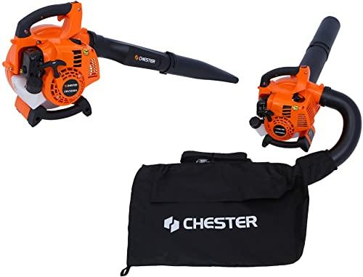
The inconvenience
One of the remarkable disadvantages of the gas leaf blower vacuum is its noise emissions and vibrations. It also has the drawback of being quite heavy because of its engine. However, its effectiveness will always prevail since it is indeed professional equipment.
It should be noted that the gas model is more difficult to maintain than the electric blower vacuum cleaner. And finally, there is its acquisition price which is relatively expensive. This is well justified by its versatility, performance, and power.
Criteria to check before buying a gas leaf blower vacuum mulcher
Choosing a professional gas shredder vacuum blower is not an easy thing. Indeed, there are dozens of models suggesting several possibilities of choice. But how do you make a purchase that specifically meets your needs? So find here the points to consider before acquiring the best 3-in-1 blower you need.
The power of the gas blower vacuum mulcher
This setting is important because it determines how well your tool performs on the job. However, there's no point in investing in a powerful device if you don't need great performance. Thus, you will choose the power that suits you according to the use you want to make of it: occasional or regular. However, the average power for professional use is 3000 watts.
The weight
Depending on what you plan to use it for, you will need a very small or very large device. Those in the last category are generally intended for professional use. However, even in this case, it is always necessary to favor the lightest possible tool. Indeed, it can be exhausting to keep it for a long time, especially if it's a 3-in-1 handheld vacuum.
suction volume
The suction volume is the number of leaves that your device is likely to store in order to signal "FULL." In general, manufacturers offer a minimum capacity of 500 m3/h. However, the most powerful tools can deliver up to 900 m3/h.
The capacity of the collection bag
If you only have a very small garden, this selection criterion is not very important. With a low-volume pick-up bag, you could do just fine. However, the problem arises when the surface is maintained large, with a large number of leaves to be shredded. You will therefore need a leaf bag with a large capacity to make fewer round trips.
The speed of the blower
This setting represents the degree of wind power your blower provides to gather the leaves. The market generally offers speeds ranging from 200 to 400 km/h. You might even get more on some high-performance models.
Grinding rate
The grinding rate defines the size of the residue you will get after grinding. The latter can vary depending on the brand between ⅕ and 1/16. We can even have a higher rate depending on the model chosen.
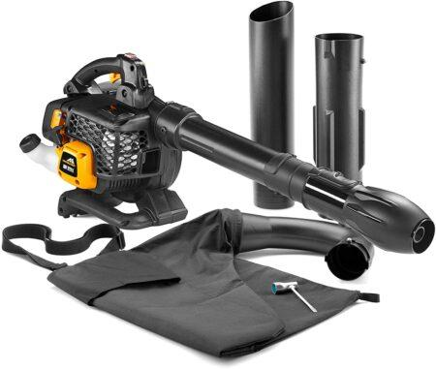
Noise emissions and vibrations of the gas shredder blower vacuum mulcher
Noise emissions and vibrations are quite disturbing with the gas grinder blower vacuum. Regular and long-term use can affect the user's hearing and well-being. Also, it can be disturbing to the neighborhood. To reduce noise, it is, therefore, necessary to favor a 4-stroke engine over a 2-stroke. As for the vibrations, it is necessary to think of checking the presence of an anti-vibration device.
Additional options and accessories
Additional options and accessories are devices whose absence does not impair the operation of the device. However, their presence makes the tool much more ergonomic for the user. Find in this section some options and accessories to look for.
Casters: the end of the suction tube of some backpack gas blowers is equipped with casters. The latter has the role of easily orienting the head of the blower. This improves ease of use and relieves you of the weight of the device. They also have the function of protecting the tube from wear caused by friction on the ground.
The vacuum/blower switch: some gas leaf blowers offer a switch to easily switch between blower and vacuum modes. This is a practical device to look absolutely.
Additional accessories: among other equipment, it would be ideal to choose a model that comes with a gutter kit, earmuffs, a container for mixing the fuel, gloves, goggles, etc.
The price
Manufacturers offer several ranges of professional gas leaf blower vacuums mulchers to buy according to your budget. The amount to be paid will therefore depend on the range of products you are purchasing. In addition, it is possible that you opt for a used model.
It's up to you how far you can compromise between price and quality. In principle, from 30 euros, you can already get a professional vacuum blower grinder. On the other hand, the most efficient models can cost more than 700 euros.
Popular brands of gas blower vacuum mulchers
It is important to pay attention to the brand of the 3-in-1 gas leaf blower that you are about to buy. Because, generally, the best manufacturers produce only good equipment. Among those competing for the vacuum blower gas pressure mill market, we can cite without being mistaken:
Ryobi
Makita
Timberpro
McCulloch
Conclusion
To conclude, using a 3 in 1 gas blower is a very good idea. This will allow you to get rid of the leaves lying around, and why not make compost. But as you can imagine, excellent quality is necessary to enjoy your device properly. Our buying guide has given you the weapons you need to choose the best leaf vacuum mulcher.

