Advertisement Survey Analysis
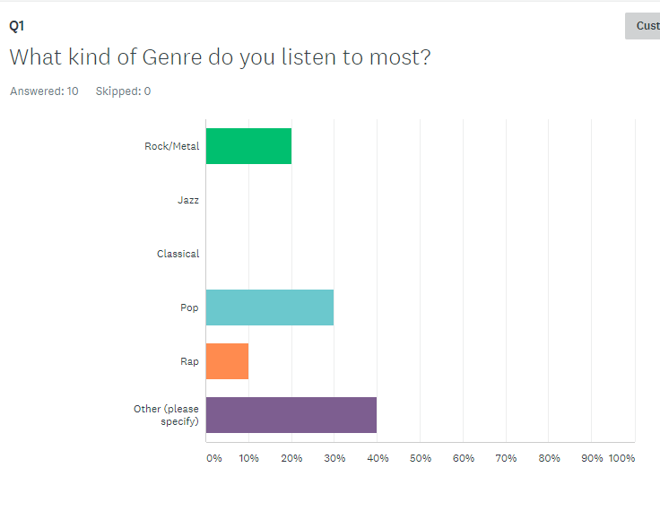
In this survey question we see that the people being surveyed listen to a wide range of music genres. This tells me that to appeal to my target audience I will have to feature a wide range of genres in my advertisement

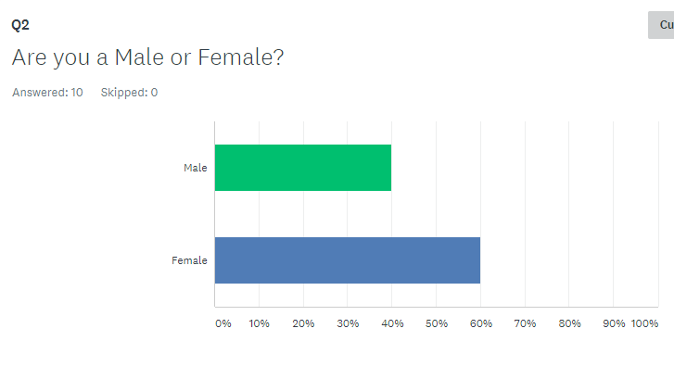
In this survey question we see that the people surveyed are split almost 50/50 for their gender, this means that for my advertisement I will have to appeal to all genders to make sure I reach the largest possible audience

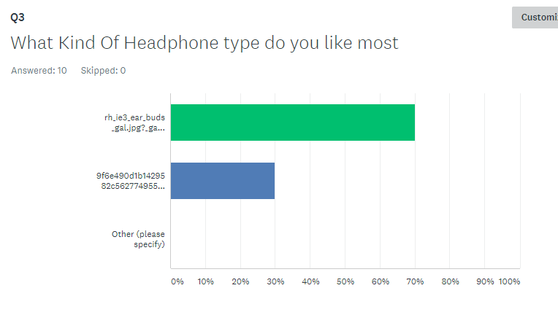

The Survey shows that the headphone that appealed to the audience the most was the small “earphone” style headphone. This tells me that to appeal to the largest market I would have to advertise a pair of earphones.

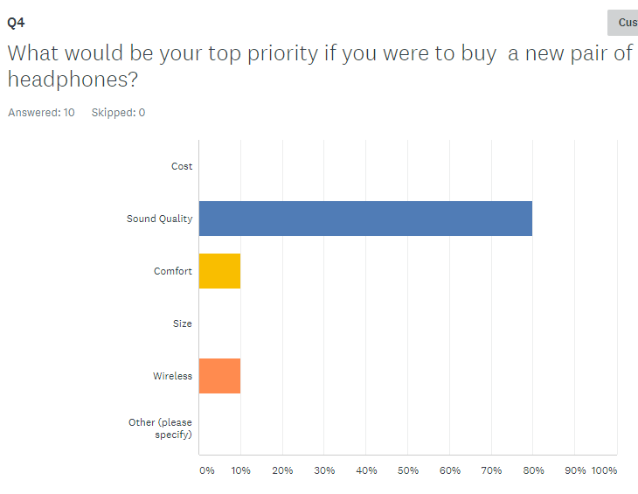
The survey shows that the people that took the survey prioritised having good sound quality in their headphones if they were to buy a new pair of headphones for their device. This tells me that in the advertisement I am planning to make, I will have to focus on how good the sound quality is of the product to attract the largest audience

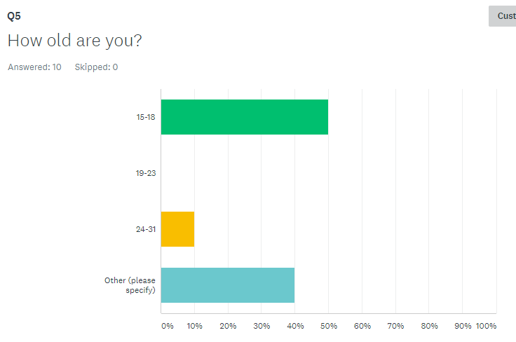
The results from the survey show that 50 percent of the people we 15-18 years old. This means that to attract the largest market it would be best to advertise to the 15-18 age bracket to ensure the largest audience.

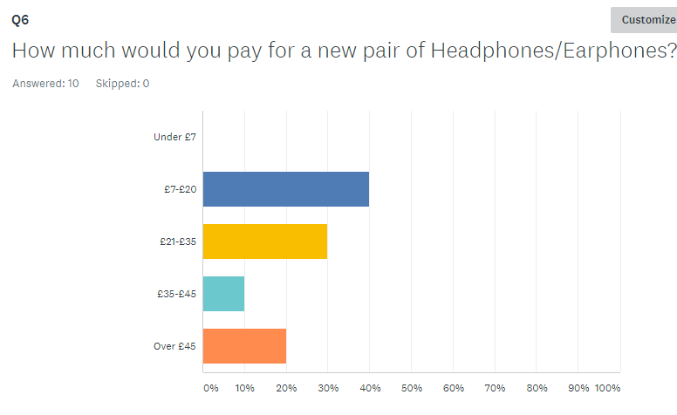
The results from the survey show a wide range of price ranges being selected, but I have decided to go for the £7-£20 range as this is a price range that most of my target audience can afford to buy, and people who have more money are still able to buy this product too.

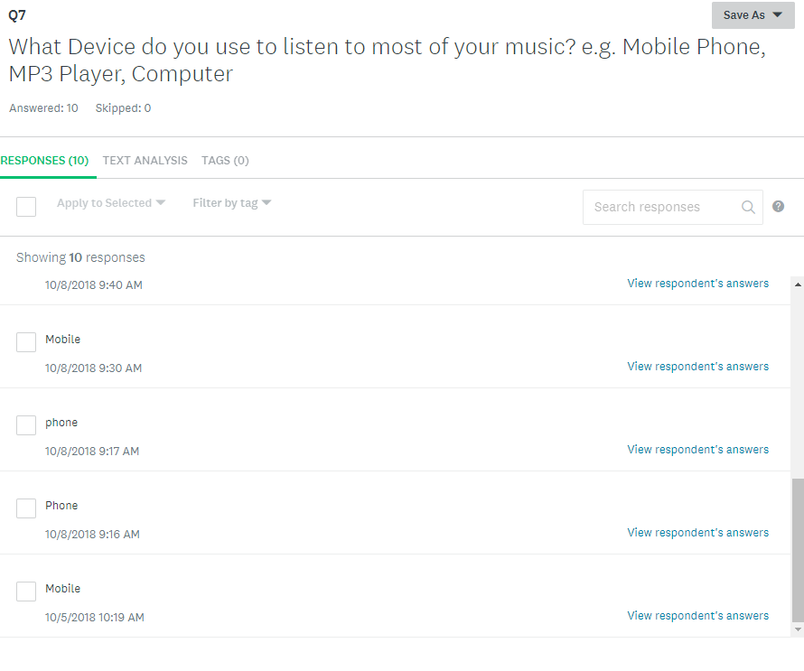
The results for this question show that almost all of the respondants listen to most of their music on their mobile phone. This tells me that to appeal to my target audience I will have to portray the characters in my TV advertisement as listening to their music on their phone to appeal to the target audience.

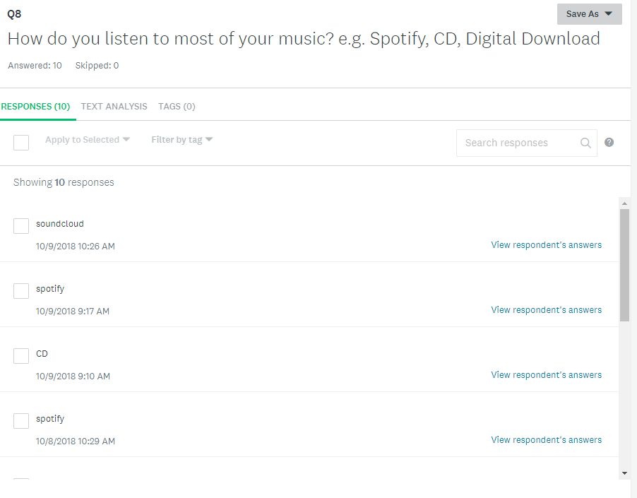
The survey responses how that most of the people that I surveyed listen to music using online streaming services and apps like Spotify, Apple Music, Amazon Music and Soundcloud. For my advertisement I will make sure that I show the earphones are compatible for use with these apps and services to appeal to the target audience.

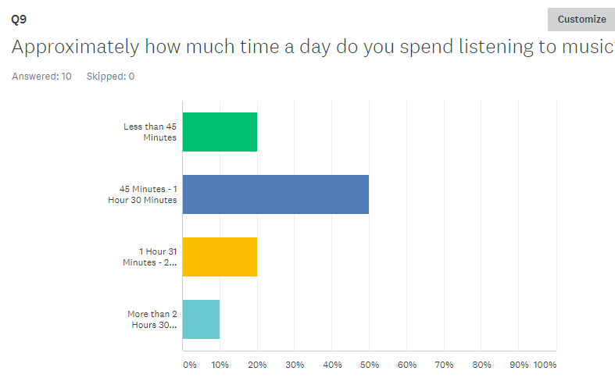

The survey responses tell us that most people listen around 45 minutes to 1 hour and 30 mins of music a day. This tells me that most of the users will be wearing these earphones at least 45 minutes a day and they will be wearing it while on the move (as they are listening using a mobile phone) which tells me that the headphones will have to be durable. However even though sound quality was the quality that the survey participants valued most, they are all quite casual listeners as only 10 percent said that they listened to more than 2 hours and 30 minutes daily.

