Vwin – Sân chơi uy tín hàng đầu Châu Á

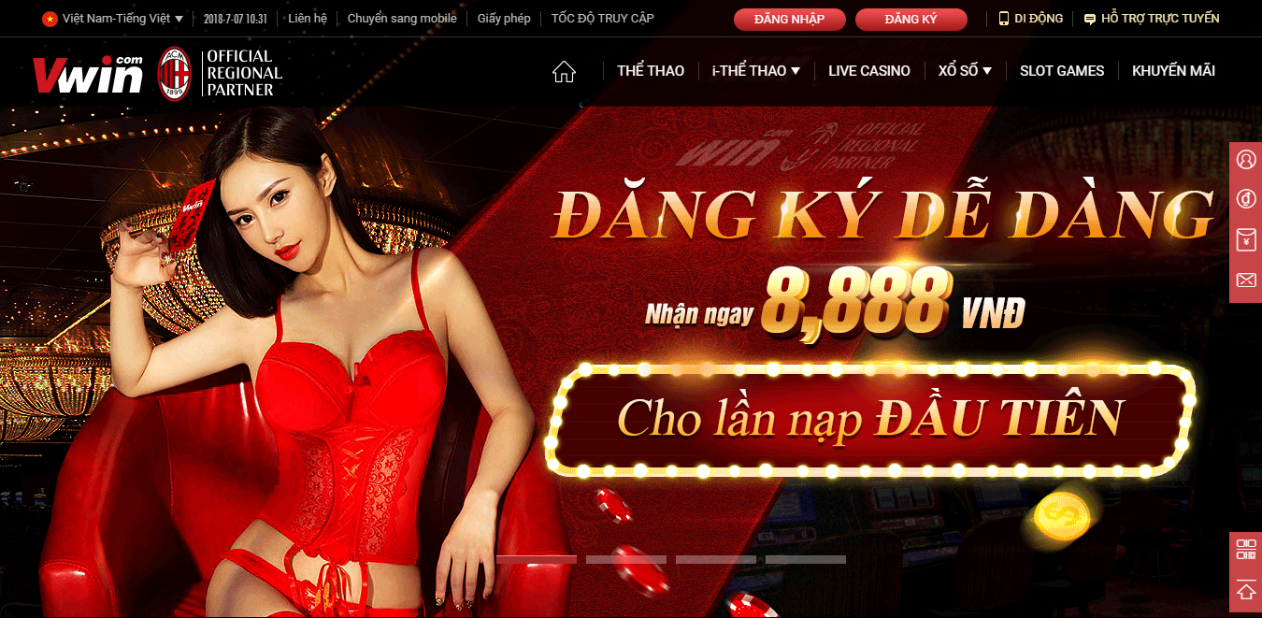
Vwin được biết đến là nhà cái hàng đầu Châu Á với đa dạng thể loại game hấp dẫn đang hot hit trên thị trường hiện nay. Đây là nhà cái uy tín với nhiều ưu điểm vượt trội.
Website: https://vwin.fund/
Mail: Vwin.fun@gmail.com
Địa chỉ: 125 Nguyễn Văn Cừ, Phường 2, Quận 5, Thành phố Hồ Chí Minh, Việt Nam
Sdt: 0336200637
Link Social
https://twitter.com/VwinFun
https://www.reddit.com/user/Vwinfun
https://www.tumblr.com/vwin-fun
https://www.hahalolo.com/@63e47f75f7c8702c1a341491
https://www.scoop.it/u/vwin-6
https://www.pinterest.com/funvwin/
https://www.flickr.com/people/197665048@N03/
https://trello.com/w/vwin2
https://gab.com/Vwinfun
https://www.gapo.vn/871369764
https://www.linkedin.com/in/vwin-fun-0ba356265/
https://myspace.com/vwin.fun24
https://www.quora.com/profile/Fun-Vwin
https://linkhay.com/u/vwinfun
https://www.diigo.com/profile/vwinfun24
https://www.pearltrees.com/vwinfun24
https://ok.ru/profile/584005918063
https://www.facebook.com/Vwin-102558119425692/
https://www.patreon.com/Vwin
https://www.instapaper.com/p/11957555
https://letterboxd.com/Vwinfun24/
https://dribbble.com/Vwinfun24/about
https://www.behance.net/funvwin
https://www.twitch.tv/vwinfun24/about
https://about.me/vwinfun/getstarted
Link Blog 2.0
https://vwinfun.blogspot.com/
https://vwinfun.wordpress.com/
https://vwinfun.bravesites.com/
https://vwinfun.wixsite.com/vwin
https://vwin.hashnode.dev/
https://sites.google.com/view/vwinfun/trang-ch%E1%BB%A7
https://vwinfun.weebly.com/
https://vwin-57cdcc.webflow.io/
https://vwin1.odoo.com/

