Art- The center of visible existence
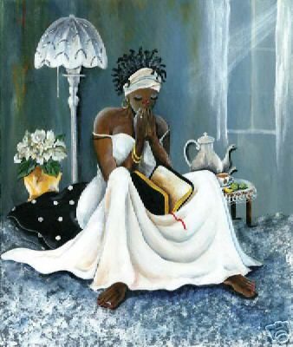
Art is a way of expressing what we imagine or what we interpret about life. Artists are considered very different from the conventional world as they possess a higher imagination and philosophy. The dexterity of converting unreal abstract thoughts into an alluring entity is the skill of a real artist. There are several forms of art. Some of them are:
- Fine Art: It is the most traditional form of art. It possesses more artistic value than functional value. It usually expresses the vision of an artist and its interpretation in the real world. Many artists like Kadir Nelson, Frank Morrison are experts in creating this form of art. Fine art includes drawing, painting, sculpture and printmaking.
- Visual Art: It is the larger body in the field of art and includes the section of fine arts like drawing, painting and sculptures. It also includes a lot of contemporary styles of art such as Assemblage, Collage, Mixed-media, Conceptual Art, Installation, Happenings and Performance art. As the name suggests this form of art focuses on the visual aspect.
- Decorative Art: This form of art has its functional value as it can be used for decorating areas. Basket-weaving, cabinet-making, ceramics and tapestry are part of decorative art which has some functional value. This form of art is also referred as “crafts”. Rugs, carpets etc. which are commonly used even today are the crafts that come under the category of Decorative art.
- Applied Art: It can be called as the application of art in more practical aspect of life. This type of art form uses all the different styles of art to put together something that holds a functional value. Result of this art can be used in day to day world, it has more conventional value. If you look around, everything you see is applied art like chair, tea pot, table, pen and even walls.
Art lives in every visible thing, whether it is living or non living. It is the center of existence as very thing we see has a shape, pattern and color. From the pattern on a beautiful butterfly to the stars every visible thing holds an artistic value in it.
Read Also: Contribution of John Holyfield and Charles Bibbs in Art World

