

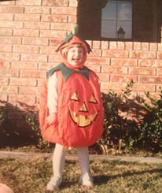
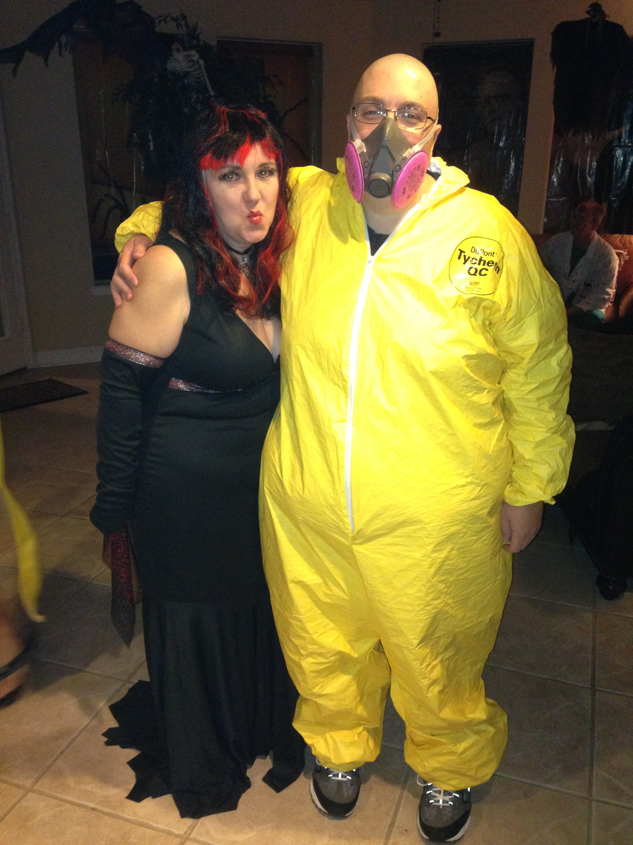

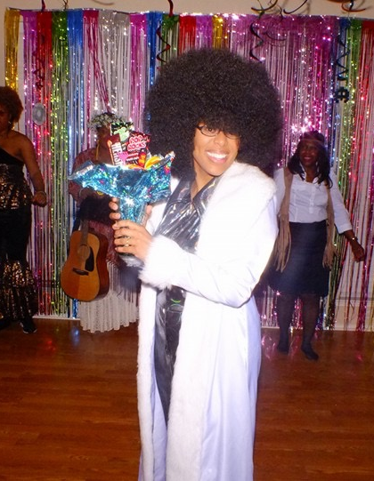




#HalloweenThrowback: Teacher Edition
Guess whose past Halloween pictures these are?
Q: What did the green grape say to the purple grape?

A: “Breathe, stupid.”
Joke of The Week
LRHS_ENN
LRHSENN

@LRHS_ENN
Eagle Nation News

Stay in The Loop!
Want to be heard? Got a story idea? Contact Mr. Sohel in room E-139
- Find out more about the bet between Coach Sohel and Coach Marsh.

- Get more in depth with Kaepernick’s National Anthem protest.

- See what happened at LRHS Band’s final competition.

