Image | Image Source | Web Address (if applicable) | Comment
 | Da Font | https://www.dafont.com/ | I choose this font because I feel that it matches my genre really well and the colours.
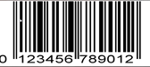 | Google Images | https://www.google.co.uk/search?q=barcode&safe=strict&source=lnms&tbm=isch&sa=X&ved=2ahUKEwi3stSw34LnAhViURUIHe68BU0Q_AUoAXoECA4QAw&biw=1920&bih=937&sout=1&surl=1&safe=vss&btnG=Search | Every magazine uses a barcode.
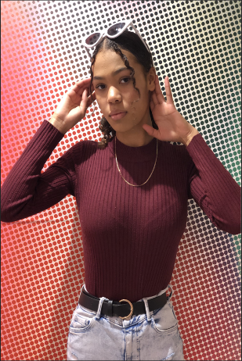 | This is an image that I took myself. | N/A | I used this image for my front cover because I feel like it reflects the pop genre and it also has a lot of colours which I wanted.
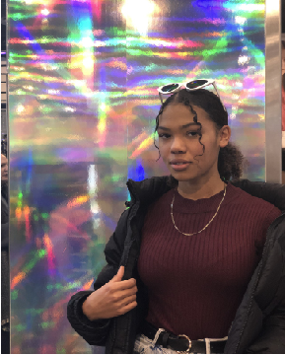 | This is an image that I took myself. | N/A | This picture that I took fits in really well in my article because in the background the colours are very vibrant and loud, so they’re reflecting the pop genre quite well.
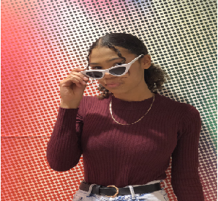 | This is an image that I took myself. | N/A | This picture that I took, it’s like the front cover image but I a bit more fun than the other ones because the others are a bit more serious.

