How To Access Various Features Of Your AVG Account?
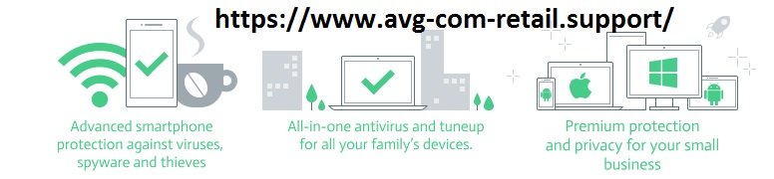

AVG account is a one-stop destination to manage everything associated with your AVG subscription. The user needs to create this account for ensuring a successful purchase of the AVG product from the official website from www.avg.com/retail login product key of this well-renowned cybersecurity products and services provider.

Once the process of purchase finishes, the next step is to download the AVG support from avg.com/retail. For this, the user wants to follow a specific set of instructions. Even after you successfully install the AVG antivirus on your respective device, the importance of AVG account remains the same. Want to know why? Just read out the information provided below:

Manage your AVG Subscription
All the AVG subscriptions are valid only for a particular period, and after that, the user needs to renew it or buy another subscription from avg.com/retail activation key. Hence, administration the subscriptions is necessary to ensure the constant protection of your device. With your AVG account, you can check and then renew your AVG subscription, effortlessly.

Manage your AVG Devices
When you log in to your AVG account, you can see the My Devices section and manage all the devices to which you have installed the AVG products. To administer, open the “My Devices” section, and then select the device from the drop-down menu. Once you click on the device, you can check the subscription status and the avg product key.

Check the product key
If you want to install your purchased AVG subscription to the other device and want the product key for its activation, then you can log in to your account and find the same under My Subscriptions.

While accessing your account, if you forget your password or face any other issue in the log in then contact the AVG customer support team to receive an immediate assistance from an expert at avg.com/registration.

#office.com/setup #webroot.com/safe

