DRIVING LESSONS



Being a professional driver is not an easy thing and people need to struggle a lot to make this happen. When it is about Manual driving lessons, they might not understand the need of it. But when a person goes into it, they will learn from the base. Usually people will learn driving easily but when it is about basics, they fail to make it. The basic idea of driving is to make things go just right. The person who drives a car should know a few things like the seat adjustment. Not all can sit in a seat of the same length and people should adjust it according to their needs. The height of people might not be the same and one should know about the adjustment. The car is planned in such a way that the driving seat can be adjusted according to the drivers need.

Also, if we talk about driving large trucks, then you cannot do without quality training. A person who wants to be a professional truck driver must have a good training. Usually, such training is not cheap, but on the Internet you can read many articles on how to raise money for a course for truck drivers, here is one of them https://nstschool.com/blog/how-to-finance-your-cdl-truck-driver-training/ . Having collected enough money, you can enroll in courses and get professional training. Then you can find a decent job as a truck driver.
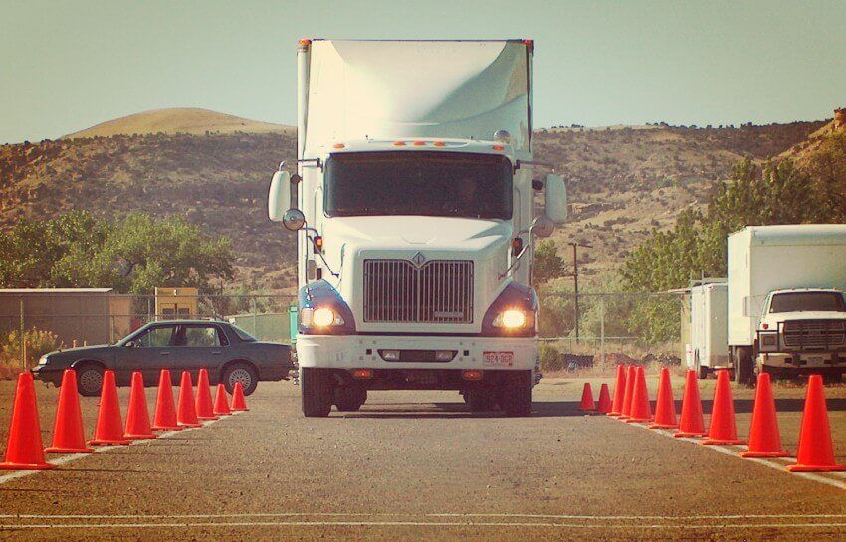
The driving lessons also checks the driver to know about the mirror adjustment too. The mirror is one of the main aspect of the car which allows the driver to see the vehicles that are behind it. The mirror helps one to take a reverse when it is necessary. There things are simple but when a person fails to understand it , they might fail in driving the vehicle. In the manual driving classes, these things are given a good prominence as people should know about these very clearly. Once these things are checked, one can go for the beginning level. The schools are having a right manual where each thing is written step wise and people can take it one after the other. Since no one can begin without a proper guide, it is very important to follow it in a right manner.

While doing these things, the person planning to go driving lessons for should check all these things again. The class should make them understand all these things in detail then people should be enough positive to take these things and follow it properly. Without the basic guidance, one might fail to get the vehicle and road and this might make one fell into problems. They not only create problems for themselves but also for those who are with them. These things should be taken care of when it is about driving. Though it is the best skill one can get, it can lead to disaster too.

