Patients First is excited to Announce that they will be opening a new Urgent Care Center in January

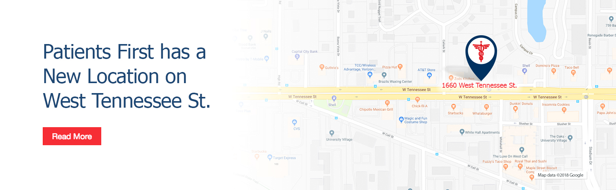

The New Center will be opening in January. It is located near the Florida State University Campus to better serve students and faculty. This is the 8th center in the greater Tallahassee area. It will be open 8:00am to 8:00pm 7 days a week- as we understand that students and faculty do get sick or injured after normal business hours. We look forward to serving the community.

